Appendix A

#1 "radical cystectomy"[Title/Abstract]
#2 "robot-assisted"[Title/Abstract] OR "robotic"[Title/Abstract] OR “robot assisted surgery” [Title/Abstract]) AND
#3 "open"[Title/Abstract] AND
#4"postoperative complications"[All Fields]
#5 ("quality of life"[Title/Abstract] OR "health related quality of life"[Title/Abstract])
#6 #1 AND #2 AND #3 AND (#4 OR #5)
Filters: Studies from Jan 01 2012 – October 01 2022
Study types: Clinical Trials, prospective, randomized

Filter Specifics
PubMed: “Filters: Clinical Trial, Randomized Controlled Trial, from 2012/1/1 - 2022/10/1”

Embase: “AND (2013:py OR 2014:py OR 2015:py OR 2016:py OR 2017:py OR 2018:py OR 2019:py OR 2020:py OR 2021:py OR 2022:py) AND ('clinical study'/de OR 'controlled study'/de OR 'major clinical study'/de OR 'multicenter study topic'/de OR 'phase 3 clinical trial'/de OR 'phase 3 clinical trial topic'/de OR 'prospective study'/de OR 'randomized controlled trial'/de OR 'randomized controlled trial topic'/de)”

Web of Science: Publication Years 2022 or 2021 or 2020 or 2019 or 2018 or 2017 or 2016 or 2015 or 2014 or 2013 or 2012

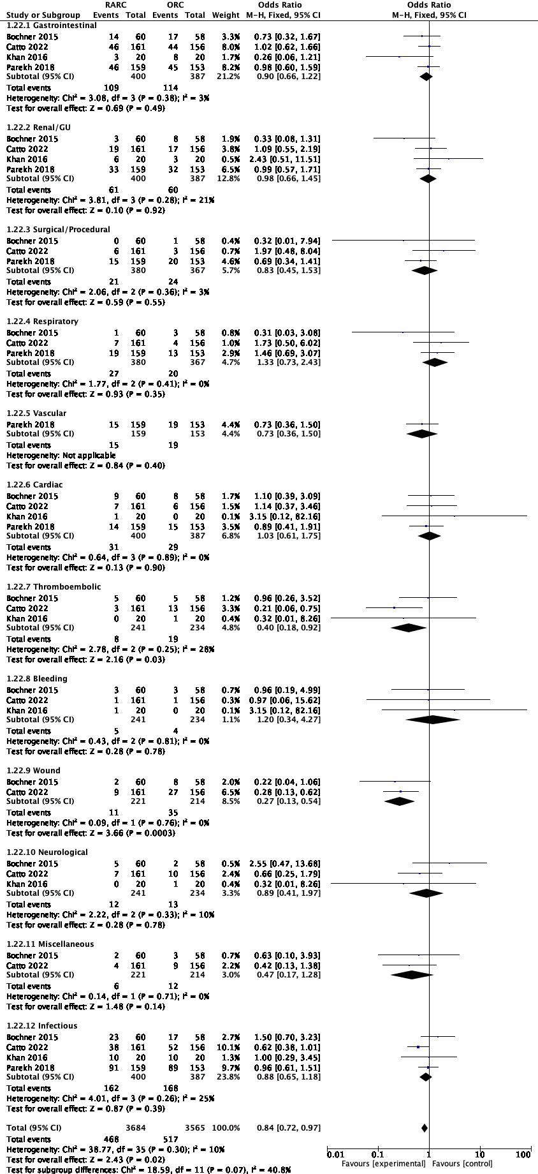
Appendix B. Complication Type

Appendix C. Sensitivity Analyses

Sensitivity Analysis for Estimated Intraoperative Blood Loss

Sensitivity Analysis for Operative Time

Appendix D: Forest Plots of Study Outcomes

Forest plot of comparison: 1 Open vs Robot-Assisted Radical Cystectomy, outcome: 1.16 90d Complications

Forest plot of comparison: 1 Open vs Robot-Assisted Radical Cystectomy, outcome: 1.11 Intraoperative Blood Loss (EBL).

Forest plot of comparison: 1 Open vs Robot-Assisted Radical Cystectomy, outcome: 1.8 Operative Time.
Forest plot of comparison: 1 Open vs Robot-Assisted Radical Cystectomy, outcome: 1.14 Length of Stay.

Forest plot of comparison: 1 Open vs Robot-Assisted Radical Cystectomy, outcome: 1.2 QoL EORTC QLQ-C30 (3 months).

Forest plot of comparison: 1 Open vs Robot-Assisted Radical Cystectomy, outcome: 1.3 QoL EORTC QLQ-C30 (6 months).

Forest plot of comparison: 1 Open vs Robot-Assisted Radical Cystectomy, outcome: 1.24 Lymph Node Yield.

Forest plot of comparison: 1 Open vs Robot-Assisted Radical Cystectomy, outcome: 1.25 Lymph Nodes pos patients.

Forest plot of comparison: 1 Open vs Robot-Assisted Radical Cystectomy, outcome: 1.26 Positive

