Supplementary materials

Supplemental Table 1. ICD-9 and ICD-10 codes used to identify cases of delirium
ICD-9 Codes |  | ICD-10 Codes
Code | Description | Code | Description
290.11 | Presenile dementia with delirium | F03.91 | Unspecified dementia with behavioral disturbance
290.3 | Senile dementia with delirium | F05 | Delirium due to known physiological condition
290.41 | Vascular dementia with delirium | F01.54 | Vascular dementia with behavioral disturbance
291.0 | Alcohol withdrawal delirium | F10.121, F10.221, F10.231, F10.921 | Alcohol dependence with withdrawal delirium
292.81 | Drug-induced delirium | F11.121, F11.221,  F11.921  F12.121, F12.221, F12.921  F13.121, F13.221, F13.231, F13.921, F13.931  F14.121, F14.221, F14.921  F15.121, F15.221, F15.921  F16.121, F16.221, F16.921  F18.121, F18.221, F18.921  F19.121, F19.221, F19.231, F19.921, F19.931 | Other psychoactive substance use, unspecified with intoxication with delirium
293.0 | Delirium due to conditions classified elsewhere | F05 | Delirium due to known physiological condition
293.1 | Subacute delirium | F05 | Delirium due to known physiological condition

Supplemental Figure 1. Overlap between methods for identifying true cases. Results indicate overlap between methods for identification of cases compared to manual chart review, ICD-codes, and NLP algorithm.

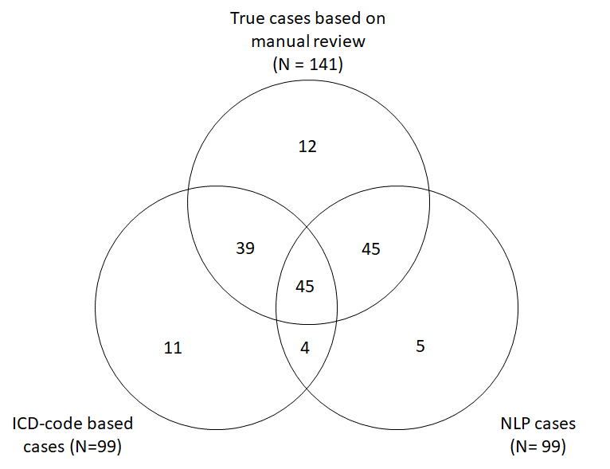

Supplemental Appendix

NLP Sources. The NLP algorithms for extracting delirium status have been previously described¹. Briefly, the infrastructure of the NLP system was an open-source NLP pipeline MedTaggerIE², which was developed using an open-source unstructured information management architecture–based information extraction framework³. The pipeline separates task-specific NLP knowledge engineering (i.e., individual CAM concepts) from the generic routine NLP, which enables words and phrases containing clinical information to be directly defined by subject matter experts (e.g., geriatricians and psychologists). To enhance research reproducibility and transparency, we released the NLP infrastructure, definition, and algorithm under the Open Health Natural Language Processing Consortium (Table A).

Table A. Access to Delirium Models and Resources
Category | Description | Link
Infrastructure | Open-source NLP pipeline MedTaggerIE | https://github.com/OHNLP/MedTagger
Algorithm Definition | Definition of the NLP-CAM and NLP-mCAM | https://github.com/OHNLP/AgingNLP/tree/master/delirium
 | Definition of the CAM-related Clinical Concepts | https://github.com/OHNLP/AgingNLP/tree/master/delirium
 | Annotation guideline | https://github.com/OHNLP/AgingNLP/tree/master/delirium/annotation_guideline
Algorithm | Lexicons and regular expression | https://github.com/OHNLP/AgingNLP/tree/master/delirium/DELIRIUM/regexp
 | Context algorithm | https://github.com/OHNLP/AgingNLP/tree/master/delirium/DELIRIUM/context
 | Rulesets | https://github.com/OHNLP/AgingNLP/tree/master/delirium/DELIRIUM/rules
Other support | Installation Guide | https://vimeo.com/392331446

Gold Standard. The gold standard corpus for the evaluation of the NLP system was established through a standard corpus annotation process⁴. One geriatrician and one psychologist manually reviewed clinical notes from the Mayo Clinic Rochester (MCR) EHR for 300 patients from the Mayo Clinic Biobank. Half of the records were from patients who had received a delirium ICD-9 code and half who did not. The annotation was conducted using a previously validated annotation guideline and scheme. An iterative process was executed involving annotation training, organizing consensus meetings, measuring agreements, updating guidelines, and conducting adjudication. Following the same process, a trained nurse abstractor manually reviewed 400 patients (3287 notes) randomly stratified by the presence of delirium ICD-9 code from the Olmsted Medical Center (OMC).

NLP Development and Evaluation. We used 50% of the MCR data to develop the initial algorithm and used the other 50% of MCR data to evaluate the final performance. The validated NLP system was then deployed to the OMC data. Similarly, we used the first 50% of the OMC data to refine the NLP algorithm and report the final performance on the second half of the data. The final NLP performance is shown in Tables B and C.

Table B. Performance Evaluation of Delirium Identification on Mayo Clinic Rochester (MCR) clinical notes
 |  | Gold standard
 |  | Delirium | No Delirium | Total
NLP | Delirium | 57 | 0 | 57
 | No Delirium | 5 | 88 | 93
 | Total | 62 | 88 | 150

Table C. Performance Evaluation of Delirium Identification on Olmsted Medical Center (OMC) clinical notes
 |  | Gold standard
 |  | Delirium | No Delirium | Total
NLP | Delirium | 22 | 0 | 22
 | No Delirium | 0 | 172 | 172
 | Total | 22 | 172 | 194

References

1. Fu S, Lopes GS, Pagali SR, Thorsteinsdottir B, LeBrasseur NK, Wen A, et al. Ascertainment of delirium status using natural language processing from electronic health records. The Journals of Gerontology: Series A. 2020.
2. Liu H, Bielinski SJ, Sohn S, Murphy S, Wagholikar KB, Jonnalagadda SR, et al. An information extraction framework for cohort identification using electronic health records. AMIA Summits Transl Sci Proc. 2013;2013:149.
3. Ferrucci D, Lally A. UIMA: an architectural approach to unstructured information processing in the corporate research environment. Nat Lang Eng. 2004:1-26.
4. Fu S, Leung LY, Raulli A-O, Kallmes DF, Kinsman KA, Nelson KB, et al. Assessment of the impact of EHR heterogeneity for clinical research through a case study of silent brain infarction. BMC Med Informatics Decis Mak. 2020;20:1-12.

