Utilizing the Un-Meeting Model to Advance Innovative Translational and Team Science
Supplementary Data
Table S 1 - Un-Agenda
 | Activity
7:45 a.m. | Registration / breakfast / networking
8:30 a.m. | Welcome and opening remarks  Martin Zand MD, PhD – Center for Leading Innovation and Collaboration (CLIC)
8:40 a.m. | Framing the issues - 4 slides x 4 minutes (4x4’s)  - Michael Kurilla, MD, PhD, NCATS - Addressing the Opioid Epidemics Through Translational Science: The CTSA Program Role  - Redonna Chandler, PhD, NIDA - The Opioid Crisis: When Evidence Based Interventions Fail to Reach Patients  - Ken Leonard, PhD, University at Buffalo - The Elder Side of the Epidemic: High and Increasing Death Rates in Older Adults  - Christian Thrasher, Clinton Foundation - Providing the Tools and Resources to Ensure Success with Long Term Recovery
9:00 a.m. | Idea generation & room topic discussion identification
9:45 a.m. | Morning breakout session 1
10:30 a.m. | Morning breakout session 2
11:30 a.m. | Lunch / networking
12:20 p.m. | Re-framing the issues - 4 slides x 4 minutes (4x4’s)  - George Mashour, MD, PhD, University of Michigan - Reducing Opioid Prescribing and Enhancing Disposal: A Preventive Approach  - Paul Dougherty, DC, DABCO, Canandaigua VA Medical Center - Whole Health Initiative, the Role of Patient Centered Non-Pharmacological Pain Management  - Michael Mendoza, MD, MPH, MS, FAAFP, Monroe County Health Department, University of Rochester - Responding to the Opioid Epidemic in Monroe County: A Cross-Sector Collaborative Approach
12:40 p.m. | Idea generation & room topic discussion identification
1:00 p.m. | Afternoon breakout session 1
1:45 p.m. | Afternoon breakout session 2
2:45 p.m. | Closing remarks

Table S 2 – Un-Meeting Post-Meeting Survey
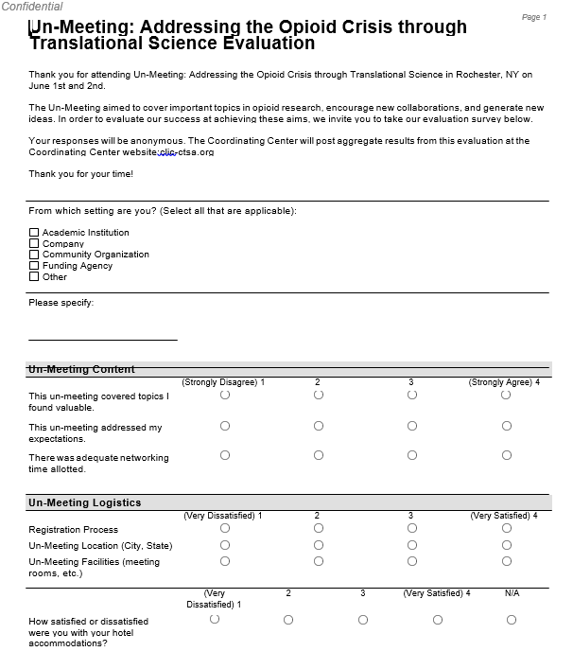
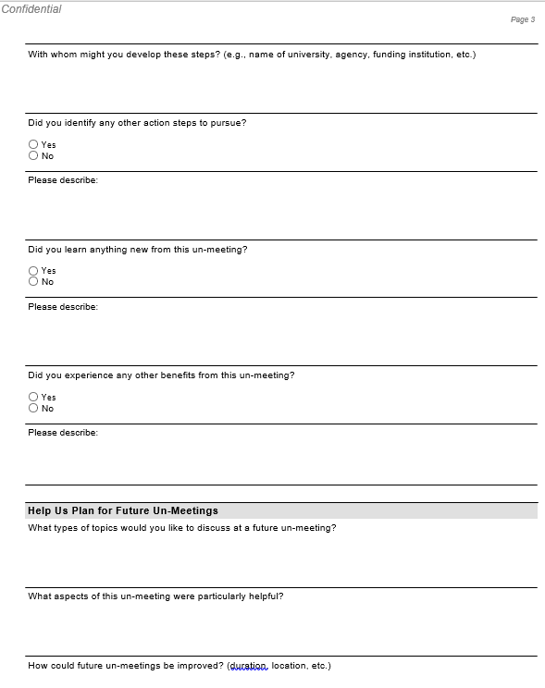
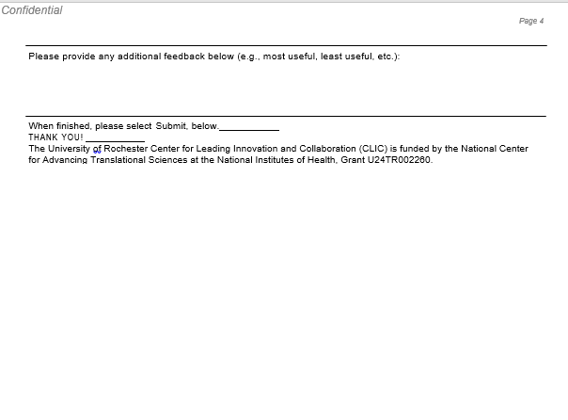

Table S 3 – Un-Meeting 6-Month Follow-up Survey
