Supplementary Information
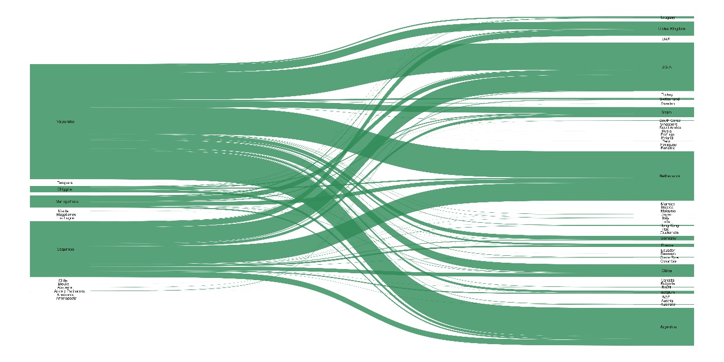
Figure S1. Sankey diagram depicting flow of avocados for export. The majority of avocados are produced in Valparaiso and Coquimbo regions in the Mediterranean zones of Central Chile.

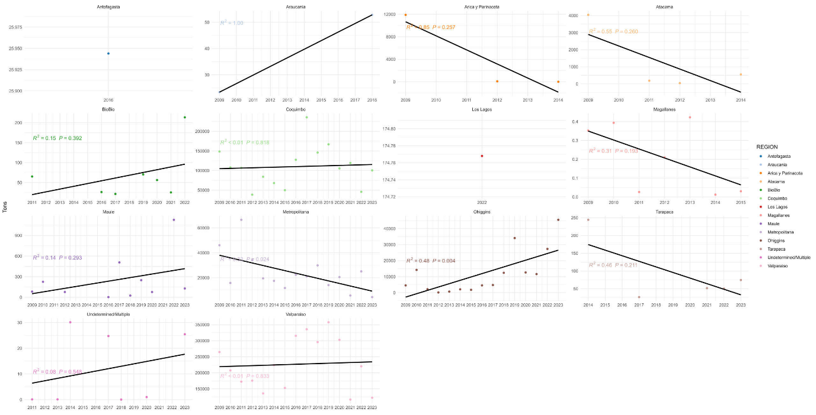
Figure S2. Linear models with regional production data. P-values less than 0.05 were considered significant.

