Appendix

Supplementary Text
Text 1 Oil palm cultivation
As of 2019, global oil palm plantation coverage, mainly distributed in Southeast Asia, the west coast of Central Africa, and Central America (Figure A1), was estimated to be 19.6 Mha. Oil palm cultivation is geographically concentrated in Southeast Asia, which accounts for 90% (17.7 Mha) of the total global planted area. Within this region, Indonesia and Malaysia have the largest oil palm plantations areas, accounting for 58.9% (11.5 Mha) and 25.9% (5.1 Mha) of the total cultivated area globally. Since the 1980s, oil palm plantations have expanded rapidly (Figure A1). More than 90% of oil palm expansion has occurred in Asia, decreasing to around 80% in recent years. By contrast, Africa's annual oil palm expansion rate and the land used for its cultivation have gradually increased (Figure 2).
Text 2 Global land cover datasets
The European Space Agency Climate Change Initiative (ESA CCI) produced the annual global land cover datasets from 1992 to 2019 at 300m spatial resolution (ESA 2017). The datasets have 37 land cover classes, and we reclassified them into 10 classes including cropland, forest, grassland, shrubland, wetland, water, tundra, impervious surface, bareland, and snow/ice (Table A1). The land cover sources of oil palm expansion were identified during 1993-2019 by overlapping the ESA CCI global land cover datasets with the global oil palm maps (Du et al 2022).
Text 3 Oil palm sample database
Using a global map of oil palm plantations (Cheng et al 2018), we applied a random, equal-area, hexagonal sampling approach using discrete global grid generation software (Sahr et al 2003) to create a sample database and rechecked by comparing the sample datasets with the Google Earth images. A total of 2,108 oil palm samples were generated across 15 countries: Indonesia, Malaysia, Thailand, Papua New Guinea, Nigeria, Ghana, Guinea, Cameroon, COD, Ivory Coast, Brazil, Colombia, Ecuador, Guatemala, and Honduras (Figure A2).
Text 4 Peatland loss
We applied an improved global peatland map developed by (Xu et al 2018). As Figure A7 shows, a large area of peatland is occupied by oil palm plantations, especially in Asia. Now globally, 11.38% (2.23 Mha) of oil palm plantations are established over peatland, of which 2.21 Mha are located in Asia (Table A2). The extent of peatland conversion for oil palm plantations is greater in Asia than on any other continent (Figure A5 (c)). The most severe peatland modification has occurred in Southeast Asia due to oil palm plantation expansion (Figure A5 (b)). In 2012, over 20% of Asian oil palm plantations were established on peatlands, coinciding with the most rapid expansion of oil palm cultivation. Peatland modification in Africa remained below 5% and was minimal in Latin America. At the country level, the most dramatic peatland modification is evident in Indonesia (1.41 Mha; 63.36% of the total peatland loss) and Malaysia (0.74 Mha; or 33.22% of the total peatland loss), followed by Papua New Guinea (0.05 Mha; 2.21% of the total peatland loss). Among these countries, Papua New Guinea, Malaysia, Indonesia, Brunei, and Equatorial Guinea exhibit the highest proportion of peatland transformation area relative to the total area of oil palm plantation expansion. Among these countries, Papua New Guinea, Malaysia, Indonesia, Brunei, and Equatorial Guinea had the highest proportions of peatland transformation area relative to the total area of oil palm plantation expansion(37.84%, 14.58%, 12.25%, 11.91%, and 11.70%, respectively) (Table A2). In contrast, the conversion of peatlands for oil palm plantations in Africa and Latin America remains limited. The most significant peatland modification has taken place in Southeast Asia due to the expansion of oil palm plantations (Figure A5 (b)). In 2012, over 20% of Asian oil palm plantations were established on peatlands, coinciding with the most rapid expansion of oil palm cultivation. Peatland modification in Africa remained below 5% and was minimal in Latin America. Looking at individual countries, the most extensive peatland modification is observed in Indonesia (1.41 million hectares; 63.36% of the total peatland) and Malaysia (0.74 million hectares; 33.22% of the total peatland), followed by Papua New Guinea (0.05 million hectares; 2.21% of the total peatland). Among these, Papua New Guinea, Malaysia, Indonesia, Brunei, and Equatorial Guinea had the highest proportions of peatland modification, accounting for 37.84%, 14.58%, 12.25%, 11.91%, and 11.70%, respectively (Table A2). In contrast, the conversion of peatlands for oil palm plantations in Africa and Latin America remains limited.
Text 5 Protected areas loss
Using WDPA database on global protected areas, we identified oil palm expansion into strict nature reserves (Category Ia), wilderness areas (Category Ib), and national parks (Category II) (Figure A8). Since the 1980s, the invasion of protected areas by oil palm plantations has intensified (Figure A5 (d)). Globally, a total of 344 (0.1 Mha) protected areas, covering approximately 0.1 million hectares (0.1 Mha), were converted to oil palm plantations. In particular, a total of 182 Category I protected areas (covering 28,143 hectares) were encroached upon by oil palm plantations, with 167 of these areas in Asia (23,524 hectares), 6 in Africa (265 hectares), and 9 in Latin America (313 hectares). Additionally, 162 Category II protected areas (encompassing 77,245 hectares) were affected, comprising 87 areas in Asia (23,524 hectares), 21 in Africa (12,942 hectares), and 54 in Latin America (40,779 hectares) (see Table A2).Specifically, a total of 182 (28,143 ha) Category I protected areas (covering 28,143 ha) were converted to oil palm plantations, with 167 of these areas in Asia (23,524 ha), 6 in Africa (265 ha), and 9 in Latin America (313 ha). Additionally, 162 Category II protected areas (encompassing 77,245 ha) were affected, comprising 87 areas in Asia (23,524 ha), 21 in Africa (12,942 ha), and 54 in Latin America (40,779 ha) (Table A2). Considerably more protected areas have been invaded in Malaysia (I: 106, II: 23), Indonesia (I: 32, II: 22), and Thailand (I: 19, II: 34) than in other countries (Table A2).
We found that the invasion of Category I protected areas by oil palm was concentrated in Asia (97.9%) but accounted for only a small part of the expanded area of oil palm cultivation in Asia, whereas the invasion of Category II protected areas in Africa and Latin America was more severe (Figure A5 [e]–[h]). The countries evidencing the most dramatic oil palm plantations conversion were Indonesia (30,433 ha: 13,575 ha of Category I and 16,857 ha of Category II protected areas) and Guatemala (28,213 ha: 13 ha of Category I and 28,199 ha of Category II protected areas) (Table A2). In other countries, such as Honduras, Malaysia, Nigeria, and Thailand, the transformation of protected areas by oil palm plantations was also extensive.
Text 6 IPCC method of calculating carbon stock changes
We used Intergovernmental Panel on Climate Change's (IPCC) 2006 methodology for determining greenhouse gas inventories in the Agriculture, Forestry, and Other Land Use (AFOLU) sector (https://www.ipcc-nggip.iges.or.jp/public/2006gl/vol4.html) to calculate carbon stock for cropland, forest, and grassland.
More specifically, Table 4.3, Table 4.4, and Table 4.7 were used in carbon stock for forest, including above-ground and below-ground biomass. Table 5.2 were used in carbon stock for cropland only, including above-ground biomass. Table 6.1 and 6.4 were used in carbon stock for grassland including above-ground and below-ground biomass. The following two equations were used in the calculation.
$M_{B}=M_{A}×RSR$ （1）
$M_{B}$ : below-ground biomass. $M_{A}$ : above-ground biomass. RSR: The ratio of below-ground biomass to above-ground biomass.
$CD=M×CF$ （2）
CD: carbon density. M: biomass. CF: carbon fraction of biomass, default value is 0.5.

As for carbon stock of oil palm, we used Global Aboveground and Belowground Biomass Carbon Density Maps (https://daac.ornl.gov/cgi-bin/dsviewer.pl?ds_id=1763) provided by NASA ORNL DAAC at Oak Ridge National Laboratory as the data source. This dataset provides temporally consistent and harmonized global maps of above-ground and below-ground biomass carbon density for the year 2010 at a 300-m spatial resolution. Based on this map, we calculated the average carbon density of oil palm by country.
Based on the carbon density results of cropland, forest, grassland, and oil palm, carbon density changes caused by each land cover change were calculated. We added up the results of carbon density change multiplied by pixel area to get the final results of carbon stock change by each type of land cover change in the world's countries.

Supplementary Figure
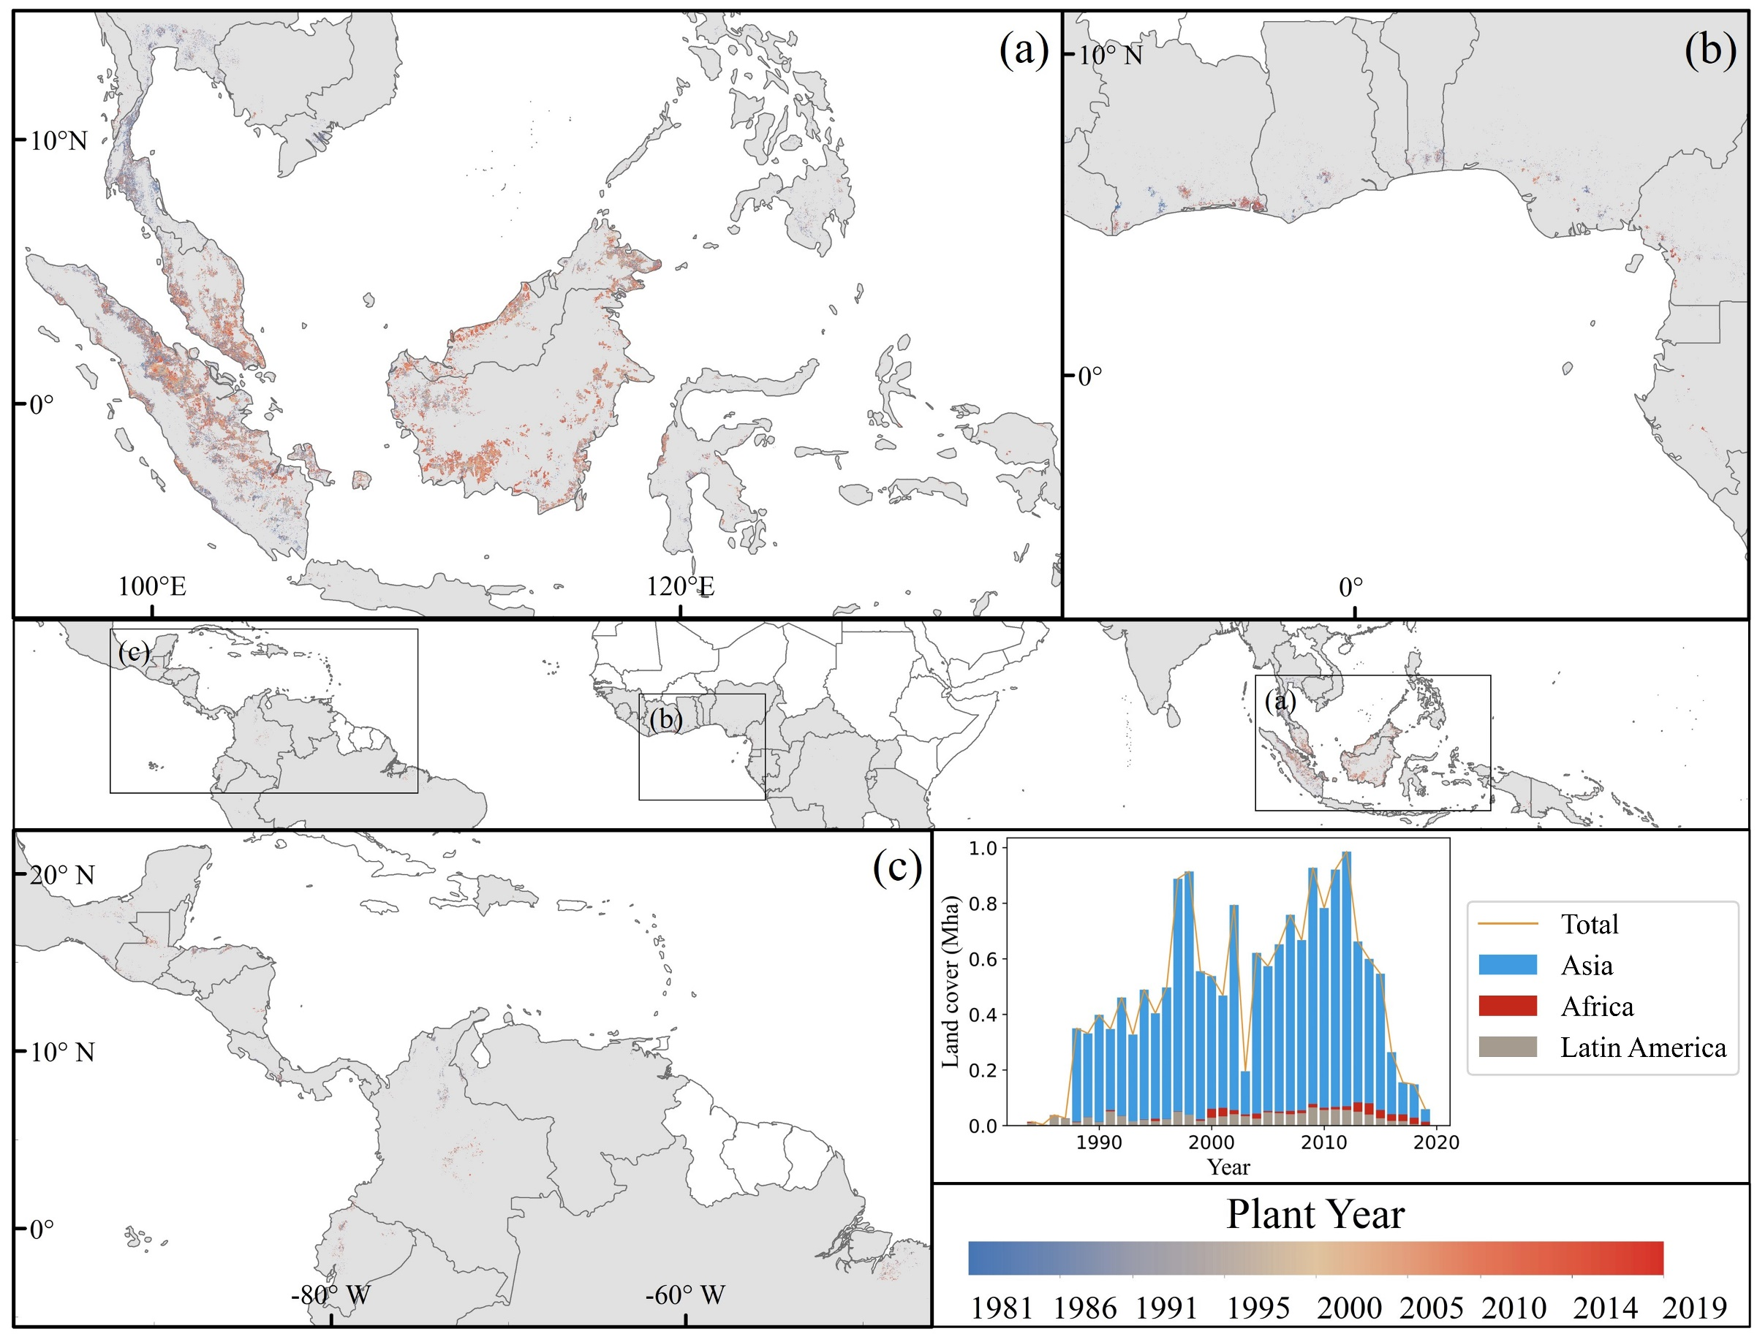
Figure S1. Annual global expansion of oil palm plantations

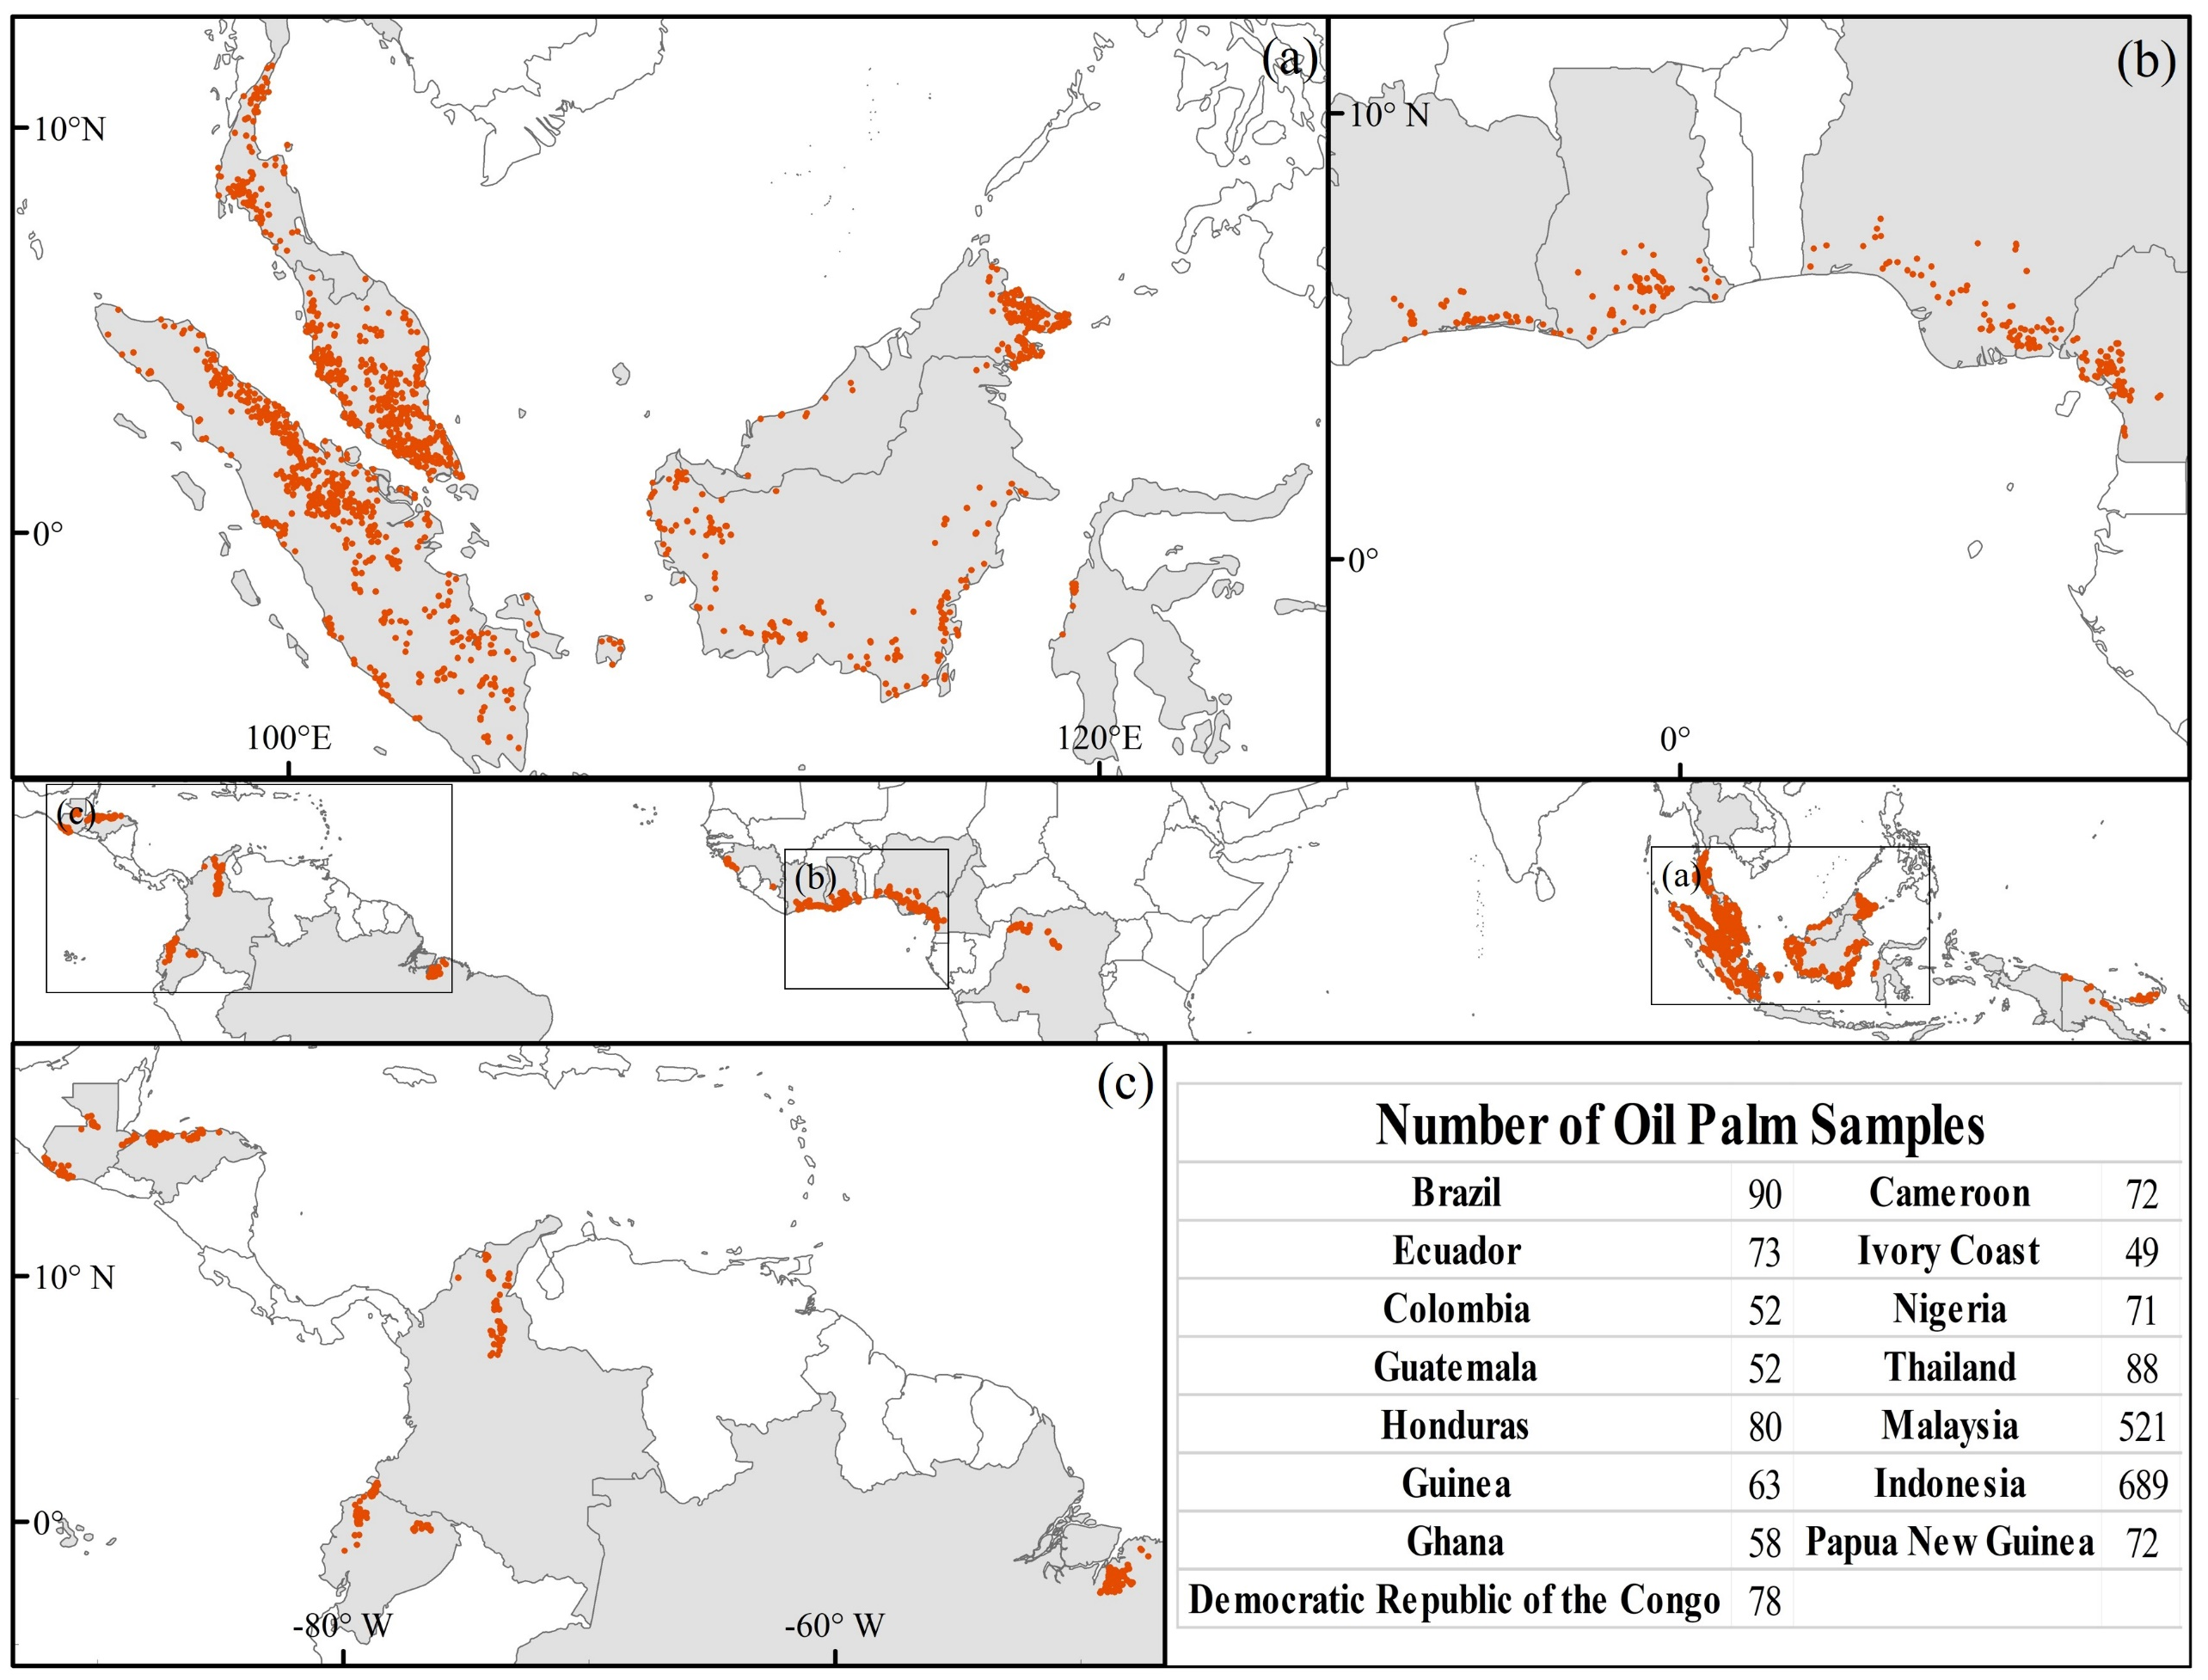
Figure S2. The distribution of oil palm plantation samples. The samples were obtained from a global map of oil palm plantations (Cheng et al 2018), and subsequently verified using Google Earth imagery.

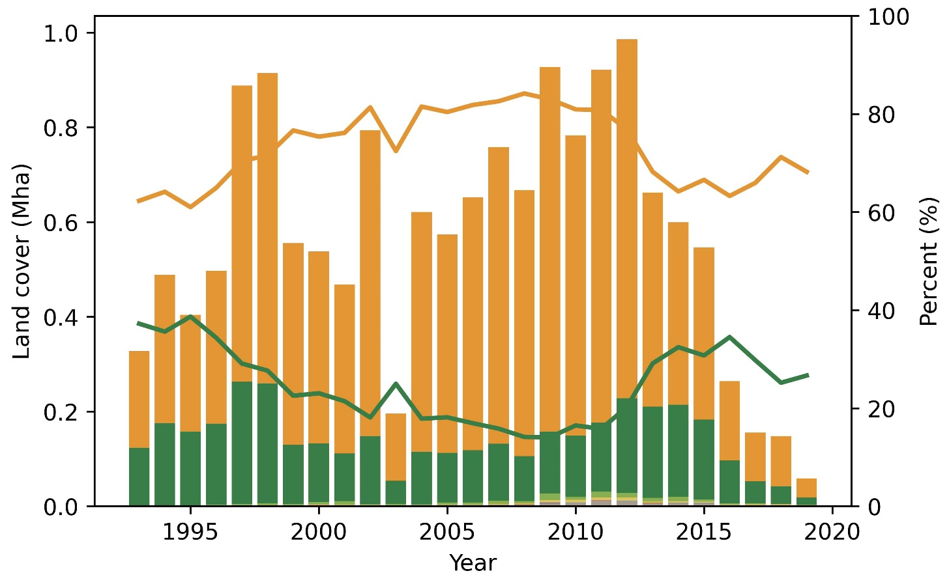 | 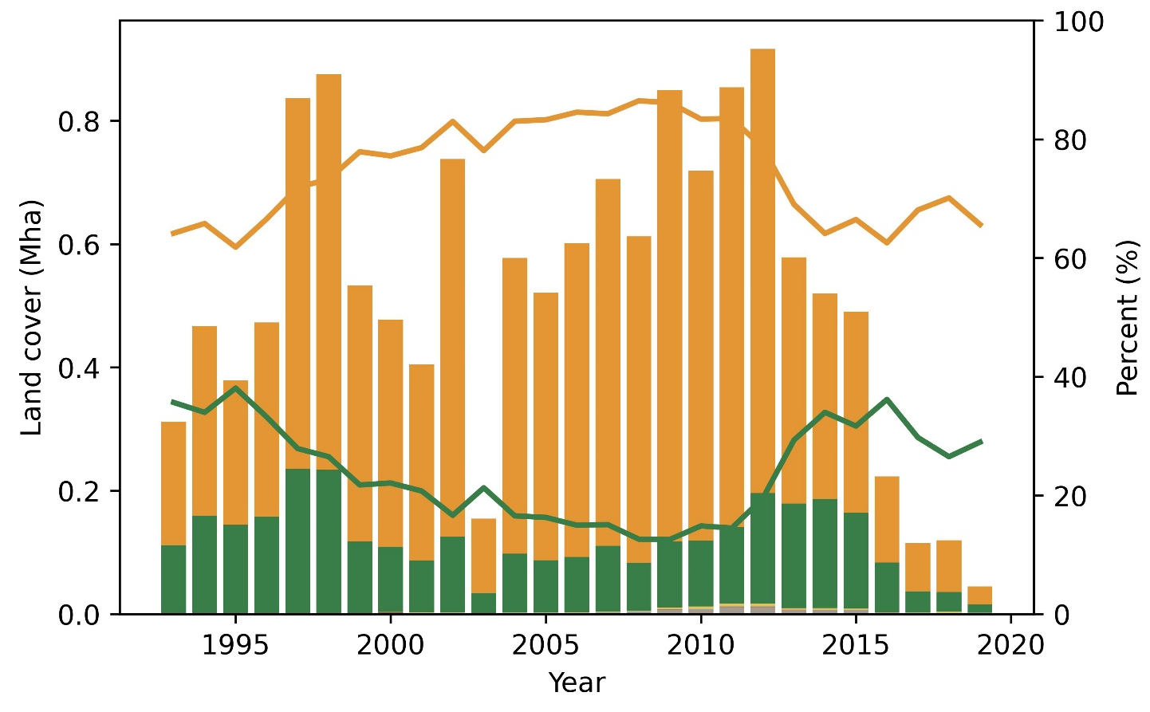
Global | Asia
 | 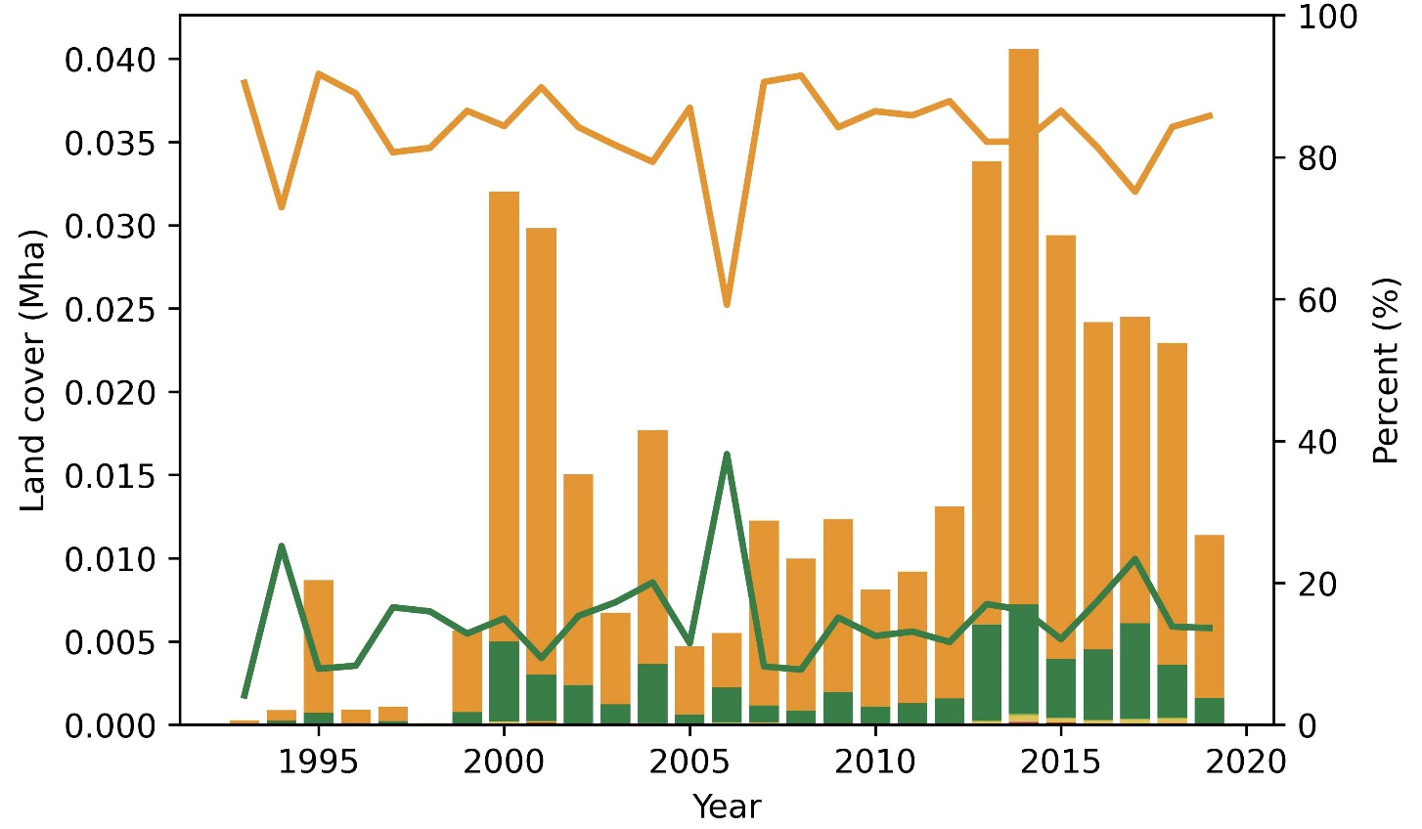
Latin America | Africa
Left axis
Right axis

Figure S3. Global land conversions of various land use types caused by oil palm plantations

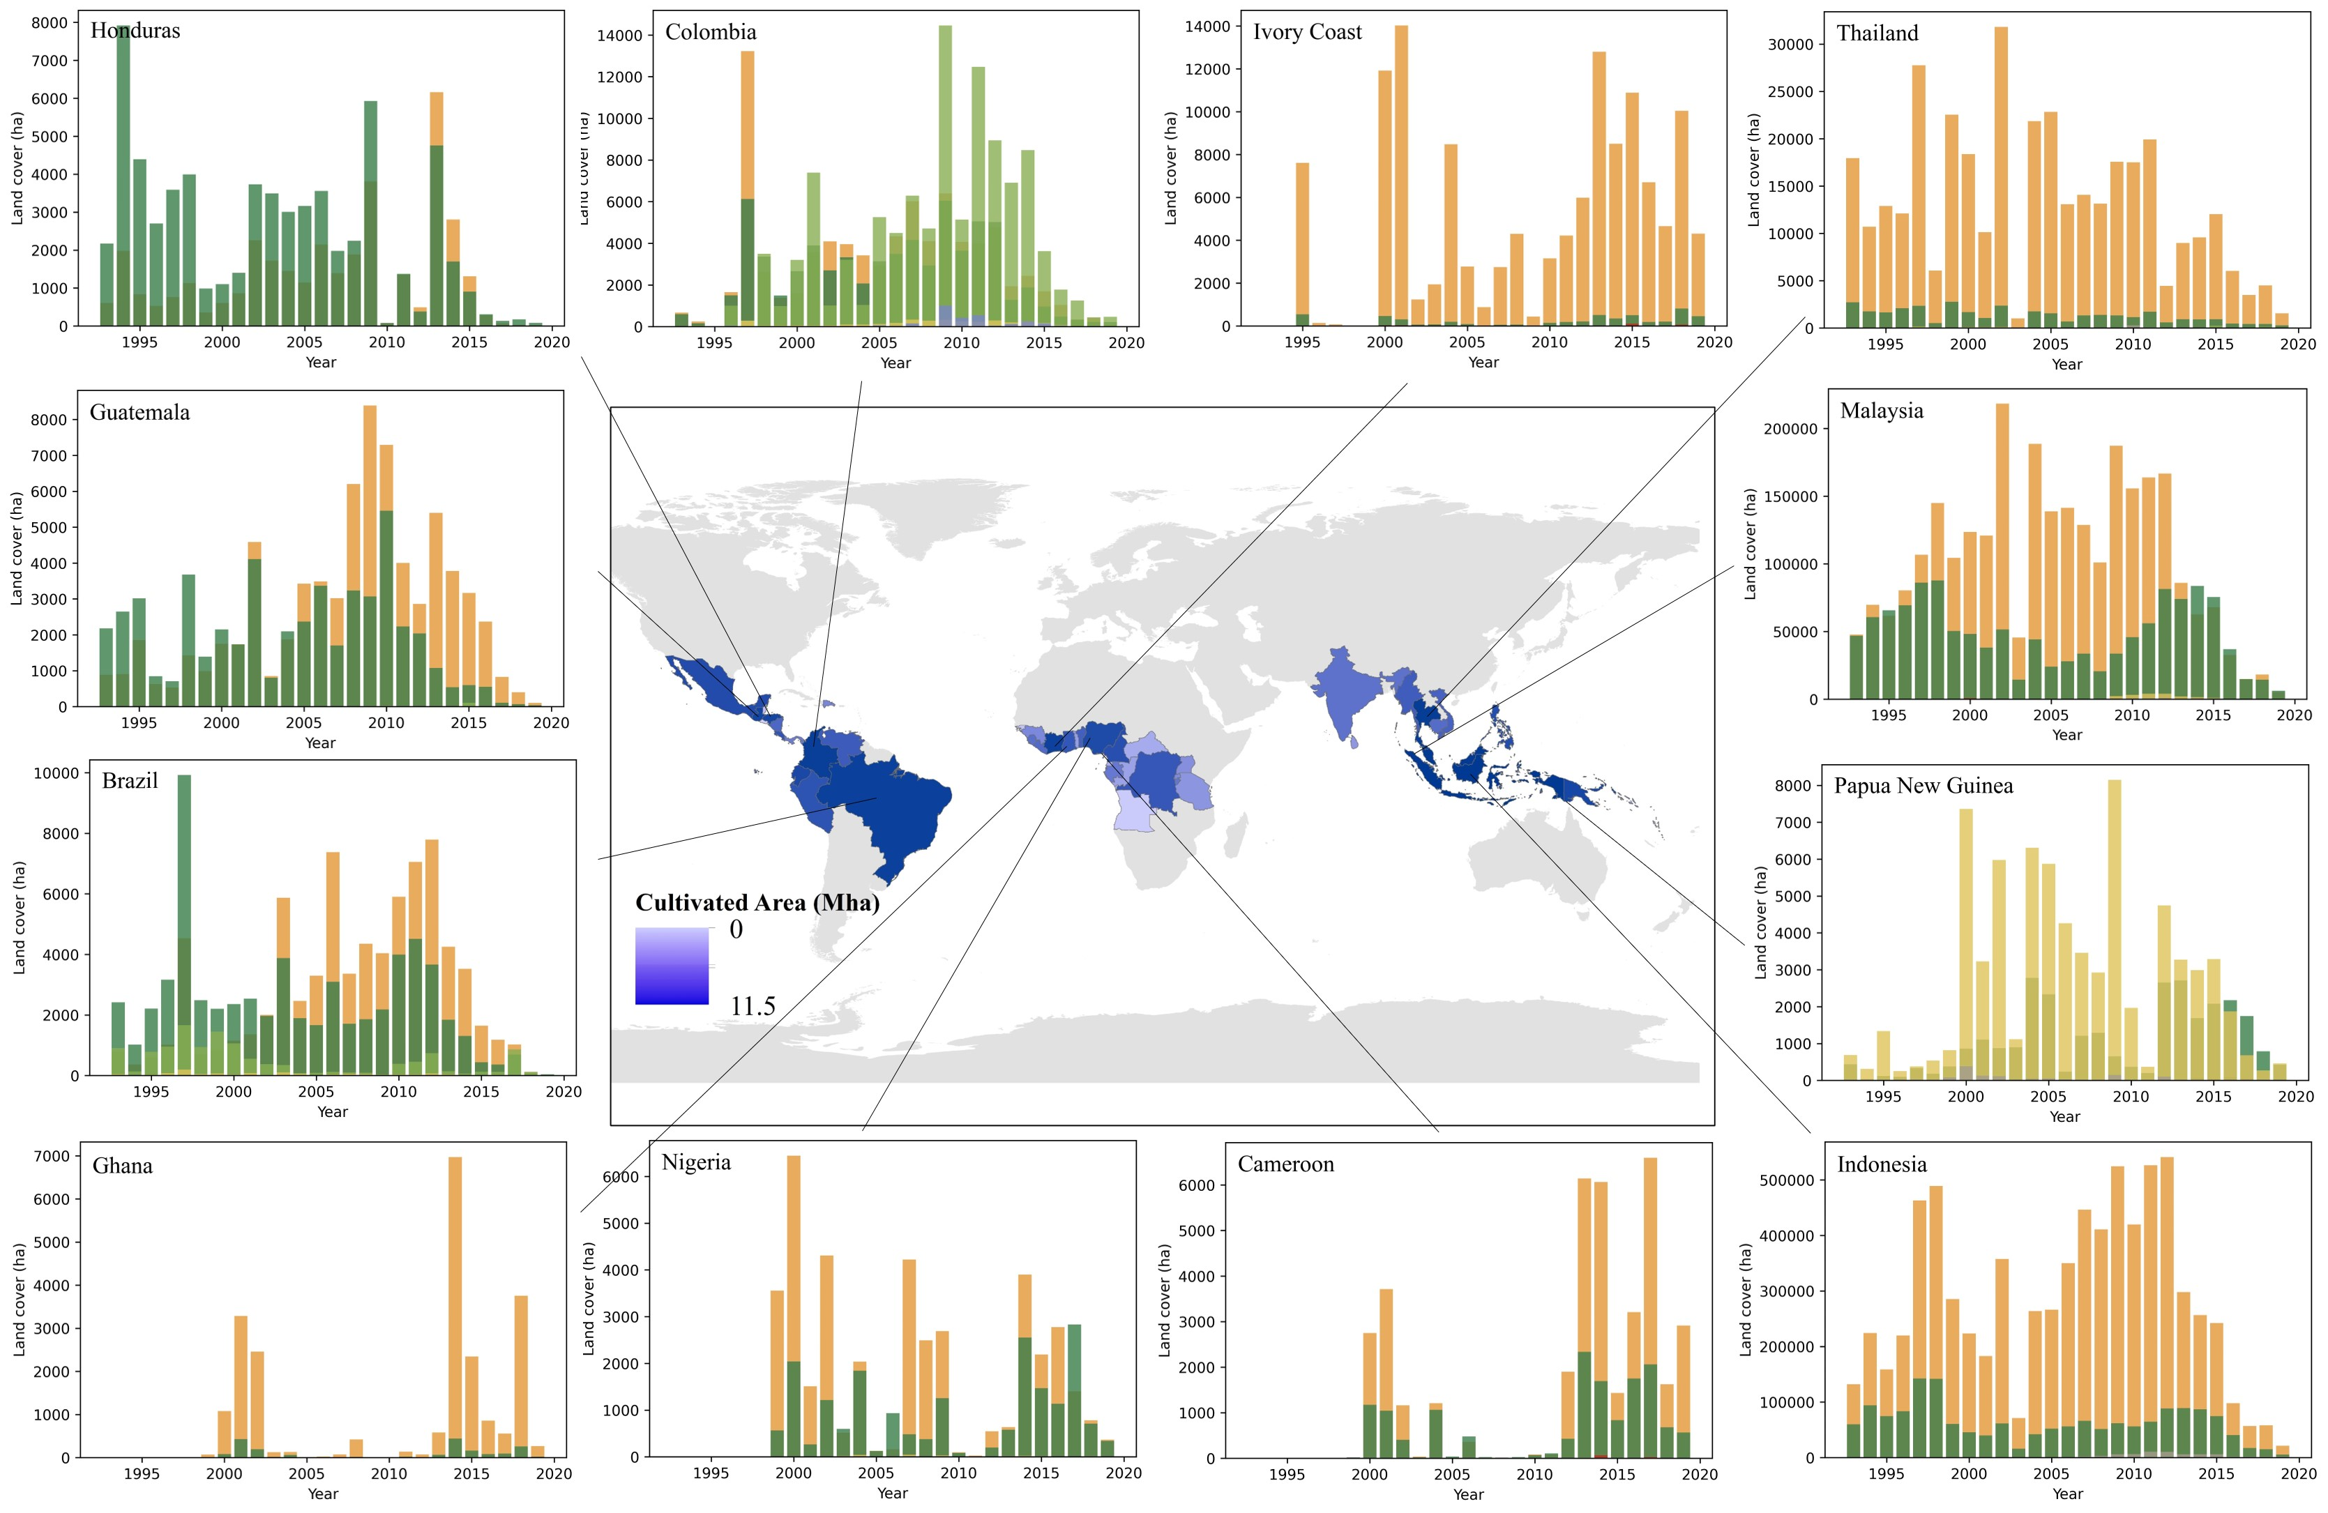
Figure S4. Land conversions in various countries caused by oil palm plantations
(a) | (b)
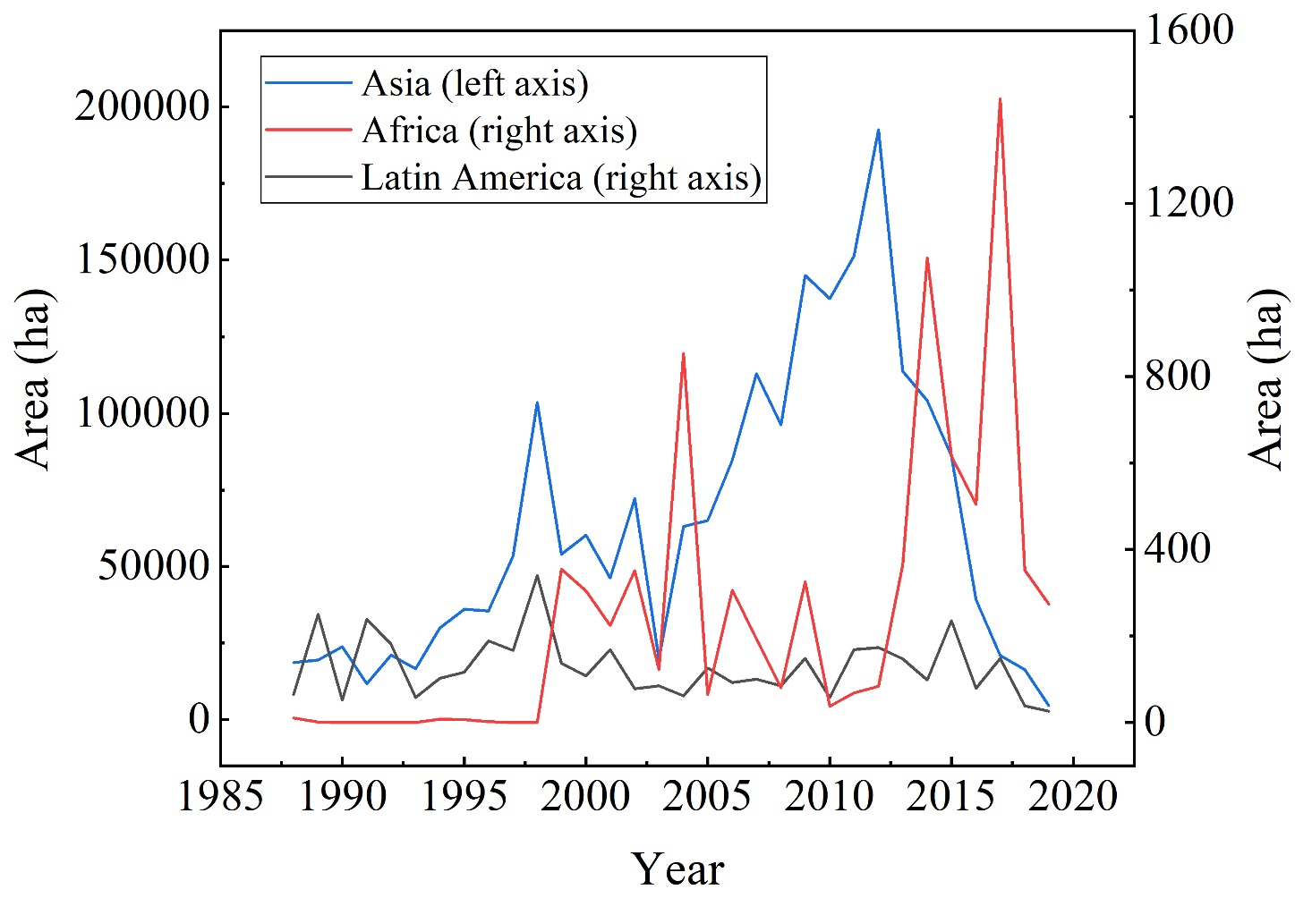 | 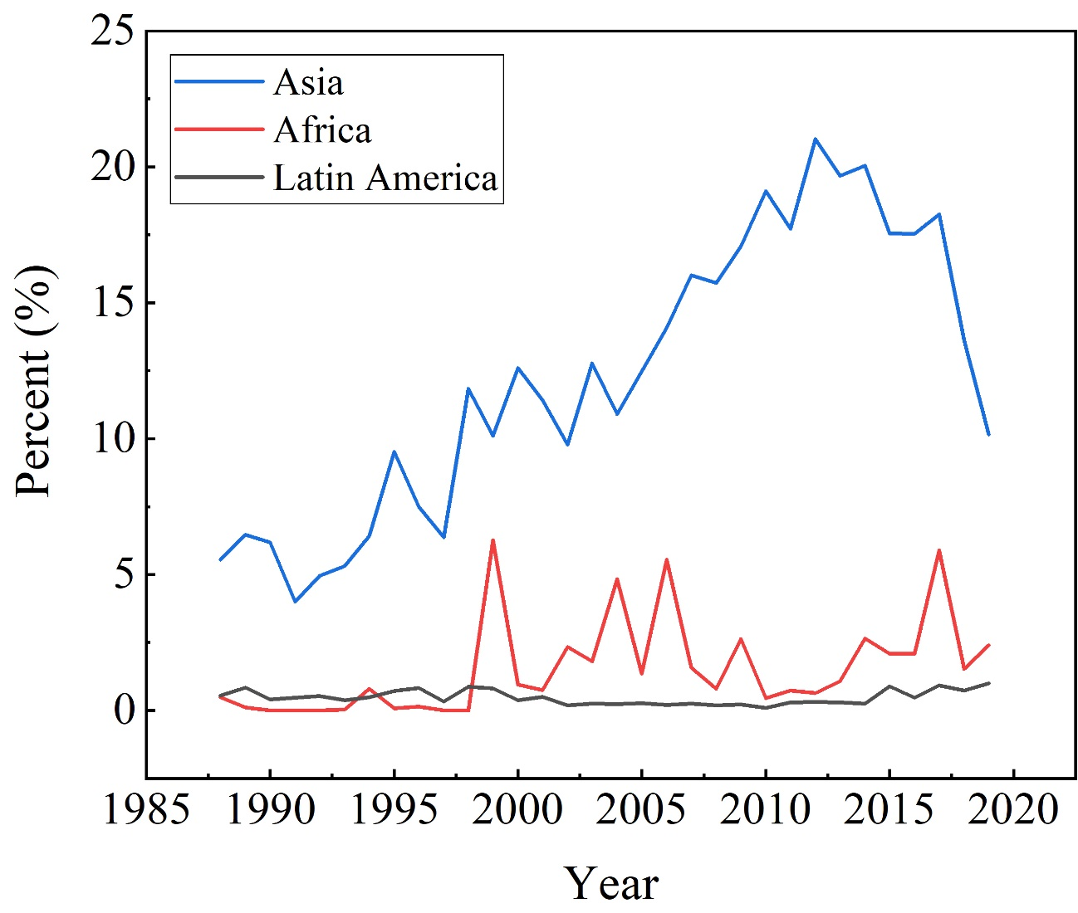
(c) | (d)
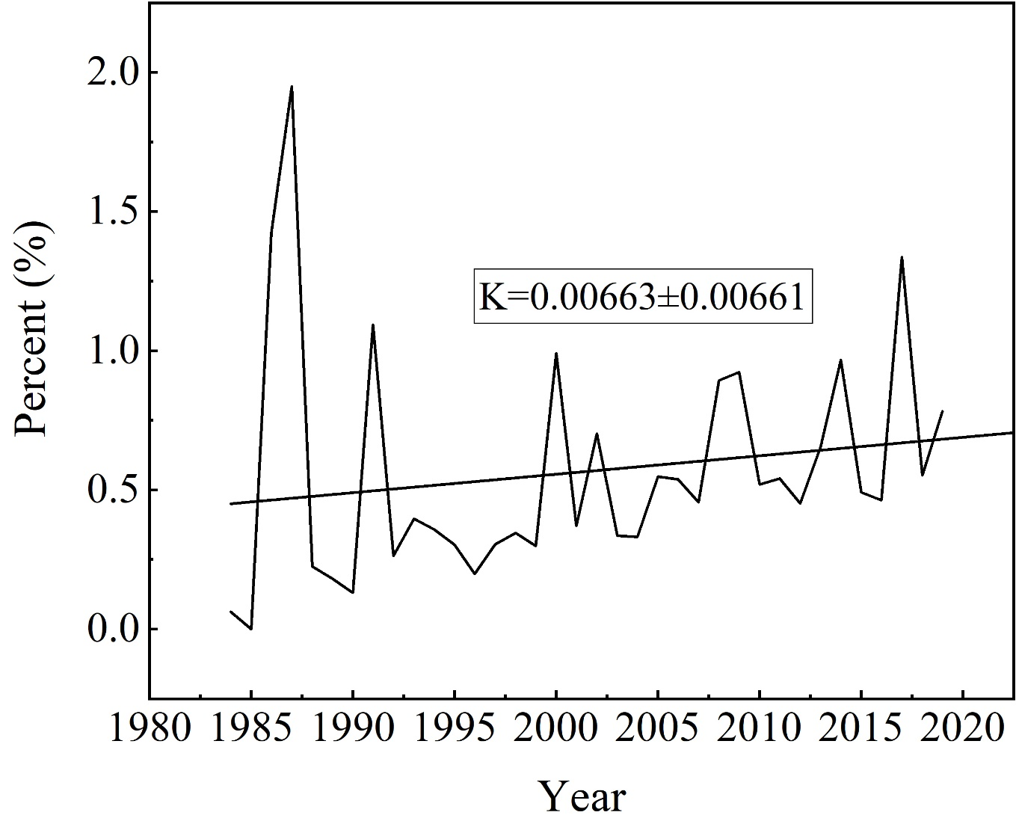 | 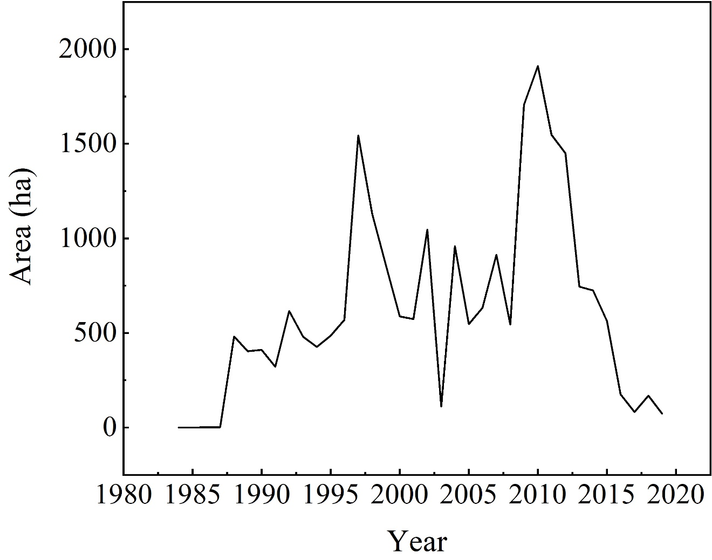
(e) | (f)
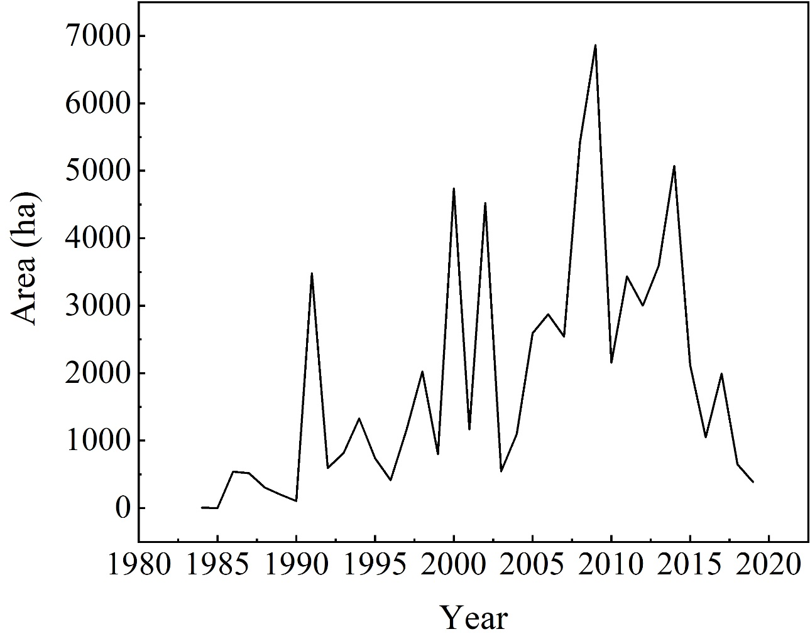 | 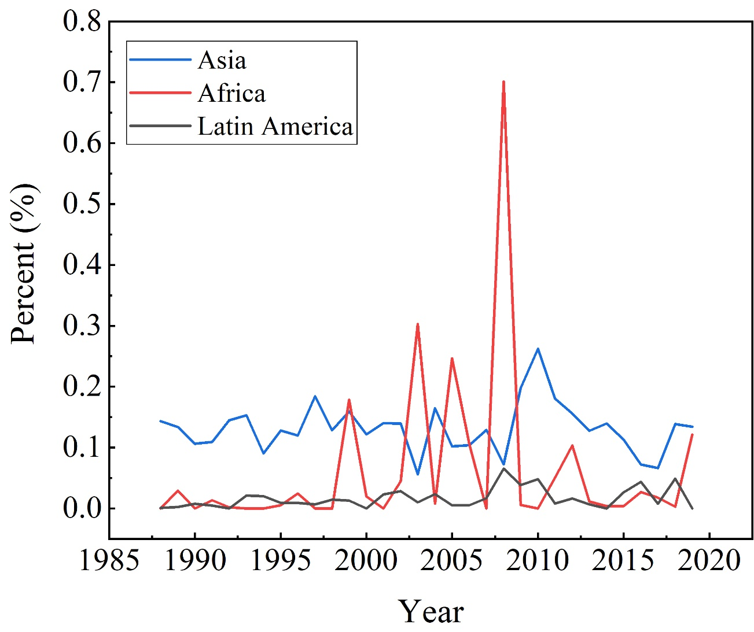
(g) | (h)
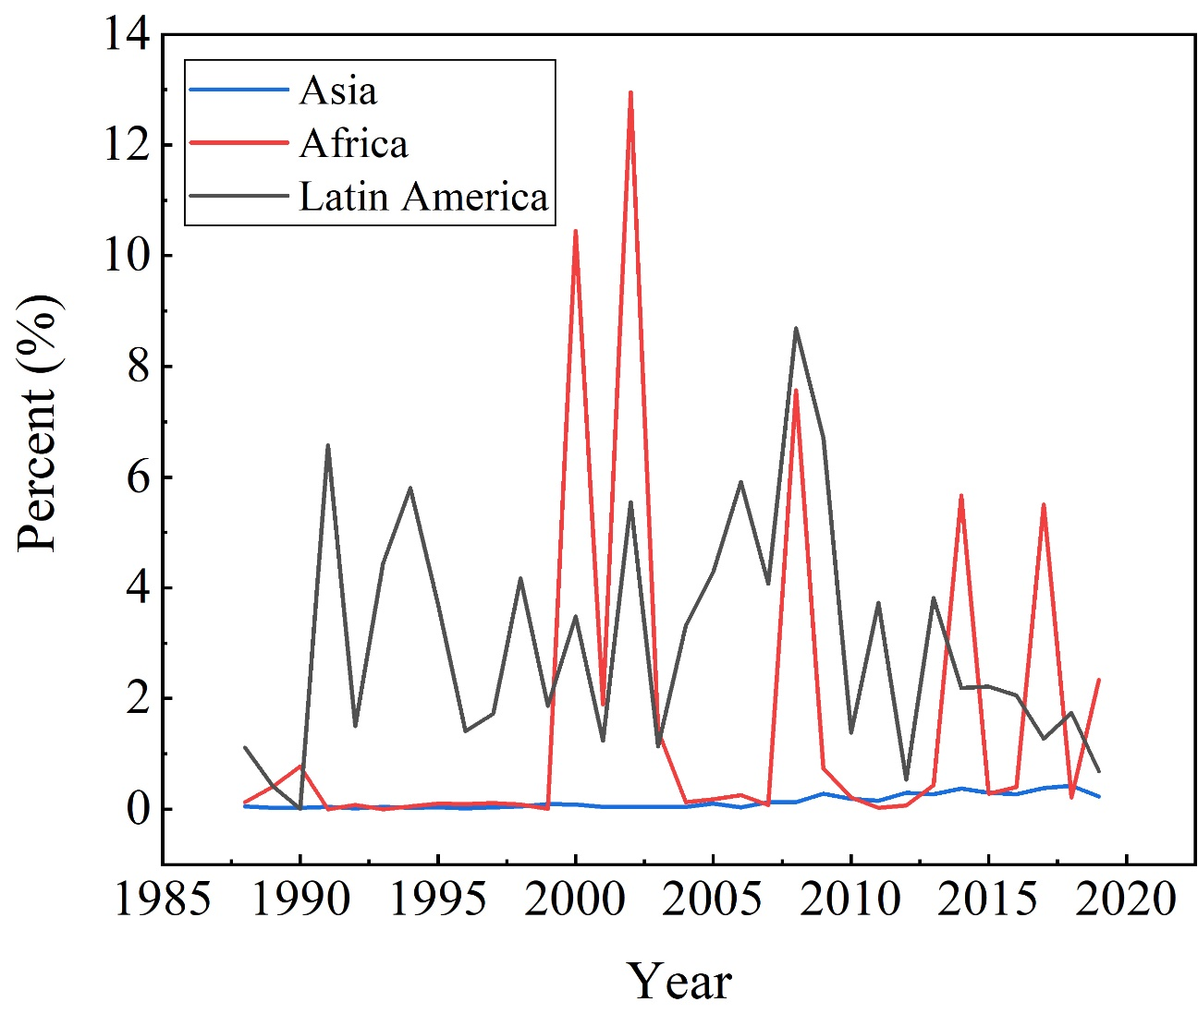
Figure S5. The characteristics of peatland loss due oil palm plantation expansion. (a) The area of oil palm plantations at the expense of peatlands. (b) The percent of peatland converted to oil palm plantations relative to annual oil palm expansion. (c) The percent of WDPA converted to oil palm plantations relative to annual oil palm plantation expansion. (d) The area of WDPA Category I (Ia, nature reserves; Ib, wilderness areas) converted to oil palm plantations. (e) The area of WDPA Category II (national parks) converted to oil palm plantations. (f) The percent of WDPA Category I converted to oil palm plantations relative to annual oil palm expansion. (g) The percent of WDPA Category II converted to oil palm plantations relative to annual oil palm expansion.

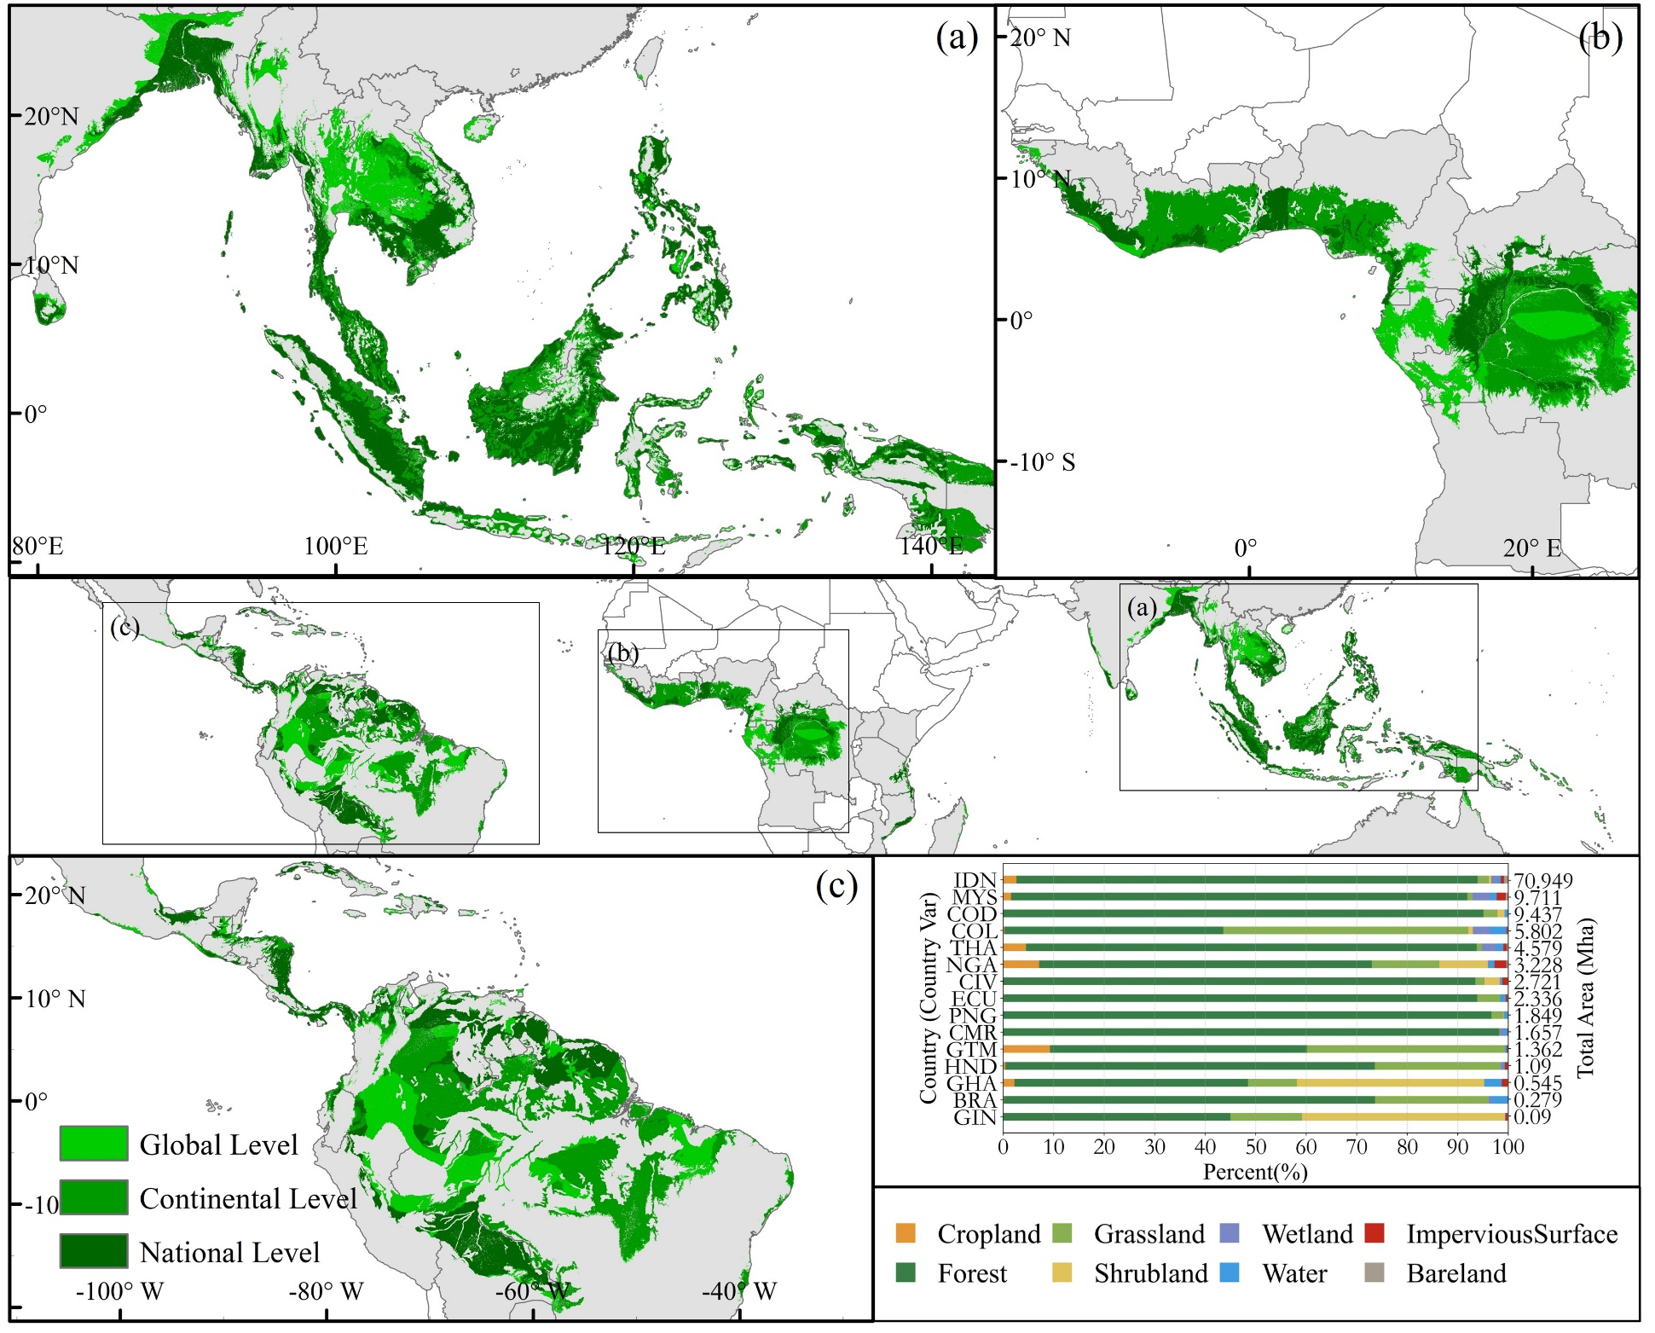
Figure S6. Global map of suitable land for oil palm cultivation under climatic, soil, and topographic restrictions. These areas include unconvertible areas, peatland, protected areas, and high biomass density areas (>100 t/ha).
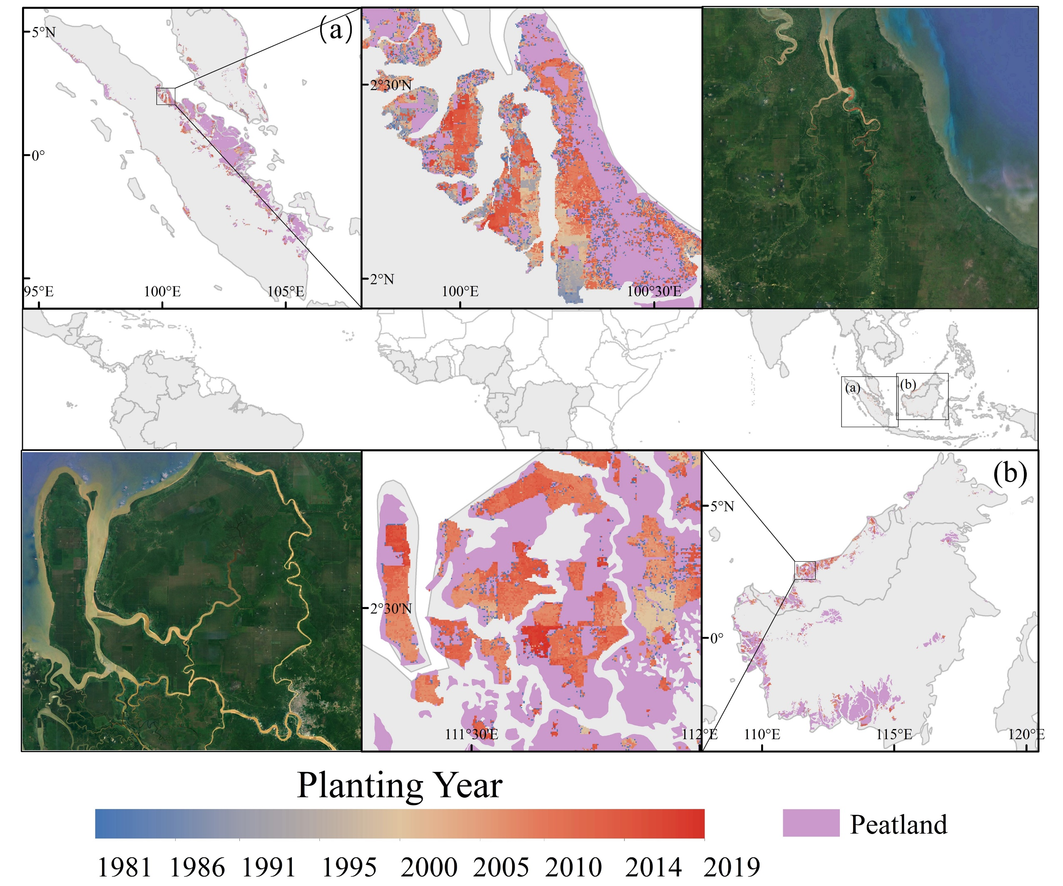
Figure S7. Peatland loss caused by oil palm plantation expansion in Southeast Asia
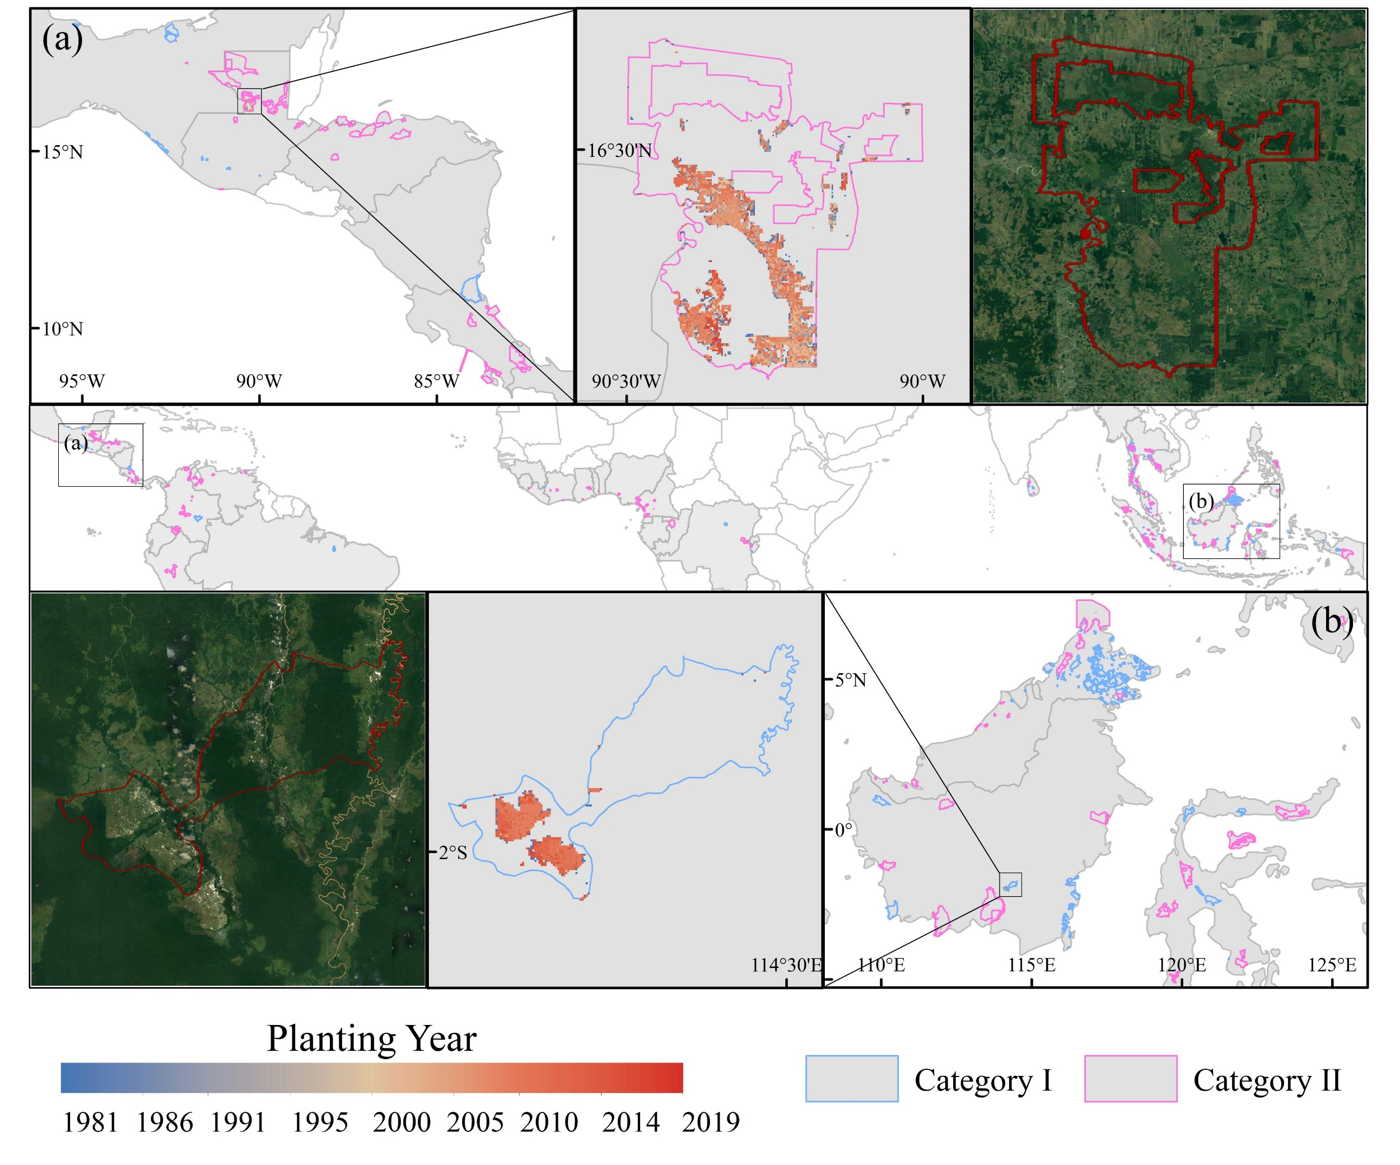
Figure S8. WDPA converted to oil palm plantations. (a) Latin America, Guatemala, San Román Biological Reserve (Category II); (b) Asia, Indonesia, Sungai Barito KSA/KPA (Category I).

Supplementary Table

Table S1. Correspondence between land categories used for the change detection and the LCCS legend used in the CCI-LC classes.
IPCC Classes Considered for the Change Detection | LCCS Legend Used in the CCI-LC Maps
Agriculture | 10, 11, 12 | Rainfed cropland
 | 20 | Irrigated cropland
 | 30 | Mosaic cropland (＞50%)/natural vegetation (tree, shrub herbaceous cover) (<50%)
 | 40 | Mosaic natural vegetation (tree, shrub, herbaceous cover) (>50%)/cropland (<50%)
Forest | 50 | Tree cover broadleaved, evergreen closed to open (＞15%)
 | 60, 61, 62 | Tree cover, broadleaved, deciduous, closed to open (>15%)
 | 70, 71, 72 | Tree cover, needleleaved, evergreen, closed to open (＞15%)
 | 80, 81, 82 | Tree cover needleleaved, deciduous, closed to open (＞15%)
 | 90 | Tree cover, mixed leaf type (broadleaved and needleleaved)
 | 100 | Mosaic tree and shrub (>50%)/herbaceous cover (<50%)
 | 160 | Tree cover, flooded, fresh or brakish water
 | 170 | Tree cover, flooded, saline water
Grassland | 110 | Mosaic herbaceous cover (>50%)/tree and shrub (<50%)
 | 130 | Grassland
Shrubland | 120, 121, 122 | Shrubland
Wetland | 180 | Shrub or herbaceous cover flooded fresh-saline or brakish
Water | 210 | Water
Tundra | 140 | Lichens and mosses
 | 150, 151, 152, 153 | Sparse vegetation (tree, shrub, herbaceous cover)
Settlement | 190 | Urban
Bareland | 200, 201, 202 | Bare areas
Snow/ice | 220 | Permanent snow and ice

Table S2. Oil Palm Expansion on Forest, Peatland and Protected Areas.
Country | Oil Palm Area (ha) | Forest Area (ha) | Peatland Area (ha) | Number of PA_I | PA_I Area (ha) | Number of PA_II | PA_II Area (ha)
Indonesia | 11540045.12 | 1690067.91 | 1413683.77 | 32 | 13575.96 | 22 | 16857.23
Malaysia | 5083493.62 | 1292946.78 | 741343.33 | 106 | 7050.68 | 23 | 3869.46
Thailand | 746825.46 | 34928.05 | 5438.76 | 19 | 6890.08 | 34 | 1978.68
Colombia | 397796.20 | 66817.04 | 1450.72 | 1 | 1.07 | 13 | 119.13
Brazil | 212883.82 | 63521.52 | 474.76 | 1 | 2.14 | 0 | 0
Ivory Coast | 199534.84 | 5503.55 | 191.84 | 0 | 0 | 3 | 102.66
Guatemala | 160557.81 | 51834.56 | 236.14 | 3 | 13.5 | 9 | 28199.7
Honduras | 152510.99 | 65268.08 | 228.02 | 0 | 0 | 10 | 11397.92
Papua New Guinea | 130493.92 | 72905.40 | 49379.50 | 0 | 0 | 0 | 0
Ecuador | 118168.86 | 35586.58 | 817.23 | 0 | 0 | 1 | 2.5
Nigeria | 90487.03 | 19615.65 | 7877.53 | 0 | 0 | 2 | 10338.68
Mexico | 77619.03 | 16906.79 | 109.16 | 3 | 277.6 | 2 | 18.53
Philippines | 76481.93 | 10053.62 | 2264.45 | 0 | 0 | 4 | 8.09
Cameroon | 69699.39 | 14867.57 | 2510.60 | 0 | 0 | 9 | 2238.82
Peru | 67183.43 | 36020.16 | 2031.21 | 0 | 0 | 3 | 9.69
Costa Rica | 60972.90 | 22234.59 | 1199.64 | 0 | 0 | 6 | 836.5
Ghana | 47573.92 | 1987.99 | 8.67 | 0 | 0 | 1 | 16.95
Democratic Republic of the Congo | 45543.69 | 4638.59 | 158.69 | 1 | 194.82 | 1 | 224.32
Venezuela | 42996.21 | 9225.38 | 47.37 | 0 | 0 | 8 | 189.75
Myanmar | 37621.44 | 9531.65 | 143.01 | 2 | 0.37 | 0 | 0
Benin | 32372.30 | 129.64 | 0 | 0 | 0 | 0 | 0
Viet Nam | 29908.15 | 5650.36 | 0.96 | 0 | 0 | 0 | 0
Nicaragua | 21873.58 | 7849.09 | 50.98 | 1 | 18.7 | 0 | 0
Liberia | 20758.69 | 1128.85 | 654.01 | 0 | 0 | 0 | 0
Cambodia | 20666.15 | 3544.09 | 275.32 | 0 | 0 | 4 | 809.42
Sierra Leone | 19723.50 | 198.22 | 206.74 | 0 | 0 | 1 | 5.55
India | 19114.42 | 3187.21 | 88.67 | 0 | 0 | 0 | 0
Burundi | 16895.32 | 584.43 | 264.35 | 4 | 68.36 | 2 | 9.21
Gabon | 14006.37 | 4965.81 | 30.57 | 0 | 0 | 0 | 0
Panama | 12713.44 | 3013.57 | 0 | 0 | 0 | 2 | 3.53
Solomon Islands | 5890.90 | 4896.57 | 0 | 0 | 0 | 0 | 0
Dominican Republic | 5262.03 | 2464.63 | 0 | 0 | 0 | 0 | 0
Guinea | 5044.15 | 566.11 | 21.36 | 1 | 2.13 | 0 | 0
Rwanda | 3987.78 | 297.80 | 0 | 0 | 0 | 0 | 0
Uganda | 3163.72 | 1565.86 | 8.97 | 0 | 0 | 0 | 0
United Republic of Tanzania | 2397.64 | 195.09 | 0 | 0 | 0 | 0 | 0
Sri Lanka | 2381.89 | 360.79 | 1.52 | 7 | 39.5 | 0 | 0
Togo | 1813.02 | 39.56 | 0 | 0 | 0 | 1 | 4.35
Congo | 1166.55 | 316.57 | 103.75 | 0 | 0 | 1 | 1.59
Sao Tome and Principe | 1129.71 | 0.00 | 0 | 0 | 0 | 0 | 0
Central African Republic | 1058.81 | 373.91 | 34.49 | 0 | 0 | 0 | 0
Equatorial Guinea | 294.83 | 140.80 | 0 | 0 | 0 | 0 | 0
Vanuatu | 281.86 | 201.42 | 0 | 0 | 0 | 0 | 0
Brunei Darussalam | 140.80 | 99.91 | 16.77 | 1 | 0.53 | 0 | 0
Belize | 37.74 | 6.79 | 0 | 0 | 0 | 0 | 0
Guinea-Bissau | 28.15 | 2.19 | 0 | 0 | 0 | 0 | 0
Angola | 3.78 | 1.07 | 0 | 0 | 0 | 0 | 0
El Salvador | 2.43 | 0.00 | 0 | 0 | 0 | 0 | 0
Total | 19600607.32 | 3566241.78 | 2231352.875 | 182 | 28135.44 | 162 | 77242.26

Table S3. Full List of Criteria Identified in the Literature Review
 | Criterion | Perfect | Highly suitable | Suitable | Moderately suitable | Currently unsuitable | Var Reference
Climate | Annual Precipitation | 2000-2500 | 2500-3000  1700-2000 | 3000-4000  1400-1700 | 4000-5000  1100-1400 | >5000  1100-800 | (Pirker, et al., 2016)
 | Annual Precipitation on well-drained soils | <4000 | 4000-4500 | 4500-4750 | 4750-5500 | 5500-6000
 | Number of dry months | 0 | 1 | 2-4 | 5-6 | <10
 | Average Annual Temperature | 26-29 | 29-32  23-26 | 32-34  20-23 | 34-36  17-20 | >36  <20
 | Min Temperature | >15 | >15 | >15 | >15 | >15
 | Wind | <10 | 10-15 | 15-25 | 25-40 | >40 | (Corley and Tinker, 2008)
 | Daily solar radiation | 16-17 | 17-19  14-16 | 19-21  <14 | 21-23 | >23
Soil | Pre dominant soil texture type | Clay loam 5  Sandy clay loam 10  Silty clay loam 4 | Sandy loam 11  Silt loam 7  Silt 6 | Loam 9 | Clay (heavy) 1  Loamy sand 12 | Sand 13 | (Pirker, et al., 2016)
 | Water Content of Soil | >100 | 100-75 | 75-50 | 50-15 | <15 | (Corley and Tinker, 2008)
 | Effective Soil Depth | >100 | - | 100-75 | 75-50 | <50
Topography | Slope | 0-4 | 4-10 | 10-15 | 15-18 | 18-20 | (Pirker, et al., 2016)
 | Elevation | <500 | 500-800 | 800-1000 | 1000-1200 | 1200-1500
Note: We classify (suitable, moderately suitable, etc.) based on relevant information obtained from the literature. he soil data is sourced from the HWSD (Harmonized World Soil Database version 1.1), and the primary soil classification system used is FAO-90.

Table S4. Potentially Available Land per Country (Mha)
 | Global Level |  |  |  |  |  | Continent Level |  |  |  |  |  | National Level
Country | Suitable Land | Cropland | Forest | Grassland | Shrubland | Bareland | Suitable Land | Cropland | Forest | Grassland | Shrubland | Bareland | Suitable Land | Cropland | Forest | Grassland | Shrubland | Bareland
Brazil | 53.84 | 1.85 | 17.87 | 30.39 | 3.63 | 0.09 | 41.20 | 1.57 | 12.76 | 24.88 | 1.90 | 0.08 | 0.05 | 0.00 | 0.02 | 0.03 | 0.00 | 0.00
Thailand | 23.89 | 15.94 | 7.48 | 0.35 | 0.01 | 0.10 | 5.22 | 2.70 | 2.38 | 0.11 | 0.00 | 0.03 | 0.71 | 0.08 | 0.60 | 0.02 | 0.00 | 0.01
Democratic Republic of the Congo | 20.20 | 0.00 | 7.80 | 9.08 | 3.31 | 0.01 | 14.58 | 0.00 | 6.19 | 5.90 | 2.49 | 0.00 | 1.17 | 0.00 | 0.90 | 0.20 | 0.07 | 0.00
Colombia | 19.45 | 0.21 | 3.94 | 15.12 | 0.11 | 0.08 | 16.27 | 0.18 | 2.99 | 12.95 | 0.09 | 0.06 | 2.27 | 0.01 | 0.30 | 1.94 | 0.01 | 0.01
Nigeria | 19.07 | 4.00 | 8.40 | 1.50 | 5.08 | 0.09 | 18.69 | 3.94 | 8.17 | 1.45 | 5.04 | 0.08 | 1.93 | 0.20 | 1.17 | 0.28 | 0.27 | 0.01
Indonesia | 17.34 | 3.84 | 11.28 | 1.74 | 0.18 | 0.31 | 15.81 | 3.67 | 10.29 | 1.38 | 0.17 | 0.30 | 7.16 | 1.31 | 5.01 | 0.56 | 0.08 | 0.20
India | 15.48 | 8.17 | 6.61 | 0.55 | 0.02 | 0.13 | 6.77 | 3.29 | 3.26 | 0.18 | 0.00 | 0.04 | 6.77 | 3.29 | 3.26 | 0.18 | 0.00 | 0.04
Ivory Coast | 15.08 | 0.26 | 10.38 | 1.27 | 3.16 | 0.01 | 14.97 | 0.26 | 10.30 | 1.26 | 3.14 | 0.01 | 1.32 | 0.00 | 1.24 | 0.03 | 0.05 | 0.00
Venezuela | 13.13 | 0.09 | 2.50 | 10.29 | 0.23 | 0.02 | 9.92 | 0.08 | 2.00 | 7.65 | 0.18 | 0.01 | 9.92 | 0.08 | 2.00 | 7.65 | 0.18 | 0.01
Ghana | 10.94 | 0.81 | 4.37 | 2.03 | 3.68 | 0.05 | 10.63 | 0.80 | 4.22 | 1.95 | 3.62 | 0.05 | 0.44 | 0.01 | 0.20 | 0.05 | 0.18 | 0.00
Bolivia | 9.92 | 0.59 | 2.94 | 5.95 | 0.44 | 0.00 | 9.20 | 0.40 | 2.55 | 5.86 | 0.39 | 0.00 | 9.20 | 0.40 | 2.55 | 5.86 | 0.39 | 0.00
Bangladesh | 9.65 | 6.29 | 3.30 | 0.01 | 0.00 | 0.05 | 8.56 | 5.47 | 3.04 | 0.01 | 0.00 | 0.04 | 8.56 | 5.47 | 3.04 | 0.01 | 0.00 | 0.04
Myanmar | 8.25 | 3.57 | 3.88 | 0.64 | 0.10 | 0.06 | 3.60 | 1.07 | 2.35 | 0.16 | 0.00 | 0.01 | 3.60 | 1.07 | 2.35 | 0.16 | 0.00 | 0.01
Philippines | 7.78 | 2.00 | 5.11 | 0.63 | 0.00 | 0.04 | 6.08 | 1.64 | 3.96 | 0.45 | 0.00 | 0.03 | 6.08 | 1.64 | 3.96 | 0.45 | 0.00 | 0.03
Cambodia | 7.28 | 4.72 | 1.56 | 0.95 | 0.01 | 0.04 | 4.92 | 3.03 | 1.15 | 0.71 | 0.01 | 0.03 | 4.92 | 3.03 | 1.15 | 0.71 | 0.01 | 0.03
Congo | 7.03 | 0.00 | 1.75 | 5.11 | 0.16 | 0.00 | 2.36 | 0.00 | 0.59 | 1.74 | 0.03 | 0.00 | 2.36 | 0.00 | 0.59 | 1.74 | 0.03 | 0.00
Mexico | 5.38 | 0.20 | 2.03 | 3.05 | 0.10 | 0.01 | 3.51 | 0.14 | 1.12 | 2.23 | 0.01 | 0.00 | 3.51 | 0.14 | 1.12 | 2.23 | 0.01 | 0.00
Viet Nam | 5.16 | 1.75 | 2.68 | 0.60 | 0.00 | 0.13 | 3.77 | 1.27 | 2.00 | 0.40 | 0.00 | 0.10 | 3.77 | 1.27 | 2.00 | 0.40 | 0.00 | 0.10
Lao People's Democratic Republic | 3.24 | 1.13 | 1.67 | 0.41 | 0.00 | 0.02 | 1.69 | 0.74 | 0.72 | 0.22 | 0.00 | 0.01 | 1.69 | 0.74 | 0.72 | 0.22 | 0.00 | 0.01
Mozambique | 2.90 | 0.03 | 0.93 | 1.47 | 0.47 | 0.00 | 2.79 | 0.03 | 0.92 | 1.38 | 0.46 | 0.00 | 2.79 | 0.03 | 0.92 | 1.38 | 0.46 | 0.00
Benin | 2.87 | 0.17 | 0.64 | 0.15 | 1.89 | 0.01 | 2.84 | 0.17 | 0.64 | 0.14 | 1.89 | 0.01 | 2.84 | 0.17 | 0.64 | 0.14 | 1.89 | 0.01
Papua New Guinea | 2.87 | 0.00 | 2.07 | 0.77 | 0.02 | 0.01 | 2.81 | 0.00 | 2.04 | 0.74 | 0.02 | 0.01 | 0.05 | 0.00 | 0.02 | 0.03 | 0.00 | 0.00
Panama | 2.83 | 0.06 | 1.66 | 1.11 | 0.00 | 0.00 | 2.59 | 0.05 | 1.54 | 0.99 | 0.00 | 0.00 | 2.59 | 0.05 | 1.54 | 0.99 | 0.00 | 0.00
Nicaragua | 2.67 | 0.00 | 1.47 | 1.20 | 0.00 | 0.00 | 2.67 | 0.00 | 1.47 | 1.20 | 0.00 | 0.00 | 2.67 | 0.00 | 1.47 | 1.20 | 0.00 | 0.00
Central African Republic | 2.66 | 0.00 | 1.85 | 0.45 | 0.35 | 0.00 | 2.32 | 0.00 | 1.59 | 0.43 | 0.30 | 0.00 | 2.32 | 0.00 | 1.59 | 0.43 | 0.30 | 0.00
Sierra Leone | 2.55 | 0.00 | 1.63 | 0.40 | 0.51 | 0.00 | 2.44 | 0.00 | 1.55 | 0.38 | 0.51 | 0.00 | 2.44 | 0.00 | 1.55 | 0.38 | 0.51 | 0.00
Togo | 2.41 | 0.32 | 0.44 | 0.27 | 1.38 | 0.00 | 2.22 | 0.30 | 0.38 | 0.24 | 1.30 | 0.00 | 2.22 | 0.30 | 0.38 | 0.24 | 1.30 | 0.00
United Republic of Tanzania | 2.30 | 0.06 | 1.15 | 0.56 | 0.52 | 0.00 | 1.88 | 0.06 | 0.93 | 0.46 | 0.42 | 0.00 | 1.88 | 0.06 | 0.93 | 0.46 | 0.42 | 0.00
Guatemala | 2.14 | 0.20 | 0.96 | 0.95 | 0.02 | 0.00 | 1.70 | 0.19 | 0.81 | 0.68 | 0.02 | 0.00 | 0.79 | 0.10 | 0.28 | 0.41 | 0.00 | 0.00
Cuba | 1.84 | 0.13 | 0.69 | 0.97 | 0.05 | 0.00 | 1.73 | 0.12 | 0.68 | 0.89 | 0.05 | 0.00 | 1.73 | 0.12 | 0.68 | 0.89 | 0.05 | 0.00
Cameroon | 1.75 | 0.00 | 1.31 | 0.40 | 0.03 | 0.00 | 0.96 | 0.00 | 0.74 | 0.21 | 0.01 | 0.00 | 0.10 | 0.00 | 0.10 | 0.00 | 0.00 | 0.00
Gabon | 1.50 | 0.00 | 0.59 | 0.84 | 0.06 | 0.00 | 0.33 | 0.00 | 0.05 | 0.28 | 0.00 | 0.00 | 0.33 | 0.00 | 0.05 | 0.28 | 0.00 | 0.00
Honduras | 1.50 | 0.05 | 0.78 | 0.67 | 0.00 | 0.00 | 1.43 | 0.05 | 0.73 | 0.65 | 0.00 | 0.00 | 0.26 | 0.00 | 0.15 | 0.11 | 0.00 | 0.00
Sri Lanka | 1.38 | 0.16 | 1.14 | 0.08 | 0.00 | 0.00 | 0.81 | 0.07 | 0.70 | 0.04 | 0.00 | 0.00 | 0.81 | 0.07 | 0.70 | 0.04 | 0.00 | 0.00
Angola | 1.26 | 0.00 | 0.25 | 0.95 | 0.06 | 0.00 | 0.00 | 0.00 | 0.00 | 0.00 | 0.00 | 0.00 | 0.00 | 0.00 | 0.00 | 0.00 | 0.00 | 0.00
Guyana | 1.21 | 0.05 | 0.17 | 0.98 | 0.00 | 0.01 | 1.11 | 0.05 | 0.14 | 0.93 | 0.00 | 0.00 | 1.11 | 0.05 | 0.14 | 0.93 | 0.00 | 0.00
Liberia | 1.05 | 0.00 | 1.00 | 0.03 | 0.02 | 0.00 | 0.83 | 0.00 | 0.80 | 0.01 | 0.02 | 0.00 | 0.83 | 0.00 | 0.80 | 0.01 | 0.02 | 0.00
China | 1.03 | 0.21 | 0.77 | 0.01 | 0.00 | 0.03 | 0.00 | 0.00 | 0.00 | 0.00 | 0.00 | 0.00 | 0.00 | 0.00 | 0.00 | 0.00 | 0.00 | 0.00
Malaysia | 0.92 | 0.11 | 0.73 | 0.05 | 0.00 | 0.02 | 0.91 | 0.11 | 0.73 | 0.05 | 0.00 | 0.02 | 0.39 | 0.05 | 0.32 | 0.02 | 0.00 | 0.01
Guinea | 0.89 | 0.01 | 0.40 | 0.17 | 0.31 | 0.00 | 0.79 | 0.01 | 0.34 | 0.15 | 0.29 | 0.00 | 0.08 | 0.00 | 0.04 | 0.01 | 0.04 | 0.00
Madagascar | 0.78 | 0.01 | 0.44 | 0.17 | 0.16 | 0.00 | 0.00 | 0.00 | 0.00 | 0.00 | 0.00 | 0.00 | 0.00 | 0.00 | 0.00 | 0.00 | 0.00 | 0.00
Dominican Republic | 0.68 | 0.02 | 0.46 | 0.19 | 0.01 | 0.00 | 0.61 | 0.02 | 0.41 | 0.18 | 0.00 | 0.00 | 0.61 | 0.02 | 0.41 | 0.18 | 0.00 | 0.00
Haiti | 0.58 | 0.01 | 0.34 | 0.17 | 0.04 | 0.02 | 0.00 | 0.00 | 0.00 | 0.00 | 0.00 | 0.00 | 0.00 | 0.00 | 0.00 | 0.00 | 0.00 | 0.00
Ecuador | 0.53 | 0.00 | 0.38 | 0.14 | 0.00 | 0.01 | 0.52 | 0.00 | 0.37 | 0.14 | 0.00 | 0.01 | 0.10 | 0.00 | 0.08 | 0.02 | 0.00 | 0.00
Guinea-Bissau | 0.41 | 0.03 | 0.29 | 0.01 | 0.07 | 0.00 | 0.00 | 0.00 | 0.00 | 0.00 | 0.00 | 0.00 | 0.00 | 0.00 | 0.00 | 0.00 | 0.00 | 0.00
Costa Rica | 0.40 | 0.01 | 0.30 | 0.09 | 0.00 | 0.00 | 0.38 | 0.01 | 0.28 | 0.09 | 0.00 | 0.00 | 0.38 | 0.01 | 0.28 | 0.09 | 0.00 | 0.00
Nepal | 0.36 | 0.30 | 0.05 | 0.00 | 0.00 | 0.01 | 0.00 | 0.00 | 0.00 | 0.00 | 0.00 | 0.00 | 0.00 | 0.00 | 0.00 | 0.00 | 0.00 | 0.00
El Salvador | 0.35 | 0.04 | 0.17 | 0.14 | 0.00 | 0.00 | 0.34 | 0.04 | 0.16 | 0.14 | 0.00 | 0.00 | 0.34 | 0.04 | 0.16 | 0.14 | 0.00 | 0.00
Australia | 0.32 | 0.00 | 0.30 | 0.02 | 0.00 | 0.00 | 0.01 | 0.00 | 0.00 | 0.00 | 0.00 | 0.00 | 0.01 | 0.00 | 0.00 | 0.00 | 0.00 | 0.00
Peru | 0.16 | 0.02 | 0.11 | 0.03 | 0.00 | 0.00 | 0.10 | 0.02 | 0.06 | 0.02 | 0.00 | 0.00 | 0.10 | 0.02 | 0.06 | 0.02 | 0.00 | 0.00
Suriname | 0.11 | 0.02 | 0.05 | 0.05 | 0.00 | 0.00 | 0.10 | 0.01 | 0.05 | 0.04 | 0.00 | 0.00 | 0.10 | 0.01 | 0.05 | 0.04 | 0.00 | 0.00
Belize | 0.11 | 0.00 | 0.10 | 0.01 | 0.00 | 0.00 | 0.06 | 0.00 | 0.05 | 0.01 | 0.00 | 0.00 | 0.06 | 0.00 | 0.05 | 0.01 | 0.00 | 0.00
Puerto Rico | 0.11 | 0.00 | 0.10 | 0.01 | 0.00 | 0.00 | 0.00 | 0.00 | 0.00 | 0.00 | 0.00 | 0.00 | 0.00 | 0.00 | 0.00 | 0.00 | 0.00 | 0.00
Trinidad and Tobago | 0.11 | 0.00 | 0.07 | 0.03 | 0.00 | 0.00 | 0.00 | 0.00 | 0.00 | 0.00 | 0.00 | 0.00 | 0.00 | 0.00 | 0.00 | 0.00 | 0.00 | 0.00
Brunei Darussalam | 0.06 | 0.00 | 0.05 | 0.00 | 0.00 | 0.00 | 0.06 | 0.00 | 0.05 | 0.00 | 0.00 | 0.00 | 0.06 | 0.00 | 0.05 | 0.00 | 0.00 | 0.00
Timor-Leste | 0.06 | 0.00 | 0.04 | 0.02 | 0.00 | 0.00 | 0.00 | 0.00 | 0.00 | 0.00 | 0.00 | 0.00 | 0.00 | 0.00 | 0.00 | 0.00 | 0.00 | 0.00
Jamaica | 0.04 | 0.00 | 0.03 | 0.01 | 0.00 | 0.00 | 0.00 | 0.00 | 0.00 | 0.00 | 0.00 | 0.00 | 0.00 | 0.00 | 0.00 | 0.00 | 0.00 | 0.00
Equatorial Guinea | 0.02 | 0.00 | 0.02 | 0.00 | 0.00 | 0.00 | 0.01 | 0.00 | 0.01 | 0.00 | 0.00 | 0.00 | 0.01 | 0.00 | 0.01 | 0.00 | 0.00 | 0.00
Kenya | 0.02 | 0.00 | 0.02 | 0.00 | 0.00 | 0.00 | 0.00 | 0.00 | 0.00 | 0.00 | 0.00 | 0.00 | 0.00 | 0.00 | 0.00 | 0.00 | 0.00 | 0.00
Singapore | 0.02 | 0.00 | 0.01 | 0.00 | 0.00 | 0.00 | 0.00 | 0.00 | 0.00 | 0.00 | 0.00 | 0.00 | 0.00 | 0.00 | 0.00 | 0.00 | 0.00 | 0.00
Uganda | 0.02 | 0.00 | 0.00 | 0.01 | 0.00 | 0.00 | 0.00 | 0.00 | 0.00 | 0.00 | 0.00 | 0.00 | 0.00 | 0.00 | 0.00 | 0.00 | 0.00 | 0.00
French Guiana | 0.01 | 0.00 | 0.01 | 0.00 | 0.00 | 0.00 | 0.01 | 0.00 | 0.01 | 0.00 | 0.00 | 0.00 | 0.01 | 0.00 | 0.01 | 0.00 | 0.00 | 0.00
Bahamas | 0.01 | 0.00 | 0.01 | 0.00 | 0.00 | 0.00 | 0.00 | 0.00 | 0.00 | 0.00 | 0.00 | 0.00 | 0.00 | 0.00 | 0.00 | 0.00 | 0.00 | 0.00
Sao Tome and Principe | 0.01 | 0.00 | 0.01 | 0.00 | 0.00 | 0.00 | 0.00 | 0.00 | 0.00 | 0.00 | 0.00 | 0.00 | 0.00 | 0.00 | 0.00 | 0.00 | 0.00 | 0.00
Bhutan | 0.00 | 0.00 | 0.00 | 0.00 | 0.00 | 0.00 | 0.00 | 0.00 | 0.00 | 0.00 | 0.00 | 0.00 | 0.00 | 0.00 | 0.00 | 0.00 | 0.00 | 0.00
Fiji | 0.00 | 0.00 | 0.00 | 0.00 | 0.00 | 0.00 | 0.00 | 0.00 | 0.00 | 0.00 | 0.00 | 0.00 | 0.00 | 0.00 | 0.00 | 0.00 | 0.00 | 0.00
Paraguay | 0.00 | 0.00 | 0.00 | 0.00 | 0.00 | 0.00 | 0.00 | 0.00 | 0.00 | 0.00 | 0.00 | 0.00 | 0.00 | 0.00 | 0.00 | 0.00 | 0.00 | 0.00
Solomon Islands | 0.00 | 0.00 | 0.00 | 0.00 | 0.00 | 0.00 | 0.00 | 0.00 | 0.00 | 0.00 | 0.00 | 0.00 | 0.00 | 0.00 | 0.00 | 0.00 | 0.00 | 0.00
United States of America | 0.00 | 0.00 | 0.00 | 0.00 | 0.00 | 0.00 | 0.00 | 0.00 | 0.00 | 0.00 | 0.00 | 0.00 | 0.00 | 0.00 | 0.00 | 0.00 | 0.00 | 0.00
Vanuatu | 0.00 | 0.00 | 0.00 | 0.00 | 0.00 | 0.00 | 0.00 | 0.00 | 0.00 | 0.00 | 0.00 | 0.00 | 0.00 | 0.00 | 0.00 | 0.00 | 0.00 | 0.00
Total | 317.92 | 57.47 | 129.54 | 103.28 | 26.23 | 1.39 | 233.11 | 31.55 | 98.23 | 79.97 | 22.39 | 0.98 | 103.47 | 19.83 | 45.63 | 31.16 | 6.29 | 0.56

Table S5. Historical Carbon Emission Caused by Oil Palm Expansion (1993–2019, unit: Tg C)
 | All Land Cover Conversion |  |  | Forest Loss
Country | Estimate | Low | High | Estimate | Low | High
Thailand | 15.88 | 5.47 | 26.95 | 7.19 | 5.85 | 9.43
Honduras | 14.97 | 9.14 | 21.88 | 11.99 | 6.67 | 18.26
Brazil | 12.81 | 5.47 | 17.94 | 13.09 | 5.66 | 18.31
Guatemala | 12.17 | 7.71 | 16.82 | 7.45 | 3.92 | 10.84
Colombia | 11.52 | 3.41 | 16.53 | 13.52 | 4.95 | 19.00
Papua New Guinea | 11.51 | 8.47 | 18.96 | 11.87 | 9.29 | 18.86
Ecuador | 6.80 | 1.70 | 10.49 | 7.11 | 2.31 | 10.49
Peru | 5.67 | 2.00 | 7.62 | 5.68 | 2.06 | 7.58
Nigeria | 4.71 | 3.14 | 7.68 | 5.17 | 2.52 | 9.23
Mexico | 3.99 | 2.81 | 6.06 | 1.79 | 1.10 | 3.32
Costa Rica | 3.83 | 2.04 | 5.13 | 3.39 | 1.58 | 4.66
Philippines | 3.10 | -0.68 | 7.78 | 2.71 | 2.01 | 4.32
Cameroon | 2.60 | 1.69 | 4.35 | 3.85 | 1.70 | 6.84
Nicaragua | 2.40 | 1.42 | 3.37 | 1.74 | 0.84 | 2.57
Myanmar | 2.02 | 1.07 | 3.28 | 1.98 | 1.40 | 2.88
Venezuela (Bolivarian Republic of) | 1.69 | 0.78 | 2.41 | 1.60 | 0.73 | 2.30
Solomon Islands | 1.30 | 1.00 | 2.03 | 1.30 | 1.00 | 2.04
Gabon | 1.27 | 0.54 | 2.17 | 1.46 | 0.57 | 2.52
Viet Nam | 1.01 | 0.58 | 1.58 | 0.94 | 0.72 | 1.31
Democratic Republic of the Congo | 0.64 | 0.57 | 0.94 | 1.41 | 0.59 | 2.46
India | 0.63 | 0.33 | 1.35 | 0.62 | 0.26 | 1.40
Benin | 0.57 | 0.75 | 0.43 | 0.10 | 0.06 | 0.19
Dominican Republic | 0.52 | 0.26 | 0.73 | 0.42 | 0.17 | 0.60
Cambodia | 0.48 | 0.70 | 0.34 | 0.63 | 0.61 | 0.73
Ghana | 0.39 | 0.85 | 0.10 | 0.49 | 0.26 | 0.89
Uganda | 0.29 | 0.14 | 0.55 | 0.33 | 0.15 | 0.61
Guinea | 0.25 | 0.18 | 0.43 | 0.27 | 0.14 | 0.49
Panama | 0.21 | 0.13 | 0.27 | 0.08 | 0.04 | 0.11
Togo | 0.17 | 0.17 | 0.21 | 0.11 | 0.06 | 0.20
Congo | 0.11 | 0.05 | 0.19 | 0.13 | 0.05 | 0.23
Equatorial Guinea | 0.08 | 0.03 | 0.15 | 0.10 | 0.04 | 0.17
Sri Lanka | 0.08 | 0.02 | 0.27 | 0.12 | 0.04 | 0.32
Ivory Coast | 0.06 | 1.56 | -1.24 | 0.61 | 0.31 | 1.12
Central African Republic | 0.06 | 0.04 | 0.11 | 0.07 | 0.04 | 0.13
Sierra Leone | 0.03 | 0.33 | -0.23 | 0.15 | 0.08 | 0.27
Brunei Darussalam | 0.01 | 0.04 | 0.02 | 0.04 | 0.05 | 0.05
Tanzania (United Republic of) | 0.01 | 0.01 | 0.02 | 0.01 | 0.01 | 0.03
Belize | 0.01 | 0.01 | 0.01 | 0.01 | 0.00 | 0.01
Vanuatu | 0.01 | 0.00 | 0.01 | 0.01 | 0.00 | 0.01
El Salvador | 0.00 | 0.00 | 0.00 | 0.00 | 0.00 | 0.00
Guinea-Bissau | 0.00 | 0.00 | 0.00 | 0.00 | 0.00 | 0.00
Angola | -0.01 | 0.00 | -0.01 | 0.01 | 0.01 | 0.02
Rwanda | -0.02 | 0.00 | -0.04 | 0.03 | 0.00 | 0.05
Burundi | -0.04 | 0.05 | -0.13 | 0.05 | 0.02 | 0.09
Liberia | -0.16 | 0.02 | -0.30 | 0.31 | 0.12 | 0.55
Malaysia | -34.50 | -55.26 | 82.47 | 161.25 | 151.02 | 267.71
Indonesia | -162.09 | -263.91 | 56.46 | 230.59 | 199.52 | 378.62
Total | -72.98 | -255.16 | 326.15 | 501.76 | 408.51 | 811.79

Table S6. Potential Carbon Emission for The Oil Palm Expansion on The Suitable Land Based on The Global Level Map (Tg C)
 | Before Filtration |  |  |  | After Filtration
 | Total | Cropland | Forest | Grassland | Total | Cropland | Forest | Grassland
Angola | 83.77 (-8.98~188.39) | -4.33 (-9~0.33) | 90.56 (4.11~188.88) | -2.46 (-4.09~-0.82) | 59.64 (-8.87~136.61) | -3.82 (-7.94~0.3) | 65.87 (3.09~137.11) | -2.41 (-4.02~-0.8)
Belize | 47.74 (5.34~77.4) | 1.06 (-0.13~2.35) | 46.69 (5.49~75.05) | -0.01 (-0.02~0) | 15.09 (1.67~24.7) | 0.58 (-0.09~1.3) | 14.52 (1.78~23.4) | -0.01 (-0.02~0)
Benin | 278.23 (88.86~569.59) | 18.47 (-13.64~50.58) | 259.76 (102.51~519.01) | 0 (-0.01~0) | 203.76 (64.75~417.23) | 13.83 (-10.18~37.84) | 189.93 (74.93~379.39) | 0 (0~0)
Brazil | 24810.32 (2500.13~40914.7) | -37.18 (-885.78~811.42) | 25140.48 (3889.64~40185.51) | -292.98 (-503.73~-82.23) | 935.53 (-567.84~2564.68) | -22.17 (-556.59~512.25) | 1204.27 (412.54~2121.78) | -246.57 (-423.79~-69.35)
Brunei Darussalam | 22.91 (-41.03~111.98) | -6.92 (-17.92~4.07) | 29.83 (-23.11~107.91) | 0 (0~0) | -1.9 (-8.8~5.98) | -3.05 (-7.89~1.79) | 1.15 (-0.91~4.19) | 0 (0~0)
Burundi | 0 (0~0) | 0 (0~0) | 0 (0~0) | 0 (0~0) | 0 (0~0) | 0 (0~0) | 0 (0~0) | 0 (0~0)
Cambodia | 700.79 (4.60~1476.77) | -44.17 (-358.33~267.05) | 748.66 (369.03~1211.02) | -3.7 (-6.1~-1.3) | 66.25 (-224.98~359.7) | -39.05 (-267.89~187.43) | 107.94 (47.26~173.19) | -2.64 (-4.35~-0.92)
Cameroon | 1245.52 (54.79~2590.89) | -31.35 (-84.07~21.37) | 1279.63 (144.06~2569.85) | -2.76 (-5.2~-0.33) | 117.24 (-25.33~278.03) | -13.97 (-37.46~9.52) | 133.32 (16.1~268.76) | -2.11 (-3.97~-0.25)
Central African Republic | 511.5 (-30.99~1134.89) | -6.77 (-15.7~2.16) | 538.56 (21.52~1136.5) | -20.29 (-36.81~-3.77) | 256.19 (-35.52~594.41) | -4.77 (-11.07~1.52) | 280.5 (11.01~596.52) | -19.54 (-35.46~-3.63)
Colombia | 7335.49 (883.93~11774.09) | 51.79 (-183.64~287.23) | 7560.05 (1545.48~11561.66) | -276.35 (-477.91~-74.8) | 98.32 (-410~594.31) | 34.91 (-117.35~187.18) | 288.78 (97.11~468.12) | -225.37 (-389.76~-60.99)
Congo | 3049.14 (78.17~6403.31) | -60.11 (-140.9~20.67) | 3140.95 (275.41~6389.69) | -31.7 (-56.34~-7.05) | 542.7 (-78.02~1237.25) | -37.99 (-89.07~13.1) | 604.28 (53~1229.38) | -23.59 (-41.95~-5.23)
Democratic Republic of the Congo | 14337.12 (1170.92~29217.03) | -224.19 (-597.27~148.89) | 14588.44 (1818.93~29071.67) | -27.13 (-50.74~-3.53) | 2051.49 (-2.98~4360.02) | -86.1 (-228.79~56.58) | 2160.88 (269.36~4306.47) | -23.29 (-43.55~-3.03)
Costa Rica | 205.78 (16.52~348.03) | 17.71 (-4.58~41.86) | 188.11 (21.17~306.18) | -0.04 (-0.07~-0.01) | 37.69 (2.93~64.8) | 4.1 (-1.12~9.72) | 33.62 (4.11~55.09) | -0.03 (-0.06~-0.01)
Dominican Republic | 63.26 (13.21~98.59) | 7.65 (2.41~13.48) | 56.87 (13.15~85.28) | -1.26 (-2.35~-0.17) | 58.31 (12.09~91.07) | 7.34 (2.31~12.93) | 52.21 (12.09~78.31) | -1.24 (-2.31~-0.17)
Ecuador | 1113.24 (45.45~1834.08) | -7.89 (-36.83~21.05) | 1122.13 (83.89~1813.43) | -1 (-1.61~-0.4) | 34.01 (-4.77~64.4) | -1.79 (-8.41~4.82) | 36.16 (4.21~59.72) | -0.36 (-0.57~-0.14)
El Salvador | 32.59 (16.68~73.03) | 10.26 (2.34~18.41) | 22.35 (14.38~54.62) | -0.02 (-0.04~0) | 25.07 (12.81~54.83) | 8.08 (1.9~14.48) | 17.01 (10.94~40.35) | -0.02 (-0.03~0)
Equatorial Guinea | 79.66 (-30.85~202.79) | -3.18 (-6.06~-0.29) | 82.85 (-24.78~203.08) | -0.01 (-0.01~0) | 0.75 (-0.78~2.45) | -0.24 (-0.46~-0.02) | 1 (-0.31~2.47) | -0.01 (-0.01~0)
Gabon | 2183.19 (175.24~4455.72) | -16.36 (-39.66~6.94) | 2213.57 (240.05~4451.67) | -14.02 (-25.15~-2.89) | 83 (-24.84~202.92) | -5.41 (-13.06~2.24) | 101.03 (10.86~203.28) | -12.62 (-22.64~-2.6)
Ghana | 863.79 (63.97~1960.51) | -11.81 (-180.27~156.65) | 875.61 (244.27~1803.86) | -0.01 (-0.03~0) | 583.4 (25.18~1377.06) | -9.62 (-146.95~127.72) | 593.03 (172.15~1249.34) | -0.01 (-0.02~0)
Guatemala | 367.41 (116.09~591.93) | 87.89 (25.74~156.84) | 280.11 (91.43~435.19) | -0.59 (-1.08~-0.1) | 188.93 (51.48~306.1) | 60.32 (17.73~107.54) | 129.08 (34.61~198.64) | -0.47 (-0.86~-0.08)
Guinea | 98.26 (10.25~197.12) | -1.22 (-12.89~10.45) | 99.48 (23.15~186.67) | 0 (-0.01~0) | 56.14 (2.39~116.2) | -1.04 (-10.95~8.87) | 57.18 (13.34~107.33) | 0 (0~0)
Guinea-Bissau | 40.35 (-5.93~97.69) | -4.58 (-13.21~4.05) | 44.99 (7.39~93.65) | -0.06 (-0.11~-0.01) | 19.94 (-5.3~51.25) | -3.19 (-9.19~2.82) | 23.14 (3.91~48.43) | -0.01 (-0.02~0)
Honduras | 461.04 (109.2~750.25) | 46.31 (12.38~82.45) | 419.94 (107.71~667.34) | -5.21 (-10.89~0.46) | 140.9 (39.45~251.38) | 30.2 (7.75~53.88) | 112.92 (36.33~197.31) | -2.22 (-4.63~0.19)
India | 836.8 (223.87~2256.34) | 8.09 (-54.15~70.34) | 828.71 (279.58~2184.43) | 0 (-1.56~1.57) | 319.02 (58.98~881.96) | 6.28 (-42.01~54.56) | 312.74 (101.77~826.62) | 0 (-0.78~0.78)
Indonesia | 5261.85 (-5304.15~19570.77) | -1986.02 (-6999.31~3027.22) | 7253.11 (1703.13~16546.06) | -5.24 (-7.97~-2.51) | -257 (-1612.89~1206.47) | -471.32 (-1658.07~715.42) | 216.13 (47.93~491.92) | -1.81 (-2.75~-0.87)
Ivory Coast | 1064.64 (-68.07~2518.03) | -45.84 (-354.1~262.41) | 1110.49 (286.04~2255.62) | -0.01 (-0.01~0) | 677.75 (-64.17~1641.46) | -32.39 (-250.27~185.49) | 710.14 (186.1~1455.97) | 0 (0~0)
Liberia | 417.15 (-135.75~1030.13) | -76.89 (-176.66~22.88) | 494.06 (40.94~1007.25) | -0.02 (-0.03~0) | -20.65 (-54.52~13.61) | -23.9 (-54.75~6.94) | 3.26 (0.24~6.67) | -0.01 (-0.01~0)
Malaysia | 1008.56 (-1515.43~4463.23) | -555.67 (-1600.68~489.34) | 1564.23 (85.25~3973.89) | 0 (0~0) | -20.85 (-89.83~54.68) | -31.48 (-90.45~27.49) | 10.63 (0.62~27.19) | 0 (0~0)
Mexico | 528.11 (190.09~889.8) | 212.91 (85.48~352.77) | 316.73 (107.81~536.89) | -1.53 (-3.2~0.14) | 406.81 (154.53~701.09) | 188.94 (75.71~313.07) | 218.63 (80.36~388) | -0.76 (-1.54~0.02)
Myanmar | 1022.49 (159.14~2137.59) | 58.04 (-407.83~523.55) | 966.15 (569.56~1614.84) | -1.7 (-2.59~-0.8) | 258.96 (-183.86~735.76) | 41.89 (-310.59~394.01) | 218.01 (128.16~342.2) | -0.94 (-1.43~-0.45)
Nicaragua | 655.83 (83.14~1103.22) | 89.56 (-3.13~191.19) | 575.48 (102.08~914.64) | -9.21 (-15.81~-2.61) | 212.87 (27.86~374.53) | 47.5 (-1.44~101.18) | 170.21 (37.61~274.72) | -4.84 (-8.31~-1.37)
Nigeria | 1845.51 (79.58~4031.86) | -61.47 (-347.99~225.05) | 1907.37 (428.44~3806.73) | -0.39 (-0.87~0.08) | 1176.11 (23.55~2630.01) | -45.34 (-256.44~165.75) | 1221.72 (280.58~2464.2) | -0.27 (-0.59~0.06)
Panama | 506.65 (198.75~772.46) | 94.21 (42.14~151.86) | 412.83 (157.45~620.54) | -0.39 (-0.84~0.06) | 227.38 (93.67~351.94) | 88.45 (39.58~142.54) | 139.28 (54.85~209.34) | -0.35 (-0.76~0.06)
Papua New Guinea | 2462.49 (941.71~4916.19) | -18.4 (-294.85~257.92) | 2483.82 (1241.13~4659.57) | -2.93 (-4.57~-1.3) | 114.54 (-72.89~329.92) | -7.4 (-129.29~114.44) | 123.84 (59.35~216.33) | -1.9 (-2.95~-0.85)
Peru | 3827.14 (-456.64~6816.39) | -7.05 (-26.26~12.17) | 3834.45 (-429.93~6804.29) | -0.26 (-0.45~-0.07) | 10.76 (-5.47~22.99) | -1.14 (-3.92~1.65) | 11.93 (-1.5~21.35) | -0.03 (-0.05~-0.01)
Philippines | 696.36 (-516.86~2132.97) | 65.13 (-873.49~1003.71) | 631.23 (356.63~1129.26) | 0 (0~0) | 56.67 (-422.76~544.8) | 32.73 (-435.83~501.27) | 23.94 (13.07~43.53) | 0 (0~0)
Rwanda | 0 (0~0) | 0 (0~0) | 0 (0~0) | 0 (0~0) | 0 (0~0) | 0 (0~0) | 0 (0~0) | 0 (0~0)
Sierra Leone | 119.72 (-63.33~327.22) | -13.3 (-91.92~65.33) | 133.66 (30.06~261.71) | -0.64 (-1.47~0.18) | 63.5 (-43.43~185.72) | -8.59 (-60.22~43.05) | 72.12 (16.85~142.66) | -0.03 (-0.06~0.01)
Solomon Islands | 144.77 (101.02~236.44) | -0.17 (-0.58~0.23) | 144.94 (101.6~236.21) | 0 (0~0) | 0 (0~0) | 0 (0~0) | 0 (0~0) | 0 (0~0)
Sri Lanka | 85.02 (-9.35~287.42) | -17.18 (-28.95~-5.41) | 102.21 (19.62~292.83) | -0.01 (-0.02~0) | 10.8 (-15.21~61.39) | -11.22 (-18.91~-3.53) | 22.02 (3.71~64.92) | 0 (-0.01~0)
Tanzania (United Republic of) | 244.56 (14.76~581.57) | -12.67 (-41.18~15.84) | 260.67 (62.47~566.08) | -3.44 (-6.53~-0.35) | 119.97 (-2.16~299.23) | -8.59 (-27.91~10.74) | 129.53 (27.65~288.52) | -0.97 (-1.9~-0.03)
Thailand | 1097.01 (-187.67~2523.41) | 327.54 (-695.15~1341.34) | 774.11 (514.31~1184.53) | -4.64 (-6.83~-2.46) | 307.28 (-389.21~1003.92) | 196.17 (-460.13~844.53) | 115 (76.64~161.45) | -3.89 (-5.72~-2.06)
Togo | 178.62 (43.61~369.49) | 11.91 (-16.5~40.31) | 166.71 (60.11~329.18) | 0 (0~0) | 155.28 (38.35~321.68) | 10.24 (-14.19~34.66) | 145.04 (52.54~287.02) | 0 (0~0)
Uganda | -0.73 (-1.8~0.36) | -0.59 (-1.5~0.31) | 0.03 (-0.03~0.12) | -0.17 (-0.27~-0.07) | -0.27 (-0.7~0.17) | -0.23 (-0.58~0.12) | 0.03 (0~0.08) | -0.07 (-0.12~-0.03)
Vanuatu | 19.46 (13.46~31.92) | -0.07 (-0.23~0.09) | 19.53 (13.69~31.83) | 0 (0~0) | 0 (0~0) | 0 (0~0) | 0 (0~0) | 0 (0~0)
Venezuela (Bolivarian Republic of) | 1781.39 (-283.32~3492.85) | 5.79 (-231.12~242.7) | 2011.03 (366.08~3302.74) | -235.43 (-418.28~-52.59) | -85.76 (-385.63~240.78) | 1.3 (-110.02~112.63) | 93.38 (45.01~168.41) | -180.44 (-320.62~-40.26)
Viet Nam | 255.46 (-174.11~712.82) | 43.35 (-300.23~386.05) | 213.64 (128.47~327.48) | -1.53 (-2.35~-0.71) | 88.84 (-166.58~349.77) | 25.16 (-203.75~253.34) | 64.79 (38.88~96.95) | -1.11 (-1.71~-0.52)
Total | 81989.93 (-1431.77~166271.29) | -2097.72 (-14975.19~10805.22) | 85034.81 (15199.38~155704.43) | -947.16 (-1655.96~-238.36) | 9394.47 (-4297.64~25107.25) | -75.8 (-5508.28~5373.18) | 10230.21 (2537.97~19926.62) | -759.94 (-1327.33~-192.55)
Note: Negative emissions refer to the net carbon accumulation achieved after land is converted to oil palm plantations. Filtration involves the overlay of suitable land with land masks, specifically areas unsuitable for oil palm expansion, including non-convertible regions (such as wetlands, water bodies, and urban areas), peatlands, protected areas, and areas with high biomass density (>100 t/ha).

Table S7. Potential Carbon Emission for The Oil Palm Expansion on The Suitable Land Based on The Continental Level Map (Tg C)
 |  | Before Filtration |  |  |  | After Filtration
 | Total | Cropland | Forest | Grassland | Total | Cropland | Forest | Grassland
Angola | 0.01 (0~0.02) | 0 (0~0) | 0.01 (0~0.02) | 0 (0~0) | 0 (0~0.01) | 0 (0~0) | 0 (0~0.01) | 0 (0~0)
Belize | 30.17 (3.48~49.22) | 0.95 (-0.12~2.12) | 29.23 (3.62~47.1) | -0.01 (-0.02~0) | 8.5 (0.99~14.1) | 0.52 (-0.08~1.16) | 7.99 (1.09~12.94) | -0.01 (-0.02~0)
Benin | 275.88 (88.26~564.94) | 18.26 (-13.48~49.99) | 257.62 (101.75~514.95) | 0 (-0.01~0) | 202.26 (64.36~414.26) | 13.7 (-10.08~37.48) | 188.56 (74.44~376.78) | 0 (0~0)
Brazil | 18682.27 (1828.33~30779.35) | -32.37 (-718.56~653.82) | 18901.67 (2868.64~30177.84) | -187.03 (-321.75~-52.31) | 733.82 (-452.58~1972.86) | -20.05 (-460.79~420.68) | 914.21 (284~1597.07) | -160.34 (-275.79~-44.89)
Brunei Darussalam | 22.91 (-41.03~111.98) | -6.92 (-17.92~4.07) | 29.83 (-23.11~107.91) | 0 (0~0) | -1.9 (-8.8~5.98) | -3.05 (-7.89~1.79) | 1.15 (-0.91~4.19) | 0 (0~0)
Burundi | 0 (0~0) | 0 (0~0) | 0 (0~0) | 0 (0~0) | 0 (0~0) | 0 (0~0) | 0 (0~0) | 0 (0~0)
Cambodia | 475.44 (-6.36~1021.16) | -21.92 (-256.44~210.78) | 500.1 (254.63~811.31) | -2.74 (-4.55~-0.93) | 49.8 (-160.21~261) | -20.68 (-189.8~146.96) | 72.52 (32.98~114.73) | -2.04 (-3.39~-0.69)
Cameroon | 748.05 (22.14~1567.84) | -23.09 (-61.92~15.74) | 771.99 (85.66~1552.2) | -0.85 (-1.6~-0.1) | 41.63 (-21.7~113.1) | -10.01 (-26.83~6.82) | 52.32 (6.4~106.36) | -0.68 (-1.27~-0.08)
Central African Republic | 450.58 (-24.28~994.29) | -6.39 (-14.81~2.04) | 472.64 (18.96~995.16) | -15.67 (-28.43~-2.91) | 232.09 (-27.95~531.82) | -4.49 (-10.4~1.43) | 251.74 (9.96~533.21) | -15.16 (-27.51~-2.82)
Colombia | 4286.6 (375.8~7032.87) | 35.84 (-121.73~193.4) | 4512.87 (950.84~6910.38) | -262.11 (-453.31~-70.91) | -5.26 (-382.05~378.97) | 25.76 (-82.67~134.19) | 183.93 (72.37~302.93) | -214.95 (-371.75~-58.15)
Congo | 2128.52 (91.05~4429.78) | -26.08 (-61.1~8.95) | 2176.87 (191.76~4425.76) | -22.27 (-39.61~-4.93) | 203.72 (-30.26~465.48) | -9.18 (-21.5~3.14) | 229.09 (20.03~465.93) | -16.19 (-28.79~-3.59)
Democratic Republic of the Congo | 9874.73 (809.3~20119.92) | -158.75 (-423.77~106.26) | 10043.8 (1252.36~20015) | -10.32 (-19.29~-1.34) | 1629.43 (38.39~3419.85) | -60.14 (-160.52~40.25) | 1696.3 (211.5~3380.47) | -6.73 (-12.59~-0.87)
Costa Rica | 195.9 (15.96~331.16) | 16.59 (-4.28~39.21) | 179.35 (20.31~291.96) | -0.04 (-0.07~-0.01) | 35.29 (2.72~60.65) | 3.86 (-1.05~9.17) | 31.46 (3.82~51.49) | -0.03 (-0.05~-0.01)
Dominican Republic | 56.77 (11.77~88.22) | 6.75 (2.13~11.9) | 51.05 (11.57~76.46) | -1.03 (-1.93~-0.14) | 52.46 (10.81~81.68) | 6.48 (2.04~11.42) | 47 (10.66~70.4) | -1.02 (-1.89~-0.14)
Ecuador | 734.23 (16.83~1223.91) | -7.72 (-35.99~20.56) | 742.93 (54.39~1203.74) | -0.98 (-1.57~-0.39) | 33.3 (-4.83~63.08) | -1.77 (-8.3~4.76) | 35.43 (4.04~58.46) | -0.36 (-0.57~-0.14)
El Salvador | 31.73 (16.21~71.27) | 10.07 (2.29~18.07) | 21.68 (13.96~53.2) | -0.02 (-0.04~0) | 24.37 (12.41~53.38) | 7.96 (1.86~14.27) | 16.43 (10.58~39.11) | -0.02 (-0.03~0)
Equatorial Guinea | 54.16 (-18.67~135.4) | -0.98 (-1.87~-0.09) | 55.15 (-16.79~135.49) | -0.01 (-0.01~0) | 0.68 (-0.64~2.14) | -0.19 (-0.36~-0.02) | 0.88 (-0.27~2.16) | -0.01 (-0.01~0)
Gabon | 24.7 (-10.12~63.36) | -0.61 (-1.48~0.26) | 32.07 (3.48~64.49) | -6.76 (-12.12~-1.39) | 11.01 (-10.79~34.94) | -0.45 (-1.09~0.19) | 17.95 (1.95~36.09) | -6.49 (-11.65~-1.34)
Ghana | 839.65 (64.22~1907.69) | -11.39 (-173.91~151.12) | 851.05 (238.15~1756.57) | -0.01 (-0.02~0) | 571.69 (26.8~1349.24) | -9.31 (-142.2~123.59) | 581.01 (169.01~1225.65) | -0.01 (-0.01~0)
Guatemala | 266.94 (78.33~427.09) | 61.88 (18.18~110.35) | 205.46 (60.88~316.81) | -0.4 (-0.73~-0.07) | 156.16 (41.77~251.33) | 45.8 (13.51~81.59) | 110.68 (28.85~169.8) | -0.32 (-0.59~-0.06)
Guinea | 68.08 (5.1~138.6) | -1.04 (-11~8.92) | 69.12 (16.11~129.68) | 0 (-0.01~0) | 49.08 (2.1~101.54) | -0.9 (-9.56~7.75) | 49.98 (11.66~93.79) | 0 (0~0)
Guinea-Bissau | 0 (0~0) | 0 (0~0) | 0 (0~0) | 0 (0~0) | 0 (0~0) | 0 (0~0) | 0 (0~0) | 0 (0~0)
Honduras | 451.98 (105.95~733.94) | 44.61 (11.93~79.43) | 412.57 (104.88~654.05) | -5.2 (-10.86~0.46) | 134.72 (36.92~239.54) | 28.62 (7.34~51.06) | 108.31 (34.19~188.29) | -2.21 (-4.61~0.19)
India | 450.69 (126.8~1215.58) | 3.54 (-23.69~30.77) | 447.15 (151.26~1184.04) | 0 (-0.77~0.77) | 168.78 (36.91~463.64) | 2.71 (-18.13~23.55) | 166.07 (55.53~439.59) | 0 (-0.49~0.5)
Indonesia | 4628.33 (-5170.09~17804.07) | -1906.44 (-6724.01~2911.12) | 6539.89 (1561.7~14895.4) | -5.12 (-7.78~-2.45) | -233.85 (-1474.49~1105.36) | -430.51 (-1515.85~654.82) | 198.43 (44.06~451.39) | -1.77 (-2.7~-0.85)
Ivory Coast | 1056.37 (-67.9~2498.82) | -45.54 (-351.71~260.64) | 1101.91 (283.82~2238.18) | 0 (-0.01~0) | 673.07 (-63.88~1630.23) | -32.19 (-248.69~184.32) | 705.26 (184.81~1445.91) | 0 (0~0)
Liberia | 340.77 (-96.02~825.78) | -56.37 (-129.66~16.93) | 397.14 (33.65~808.85) | 0 (-0.01~0) | -17.66 (-43.97~8.85) | -19.25 (-44.09~5.6) | 1.59 (0.12~3.25) | 0 (0~0)
Malaysia | 867.19 (-1487.68~4063.03) | -545.9 (-1573.56~481.75) | 1413.09 (85.88~3581.28) | 0 (0~0) | -20.54 (-88.94~54.39) | -31.16 (-89.57~27.25) | 10.62 (0.63~27.14) | 0 (0~0)
Mexico | 382.41 (125.19~606.14) | 152.17 (62.95~251.79) | 231.16 (64.22~354.2) | -0.92 (-1.98~0.15) | 286.14 (98.13~459.21) | 131.89 (54.58~218.23) | 154.64 (44.38~240.92) | -0.39 (-0.83~0.06)
Myanmar | 534.56 (113.7~1131.78) | 31.33 (-183.36~246.01) | 503.91 (298.11~886.09) | -0.68 (-1.05~-0.32) | 115.51 (-61.74~320.77) | 20.23 (-117.77~158.22) | 95.49 (56.35~162.65) | -0.21 (-0.32~-0.1)
Nicaragua | 652.12 (82.88~1097.12) | 89.38 (-3.13~190.82) | 571.8 (101.56~908.87) | -9.06 (-15.55~-2.57) | 212.62 (27.83~374.07) | 47.45 (-1.43~101.05) | 170.01 (37.57~274.39) | -4.84 (-8.31~-1.37)
Nigeria | 1763.97 (71.07~3862.35) | -59.77 (-338.47~218.93) | 1824.12 (410.37~3643.34) | -0.38 (-0.83~0.08) | 1145.75 (20.71~2564.63) | -44.58 (-252.18~163.01) | 1190.59 (273.46~2401.56) | -0.26 (-0.57~0.06)
Panama | 487.14 (191.51~742.55) | 87.22 (38.99~140.6) | 400.29 (153.31~601.9) | -0.37 (-0.79~0.05) | 214.92 (88.83~332.63) | 81.99 (36.66~132.14) | 133.26 (52.88~200.44) | -0.33 (-0.71~0.05)
Papua New Guinea | 2304.63 (870.07~4608.31) | -17.94 (-287.33~251.33) | 2325.1 (1161.33~4358.1) | -2.53 (-3.93~-1.12) | 113.38 (-70.04~324.22) | -7.23 (-125.96~111.43) | 122.36 (58.64~213.57) | -1.75 (-2.72~-0.78)
Peru | 1529.47 (-198.81~2748.06) | -4.11 (-16.22~8.01) | 1533.78 (-182.24~2740.11) | -0.2 (-0.35~-0.06) | 6.22 (-3.71~13.82) | -0.79 (-2.74~1.16) | 7.03 (-0.94~12.67) | -0.02 (-0.03~-0.01)
Philippines | 557.65 (-402.92~1697.09) | 52.27 (-689.19~793.72) | 505.38 (286.27~903.37) | 0 (0~0) | 45.26 (-321.92~419.72) | 25.35 (-332.8~383.5) | 19.91 (10.88~36.22) | 0 (0~0)
Rwanda | 0 (0~0) | 0 (0~0) | 0 (0~0) | 0 (0~0) | 0 (0~0) | 0 (0~0) | 0 (0~0) | 0 (0~0)
Sierra Leone | 106.25 (-61.09~295.36) | -12.62 (-87.23~61.99) | 119.15 (26.79~233.29) | -0.28 (-0.65~0.08) | 60.07 (-42.42~176.57) | -8.31 (-58.27~41.65) | 68.4 (15.9~134.91) | -0.02 (-0.05~0.01)
Solomon Islands | 0 (0~0) | 0 (0~0) | 0 (0~0) | 0 (0~0) | 0 (0~0) | 0 (0~0) | 0 (0~0) | 0 (0~0)
Sri Lanka | 51.72 (-4.5~172.9) | -10.53 (-17.75~-3.32) | 62.26 (13.26~176.22) | -0.01 (-0.01~0) | 8.21 (-7.79~39.59) | -6.31 (-10.64~-1.99) | 14.52 (2.85~41.58) | 0 (0~0)
Tanzania (United Republic of) | 216.46 (15.19~512.56) | -10.69 (-34.75~13.37) | 230.25 (55.81~499.53) | -3.1 (-5.87~-0.34) | 105.2 (-0.13~261.12) | -6.98 (-22.69~8.73) | 113.03 (24.23~252.42) | -0.85 (-1.67~-0.03)
Thailand | 543.32 (-93.9~1288.74) | 182.16 (-329.63~692.34) | 362.9 (238.35~597.25) | -1.74 (-2.62~-0.85) | 93.79 (-125.9~316.01) | 71.47 (-139.37~281.06) | 23.83 (15.75~35.68) | -1.51 (-2.28~-0.73)
Togo | 156.64 (37.45~326.25) | 11.18 (-15.46~37.83) | 145.46 (52.91~288.42) | 0 (0~0) | 137.72 (33.44~287.12) | 9.65 (-13.34~32.65) | 128.07 (46.78~254.47) | 0 (0~0)
Uganda | 0 (0~0) | 0 (0~0) | 0 (0~0) | 0 (0~0) | 0 (0~0) | 0 (0~0) | 0 (0~0) | 0 (0~0)
Vanuatu | 0 (0~0) | 0 (0~0) | 0 (0~0) | 0 (0~0) | 0 (0~0) | 0 (0~0) | 0 (0~0) | 0 (0~0)
Venezuela (Bolivarian Republic of) | 1640.96 (-134.53~3076.91) | 3.02 (-193.43~199.47) | 1780.82 (312.77~2909.34) | -142.88 (-253.87~-31.9) | -43.05 (-270.82~203.07) | 1 (-100.6~102.61) | 70.54 (33.41~126.01) | -114.59 (-203.63~-25.55)
Viet Nam | 181.84 (-148.44~527.4) | 39.38 (-233.26~311.51) | 143.68 (86.72~216.44) | -1.22 (-1.9~-0.55) | 69.98 (-131.21~274.25) | 24.13 (-158.19~206.04) | 46.73 (28.35~68.61) | -0.88 (-1.37~-0.4)
Total | 58151.79 (-2799.73~120892.81) | -2120.55 (-13013.74~8802.51) | 60956.28 (11407.9~112264.29) | -683.94 (-1193.89~-173.99) | 7304.35 (-3263.73~19444.17) | -178.95 (-4269.46~3932.7) | 8037.29 (1971.98~15653.2) | -553.99 (-966.25~-141.73)
Note: Negative emissions refer to the net carbon accumulation achieved after land is converted to oil palm plantations. Filtration involves the overlay of suitable land with land masks, specifically areas unsuitable for oil palm expansion, including non-convertible regions (such as wetlands, water bodies, and urban areas), peatlands, protected areas, and areas with high biomass density (>100 t/ha).

Table S8. Potential Carbon Emission for The Oil Palm Expansion on The Suitable Land Based on The National Level Map (Tg C)
 | Before Filtration |  |  |  | After Filtration
 | Total | Cropland | Forest | Grassland | Total | Cropland | Forest | Grassland
Angola | 0.01 (0~0.02) | 0 (0~0) | 0.01 (0~0.02) | 0 (0~0) | 0 (0~0.01) | 0 (0~0) | 0 (0~0.01) | 0 (0~0)
Belize | 30.17 (3.49~49.22) | 0.95 (-0.12~2.12) | 29.23 (3.62~47.1) | -0.01 (-0.02~0) | 8.5 (0.99~14.11) | 0.52 (-0.08~1.16) | 7.99 (1.09~12.94) | -0.01 (-0.02~0)
Benin | 275.87 (88.27~564.94) | 18.26 (-13.48~49.99) | 257.62 (101.75~514.95) | 0 (-0.01~0) | 202.26 (64.35~414.26) | 13.7 (-10.08~37.48) | 188.56 (74.44~376.78) | 0 (0~0)
Brazil | 107.52 (25.29~186) | -0.23 (-4.49~4.02) | 107.93 (30.08~182.02) | -0.18 (-0.31~-0.05) | 2.88 (-0.42~6.41) | -0.07 (-1.31~1.18) | 3.07 (1.09~5.27) | -0.12 (-0.2~-0.03)
Brunei Darussalam | 22.91 (-41.03~111.98) | -6.92 (-17.92~4.07) | 29.83 (-23.11~107.91) | 0 (0~0) | -1.9 (-8.8~5.97) | -3.05 (-7.89~1.79) | 1.15 (-0.91~4.19) | 0 (0~0)
Burundi | 0 (0~0) | 0 (0~0) | 0 (0~0) | 0 (0~0) | 0 (0~0) | 0 (0~0) | 0 (0~0) | 0 (0~0)
Cambodia | 475.45 (-6.35~1021.16) | -21.92 (-256.44~210.78) | 500.1 (254.63~811.31) | -2.74 (-4.55~-0.93) | 49.8 (-160.2~261) | -20.68 (-189.8~146.96) | 72.52 (32.98~114.73) | -2.04 (-3.39~-0.69)
Cameroon | 219.16 (13.27~451.68) | 0 (0~0) | 224.17 (26.68~448.27) | -0.01 (-0.02~0) | 2.17 (-3.3~8.24) | 0 (0~0) | 3.56 (0.44~7.29) | 0 (0~0)
Central African Republic | 450.59 (-24.27~994.28) | -6.39 (-14.81~2.04) | 472.64 (18.96~995.16) | -15.67 (-28.43~-2.91) | 232.09 (-27.96~531.82) | -4.49 (-10.4~1.43) | 251.74 (9.96~533.21) | -15.16 (-27.51~-2.82)
Colombia | 431.39 (29.55~732.7) | 16.79 (-54.54~88.12) | 418.36 (90.6~645.61) | -3.77 (-6.5~-1.03) | 29.71 (-37.67~100.48) | 12.99 (-40.01~65.98) | 19.96 (7.9~35.39) | -3.23 (-5.57~-0.89)
Congo | 2128.53 (91.04~4429.77) | -26.08 (-61.1~8.95) | 2176.87 (191.76~4425.76) | -22.27 (-39.61~-4.93) | 203.72 (-30.27~465.48) | -9.18 (-21.5~3.14) | 229.09 (20.03~465.93) | -16.19 (-28.79~-3.59)
Costa Rica | 195.9 (15.95~331.16) | 16.59 (-4.28~39.21) | 179.35 (20.31~291.96) | -0.04 (-0.07~-0.01) | 35.29 (2.72~60.65) | 3.86 (-1.05~9.17) | 31.46 (3.82~51.49) | -0.03 (-0.05~-0.01)
Democratic Republic of the Congo | 1299.02 (-242.6~3011.91) | 0 (0~0) | 1458.11 (181.81~2905.69) | -0.35 (-0.65~-0.05) | 189.5 (-129.84~538.21) | 0 (0~0) | 249.89 (31.16~498) | -0.25 (-0.47~-0.03)
Dominican Republic | 56.76 (11.77~88.22) | 6.75 (2.13~11.9) | 51.05 (11.57~76.46) | -1.03 (-1.93~-0.14) | 52.47 (10.81~81.68) | 6.48 (2.04~11.42) | 47 (10.66~70.4) | -1.02 (-1.89~-0.14)
Ecuador | 267.18 (1.18~447.36) | -3.77 (-17.75~10.22) | 271.13 (19.22~437.22) | -0.18 (-0.29~-0.07) | 7.16 (-1.07~13.03) | -0.3 (-1.51~0.9) | 7.5 (0.5~12.14) | -0.04 (-0.06~-0.01)
El Salvador | 31.73 (16.22~71.27) | 10.07 (2.29~18.07) | 21.68 (13.96~53.2) | -0.02 (-0.04~0) | 24.38 (12.4~53.37) | 7.96 (1.86~14.27) | 16.43 (10.58~39.11) | -0.02 (-0.03~0)
Equatorial Guinea | 54.16 (-18.67~135.4) | -0.98 (-1.87~-0.09) | 55.15 (-16.79~135.49) | -0.01 (-0.01~0) | 0.69 (-0.64~2.15) | -0.19 (-0.36~-0.02) | 0.88 (-0.27~2.16) | -0.01 (-0.01~0)
Gabon | 24.7 (-10.12~63.36) | -0.61 (-1.48~0.26) | 32.07 (3.48~64.49) | -6.76 (-12.12~-1.39) | 11 (-10.79~34.94) | -0.45 (-1.09~0.19) | 17.95 (1.95~36.09) | -6.49 (-11.65~-1.34)
Ghana | 22.4 (-3.39~52.97) | -0.61 (-9.24~8.01) | 23.01 (5.85~44.96) | 0 (0~0) | 18.3 (-3.09~43.97) | -0.53 (-7.95~6.89) | 18.82 (4.86~37.08) | 0 (0~0)
Guatemala | 116.81 (38.38~190.78) | 39.21 (11.62~69.85) | 77.81 (27.16~120.96) | -0.21 (-0.4~-0.03) | 61.66 (17.6~101.38) | 27.45 (8.15~48.89) | 34.36 (9.73~52.52) | -0.15 (-0.27~-0.02)
Guinea | 0.99 (-1.01~3.1) | -0.12 (-1.27~1.03) | 1.11 (0.26~2.08) | 0 (0~0) | 0.88 (-0.93~2.79) | -0.11 (-1.16~0.94) | 0.99 (0.23~1.85) | 0 (0~0)
Guinea-Bissau | 0 (0~0) | 0 (0~0) | 0 (0~0) | 0 (0~0) | 0 (0~0) | 0 (0~0) | 0 (0~0) | 0 (0~0)
Honduras | 180.51 (44.26~283.66) | 10.84 (3.19~19.21) | 169.68 (41.09~264.46) | -0.01 (-0.02~0) | 35.84 (10.29~60.43) | 4.5 (1.31~7.98) | 31.35 (9.01~52.45) | -0.01 (-0.02~0)
India | 450.68 (126.8~1215.59) | 3.54 (-23.69~30.77) | 447.15 (151.26~1184.04) | 0 (-0.77~0.77) | 168.78 (36.91~463.63) | 2.71 (-18.13~23.55) | 166.07 (55.53~439.59) | 0 (-0.49~0.5)
Indonesia | 3134.72 (-3191.61~11705.53) | -1200.25 (-4238.03~1837.51) | 4336.24 (1048.34~9868.62) | -1.26 (-1.92~-0.61) | -97.11 (-668.01~523.83) | -195.6 (-689.28~298.09) | 99.35 (22.6~226.16) | -0.87 (-1.32~-0.42)
Ivory Coast | 72.91 (-43.01~197.59) | -7.92 (-61~45.17) | 80.82 (17.99~152.42) | 0 (0~0) | 1.66 (-31.87~35.83) | -4.3 (-33.21~24.61) | 5.96 (1.34~11.22) | 0 (0~0)
Liberia | 340.77 (-96.01~825.77) | -56.37 (-129.66~16.93) | 397.14 (33.65~808.85) | 0 (-0.01~0) | -17.66 (-43.97~8.84) | -19.25 (-44.09~5.6) | 1.59 (0.12~3.25) | 0 (0~0)
Malaysia | 235.55 (-738.39~1510.87) | -269.23 (-776.47~238) | 504.79 (38.08~1272.88) | 0 (0~0) | -10.29 (-41.43~23.41) | -14.49 (-41.72~12.73) | 4.2 (0.28~10.68) | 0 (0~0)
Mexico | 382.4 (125.2~606.13) | 152.17 (62.95~251.79) | 231.16 (64.22~354.2) | -0.92 (-1.98~0.15) | 286.14 (98.12~459.21) | 131.89 (54.58~218.23) | 154.64 (44.38~240.92) | -0.39 (-0.83~0.06)
Myanmar | 534.55 (113.7~1131.78) | 31.33 (-183.36~246.01) | 503.91 (298.11~886.09) | -0.68 (-1.05~-0.32) | 115.5 (-61.74~320.77) | 20.23 (-117.77~158.22) | 95.49 (56.35~162.65) | -0.21 (-0.32~-0.1)
Nicaragua | 652.12 (82.88~1097.12) | 89.38 (-3.13~190.82) | 571.8 (101.56~908.87) | -9.06 (-15.55~-2.57) | 212.61 (27.83~374.07) | 47.45 (-1.43~101.05) | 170.01 (37.57~274.39) | -4.84 (-8.31~-1.37)
Nigeria | 232.25 (4.26~494.17) | -7.59 (-46.78~31.59) | 239.88 (51.12~462.57) | -0.04 (-0.09~0.01) | 129.23 (-0.2~280.05) | -4.72 (-29.17~19.74) | 133.96 (29.01~260.31) | -0.02 (-0.04~0)
Panama | 487.14 (191.51~742.56) | 87.22 (38.99~140.6) | 400.29 (153.31~601.9) | -0.37 (-0.79~0.05) | 214.92 (88.82~332.63) | 81.99 (36.66~132.14) | 133.26 (52.88~200.44) | -0.33 (-0.71~0.05)
Papua New Guinea | 291.51 (133.15~570.69) | 0 (0~0) | 292.36 (143.72~561.83) | -0.32 (-0.51~-0.14) | 1.76 (-2.19~6.53) | 0 (0~0) | 1.99 (0.91~3.9) | -0.11 (-0.18~-0.05)
Peru | 1529.47 (-198.81~2748.07) | -4.11 (-16.22~8.01) | 1533.78 (-182.24~2740.11) | -0.2 (-0.35~-0.06) | 6.23 (-3.71~13.83) | -0.79 (-2.74~1.16) | 7.03 (-0.94~12.67) | -0.02 (-0.03~-0.01)
Philippines | 557.65 (-402.92~1697.09) | 52.27 (-689.19~793.72) | 505.38 (286.27~903.37) | 0 (0~0) | 45.26 (-321.92~419.72) | 25.35 (-332.8~383.5) | 19.91 (10.88~36.22) | 0 (0~0)
Rwanda | 0 (0~0) | 0 (0~0) | 0 (0~0) | 0 (0~0) | 0 (0~0) | 0 (0~0) | 0 (0~0) | 0 (0~0)
Sierra Leone | 106.25 (-61.09~295.36) | -12.62 (-87.23~61.99) | 119.15 (26.79~233.29) | -0.28 (-0.65~0.08) | 60.07 (-42.43~176.57) | -8.31 (-58.27~41.65) | 68.4 (15.9~134.91) | -0.02 (-0.05~0.01)
Solomon Islands | 0 (0~0) | 0 (0~0) | 0 (0~0) | 0 (0~0) | 0 (0~0) | 0 (0~0) | 0 (0~0) | 0 (0~0)
Sri Lanka | 51.72 (-4.5~172.9) | -10.53 (-17.75~-3.32) | 62.26 (13.26~176.22) | -0.01 (-0.01~0) | 8.21 (-7.79~39.6) | -6.31 (-10.64~-1.99) | 14.52 (2.85~41.58) | 0 (0~0)
Tanzania (United Republic of) | 216.46 (15.19~512.56) | -10.69 (-34.75~13.37) | 230.25 (55.81~499.53) | -3.1 (-5.87~-0.34) | 105.2 (-0.13~261.13) | -6.98 (-22.69~8.73) | 113.03 (24.23~252.42) | -0.85 (-1.67~-0.03)
Thailand | 207.81 (-59.63~514.97) | 81.67 (-142.24~305.22) | 126.28 (82.82~209.83) | -0.14 (-0.21~-0.08) | 24.79 (-23.24~74.47) | 15.35 (-29.38~59.85) | 9.56 (6.32~14.68) | -0.12 (-0.18~-0.06)
Togo | 156.64 (37.44~326.25) | 11.18 (-15.46~37.83) | 145.46 (52.91~288.42) | 0 (0~0) | 137.72 (33.44~287.11) | 9.65 (-13.34~32.65) | 128.07 (46.78~254.47) | 0 (0~0)
Uganda | 0 (0~0) | 0 (0~0) | 0 (0~0) | 0 (0~0) | 0 (0~0) | 0 (0~0) | 0 (0~0) | 0 (0~0)
Vanuatu | 0 (0~0) | 0 (0~0) | 0 (0~0) | 0 (0~0) | 0 (0~0) | 0 (0~0) | 0 (0~0) | 0 (0~0)
Venezuela (Bolivarian Republic of) | 1640.96 (-134.53~3076.92) | 3.02 (-193.43~199.47) | 1780.82 (312.77~2909.34) | -142.88 (-253.87~-31.9) | -43.05 (-270.82~203.07) | 1 (-100.6~102.61) | 70.54 (33.41~126.01) | -114.59 (-203.63~-25.55)
Viet Nam | 181.83 (-148.43~527.41) | 39.38 (-233.26~311.51) | 143.68 (86.72~216.44) | -1.22 (-1.9~-0.55) | 69.98 (-131.21~274.26) | 24.13 (-158.19~206.04) | 46.73 (28.35~68.61) | -0.88 (-1.37~-0.4)
Total | 18019.42 (-3770.36~43071.59) | -976.31 (-7229.24~5304.74) | 19209.48 (3839.36~37813.9) | -213.76 (-380.48~-47.05) | 2647.98 (-1494.17~7335.05) | 137.43 (-1893.06~2187.91) | 2678.57 (697.98~5184.07) | -168.01 (-299.1~-36.93)
Note: Negative emissions refer to the net carbon accumulation achieved after land is converted to oil palm plantations. Filtration involves the overlay of suitable land with land masks, specifically areas unsuitable for oil palm expansion, including non-convertible regions (such as wetlands, water bodies, and urban areas), peatlands, protected areas, and areas with high biomass density (>100 t/ha).

References
Cheng Y, Yu L, Xu Y, Liu X, Lu H, Cracknell A P, Kanniah K, and Gong P 2018 Towards Global Oil Palm Plantation Mapping Using Remote-Sensing Data International Journal of Remote Sensing 39 5891-906
Du Z, Yu L, Yang J, Xu Y, Chen B, Peng S, Zhang T, Fu H, Harris N, and Gong P 2022 A global map of planting years of plantations Scientific data 9 1-9
ESA 2017 Land Cover CCI Product User Guide Version 2 Tech. Rep. Available at: maps.elie.ucl.ac.be/CCI/viewer/download/ESACCI-LC-Ph2-PUGv2_2.0.pdf
Sahr K, White D, and Kimerling A J 2003 Geodesic discrete global grid systems Cartography and Geographic Information Science 30 121-34
Xu J, Morris P J, Liu J, and Holden J 2018 PEATMAP: Refining estimates of global peatland distribution based on a meta-analysis Catena 160 134-40

