Appendix

Part 1: Demographic data from the two surveys 2

Part 2: Question wording & variable operationalisation 3

Part 3: Operationalisation and Validation of Intersubjective Empathy and Attitudes towards Refugees variables 11

3.1. Measuring intersubjective empathy 11

3.2. Validating intersubjective empathy 11

3.3. Measuring attitudes towards refugees 12

3.4. Validating attitudes towards refugees 12

3.5. Reliability of attitudes towards refugees 13

Part 4: Sensitivity analysis of excluding “Don’t know” responses from IE scores 14

Part 5: Correlation matrix, regression tables and assumption checks 20

5.1. Correlation matrix of all variables 20

5.2. Regression model testing intersubjective empathy and other predictors of attitudes towards refugees 21

5.2.1 Residual plots 21

5.2.2 Assumption checks 24

5.2.3 Effect plots 25

5.2.4 Regression table 36

5.3 General Linear Model testing intersubjective empathy and other predictors of Duty to Help refugees 38

5.3.1 Residual Plots 38

5.3.2 Assumption checks 43

5.3.3 Effect plots 44

5.3.4 Regression table 55

# Part 1: Demographic data from the two surveys

**Table 1.1.: UK citizens’ and young Syrian refugees’ sociodemographic data (counts)**

|  |  |  |
| --- | --- | --- |
|  | **UK Citizens** | **Refugees** |
| **Age** |  |  |
| 18-24 | 161 | 151 |
| 25-34 | 290 | 324 |
| 35-44 | 240 | - |
| 45-54 | 271 | - |
| 55-64 | 272 | - |
| 65+ | 300 | - |
| **Sex** |  |  |
| Male | 692 | 309 |
| Female | 842 | 170 |
| **Ethnic Group** |  |  |
| Arab | - | 431 |
| Kurd | - | 39 |
| Turkmen | - | 3 |
| Other: | - | 6 |
| **Ethnic Minority group status** |  |  |
| Ethnic Minority group | 124 | - |
| Ethnic Majority group | 1410 | - |
| **Religion** |  |  |
| Christian | 749 | 6 |
| Muslim | 38 | 437 |
| Yazidi | - | 2 |
| Other | 42 | 9 |
| Not religious/none | 677 | 8 |
| Prefer not to say | - | 16 |
| **Region** |  |  |
| England | 1294 | 212 |
| Scotland | 125 | 265 |
| Wales | 82 | 6 |
| Northern Ireland | 33 | 1 |
| **Mode of entry to UK** |  |  |
| Asylum Route | - | 202 |
| Resettlement | - | 189 |
| **Date of entry to UK** |  |  |
| 2004-2008 | - | 7 |
| 2009-2013 | - | 76 |
| 2014-2017 | - | 387 |

# Part 2: Question wording & variable operationalisation

**Table 2.1.: Question wording & variable operationalisation**

|  |  |  |
| --- | --- | --- |
| Variable (name in the dataset) | Question wordings | Answer and coding |
| IntersubjectiveEmpathy | = (FeelHopeful * .258) + (FeelHappy*.189) + (FeelGrateful*.119) + (FeelConfident*.115) + (FeelAnxious*.113) + (FeelProud*.056) + (FeelAfraid*.056) + (FeelSad*.055) + (FeelDesperate* .029) + (FeelAngry*.009) | Continuous (0 - 0.682) |
| AttitudesTowardsRefugees | MEAN(6-“Refugees increase crime rates”, 6-“Refugees are to blame for the rise of terrorism”, “Refugees are generally good for the host country's economy”, 6-“How important, if at all, do you consider cultural differences in causing any divisions between Syrians and citizens in the UK?”) | Continuous (1-5) |
| Age | What is your age? | 1 Under 18  2 18-24  3 25-34  4 35-44  5 45-54  6 55-64  7 65+ |
| Sex | What is your sex? | 1 Male  2 Female |
| EthnicMinority | What is your ethnic group? Please choose one option which best describes your ethnic group or background | 1 White - English/Welsh/Scottish/Northern Irish/British  2 White – Irish  3 White - Gypsy or Irish Traveller  4 White - Any other white background  5 Mixed/multiple ethnic groups - White and Black Caribbean  6 Mixed/multiple ethnic groups - White and Black African  7 Mixed/multiple ethnic groups - White and Asian  8 Mixed/Multiple ethnic groups - Any other mixed/multiple ethnic background  9 Asian/Asian British – Indian  10 Asian/Asian British – Pakistani  11 Asian/Asian British – Bangladeshi  12 Asian/Asian British – Chinese  13 Asian/Asian British - Any other Asian background  14 Black/ African/Caribbean/Black British – African  15 Black/ African/Caribbean/Black British – Caribbean  16 Black/ African/Caribbean/Black British - Any other Black/African/Caribbean background  17 Arab  18 Any other ethnic group  19 Prefer not to say  1 to 4 are coded as ‘1 White’  5 to 18 are coded as ‘2 Non-white’  Missing: 19 |
| HigherEducation | Degree/Postgraduate Degree (i e BA, BSc, MA, MSc, MRes, MBA, PGCE): Which of these qualifications do you have? | 0 No  1 Yes |
| Dutytohelp | Everyone has a duty to help refugees: To what extent do you agree or disagree with the following statements? | 1 Strongly disagree  2 Disagree  7 Neither agree nor disagree  8 Agree  9 Strongly agree  10 Don’t know  7 is coded as 3  8 is coded as 4  9 is coded as 5  Missing: 10 |
| IncomeSatisfaction | With your income: How satisfied or dissatisfied would you say you are nowadays | 1 Very dissatisfied  2 Dissatisfied  7 Neutral  8 Satisfied  9 Very satisfied  10 Dont know  7 is coded as 3  8 is coded as 4  9 is coded as 5  Missing: 10 |
| Married | What is your marital status? | 1 Married  2 Civil Partnership  3 Widowed  4 Divorced/Separated  5 Single (never married)  6 Prefer not to say  1 is coded as ‘1 Married’  2 to 5 are coded as ‘0 Other’  Missing: 6 |
| UnemployedInactive | What is your current employment status? | 1 Full time salaried/waged employment (more than 30 hours / week)  2 Part-time salaried/waged employment (less than 30 hours / week)  3 Zero hours  4 Full time self-employment (more than 30 hours / week)  5 Part-time self-employment (less than 30 hours / week)  6 Homemaker  7 Student  8 Unable to work (e g due to disability)  9 Unemployed and looking for a job  10 Unemployed and not looking for a job  11 Pensioner  12 Dont know  1 to 5 are coded as 1  6 to 11 are coded as 2  Missing: 12 |
| UrbanResidence | How would you describe your place of residency? | 1 A big city  2 The suburbs or outskirts of a big city  3 A small city or town  4 A country village  Reverse coding |
| DiverseNeighbourhood | Which of these statements best applies to your area of residency? | 1 An area where almost nobody is of a different race, ethnic, or nationality group from most British people  2 Some people are of different race, ethnic, or nationality group from most British people  3 Many people are of a different race, ethnic, or nationality group  4 Dont know  Missing: 4 |
| Religious | What is your religion, or are you not religious? | 1 Christian  2 Muslim  3 Buddhist  4 Jewish  5 Hindu  6 Sikh  7 Other (please state):  8 Not religious  8 is coded as ‘0 Not Religious’  1 to 6 are coded as ‘1 Religious’  Missing: 7 |
| DualCitizenship | Which of the following citizenships do you have?  UK  EU  Commonwealth  Other | 1 One citizenship  2 Two or more citizenships |
| ImmigrationBackground | Immigrated to the UK: Have you or anyone else in your household done any of the following? | 1 Yes, I have  2 Yes, someone else has  6 Yes, both I and someone have  7 No  8 Dont know  7 is coded as ‘1 No’  1, 2, and 6 are coded as ‘2 Yes’  Missing: 8 |
| EmigrationBackground | Emigrated from the UK to another country: Have you or anyone else in your household done any of the following? | 1 Yes, I have  2 Yes, someone else has  6 Yes, both I and someone have  7 No  8 Dont know  7 is coded as ‘1 No’  1, 2, and 6 are coded as ‘2 Yes’  Missing: 8 |
| ContactSocialise | Socialise with people having a different ethnicity or nationality than your own: On average, how often do you… | 1 Never  2 Rarely  3 A few times a month  4 Once a week  5 A few times per week  6 Every day |
| ContactSpeak | Speak with people having a different ethnicity or nationality than your own: On average, how often do you… | 1 Never  2 Rarely  3 A few times a month  4 Once a week  5 A few times per week  6 Every day |
| ContactSee | See people having a different ethnicity or nationality than your own: On average, how often do you… | 1 Never  2 Rarely  3 A few times a month  4 Once a week  5 A few times per week  6 Every day |
| EconomicCompetition | Availability of employment opportunities: How important, if at all, do you consider each of the following factors is in causing any divisions between Syrians and citizens in the UK? | 1 Not at all  2 Slightly  7 Moderately  8 Very  9 Extremely  10 Dont know  7 is coded as 3  8 is coded as 4  9 is coded as 5  Missing: 10 |
| Volunteerism | Volunteered for charity / community organisations: In the past 10 years, have you done the following? | 1 No  2 Yes |
| RetrospectiveSociotropic | Compared to twelve months ago, do you think that the current economic situation in the UK is? | 1 Much worse  2 A bit worse  3 About the same  4 A bit better  5 Much better  6 Dont know  Missing: 6 |
| ProspectiveSociotropic | How do you think the economy will be in 12 months? | 1 Much worse  2 A bit worse  3 About the same  4 A bit better  5 Much better  6 Dont know  Missing: 6 |
| RetrospectiveEgocentric | And compared to twelve months ago, is the financial situation of your household? | 1 Much worse  2 A bit worse  3 About the same  4 A bit better  5 Much better  6 Dont know  Missing: 6 |
| ProspectiveEgocentric | And how do you think the financial situation of your household will be in 12 months? | 1 Much worse  2 A bit worse  3 About the same  4 A bit better  5 Much better  6 Dont know  Missing: 6 |
| IdeologyRight | In politics people sometimes talk of 'left' and 'right'. Where would you place yourself on this 0 to 10 scale, where 0 means left and 10 means right? | 0 to 10  not applicable  Missing: not applicable |
| Authoritarianism | There are times when people should follow their conscience even if it means breaking the law: To what extent do you agree or disagree with the following statements? | 1 Strongly disagree  2 Disagree  3 Neither agree nor disagree  4 Agree  5 Strongly agree  6 Don’t know  Reverse coding  Missing: 6 |
| Egalitarianism | As long as everyone has enough for a decent life, we shouldn't worry about further inequalities: To what extent do you agree or disagree with the following statements? | 1 Strongly disagree  2 Disagree  3 Neither agree nor disagree  4 Agree  5 Strongly agree  6 Don’t know  Reverse coding  Missing: 6 |
| RecVoteRight[1] | Thinking back to the General Election in June 2017, can you recall which party you voted for in that election? | 1 Conservative  2 Labour  3 Liberal Democrat  4 UKIP  5 Green  6 Scottish National Party (SNP)  7 Plaid Cymru  8 (A Northern Irish Party)  9 Other (Please state)  10 Cant Remember  11 Refuse  2, 3, 5, 6, and 7 are coded as 0  1 and 4 are coded as 1  Missing: 8, 9, 10, 11 |
| Leave | How did you vote in the EU Referendum? | 1 Leave  2 Remain  3 Cant remember  13 Refuse  Reverse coding  Missing: 3, 13 |
| IdentityBirth | To have been born in the UK: How important do you think each of the following is for being British? | 1 Not at all  2 Slightly  3 Moderately  4 Very  5 Extremely  6 Dont know  Missing: 6 |
| IdentityLanguage | To be able to speak English: How important do you think each of the following is for being British? | 1 Not at all  2 Slightly  3 Moderately  4 Very  5 Extremely  6 Dont know  Missing: 6 |
| IdentityReligion | To be a Christian: How important do you think each of the following is for being British? | 1 Not at all  2 Slightly  3 Moderately  4 Very  5 Extremely  6 Dont know  Missing: 6 |
| IdentityCustoms | To share British customs and traditions: How important do you think each of the following is for being British? | 1 Not at all  2 Slightly  3 Moderately  4 Very  5 Extremely  6 Dont know  Missing: 6 |
| InterpersonalTrust | Generally speaking, would you say that most people can be trusted, or that you can't be too careful dealing with people? Please indicate your view using the 0 to 10 scale, where 0 means 'can't be too careful' and 10 means 'most people can be trusted' | Continuous (0-10)  Missing: not applicable |
| PersonalPoliticalInfluence | People like me can have a real influence on politics if they are prepared to get involved: To what extent do you agree or disagree with the following statements? | 1 Strongly disagree  2 Disagree  3 Neither agree nor disagree  4 Agree  5 Strongly agree  6 Don’t know  Missing: 6 |
| AnxiousTowards | Anxious: Thinking about the Syrian refugees who are currently in the UK, which of the following emotions best capture your feelings towards them? Please select UP TO 4 emotions from the list below that best describe how you feel [Rotated] | 0 Unchecked  1 Checked |
| DesperateTowards | Desperate: Thinking about the Syrian refugees who are currently in the UK, which of the following emotions best capture your feelings towards them? Please select UP TO 4 emotions from the list below that best describe how you feel [Rotated] | 0 Unchecked  1 Checked |
| AfraidTowards | Afraid: Thinking about the Syrian refugees who are currently in the UK, which of the following emotions best capture your feelings towards them? Please select UP TO 4 emotions from the list below that best describe how you feel [Rotated] | 0 Unchecked  1 Checked |
| AngryTowards | Angry: Thinking about the Syrian refugees who are currently in the UK, which of the following emotions best capture your feelings towards them? Please select UP TO 4 emotions from the list below that best describe how you feel [Rotated] | 0 Unchecked  1 Checked |
| SadTowards | Sad: Thinking about the Syrian refugees who are currently in the UK, which of the following emotions best capture your feelings towards them? Please select UP TO 4 emotions from the list below that best describe how you feel [Rotated] | 0 Unchecked  1 Checked |
| ConfidentTowards | Confident: Thinking about the Syrian refugees who are currently in the UK, which of the following emotions best capture your feelings towards them? Please select UP TO 4 emotions from the list below that best describe how you feel [Rotated] | 0 Unchecked  1 Checked |
| HopefulTowards | Hopeful: Thinking about the Syrian refugees who are currently in the UK, which of the following emotions best capture your feelings towards them? Please select UP TO 4 emotions from the list below that best describe how you feel [Rotated] | 0 Unchecked  1 Checked |
| ProudTowards | Proud: Thinking about the Syrian refugees who are currently in the UK, which of the following emotions best capture your feelings towards them? Please select UP TO 4 emotions from the list below that best describe how you feel [Rotated] | 0 Unchecked  1 Checked |
| HappyTowards | Happy: Thinking about the Syrian refugees who are currently in the UK, which of the following emotions best capture your feelings towards them? Please select UP TO 4 emotions from the list below that best describe how you feel [Rotated] | 0 Unchecked  1 Checked |
| GratefulTowards | Grateful: Thinking about the Syrian refugees who are currently in the UK, which of the following emotions best capture your feelings towards them? Please select UP TO 4 emotions from the list below that best describe how you feel [Rotated] | 0 Unchecked  1 Checked |

# Part 3: Operationalisation and Validation of Intersubjective Empathy and Attitudes towards Refugees variables

## 3.1. Measuring intersubjective empathy

**Intersubjective empathy** was calculated for each UK participant by multiplying each selected emotion (“Feel*Emotion*” variable) by the proportion of Syrian refugees selecting that emotion. UK citizen participants were asked to select up to 4 emotions from a list of 10 emotions and these were rotated by the interviewer to avoid response bias. Intersubjective empathy was calculated as follows:

IntersubjectiveEmpathy = (FeelHopeful * .258) + (FeelHappy*.189) + (FeelGrateful*.119) + (FeelConfident*.115) + (FeelAnxious*.113) + (FeelProud*.056) + (FeelAfraid*.056) + (FeelSad*.055) + (FeelDesperate* .029) + (FeelAngry*.009)

The calculated variable (N = 1534) had mean of .237 (SD = .195), median = .207, and a range of 0 to .682.

*Figure* 3.1.1.: Distribution of scores for intersubjective empathy

The distribution is not normal due to the left-skew. This indicates that most participants did not identify any of the emotions experienced by refugees (i.e., through selecting “Don’t know” on the question). We considered excluding zero values but this would mean that the results would only apply to participants who experienced some degree of empathy. For this reason, zero values were included.

## 3.2. Validating intersubjective empathy

**Validation of intersubjective empathy** was through examining the correlations between the variable and attitudes towards refugees against other prosocial emotions (predictive validity). If the measure has validity, it should positively predict attitudes towards refugees and should correlate with other prosocial emotions towards refugees.

Prosocial emotions were specified as sadness, hope, pride, happy, and grateful towards refugees.

Figure 3.2.1.: Correlation matrix of intersubjective empathy with attitudes towards refugees and emotions 

Intersubjective empathy correlates significantly with all variables apart from anger. It positively predicts attitudes towards refugees and each of the prosocial emotions identified. The strongest correlate is feeling hopeful towards refugees (r = .32) indicating that it adequately captures prosocial affect towards refugees.

## 3.3. Measuring attitudes towards refugees

**Attitudes Towards Refugees** was measured by taking the mean of four items: “Refugees increase crime rates”, “Refugees are to blame for the rise of terrorism”, “Refugees are generally good for the host country's economy”, and “How important, if at all, do you consider cultural differences in causing any divisions between Syrians and citizens in the UK?”. All items were measured on a 5-point Likert scale and all (apart from the economy item) were reverse scored to indicate positive attitudes towards refugees.

The calculated variable (N = 1355) had a mean of 2.83 (SD = .912), median = 2.75, range = 1 to 5.

*Figure* 3.3.1: Distribution of scores for attitudes towards refugees

## 3.4. Validating attitudes towards refugees

**Validation** **of attitudes towards refugees** was assessed by testing the correlation between attitudes towards refugees and perception of duty to help refugees (predictive validity). There was a strong correlation between the two variables indicating that attitudes towards refugees predicts a similar variable – the sense of obligation to help refugees (r = .60, p < .001, df = 1352).

## 3.5. Reliability of attitudes towards refugees

To ensure that the measure of attitudes towards refugees is reliable, we checked Cronbach’s alpha for the four items (α = .762). Removing none of the items affects reliability.

| Table 3.5.1.: Scale Reliability Statistics | | | |
| --- | --- | --- | --- |
|  | | **Cronbach's α** | |
| scale |  | 0.762 |  |
|  | | | |

| Table 3.5.2.: Item Reliability Statistics | | | |
| --- | --- | --- | --- |
|  | | **If item dropped** | |
|  | | **Cronbach's α** | |
| RefCrime ᵃ |  | 0.611 |  |
| RefEconomy |  | 0.770 |  |
| RefTerrorism ᵃ |  | 0.644 |  |
| DivisionsCultural ᵃ |  | 0.767 |  |
| ᵃ reverse scaled item | | | |
|  | | | |

# Part 4: Sensitivity analysis of excluding “Don’t know” responses from IE scores

To assess the effect of including or excluding “Don’t know” answers from the intersubjective empathy score, we ran the analyses both including (N = 1534) and excluding the “Don’t know” scores (giving a sample of N = 1225). The distribution of scores when excluding these is given in Figure 4.1.

*Figure 4.1:* Distribution of intersubjective empathy scores after excluding “Don’t know” responses.

While there are some changes in the correlations, most are minor. For the regression models, intersubjective empathy has a similar effect on outcomes, regardless of whether the “don’t know” responses are excluded from the calculation of intersubjective empathy.

Table 4.1: Correlation table comparing inclusion and exclusion of “Don’t know” responses for intersubjective empathy

|  |  |  |  |  |
| --- | --- | --- | --- | --- |
|  | **IntersubjectiveEmpathy (with DKs)** | | **IntersubjectiveEmpathy (without DKs)** | |
| AttitudesTowardsRefugees | 0.186 | *** | 0.142 | *** |
| Age | 0.08 | ** | 0.125 | *** |
| Sex | -0.014 |  | -0.004 |  |
| EthnicMinority | 0.003 |  | 0.009 |  |
| HigherEducation | 0.032 |  | 0.007 |  |
| DutyToHelp | 0.173 | *** | 0.089 | ** |
| IncomeSatisfaction | 0.017 |  | -0.008 |  |
| Married | 0.021 |  | 0.001 |  |
| UnemployedInactive | 0.055 | * | 0.107 | *** |
| UrbanResidence | -0.04 |  | -0.063 | * |
| DiverseNeighbourhood | 0.034 |  | 0.066 | * |
| Religious | 0.057 | * | 0.005 |  |
| DualCitizenship | 0.024 |  | -0.047 |  |
| ImmigrationBackground | -0.039 |  | -0.122 | *** |
| EmigrationBackground | -0.041 |  | -0.143 | *** |
| ContactSocialise | 0.052 | * | 0.01 |  |
| ContactSpeak | 0.118 | *** | 0.08 | ** |
| ContactSee | 0.154 | *** | 0.141 | *** |
| EconomicCompetition | -0.032 |  | -0.019 |  |
| Volunteerism | 0.128 | *** | 0.067 | * |
| RetrospectiveSociotropic | -0.059 | * | -0.058 | * |
| ProspectiveSociotropic | -0.082 | ** | -0.05 |  |
| RetrospectiveEgocentric | -0.034 |  | -0.047 |  |
| ProspectiveEgocentric | -0.005 |  | -0.015 |  |
| IdeologyRight | -0.129 | *** | -0.121 | *** |
| Authoritarianism | 0.041 |  | 0.1 | *** |
| Egalitarianism | 0.071 | ** | 0.092 | ** |
| RecVoteRight | -0.052 |  | 0 |  |
| Leave | -0.103 | *** | -0.038 |  |
| IdentityBirth | -0.073 | ** | -0.042 |  |
| IdentityLanguage | 0.011 |  | 0.06 | * |
| IdentityReligion | -0.088 | *** | -0.136 | *** |
| IdentityCustoms | -0.045 |  | -0.014 |  |
| AnxiousTowards | 0.169 | *** | 0.128 | *** |
| DesperateTowards | 0.088 | *** | 0.037 |  |
| AfraidTowards | 0.072 | ** | 0.052 |  |
| AngryTowards | 0.04 |  | 0.048 |  |
| SadTowards | 0.246 | *** | 0.147 | *** |
| ConfidentTowards | 0.107 | *** | 0.051 |  |
| HopefulTowards | 0.32 | *** | 0.241 | *** |
| ProudTowards | 0.201 | *** | 0.152 | *** |
| HappyTowards | 0.144 | *** | 0.084 | ** |
| GratefulTowards | 0.143 | *** | 0.101 | *** |
| *Note.* * p < .05, ** p < .01, *** p < .001 | | |  |  |

**Regression model predicting attitudes toward refugees**

As indicated in the regression summary tables, removing “Don’t know” values from the Intersubjective Empathy variable has very little effect on the results. Only two variables, Age and ContactSocialise (Social contact with different ethnic or national groups) lost statistical significance when “don’t know” values were removed.

Table 4.2: Regression model summaries for a model including “Don’t Know” responses for Intersubjective Empathy and one excluding “Don’t Know” responses (Attitudes towards refugees as DV).

|  |  |  |  |  |  |  |
| --- | --- | --- | --- | --- | --- | --- |
|  | **Incl. DKs** | | | **Remove DKs** | | |
| *Predictors* | *Estimates* | *CI* | *p* | *Estimates* | *CI* | *p* |
| (Intercept) | 4.35 *** | 3.63 – 5.08 | **<0.001** | 4.22 *** | 3.42 – 5.01 | **<0.001** |
| IntersubjectiveEmpathy | 0.43 ** | 0.16 – 0.71 | **0.002** | 0.49 ** | 0.14 – 0.84 | **0.006** |
| Married | -0.02 | -0.13 – 0.08 | 0.666 | -0.04 | -0.16 – 0.09 | 0.547 |
| DualCitizenship | 0.04 | -0.07 – 0.15 | 0.456 | 0.01 | -0.11 – 0.13 | 0.861 |
| EthnicMinority | -0.09 | -0.28 – 0.10 | 0.363 | 0.01 | -0.20 – 0.22 | 0.926 |
| HigherEducation | 0.04 | -0.06 – 0.14 | 0.454 | 0.01 | -0.11 – 0.13 | 0.876 |
| UrbanResidenceScaled | -0.08 ** | -0.14 – -0.02 | **0.006** | -0.09 ** | -0.15 – -0.02 | **0.009** |
| UrbanResidenceScaled^2 | 0.02 | -0.03 – 0.07 | 0.492 | 0.01 | -0.05 – 0.07 | 0.670 |
| Age | 0.05 * | 0.00 – 0.09 | **0.031** | 0.05 | -0.00 – 0.10 | 0.061 |
| Sex | 0.06 | -0.05 – 0.16 | 0.288 | 0.05 | -0.07 – 0.17 | 0.396 |
| Religious | 0.07 | -0.04 – 0.19 | 0.208 | 0.04 | -0.09 – 0.17 | 0.581 |
| ProspectiveEgocentric | 0.07 | -0.01 – 0.15 | 0.093 | 0.06 | -0.03 – 0.15 | 0.205 |
| RetrospectiveEgocentric | 0.03 | -0.06 – 0.11 | 0.536 | 0.05 | -0.04 – 0.15 | 0.270 |
| ProspectiveSociotropic | -0.17 *** | -0.26 – -0.07 | **<0.001** | -0.18 *** | -0.28 – -0.07 | **0.001** |
| RetrospectiveSociotropic | 0.09 | -0.01 – 0.19 | 0.073 | 0.10 | -0.01 – 0.21 | 0.070 |
| IncomeSatisfaction | 0.03 | -0.02 – 0.09 | 0.256 | 0.04 | -0.03 – 0.10 | 0.292 |
| UnemployedInactive | 0.02 | -0.10 – 0.14 | 0.781 | 0.02 | -0.11 – 0.15 | 0.788 |
| Leave | -0.23 *** | -0.35 – -0.11 | **<0.001** | -0.23 *** | -0.36 – -0.09 | **0.001** |
| RecVoteRight | -0.01 | -0.14 – 0.12 | 0.897 | -0.04 | -0.19 – 0.10 | 0.568 |
| Egalitarianism | 0.02 | -0.04 – 0.09 | 0.439 | 0.03 | -0.04 – 0.10 | 0.412 |
| Authoritarianism | -0.05 | -0.11 – 0.00 | 0.051 | -0.04 | -0.10 – 0.02 | 0.167 |
| IdeologyRight | -0.07 *** | -0.10 – -0.04 | **<0.001** | -0.06 *** | -0.10 – -0.03 | **<0.001** |
| IdentityBirth | -0.14 *** | -0.19 – -0.09 | **<0.001** | -0.14 *** | -0.20 – -0.09 | **<0.001** |
| IdentityLanguage | -0.11 ** | -0.18 – -0.04 | **0.002** | -0.13 *** | -0.20 – -0.05 | **0.001** |
| IdentityReligionScaled | -0.16 *** | -0.25 – -0.07 | **0.001** | -0.15 ** | -0.25 – -0.05 | **0.004** |
| IdentityReligionScaled^2 | 0.05 | -0.02 – 0.12 | 0.159 | 0.06 | -0.02 – 0.14 | 0.175 |
| IdentityCustoms | -0.14 *** | -0.21 – -0.07 | **<0.001** | -0.13 *** | -0.20 – -0.05 | **0.001** |
| DiverseNeighbourhood | 0.06 | -0.02 – 0.15 | 0.115 | 0.04 | -0.05 – 0.13 | 0.355 |
| ContactSee | -0.11 *** | -0.17 – -0.05 | **<0.001** | -0.10 ** | -0.17 – -0.03 | **0.004** |
| ContactSpeak | 0.08 * | 0.01 – 0.15 | **0.027** | 0.08 * | 0.00 – 0.16 | **0.039** |
| ContactSocialise | 0.06 * | 0.01 – 0.11 | **0.029** | 0.05 | -0.01 – 0.12 | 0.094 |
| Observations | 800 | | | 689 | | |
| R2 / R2 adjusted | 0.551 / 0.533 | | | 0.537 / 0.515 | | |
| *\* p<0.05   ** p<0.01   *** p<0.001* | | | | | | |

**Regression model predicting duty to help refugees**

As with attitudes towards refugees, excluding “Don’t know” responses from intersubjective empathy produces little change in the model.

Table 4.3: Regression model summaries for a model including “Don’t Know” responses for Intersubjective Empathy and one excluding “Don’t Know” responses (Duty To Help refugees as DV).

|  |  |  |  |  |  |  |
| --- | --- | --- | --- | --- | --- | --- |
|  | **Incl. DKs** | | | **Remove DKs** | | |
| *Predictors* | *Estimates* | *CI* | *p* | *Estimates* | *CI* | *p* |
| (Intercept) | 4.12 *** | 2.99 – 5.24 | **<0.001** | 3.93 *** | 2.69 – 5.17 | **<0.001** |
| IntersubjectiveEmpathyScaled | 0.18 *** | 0.09 – 0.27 | **<0.001** | 0.23 ** | 0.09 – 0.37 | **0.001** |
| IntersubjectiveEmpathyScaled^2 | -0.08 * | -0.16 – -0.00 | **0.039** | -0.12 * | -0.22 – -0.02 | **0.022** |
| Married | 0.01 | -0.16 – 0.17 | 0.947 | 0.02 | -0.16 – 0.20 | 0.868 |
| DualCitizenship | -0.01 | -0.19 – 0.17 | 0.909 | -0.06 | -0.26 – 0.13 | 0.518 |
| EthnicMinority | -0.29 | -0.63 – 0.05 | 0.098 | -0.12 | -0.47 – 0.24 | 0.515 |
| HigherEducation | 0.14 | -0.02 – 0.30 | 0.082 | 0.13 | -0.05 – 0.30 | 0.159 |
| UrbanResidenceScaled | -0.05 | -0.14 – 0.04 | 0.281 | -0.02 | -0.12 – 0.07 | 0.661 |
| UrbanResidenceScaled^2 | 0.02 | -0.06 – 0.10 | 0.641 | 0.03 | -0.06 – 0.12 | 0.469 |
| Age | 0.02 | -0.05 – 0.09 | 0.543 | 0.03 | -0.04 – 0.10 | 0.436 |
| Sex | 0.20 * | 0.03 – 0.36 | **0.020** | 0.20 * | 0.02 – 0.37 | **0.032** |
| Religious | 0.24 ** | 0.07 – 0.41 | **0.007** | 0.18 | -0.01 – 0.37 | 0.068 |
| ProspectiveEgocentricScaled | 0.07 | -0.05 – 0.18 | 0.263 | 0.07 | -0.06 – 0.20 | 0.310 |
| ProspectiveEgocentricScaled^2 | 0.04 | -0.02 – 0.10 | 0.177 | 0.03 | -0.03 – 0.09 | 0.371 |
| RetrospectiveEgocentric | 0.06 | -0.08 – 0.19 | 0.409 | 0.11 | -0.04 – 0.26 | 0.158 |
| ProspectiveSociotropic | -0.12 | -0.25 – 0.02 | 0.100 | -0.13 | -0.29 – 0.02 | 0.097 |
| RetrospectiveSociotropic | 0.11 | -0.04 – 0.26 | 0.156 | 0.09 | -0.08 – 0.25 | 0.301 |
| IncomeSatisfaction | 0.10 * | 0.01 – 0.18 | **0.029** | 0.09 | -0.01 – 0.18 | 0.071 |
| UnemployedInactive | 0.12 | -0.06 – 0.30 | 0.185 | 0.15 | -0.04 – 0.34 | 0.128 |
| Leave | -0.43 *** | -0.62 – -0.24 | **<0.001** | -0.44 *** | -0.65 – -0.23 | **<0.001** |
| RecVoteRight | -0.18 | -0.41 – 0.04 | 0.110 | -0.21 | -0.46 – 0.04 | 0.097 |
| Egalitarianism | 0.10 * | 0.01 – 0.18 | **0.037** | 0.09 | -0.01 – 0.19 | 0.070 |
| Authoritarianism | -0.11 ** | -0.19 – -0.03 | **0.005** | -0.11 ** | -0.19 – -0.03 | **0.009** |
| IdeologyRight | -0.05 | -0.10 – 0.00 | 0.075 | -0.04 | -0.09 – 0.02 | 0.241 |
| IdentityBirth | -0.13 *** | -0.20 – -0.06 | **<0.001** | -0.16 *** | -0.23 – -0.09 | **<0.001** |
| IdentityLanguage | -0.11 * | -0.23 – -0.00 | **0.048** | -0.11 | -0.23 – 0.01 | 0.074 |
| IdentityReligionScaled | -0.04 | -0.17 – 0.09 | 0.568 | -0.04 | -0.18 – 0.11 | 0.611 |
| IdentityReligionScaled^2 | 0.07 | -0.04 – 0.18 | 0.223 | 0.07 | -0.05 – 0.19 | 0.264 |
| IdentityCustoms | -0.03 | -0.14 – 0.07 | 0.561 | -0.00 | -0.11 – 0.10 | 0.981 |
| DiverseNeighbourhood | 0.05 | -0.08 – 0.17 | 0.495 | -0.01 | -0.16 – 0.13 | 0.854 |
| ContactSee | -0.08 | -0.17 – 0.00 | 0.058 | -0.09 | -0.19 – 0.00 | 0.056 |
| ContactSpeak | 0.06 | -0.02 – 0.15 | 0.156 | 0.09 | -0.01 – 0.18 | 0.065 |
| ContactSocialise | 0.12 ** | 0.05 – 0.20 | **0.002** | 0.12 * | 0.03 – 0.21 | **0.011** |
| Observations | 856 | | | 731 | | |
| R2 / R2 adjusted | 0.375 / 0.351 | | | 0.372 / 0.343 | | |
| *\* p<0.05   ** p<0.01   *** p<0.001* | | | | | | |

# Part 5: Correlation matrix, regression tables and assumption checks

## 5.1. Correlation matrix of all variables

Figure 5.1.1: Correlation matrix for all study variables.



## 5.2. Regression model testing intersubjective empathy and other predictors of attitudes towards refugees

### 5.2.1 Residual plots

Figure 5.2.1.1: Residual plots of variables on attitudes towards refugees

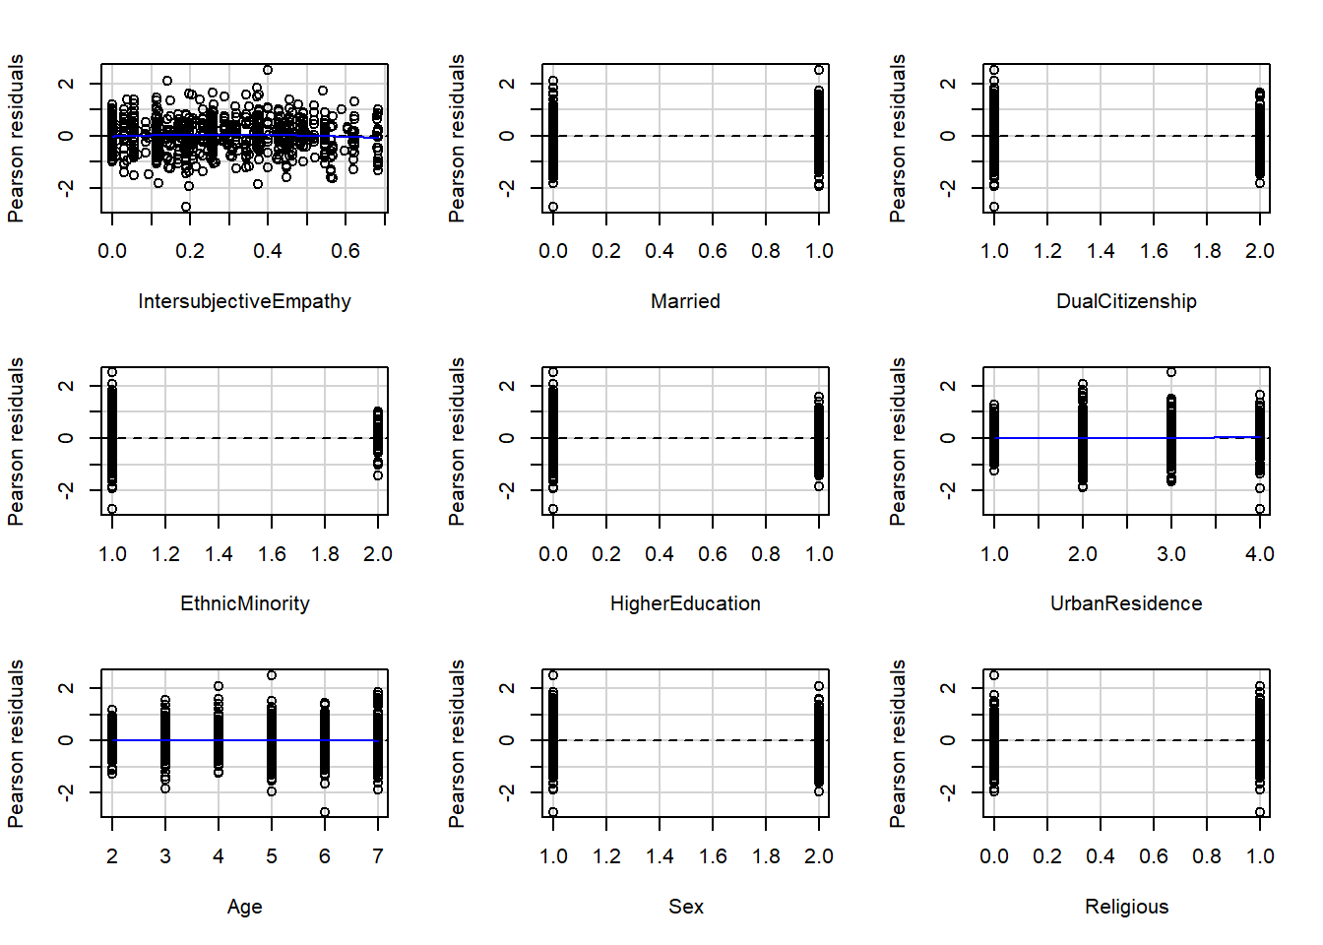

Figure 5.2.1.2: Residual plots of variables on attitudes towards refugees

Figure 5.2.1.3: Residual plots of variables on attitudes towards refugees

Figure 5.2.1.4: Residual plots of variables on attitudes towards refugees

Table 5.2.1 :  Table of curvature tests for linear terms (testing fit of model against an updated model including the quadratic term of each variable)

|  |  |  |
| --- | --- | --- |
| **Variable** | **t-test** | **p-value** |
| IntersubjectiveEmpathy | -0.9553 | 0.3397 |
| Married | -0.4735 | 0.6360 |
| DualCitizenship | 1.5773 | 0.1151 |
| EthnicMinority | 1.1647 | 0.2445 |
| HigherEducation | 0.2710 | 0.7865 |
| UrbanResidence | 3.0529 | 0.0023** |
| Age | -0.2287 | 0.8191 |
| Sex | 1.9130 | 0.0561† |
| Religious | 1.2901 | 0.1974 |
| ProspectiveEgocentric | 1.5773 | 0.1151 |
| RetrospectiveEgocentric | 0.7457 | 0.4561 |
| ProspectiveSociotropic | 1.0389 | 0.2992 |
| RetrospectiveSociotropic | 0.2326 | 0.8162 |
| IncomeSatisfaction | -0.5709 | 0.5683 |
| UnemployedInactive | 0.5238 | 0.6006 |
| Leave | 1.4470 | 0.1483 |
| RecVoteRight | 1.4454 | 0.1488 |
| Egalitarianism | 1.4426 | 0.1495 |
| Authoritarianism | -0.9571 | 0.3388 |
| IdeologyRight | 0.8093 | 0.4186 |
| IdentityBirth | 1.9339 | 0.0535† |
| IdentityLanguage | 1.5609 | 0.1190 |
| IdentityReligion | 3.8246 | 0.0001*** |
| IdentityCustoms | 1.3981 | 0.1625 |
| DiverseNeighbourhood | 1.0586 | 0.2901 |
| ContactSee | 0.6644 | 0.5066 |
| ContactSpeak | 0.3184 | 0.7503 |
| ContactSocialise | 0.1028 | 0.9182 |
|  |  |  |
| Tukey test | -2.3976 | 0.0165* |

*Note.* † p < .10, * p < .05, ** p < .01, *** p < .001

### 5.2.2 Assumption checks

Figure 5.2.2.1: Assumptions checks for regression model for attitudes towards refugees

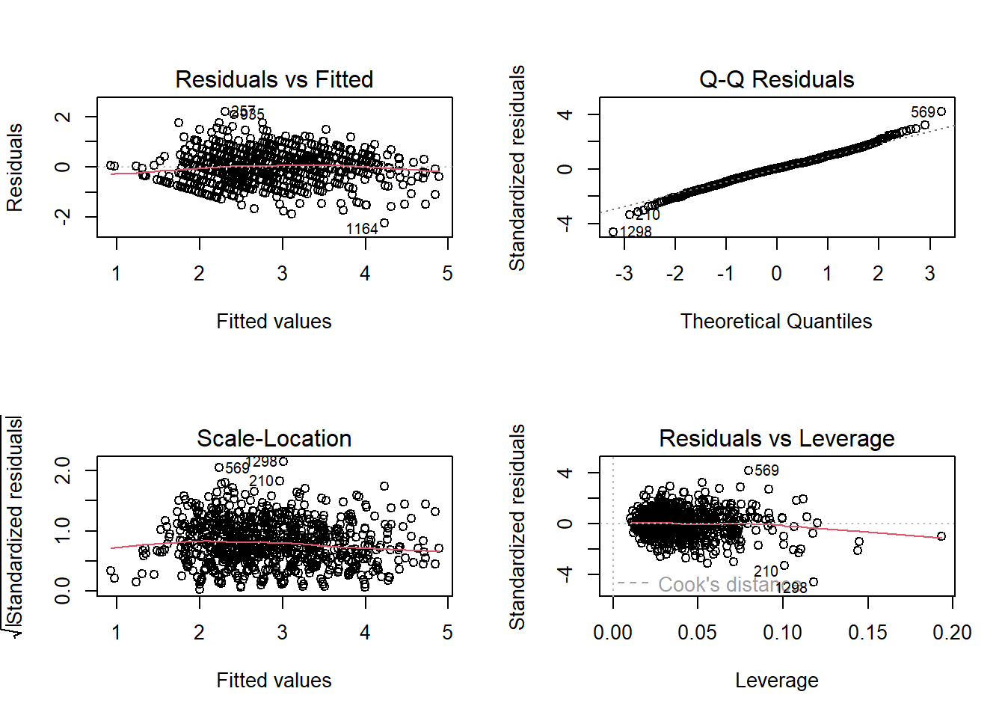

### 5.2.3 Effect plots

Figure 5.2.3.1: Summary plot of standardised estimates (Attitudes towards refugees)

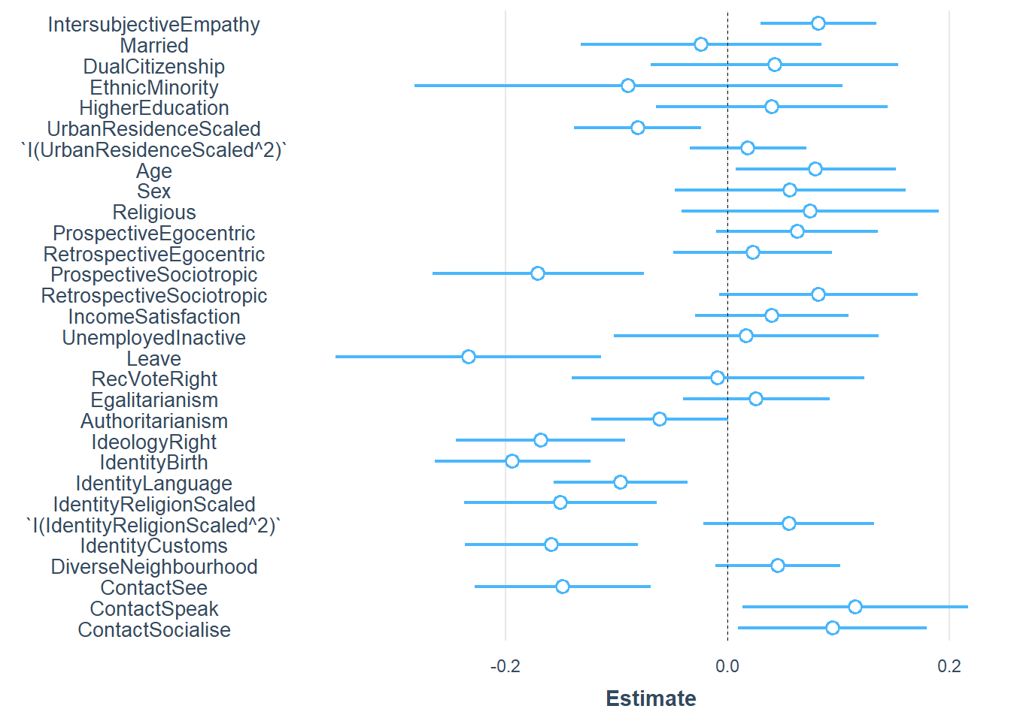

Figure 5.2.3.2: Simple effect plot for Intersubjective Empathy

Figure 5.2.3.3: Simple effect plot for Urban Residence

Figure 5.2.3.4: Simple effect plot for Age

Figure 5.2.3.5: Simple effect plot for Prospective sociotropic

Figure 5.2.3.6: Simple effect plot for Vote Leave

Figure 5.2.3.7: Simple effect plot for Right-wing ideology

Figure 5.2.3.8: Simple effect plot for importance of birthplace for British identity

Figure 5.2.3.9: Simple effect plot for importance of language for British identity

Figure 5.2.3.10: Simple effect plot for importance of religion for British identity

Figure 5.2.3.11: Simple effect plot for importance of customs for British identity

Figure 5.2.3.12: Simple effect plot for visual contact

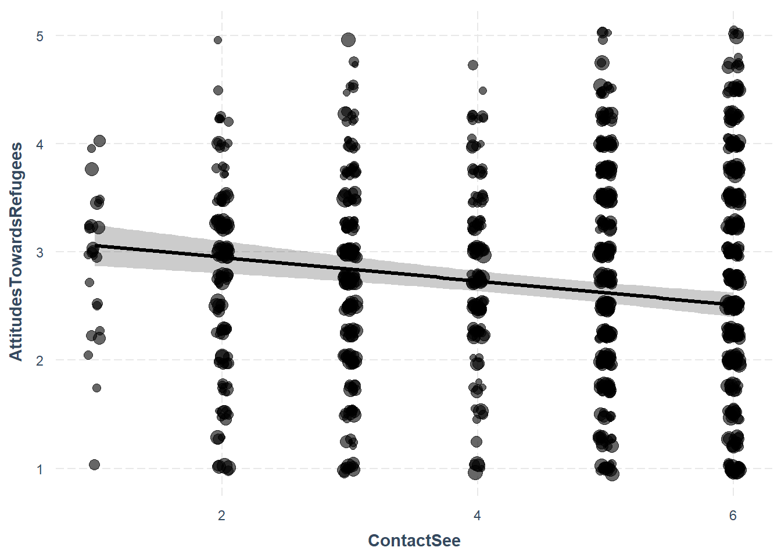

Figure 5.2.3.13: Simple effect plot for verbal contact

Figure 5.2.3.14: Simple effect plot for social contact

### 5.2.4 Regression table

Table 5.2.4.1: Regression summary table for attitudes towards refugees

|  |  |  |  |  |  |  |
| --- | --- | --- | --- | --- | --- | --- |
|  | **AttitudesTowardsRefugees** | | | | | |
| *Predictors* | *Estimates* | *std. Beta* | *CI* | *standardized CI* | *p* | *std. p* |
| (Intercept) | 4.35 *** | -0.07 | 3.63 – 5.08 | -0.16 – 0.02 | **<0.001** | 0.144 |
| IntersubjectiveEmpathy | 0.43 ** | 0.09 | 0.16 – 0.71 | 0.03 – 0.14 | **0.002** | **0.002** |
| Married | -0.02 | -0.01 | -0.13 – 0.08 | -0.07 – 0.05 | 0.666 | 0.666 |
| DualCitizenship | 0.04 | 0.02 | -0.07 – 0.15 | -0.03 – 0.08 | 0.456 | 0.456 |
| EthnicMinority | -0.09 | -0.02 | -0.28 – 0.10 | -0.07 – 0.03 | 0.363 | 0.363 |
| HigherEducation | 0.04 | 0.02 | -0.06 – 0.14 | -0.03 – 0.07 | 0.454 | 0.454 |
| UrbanResidenceScaled | -0.08 ** | -0.09 | -0.14 – -0.02 | -0.15 – -0.02 | **0.006** | **0.006** |
| UrbanResidenceScaled^2 | 0.02 | 0.02 | -0.03 – 0.07 | -0.04 – 0.07 | 0.492 | 0.492 |
| Age | 0.05 * | 0.09 | 0.00 – 0.09 | 0.01 – 0.16 | **0.031** | **0.031** |
| Sex | 0.06 | 0.03 | -0.05 – 0.16 | -0.03 – 0.09 | 0.288 | 0.288 |
| Religious | 0.07 | 0.04 | -0.04 – 0.19 | -0.02 – 0.10 | 0.208 | 0.208 |
| ProspectiveEgocentric | 0.07 | 0.07 | -0.01 – 0.15 | -0.01 – 0.15 | 0.093 | 0.093 |
| RetrospectiveEgocentric | 0.03 | 0.02 | -0.06 – 0.11 | -0.05 – 0.10 | 0.536 | 0.536 |
| ProspectiveSociotropic | -0.17 *** | -0.18 | -0.26 – -0.07 | -0.28 – -0.08 | **<0.001** | **<0.001** |
| RetrospectiveSociotropic | 0.09 | 0.09 | -0.01 – 0.19 | -0.01 – 0.18 | 0.073 | 0.073 |
| IncomeSatisfaction | 0.03 | 0.04 | -0.02 – 0.09 | -0.03 – 0.12 | 0.256 | 0.256 |
| UnemployedInactive | 0.02 | 0.01 | -0.10 – 0.14 | -0.05 – 0.07 | 0.781 | 0.781 |
| Leave | -0.23 *** | -0.13 | -0.35 – -0.11 | -0.19 – -0.06 | **<0.001** | **<0.001** |
| RecVoteRight | -0.01 | -0.00 | -0.14 – 0.12 | -0.08 – 0.07 | 0.897 | 0.897 |
| Egalitarianism | 0.02 | 0.03 | -0.04 – 0.09 | -0.04 – 0.10 | 0.439 | 0.439 |
| Authoritarianism | -0.05 | -0.07 | -0.11 – 0.00 | -0.13 – 0.00 | 0.051 | 0.051 |
| IdeologyRight | -0.07 *** | -0.18 | -0.10 – -0.04 | -0.26 – -0.10 | **<0.001** | **<0.001** |
| IdentityBirth | -0.14 *** | -0.21 | -0.19 – -0.09 | -0.28 – -0.13 | **<0.001** | **<0.001** |
| IdentityLanguage | -0.11 ** | -0.10 | -0.18 – -0.04 | -0.17 – -0.04 | **0.002** | **0.002** |
| IdentityReligionScaled | -0.16 *** | -0.16 | -0.25 – -0.07 | -0.25 – -0.07 | **0.001** | **0.001** |
| IdentityReligionScaled^2 | 0.05 | 0.05 | -0.02 – 0.12 | -0.02 – 0.12 | 0.159 | 0.159 |
| IdentityCustoms | -0.14 *** | -0.17 | -0.21 – -0.07 | -0.25 – -0.09 | **<0.001** | **<0.001** |
| DiverseNeighbourhood | 0.06 | 0.05 | -0.02 – 0.15 | -0.01 – 0.11 | 0.115 | 0.115 |
| ContactSee | -0.11 *** | -0.16 | -0.17 – -0.05 | -0.24 – -0.07 | **<0.001** | **<0.001** |
| ContactSpeak | 0.08 * | 0.12 | 0.01 – 0.15 | 0.01 – 0.23 | **0.027** | **0.027** |
| ContactSocialise | 0.06 * | 0.10 | 0.01 – 0.11 | 0.01 – 0.19 | **0.029** | **0.029** |
| Observations | 800 | | | | | |
| R2 / R2 adjusted | 0.551 / 0.533 | | | | | |
| * *p<0.05   ** p<0.01   *** p<0.001* | | | | | | |

## 5.3 General Linear Model testing intersubjective empathy and other predictors of Duty to Help refugees

### 5.3.1 Residual Plots

Figure 5.3.1.1: Residual plots of variables on duty to help refugees

Figure 5.3.1.2: Residual plots of variables on duty to help refugees

Figure 5.3.1.3: Residual plots of variables on duty to help refugees

Figure 5.3.1.4: Residual plots of variables on duty to help refugees

Table 5.3.1.1 : Table of curvature tests for linear terms (testing fit of model against an updated model including the quadratic term of each variable)

|  |  |  |
| --- | --- | --- |
| **Variable** | **Test statistic** | **p-value** |
| IntersubjectiveEmpathy | -2.0146 | 0.044272* |
| Married | -2.4403 | 0.014883* |
| DualCitizenship | 1.8554 | 0.063891† |
| EthnicMinority | 0.3305 | 0.741120 |
| HigherEducation | -1.3856 | 0.166257 |
| UrbanResidence | 2.2411 | 0.025284* |
| Age | 0.4710 | 0.637754 |
| Sex | 1.4646 | 0.143421 |
| Religious | 0.3648 | 0.715351 |
| ProspectiveEgocentric | 2.2333 | 0.025796* |
| RetrospectiveEgocentric | 0.7433 | 0.457520 |
| ProspectiveSociotropic | 1.8184 | 0.069364† |
| RetrospectiveSociotropic | 0.6474 | 0.517547 |
| IncomeSatisfaction | -1.1132 | 0.265949 |
| UnemployedInactive | 0.2768 | 0.782025 |
| Leave | 1.5002 | 0.133939 |
| RecVoteRight | 0.7908 | 0.429274 |
| Egalitarianism | 0.2359 | 0.813604 |
| Authoritarianism | -1.5625 | 0.118547 |
| IdeologyRight | 1.0708 | 0.284582 |
| IdentityBirth | 0.4699 | 0.638540 |
| IdentityLanguage | 0.7685 | 0.442431 |
| IdentityReligion | 3.2872 | 0.001055** |
| IdentityCustoms | 0.1932 | 0.846881 |
| DiverseNeighbourhood | 0.2273 | 0.820259 |
| ContactSee | 0.1526 | 0.878760 |
| ContactSpeak | 0.2010 | 0.840772 |
| ContactSocialise | -0.6952 | 0.487107 |
|  |  |  |
| Tukey test | -0.9001 | 0.368050 |

*Note*: † p < .10, * p < .05, ** p < .01

### 5.3.2 Assumption checks

Assumptions generally hold. Shapiro-Wilk’s test is significant (W = 0.9901, p-value = 1.602e-0) but Kolmogorov-Smirnov test is not significant (D = 0.040503, p-value = 0.1206). Checking histogram shows normally distributed residuals.

Tests for heterogeneity are significant indicating need to control for violations of heterogeneity.

Figure 5.3.2.1: Assumption checks for duty to help model

### 5.3.3 Effect plots

Figure 5.3.3.1: Summary plot of estimates for duty to help

Figure 5.3.3.2: Simple effect plot of intersubjective empathy

Figure 5.3.3.3: Simple effect plot of sex

Figure 5.3.3.4: Simple effect plot of religiosity

Figure 5.3.3.5: Simple effect plot of income satisfaction

Figure 5.3.3.6: Simple effect plot of vote leave

Figure 5.3.3.7: Simple effect plot of egalitarianism

Figure 5.3.3.8: Simple effect plot of authoritarianism

Figure 5.3.3.9: Simple effect plot of importance of birthplace for British identity

Figure 5.3.3.10: Simple effect plot of importance of language for British identity

Figure 5.3.3.11: Simple effect plot of social contact

### 5.3.4 Regression table

Table 5.3.4.1: Regression summary table for duty to help refugees

|  |  |  |  |  |  |  |
| --- | --- | --- | --- | --- | --- | --- |
|  | **DutyToHelp** | | | | | |
| *Predictors* | *Estimates* | *std. Beta* | *CI* | *standardized CI* | *p* | *std. p* |
| (Intercept) | 4.12 *** | -0.03 | 2.99 – 5.24 | -0.17 – 0.10 | **<0.001** | 0.625 |
| IntersubjectiveEmpathyScaled | 0.18 *** | 0.13 | 0.09 – 0.27 | 0.06 – 0.20 | **<0.001** | **<0.001** |
| IntersubjectiveEmpathyScaled^2 | -0.08 * | -0.07 | -0.16 – -0.00 | -0.13 – -0.00 | **0.039** | **0.039** |
| Married | 0.01 | 0.00 | -0.16 – 0.17 | -0.06 – 0.07 | 0.947 | 0.947 |
| DualCitizenship | -0.01 | -0.00 | -0.19 – 0.17 | -0.07 – 0.06 | 0.909 | 0.909 |
| EthnicMinority | -0.29 | -0.06 | -0.63 – 0.05 | -0.12 – 0.01 | 0.098 | 0.098 |
| HigherEducation | 0.14 | 0.05 | -0.02 – 0.30 | -0.01 – 0.11 | 0.082 | 0.082 |
| UrbanResidenceScaled | -0.05 | -0.04 | -0.14 – 0.04 | -0.11 – 0.03 | 0.281 | 0.293 |
| UrbanResidenceScaled^2 | 0.02 | 0.02 | -0.06 – 0.10 | -0.05 – 0.08 | 0.641 | 0.641 |
| Age | 0.02 | 0.03 | -0.05 – 0.09 | -0.06 – 0.12 | 0.543 | 0.543 |
| Sex | 0.20 * | 0.08 | 0.03 – 0.36 | 0.01 – 0.15 | **0.020** | **0.020** |
| Religious | 0.24 ** | 0.10 | 0.07 – 0.41 | 0.03 – 0.17 | **0.007** | **0.007** |
| ProspectiveEgocentricScaled | 0.07 | 0.06 | -0.05 – 0.18 | -0.03 – 0.16 | 0.263 | 0.213 |
| ProspectiveEgocentricScaled^2 | 0.04 | 0.03 | -0.02 – 0.10 | -0.01 – 0.08 | 0.177 | 0.177 |
| RetrospectiveEgocentric | 0.06 | 0.04 | -0.08 – 0.19 | -0.06 – 0.14 | 0.409 | 0.409 |
| ProspectiveSociotropic | -0.12 | -0.10 | -0.25 – 0.02 | -0.21 – 0.02 | 0.100 | 0.100 |
| RetrospectiveSociotropic | 0.11 | 0.08 | -0.04 – 0.26 | -0.03 – 0.19 | 0.156 | 0.156 |
| IncomeSatisfaction | 0.10 * | 0.09 | 0.01 – 0.18 | 0.01 – 0.18 | **0.029** | **0.029** |
| UnemployedInactive | 0.12 | 0.05 | -0.06 – 0.30 | -0.02 – 0.12 | 0.185 | 0.185 |
| Leave | -0.43 *** | -0.18 | -0.62 – -0.24 | -0.26 – -0.10 | **<0.001** | **<0.001** |
| RecVoteRight | -0.18 | -0.08 | -0.41 – 0.04 | -0.17 – 0.02 | 0.110 | 0.110 |
| Egalitarianism | 0.10 * | 0.09 | 0.01 – 0.18 | 0.01 – 0.16 | **0.037** | **0.037** |
| Authoritarianism | -0.11 ** | -0.10 | -0.19 – -0.03 | -0.18 – -0.03 | **0.005** | **0.005** |
| IdeologyRight | -0.05 | -0.10 | -0.10 – 0.00 | -0.20 – 0.01 | 0.075 | 0.075 |
| IdentityBirth | -0.13 *** | -0.15 | -0.20 – -0.06 | -0.24 – -0.07 | **<0.001** | **<0.001** |
| IdentityLanguage | -0.11 * | -0.08 | -0.23 – -0.00 | -0.16 – -0.00 | **0.048** | **0.048** |
| IdentityReligionScaled | -0.04 | -0.03 | -0.17 – 0.09 | -0.13 – 0.07 | 0.568 | 0.560 |
| IdentityReligionScaled^2 | 0.07 | 0.05 | -0.04 – 0.18 | -0.03 – 0.13 | 0.223 | 0.223 |
| IdentityCustoms | -0.03 | -0.03 | -0.14 – 0.07 | -0.13 – 0.07 | 0.561 | 0.561 |
| DiverseNeighbourhood | 0.05 | 0.03 | -0.08 – 0.17 | -0.05 – 0.10 | 0.495 | 0.495 |
| ContactSee | -0.08 | -0.10 | -0.17 – 0.00 | -0.19 – 0.00 | 0.058 | 0.058 |
| ContactSpeak | 0.06 | 0.08 | -0.02 – 0.15 | -0.03 – 0.19 | 0.156 | 0.156 |
| ContactSocialise | 0.12 ** | 0.16 | 0.05 – 0.20 | 0.06 – 0.26 | **0.002** | **0.002** |
| Observations | 856 | | | | | |
| R2 / R2 adjusted | 0.375 / 0.351 | | | | | |
| * *p<0.05   ** p<0.01   *** p<0.001* | | | | | | |

1. We follow the same coding as Sirin et al. (2021).