Screenshots from the video #NATO2030, published on YouTube 7 June 2021, available at https://www.youtube.com/watch?v=UF5wzTe5HWc (last access: 28 April 2022).

Image used under NATO’s ‘fair use’ policy: https://www.nato.int/cps/en/natohq/68162.htm (last access: 10 January 2025).



Sequence 1 & 2

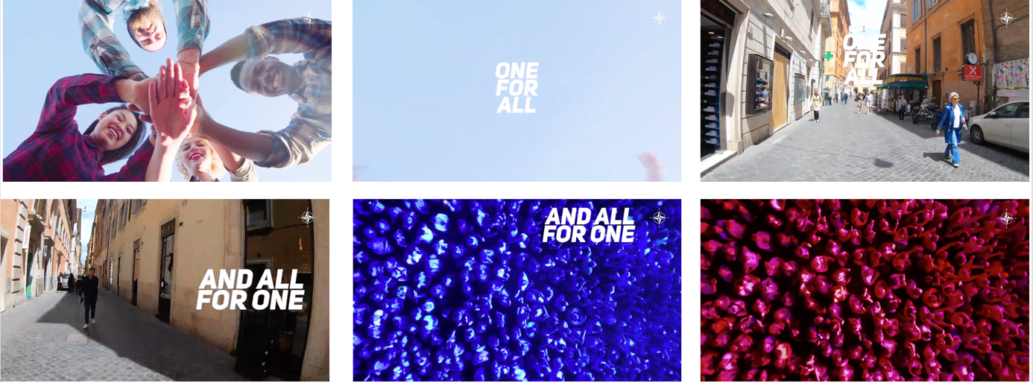

Sequence 3

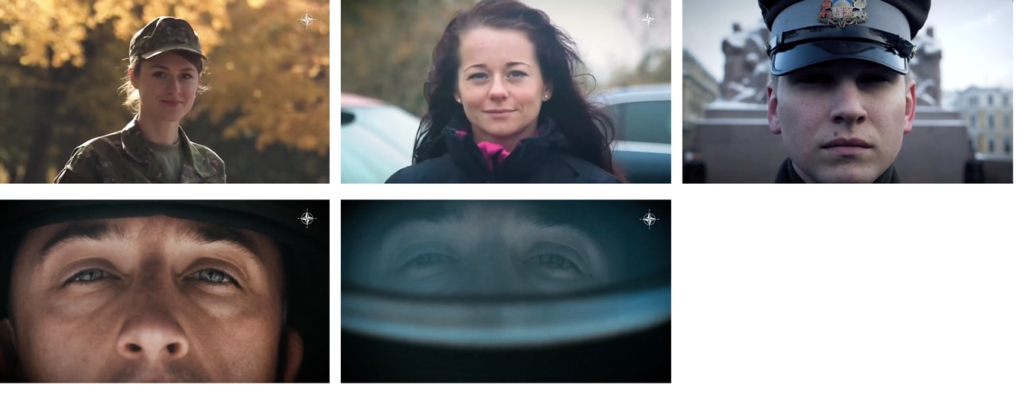
Sequence 4

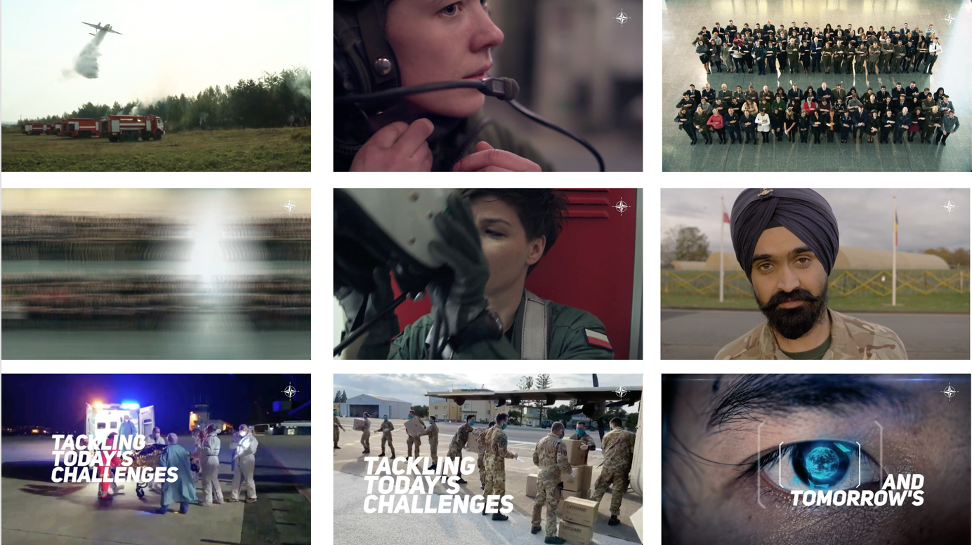

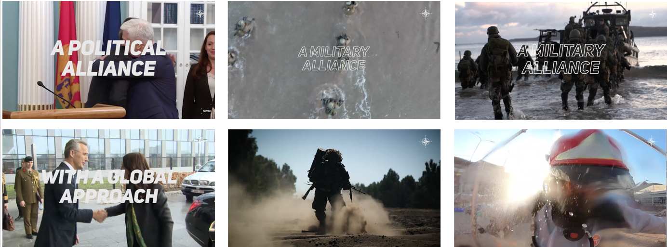

Sequence 5

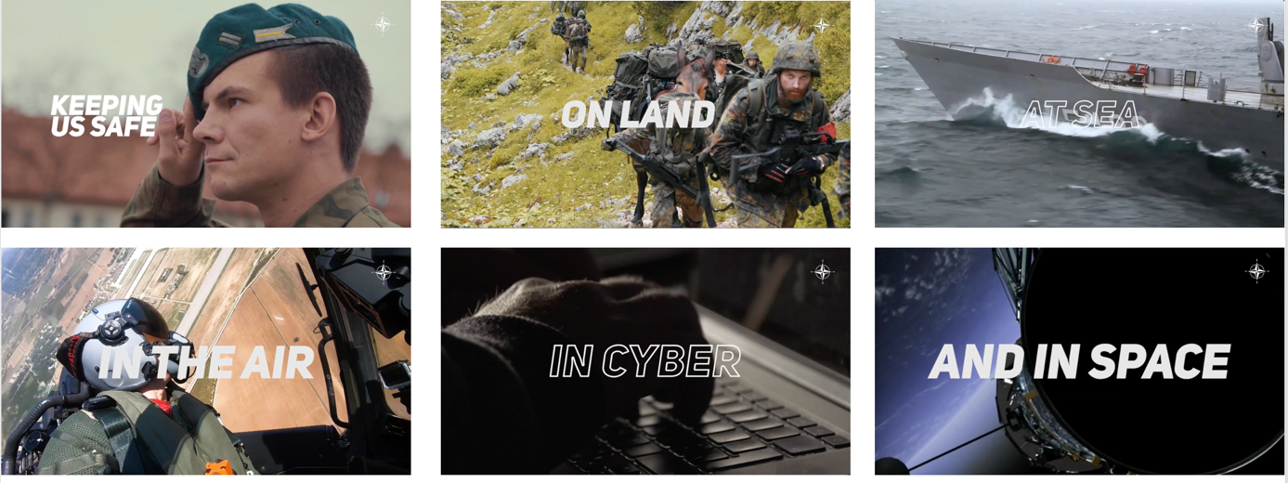

Sequence 6

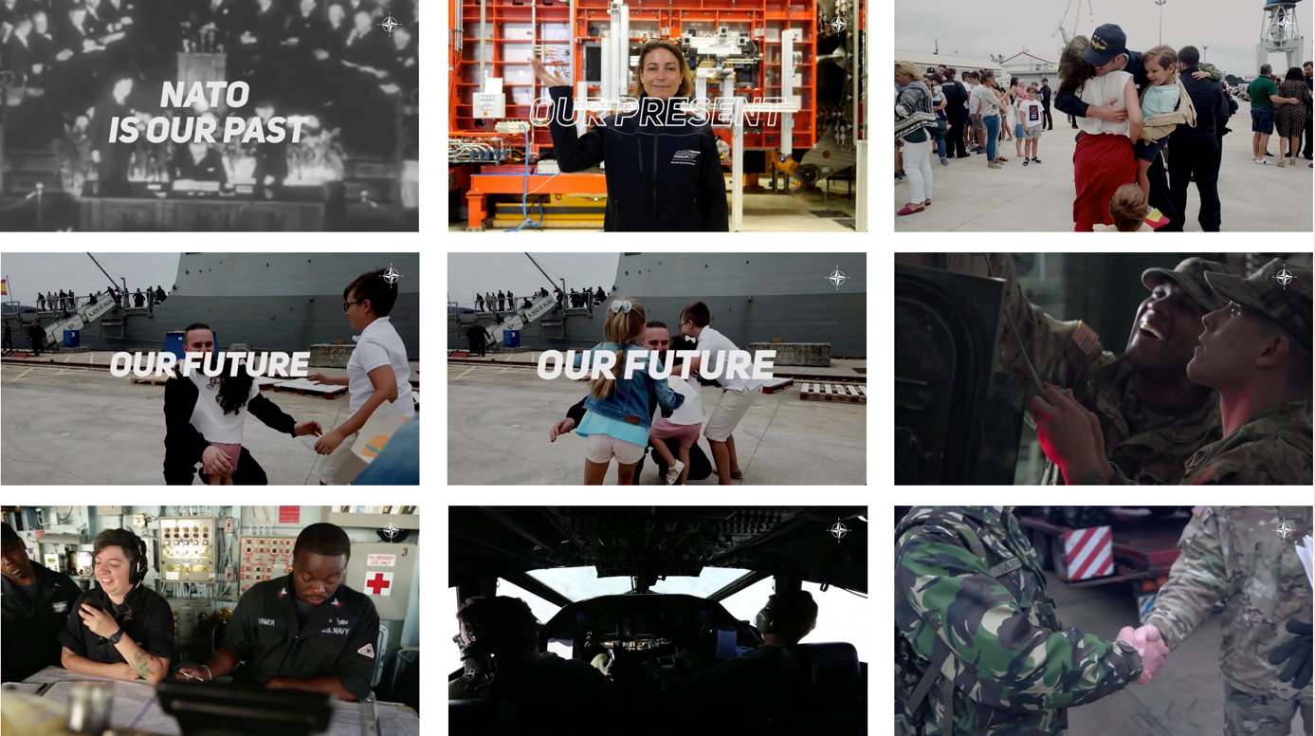

Sequence 7

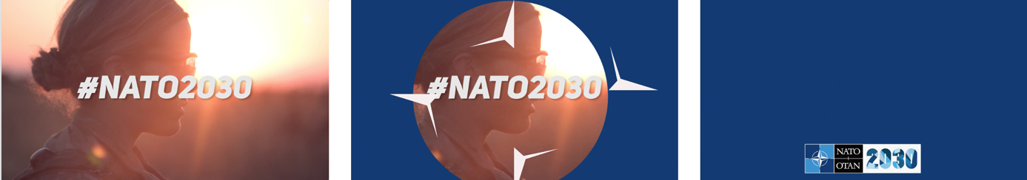

Sequence 8

