Supplementary Materials

“Engaged or Obedient? Racially Differentiated Models of Democratic Education”

Appendix A: Constructing the Datasets 2
Appendix B: Additional Data and Figures, Word Frequency 3
Appendix C: Codebook 9
Appendix D: Additional Data and Figures, Coded Data 17
Appendix E: Supplementary Class Analysis 20

Appendix A: Constructing the Datasets

Dataset for Word Frequency Analysis
To construct the initial dataset, we drew a random sample of charter schools from the National Center for Education Statistics’ (NCES) Public School Directory for the 2019-2020 academic year, which is available through NCES’s Elementary/Secondary Information System and included demographic information for each school (National Center for Education Statistics 2022). Our initial random sample consisted of 1,040 public charter schools and represented 13.7% of all U.S. public charter schools. From that sample, we excluded 238 schools. These schools were excluded for one of the following reasons: They were not primarily an educational institution; they did not have a physical campus (cyber-campus, home schooling); they exclusively served populations that are already differently oriented toward the democratic process (criminal justice centers, military schools, rehabilitation centers, domestic violence shelters, hospitals); they did not make school handbooks publicly available. After these exclusions, our sample consisted of 802 public charter schools, which represents 10.6% of all charter schools from 2019-2020.
The first dataset consists of raw text data of school handbooks and school demographic information. To build this dataset, we used the R environment to load the text of the school handbooks as unstructured text data. We broke the data by page (n=41977) to make it easier to view in parts. Using a unique school ID, we then merged the school handbook text with our pre-existing dataset of charter school demographics. We created a corpus from our dataset whereby we separated the data into individual words. We then “cleaned” the data by removing common English words (such as “the,” “on” and “to”), URLs, and punctuation, and stemmed the words to their root. Finally, we added a race dummy variable (white_dummy) wherein we coded 1 if a majority of students are White and 0 if a majority of students are non-White. We elected to collapse students of different ethnicities into a single “non-White” category so that the N is large enough to yield a meaningful comparison to schools where a majority of students are White. We further discuss our normative reservations about this decision in the text of the paper. Additionally, we elected to examine the racial make-up of the student body as a simple majority (more than 50%) and greater majority (more than 70%) of White or non-White students over a measure such as quartiles. Due to patterns of school enrollment, the quartile of schools with the highest percentage of White students was 61% or more White, while for non-White schools was 97.5% non-White. Given that we are pursuing normative questions, we felt the project was better served by drawing substantively consistent and normatively meaningful lines (instead of comparing schools that are segregated to very differing degrees).

Dataset for Citizenship Analysis
The second dataset consists of the school handbook pages whereby the terms citizen* or civic* are mentioned explicitly. To build this dataset, we first separated each school handbook page into a separate observation (n= 41,977). We then used the grepl function to separate out school handbook pages that use word derivations of citizen or civic (n=1,412). We exported this data for coding. We read each page of the handbooks where these terms are mentioned and code according to the codebook, which can be found in appendix C. Some pages are excluded because they refer to citizenship in a legalistic way, are not referring to students, are discussing online practices, or refer specifically to athletics or extracurriculars. Further information about these exclusions can be found in appendix C. We verified the integrity of the coding by drawing a random sample and ensuring that each variable is coded with 90% agreement or higher. The coded data was then imported into R and merged with school demographic information. The resulting dataset consists of 895 pages where citizenship or civics is discussed in a normatively meaningful way. We added a race dummy variable here in the same manner as we did in the previous dataset.

Appendix B: Additional Data and Figures, Word Frequency

Table B.1: Most Frequently Used Terms in School Handbooks
Majority White Schools (>50%) | Term Count | Majority Non-White Schools (>50%) | Term Count
Educ | 15,499 | Activ | 24,049
Must | 13,688 | Conduct | 22,780
Teacher | 12,325 | Follow | 21,903
Include | 12,128 | Program | 21,707
Requir | 11,600 | Attend | 20,822
Shall | 11,563 | Famili | 20,422
Polici | 11,512 | Scholar | 19,846
Child | 11,100 | Behavior | 19,797
Inform | 11,071 | Office | 19,537
Time | 10,630 | Code | 19,516
Provid | 10,332 | Year | 19,212
Grade | 10,131 | Staff | 19,100
Activ | 9,754 | Respons | 18,665
Person | 9,678 | Report | 18,385
Guardian | 8,534 | Record | 17,927
Follow | 8,496 | Princip | 17,533
Offic | 7,997 | Right | 17,314
Staff | 7,828 | Servic | 17,300
Program | 7,798 | Administr | 17,048
Class | 7,794 | Class | 16,562
Attend | 7,753 | Suspens | 16,436
Respons | 7,687 | State | 16,411
Administr | 7,658 | Academ | 15,170
District | 7,464 | Receiv | 15,005
Year | 7,458 | Request | 14,852
Academi | 7,091 | Meet | 14,729
Learn | 6,983 | Absenc | 14,702
Work | 6,899 | Learn | 14,554
Behavior | 6,876 | Appropri | 14,507
Report | 6,840 | Medic | 14,306

Table B.2: Most Frequently Used Terms in School Handbooks
Majority White Schools (>70%) | Term Count | Majority Non-White Schools (>70%) | Term Count
Will | 20,795 | Provid | 24,997
Parent | 17,628 | Polici | 24,414
Educ | 9,159 | Grade | 22,663
Must | 7,642 | Teacher | 21,955
Shall | 7,426 | Person | 21,738
Include | 7,173 | Guardian | 21,653
Polici | 7,167 | Time | 20,962
Teacher | 6,898 | Activ | 20,301
Require | 6,676 | Conduct | 19,789
Child | 6,365 | Follow | 18,381
Inform | 6,339 | Program | 18,304
Provid | 6,003 | Scholar | 18,089
Time | 5,902 | Famili | 17,523
Person | 5,847 | Attend | 17,473
Activ | 5,723 | Code | 16,843
Grade | 5,654 | Behavior | 16,466
Guardian | 4,879 | Offic | 16,214
Follow | 4,874 | Year | 16,169
District | 4,798 | Staff | 15,908
Administr | 4,709 | Report | 15,742
Respons | 4,608 | Record | 15,668
Staff | 4,507 | Respons | 15,404
Program | 4,440 | Princip | 15,281
Attend | 4,419 | Servic | 14,776
Offic | 4,409 | Right | 14,732
Class | 4,406 | State | 14,072
Year | 4,215 | Suspens | 13,901
Board | 4,142 | Administr | 13,739
Learn | 4,073 | Class | 13,627
Behavior | 4,071 | Receiv | 12,881

When we look at schools where 70% or more of students are White or non-White, the terms teacher, provid*, time, person, activ*, grade, guardian, follow, and respons* are all shared. Nevertheless, once we remove the terms in common, we notice that schools with 70% or more White students continue to use words we associate with education frequently. Meanwhile, schools where a majority of students are non-White continue to use frequent disciplinary terms (See appendix B, figure 1).

Figure B.1: Top Unique Features in School Handbooks by Race
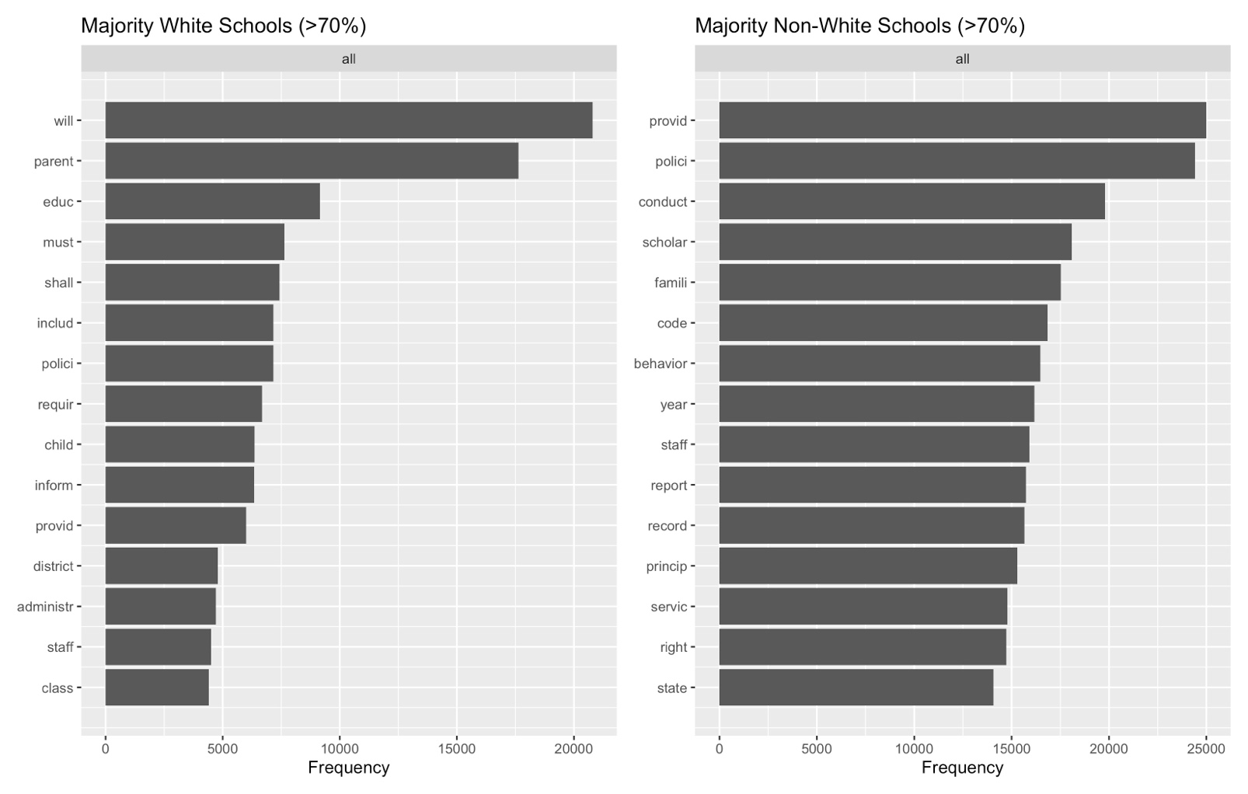

Figure B.2: Top Unique Terms in the 10 Highest Topic Proportions of LDA Topic Model (k=25)
Majority White Schools (>50%)
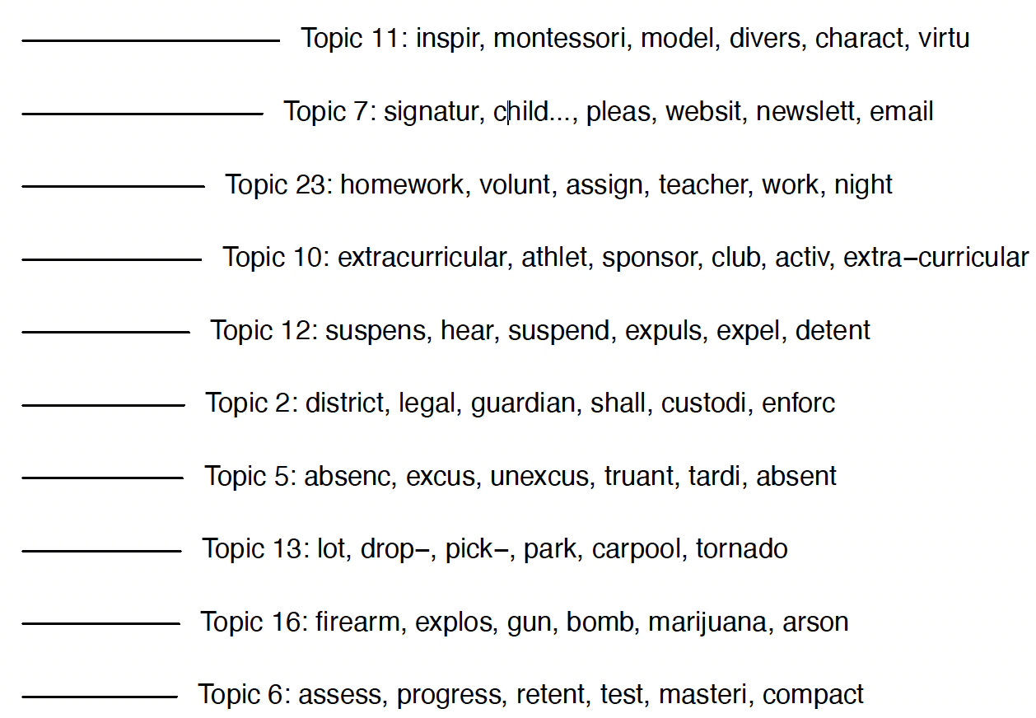

Majority Non-White Schools (>50%)
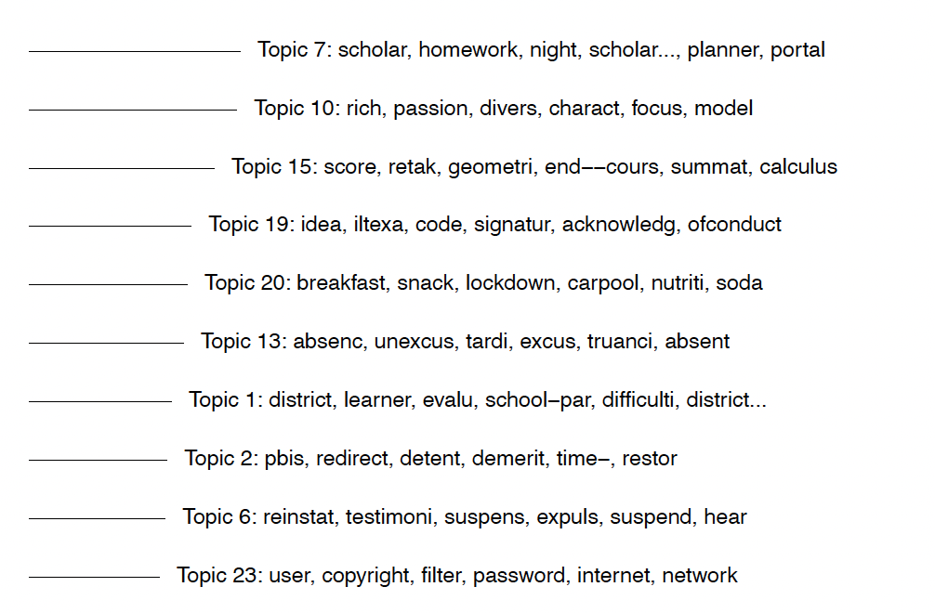

Figure B.3: Top Unique Terms in the 10 Highest Topic Proportions of LDA Topic Model (k=25)
Majority White Schools (>70%)
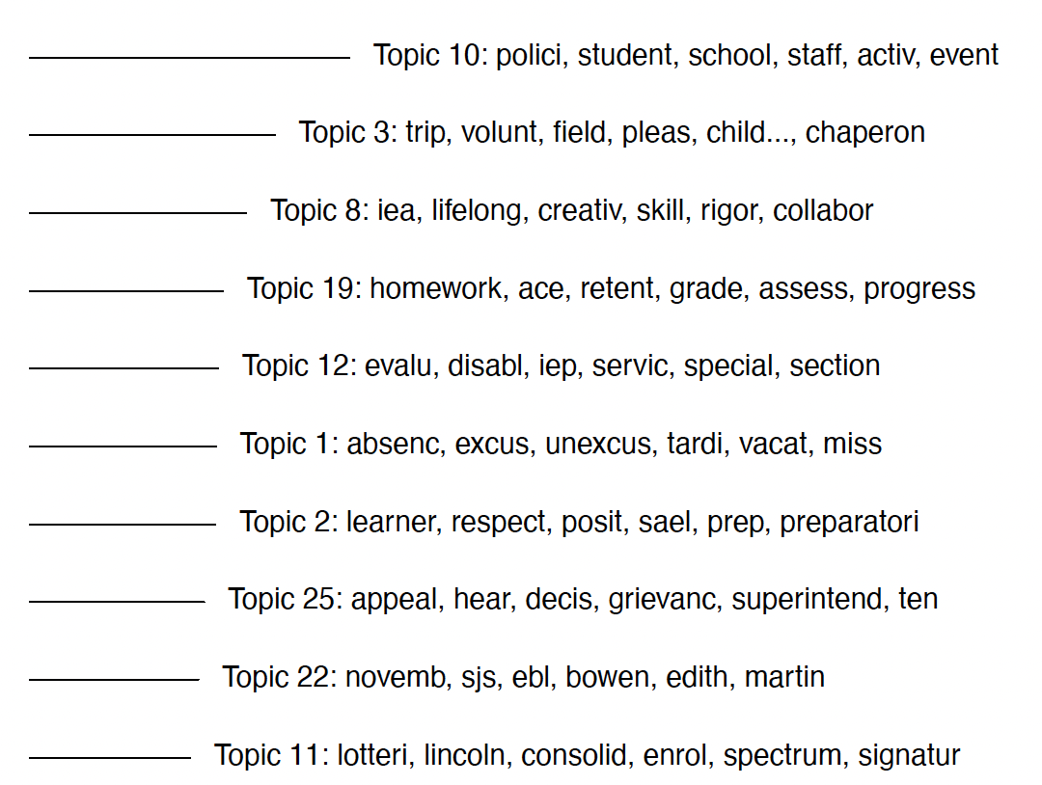

Majority Non-White Schools (>70%)
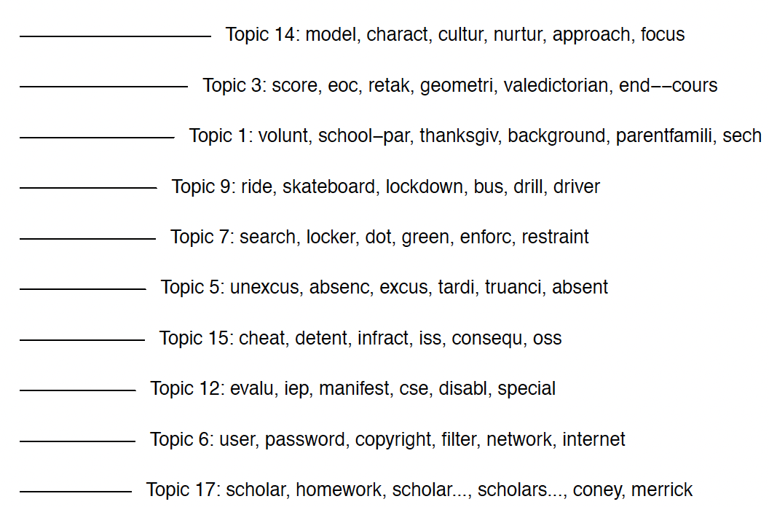

We conducted several analyses to ensure that we were correctly interpreting the top frequency terms. Before conducting our word frequency analysis, we read hundreds of pages of handbooks to get a sense for the language and topics in the texts. Then, we drew a random sample (n=1000) of pages and estimated an LDA topic model. Here, an unsupervised algorithm partitioned the text into categories (k=25). We generated a list of unique terms for each category. Then, we drew a random sample of pages from the categories to ensure we were interpreting the terms appropriately.

Additionally, as a validity test for our word frequency analysis, we repeated the topic models on all of our data, partitioned by race, and generate top unique terms for each topic. Above, we report the top 10 for each demographic split. Note that when schools have a student body that is 50% or more white, Topic 12, the only topic concerned with discipline, is the 5th most common topic. However, for schools with a 50% or more non-White student population, there are several topics in the top 10 topics concerning discipline, including Topic 19, Topic 2, and Topic 6. When schools have a larger percentage of White students (>70%), the disciplinary category is not within the top 10 topic proportions (it is 11th). When schools have a larger percentage of non-White students (>70%), discipline is the 7th largest topic proportion.

Appendix C: Codebook
Each observation is coded according to the following criteria:

Location and body of the text
- A coder changes the font color of the text that was coded to red. This should include all text that is relevant to the way that citizen* or civic* is used, but should not include other text.
  - The textual connection should be clear and direct. For instance, coders should include a list of traits under “Qualities of a citizen include:” or “We live by these values because they are the traits of productive and honest citizens” but should not include a list of traits under “There are many qualities that are an important part of good citizenship. As a school, we cultivate students’ strengths, including:”
  - If the header of a section is about citizens, citizenship, and/or civics (e.g., “Citizenship,” “Civic Values,” “Citizenship and Character,” etc.) the text of the entire section should be coded.
  - If a coder does not have all of the text they need in order to code an observation (for instance, if the relevant text breaks off mid-sentence) they make a note in the “notes” column and highlight column A (observation number), so that a PI or another coder can retrieve and provide the needed information
- A coder notes the handbook section or location of the relevant terms (for instance, if they are included in a school’s mission statement, code of conduct, student contract, curriculum, etc.).
  - If a coder does not have all of the text they need (for instance, if the section header is on a different page) they make a note in the “notes” column and highlight column A (observation number), so that another coder can retrieve and provide the needed information

Exclusion criteria
Coders then proceed to code observations according to the follow criteria, which may exclude the observation from additional coding:
- Legalistic
  - “1” if citizen* and/or civic* are used to denote a legal status in accordance with U.S. law or U.S. state law; 0 if they are not
    - Examples: “This school prohibits discrimination on the basis of race, gender, disability, and citizenship.” “Students’ absences may be permitted for religious activities, documented health-care appointments, and activities related to obtaining United States citizenship.” “The school directory does not include information about students’ immigration or citizenship status.”
  - If “1” the rest of the document is not coded (the cells are left blank) unless the relevant terms are used in a substantively different way elsewhere within the same observation
  - Documents should not be coded as legalistic, and should be coded normatively (not excluded), if they refer to legal status as conceptual rather than technical.
    - Example: “The Constitution of the United States, through the Bill of Rights and subsequent amendments, gives each citizen certain rights. The Supreme Court has declared that a student does not shed those constitutional rights by walking through the school door.”
- Digital
  - “1” if citizen* and/or civic* are used in the context of guidelines for technology usage, including internet usage and electronic communication; 0 if not
    - Examples: “In using school-owned equipment, students are expected to be responsible digital citizens.” “This school believes that teaching students how to use electronic resources is an important part of preparing them to be technologically literate citizens.” “Choosing the right type of communication is part of responsible digital communication citizenship.”
  - If “1” the rest of the document is not coded (the cells are left blank) unless the relevant terms are used in a substantively different way elsewhere within the same observation.
  - Documents should not be coded as digital and should be coded normatively (not excluded) if schools frame technological competence as an integral part of citizenship more broadly.
    - Example: “This school is committed to preparing students to be highly successful citizens in a global economy and have therefore developed a technology program to develop students’ digital literacy.
- Athletics
  - “1” if citizen* and/or civic* are used in ways that are directed specifically and exclusively to athletes and/or athletic support staff; 0 if not
    - Examples: “All players are expected to demonstrate good sportsmanship and good citizenship at all times” “Coaches and players are role models and must exemplify good citizenship.”
  - If “1” the rest of the document is not coded (the cells are left blank) unless the relevant terms are used in a substantively different way elsewhere within the same observation
- Extracurriculars
  - “1” if citizen* or civic* are used in ways that are directed specifically and exclusively to students’ eligibility for extracurricular activities other than athletics; 0 if not
    - Examples: “In order to encourage and promote academic excellence and outstanding citizenship, students participating in extra/co-curricular activities shall have a minimum Grade Point Average of 2.0.”
  - If “1” the rest of the document is not coded (the cells are left blank) unless the relevant terms are used in a substantively different way elsewhere within the same observation
- Not_students
  - “1” if citizen* or civic* are used in ways that are not directed at students and are instead directed at/written about other stakeholders (e.g., parents and guardians, teachers, staff members, school districts, members of the school or geographic community); s; 0 if the terms are used in ways that are directed at or written about students
    - Examples: “Parents must follow safe dismissal procedures to demonstrate positive citizenship in our neighborhood.” “This school encourages school citizens, such as parents and guardians, to visit classrooms.” “This school’s founder was awarded the city’s civic award for community service.”
  - If “1” the rest of the document is not coded (the cells are left blank) unless the relevant terms are used in a substantively different way elsewhere within the same observation

In cases where citizen* and civic* are not used in these five ways, and/or when they are also used in other substantive ways, observations are coded in the following ways that document the role of citizenship and civics in the structure and mission of the school.
Structure and mission
It is possible and even likely that a single observation will meet multiple criteria, thus coded “1” in more than one of the following:
- Curric_sub
  - “1” if citizen* or civic* is used with reference to an explicit, substantive curricular requirement such as civics tests, civics courses, state civics requirements; 0 if not
    - Examples: “Students must pass the state civics exam in order to graduate” “All students are required to take a sequence of civics courses that provide them with the information they need to participate as citizens.”
  - Note that discussion of a grade in citizenship does not necessarily indicate a substantive curriculum; some schools assign citizenship grades that function as assessments of students’ overall behavior rather than their mastery of a specific curriculum. Curric_sub should not be coded as 1 unless there’s clear reference to material being taught in a formal class setting.
  - Note that this category includes classes that are not exclusively or primarily about civics and citizenship, but that clearly and explicitly include relevant material. For instance, a social studies course that includes a unit on the history and responsibilities of U.S. citizenship would be coded as a 1.
  - Note that this can include community service or internship requirements if and only if they explicitly make reference to citizen* or civic*
    - Example: “In order to foster a sense of civic responsibility, each student must complete 75 hours of community service.” “Each student must contribute to a community project, via community service or an internship with a local non-profit or government agency, in order to better understand the duties and responsibilities of citizenship.”
- Curric_char
  - “1” if citizen* or civic* is used with reference to explicit, formal character education and/or social and emotional goals; 0 if not
    - Examples: “This school’s Social and Emotional Learning Program is designed to support students so that they can fulfill their potential as future citizens.” “Student’s weekly extended homeroom will include topics such as study techniques, leadership, mindfulness, conflict resolution, responsible citizenship, and relationship-building.”
  - Note that this category includes formal classes and programs that are not exclusively or primarily about civics and citizenship, but that clearly and explicitly include relevant material. For instance, a homeroom, morning meeting, physical education class, weekly tutorial, leadership program, or broader social-emotional learning curriculum that includes instruction on character and social/emotional goals in relationship to citizenship would be coded as a 1.
- As_goal
  - “1” if citizen* or civic* is framed as a goal, ideal, and/or something to which students should aspire; 0 if not
    - Examples: “At this school we believe that all students can become responsible citizens” “We strive to support our students in realizing their ability as scholars and citizens” “Students should always demonstrate good character and citizenship.” “This school encourages individuality, citizenship, and fair play.”
  - Note that this category involves a forward-looking temporal perspective, in which students are, i.e., encouraged to become citizens. For the purposes of coding, this is distinct from expectations that students already are citizens or already behave with civic virtue. For instance, while “We encourage students to develop a sense of citizenship and civic responsibility” would be coded as a 1, “We expect students to demonstrate a sense of citizenship and civic responsibility” would be coded as a 0.
  - Note that this category aims to capture instances where citizenship is a goal for students, not a goal for the school or for other entities. Therefore, while something like “We will encourage students to develop a sense of citizenship and civic responsibility” should be coded as a 1, “As a school we strive to be a pillar of responsible citizenship in our community” or “We strive to inspire and bring out civic responsibility in our teachers, parents, and community volunteers” should be coded as a 0.
- As_grade_points
  - “1” if citizen* or civic* are the basis for a grading and/or points system that involves evaluating students’ behavior and/or understanding; 0 if not
    - Examples: “All students begin each term with 100 citizenship points. Teachers will add or deduct points for appropriate or inappropriate classroom behavior” “Students with unsatisfactory marks in work habits or citizenship may not be permitted to go on field trips” “Students will receive quarterly report cards documenting their progress in social studies, reading, math, science, citizenship, and leadership.”
- As_awards
  - “1” if citizen* or civic* are the basis for awards, rewards, or forms of recognition (school bucks, etc.); 0 if not
    - Examples: “Students in grades 9-12 have the opportunity to be awarded a letter in Fine Arts, Academics, and Athletics. Criteria includes citizenship, commitment, and leadership.” “The National Honor Society is the nation’s premier organization recognizing outstanding student scholarship, service, and citizenship.” “The purpose of our Behavior Program is to provide students with opportunities to be recognized for their citizenship at our monthly “SUCCESS” assemblies.” “Students who earn 100 citizenship points or more in a term will receive 5 School Bucks, redeemable for merchandise at the school store.”
Normative
Coders then continue coding each observation for the following normative uses. It is possible and even likely that a single observation will meet multiple criteria, thus coded “1” in more than one of the following:
- Generic
  - “1” if citizen* or civic* appears in the observation, but the term is not defined or normatively described; “0” if the observation offers a specific normative meaning associated with citizenship.
    - Examples: “This school provides expectations that help build a sense of citizenship and civic community.” “Students must exemplify good citizenship at all times.” “With a commitment to hard work, personal responsibility, and good citizenship, we believe that all students can excel.”
  - Observations coded “1” for generic may also be coded “1” for subsequent categories. This is likely to occur when the usage of citizen* or civic* is generic/does not itself suggest a normative value to citizenship, but the rest of the relevant passage gives a clear and tightly linked sense that/how citizenship is treated as a normative value. For instance, “This school believes that students should develop citizenship” should be coded as a 1 for generic and a 0 for other normative qualities; a passage under the heading “Citizenship” that includes that statement and says “timeliness and obedience are critical to the schools rules” should be coded as a 1 for generic and obedience; a passage that says something like “the central mission of this school is to develop citizenship and civic virtue; respect for rules and authority; and a robust grasp of foundational Western texts” should be coded as a 1 for generic and a 1 for obedience and classical.”
  - Observations may also be coded “1” for generic when citizen* or civic* is attached to an adverb modifying citizenship, but when the document does not otherwise give a clear vision of what citizenship means. For instance, “This school believes that students should become responsible citizens” should be coded as a 1; “This school believes that students should become responsible citizens who defend their country, listen to their community leaders, and learn the classics” should be coded as a 0 because the passage gives a clear sense for what the school means in reference to citizenship/civics.
- Obedience
  - “1” if citizen* or civic* is used in a context that suggests that citizenship involves deference to rules and authority; 0 if not.
  - This may, but does not necessarily, include text that indicates that a school takes punitive action against or applies disciplinary consequences to students who do not display citizenship, which may include punishment, demerits, low citizenship grades, or other forms of reinforcement. When a school does not outline consequences for misbehavior, the relevant text may still be coded 1 if the document frames obedience as closely tied to citizenship.
    - Example: “Students will begin each week with 10 citizenship points; points may be deducted if students disobey instructions or exhibit disorderly conduct or a lack of focus” “students are expected to promote good citizenship through their adherence to the dress code” “giving students the ability to listen to teachers and follow directions helps them build a sense of citizenship” “students with citizenship grades below a C will not be eligible for school field trips” “Training in these key moral virtues helps students become law-abiding citizens.” “The school’s character program will promote good behavior in the classroom and off campus and prepare students for good citizenship in adulthood.”
  - In distinguishing between obedience and responsibility, it is relevant to consider whether something is supposed to be motivated by a fear of consequence/aversion to getting in trouble (obedience) as opposed to an internalized normative sense that something is the right, good, or appropriate thing to do (responsibility)
- Responsibility
  - “1” if citizen* or civic* is used in a way that suggests that students should internalize a sense of obligation to others and to themselves, including by placing some obligation to act on the student that goes beyond strict rule-following, AND/OR the school uses the term “responsible citizenship” or similar; 0 if not
    - Examples: “Students will learn to internalize the virtues of citizenship through an intentional and consistent focus on character and support for others” “Students will develop attitudes of responsible citizenship” “Our mission is to develop ethical, literate, well-rounded, and self-sufficient citizens who contribute actively to their communities.”
  - Note that responsibility refers to the presence or inculcation of a sense of responsibility in students--not the school or other community stakeholders, and not out of a sense of obedience to authority or fear of punishment. Therefore, while something like “We will encourage students to develop a sense of citizenship and civic responsibility” should be coded as 1, “As a school, it is our responsibility to to create future citizens” should be coded as 0, and something like “Students will receive 10 demerits if they do not follow school rules” should be coded as 0.
  - In distinguishing between obedience and responsibility, it is relevant to consider whether something is supposed to be motivated by a fear of consequence/aversion to getting in trouble (obedience) as opposed to an internalized normative sense that something is the right, good, or appropriate thing to do (responsibility)
- Doing_good
  - “1” if citizen* or civic* is used in a way that suggests that students should understand citizenship as involving some form of doing good for other people and/or the larger community, and doing so for altruistic and/or normative reasons; 0 if not
    - Examples: “Students must demonstrate good citizenship, which includes always doing the right thing, seeking and giving assistance to others, making good choices, and following the golden rule” “We strive to help students develop into responsible citizens who foster the growth of others” “We strive to ensure that students become effective citizens who possess the intelligence, skills, and desire to dedicate their lives to changing the world for the better.”
  - Note that doing_good should be coded as a “1” when the relevant text indicates some concrete action that students are encouraged or expected to take, during school or in the future (e.g., “we expect students to grow into responsible citizens who will help their communities” “students are expected to provide aid to others whenever they can”). However, doing_good should be coded as a 0 when it refers to a general attitude (e.g., “we expect students to grow into responsible, caring citizens” “students will develop citizenship skills like empathy, respect, kindness, and inclusivity”)
- Self_actualization
  - “1” if citizen* or *civic* is used in a way that suggests that developing a sense of citizenship and civic belonging/responsibility/virtue involves developing one’s own understanding of the good life, sense of values and judgement, and becoming a confident and autonomous actor; 0 if not
    - Examples: “We provide an academically rigorous education that develops conscientious, confident citizens who think clearly, are effective proponents of those thoughts, and are actively involved in the building and governing of society” “We prepare students to be good citizens who participate confidently in their communities” “We encourage our students to be engaged, knowledgeable critical thinkers who develop and advocate for their beliefs within their school and civic communities.”
  - Note that self-actualization refers to students’ developing and enacting their own sense of the good. Therefore, while something like “Students are encouraged to develop the skills to advocate for their beliefs and vision of a better world” should be coded as 1, something like “Students are encouraged to develop the skills to advocate the school’s values of justice and equity” or “We develop students’ sense of right and wrong so that they can understand and advocate for the value of a classical education” should be coded as 0.
- Critical Thinking
  - “1” if citizen* or civic* is used in a way that encourages students to engage actively and form their own value judgments, uses terms like rigorous, critical, relevant, problem solving, engagement, debate; 0 if not
    - Examples: “We provide an academically rigorous education that develops conscientious, confident citizens who think clearly, are effective proponents of those thoughts, and are actively involved in the building and governing of society” “Our mission is to engage students in rigorous, relevant, comprehensive learning which prepares them to combine creativity and critical thinking in the question to become successful, responsible, and valuable citizens”
- Patriotism
  - “1” if citizen* or civic* is used in a way that makes explicit, favorable (non-neutral) reference to the United States (include euphemisms like “our nation” “the republic,” etc.); 0 if not
    - Example: “Students are prepared to assume their places as responsible citizens, which is paramount to the success of the American Republic” “The trust of the citizens of our nation, expressed in the hard-earned tax dollars that support this school, must be maintained through strict accountability and repaid by students who benefit from that public trust by their diligence, hard work, and commitment to community” “The development of students’ intellect and character is a testament to the opportunities provided by the United States and our shared commitment to supporting our great republic.”
- Productive
  - “1” if citizen* or civic* is used in a way that emphasizes the importance of productivity and/or preparedness for work; 0 if not
    - Examples: “Our curriculum is designed in pursuit of college readiness, productive citizenship, and lifelong learning” “We are committed to supporting our students’ development into caring and productive citizens who are able to develop fulfilling work lives and careers” “We help students become productive, responsible citizens who are able to contribute to their communities.”
- Classics
  - “1” if citizen* or civic* is used in a way that refers to classical traditions, including Greek and Roman tradition, the idea of Western tradition and Western civilization, and/or the U.S. founders/founding fathers; 0 if not
    - Examples: “Our educational traditions trace their roots to the Greek philosophical tradition” “Students will learn and engage with the Western values and traditions that have produced great scholars and philosophers for over 3,000 years” “Students at this school will learn the value of timeless Western aesthetic and moral values.” “Students will learn to become thoughtful citizens in the tradition of the Founding Fathers”
- Caring
  - “1” if citizen* or civic* is used in a way that suggests that students should develop a caring attitude towards others, without necessarily implying action; uses terms like caring, kindness, compassion, thoughtfulness, empathy, helpful, nice; 0 if not
    - Examples: “Our goal is to graduate productive and caring citizens who are prepared to succeed.” “We view a collaborative spirit and compassion for self, others, and the world as a foundation for good citizenship.” “Students have the responsibility to treat others in a kind, understanding way.”
  - Note that “caring” is taken here to refer to the development of an attitude towards others, and so is distinct from following rules of good behavior. Therefore, while something like “Students will learn to treat their peers with empathy and care” should be coded as a 1, something like “students will follow the golden rule” or “students will cooperate with one another” should be coded as 0.
  - Note that where caring involves action, it is more likely to refer to intersubjective, small-scale, and generic actions, e.g., “Students will help one another” rather than “Students will volunteer to improve their communities.”
- Global citizen
  - “1” if citizen* or civic* is used with specific reference to global or international citizenship, an increasingly global community, citizens of the world, etc.; 0 if not
    - Examples: “The mission of this school is to teach our students to think and behave as citizens of the world.” “Students will work in their homerooms to practice local and global citizenship.” “As a school that prides itself on developing its students to become global citizens of the world, we take identity-based discrimination extremely seriously.”
  - Note that for these purposes “global” is not taken to be synonymous with “diverse” or “multicultural.” Therefore, while something like “We will help students grow into citizens of the world” would be coded as 1, something like “We will help students develop cross-cultural literacy” or “We will help students develop multicultural awareness” would be coded as 0.
- Knowledgeable
  - “1” if citizen* or civic* is framed as requiring or benefitting from knowledge; 0 if not
    - Examples: “The goal of the North Carolina Essential Standards for Science is to achieve scientific literacy…[defined] as "the knowledge and understanding of scientific concepts and processes required for scientific decision making, participation in civic and cultural affairs, and economic productivity,”” “Statewide assessment results are just one tool to monitor that we are providing our children with the education that will ensure a strong workforce and knowledgeable citizens,” “We serve our students to develop into exemplary citizens by promoting excellence in academics, character, and relationships.”
  - Note that the relevant text should articulate a clear causal relationship wherein knowledge leads to good citizenship, and/or citizenship requires knowledge. For instance, to be coded as a “1” the text might say something like “we seek to develop lifelong learners so that our students will have the knowledge to become active and engaged citizens.” On the other hand, text should be coded as “0” if knowledge and citizenship are not linked outcomes, e.g., “we seek to develop lifelong learners and active, engaged citizens.”
  - Note that, for these purposes, knowledge and information refer to substantive knowledge (including language) rather than skills. Text ought to be coded as a 1 if it says something like “though our curriculum, students learn about U.S. history and government, which enables them to become confident citizens,” but should be coded as a 0 if it says something like “students will develop the 21st century skills they will need to be active citizens.”

Appendix D: Additional Data and Figures, Coded Data

Table D.1: Raw Data: Normative Conceptions of Citizen* and Civic* By Race (>50%)

Normative Conceptions of Citizenship | Majority White Schools (>50%) | Majority Non-White Schools (>50%) | Difference
Generic | 45% | 49% | 2%
Obedience | 23% | 20% | 3%
Responsibility | 51% | 39% | 12%
Doing Good | 13% | 12% | 1%
Self-actualization | 9% | 10% | -1%
Critical Thinking | 7% | 6% | 1%
Patriotism | 9% | 5% | 4%
Productive | 13% | 17% | -4%
Classical | 9% | 4% | 5%
Caring | 10% | 11% | -1%
Global | 15% | 15% | 0%
Knowledgeable | 17% | 17% | 0%

Table D.2: Raw Data: Normative Conceptions of Citizen* and Civic* By Race (>70%)

Normative Conceptions of Citizenship | Majority White Schools (>70%) | Majority Non-White Schools (>70%) | Difference
Generic | 47% | 49% | -2%
Obedience | 24% | 20% | 4%
Responsibility | 53% | 40% | 13%
Doing Good | 10% | 10% | 0%
Self-actualization | 9% | 10% | -1%
Critical Thinking | 7% | 6% | 1%
Patriotism | 9% | 5% | 4%
Productive | 15% | 17% | -2%
Classical | 8% | 3% | 5%
Caring | 7% | 10% | -3%
Global | 13% | 15% | -2%
Knowledgeable | 18% | 15% | 3%

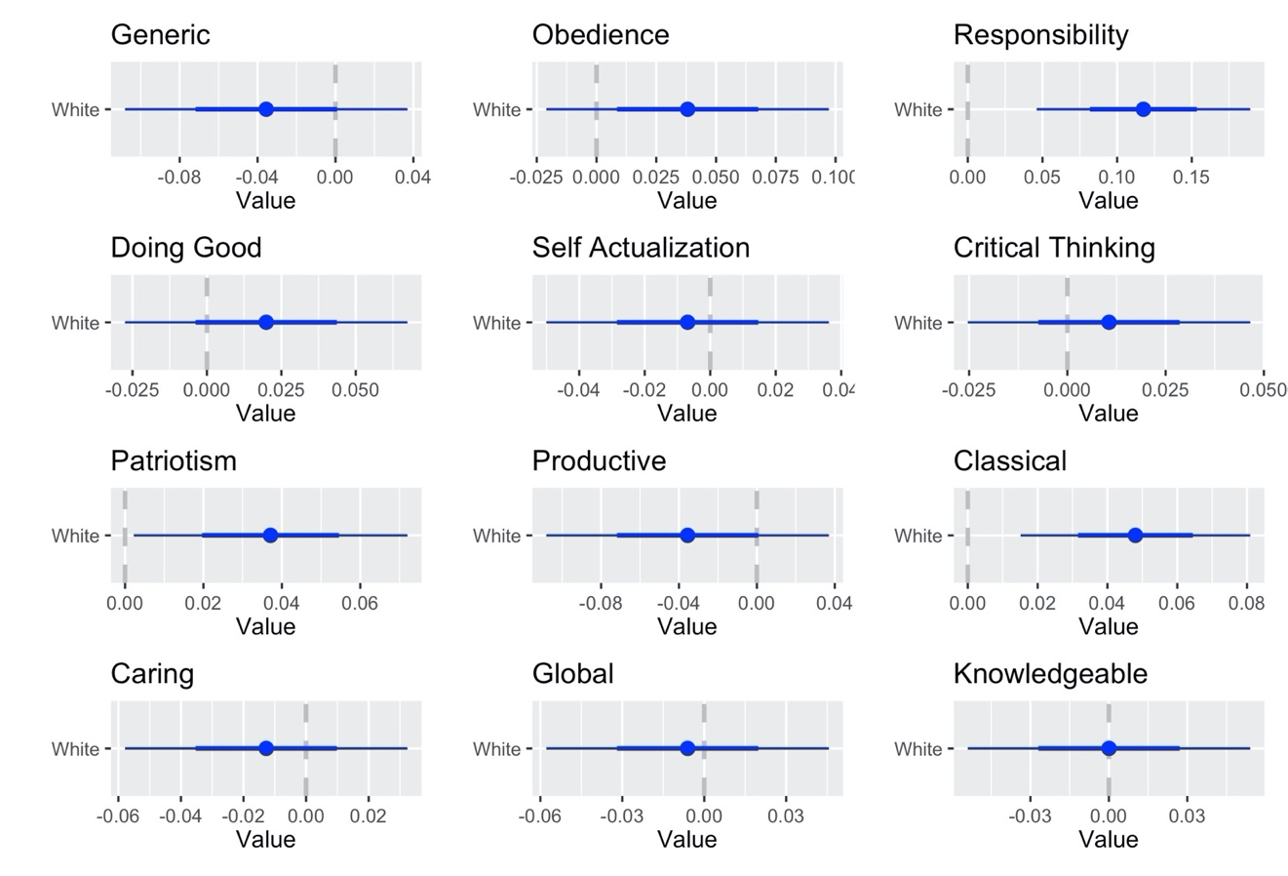
Figure D.1: Coefficient Plots- All Variables when White and Non-White >50%

Table D.3: Regression Table when White and Non-White >50%
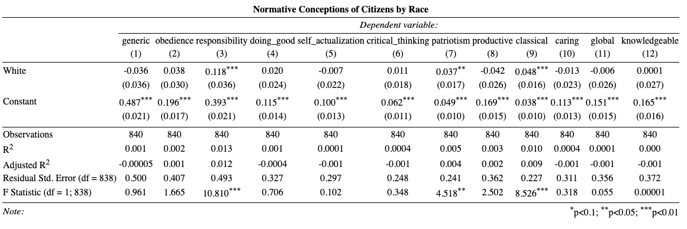

Figure D.2: Coefficient Plots: All Variables when White and Non-White >70%

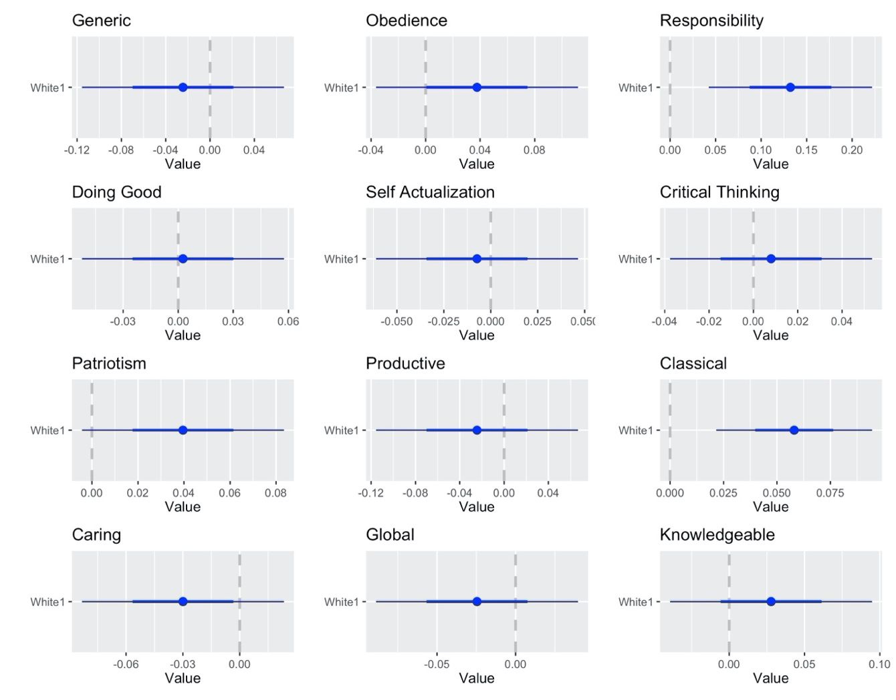

Table D.4: Regression Table when White and Non-White > 70%
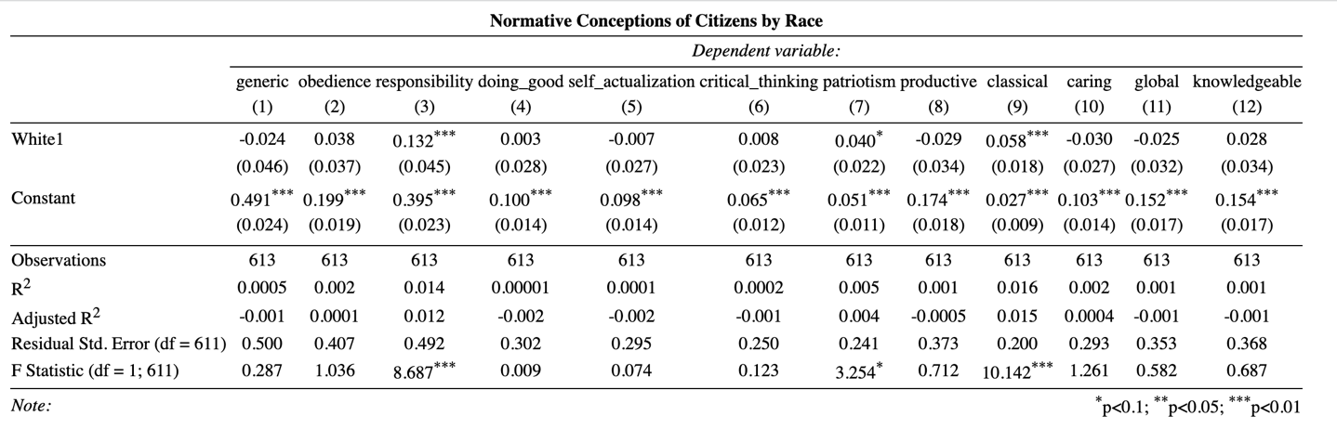

Appendix E: Supplementary Class Analysis

As noted in the paper, we control for class in instances of both word frequency and citizenship discussions in order to better isolate the effects of race despite our concerns about the available data. We present our findings below and offer some additional analysis beyond what we present in the paper.

Figure E.1: Word Frequency in Majority Non-White Schools (>70%) by Free or Reduced-Price (FRL) Percentage
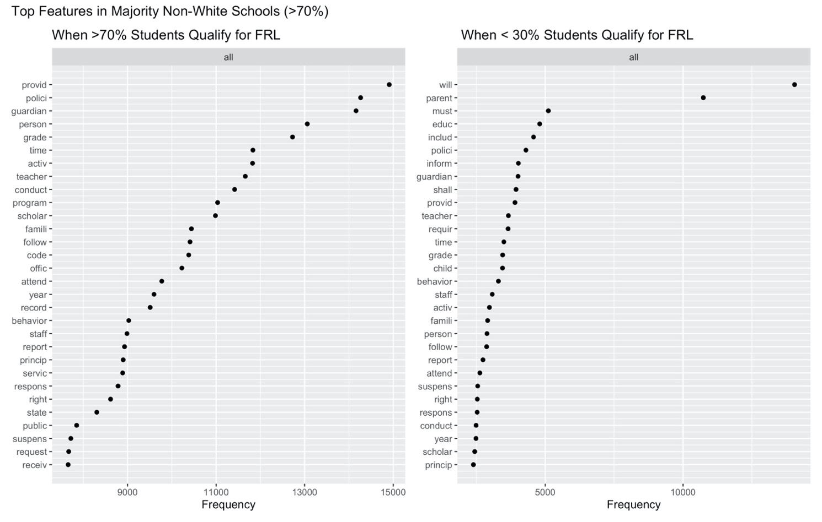
Here we note that regardless of the percentage of students who qualify for free or reduced-price lunch, majority non-White schools continue to deploy disciplinary language, with the terms conduct, behavior, and the roots of suspension and principal appearing in both lists.

We repeat this analysis for schools where a majority of students are White. In this instance, we had to draw the free or reduced-price lunch lines at 50% since only 9 schools that were 70% White also had 70% or more students qualify for free or reduced-price lunch. Even when drawing this line at half of the student body qualifying for lunch assistance, we only have 18 White schools in the sample. Even so, we report our results below in figure E.2. We note no substantive differences in the language of White schools, regardless of the percentage of students who qualify for free and reduced-price lunch. Additionally, we find very few disciplinary terms. While “Conduct” appears in the top 30 terms when 50% or more students qualify for free or reduced-price lunch and “Behavior” appears when 50% or less students qualify for free or reduced-price lunch, these disciplinary terms appear in isolation and near the end of the list of most frequent terms.

Figure E.2: Word Frequency in Majority White Schools (>70%) by FRL Percentage
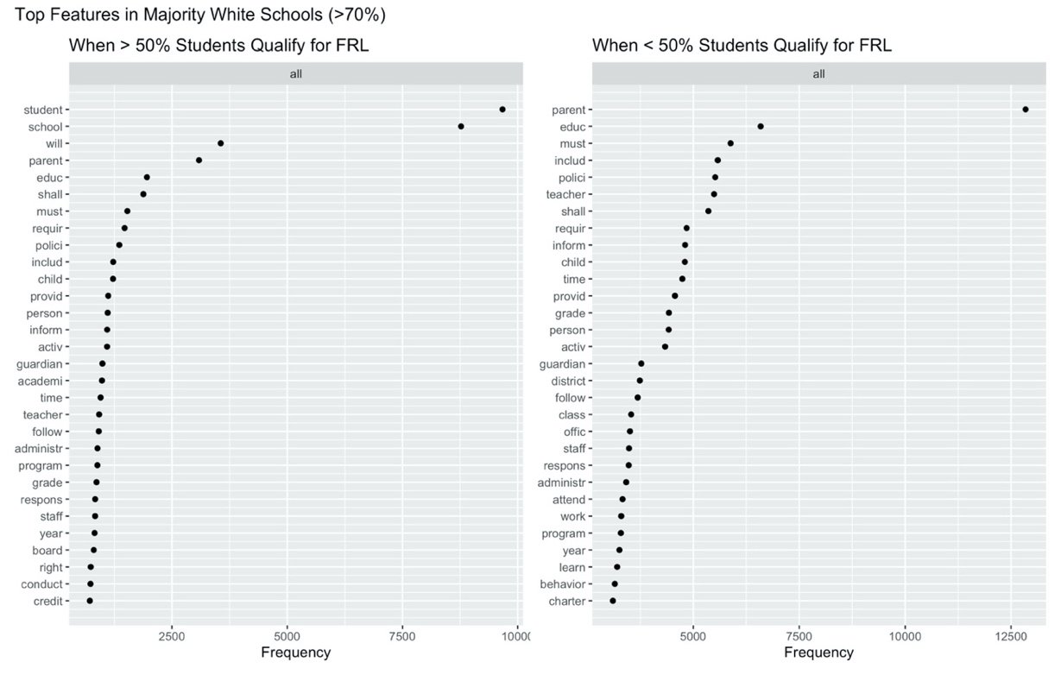
Finally, a visual comparison of racial differences while holding class constant rounds out this analysis. To preserve a large enough N, we isolate schools where 30% or less of students qualify for free or reduced-price lunch (FRL). We then subset this group by race (N=81 majority non-White schools and N=103 majority White schools). The term behavior appears as the single disciplinary term in majority White schools. Meanwhile, majority non-White schools show a pattern of disciplinary language, with behavior, suspens*, princip*, and conduct all appearing as top terms.

Figure E.3: Word Frequency- < 30% of Students Qualify for FRL
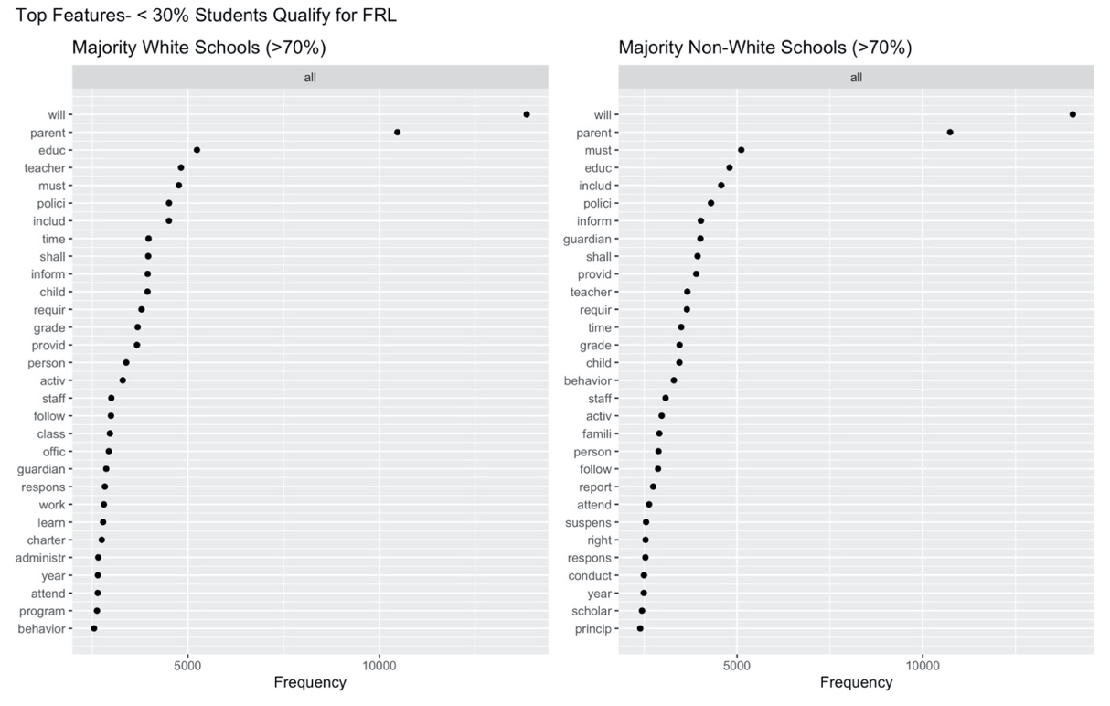

We repeat these imperfect class controls for our second dataset where we coded for explicit discussions of citizenship. Here, we isolate the data by race (70% majority non-White or majority White students). We then subset those data frames by the percentage of students who qualify for free or reduced-price lunch. For consistency, we use the 50% mark to ensure we include enough majority-White schools in our sample. We do not find any substantive or statistically significant differences in the ways that majority non-White schools conceive of citizenships, regardless of the number of students who qualify for free or reduced-price lunch.

Figure E.4: Majority Non-White and White Schools by FRL Qualification
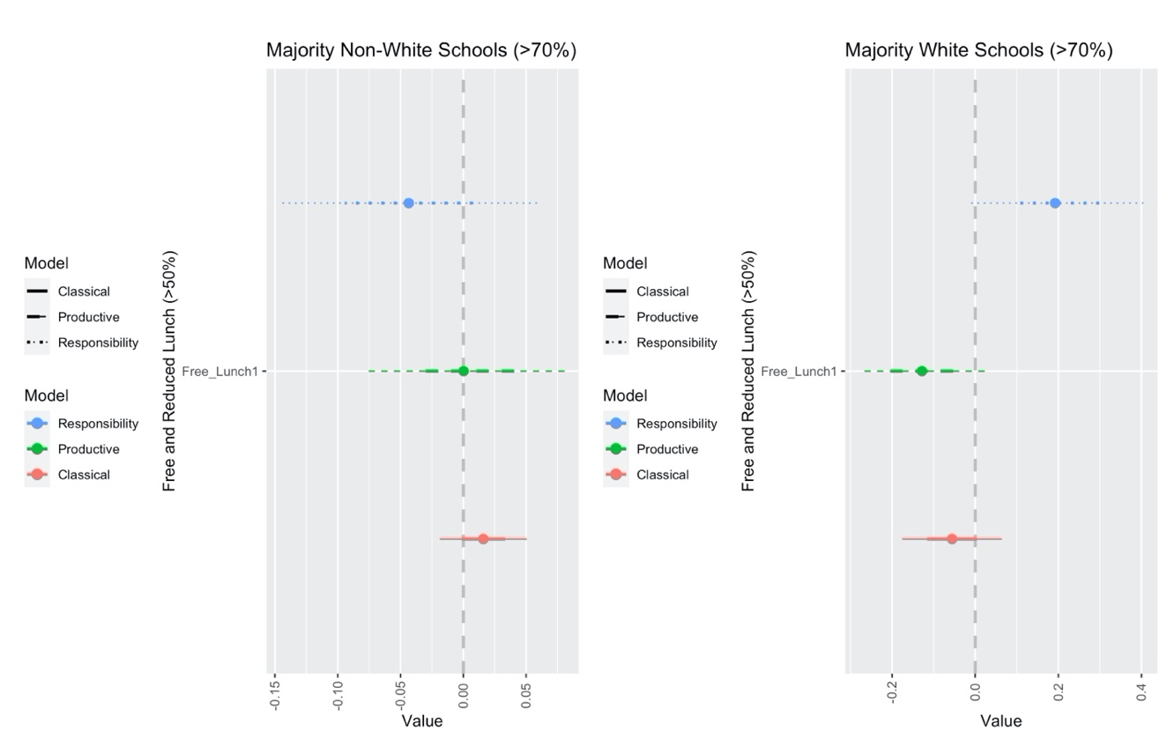
When we use the available data to hold the percentage of students who qualify for free or reduced-priced lunch constant at 30% or less or 70% or more, we find interesting results. When 30% or less of students in the school qualify for free or reduced-price lunch, White schools remain significantly more likely to discuss citizenship in terms of classical education. However, we no longer find statistically significant differences in how often schools conceive of citizenship in terms of responsibility or productivity. However, we would again caution against drawing any formal conclusions from this data and would suggest this as an area for further analysis,
Meanwhile, when we isolate schools where 70% or more of students qualify for free or reduced-price lunch, responsibility and productivity remain significantly different depending on the racial makeup at the school. Classical education does not. In fact, only 3% of mentions of citizenship in majority White schools in this category discuss citizenship as classical democracy or as classical education, a marked departure from the 9% we see when we consider all non-White schools. However, to generate a large enough N for majority White schools, we had to use a simple majority, and, even then, have only 32 observations in this group. We take this result to indicate an interesting area for further analysis.

Figure E.5: Free and Reduced-Price Lunch Qualification by Race
