S8. BDS model performance characteristics for each sub cohort.

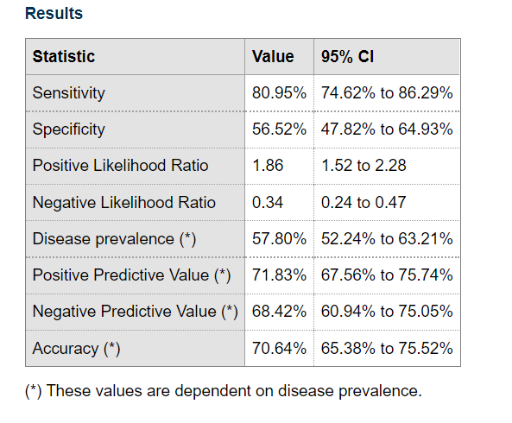
Figure S8A BDS model performance characteristics for MOTAR. BDS score criterium is set on > -0.5. the balanced accuracy rate is 0,69.

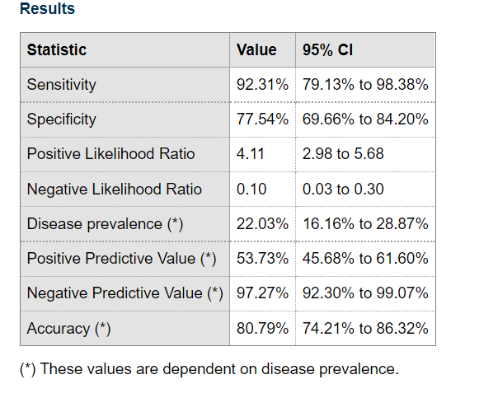
Figure S8B. BDS model performance characteristics for tPEMF. Bds score criterium is set on >1,5. The balanced accuracy of rate is 0.85

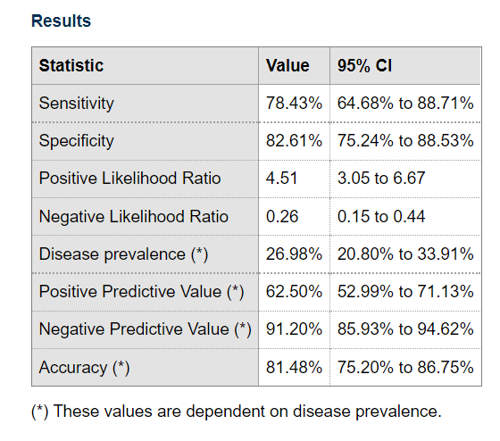
Figure S8C. BDS model performance characteristics for Pidon/Vilnius. BDS score criterium is set on >0.5. The balanced accuracy rate is 0,81.
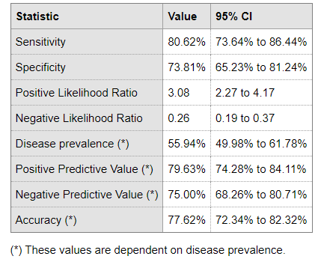
Figure S8D. BDS model performance characteristics for total cohort. BDS score criterium is set on >2.5. the balanced accuracy rate 0,77.

