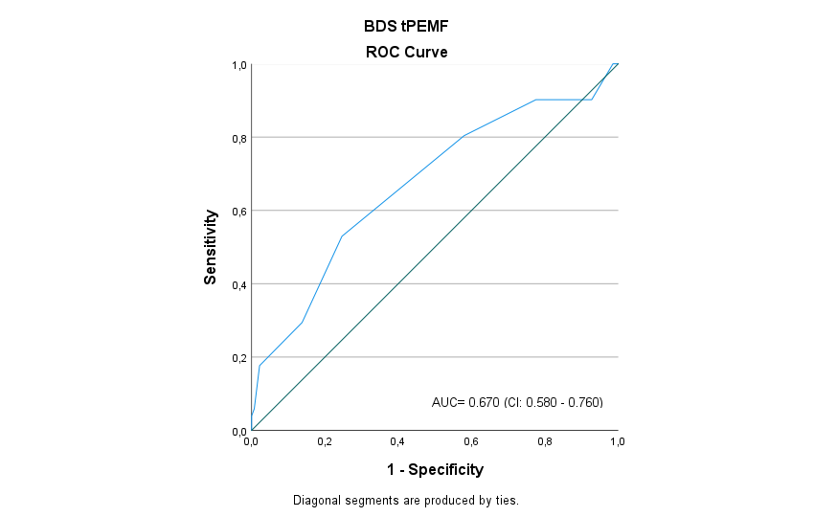
Fig. S6a. ROC curve of BDS tPEMF. ROC curve of BDS for the tPEMF cohort determined based on the internal-external validation.

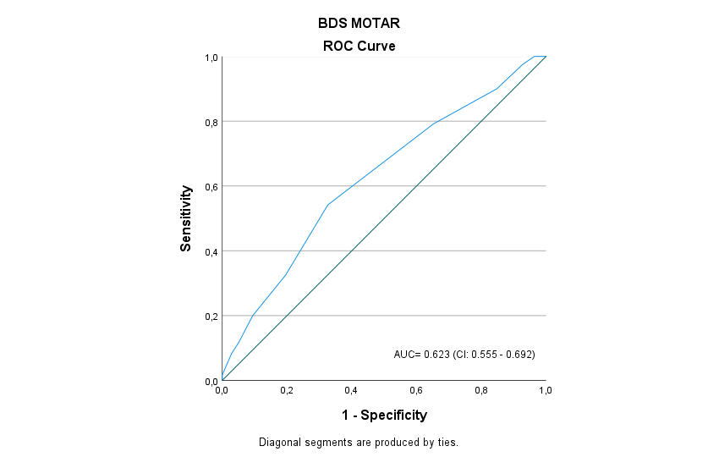
Fig. S6b.ROC curve for BDS MOTAR. ROC curve of BDS for the MOTAR cohort determined based on the internal-external validation.

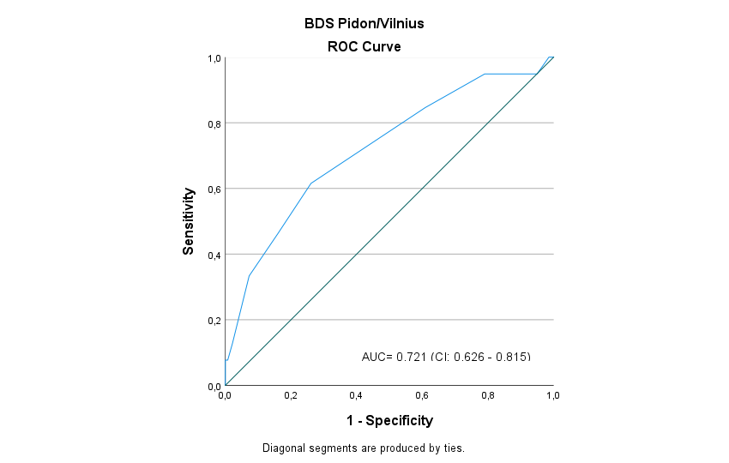
Fig. S6c. ROC curve BDS Pidon/Vilnius. ROC curve of BDS for the Pidon/Vilnius cohort determined based on the internal-external validation.

