Supplementary table 1. Distribution of klotho levels between groups
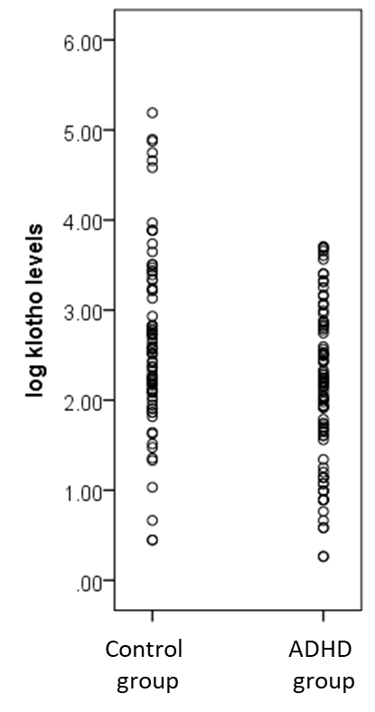
ADHD: attention deficit hyperactivity disorder

