Psychotropic Medication Prescribing for Patients with Insomnia Comorbid with Depression or Anxiety Disorder in Primary Healthcare Facilities in Beijing

Supplement
eFigure 1. Study Flow Diagram
eTable 1. List and Classification of Psychotropic Medications according to the Anatomical Therapeutic Chemical (ATC) classifications and Related Clinical Guidelines
eTable 2. Key Recommendations from Chinese Clinical Guidance

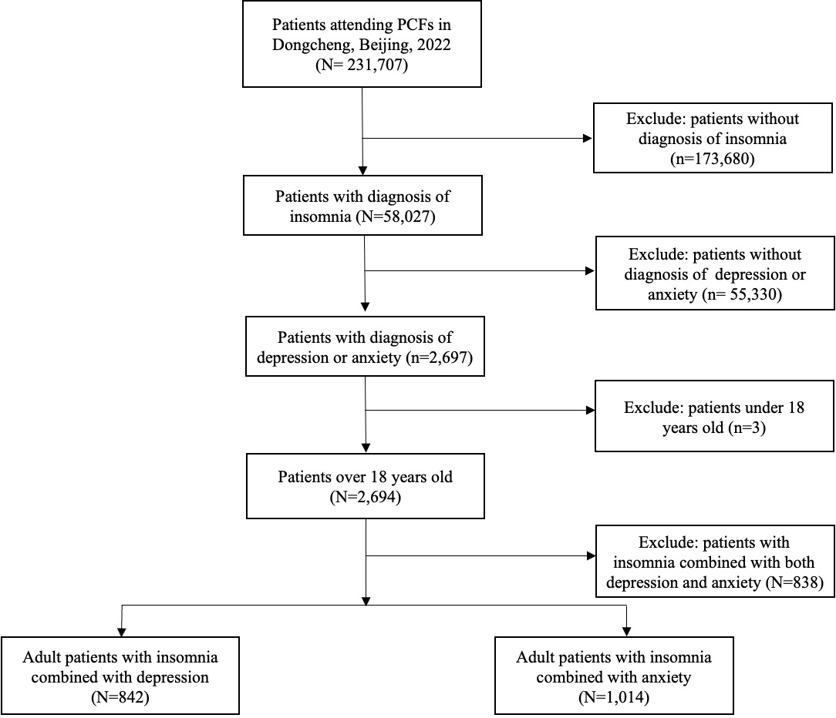

eFigure 1. Study Flow Diagram

eTable 1. List and Classification of Psychotropic Medications according to the Anatomical Therapeutic Chemical (ATC) classifications and Related Clinical Guidelines
Classification | Medications
Hypnotics and Sedatives and Other Anxiolytics | Benzodiazepines: Alprazolam, Clonazepam, Diazepam, Estazolam, Flurazepam, Lorazepam, Midazolam, Nitrazepam, Oxazepam, Quazepam, Temazepam, Triazolam  Nonbenzodiazepine, benzodiazepine receptor agonist hypnotics: Eszopiclone, Zopiclone, Zaleplon, Zolpidem  Other anxiolytics: Hydroxyzine, Buspirone, Tandospirone
Antidepressants | Selective serotonin reuptake inhibitors: Citalopram, Escitalopram, Fluoxetine, Fluvoxamine, Paroxetine, Sertraline  Serotonin and Noradrenalin Reuptake Inhibitors: Duloxetine, Milnacipran, Venlafaxine  Tricyclicantidepressants: Amitriptyline, Doxepin, Imipramine  Monoamine oxidase A inhibitor: Moclobemide  Other antidepressants: Agomelatine, Bupropion, Mirtazapine*, Maprotiline, Mianserin, Riboxetine, Tianeptine, Trazodone*, Vortioxetine, Flupentixol-melitracen
Antipsychotics | Aripiprazole, Asenapine, Chlorpromazine, Clozapine, Droperidol, Fluphenazine, Haloperidol, Iloperidone, Loxapine, Lurasidone, Olanzapine, Paliperidone, Perphenazine, Pimozide, quetiapine, Risperidone, Sulpiride, Thioridazine, Thiothixene, Trifluoperazine, Ziprasidone
Fixed-dose combination | Flupentixol/melitracen
* Antidepressant with sedative effects.

eTable 2. Key Recommendations from Chinese Clinical Guidance
Condition | Guideline recommendation | Pharmacotherapy | Our mapping in analyses
Insomnia comorbid depressive disorder | CBT-I is first-line for chronic insomnia; initiate antidepressants for moderate to severe depression; when insomnia is prominent, consider agents with sedative properties; BZDs/non-BZDs used short-term only; avoid long-term BZDs/non-BZDs use. | SSRIs/SNRIs as first-line; NaSSA (i.e., mirtazapine)/SARI (trazodone) as alternatives/adjuncts; BZDs/non-BZDs as short-term adjuncts. | Recommended: SSRI/SNRI/NaSSA/SARI. Conditional recommended: BZDs/non-BZDs adjunct.
Insomnia comorbid anxiety disorder | Disorder-specific CBT first-line for mild; pharmacotherapy (SSRIs/SNRIs) for moderate to severe; BZDs/non-BZDs may be used short-term as adjuncts for acute anxiety/insomnia; avoid long-term BZDs/non-BZDs use. | SSRIs/SNRIs as first-line for moderate to severe; BZDs/non-BZDs as short-term adjuncts. | Recommended: SSRI/SNRI NaSSA/SARI. Conditional recommended: short-term BZDs/non-BZDs adjunct.
Insomnia + depression + anxiety (tri-morbid) | Guidance emphasizes individualized treatment addressing both psychiatric disorders and insomnia; CBT-I + antidepressant ± anxiolytic/hypnotic may be tailored to symptom profile and risk. | No single uniform algorithm; short-term BZDs/non-BZDs adjuncts may be used cautiously; prioritize antidepressants for depression or anxiety. | No analyses.
- “Short-term” refers to brief, adjunctive use during the acute phase (e.g., typically ≤4 weeks) with tapering plans; prolonged or continuous use beyond this window is treated as long-term in our classification.
- CBT-I/CBT recommendations are summarized here for context; psychotherapy was not observed in the EHR and not used for classification.
Abbreviations. CBT-I, cognitive behavioral therapy for insomnia; CBT, cognitive behavioral therapy; SSRI, selective serotonin reuptake inhibitor; SNRI, serotonin-noradrenaline reuptake inhibitor; NaSSA, noradrenergic and specific serotonergic antidepressant; SARI, serotonin antagonist and reuptake inhibitor; BZD, benzodiazepine.

