S-Figure 1. Study procedure flow diagram
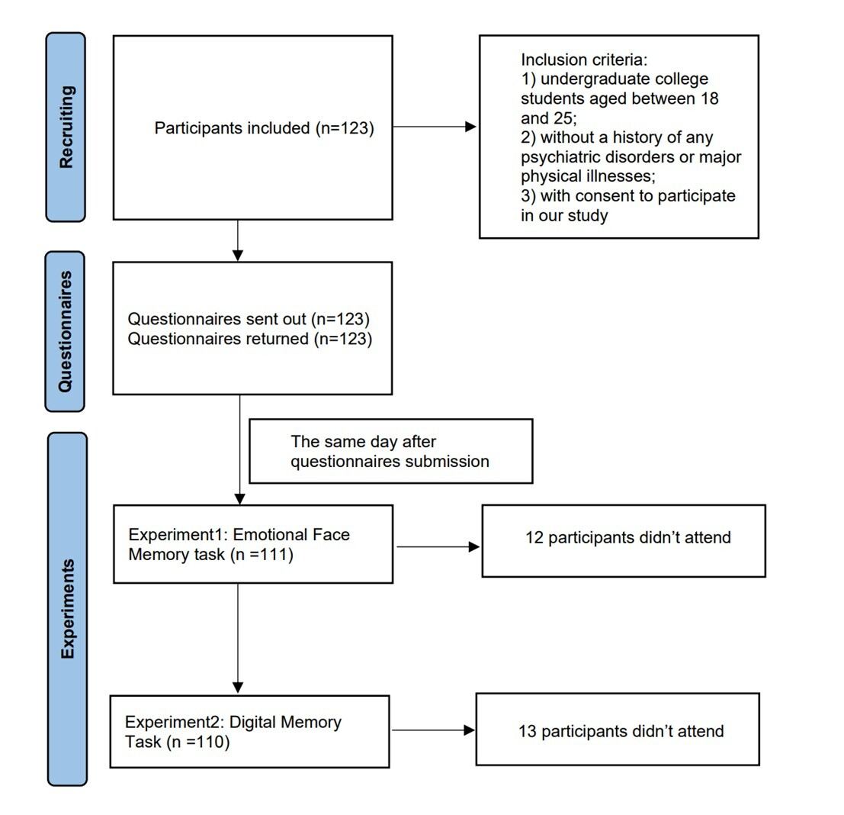

S-TABLE 1 | Descriptive statistics of demographic characteristics
 | Experiment1 |  |  | Experiment2 |  |  | Both  Experiments |  |  | Statistics
 | N/Average±  SD | (%) |  | N/Average±  SD | (%) |  | N/Average±  SD | (%) |  | F/X² | P
Sex |  |  |  |  |  |  |  |  |  | .403 | .817
Male | 35 | 31.8 |  | 36 | 32.4 |  | 35 | 35.7
Female | 75 | 68.2 |  | 75 | 67.6 |  | 63 | 64.3
Age(years) | 19.96 ± 1.30 |  |  | 19.96 ± 1.32 |  |  | 20.00 ± 1.33 |  |  | .032 | .968
Grade |  |  |  |  |  |  |  |  |  | .375 | .999
Freshman | 26 | 23.6 |  | 26 | 23.4 |  | 23 | 23.5
Sophomore | 51 | 46.4 |  | 50 | 45.1 |  | 45 | 45.9
Junior | 14 | 12.7 |  | 15 | 13.5 |  | 11 | 11.2
Senior | 19 | 17.3 |  | 20 | 18.0 |  | 19 | 19.4
Major |  |  |  |  |  |  |  |  |  | .065 | .968
Science & Engineering | 40 | 36.4 |  | 39 | 35.1 |  | 36 | 36.7
Other Majors | 70 | 63.6 |  | 72 | 64.9 |  | 62 | 63.3

S-TABLE2｜Hierarchical linear regression analysis of Task1 of negative face memory accuracy (Continued)
Factors | Model5 |  |  |  | Model6 |  |  |  | Model7
 | β | T | P |  | β | T | P |  | β | T | P
Age  Grade  Sex  DAS-A  RRS  CESD  R²  F  P | .335  -.182  -.040  -.154  -.118 | 1.917  -1.001  -.423  -1.426  -1.069 | .058  .319  .673  .157  .287  .107  2.503  .035 |  | .324  -.163  -.045  -.169  -.102 | 1.852  -.908  -.476  -1.635  -.991 | .067  .366  .635  .366  .105  .098  2.839  .037 |  | .330  -.184  -.044  -.141  -.089  -.070 | 1.880  -1.010  -.462  -1.289  -.742  -.625 | .063  .315  .645  .200  .460  .533  .111  2.139  .055

S-Figure 2. The relation of rumination/dysfunctional attitude to negative face memory accuracy
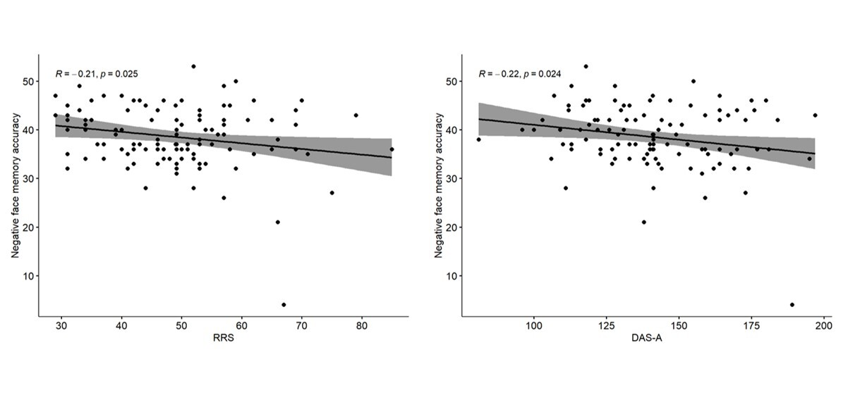
(RRS, Rumination Responses Scale; DAS-A, Dysfunctional Attitude Scale Form A.)

S-Figure 3. The relation of rumination/mind-wandering to digit memory accuracy

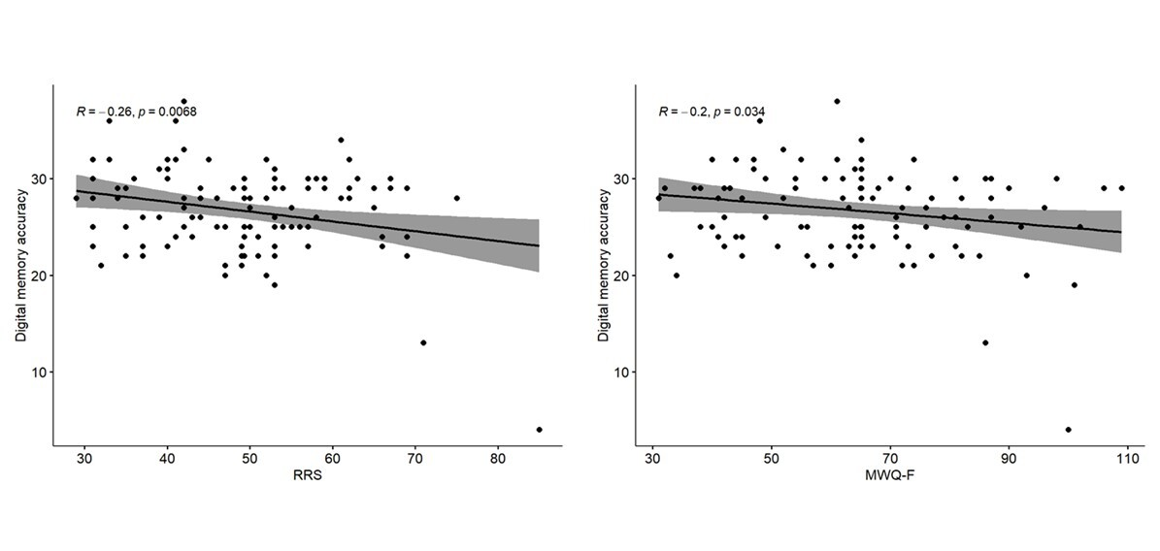 (RRS, Rumination Responses Scale; MWQ-F, Mind Wandering Frequency Scale)

