Mental Health Intervention for Children with Epilepsy (MICE): Cost-effectiveness analysis of psychological therapy in addition to usual care compared to assessment-enhanced usual care alone for children and young people with epilepsy and common mental health disorders

Supplement

Exclusion criteria
Exclusion criteria included: not speaking/understanding English well enough to complete screening assessments; having an intellectual disability at a level that precluded access to the measures and/or intervention; screening results indicating a severe mental health disorder not considered suitable for the trial intervention; actively receiving, or due to receive during the study period, intensive psychological input focused on cognitive and/or behavioural strategies to address emotional or behavioural difficulties; refusing to consent to the research team contacting their GP/other relevant health professionals about their participation in the research; refusing to have the trial therapy sessions audio and/or video recorded; unable to complete the screening measures (SDQ and DAWBA).

Unit costs
Unit costs are summarised in Table S1. Unit costs for hospital contacts were obtained from NHS reference costs.¹ Unit costs for community-based services, as well as accommodation provided by Local Authorities, were obtained from an annual compendium of unit costs of health and social care.² The costs of medications were based on prices listed in the British National Formulary for Children³ and Prescription Cost Analysis data (NHS Business Services Authority Statistics).⁴

Table S1: Unit costs
Service | Unit cost (£) | Source
Hospital services
Inpatient - Epilepsy | 922.55 | 1
Inpatient - Mental health | 1066.25 | 1
Inpatient - Other | 1159.48 | 1
Outpatient - Epilepsy | 308.00 | 1
Outpatient - Mental health | 373.60 | 1
Outpatient - Other | 258.00 | 1
Accident emergency | 188.77 | 1
Ambulance | 292.09 | 1
Community services
General practitioner | 39.23 | 2
Nurse | 21.00 | 2
Community paediatrician | 76.45 | 1
Psychiatrist | 131.74 | 1
CAMHS | 254.90 | 1
Clinical psychologist | 55.57 | 1
Counsellor | 51.00 | 1
Art therapy | 90.00 | 2
Occupational therapy | 93.00 | 2
Family therapy | 93.00 | 2
Dietician | 92.00 | 2
Social worker | 23.00 | 2
Youth worker | 23.00 | 2
Family support worker | 23.00 | 2
Inclusion worker | 23.00 | 2
Education psychologist | 51.00 | 2
Speech and language therapy | 84.00 | 2
Physiotherapist | 94.00 | 2
Local authority accommodation
Foster care | 94.43 | 2
Residential care | 721.00 | 2
Respite care | 467.00 | 2
CAMHS=Child and Adolescent Mental Health Services
1 National Cost Collection: National Schedule of NHS costs, 2019-20
2 Personal Social Services Research Unit (PSSRU) Unit Costs of Health and Social Care 2021

Table S2: Intervention cost
Cost for | Cost per session | Source | Notes
Delivery | 77.90 | PSSRU | Based on cost per working hour of Band 5 clinical staff and direct to indirect ratio of 0.9
Supervision* | 2.04 | PSSRU | Based on average cost per working hour of Band 7 and Band 8a clinical staff, and on assumption that supervisors provide three hours of supervision each week during period of intervention delivery
Training* | 0.47 | Trial data | Based on costs of initial training (five-day face-to-face workshop delivered to groups of 1-4 health professionals (minimum NHS Band 5/graduate level)) and ongoing consultations with developers of the intervention, and on assumption that training is valid for three years and therapists deliver the same number of sessions each year
Total | 80.41
PSSRU=Personal Social Services Research Unit: Unit Costs of Health and Social Care 2021
More detailed description of the training and supervision approach is provided in Coughtrey et al. (2024)⁵

Table S3: Baseline characteristics
Participant characteristics | MICE  (N=166) | Control  (N=168)
Age (years); mean (SD) | 10.5 (3.6) | 10.3 (4.0)
Age (years); n (%)
<11 | 99 (59.6) | 101 (60.1)
11 or more | 67 (40.4) | 67 (39.9)
Gender; n (%)
Female | 81 (48.8) | 87 (51.8)
Male | 85 (51.2) | 81 (48.2)
Ethnicity; n (%)
White or White British | 122 (73.5) | 116 (69.0)
Mixed | 18 (10.8) | 18 (10.7)
Asian or Asian British | 11 (6.6) | 12 (7.1)
Black or Black British | 7 (4.2) | 16 (9.5)
Other ethnic groups | 4 (2.4) | 5 (3.0)
Did not disclose | 4 (2.4) | 1 (0.6)
Socio economic status; n (%)
Most deprived 20% | 17 (11.0) | 23 (14.4)
20 - 40% | 42 (27.1) | 40 (25.0)
40 - 60% | 38 (24.5) | 40 (25.0)
60 - 80% | 20 (12.9) | 24 (15.0)
Least deprived 20% | 38 (24.5) | 33 (20.6)
Primary mental health disorder; n (%)
Anxiety | 66 (39.8) | 67 (39.9)
Depression | 7 (4.2) | 9 (5.4)
Disruptive behaviour | 93 (56.0) | 92 (54.8)
SDQ Total Difficulties; mean (SD) | 23.0 (5.2) | 23.5 (5.4)
CHU9D; mean (SD) | 0.80 (0.12) | 0.78 (0.13)
Caregiver EQ-5D-5L; mean (SD) | 0.80 (0.22) | 0.78 (0.25)
Costs 3-months prior to trial entry; mean (SD) | 1601.84 (2200.70) | 2075.98 (3124.56)

Table S4: Data completeness for the economic evaluation
 | MICE  N (%) | Control  N (%)
Baseline
Service use | 166 (100%) | 168 (100%
SDQ | 166 (100%) | 168 (100%)
CHU9D | 166 (100%) | 168 (100%)
EQ-5D-5L | 166 (100%) | 168 (100%)
6-month follow-up
Service use | 136 (82%) | 144 (86%)
SDQ | 160 (96%) | 158 (94%)
CHU9D | 131 (79%) | 126 (75%)
EQ-5D-5L | 130 (78%) | 126 (75%)
12-month follow-up
Service use | 138 (83%) | 139 (82%)
SDQ | 153 (92%) | 153 (91%)
CHU9D | 134 (80%) | 124 (74%)
EQ-5D-5L | 134 (80%) | 124 (74%)
Overall
Primary analysis: SDQ at 12-months | 128 (77%) | 133 (79%)
Secondary analysis: SDQ at 6-months | 136 (82%) | 143 (85%)
Secondary analysis: CHU9D at 12-months | 115 (69%) | 105 (63%)
Secondary analysis: EQ-5D-5L at 12-months | 114 (69%) | 106 (63%)
Secondary analysis: CHU9D + EQ-5D-5L at 12-months | 113 (68%) | 105 (63%)

Table S5: Hospital and community health and social care service use over the 12-month follow-up period
Service | MICE  (N=128) |  |  |  | Control  (N=133)
 | N | Mean (SD) | Range | % using | N | Mean (SD) | Range | % using
MICE intervention
Total sessions | 128 | 18.23 (3.90) | 2 - 23 | 100% | n/a | n/a | n/a | n/a
Intervention sessions | 128 | 16.50 (3.65) | 2 - 21 | 100% | n/a | n/a | n/a | n/a
Booster sessions | 116 | 1.73 (0.62) | 0 - 2 | 90% | n/a | n/a | n/a | n/a
Hospital services
Inpatient – Epilepsy | 25 | 0.77 (2.00) | 0 - 10 | 20% | 28 | 0.82 (2.28) | 0 - 17 | 21%
Inpatient - Mental health | 1 | 0.01 (0.09) | 0 - 1 | 1% | 0 | 0.00 (0.00) | 0 | 0%
Inpatient – Other (not specified) | 17 | 0.41 (1.52) | 0 - 12 | 13% | 33 | 1.05 (3.49) | 0 - 22 | 25%
Outpatient – Epilepsy | 107 | 2.97 (3.50) | 0 - 28 | 84% | 113 | 3.82 (5.98) | 0 - 58 | 85%
Outpatient - Mental health | 15 | 0.21 (0.66) | 0 - 3 | 12% | 18 | 0.48 (2.02) | 0 - 18 | 14%
Outpatient – Other (not specified) | 87 | 3.06 (4.95) | 0 - 33 | 68% | 99 | 4.11 (6.48) | 0 - 42 | 74%
Accident & Emergency | 30 | 0.39 (0.86) | 0 - 5 | 23% | 33 | 0.44 (1.33) | 0 - 12 | 25%
Ambulance | 18 | 0.50 (1.55) | 0 - 9 | 14% | 37 | 0.67 (1.49) | 0 - 10 | 28%
Community services
General practitioner | 25 | 0.77 (2.00) | 0 - 10 | 20% | 28 | 0.82 (2.28) | 0 - 17 | 21%
Nurse/school nurse | 93 | 4.22 (8.63) | 0 - 71 | 73% | 96 | 5.18 (13.78) | 0 - 120 | 72%
Community paediatrician | 38 | 0.58 (1.19) | 0 - 9 | 30% | 31 | 0.51 (1.35) | 0 - 10 | 23%
Psychiatrist | 2 | 0.08 (0.63) | 0 - 6 | 2% | 14 | 0.41 (1.78) | 0 - 14 | 11%
CAMHS | 26 | 0.77 (2.34) | 0 - 13 | 20% | 24 | 0.86 (4.12) | 0 - 44 | 18%
Clinical psychologist | 13 | 0.4 (2.31) | 0 - 22 | 10% | 22 | 0.56 (1.87) | 0 - 12 | 17%
Counsellor | 4 | 0.30 (1.98) | 0 - 18 | 3% | 16 | 1.12 (4.29) | 0 - 30 | 12%
Education psychologist | 36 | 1.88 (6.31) | 0 - 43 | 28% | 40 | 1.88 (4.80) | 0 - 27 | 30%
Speech & language therapy | 32 | 4.38 (13.62) | 0 - 85 | 25% | 39 | 3.20 (8.65) | 0 - 56 | 29%
Physiotherapy | 31 | 2.11 (8.17) | 0 - 70 | 24% | 32 | 2.38 (8.10) | 0 - 58 | 24%
Occupational therapy | 32 | 4.56 (16.60) | 0 - 102 | 25% | 33 | 2.11 (7.28) | 0 - 56 | 25%
Art/drama/music/play therapy | 16 | 2.78 (10.61) | 0 - 85 | 13% | 20 | 2.83 (8.42) | 0 - 48 | 15%
Family therapy | 0 | 0.00 (0.00) | 0 | 0% | 2 | 0.39 (4.17) | 0 - 48 | 2%
Dietician | 13 | 0.25 (1.08) | 0 - 10 | 10% | 18 | 0.48 (1.68) | 0 - 15 | 14%
Social worker | 15 | 0.79 (3.79) | 0 - 30 | 12% | 21 | 1.50 (6.77) | 0 - 68 | 16%
Youth worker | 2 | 0.25 (2.05) | 0 - 20 | 2% | 6 | 0.55 (2.89) | 0 - 21 | 5%
Family support worker | 14 | 0.89 (4.01) | 0 - 26 | 11% | 11 | 0.56 (2.57) | 0 - 20 | 8%
Social inclusion worker | 2 | 0.02 (0.12) | 0 - 1 | 2% | 0 | 0.00 (0.00) | 0 | 0%
Foster care | 0 | 0.00 (0.00) | 0 | 0% | 0 | 0.00 (0.00) | 0 | 0%
Residential care | 0 | 0.00 (0.00) | 0 | 0% | 0 | 0.00 (0.00) | 0 | 0%
Respite care | 4 | 0.52 (4.15) | 0 - 45 | 3% | 7 | 0.56 (2.79) | 0 - 22 | 5%
CAMHS=Child and Adolescent Mental Health Services

Table S6: Prescribed medications over the 12-month follow-up period
Medication for | Intervention  (N=128) |  | Control  (N=133)
 | N | % using | N | % using
Epilepsy | 123 | 96% | 122 | 92%
Mental health (anxiety, depression, ADHD) | 8 | 6% | 11 | 8%
Other | 62 | 48% | 61 | 46%
ADHD=attention deficit hyperactivity disorder

Figure S1: Cost-effectiveness plane for SDQ
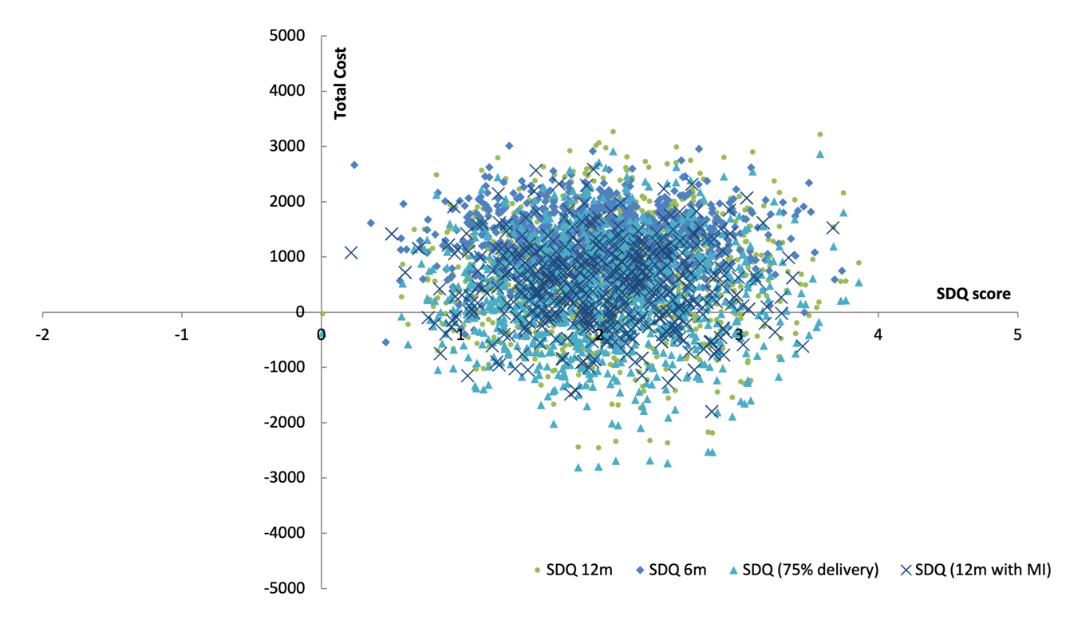

Figure S2: Cost-effectiveness plane for QALYs
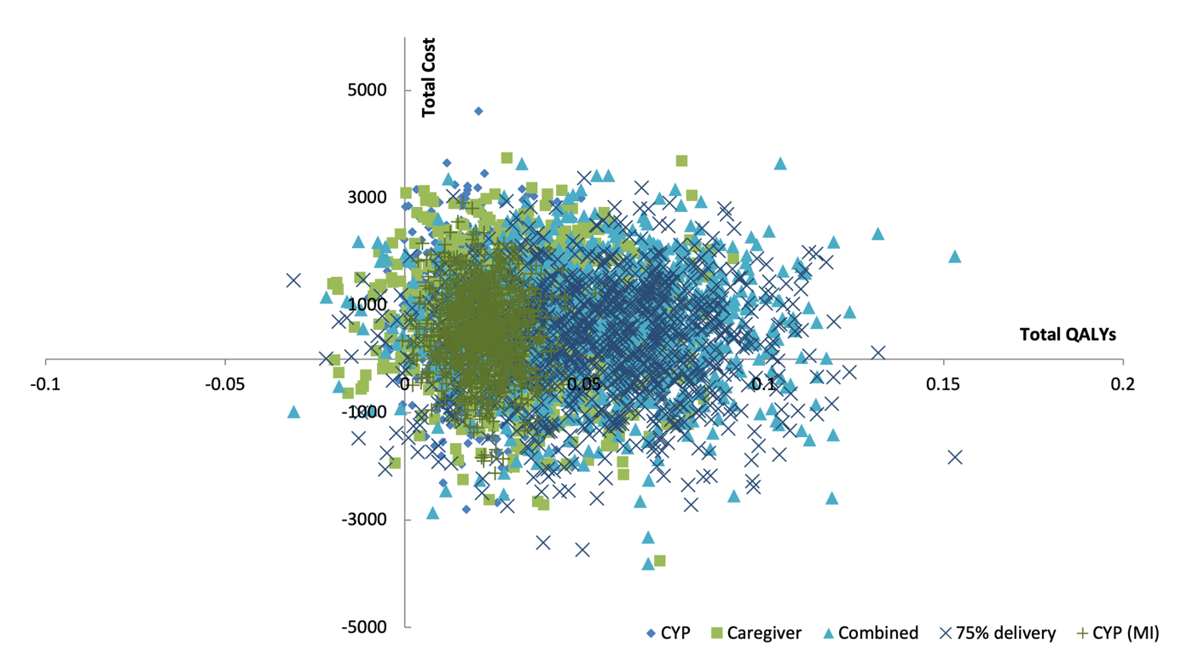

References
1. Department of Health (DH). NHS Reference Costs 2020-21. London DH, 2021.
2. Jones K, Burns A. Unit Costs of Health and Social Care 2021. Personal Social Services Research Unit: University of Kent, Canterbury, 2021.
3. Royal Pharmaceutical Society of Great Britain. British National Formulary for Children. 2021. https://about.medicinescomplete.com/publication/british-national-formulary-for-children/.
4. NHS Business Services Authority Statistics. Prescription Cost Analysis - England 2021. 2021. https://www.nhsbsa.nhs.uk/statistical-collections/prescription-cost-analysis-england/prescription-cost-analysis-england-2020-21.
5. Coughtrey AE, Bennett SD, Stanick C, et al. Training and supervision of physical health professionals to implement mental health care in paediatric epilepsy clinics. Epilepsy & Behavior 2024; 157: 109905.

