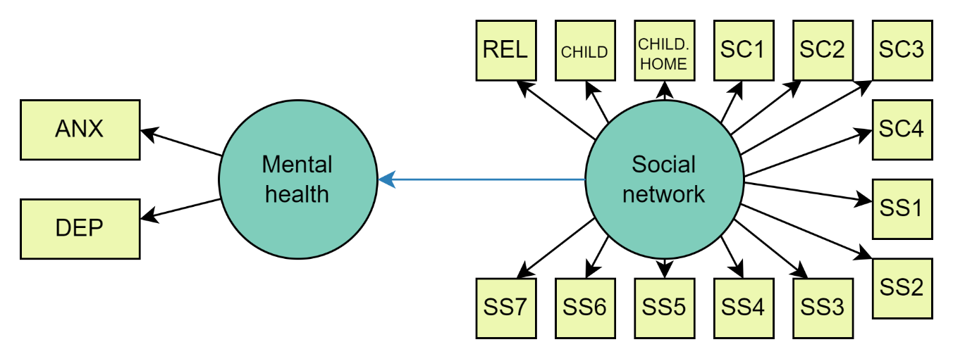
Supplementary Figure 1. Hypothesized cross-sectional structural equation model. ANX = anxiety symptoms; DEP = depressive symptoms; REL = relationship status; CHILD = children; CHILD. HOME = children living at home; SC1 = phone contact; SC2 = social media contact; SC3 = in-person contact; SC4 = left home; SS1 = emotional support from family; SS2 = emotional support from a specific person; SS3 = feeling safe at home; SS4 = family closeness; SS5 = perceived warmth or love from others; SS6 = increased societal cohesion; SS7 = feeling helpful during a crisis.

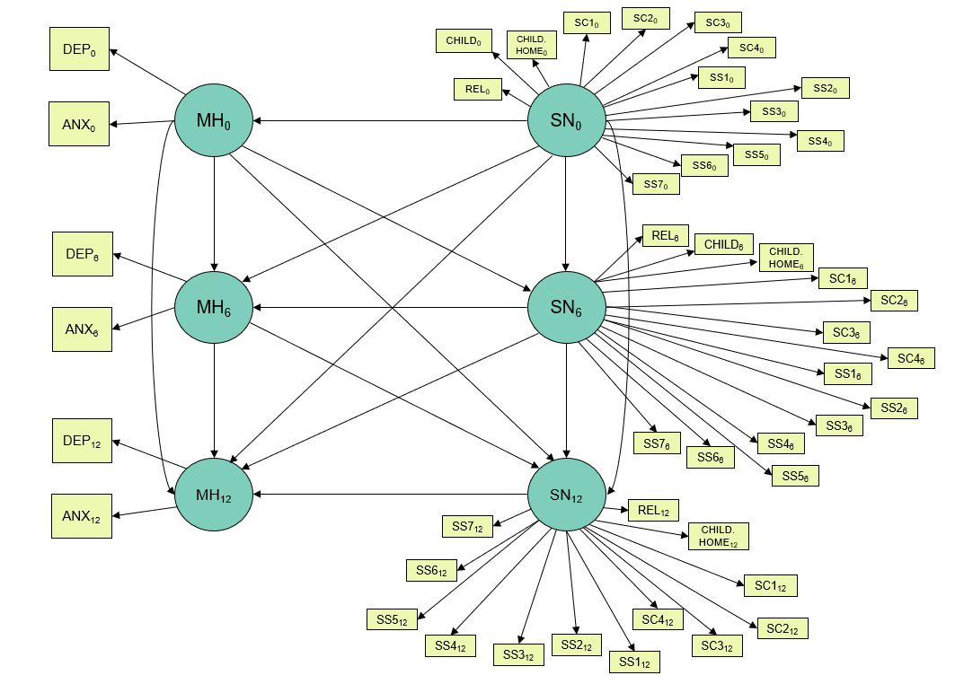
Supplementary Figure 2. Hypothesized cross-lagged panel model at baseline (0), six-month follow-up (6), and 12-month follow-up (12). ANX = anxiety symptoms; DEP = depressive symptoms; MH = mental health; SN = social network; REL = relationship status; CHILD = children; CHILD. HOME = children living at home; SC1 = phone contact; SC2 = social media contact; SC3 = in-person contact; SC4 = left home; SS1 = emotional support from family; SS2 = emotional support from a specific person; SS3 = feeling safe at home; SS4 = family closeness; SS5 = perceived warmth or love from others; SS6 = increased societal cohesion; SS7 = feeling helpful during the crisis.

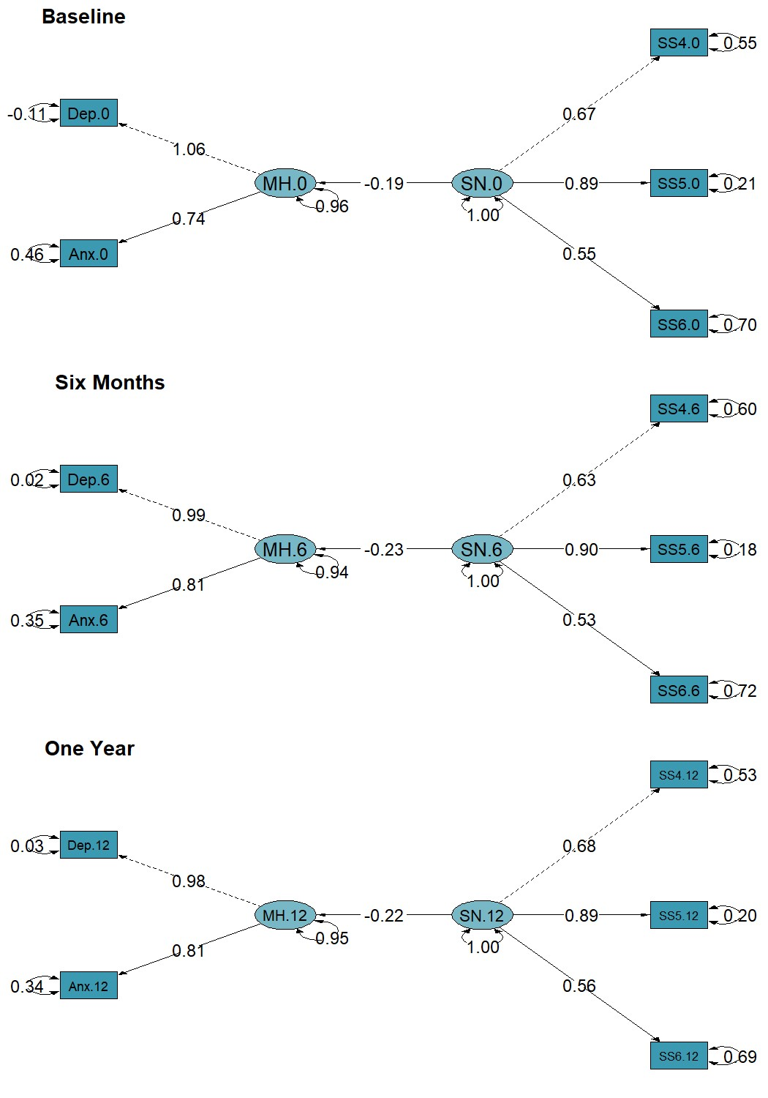
Supplementary Figure 3. Path diagrams of unadjusted cross-sectional models at baseline (0), six-month follow-up (6), and one-year follow-up (12). ANX = anxiety symptoms; DEP = depressive symptoms; MH = mental health; SN = social network; SS4 = family closeness; SS5 = perceived warmth or love from others; SS6 = increased societal cohesion. Dashed lines indicate paths from latent variables to the first observed endogenous variables, which are set to a normalization constraint of 1.00; solid lines indicate other regression paths between latent variables SN and MH, as well as regression paths between latent variables and observed variables. Two-headed curved arrows indicate the standardized variance for each observed variable. All paths presented in the diagram are statistically significant.

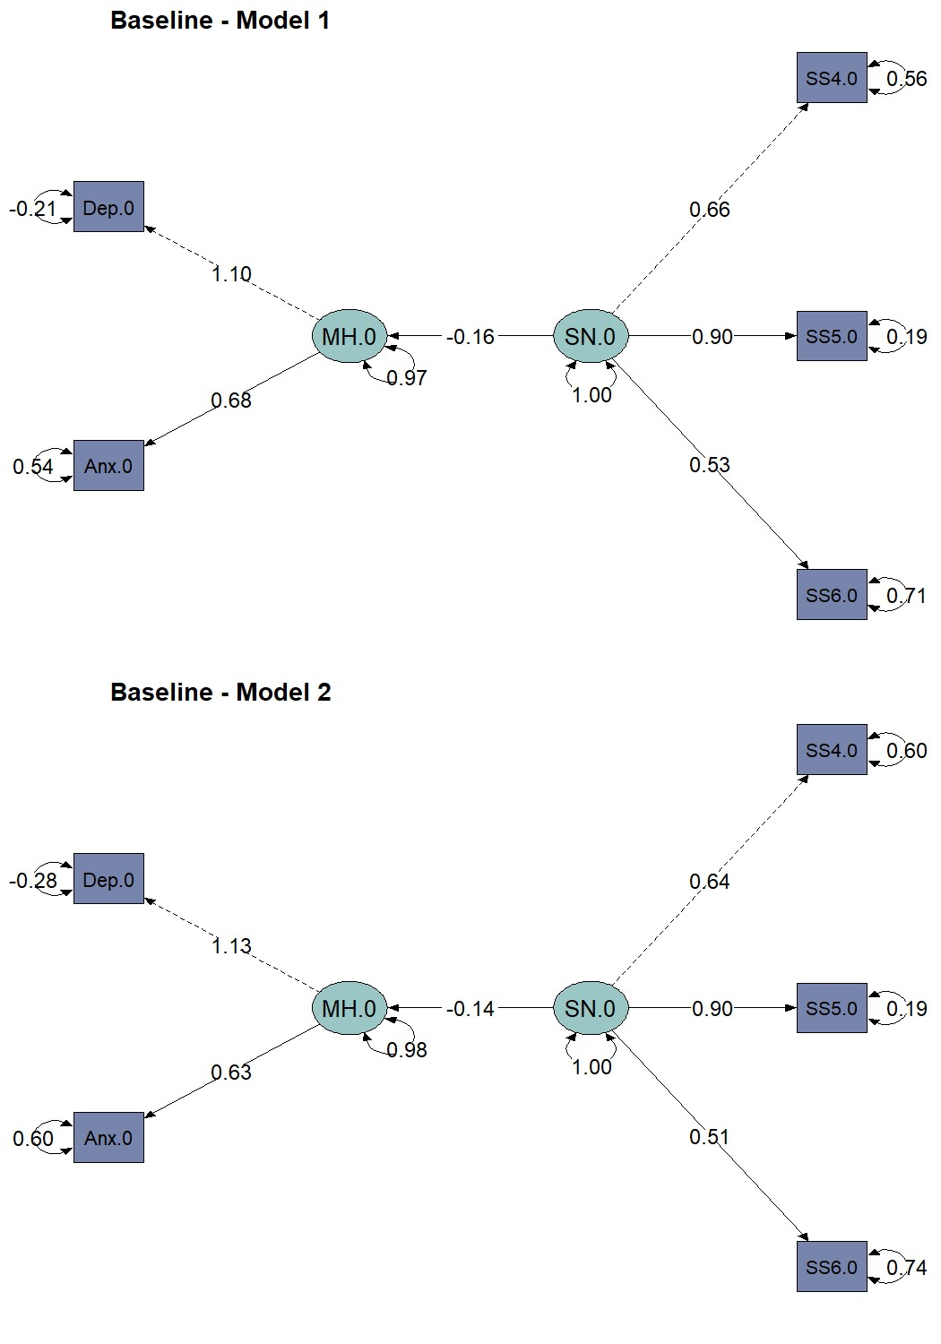
Supplementary Figure 4. Path diagrams of partially adjusted baseline cross-sectional models. ANX = anxiety symptoms; DEP = depressive symptoms; MH = mental health; SN = social network; SS4 = family closeness; SS5 = perceived warmth or love from others; SS6 = increased societal cohesion. Dashed lines indicate paths from latent variables to the first observed endogenous variables, which are set to a normalization constraint of 1.00; solid lines indicate other regression paths between latent variables SN and MH, as well as regression paths between latent variables and observed variables. Two-headed curved arrows indicate the standardized variance for each observed variable. All paths presented in the diagram are statistically significant. Model 1 has been adjusted for age and sex, while Model 2 has been additionally adjusted for previous psychiatric diagnosis, physical comorbidities, BMI, smoking status, CAGE score, physical activity, and recruitment type.

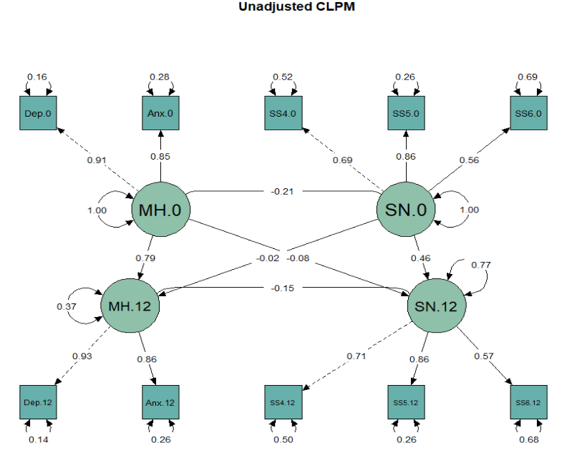

Supplementary Figure 5. Path diagram of the unadjusted cross-lagged panel model (CLPM) at baseline (0) and one-year follow-up (12). ANX = anxiety symptoms; DEP = depressive symptoms; MH = mental health; SN = social network; SS4 = family closeness; SS5 = perceived warmth or love from others; SS6 = increased societal cohesion. Dashed lines indicate paths from latent variables to the first observed endogenous variables, which are set to a normalization constraint of 1.00; solid lines indicate other regression paths between latent variables SN and MH, as well as regression paths between latent variables and observed variables. Two-headed curved arrows indicate the standardized variance for each observed variable. All paths presented in the diagram are statistically significant.

Supplementary Table 1. Description of the social network items included in the baseline, six-month, and one-year follow-up surveys.
Category | Variable Name | Questions | Possible Answers
Family | REL | What is your current relationship status? | Married; cohabitating or other firm relationship; single or divorced; widow
Family | CHILD | Do you have children?† | Yes; no
Family | CHILD.HOME | Does/do your child/any of your children in your household live at home? | Yes; no
Frequency of social contact |  | In the last two weeks, how often have you… | Several times per day; once per day; 5-6 days per week; 3-4 days per week; 1-2 days per week; less than once per week
Frequency of social contact | SC1 | 1. Spoken with your family members, relatives, friends, or neighbors on the phone?
Frequency of social contact | SC2 | 2. Been in contact with your family, relatives, friends, or neighbors via social media?
Frequency of social contact | SC3 | 3. Met your family, relatives, or friends in person?
Frequency of social contact | SC4 | 4. Left your home?
Perceived Social support |  | Do you agree or disagree with the following statements when you think of the last two months? | Do not agree at all; do not agree; do not agree nor disagree; agree a lot; completely agree
Perceived Social support | SS1 | 1. I get the emotional support and help I need from my family.
Perceived Social support | SS2 | 2. I have a specific person I can turn to when I need comforting.
Perceived Social support | SS3 | 3. I feel safe in my home.
Perceived Social support | SS4 | 4. My family is closer to me than before.
Perceived Social support | SS5 | 5. I have felt more warmth/love from others than before.
Perceived Social support | SS6 | 6. I feel that the cohesion in society has increased.
Perceived Social support | SS7 | 7. I feel that I have been helpful to others in the current situation.
†Participants were not asked this question at the one-year follow-up.

Supplementary Table 2. Characteristics of participants excluded due to missing social network and/or mental health data (N = 17,384) compared with the final analytic sample (N = 10,918).
Characteristic | Excluded  N = 17,384 | Final sample  N = 10,918 | p-value¹
Age, mean (SD) | 46 (15) | 53 (15) | <0.001
Sex |  |  | <0.001
Female | 14,023 (81%) | 9,048 (83%)
Male | 3,361 (19%) | 1,870 (17%)
Age group |  |  | <0.001
18-29 | 2,999 (17%) | 931 (8.5%)
30-39 | 3,751 (22%) | 1,467 (13%)
40-49 | 3,570 (21%) | 1,840 (17%)
50-59 | 3,529 (20%) | 2,516 (23%)
60-69 | 2,147 (12%) | 2,315 (21%)
≥70 | 1,388 (8.0%) | 1,849 (17%)
Depressive symptoms
Mean (SD) | 6.5 (5.8) | 4.8 (4.8) | <0.001
Above cutoff² | 4,290 (25%) | 1,634 (15%) | <0.001
Missing | 405 | 0
Anxiety symptoms
Mean (SD) | 5.0 (5.0) | 3.5 (4.2) | <0.001
Above cutoff³ | 3,083 (18%) | 1,085 (9.9%) | <0.001
Missing | 405 | 0
Relationship |  |  | 0.2
Single/divorced or widowed | 4,691 (27%) | 2,968 (27%)
Married or cohabitating | 12,594 (72%) | 7,905 (72%)
Missing | 99 (0.6%) | 45 (0.4%)
Children |  |  | <0.001
No | 5,668 (33%) | 3,001 (27%)
Yes | 11,690 (67%) | 7,911 (72%)
Missing | 26 (0.1%) | 6 (<0.1%)
Children at home |  |  | <0.001
No | 10,244 (59%) | 7,535 (69%)
Yes | 7,108 (41%) | 3,368 (31%)
Missing | 32 (0.2%) | 15 (0.1%)
Employment |  |  | <0.001
Full-time work | 7,895 (45%) | 5,197 (48%)
Part-time work | 1,036 (6.0%) | 634 (5.8%)
Not working | 1,325 (7.6%) | 696 (6.4%)
Retired | 2,126 (12%) | 3,036 (28%)
Student | 1,269 (7.3%) | 489 (4.5%)
Missing | 3,733 (21%) | 866 (7.9%)
Economic difficulties |  |  | <0.001
Very easy | 10,161 (58%) | 7,693 (70%)
Quite easy | 3,310 (19%) | 1,704 (16%)
Neither/nor | 2,443 (14%) | 1,149 (11%)
Quite difficult | 1,001 (5.8%) | 274 (2.5%)
Very difficult | 353 (2.0%) | 81 (0.7%)
Missing | 116 (0.7%) | 17 (0.2%)
Previous COVID-19 infection |  |  | <0.001
No | 5,494 (32%) | 2,459 (23%)
Yes | 1,064 (6.1%) | 377 (3.5%)
Missing | 10,749 (62%) | 8,046 (74%)
COVID-19-related worry |  |  | <0.001
Very much | 1,720 (9.9%) | 757 (6.9%)
Somewhat | 4,167 (24%) | 2,618 (24%)
Neither/nor | 2,928 (17%) | 1,953 (18%)
A little | 5,550 (32%) | 4,029 (37%)
Not at all | 2,452 (14%) | 1,540 (14%)
Missing | 567 (3.3%) | 21 (0.2%)
History of mental illness |  |  | <0.001
No | 10,229 (59%) | 7,583 (69%)
Yes | 6,262 (36%) | 3,212 (29%)
Missing | 893 (5.1%) | 123 (1.1%)
Number of physical comorbidities |  |  | <0.001
None | 11,129 (64%) | 7,050 (65%)
One | 3,649 (21%) | 2,595 (24%)
Two | 972 (5.6%) | 683 (6.3%)
Three or more | 340 (2.0%) | 216 (2.0%)
Missing | 1,294 (7.4%) | 374 (3.4%)
Body mass index (kg/m²)
Mean (SD) | 25.6 (5.0) | 25.2 (4.4) | <0.001
Under or normal weight (<25) | 8,563 (49%) | 5,901 (54%)
Overweight (25-30) | 4,899 (28%) | 3,294 (30%)
Obese (>30) | 2,480 (14%) | 1,295 (12%)
Missing | 1,442 (8.3%) | 428 (3.9%)
Physical activity during the past two weeks |  |  | <0.001
Every day | 2,448 (14%) | 1,864 (17%)
4-6 days | 5,229 (30%) | 3,861 (35%)
1-3 days | 6,387 (37%) | 3,768 (35%)
None | 2,519 (14%) | 1,354 (12%)
Missing | 801 (4.6%) | 71 (0.7%)
Currently smoking |  |  | <0.001
No | 13,271 (76%) | 9,550 (87%)
Yes | 3,337 (19%) | 1,321 (12%)
Missing | 776 (4.5%) | 47 (0.4%)
CAGE score |  |  | <0.001
0 | 11,656 (67%) | 8,016 (73%)
1 | 1,297 (7.5%) | 846 (7.7%)
≥2 | 1,044 (6.0%) | 556 (5.1%)
Missing | 3,387 (19%) | 1,500 (14%)

¹ Wilcoxon rank sum test; Pearson’s Chi-squared test
² A score of ≥10 on the PHQ-9 indicates moderate-to-severe depressive symptoms.
³ A score of ≥10 on the GAD-7 indicates moderate-to-severe anxiety symptoms.

Supplementary Table 3. Changes in mental health, social network, and time-varying covariates (N=10,918)
 | Baseline | Six-month follow-up | One-year follow-up
Mental Health
Depressive symptoms
Below cutoff | 9,284 (85.0%) | 9,450 (86.6%) | 9,535 (87.3%)
Above cutoff | 1,634 (15.0%) | 1,468 (13.4%) | 1,383 (12.7%)
Mean (SD) | 4.77 (4.85) | 4.43 (4.81) | 4.25 (4.76)
Median [min, max] | 3 [0, 27] | 3 [0, 27] | 3 [0, 27]
Anxiety symptoms
Below cutoff | 9,833 (90.1%) | 9,880 (90.5%) | 9,944 (91.1%)
Above cutoff | 1,085 (9.9%) | 1,038 (9.5%) | 974 (8.9%)
Mean (SD) | 3.49 (4.19) | 3.40 (4.22) | 3.16 (4.13)
Median [min, max] | 2 [0, 21] | 2 [0, 21] | 2 [0, 21]
Social network
Relationship
Single/divorced or widowed | 2,968 (27.2%) | 2,994 (27.4%) | 2,999 (27.5%)
Married or cohabitating | 7,905 (72.4%) | 7,880 (72.2%) | 7,881 (72.2%)
Missing | 45 (0.4%) | 44 (0.4%) | 38 (0.3%)
Children
No | 3,001 (27.5%) | 2,972 (27.2%) | -
Yes | 7,911 (72.5%) | 7,934 (72.7%) | -
Missing | 6 (0.1%) | 12 (0.1%) | -
Children at home
No | 7,535 (69.0%) | 7,564 (69.3%) | 7,701 (70.5%)
Yes | 3,368 (30.8%) | 3,337 (30.6%) | 3,202 (29.3%)
Missing | 15 (0.1%) | 17 (0.2%) | 15 (0.1%)
Phone contact
Less than once a week | 1,159 (10.6%) | 1,267 (11.6%) | 1,210 (11.1%)
1-2 days a week | 2,513 (23.0%) | 2,619 (24.0%) | 2,530 (23.2%)
3-4 days a week | 1,998 (18.3%) | 1,988 (18.2%) | 1,974 (18.1%)
5-6 days a week | 1,394 (12.8%) | 1,330 (12.2%) | 1,334 (12.2%)
Once a day | 1,739 (15.9%) | 1,842 (16.9%) | 1,778 (16.3%)
Several times a day | 2,056 (18.8%) | 1,837 (16.8%) | 2,030 (18.6%)
Missing | 59 (0.5%) | 35 (0.3%) | 62 (0.6%)
Social media contact
Less than once a week | 1,454 (13.3%) | 1,512 (13.8%) | 1,400 (12.8%)
1-2 days a week | 1,483 (13.6%) | 1,607 (14.7%) | 1,543 (14.1%)
3-4 days a week | 1,616 (14.8%) | 1,660 (15.2%) | 1,673 (15.3%)
5-6 days a week | 1,432 (13.1%) | 1,476 (13.5%) | 1,409 (12.9%)
Once a day | 1,439 (13.2%) | 1,390 (12.7%) | 1,445 (13.2%)
Several times a day | 3,226 (29.5%) | 3,012 (27.6%) | 3,152 (28.9%)
Missing | 268 (2.5%) | 261 (2.4%) | 296 (2.7%)
In-person contact
Less than once a week | 4,533 (41.5%) | 4,602 (42.2%) | 3,487 (31.9%)
1-2 days a week | 2,835 (26.0%) | 2,935 (26.9%) | 3,268 (29.9%)
3-4 days a week | 1,113 (10.2%) | 1,140 (10.4%) | 1,379 (12.6%)
5-6 days a week | 471 (4.3%) | 482 (4.4%) | 592 (5.4%)
Once a day | 466 (4.3%) | 454 (4.2%) | 587 (5.4%)
Several times a day | 1,370 (12.5%) | 1,180 (10.8%) | 1,492 (13.7%)
Missing | 130 (1.2%) | 125 (1.1%) | 113 (1.0%)
Left home
Less than once a week | 209 (1.9%) | 203 (1.9%) | 101 (0.9%)
1-2 days a week | 812 (7.4%) | 799 (7.3%) | 518 (4.7%)
3-4 days a week | 1,119 (10.2%) | 1,059 (9.7%) | 1,066 (9.8%)
5-6 days a week | 1,463 (13.4%) | 1,375 (12.6%) | 1,627 (14.9%)
Once a day | 3,232 (29.6%) | 3,414 (31.3%) | 3,420 (31.3%)
Several times a day | 4,001 (36.6%) | 4,014 (36.8%) | 4,129 (37.8%)
Missing | 82 (0.8%) | 54 (0.5%) | 57 (0.5%)
Emotional support from family
Strongly disagree | 322 (2.9%) | 330 (3.0%) | 353 (3.2%)
Disagree | 1,032 (9.5%) | 1,077 (9.9%) | 1,083 (9.9%)
Do not agree nor disagree | 1,291 (11.8%) | 1,253 (11.5%) | 1,087 (10.0%)
Agree | 3,080 (28.2%) | 3,227 (29.6%) | 3,327 (30.5%)
Strongly agree | 5,072 (46.5%) | 4,914 (45.0%) | 4,920 (45.1%)
Missing | 121 (1.1%) | 117 (1.1%) | 148 (1.4%)
Emotional support from specific person
Strongly disagree | 742 (6.8%) | 749 (6.9%) | 748 (6.9%)
Disagree | 1,096 (10.0%) | 1,086 (9.9%) | 1,036 (9.5%)
Do not agree nor disagree | 992 (9.1%) | 1,083 (9.9%) | 915 (8.4%)
Agree | 2,464 (22.6%) | 2,645 (24.2%) | 2,772 (25.4%)
Strongly agree | 5,502 (50.4%) | 5,226 (47.9%) | 5,303 (48.6%)
Missing | 122 (1.1%) | 129 (1.2%) | 144 (1.3%)
Safety at home
Strongly disagree | 47 (0.4%) | 62 (0.6%) | 68 (0.6%)
Disagree | 145 (1.3%) | 137 (1.3%) | 143 (1.3%)
Do not agree nor disagree | 216 (2.0%) | 256 (2.3%) | 221 (2.0%)
Agree | 1,434 (13.1%) | 1,581 (14.5%) | 1,787 (16.4%)
Strongly agree | 9,027 (82.7%) | 8,851 (81.1%) | 8,648 (79.2%)
Missing | 49 (0.4%) | 31 (0.3%) | 51 (0.5%)
Family closeness
Strongly disagree | 1,158 (10.6%) | 1,010 (9.3%) | 972 (8.9%)
Disagree | 789 (7.2%) | 727 (6.7%) | 678 (6.2%)
Do not agree nor disagree | 5,169 (47.3%) | 5,300 (48.5%) | 5,420 (49.6%)
Agree | 2,035 (18.6%) | 2,175 (19.9%) | 2,122 (19.4%)
Strongly agree | 1,654 (15.1%) | 1,595 (14.6%) | 1,608 (14.7%)
Missing | 113 (1.0%) | 111 (1.0%) | 118 (1.1%)
Love from others
Strongly disagree | 1,703 (15.6%) | 1,631 (14.9%) | 1,495 (13.7%)
Disagree | 1,361 (12.5%) | 1,153 (10.6%) | 1,080 (9.9%)
Do not agree nor disagree | 5,291 (48.5%) | 5,663 (51.9%) | 5,883 (53.9%)
Agree | 1,709 (15.7%) | 1,659 (15.2%) | 1,616 (14.8%)
Strongly agree | 745 (6.8%) | 715 (6.5%) | 712 (6.5%)
Missing | 109 (1.0%) | 97 (0.9%) | 132 (1.2%)
Societal cohesion
Strongly disagree | 2,021 (18.5%) | 2,550 (23.4%) | 2,702 (24.7%)
Disagree | 2,292 (21.0%) | 1,802 (16.5%) | 1,695 (15.5%)
Do not agree nor disagree | 4,330 (39.7%) | 4,899 (44.9%) | 5,067 (46.4%)
Agree | 1,681 (15.4%) | 1,115 (10.2%) | 947 (8.7%)
Strongly agree | 344 (3.2%) | 270 (2.5%) | 225 (2.1%)
Missing | 250 (2.3%) | 282 (2.6%) | 282 (2.6%)
Helpful to others
Strongly disagree | 1,036 (9.5%) | 986 (9.0%) | 965 (8.8%)
Disagree | 2,642 (24.2%) | 2,526 (23.1%) | 2,480 (22.7%)
Do not agree nor disagree | 3,370 (30.9%) | 3,790 (34.7%) | 4,033 (36.9%)
Agree | 2,574 (23.6%) | 2,498 (22.9%) | 2,387 (21.9%)
Strongly agree | 1,130 (10.3%) | 948 (8.7%) | 819 (7.5%)
Missing | 166 (1.5%) | 170 (1.6%) | 234 (2.1%)
Time-varying covariates
Employment
Full-time work | 5,197 (47.6%) | 5,662 (51.9%) | 5,676 (52.0%)
Part-time work | 634 (5.8%) | 575 (5.3%) | 578 (5.3%)
Not working | 696 (6.4%) | 758 (6.9%) | 646 (5.9%)
Retired | 3,036 (27.8%) | 3,229 (29.6%) | 3,348 (30.7%)
Student | 489 (4.5%) | 557 (5.1%) | 550 (5.0%)
Missing | 866 (7.9%) | 137 (1.3%) | 120 (1.1%)
Economic difficulties
Very easy | 7,693 (70.5%) | 7,428 (68.0%) | 7,041 (64.5%)
Quite easy | 1,704 (15.6%) | 1,631 (14.9%) | 1,839 (16.8%)
Neither/nor | 1,149 (10.5%) | 1,408 (12.9%) | 1,582 (14.5%)
Quite difficult | 274 (2.5%) | 316 (2.9%) | 310 (2.8%)
Very difficult | 81 (0.7%) | 95 (0.9%) | 96 (0.9%)
Missing | 17 (0.2%) | 40 (0.4%) | 50 (0.5%)
Previous COVID-19 infection*
No | 2,459 (22.5%) | 3,983 (36.5%) | 3,456 (31.7%)
Yes | 377 (3.5%) | 803 (7.4%) | 366 (3.4%)
Missing | 8,082 (74.0%) | 6,132 (56.2%) | 7,096 (65.0%)
COVID-19 worry
Very much | 757 (6.9%) | 597 (5.5%) | 295 (2.7%)
Somewhat | 2,618 (24.0%) | 1,889 (17.3%) | 1,464 (13.4%)
Neither/nor | 1,953 (17.9%) | 1,596 (14.6%) | 1,606 (14.7%)
A little | 4,029 (36.9%) | 4,257 (39.0%) | 4,772 (43.7%)
Not at all | 1,540 (14.1%) | 2,567 (23.5%) | 2,759 (25.3%)
Missing | 21 (0.2%) | 12 (0.1%) | 22 (0.2%)
Employment change
No change | - | 5,625 (51.5%) | 5,980 (54.8%)
Not relevant | - | 2,077 (19.0%) | 2,193 (20.1%)
Lost job or other negative change | - | 933 (8.5%) | 544 (5.0%)
Positive change | - | 1,242 (11.4%) | 1,346 (12.3%)
Other | - | 984 (9.0%) | 800 (7.3%)
Missing | - | 57 (0.5%) | 55 (0.5%)
*Participants were asked at six-month and one-year follow-ups if they had tested positive for COVID-19 since the last time they took the survey.

Supplementary Table 4. Results from sex-specific analysis showing standardized regression coefficients and model evaluation statistics for cross-sectional structural equation models (women: N=9048; men: N=1870).

 | Baseline |  | Six-month follow-up |  | One-year follow-up
 | Women | Men | Women | Men | Women | Men
Mental health Depression | 1.10* | 1.25* | 0.99* | 0.95* | 0.97* | 1.01*
Mental health Anxiety | 0.63*** | 0.57*** | 0.76*** | 0.82*** | 0.78*** | 0.74***
Social network Family closeness | 0.63* | 0.67* | 0.61* | 0.65* | 0.67* | 0.65*
Social network Warmth from others | 0.90*** | 0.85*** | 0.91*** | 0.91*** | 0.89*** | 0.91***
Social network Societal cohesion | 0.51*** | 0.50*** | 0.51*** | 0.50*** | 0.54*** | 0.49***
Mental health Social network | -0.15*** | -0.12*** | -0.20*** | -0.25*** | -0.22*** | -0.22***
Model Fit
$χ^{2}$/df | 32.45/4*** | 26.45/4*** | 45.55/4*** | 11.81/4 | 54.92/4*** | 9.08/4
CFI | 0.998† | 0.991† | 0.997† | 0.997† | 0.996† | 0.998†
TLI | 0.994† | 0.978† | 0.992† | 0.994† | 0.991† | 0.996†
RMSEA | 0.028† | 0.055 | 0.034† | 0.032† | 0.038† | 0.026†
SRMR | 0.015† | 0.030† | 0.018† | 0.021† | 0.016† | 0.019†
* Coefficients on paths from latent variables to first observed endogenous variables set to normalization constraint of 1 and therefore do not have a p value.
*** p < 0.001
Model 3 was used for baseline analysis.
df: degrees of freedom. CFI: comparative fit index; TLI: Tucker–Lewis index; RMSEA: root mean square error of approximation; SRMR: standardized root mean squared residual.
†Meets the requirement for good model fit.

Supplementary Table 5. Results from sex-specific analysis showing standardized regression coefficients and model evaluation statistics for cross-lagged panel models.
 | Women  N=9048 | Men  N=1870
Baseline
Mental health Depression | 0.90* | 0.87*
Mental health Anxiety | 0.76*** | 0.82***
Social network Family closeness | 0.66* | 0.70*
Social network Warmth from others | 0.85*** | 0.82***
Social network Societal cohesion | 0.52*** | 0.51***
One-year follow-up
Mental health Depression | 0.92* | 0.90*
Mental health Anxiety | 0.81*** | 0.82***
Social network Family closeness | 0.69* | 0.69*
Social network Warmth from others | 0.85*** | 0.85***
Social network Societal cohesion | 0.55*** | 0.52***
Cross-lagged paths
Mental health (one year) Mental health (baseline) | 0.56*** | 0.66***
Social network (one year) Social network (baseline) | 0.49*** | 0.46***
Model Fit
$χ^{2}$/df | 2277.23/31*** | 488.59/31***
CFI | 0.930 | 0.932
TLI | 0.898 | 0.901
RMSEA | 0.089 | 0.089
SRMR | 0.037† | 0.046†
* Coefficients on paths from latent variables to first observed endogenous variables set to normalization constraint of 1 and therefore do not have a p value.
*** p < 0.001
Model 3 was used for baseline analysis.
df: degrees of freedom. CFI: comparative fit index; TLI: Tucker–Lewis index; RMSEA: root mean square error of approximation; SRMR: standardized root mean squared residual.
†Meets the requirement for good model fit.

Supplementary Table 6. Results from age-specific analysis showing standardized regression coefficients and model evaluation statistics for cross-sectional structural equation models (18-39: N=2398; 40-59: N=4356; 60+: N=4164).

 | Baseline |  |  | Six-month follow-up |  |  | One-year follow-up
 | 18-39 | 40-59 | 60+ | 18-39 | 40-59 | 60+ | 18-39 | 40-59 | 60+
Mental health Depression | 1.12* | 1.12* | 1.21* | 0.98* | 0.98* | 1.03* | 0.97* | 0.97* | 0.97*
Mental health Anxiety | 0.62*** | 0.62*** | 0.57*** | 0.77*** | 0.77*** | 0.72*** | 0.77*** | 0.77*** | 0.76***
Social network Family closeness | 0.64* | 0.64* | 0.67* | 0.62* | 0.62* | 0.61* | 0.66* | 0.66* | 0.70*
Social network Warmth from others | 0.90*** | 0.90*** | 0.88*** | 0.91*** | 0.91*** | 0.91*** | 0.89*** | 0.89*** | 0.89***
Social network Societal cohesion | 0.51*** | 0.51*** | 0.47*** | 0.51*** | 0.51*** | 0.47*** | 0.53*** | 0.53*** | 0.51***
Mental health Social network | -0.15*** | -0.15*** | -0.10*** | -0.21*** | -0.21*** | -0.17*** | -0.22*** | -0.22*** | -0.20***
Model Fit
$χ^{2}$/df | 47.99/4*** | 47.99/4*** | 15.03/4** | 52.95/4*** | 52.95/4*** | 18.55/4*** | 52.70/4*** | 52.70/4*** | 23.1/4***
CFI | 0.997† | 0.997† | 0.998† | 0.997† | 0.997† | 0.998† | 0.997† | 0.997† | 0.997†
TLI | 0.992† | 0.992† | 0.995† | 0.993† | 0.993† | 0.994† | 0.993† | 0.993† | 0.993†
RMSEA | 0.032† | 0.032† | 0.026† | 0.033† | 0.033† | 0.030† | 0.033† | 0.033† | 0.034†
SRMR | 0.017† | 0.017† | 0.016† | 0.018† | 0.018† | 0.018† | 0.015† | 0.015† | 0.016†
* Coefficients on paths from latent variables to first observed endogenous variables set to normalization constraint of 1 and therefore do not have a p value.
** p < 0.01
*** p < 0.001
Model 3 was used for baseline analysis.
df: degrees of freedom. CFI: comparative fit index; TLI: Tucker–Lewis index; RMSEA: root mean square error of approximation; SRMR: standardized root mean squared residual.
†Meets the requirement for good model fit.

Supplementary Table 7. Results from age-specific analysis showing standardized regression coefficients and model evaluation statistics for cross-lagged panel models.
 | 18-39  N=2398 | 40-59  N=4356 | 60+  N=4164
Baseline
Mental health Depression | 0.90* | 0.90* | 0.88*
Mental health Anxiety | 0.77*** | 0.77*** | 0.77***
Social network Family closeness | 0.67* | 0.67* | 0.71*
Social network Warmth from others | 0.85*** | 0.85*** | 0.81***
Social network Societal cohesion | 0.52*** | 0.52*** | 0.48***
One year
Mental health Depression | 0.92* | 0.92* | 0.92*
Mental health Anxiety | 0.82*** | 0.82*** | 0.80***
Social network Family closeness | 0.69* | 0.69* | 0.74*
Social network Warmth from others | 0.85*** | 0.85*** | 0.84***
Social network Societal cohesion | 0.54*** | 0.54*** | 0.51***
Cross-lagged paths
Mental health (one year) Mental health (baseline) | 0.58*** | 0.58*** | 0.58***
Social network (one year) Social network (baseline) | 0.48*** | 0.48*** | 0.50***
Model Fit
$χ^{2}$/df | 2713.71/31*** | 2713.71/31*** | 1023.46/31***
CFI | 0.931 | 0.931 | 0.931
TLI | 0.899 | 0.899 | 0.900
RMSEA | 0.089 | 0.089 | 0.088
SRMR | 0.038† | 0.038† | 0.040†
* Coefficients on paths from latent variables to first observed endogenous variables set to normalization constraint of 1 and therefore do not have a p value.
*** p < 0.001
Model 3 was used for baseline analysis.
df: degrees of freedom. CFI: comparative fit index; TLI: Tucker–Lewis index; RMSEA: root mean square error of approximation; SRMR: standardized root mean squared residual.
†Meets the requirement for good model fit.

Supplementary Material: R code for SEM analysis

# Load required packages
library(lavaan)
library(semPlot)

************************************************************************************************
Cross-sectional models
************************************************************************************************

# Unadjusted cross-sectional SEM at baseline

cmodel.0 <- '
# Measurement model
mh.0 =~ dep0 + anx0
sn.0 =~ ss4.0 + ss5.0 + ss6.0

# Regression
mh.0 ~ sn.0
'

fit1 <- sem(cmodel.0, data = df.unadj)
summary(fit1, fit.measures=TRUE, standardized = TRUE)
standardizedSolution(fit1)

************************************************************************************************

# Unadjusted cross-sectional SEM at 6 months

cmodel.6 <- '
# Measurement model
mh.6 =~ dep6 + anx6
sn.6 =~ ss4.6 + ss5.6 + ss6.6

# Regression
mh.6 ~ sn.6
'

fit2 <- sem(cmodel.6, data = df.unadj)
summary(fit2, fit.measures=TRUE, standardized = TRUE)
standardizedSolution(fit2)

************************************************************************************************

# Unadjusted cross-sectional SEM at 12 months

cmodel.12 <- '
# Measurement model
mh.12 =~ dep12 + anx12
sn.12 =~ ss4.12 + ss5.12 + ss6.12

# Regression
mh.12 ~ sn.12
'

fit3 <- sem(cmodel.12, data = df.unadj)
summary(fit3, fit.measures=TRUE, standardized = TRUE)
standardizedSolution(fit3)

************************************************************************************************

# Baseline Model 1 – adjusted for age and sex

model.adjm1 <- '
# Measurement model
mh.m1 =~ dep.m1 + anx.m1
sn.m1 =~ ss4.m1 + ss5.m1 + ss6.m1

# Regression
mh.m1 ~ sn.m1
'
fit.adjm1 <- sem(model.adjm1, data = df.adj)
summary(fit.adjm1, fit.measures=TRUE, standardized = TRUE)
standardizedSolution(fit.adjm1)

************************************************************************************************

# Baseline Model 2 – adjusted additionally for previous psychiatric diagnosis, physical comorbidities, BMI, smoking, CAGE score, physical activity, recruitment type

model.adjm2 <- '
# Measurement model
mh.m2 =~ dep.m2 + anx.m2
sn.m2 =~ ss4.m2 + ss5.m2 + ss6.m2

# Regression
mh.m2 ~ sn.m2
'
fit.adjm2 <- sem(model.adjm2, data = df.adj)
summary(fit.adjm2, fit.measures=TRUE, standardized = TRUE)
standardizedSolution(fit.adjm2)

************************************************************************************************

# Baseline Model 3 – adjusted additionally for previous COVID-19 infection, COVID-19-related worries, economic difficulties, employment status, response period

model.adjm3 <- '
# Measurement model
mh.m3 =~ dep.m3 + anx.m3
sn.m3 =~ ss4.m3 + ss5.m3 + ss6.m3

# Regression
mh.m3 ~ sn.m3
'
fit.adjm3 <- sem(model.adjm3, data = df.adj)
summary(fit.adjm3, fit.measures=TRUE, standardized = TRUE)
standardizedSolution(fit.adjm3)

************************************************************************************************

# 6 months "Model 4" – fully adjusted

model.adjm4 <- '
# Measurement model
mh.m4 =~ dep.m4 + anx.m4
sn.m4 =~ ss4.m4 + ss5.m4 + ss6.m4

# Regression
mh.m4 ~ sn.m4
'

fit.adjm4 <- sem(model.adjm4, data = df.adj)
summary(fit.adjm4, fit.measures=TRUE, standardized = TRUE)
standardizedSolution(fit.adjm4)

************************************************************************************************

#12 months "Model 5" – fully adjusted
model.adjm5 <- '
# Measurement model
mh.m5 =~ dep.m5 + anx.m5
sn.m5 =~ ss4.m5 + ss5.m5 + ss6.m5

# Regression
mh.m5 ~ sn.m5
'

fit.adjm5 <- sem(model.adjm5, data = df.adj)
summary(fit.adjm5, fit.measures=TRUE, standardized = TRUE)
standardizedSolution(fit.adjm5)

************************************************************************************************
Cross-lagged panel models
************************************************************************************************

# Unadjusted CLPM

xlag.unadj <- '
# Measurement models
# Baseline
mh.0 =~ dep0 + anx0
sn.0 =~ ss4.0 + ss5.0 + ss6.0

# 12 months
mh.12 =~ dep12 + anx12
sn.12 =~ ss4.12 + ss5.12 + ss6.12

# Latent autoregressive paths
mh.12 ~ c_mh.0 * mh.0
sn.12 ~ c_sn.0 * sn.0

# Cross-lagged paths
mh.12 ~ b_sn.0 * sn.0
sn.12 ~ b_mh.0 * mh.0

# Residual covariances
mh.0 ~~ sn.0
mh.12 ~~ sn.12
'

fit.xunadj <- sem(xlag.unadj, data = df.unadj)
summary(fit.xunadj, fit.measures=TRUE, standardized = TRUE)
standardizedSolution(fit.xunadj)

************************************************************************************************

# Adjusted model 1: adjusted for age and sex

xlag.m1 <- '
# Measurement models
# Baseline
mh.m1 =~ dep.m1 + anx.m1
sn.m1 =~ ss4.m1 + ss5.m1 + ss6.m1

# 12 months
mh.m5 =~ dep.m5 + anx.m5
sn.m5 =~ ss4.m5 + ss5.m5 + ss6.m5

# Latent autoregressive paths
mh.m5 ~ c_mh.m1 * mh.m1
sn.m5 ~ c_sn.m1 * sn.m1

# Residual covariances
mh.m1 ~~ sn.m1
mh.m5 ~~ sn.m5
'

fit.xlagm1 <- sem(xlag.m1, data = df.adj)
summary(fit.xlagm1, fit.measures=TRUE, standardized = TRUE)
standardizedSolution(fit.xlagm1)

************************************************************************************************

# Adjusted model 2: adjusted additionally for previous psychiatric diagnosis, physical comorbidities, BMI, smoking, CAGE score, physical activity, and recruitment type

xlag.m2 <- '
# Measurement models
# Baseline
mh.m2 =~ dep.m2 + anx.m2
sn.m2 =~ ss4.m2 + ss5.m2 + ss6.m2

# 12 months
mh.m5 =~ dep.m5 + anx.m5
sn.m5 =~ ss4.m5 + ss5.m5 + ss6.m5

# Latent autoregressive paths
mh.m5 ~ c_mh.m2 * mh.m2
sn.m5 ~ c_sn.m2 * sn.m2

# Residual covariances
mh.m2 ~~ sn.m2
mh.m5 ~~ sn.m5
'

fit.xlagm2 <- sem(xlag.m2, data = df.adj)
summary(fit.xlagm2, fit.measures=TRUE, standardized = TRUE)
standardizedSolution(fit.xlagm2)

************************************************************************************************

# Adjusted model 3: adjusted additionally for previous COVID-19 infection, COVID-19-related worries, economic difficulties, employment status, and response period

xlag.m3 <- '
# Measurement models
# Baseline
mh.m3 =~ dep.m3 + anx.m3
sn.m3 =~ ss4.m3 + ss5.m3 + ss6.m3

# 12 months
mh.m5 =~ dep.m5 + anx.m5
sn.m5 =~ ss4.m5 + ss5.m5 + ss6.m5

# Latent autoregressive paths
mh.m5 ~ c_mh.m3 * mh.m3
sn.m5 ~ c_sn.m3 * sn.m3

# Cross-lagged paths
mh.m5 ~ b_sn.m3 * sn.m3
sn.m5 ~ b_mh.m3 * mh.m3

# Residual covariances
mh.m3 ~~ sn.m3
mh.m5 ~~ sn.m5
'

fit.xlagm3 <- sem(xlag.m3, data = df.adj)
summary(fit.xlagm3, fit.measures=TRUE, standardized = TRUE)
standardizedSolution(fit.xlagm3)

