Appendix A. Geographic and demographic details of recruitment areas
Geographical coverage | Number of GP practices | Type of GP practices | Number of recruitment packages sent |  | Number of recruited participants |  | Ethnicity distribution
 |  |  | Wave 1 | Wave 2 | Wave 1 | Wave 2
Northeast and North Cumbria | 2 | Rural | 276 | 450 | 17 | 12 | 100% White
Greater Manchester | 2 | Urban | 1150 | 0 | 67 | 0 | 95.5% White, 1.5% Other (Mixed/multiple, Asian/Asian British or Black/Black British), 3.0% missing
Yorkshire and Humber | 11 | 7 urban GP practices  1 coastal GP practice  3 rural GP practices | 7758 | 6215 | 762 | 162 | 98.6% White, 1% Other (Mixed/multiple, Asian/Asian British or Black/Black British), 0.4% missing
Note: Wave 1 = recruitment via postal recruitment packs; Wave 2 = text recruitment

Appendix B. Unit costs of health resource use and associated data sources
Cost category | Unit cost¹ (£) | Unit | Reference
Mental health-related community care
GP consultations | 47.98 | session | Assuming one hour per session  PSSRU 2017, page 185, table 12.1  Average hourly cost of a team member of the NHS community mental health team (CMHT) for older people with mental health problems²
Nurse consultations | 47.98 | session
Consultations with other health care practitioners | 47.98 | session
Mental health-related hospital care
A&E or an Urgent Care Centre | 82.90 | visit | National cost collection 2021/2022 (T01NA and T04NA); Weighted average of cost of A&E and urgent care centre, based on the unit cost and number of attendances per year
Inpatient overnight stay | 572.83 | stay | National cost collection 2021/2022; Non-Elective Inpatient - Short Stay; WD09Z
Social care
Social worker visit | 52.00 | visit | PSSRU 2021, page 122, table 11.1, assuming one hour per visit
Home visits from paid home worker | 33.00 | visit | PSSRU 2021, page 126, table 11.5, assuming one hour per visit; Unit cost was derived by taking the average cost of visit provided for private purchases and social services
NHS mental health services
Psychologist consultation for depression | 360.98 | session | National cost collection 2021/2022; Service code 656, "Clinical Psychology Service"
Psychiatrist consultation for depression | 493.35 | session | National cost collection 2021/2022; Service code 715, "OLD AGE PSYCHIATRY SERVICE", consultant-led
Community psychiatric nurse consultation for depression | 565.32 | session | National cost collection 2021/2022; Service code 715, "OLD AGE PSYCHIATRY SERVICE", non-consultant-led
Group therapy for depression | 228.00 | session | National cost collection 2021/2022; A01AG, Other Therapist, Adult, Group
Outreach worker consultation for depression | 25.00 | session | PSSRU 2021; page 128, table 11.7, assuming one hour per session
IAPT service for depression | 132.00 | session | PSSRU 2021; page 34, table 2.1
Counsellor consultation for depression | 51.00 | session | PSSRU 2021; page 80 table 6.10; used child as a proxy, assuming one-hour session
Private counselling session | 51.00 |  | Assume the same as counsellor
First contact mental health consultant | 360.98 |  | Assume the same as psychologist
Help from charities | 33.00 | visit | Assume the cost of charity worker is the same as hourly rate of paid home worker to simplify
Medications
Citalopram (Cipramil) 20 mg | 0.09 | mg | PCA  BNF code: 0403030D0AAAAAA
Dapoxetine (Priligy) 30 mg | 1.10 | mg | PCA  BNF code: 0704060A0BBACAA
Escitalopram (Cipralex) | 0.13 | mg | PCA  BNF code: 0403030X0AAAAAA
Fluoxetine (Prozac or Oxactin) | 0.05 | mg | PCA  BNF code: 0403030E0AAAAAA
Fluvoxamine (Faverin) | 0.32 | mg | PCA  BNF code: 0403030L0AAAAAA
Paroxetine (Seroxat) | 0.08 | mg | PCA  BNF code: 0403030P0AAAAAA
Sertraline (Lustral) | 0.02 | mg | PCA  BNF code: 0403030Q0AAAAAA
Vortioxetine (Brintellix) | 4.91 | mg | PCA  BNF code: 0403040ABBBAAAA
Productivity loss
Median wages | 114.98 | day | ONS 2023; Assuming 5 working days per week; £574.9 per week (all employees, including full-time and part-time)
Private mental health services (according to patient-reported categories of services)
Private counsellor | 55 | session | How Much Does Private Therapy Cost? -Select Psychology  https://selectpsychology.co.uk/blog/mental-health/how-much-does-private-therapy-cost
Psychotherapist | 80 | session | How Much Does Private Therapy Cost? -Select Psychology  https://selectpsychology.co.uk/blog/mental-health/how-much-does-private-therapy-cost/
Abbreviations: A&E: accident and emergency; BNF: British National Formulary; GP: general practitioner; IAPT: Improving Access to Psychological Therapies; NHS: National Health Service; PCA: Prescription Cost Analysis; PSSRU: Personal Social Services Research Unit
Note: ¹All costs presented in the table have been inflated with appropriate Hospital & Community Health Services (HCHS) indices based on the original pricing year. Travel costs and cost of self-care were directly estimated by each participant, hence not reported here. ² A standardised unit cost was used here to provide a comprehensive and unified basis for costing that reflects a broad spectrum of healthcare services delivered by multidisciplinary team members within the community setting. The reason why the unit cost of GP/nurse/other healthcare practitioners was not individually sourced and applied was because we believe those individually-sourced unit costs were less specific about mental health services provided for older adults.

Appendix C. Availability of quality of life and cost data (before imputation)
Type of data | Baseline  (N=1020), n(%) | 6-month  (N=1020), n(%) | Complete case  (N=1020), n(%)
Cost data
Resource use from NHS  and PSS perspective | 750 (73.5) | 832 (81.6) | 635 (62.3)
Resource use from societal  perspective | 591 (57.9) | 596 (58.4) | 396 (38.8)
Quality of life data
EQ-5D-3L | 1006 (98.6) | 939 (92.1) | 926 (90.8)
Economic evaluation
EQ-5D-3L and costs (NHS  and PSS perspective) | 744 (72.9) | 823 (80.7) | 623 (61.1)
EQ-5D-3L and costs  (societal perspective) | 585 (57.4) | 593 (58.1) | 392 (38.4)
Abbreviations: NHS: National Health Service; PSS: personal social services

Appendix D. Missing pattern of cost and EQ-5D-3L utility
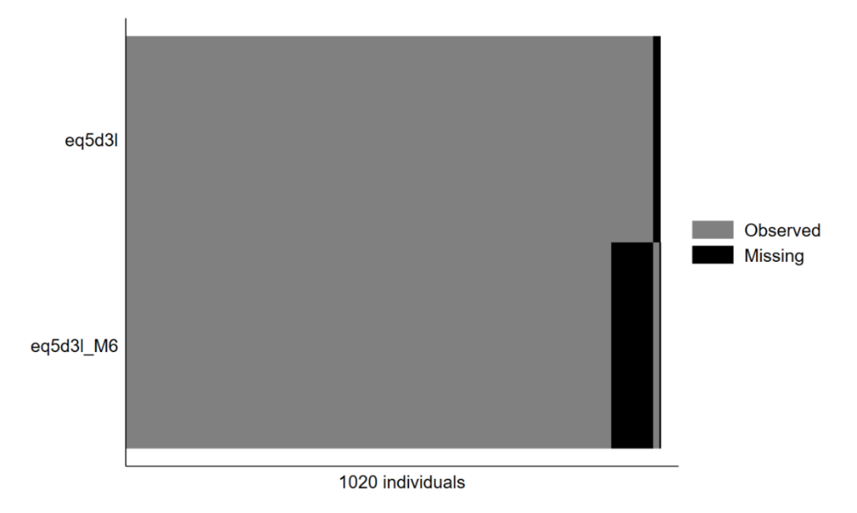
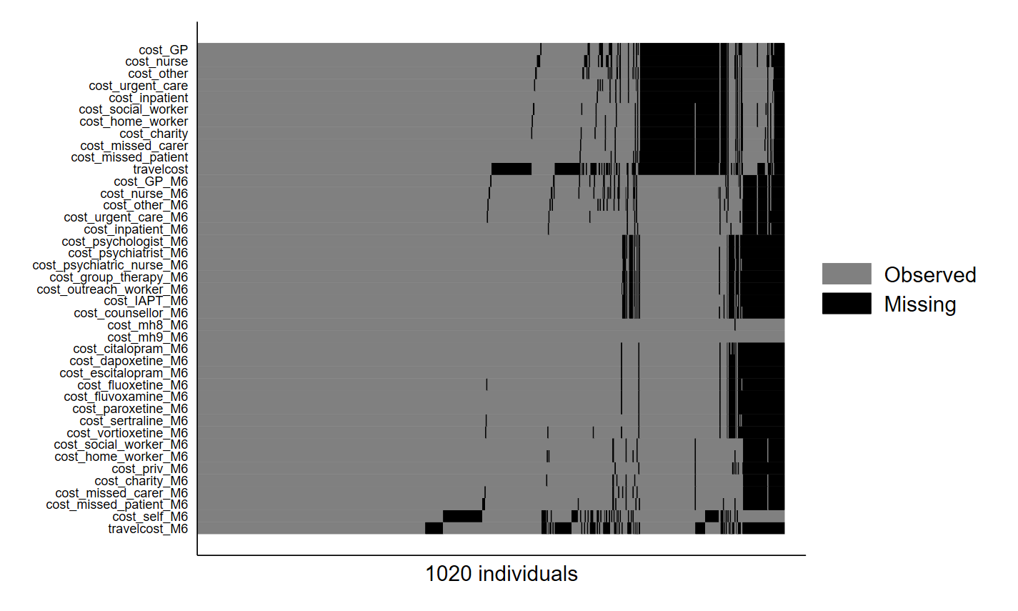
According to the missing pattern, the following categories of data were imputed as a whole because they exhibited similar missing pattern, indicating that they could be imputed aggregately:
- cost_community_M0: cost_GP, cost_nurse, cost_other
- cost_hospital_M0: cost_urgent_care, cost_inpatient
- cost_PSS_M0: cost_social_worker, cost_home_worker
- cost_broader_M0: cost_charity, cost_missed_carer, cost_missed_patient
- cost_travel_M0: travelcost
- cost_community_M6: cost_GP_M6, cost_nurse_M6, cost_other_M6
- cost_hospital_M6: cost_urgent_care_M6, cost_inpatient_M6
- cost_mh_M6: cost_psychologist_M6 - cost_mh9_M6
- cost_med_M6: cost_citalopram_M6 - cost_vortioxetine_M6
- cost_PSS_M6: cost_social_worker_M6, cost_home_worker_M6
- cost_broader_M6: cost_priv_M6, cost_charity_M6, cost_missed_carer_M6, cost_missed_patient_M6
- cost_self_M6: cost_self_M6
- cost_travel_M6: travelcost_M6

Appendix E. Average resource use by treatment group and assessment points: complete case (N=392)
Variable | Unit | Time point, mean (SD)
 |  | Baseline |  | 6-month
 |  | SoC  (n=356) | SG  (n=36) | SoC  (n=356) | SG  (n=36)
NHS and PSS
Community-based
GP consultation | session | 0.00 (0.00) | 0.06 (0.23) | 0.00 (0.05) | 0.22 (0.72)
Nurse consultation | session | 0.00 (0.00) | 0.00 (0.00) | 0.01 (0.07) | 0.00 (0.00)
Other consultation | session | 0.00 (0.00) | 0.03 (0.17) | 0.01 (0.16) | 0.06 (0.23)
Hospital-based
AE & Urgent Care  Centre | visit | 0.01 (0.26) | 0.00 (0.00) | 0.00 (0.00) | 0.00 (0.00)
Inpatient overnight | night | 0.00 (0.00) | 0.00 (0.00) | 0.00 (0.00) | 0.00 (0.00)
PSS-based care
Social worker | visit | 0.00 (0.00) | 0.00 (0.00) | 0.00 (0.00) | 0.08 (0.50)
Home worker | visit | 0.01 (0.07) | 0.25 (1.20) | 0.02 (0.37) | 0.44 (2.35)
NHS mental health services
Psychologist | session | - | - | 0.00 (0.00) | 0.00 (0.00)
Psychiatrist | session | - | - | 0.00 (0.00) | 0.00 (0.00)
Psychiatric nurse | session | - | - | 0.00 (0.00) | 0.00 (0.00)
Group therapy | session | - | - | 0.00 (0.00) | 0.00 (0.00)
Outreach worker | session | - | - | 0.01 (0.17) | 0.03 (0.17)
IAPT service | session | - | - | 0.00 (0.00) | 0.00 (0.00)
Counsellor | session | - | - | 0.04 (0.64) | 0.00 (0.00)
Medications
Citalopram | £ | - | - | 0.00 (0.00) | 0.00 (0.00)
Dapoxetine | £ | - | - | 0.00 (0.00) | 0.00 (0.00)
Escitalopram | £ | - | - | 0.00 (0.00) | 0.00 (0.00)
Fluoxetine | £ | - | - | 0.00 (0.00) | 0.00 (0.00)
Fluvoxamine | £ | - | - | 0.00 (0.00) | 0.00 (0.00)
Paroxetine | £ | - | - | 0.00 (0.00) | 0.00 (0.00)
Sertraline | £ | - | - | 0.00 (0.00) | 1.81 (10.83)
Vortioxetine | £ | - | - | 0.00 (0.00) | 0.00 (0.00)
Private perspective
Charity | contact | 0.01 (0.17) | 0.14 (0.68) | 0.01 (0.12) | 0.44 (2.67)
Missed work of carers | day | 0.00 (0.05) | 0.14 (0.59) | 0.00 (0.00) | 0.33 (1.69)
Missed work of patients | Day | 0.00 (0.00) | 0.00 (0.00) | 0.00 (0.00) | 0.00 (0.00)
Private mental health services | session | - | - | 0.00 (0.00) | 0.00 (0.00)
Self-care
Dietary changes | £ | - | - | 2.02 (19.06) | 5.56 (33.33)
Exercise | £ | - | - | 14.71 (73.14) | 4.17 (25.00)
Herbal, homeopathic  or over the counter  medication | £ | - | - | 1.69 (12.67) | 1.39 (5.93)
Hobbies/activities | £ | - | - | 24.54 (104.99) | 27.50 (80.51)
Websites or online  resources | £ | - | - | 1.76 (18.41) | 2.22 (13.33)
Online forums or  online support groups | £ | - | - | 0.00 (0.00) | 0.00 (0.00)
Online videos (e.g.  YouTube) | £ | - | - | 0.20 (2.85) | 0.00 (0.00)
Apps | £ | - | - | 0.17 (2.70) | 0.28 (1.67)
Podcasts | £ | - | - | 0.00 (0.00) | 0.00 (0.00)
Support network  (friends/family) | £ | - | - | 0.14 (2.18) | 1.11 (6.67)
Self-help book | £ | - | - | 0.05 (0.90) | 0.03 (0.17)
Mindfulness | £ | - | - | 0.00 (0.00) | 0.00 (0.00)
Meditation | £ | - | - | 1.46 (26.52) | 16.67 (100.00)
Journaling/keeping a  diary | £ | - | - | 0.01 (0.26) | 0.28 (1.67)
Abbreviations: SD, standard deviation; SoC, standard of care; SOG, screening + alerting participants and GP.

