SUPPLEMENTARY MATERIAL

SUPLLEMENTARY TABLES

 | Mood disorder | Anxiety  disorder | Internalising disorders
Help-seeking | 169,330 (33.70%) | 169,330 (33.70%) | 169,330 (33.70%)
Minimal | 31,214 (19.84%) | 22,472 (14.28%) | 48,819 (31.03%)
Primary care | 50,708 (22.06%) | 30,829 (13.41%) | 60,490 (26.32%)
Hospital | 30,585  (6.92%) | 22,837  (5.16%) | 40,753  (9.21%)
Medications | 34,266  (9.14%) | 35,659  (9.51%) | 36,244  (9.83%)
Initial self-report | 27,411  (7.31%) | 6,502  (1.73%) | 31,869  (7.74%)
MHQ self-report | 32,408 (20.60%) | 26,902 (17.10%) | 46,514 (29.57%)
CIDI-SF | 36,374 (23.12%) | 10,334  (6.57%) | 38,887 (24.71%)
Supplementary Table 1. Number of individuals endorsing each definition of mood, anxiety and internalising disorder and prevalence of each definition. For each definition, individuals with missing values were removed from the prevalence calculation.
.

 | Total |  | Cases |  | Prevalence
 | Female | Male | Female | Male | Female | Male
Help-seeking | 273,325 | 269,710 | 109,863 | 58,249 | 40.7% | 25.8%
Minimal | 88,141 | 67,514 | 32,595 | 15,984 | 36.9% | 23.7%
Primary care | 123,980 | 102,727 | 39,073 | 21,157 | 31.5% | 20.6%
Hospital | 239,651 | 196,913 | 25,654 | 14,093 | 10.7% | 7.2%
Medications | 270,157 | 226,255 | 24,598 | 11,108 | 9.1% | 4.9%
Initial self-report | 270,157 | 226,255 | 20,931 | 10,564 | 7.8% | 4.7%
MHQ self-report | 88,141 | 67,514 | 31,290 | 15,121 | 35.5% | 22.4%
CIDI-SF | 88,141 | 67,514 | 26,714 | 12,086 | 30.3% | 17.9%
Supplementary Table 2. Number of individuals endorsing each definition and prevalence of internalising disorders for each definition. For each definition, individuals with missing values were removed from the prevalence calculation.
 | MDD PRS |  |  |  | Anxiety PRS
 | OR  (95% CI) | p-value |  | AUC | OR  (95% CI) | p-value |  | AUC
Help-seeking | 1.19  (1.18-1.20) | <10⁻³⁰⁰ |  | 0.6133 | 1.09  (1.08-1.09) | 7.57x10⁻¹³⁹ |  | 0.6036
Minimal | 1.20  (1.18-1.21) | 2.71x10⁻¹⁶⁰ |  | 0.5670 | 1.08  (1.06-1.09) | 3.14x10⁻³¹ |  | 0.5528
Primary care | 1.19  (1.17-1.20) | 9.43x10⁻¹⁹⁹ |  | 0.5594 | 1.08  (1.07-1.09) | 7.84x10⁻⁴³ |  | 0.5440
Hospital | 1.20  (1.19-1.22) | 2.15x10⁻¹⁶⁹ |  | 0.5591 | 1.09  (1.07-1.10) | 8.85x10⁻³⁹ |  | 0.5371
Medications | 1.20  (1.19-1.22) | 1.51x10⁻¹⁹² |  | 0.5582 | 1.10  (1.08-1.11) | 6.57x10⁻⁵⁴ |  | 0.5356
Initial self-report | 1.21  (1.19-1.22) | 5.72x10⁻¹⁷⁹ |  | 0.5752 | 1.09  (1.07-1.10) | 1.08x10⁻³⁴ |  | 0.5610
MHQ self-report | 1.21  (1.19-1.22) | 3.12x10⁻¹⁶⁰ |  | 0.5797 | 1.08  (1.06-1.09) | 1.26x10⁻²⁴ |  | 0.5665
CIDI-SF | 1.18  (1.17-1.20) | 6.67x10⁻¹³⁶ |  | 0.5993 | 1.07  (1.06-1.08) | 3.23x10⁻²⁴ |  | 0.5915
Supplementary Table 3. Association metrics of the adjusted MDD and anxiety PRS with the eight definitions of mood disorder.

 | MDD PRS |  |  |  | Anxiety PRS
 | OR  (95% CI) | p-value |  | AUC | OR  (95% CI) | p-value |  | AUC
Help-seeking | 1.19  (1.18-1.20) | <10⁻³⁰⁰ |  | 0.6135 | 1.09  (1.08-1.09) | 7.57x10⁻¹³⁹ |  | 0.6036
Minimal | 1.15  (1.13-1.17) | 3.94x10⁻⁷⁷ |  | 0.6012 | 1.06  (1.04-1.07) | 6.14x10⁻¹⁴ |  | 0.5960
Primary care | 1.16  (1.15-1.18) | 1.05x10⁻¹⁰⁸ |  | 0.5512 | 1.09  (1.07-1.10) | 2.89x10⁻³⁷ |  | 0.5368
Hospital | 1.17  (1.15-1.29) | 9.00x10⁻⁹⁴ |  | 0.5496 | 1.08  (1.06-1.09) | 2.86x10⁻²³ |  | 0.5320
Medications | 1.20  (1.19-1.22) | 8.56x10⁻¹⁹⁹ |  | 0.5582 | 1.10  (1.08-1.11) | 1.42x10⁻⁵⁴ |  | 0.5356
Initial self-report | 1.17  (1.14-1.21) | 7.96x10⁻³¹ |  | 0.5659 | 1.10  (1.07-1.13) | 6.85x10⁻¹³ |  | 0.5574
MHQ self-report | 1.16  (1.14-1.18) | 2.05x10⁻⁸⁷ |  | 0.5504 | 1.08  (1.07-1.10) | 4.66x10⁻²⁸ |  | 0.5382
CIDI-SF | 1.21  (1.18-1.24) | 1.76x10⁻⁶³ |  | 0.6075 | 1.07  (1.05-1.09) | 4.49x10⁻¹⁰ |  | 0.5969
Supplementary Table 4. Association metrics of the adjusted MDD and anxiety PRS with the eight definitions of anxiety disorder.

 | MDD PRS |  |  | Anxiety PRS
 | OR | p-value | AUC | OR | p-value | AUC
Help-seeking | 1.19 | <10⁻³⁰⁰ | 0.6094 | 1.08 | 5.97x10⁻¹³⁷ | 0.5990
Minimal | 1.20 | 1.27x10⁻²⁴⁶ | 0.6279 | 1.08 | 9.52x10⁻⁴⁸ | 0.6206
Primary care | 1.18 | 3.37x10⁻²⁰⁹ | 0.5978 | 1.08 | 1.18x10⁻⁵⁴ | 0.5892
Hospital | 1.19 | 3.16x10⁻¹⁹⁰ | 0.5806 | 1.08 | 1.34x10⁻⁴⁴ | 0.5682
Medications | 1.19 | 1.01x10⁻¹⁹² | 0.6059 | 1.09 | 2.55x10⁻⁵³ | 0.5939
Initial self-report | 1.19 | 4.29x10⁻¹⁷⁰ | 0.5951 | 1.08 | 6.90x10⁻⁴⁰ | 0.5901
MHQ self-report | 1.20 | 2.31x10⁻¹⁹³ | 0.6093 | 1.08 | 5.32x10⁻³⁷ | 0.5998
CIDI-SF | 1.18 | 2.11x10⁻¹⁴⁷ | 0.6328 | 1.06 | 5.70x10⁻²⁴ | 0.6265
Supplementary Table 5. Association metrics of the adjusted MDD and anxiety PRS with the eight definitions of internalising disorders in individuals of European ancestry.

 | Total N | With NDD CNV
Total | 25,935 | 296
Help-seeking | 6,654 | 67
Minimal | 2,030 | 13
Primary care | 2,360 | 37
Hospital | 1,837 | 26
Medications | 1,284 | 14
Initial self-report | 1,153 | 17
MHQ self-report | 1,111 | 4
CIDI-SF | 1,029 | 9

Supplementary Table 6. Number of individuals of non-European ancestry with each of the definitions of internalising disorder.

 | Unadjusted  PRS |  |  |  |  | Adjusted PRS
 | MDD PRS |  | Anxiety PRS |  |  | MDD PRS |  | Anxiety PRS
 | OR | p-value | OR | p-value |  | OR | p-value | OR | p-value
Help-seeking | 1.11 | 2.51x10⁻¹² | 1.04 | 2.04x10⁻³ |  | 1.14 | 1.48x10⁻¹² | 1.07 | 2.61x10⁻³
Minimal | 1.13 | 2.83x10⁻⁷ | 1.07 | 6.32x10⁻³ |  | 1.16 | 1.62x10⁻⁷ | 1.11 | 4.68x10⁻³
Primary care | 1.09 | 5.90x10⁻⁴ | 1.01 | 0.833 |  | 1.11 | 1.82x10⁻⁴ | 1.01 | 0.811
Hospital | 1.15 | 2.70x10⁻⁸ | 1.07 | 7.60x10⁻³ |  | 1.19 | 1.20x10⁻⁸ | 1.12 | 2.11x10⁻³
Medications | 1.16 | 7.03x10⁻⁷ | 1.05 | 0.077 |  | 1.12 | 2.72x10⁻⁷ | 1.09 | 0.067
Initial self-report | 1.19 | 3.71x10⁻⁸ | 1.06 | 0.052 |  | 1.23 | 2.69x10⁻⁸ | 1.10 | 0.045
MHQ self-report | 1.14 | 2.48x10⁻⁴ | 1.03 | 0.357 |  | 1.17 | 1.71x10⁻⁴ | 1.05 | 0.421
CIDI-SF | 1.14 | 4.37x10⁻⁴ | 1.04 | 0.279 |  | 1.17 | 4.21x10⁻⁴ | 1.06 | 0.319

Supplementary Table 7. Association metrics of the ancestry adjusted and unadjusted MDD and anxiety PRS with the eight definitions of internalising disorders in individuals of non-European ancestry.

 | Help-seeking
Primary care | 1.27x10⁻¹¹ | Primary care
Hospital | 2.73x10⁻²⁶ | 1.12x10⁻³ | Hospital
Medications | 1.96x10⁻¹³ | 0.398 | 0.143 | Medications
Initial self-report | 7.87x10⁻¹⁵ | 0.186 | 0.371 | 0.427 | Initial self-report
MHQ self-report | 9.80x10⁻⁵ | 0.198 | 7.15x10⁻⁵ | 0.325 | 0.526

Supplementary Table 8. P-values of pairwise comparisons of effect sizes of P-CNV between the definitions of internalising disorder. The two definitions of internalising disorder that were not significantly associated with the presence of a P-CNV (Minimal and CIDI-SF) were not included in this analysis

CNV | Count
Any | 7,549
TAR_del | 80
TAR_dup | 463
1q21.1del | 119
1q21.1dup | 193
NRXN1del | 176
2q11.2del | 34
2q13del | 57
2q13dup | 73
3q29del | 9
WBS_dup | 16
8p23.1dup | 16
15q11.2del | 1,748
5q11.2dup | 2,284
PWS_dup | 19
15q13.3del | 47
22q11.2distal_dup | 14
15q24dup | 9
16p13.11del | 140
16p13.11dup | 888
16p12.1del | 260
16p11.2distal_del | 62
16p11.2distal_dup | 143
16p11.2del | 123
6p11.2dup | 142
17p13.3_YWHAEdel | 27
17p13.3_YWHAEdup | 8
Potocki_Lupski | 6
17q11.2del_NF1 | 10
17q12del | 9
17q12dup | 104
22q11.2del | 10
22q11.2dup | 294
2q11.2distal_del | 14

Supplementary Table 9. Number of individuals with each of the 33 P-CNVs

 | MDD PRS |  | Anxiety PRS
 | OR | p-value | OR | p-value
Help-seeking | 0.991 | 0.746 | 1.013 | 0.605
Minimal | 0.970 | 0.498 | 0.972 | 0.521
Primary care | 0.992 | 0.836 | 0.961 | 0.317
Hospital | 1.001 | 0.891 | 0.984 | 0.698
Medications | 1.103 | 0.031 | 1.074 | 0.100
Initial self-report | 1.028 | 0.552 | 1.045 | 0.336
MHQ self-report | 1.060 | 0.275 | 0.979 | 0.668
CIDI-SF | 1.072 | 0.220 | 0.948 | 0.325
Supplementary Table 10. Association metrics of the interaction term of presence of NDD CNV with MDD and anxiety PRS for the eight definitions of internalising disorders.

SUPPLEMENTARY FIGURES

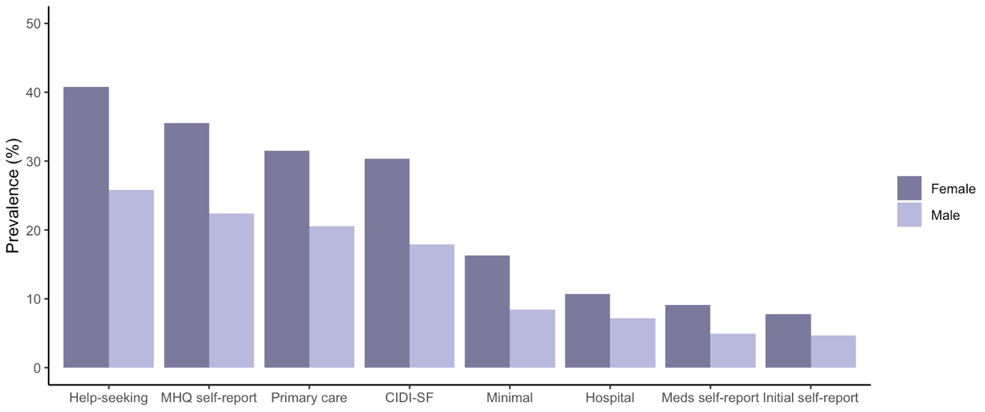
Supplementary Figure 1. Prevalence of each definition of internalising disorder by gender. For each definition, individuals with missing values were removed from the prevalence calculation.

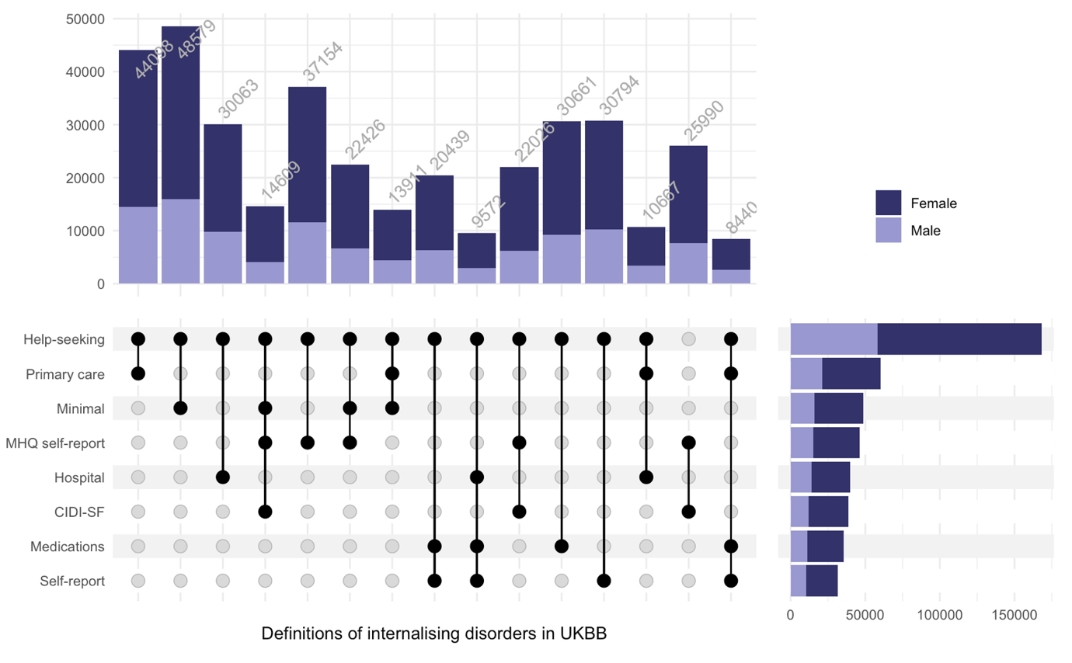
Supplementary Figure 2. Upset plot of the combinations of internalising disorder definitions.

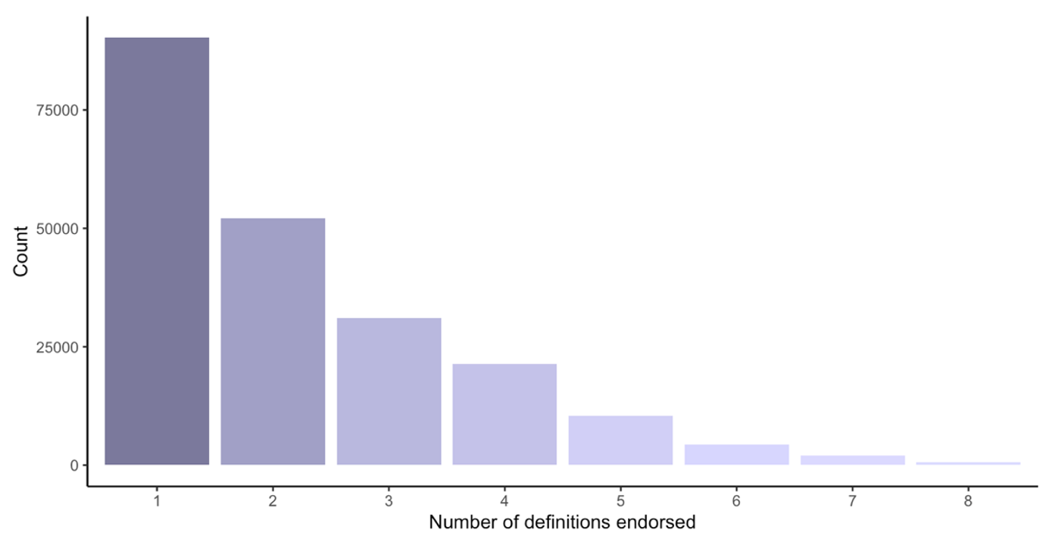
Supplementary Figure 3. Number of internalising disorder definitions endorsed by UKBB participants.

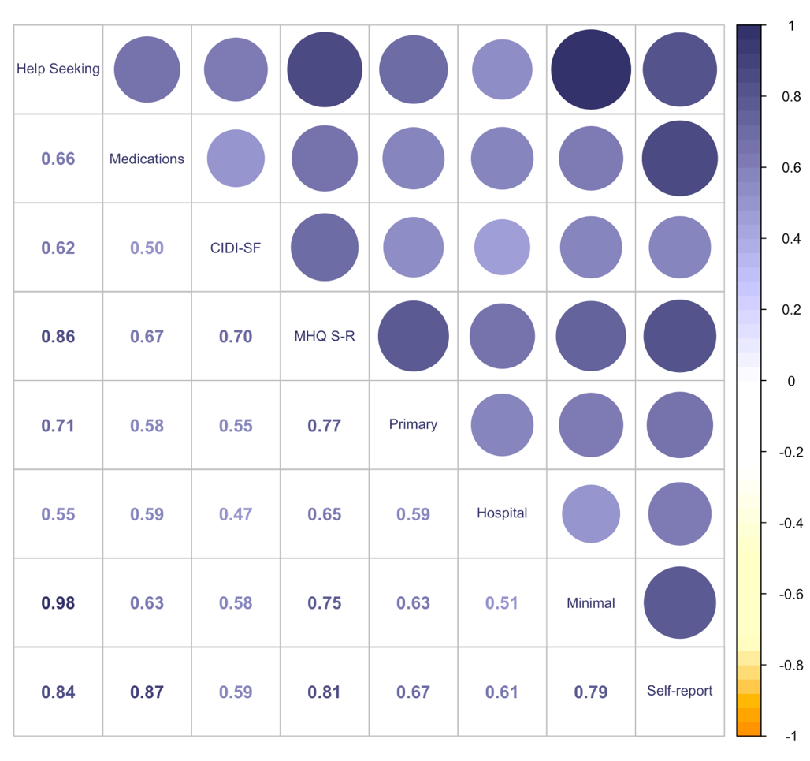
Supplementary Figure 4. Correlation plot of the eight internalising disorder definitions.

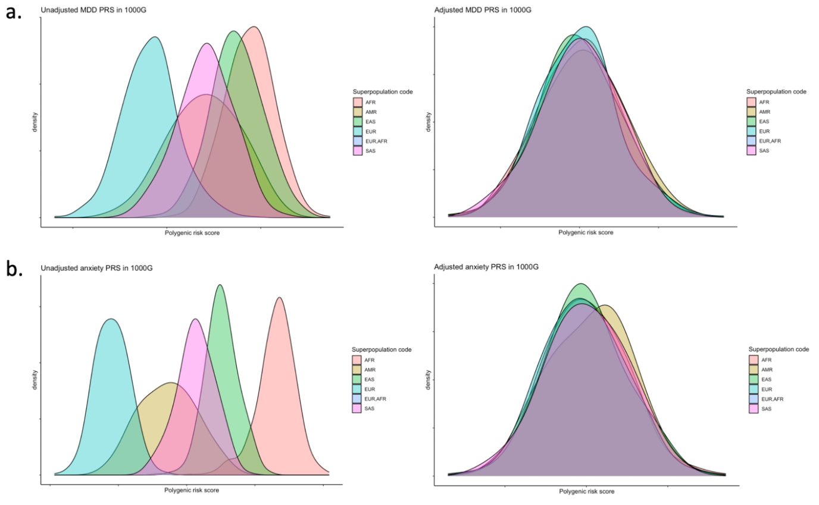
Supplementary Figure 5. Distribution of adjusted and unadjusted PRS of a. MDD and b. anxiety disorder in 1000 genomes populations.

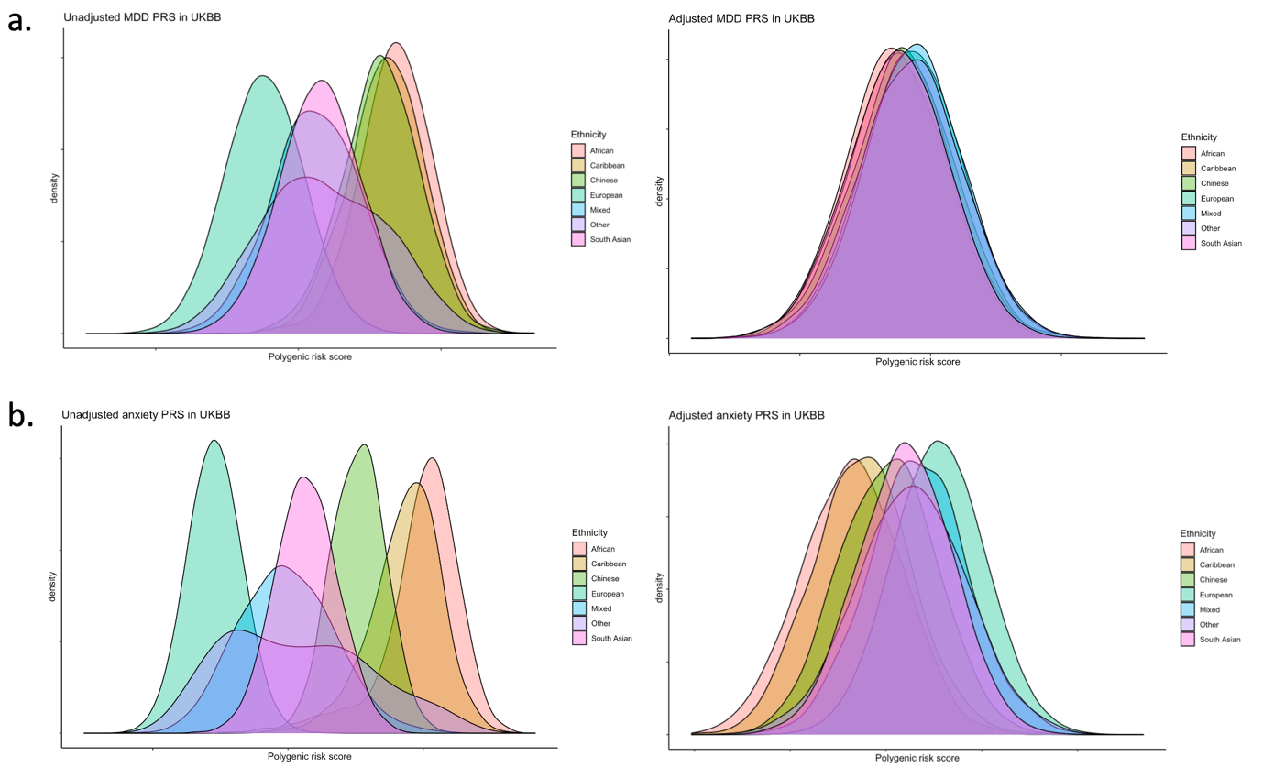
Supplementary Figure 6. Distribution of adjusted and unadjusted PRS of a. MDD and b. anxiety disorder in self-reported UKBB ethnicities.

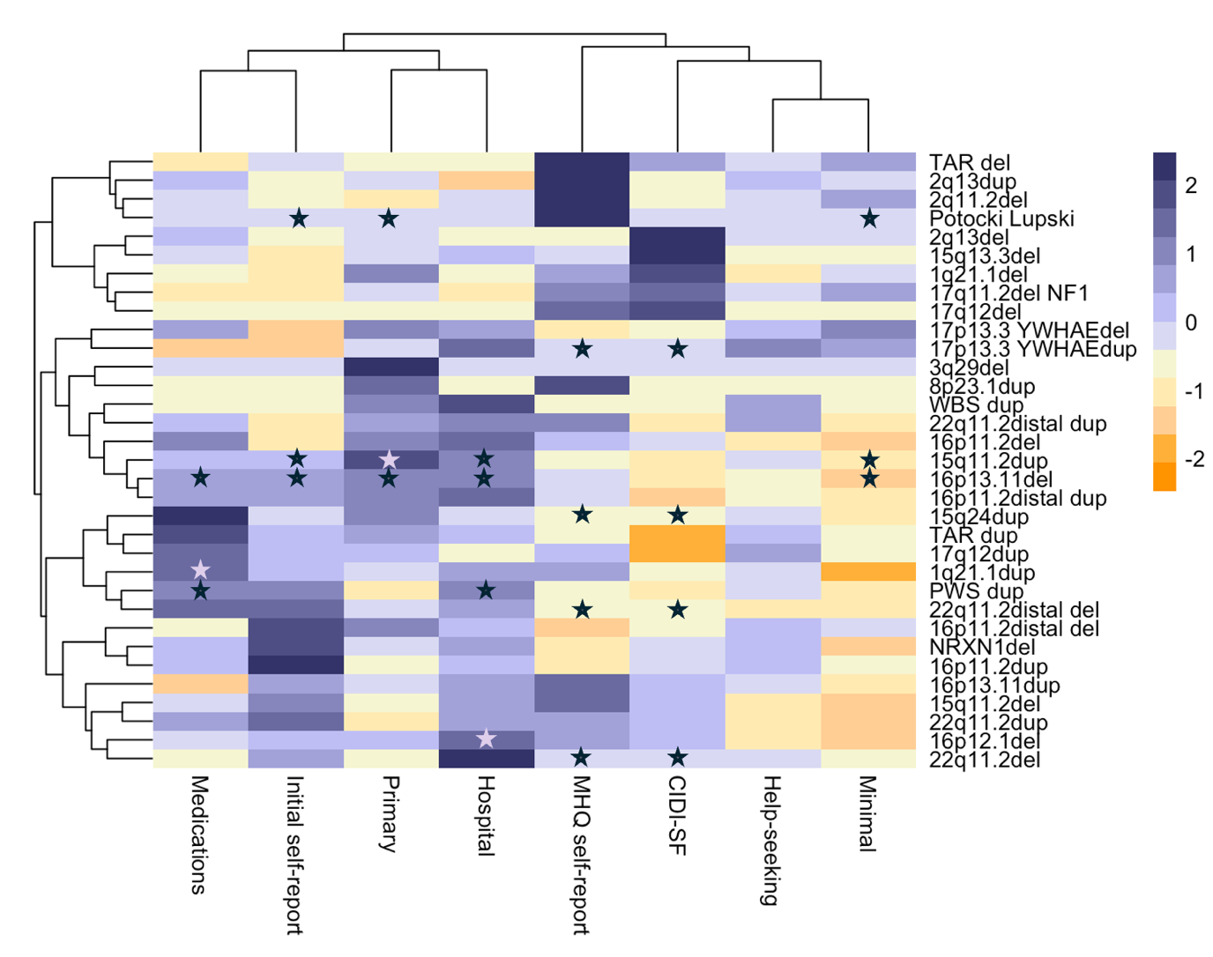
Supplementary Figure 7. Clustered heatmap of the scaled odds ratios of the logistic regression of the 33 NDD CNVs with the eight internalising disorder definitions. The stars indicate a significant association after Bonferroni correction for multiple testing (Bonferroni-corrected p-value threshold = 1.89x10^{-4,} N tests = 284).

