Supplementary materials

Supplementary Table 1. Cohort characteristics
Variable | Cohort characteristics (n=576)
Gender  Male  Female | 52.8%  47.2%
Age (Mean ± SD) | 76.6 ± 8.5
Marital Status  Married  Cohabiting  Civil Partnership  Divorced  Separated  Single  Widowed  NA | 51.91%  0.52%  0.52%  5.38%  1.56%  4.69%  24.83%  10.69%
Ethnicity  White  Mixed  Asian  Black  Other  Unknown | 89.58%  0.69%  1.91%  0.17%  0.69%  6.94%
Total HoNOS score (Mean ± SD)  Individual HoNOS categories (Mode)  Behaviour  Selfharm  Subs (Substances)  Cognitive  Disability  Hallucinations  Depressed  Other  Relationships  ADL  Living Conditions  Occupation | 13.5 ± 5.5  1  1  0  2  0  0  0  0  0  2  0  0
Cognitive Test Scores (Mean ± SD)  ACE  Mini-ACE  MMSE | 61.3 ± 17.9  13.4 ± 8.1  19.7 ± 6.5
IMD Deciles (Mode) | 6
ICD-10 Diagnosis code  Alzheimer’s disease (F00-, G30-)  Vascular dementia (F01)  Other dementia (F02)  Unspecified dementia (F03) | 64.41%  18.23%  7.99%  9.38%
Prescriptions*  Donepezil  Rivastigmine  Galantamine  Memantine  Risperidone  Mirtazapine  Citalopram  Sertraline  Trazodone | 39.41%  16.67%  6.08%  57.81%  59.55%  46.70%  30.03%  23.78%  6.77%

Table 1. Baseline characteristics of the cohort.
*”Prescriptions” refer to whether the patient had been prescribed a drug from the following list in their lifetime before admission to the DMHW.

Supplementary Table 2. Comparison between the two groups.

Variable | No death within a year (n=457) | Death within a year (n=119) | P-value
Gender  Male  Female | 48%  52% | 42.2%  57.8% | < 0.001 ***
Age (Mean ± SD) | 75.9 ± 8.67 | 79.0 ± 7.51 | < 0.001 ***
Marital Status  Married  Cohabiting  Civil Partnership  Divorced  Separated  Single  Widowed  NA | 50.3%  0.7%  0.4%  6.1%  1.5%  5.1%  25.8%  10.1% | 58%  0%  0.8%  2.5%  1.7%  3.4%  21%  12.6% | 0.46
Total HoNOS score (Mean ± SD)  Individual HoNOS categories (Mode)  Behaviour  Selfharm  Subs (Substances)  Cognitive  Disability  Hallucinations  Depressed  Other  Relationships  ADL  Living Conditions  Occupation | 13.4 ± 5.48  1  1  0  2  0  0  0  0  0  1  0  0 | 13.9 + 5.82  1  1  0  2  2  0  0  0  0  2  0  0 | 0.55  0.44  0.13  0.62  0.22  0.009 **  0.42  0.78  0.83  0.53  0.84  0.90  0.95
Cognitive Test Scores (Mean ± SD)  ACE  Mini-ACE  MMSE | 60.5 ± 18.4  10.8 ± 7.97  19.8 ± 6.55 | 66.0 ± 14.0  10.0 ± 10.0  19.2 ± 6.70 | 0.20  0.61  0.61
IMD Deciles (Mode) | 6 | 6, 7 | 0.89
ICD-10 Diagnosis code  Alzheimer’s disease (F00-, G30-)  Vascular dementia (F01)  Other dementia (F02)  Unspecified dementia (F03) | 63%  18.9%  8.5%  9.6% | 69.7%  16%  5.9%  8.4% | 0.56
Lifelong prescription  Donepezil  Rivastigmine  Galantamine  Memantine  Risperidone  Mirtazapine  Citalopram  Sertraline  Trazodone | 39.8%  16.2%  5.7%  58.2%  62.3%  48.4%  32.2%  25.6%  7.2% | 37.8%  18.5%  7.6%  56.3%  52.9%  40.3%  21.8%  16.8%  5% | 0.77  0.65  0.58  0.79  0.12  0.14  0.03 *  0.06 *  0.53

The table summarises statistical differences between the two groups. P-values were obtained after t-tests or Mann-Whitney U tests when appropriate for continuous variables, chi-squared tests or Fisher’s exact tests when appropriate for categorical variables, and Mann-Whitney U tests were used for ordinal variables.

Supplementary Table 3. Comparison between testing and training datasets for ML model.

Variable | dataset (= Test) | dataset (= Train) | dataset (= All) | test_name | test_value | p_value
Age at admission | 79.08 (8.14) | 79.71 (7.94) | 79.62 (7.97) | t.test | -0.76054 | 0.448102
Gender (= Female) | 61 (53.5%) | 325 (49.7%) | 386 (50.3%) | chisq.test | 0.422764 | 0.515561
Gender (= Male) | 53 (46.5%) | 329 (50.3%) | 382 (49.7%) | chisq.test | 0.422764 | 0.515561
Marital status (= TRUE) | 54 (47.4%) | 363 (55.5%) | 417 (54.3%) | chisq.test | 3.37571 | 0.184916
Marital status (= FALSE) | 48 (42.1%) | 218 (33.3%) | 266 (34.6%) | chisq.test | 3.37571 | 0.184916
Marital status (= Not known) | 12 (10.5%) | 73 (11.2%) | 85 (11.1%) | chisq.test | 3.37571 | 0.184916
Ethnicity (= White) | 107 (93.9%) | 575 (87.9%) | 682 (88.8%) | chisq.test | 3.646801 | 0.161476
Ethnicity (= Others) | 1 (0.9%) | 19 (2.9%) | 20 (2.6%) | chisq.test | 3.646801 | 0.161476
Ethnicity (= Unknown) | 6 (5.3%) | 60 (9.2%) | 66 (8.6%) | chisq.test | 3.646801 | 0.161476
IMD (= Most deprived) | 11 (9.6%) | 80 (12.2%) | 91 (11.8%) | chisq.test | 12.06091 | 0.209897
IMD (= 2) | 14 (12.3%) | 95 (14.5%) | 109 (14.2%) | chisq.test | 12.06091 | 0.209897
IMD (= 3) | 17 (14.9%) | 71 (10.9%) | 88 (11.5%) | chisq.test | 12.06091 | 0.209897
IMD (= 4) | 12 (10.5%) | 88 (13.5%) | 100 (13.0%) | chisq.test | 12.06091 | 0.209897
IMD (= 5) | 19 (16.7%) | 105 (16.1%) | 124 (16.1%) | chisq.test | 12.06091 | 0.209897
IMD (= 6) | 12 (10.5%) | 66 (10.1%) | 78 (10.2%) | chisq.test | 12.06091 | 0.209897
IMD (= 7) | 11 (9.6%) | 30 (4.6%) | 41 (5.3%) | chisq.test | 12.06091 | 0.209897
IMD (= 8) | 10 (8.8%) | 55 (8.4%) | 65 (8.5%) | chisq.test | 12.06091 | 0.209897
IMD (= 9) | 4 (3.5%) | 53 (8.1%) | 57 (7.4%) | chisq.test | 12.06091 | 0.209897
IMD (= Least deprived) | 4 (3.5%) | 11 (1.7%) | 15 (2.0%) | chisq.test | 12.06091 | 0.209897
Dementia diagnosis (= Alzheimer's disease) | 72 (63.2%) | 437 (66.8%) | 509 (66.3%) | chisq.test | 2.398058 | 0.493996
Dementia diagnosis (= Other dementia) | 9 (7.9%) | 49 (7.5%) | 58 (7.6%) | chisq.test | 2.398058 | 0.493996
Dementia diagnosis (= Unspecified dementia) | 14 (12.3%) | 52 (8.0%) | 66 (8.6%) | chisq.test | 2.398058 | 0.493996
Dementia diagnosis (= Vascular dementia) | 19 (16.7%) | 116 (17.7%) | 135 (17.6%) | chisq.test | 2.398058 | 0.493996
MMSE | 62.85 (21.51) | 60.72 (22.58) | 61.04 (22.42) | t.test | 0.969174 | 0.333925
ACE | 56.52 (21.30) | 56.82 (20.76) | 56.77 (20.83) | t.test | -0.14115 | 0.887934
Mini-ACE | 38.89 (28.45) | 37.20 (29.05) | 37.45 (28.95) | t.test | 0.582382 | 0.561146
HoNOS Behaviour | 2.12 (1.16) | 2.25 (1.19) | 2.23 (1.19) | t.test | -1.056 | 0.292587
HoNOS SelfHarm | 1.15 (0.52) | 1.09 (0.38) | 1.10 (0.41) | t.test | 1.127289 | 0.261614
HoNOS Subs | 0.07 (0.29) | 0.09 (0.39) | 0.08 (0.37) | t.test | -0.49861 | 0.618625
HoNOS Cognitive | 2.11 (0.97) | 2.20 (0.96) | 2.19 (0.96) | t.test | -0.86442 | 0.388695
HoNOS Disability | 1.35 (1.17) | 1.37 (1.09) | 1.37 (1.10) | t.test | -0.20244 | 0.839851
HoNOS Hallucinations | 0.89 (1.21) | 0.76 (1.04) | 0.78 (1.07) | t.test | 1.154455 | 0.250228
HoNOS Depressed | 0.73 (0.91) | 0.76 (0.89) | 0.76 (0.89) | t.test | -0.39418 | 0.693999
HoNOS Other | 1.32 (1.20) | 1.22 (1.20) | 1.23 (1.20) | t.test | 0.822567 | 0.412016
HoNOS Relationships | 0.97 (0.99) | 0.92 (1.05) | 0.93 (1.04) | t.test | 0.494424 | 0.621684
HoNOS ADL | 1.75 (1.05) | 1.85 (1.13) | 1.83 (1.12) | t.test | -0.85811 | 0.392098
HoNOS Living Conditions | 0.60 (0.95) | 0.44 (0.83) | 0.46 (0.85) | t.test | 1.636701 | 0.103867
HoNOS Occupation | 0.86 (0.94) | 0.82 (0.95) | 0.82 (0.95) | t.test | 0.435809 | 0.663579
Readmission (= 0) | 89 (78.1%) | 557 (85.2%) | 646 (84.1%) | chisq.test | 3.14844 | 0.076
Readmission (= 1) | 25 (21.9%) | 97 (14.8%) | 122 (15.9%) | chisq.test | 3.14844 | 0.076
Donepezil (= FALSE) | 73 (64.0%) | 394 (60.2%) | 467 (60.8%) | chisq.test | 0.437005 | 0.508571
Donepezil (= TRUE) | 41 (36.0%) | 260 (39.8%) | 301 (39.2%) | chisq.test | 0.437005 | 0.508571
Rivastigmine (= FALSE) | 97 (85.1%) | 545 (83.3%) | 642 (83.6%) | chisq.test | 0.108722 | 0.741604
Rivastigmine (= TRUE) | 17 (14.9%) | 109 (16.7%) | 126 (16.4%) | chisq.test | 0.108722 | 0.741604
Galantamine (= FALSE) | 106 (93.0%) | 613 (93.7%) | 719 (93.6%) | chisq.test | 0.008852 | 0.925041
Galantamine (= TRUE) | 8 (7.0%) | 41 (6.3%) | 49 (6.4%) | chisq.test | 0.008852 | 0.925041
Memantine (= FALSE) | 49 (43.0%) | 280 (42.8%) | 329 (42.8%) | chisq.test | 0 | 1
Memantine (= TRUE) | 65 (57.0%) | 374 (57.2%) | 439 (57.2%) | chisq.test | 0 | 1
risperidone (= FALSE) | 40 (35.1%) | 285 (43.6%) | 325 (42.3%) | chisq.test | 2.529539 | 0.111733
risperidone (= TRUE) | 74 (64.9%) | 369 (56.4%) | 443 (57.7%) | chisq.test | 2.529539 | 0.111733
mirtazapine (= FALSE) | 57 (50.0%) | 370 (56.6%) | 427 (55.6%) | chisq.test | 1.444072 | 0.229482
mirtazapine (= TRUE) | 57 (50.0%) | 284 (43.4%) | 341 (44.4%) | chisq.test | 1.444072 | 0.229482
citalopram (= FALSE) | 81 (71.1%) | 468 (71.6%) | 549 (71.5%) | chisq.test | 0 | 1
citalopram (= TRUE) | 33 (28.9%) | 186 (28.4%) | 219 (28.5%) | chisq.test | 0 | 1
sertraline (= FALSE) | 91 (79.8%) | 506 (77.4%) | 597 (77.7%) | chisq.test | 0.210982 | 0.645999
sertraline (= TRUE) | 23 (20.2%) | 148 (22.6%) | 171 (22.3%) | chisq.test | 0.210982 | 0.645999
trazodone (= FALSE) | 105 (92.1%) | 614 (93.9%) | 719 (93.6%) | chisq.test | 0.259451 | 0.610498
trazodone (= TRUE) | 9 (7.9%) | 40 (6.1%) | 49 (6.4%) | chisq.test | 0.259451 | 0.610498
Total number of drug prescriptions | 23.52 (14.10) | 22.68 (10.52) | 22.80 (11.12) | t.test | 0.6065 | 0.545195

Supplementary Figure 1. Flow chart of patients included in the study.

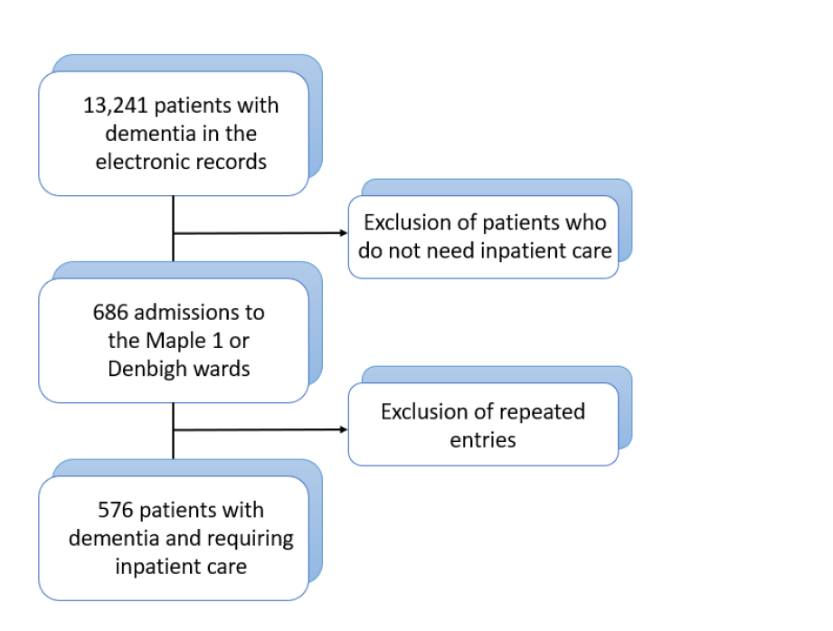

Supplementary Figure 2. Precision of machine learning models.

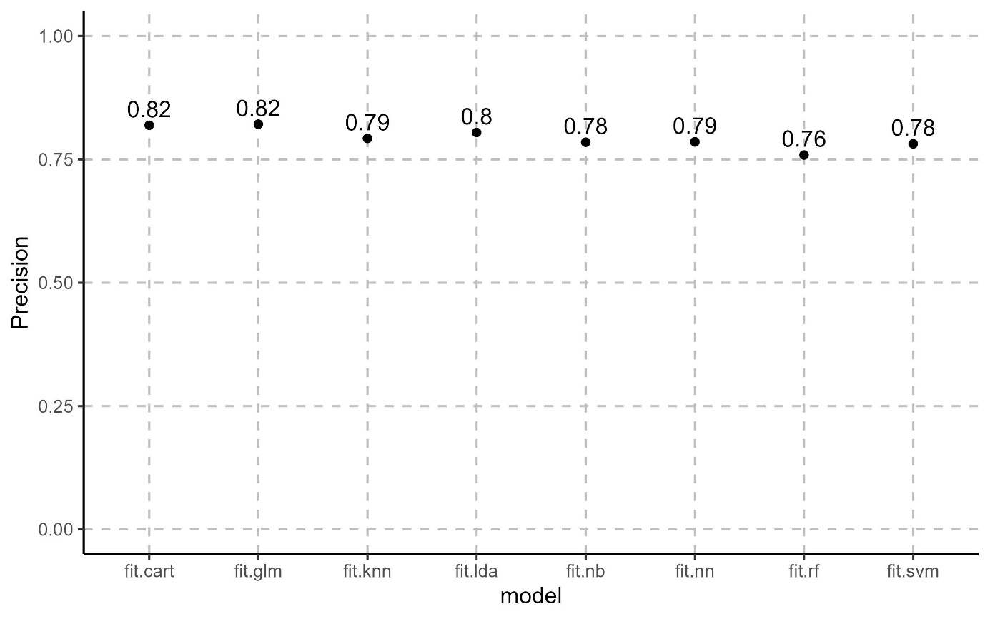

Supplementary Figure 3. Recall of machine learning models

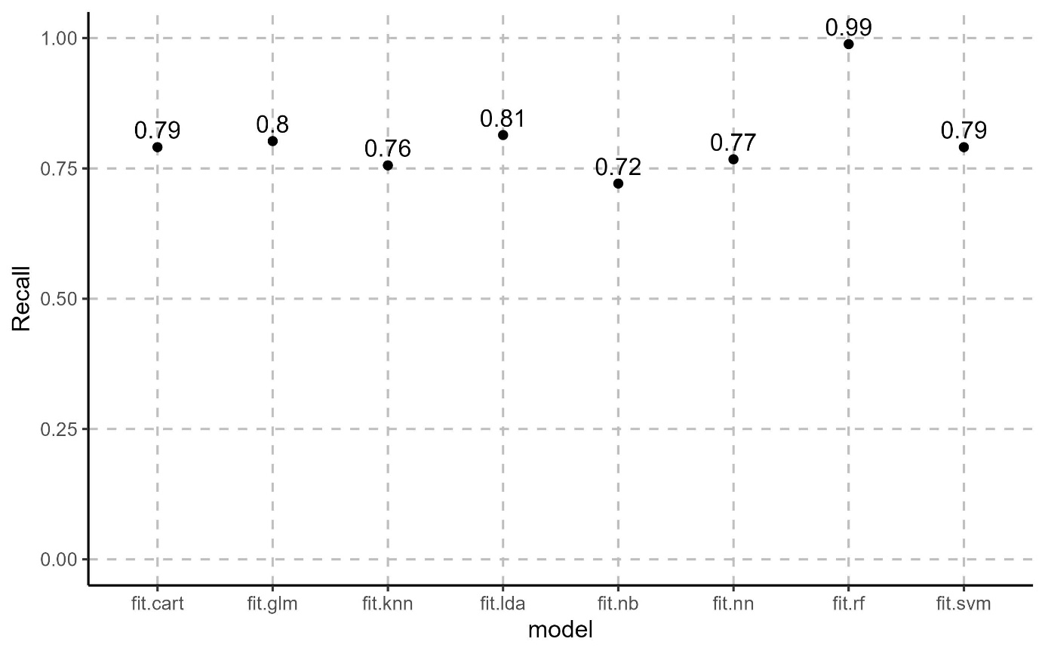

Supplementary Figure 4. Variable importance on the prediction.
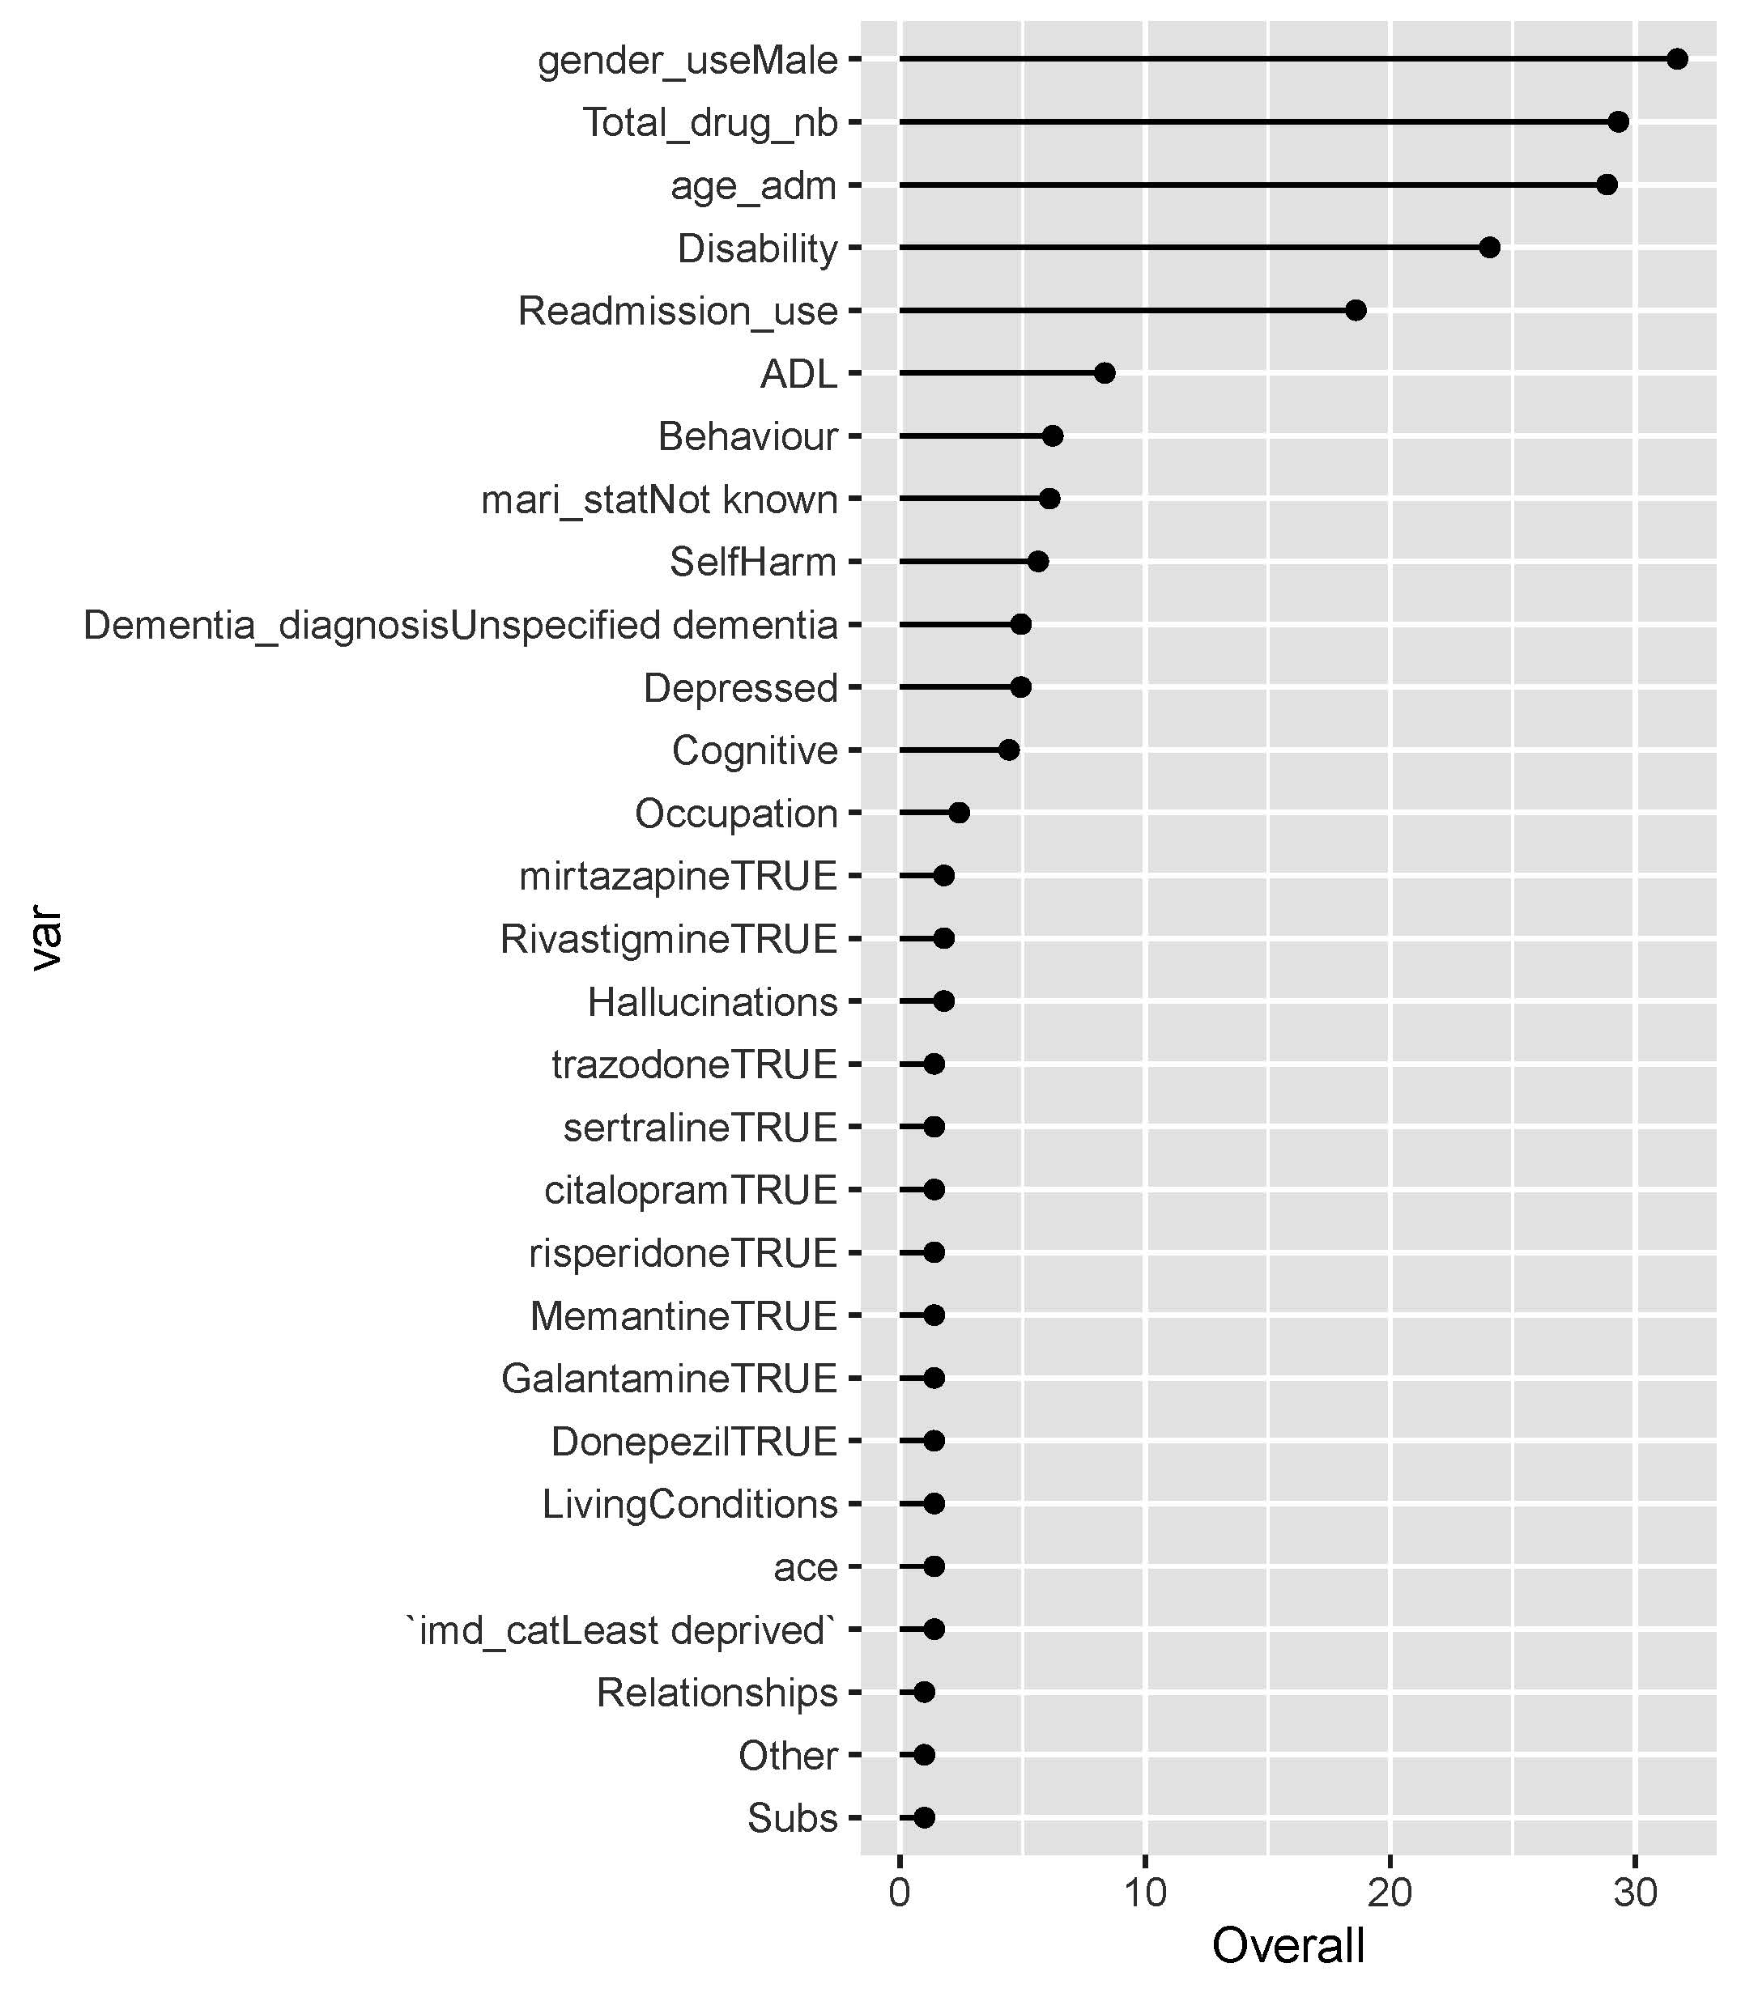
Supplementary Figure 4. Ranking of variables used in the ML model in order of importance. Signification of variable names: “gender_useMale” = gender (category male); ”Total_drug_nb” = total number of drug prescriptions; “age_adm” = age at admission; “Disability”, “ADL”, “Behaviour”, “SelfHarm”, “Depressed”, “Cognitive”, “Occupation”, “Hallucinations” “LivingConditions”, “Other”, “Subs” = HoNOS subcategories; “Readmission_use” = readmission status of patient; “mari_statUnknown” = marital status (category unknown); “Dementia_diagnosisUnspecified dementia” = diagnosis (category unspecified dementia); “trazodoneTRUE”, “sertralineTRUE”, “citalopramTRUE”, risperidoneTRUE, “MemantimeTRUE”, “GalantamineTRUE”, “DonepeziTRUE” = prescription of the corresponding drug; “ace” = score on the ACE; “imd_catLeastdeprived” = IMD (category least deprived).

