Table S1. Sociodemographic characteristics of the sample upon which normative models were built
 | Typically Developing |  | NDCs (n=1298)
 |  |  | Autism | ADHD | OCD | Other
 | (n=338) |  | (n=516) | (n=543) | (n=206) | (n=33)
Mean age in years (sd) | 10.64 (3.11) |  | 11.38 (3.27) | 9.78 (2.76) | 12.09 (2.74) | 10.18 (3.30)
N Males (sex assigned at birth) (%) | 201(59.47%) |  | 401 (77.71%) | 401 (73.84%) | 106 (51.45%) | 24 (72.73%)
N Females (sex assigned at birth) (%) | 137 (40.53%) |  | 115 (22.29%) | 142 (26.15%) | 100 (48.54%) | 9 (27.27%)
Mean FSIQ (sd) | 108.64 (12.75) |  | 96.05 (19.79) | 99.08 (15.30) | 111.11 (10.76) | 74.30 (23.50)
N of individuals with co-occurring conditions (%) (Autism, ADHD, OCD, Communication Disorders, Down Syndrome, ID, Learning Disorders, Motor Disorders, Anxiety Disorders)
0 | 338 |  | 290 (56.20%) | 404 (74.40%) | 148 (71.84%) | 26 (78.79%)
1 | 0 |  | 119 (23.06%) | 72 (13.25%) | 33 (16.02%) | 5 (15.15%)
2 | 0 |  | 67 (12.98%) | 52 (9.58%) | 16 (7.77%) | 1 (3.03%)
3 | 0 |  | 22 (4.26%) | 3 (0.56%) | 7(3.40%) | 1 (3.03%)
4 | 0 |  | 10 (1.94%) | 10 (1.84%) | 2 (0.97%) | 0
5 | 0 |  | 8 (0.16%) | 2 (0.4%) | 0 | 0
Race and Ethnicity in %
Latin American/Hispanic | 2.66 |  | 3.43 | 1.68 | 1.51 | 0
White | 87.94 |  | 83.82 | 93.82 | 95.45 | 100
Black | 2.97 |  | 3.17 | 3.37 | 1.51 | 0
Asian | 7.19 |  | 11.37 | 1.68 | 0 | 0
Jewish | 3.12 |  | 3.70 | 2.24 | 0 | 0
Arab | 0.93 |  | 2.24 | 1.12 | 0 | 0
Aboriginal | 7.84 |  | 6.61 | 12.92 | 1.51 | 0

Note. NDCs = Neurodevelopmental Conditions, ADHD = Attention-Deficit/Hyperactivity Disorder, ID = Intellectual Disability, OCD = Obsessive-Compulsive Disorder, sd = standard deviation, FSIQ = full-scale intelligence quotient. Typically developing sample includes siblings (n = 4), sub-threshold OCD (n = 4) and subthreshold ADHD (n = 111). Other NDCs comprise Tourette syndrome (n = 7), Intellectual Disability (n = 10), Fragile X syndrome (n = 2), Down syndrome (n = 1), and non-specified NDCs (n = 13). Race and ethnicity were collected in line with the way how the Canadian Census data were collected. FSIQ and race-ethnicity data were only available in a reduced number of participants (n = 1156): 312 typically developing participants, 386 autistic participants, 336 ADHD participants, 90 OCD participants and 32 participants with other NDCs. Co-occurring conditions are operationalised as the count of participants with a given number of co-occurring conditions within each diagnostic group.

Table S2. STROBE Statement
 | Item No | Recommendation | Page  No
Title and abstract | 1 | (a) Indicate the study’s design with a commonly used term in the title or the abstract | 1-2
 |  | (b) Provide in the abstract an informative and balanced summary of what was done and what was found | 2
Introduction
Background/rationale | 2 | Explain the scientific background and rationale for the investigation being reported | 4-6
Objectives | 3 | State specific objectives, including any prespecified hypotheses | 5-6
Methods
Study design | 4 | Present key elements of study design early in the paper | 6-9, Figure 1
Setting | 5 | Describe the setting, locations, and relevant dates, including periods of recruitment, exposure, follow-up, and data collection | 6-7
Participants | 6 | (a) Give the eligibility criteria, and the sources and methods of selection of participants | 6-7
Variables | 7 | Clearly define all outcomes, exposures, predictors, potential confounders, and effect modifiers. Give diagnostic criteria, if applicable | 7-9
Data sources/ measurement | 8* | For each variable of interest, give sources of data and details of methods of assessment (measurement). Describe comparability of assessment methods if there is more than one group | 6-10
Bias | 9 | Describe any efforts to address potential sources of bias | 9-12
Study size | 10 | Explain how the study size was arrived at | 6-7
Quantitative variables | 11 | Explain how quantitative variables were handled in the analyses. If applicable, describe which groupings were chosen and why | 9-12
Statistical methods | 12 | (a) Describe all statistical methods, including those used to control for confounding | 9-12
 |  | (b) Describe any methods used to examine subgroups and interactions | 9-12
 |  | (c) Explain how missing data were addressed | 9-12
 |  | (d) If applicable, describe analytical methods taking account of sampling strategy | N/A
 |  | (e) Describe any sensitivity analyses | 12
Results
Participants | 13* | (a) Report numbers of individuals at each stage of study—eg numbers potentially eligible, examined for eligibility, confirmed eligible, included in the study, completing follow-up, and analysed | 12-14
 |  | (b) Give reasons for non-participation at each stage | 9-12
 |  | (c) Consider use of a flow diagram | Figure 1
Descriptive data | 14* | (a) Give characteristics of study participants (eg demographic, clinical, social) and information on exposures and potential confounders | Table 1; Table S1
 |  | (b) Indicate number of participants with missing data for each variable of interest | 6-7, 9-12
Outcome data | 15* | Report numbers of outcome events or summary measures | 12-14
Main results | 16 | (a) Give unadjusted estimates and, if applicable, confounder-adjusted estimates and their precision (eg, 95% confidence interval). Make clear which confounders were adjusted for and why they were included | 12-14
 |  | (b) Report category boundaries when continuous variables were categorized | N/A
 |  | (c) If relevant, consider translating estimates of relative risk into absolute risk for a meaningful time period | N/A
Other analyses | 17 | Report other analyses done—eg analyses of subgroups and interactions, and sensitivity analyses | 14
Discussion
Key results | 18 | Summarise key results with reference to study objectives | 14-15
Limitations | 19 | Discuss limitations of the study, taking into account sources of potential bias or imprecision. Discuss both direction and magnitude of any potential bias | 17-18
Interpretation | 20 | Give a cautious overall interpretation of results considering objectives, limitations, multiplicity of analyses, results from similar studies, and other relevant evidence | 14-18
Generalisability | 21 | Discuss the generalisability (external validity) of the study results | 14-19
Other information
Funding | 22 | Give the source of funding and the role of the funders for the present study and, if applicable, for the original study on which the present article is based | 21
Table S3. Key bibliography guiding statistical analyses and relevant R packages
Analysis performed | Reference | Package
Normative modelling | Marquand AF, Rezek I, Buitelaar J, Beckmann CF. Understanding Heterogeneity in Clinical Cohorts Using Normative Models: Beyond Case-Control Studies. Biological Psychiatry. 2016;80(7):552-561. | Not applicable
Child Behavior Checklist Dysregulation Profile calculation | Ayer L, Althoff R, Ivanova M, Rettew D, Waxler E, Sulman J, et al. Child Behavior Checklist Juvenile Bipolar Disorder (CBCL-JBD) and CBCL Posttraumatic Stress Problems (CBCL-PTSP) scales are measures of a single dysregulatory syndrome. Journal of Child Psychology and Psychiatry. 2009 Oct 1;50(10):1291–300. | Not applicable
Stratified sampling of the training and test sets | Kuhn M. The caret package. R Foundation for Statistical Computing, Vienna, Austria URL https://cran r-project org/package= caret. Published online 2012. | caret
Principal component regression | Mevik BH, Wehrens R. Introduction to the pls Package. Help section of the “Pls” package of R studio software. Published online 2015:1-23. | pls
Selection of optimal number of principal components: one-sigma heuristic | Hastie T, Tibshirani R, Friedman JH, Friedman JH. The Elements of Statistical Learning: Data Mining, Inference, and Prediction. Vol 2. Springer; 2009. | Not applicable
Selection of optimal number of principal components: permutation approach | van der Voet H. Comparing the predictive accuracy of models using a simple randomization test. Chemometrics and intelligent laboratory systems. 1994;25(2):313-323. | Not applicable
Principal component loading significance | Hair JF, Anderson RE, Tatham RL, Black WC. Multivariate Data Analysis With Readings , Englewood Cliffs, NJ: Prentice Hall. Published online 1998. | Not applicable
Mediation | Tingley D, Yamamoto T, Hirose K, Keele L, Imai K. Mediation: R package for causal mediation analysis. Published online 2014. | mediation
Aikake Information Criterion, Bayesian Information Criterion | Vrieze SI. Model selection and psychological theory: a discussion of the differences between the Akaike information criterion (AIC) and the Bayesian information criterion (BIC). Psychological methods. 2012;17(2):228. | Not applicable
Monte Carlo Power Analysis for indirect effects | Schoemann AM, Boulton AJ, Short SD. Monte Carlo Power Analysis for Indirect Effects.; 2020. | Shiny, MASS
Temporal bias assessment for cross-sectional mediation analysis | Georgeson AR, Alvarez-Bartolo D, MacKinnon DP. A sensitivity analysis for temporal bias in cross-sectional mediation. Psychol Methods. 2023 Dec 21. | phantSEM
Table S4. Spearman correlations between T-scores based on the population norm (where available) and z-scores derived from normative modelling based on our sample
Measure | Males | Females
ABAS-II-Social | 0.976 | 0.978
CBCL Anxiety/Depression | 0.976 | 0.994
CBCL Attention | 0.970 | 0.982
CBCL Aggression | 0.966 | 0.984
Note. ABAS-II = Adaptive Behavior Assessment System 2nd Edition.
Table S5. Sociodemographic characteristics of participants in the training (n=324) and test (n=322) sets
 |  | Training set (n=324) | Test set (n=322) | Statistics
Mean age in years (sd) |  | 10.39 (3.03) | 10.61 (2.93) | t = -0.91
N Males (sex assigned at birth) (%) |  | 224 (69.35%) | 228 (70.81%) | X² = 0.01
N Females (sex assigned at birth) (%) |  | 100 (30.86%) | 94 (29.19%) | X² = 0.01
Mean FSIQ (sd) |  | 105.85 (15.88) | 102.10 (15.72) | t = 1.01
Social Cognition
Mean RMET total (sd) |  | -0.33 (1.26) | -0.35 (1.21) | t = -0.26
Mean RMET positive (sd) |  | -0.16 (1.02) | -0.09 (1.00) | t = 0.84
Mean RMET negative (sd) |  | -0.26 (1.06) | -0.19 (1.03) | t = 0.74
Mean RMET neutral (sd) |  | -0.26 (1.14) | -0.35 (1.11) | t = -1.09
Mean NEPSY-II-AR total (sd) |  | -0.20 (1.09) | -0.31(1.15) | t = -1.28
Mean NEPSY-II-AR happy (sd) |  | -0.22(1.28) | -0.30 (1.45) | t = 0.76
Mean NEPSY-II-AR sad (sd) |  | -0.15 (0.95) | -0.1 (0.91) | t = -2.19 *
Mean NEPSY-II-AR neutral (sd) |  | -0.21 (1.11) | -0.11 (1.14) | t = -1.15
Mean NEPSY-II-AR angry (sd) |  | -0.11 (1.02) | -0.11(1.00) | t = -0.09
Mean NEPSY-II-AR fear (sd) |  | -0.02 (1.08) | -0.38 (1.12) | t = 0.27
Mean NEPSY-II-AR disgust (sd) |  | 0.09 (1.01) | 0.14 (0.13) | t = -0.54
Mean NEPSY-II-ToM (sd) |  | -0.55 (1.31) | -0.77 (1.52) | t = -1.94
Mean NEPSY-II-ToM-Verbal |  | -0.49 (1.23) | -0.74 (1.47) | t = -2.34 *
(sd)
Mean NEPSY-II-ToM-Context (sd) |  | -0.29 (1.05) | -0.27 (1.17) | t = 0.13
Mean Sandbox Egocentric Bias (sd) |  | -0.04 (1.09) | -0.03 (0.98) | t = -0.06
Social Behaviours
Mean ABAS-II-Social (sd) |  | -1.81 (1.98) | -1.69 (1.97) | t = 0.77
Dysregulation
Mean CBCL-DP (sd) |  | 6.18 (6.20) | 5.58 (5.75) | t = 1.28
Diagnosis (%)
Autism |  | 107 (33.02%) | 107 (33.22%) | X² = 0.00
ADHD |  | 112 (34.57%) | 112 (34.78%) | X² = 0.00
OCD |  | 25 (7.72%) | 25 (7.76%) | X² = 0.00
Other NDCs |  | 4 (1.23%) | 3 (0.93%) | X² = 0.11
TD |  | 76 (23.46%) | 75 (23.60%) | X² = 0.00
N of individuals with co-occurring conditions (%) (Autism, ADHD, OCD, Communication Disorders, Down Syndrome, ID, Learning Disorders, Motor Disorders, Anxiety)
0 |  | 215 (66.36%) | 223 (69.25%) | X² = 0.45
1 |  | 48 (14.81%) | 37 (11.49%) | X² = 1.25
2 |  | 33 (10.19%) | 45 (13.97%) | X² = 1.88
3 |  | 19 (5.86%) | 11 (3.41%) | X² = 1.64
4 |  | 5 (1.54%) | 3 (0.93%) | X² = 0.11
5 |  | 4 (1.23%) | 3 (0.93%) | X² = 0.00
Note. TD = Typically Developing, sd = standard deviation, FSIQ = Full-scale intelligence quotient, RMET = Reading the Mind in the Eyes Test (child version), NEPSY-II-AR = Neuropsychological Assessment Affect Recognition subscale, NEPSY-II-ToM = Neuropsychological Assessment Theory of Mind subscale, CBCL-DP = Child Behavior Checklist Dysregulation Profile, ABAS-II = Adaptive Behavior Assessment System 2nd Edition, ADHD = Attention-Deficit/Hyperactivity Disorder, OCD = Obsessive-Compulsive Disorder, ID = Intellectual Disability. Other NDCs comprise Tourette syndrome, Intellectual Disability, and non-specified NDCs. ** indicates a p-value < 0.01, * indicates a p-value < 0.05. Significant effects appear in bold.
Table S6. Correlation matrix of data from the training set (n=324)
 | RMET positive | RMET negative | RMET neutral | NEPSY-II-AR happy | NEPSY-II-AR sad | NEPSY-II-AR neutral | NEPSY-II-AR fear | NEPSY-II-AR angry | NEPSY-II-AR disgust | NEPSY-II-ToM-Verbal | NEPSY-II ToM- Contextual | Sandbox Egocentric Bias | CBCL-DP | ABAS-II-Social | Age | FSIQ
RMET positive | 1.000 | - | - | - | - | - | - | - | - | - | - | - | - | - | - | -
RMET negative | 0.219 | 1.000 | - | - | - | - | - | - | - | - | - | - | - | - | - | -
RMET neutral | 0.224 | 0.317 | 1.000 | - | - | - | - | - | - | - | - | - | - | - | - | -
NEPSY-II-AR happy | 0.060 | 0.013 | -0.034 | 1.000 | - | - | - | - | - | - | - | - | - | - | - | -
NEPSY-II-AR sad | -0.098 | -0.093 | -0.058 | -0.049 | 1.000 | - | - | - | - | - | - | - | - | - | - | -
NEPSY-II-AR neutral | 0.000 | 0.006 | -0.023 | -0.047 | 0.174 | 1.000 | - | - | - | - | - | - | - | - | - | -
NEPSY-II-AR fear | 0.086 | 0.045 | 0.065 | 0.083 | 0.054 | 0.163 | 1.000 | - | - | - | - | - | - | - | - | -
NEPSY-II-AR angry | 0.006 | -0.087 | -0.110 | -0.064 | 0.292 | 0.115 | 0.171 | 1.000 | - | - | - | - | - | - | - | -
NEPSY-II-AR disgust | -0.027 | -0.051 | -0.108 | -0.104 | 0.197 | 0.015 | -0.031 | 0.166 | 1.000 | - | - | - | - | - | - | -
NEPSY-II-ToM-Verbal | 0.013 | -0.024 | 0.080 | 0.200 | 0.045 | -0.009 | 0.040 | 0.109 | 0.090 | 1.000 | - | - | - | - | - | -
NEPSY-II-ToM-Contextual | -0.098 | -0.147 | -0.067 | 0.182 | 0.093 | -0.010 | 0.034 | 0.178 | 0.116 | 0.349 | 1.000 | - | - | - | - | -
Sandbox Egocentric Bias | 0.034 | 0.005 | 0.048 | -0.077 | 0.005 | 0.107 | -0.017 | 0.010 | -0.021 | 0.049 | -0.004 | 1.000 | - | - | - | -
CBCL-DP | -0.072 | -0.185 | -0.307 | -0.020 | 0.005 | 0.058 | 0.045 | 0.025 | -0.032 | -0.081 | -0.026 | -0.064 | 1.000 | - | - | -
ABAS-II-Social | 0.137 | 0.197 | 0.274 | -0.011 | -0.052 | -0.005 | 0.031 | 0.028 | 0.058 | 0.183 | 0.040 | 0.124 | -0.598 | 1.000 | - | -
Age | -0.041 | -0.078 | -0.67 | -0.024 | -0.004 | -0.006 | -0.016 | -0.099 | 0.032 | 0.025 | 0.002 | 0.014 | 0.052 | -0.042 | 1.000 | -
FSIQ | -0.020 | -0.16 | 0.046 | 0.011 | -0.101 | -0.054 | 0.039 | 0.007 | 0.031 | 0.013 | 0.013 | 0.094 | -0.081 | 0.066 | -0.001 | 1.000
Note. RMET = Reading the Mind in the Eyes Test (child version), NEPSY-II-AR = Neuropsychological Assessment Affect Recognition subscale, NEPSY-II-ToM = Neuropsychological Assessment Theory of Mind subscale, CBCL-DP = Child Behavior Checklist Dysregulation Profile, ABAS-II = Adaptive Behavior Assessment System 2nd Edition, FSIQ = full-scale intelligence quotient.
Table S7. Effects of dysregulation (CBCL-DP) as a partial mediator of the association between social cognition (Social Cognition Component 2) and social behaviours (ABAS-II-Social), controlling for NDC diagnosis
 | Estimate | Lower CI | Upper CI | p-value
Training set (n=324)
ACME | 0.147 | 0.056 | 0.235 | 0.002
ADE | 0.397 | 0.240 | 0.547 | < 2e-16
Total effect | 0.544 | 0.370 | 0.695 | < 2e-16
Proportion mediated | 0.271 | 0.112 | 0.434 | 0.002
Test set (n=322)
ACME | 0.139 | 0.065 | 0.217 | < 2e-16
ADE | 0.264 | 0.123 | 0.406 | 0.002
Total effect | 0.403 | 0.266 | 0.551 | < 2e-16
Proportion mediated | 0.345 | 0.167 | 0.597 | < 2e-16
Note. CI = confidence interval, ACME = Average Causal Mediation Effect, ADE = Average Direct Effect.

Table S8. Comparison of hierarchical regression Step 2 statistics between the main analysis and sensitivity analyses in the subset aged 16 years and younger and with FSIQ ≥70
 | Main analysis | Sensitivity analysis
Adjusted R² | 0.414 | 0.432
MSE | 2.248 | 1.500
AIC | 1015.360 | 966.764
BIC | 1051.636 | 1002.448
Note. MSE = mean standard error, AIC = Akaike Information Criterion, BIC = Bayesian Information Criterion.

Table S9. Effects of dysregulation (CBCL-DP) as a partial mediator of the association between social cognition (Social Cognition Component 2) and social behaviours (ABAS-II-Social), controlling for full-scale intelligence quotient (FSIQ) and NDC diagnosis, in participants aged 16 years or younger and with FSIQ ≥70
 | Estimate | Lower CI | Upper CI | p-value
Training subset (n=262)
ACME | 0.113 | 0.006 | 0.215 | 0.034
ADE | 0.409 | 0.241 | 0.552 | < 2e-16
Total effect | 0.522 | 0.321 | 0.696 | < 2e-16
Proportion mediated | 0.216 | 0.013 | 0.382 | 0.034
Test subset (n=264)
ACME | 0.168 | 0.073 | 0.258 | 0.002
ADE | 0.248 | 0.089 | 0.410 | < 2e-16
Total effect | 0.411 | 0.253 | 0.590 | < 2e-16
Proportion mediated | 0.395 | 0.191 | 0.670 | 0.002
Note. CI = confidence interval, ACME = Average Causal Mediation Effect, ADE = Average Direct Effect.

Table S10. Stability of hierarchical regression findings when alternating the training and test sets
Coefficients | Estimate | Std. Error | t value | Pr (>|t|)
Step 1
(Intercept) | -1.347 | 0.219 | -6.152 | 2.32e-09
SC Comp 1 | 0.115 | 0.085 | 1.363 | 0.1739
SC Comp 2 | 0.415 | 0.082 | 5.072 | 6.74e-07
Autism | -0.674 | 0.285 | -2.362 | 0.018
ADHD | -0.237 | 0.283 | -0.834 | 0.405 | R² |  | 0.097
OCD | -0.293 | 0.438 | -0.670 | 0.503 | Adj R² |  | 0.080
Other NDC | 0.793 | 1.121 | 0.708 | 0.479 | F |  | 5.686 *
Step 2
(Intercept) | -0.647 | 0.205 | -3.150 | 0.001
SC Comp 1 | 0.119 | 0.074 | 1.599 | 0.110
SC Comp 2 | 0.276 | 0.073 | 3.771 | 0.001
CBCL-DP | -0.165 | 0.017 | -9.706 | < 2e-16
Autism | -0.301 | 0.253 | -1.185 | 0.237
ADHD | -0.123 | 0.249 | -0.496 | 0.620 | R² |  | 0.306
OCD | 0.433 | 0.392 | 1.105 | 0.269 | Adj R² |  | 0.290
Other NDC | 0.207 | 0.987 | 0.210 | 0.834 | F |  | 19.77 *
Note. SC Comp = Social Cognition Component, CBCL-DP = Child Behavior Checklist Dysregulation Profile, ADHD = Attention-Deficit/Hyperactivity Disorder, OCD = Obsessive-Compulsive Disorder, NDC = Neurodevelopmental Conditions. * indicates a p-value < 0.001. Significant effects appear in bold.
Figure S1. Selection of the optimal number of social cognition principal components 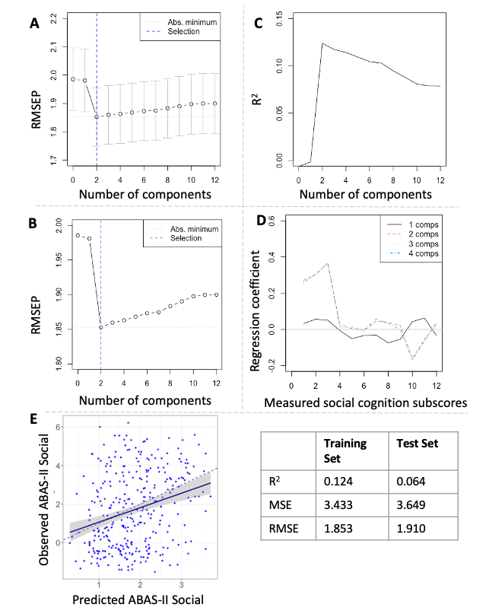 Note. RMSEP = predicted root mean standard error, MSE = mean standard error, ABAS-II = Adaptive Behavior Assessment System 2nd Edition. A: The optimal number of components (n = 2) informed by the one-sigma heuristic. B: The optimal number of components (n = 2) informed by the permutation approach. C: ABAS-II-Social variance (R²) explained by each component. D: Regression coefficients for each social cognition metric vary with the number of components kept to model ABAS-II-Social variance. E: PCR model derived from the training set (n = 324) fitted to the test set (n = 322).
Figure S2. Multicollinearity between independent variables in the hierarchical regression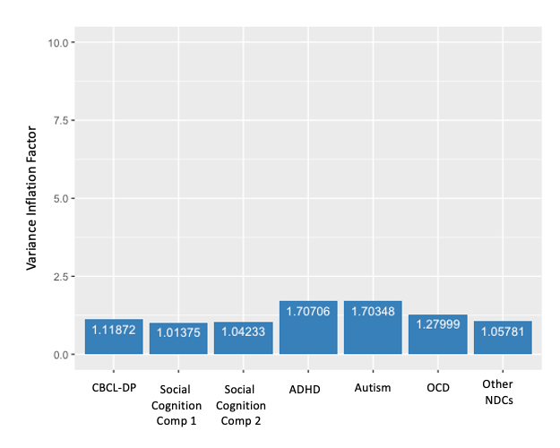 Note. CBCL-DP = Child Behavior Checklist Dysregulation Profile, NDCs = Neurodevelopmental Conditions, ADHD = Attention-Deficit/Hyperactivity Disorder, OCD = Obsessive-Compulsive Disorder.

