Examining the Effects of School-Vacation Transitions on Depression and Anxiety in Adolescents: A Network Analysis
Supplemental Information

Network accuracy and stability analysis
Accuracy of edge weights was evaluated by non-parametric bootstrapping procedure, with smaller bootstrapped CIs indicating higher accuracy of the edge-weights. Stability of the centrality indices was evaluated by case-dropping bootstrapping procedure. Various proportions of cases will be dropped from the dataset at random in each bootstrap procedure, and the correlation was calculated between the original centrality indices and those obtained from subsets. To quantify the stability of centrality indices, correlation stability coefficient (CS-coefficient) was calculated by the maximum proportion of cases that can be dropped to retain a 95% bootstrapped CIs of correlation of ≥ 0.7 between original centrality indices and those from subsamples. Higher CS-coefficient indicates higher stability of the centrality indices. The CS-coefficient ≥ 0.25 indicates acceptable stability and ≥ 0.5 indicates good stability. In addition, the edge weights and centrality indices difference from one another were tested for significance by calculating the difference between bootstrap values of one edge-weight or centrality indices and another edge-weight or centrality indices. A zero in the bootstrapped CI indicates no significant difference between the edge-weights or centrality indices.

Supplementary Figure 1
A. B.
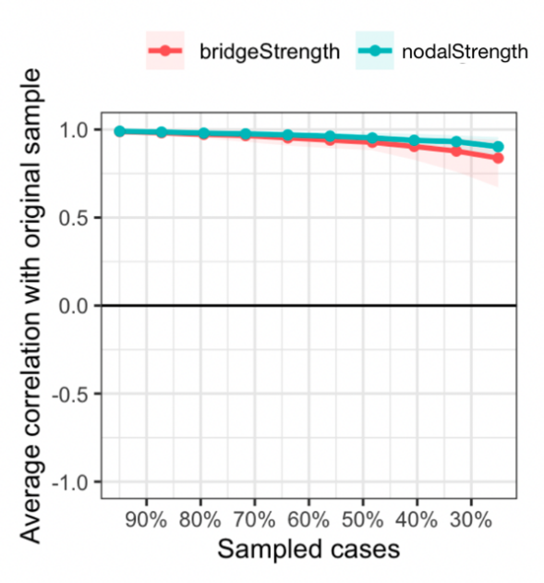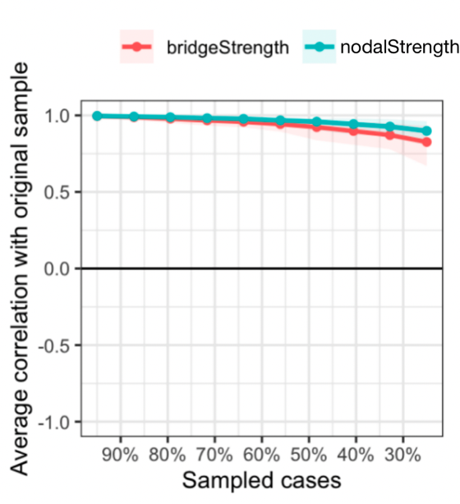
Fig S1. Result of stability analyses on strength and bridge strength in school network (A) and vacation network (B). The CS-coefficients for nodal strength and bridge strength in school network were 0.75 and 0.67 respectively. The CS-coefficients for nodal strength and bridge strength in vacation network were 0.75 and 0.67 respectively. Note: The x-axle indicates the proportion of cases included to calculate the centrality indices and the y-axle indicates the correlation between the calculated centrality indices and the original centrality indices. The dots represent the mean value of the calculated centrality indices and the colored plates represent the 95% confidence intervals of the bootstrapped sample.

Supplementary Figure 2
A.
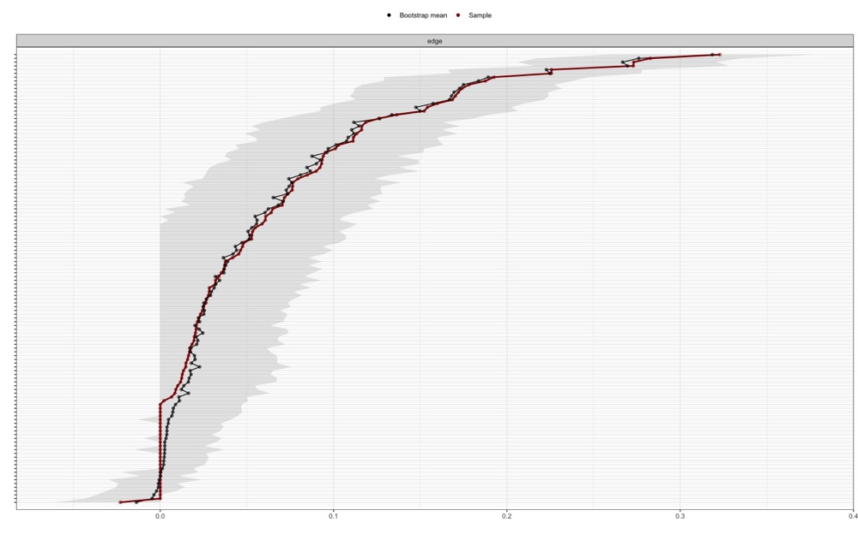
B.
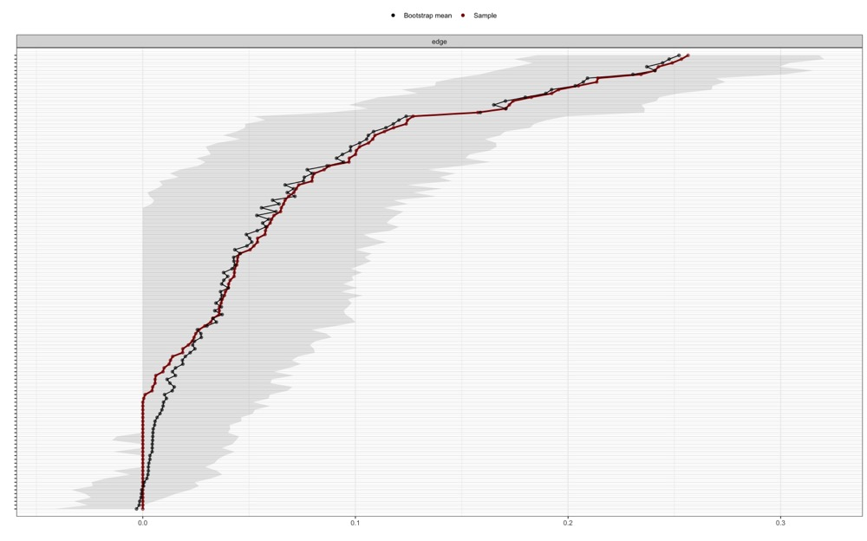
Fig S2. Result of edge stability analyses in school network (A) and vacation network (B). Stability analyses revealed that bootstrapping CIs of the edge-weights were stable in both networks. Note: The x-axle indicates the edge weights and the y-axle indicates each edge. The black dots represent the mean value of the bootstrapped edge weights and the red dots represent the edge weights from the original sample. The black lines represent the 95% confidence intervals of the bootstrapped sample.
Supplementary Figure 3
A.
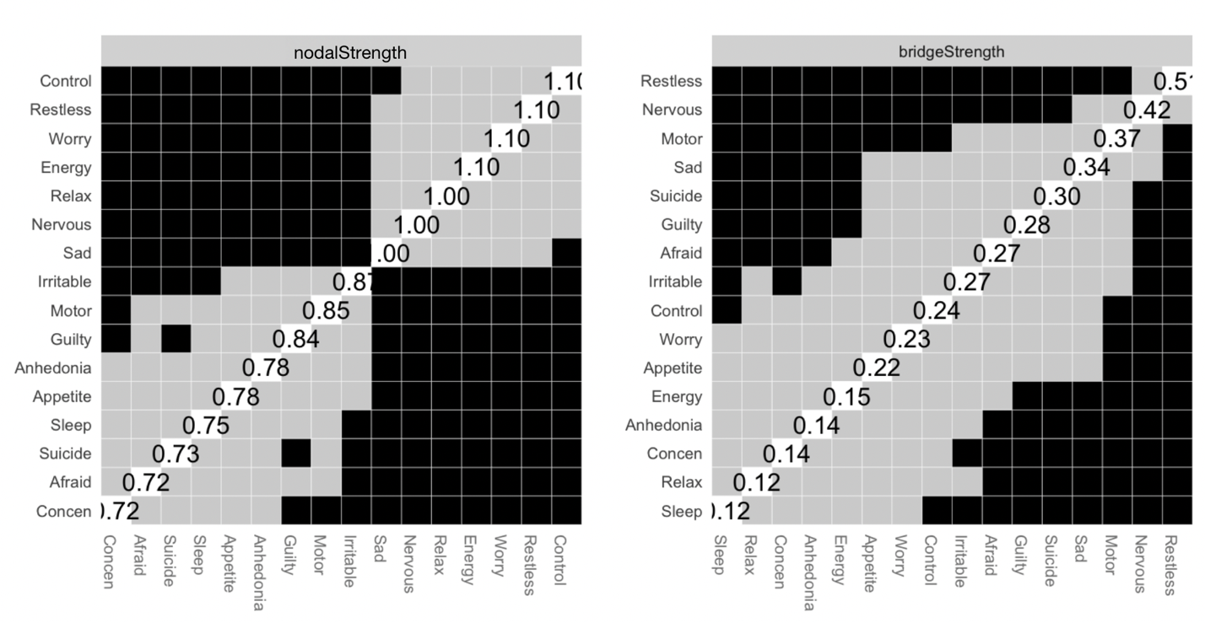B.
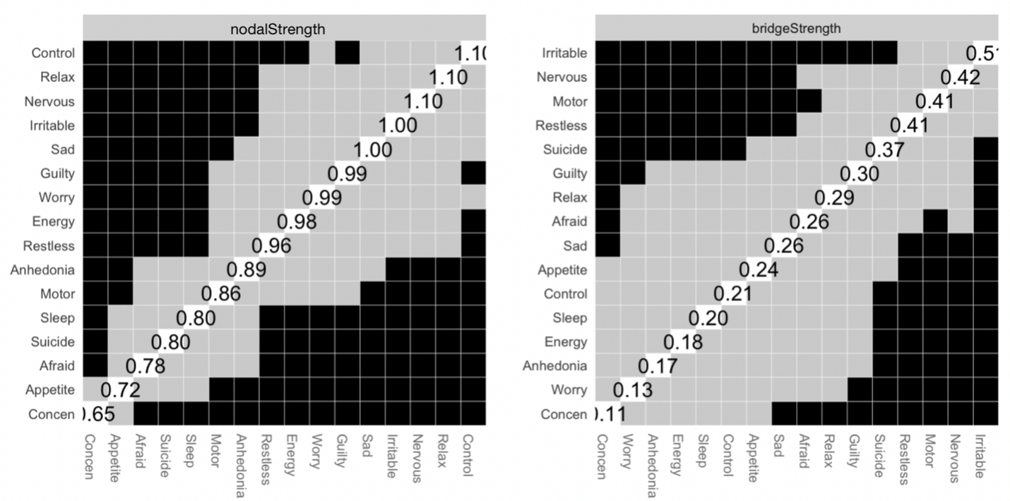Fig S3. Result of difference tests for nodal strength and bridge strength in school network (A) and vacation network (B).

Supplementary Figure 4
A.
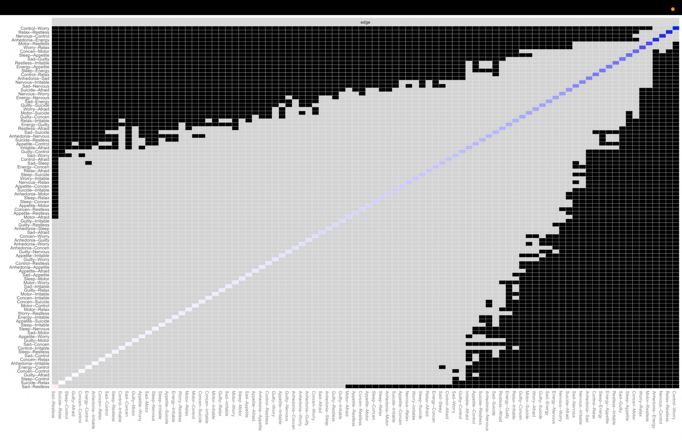

B. 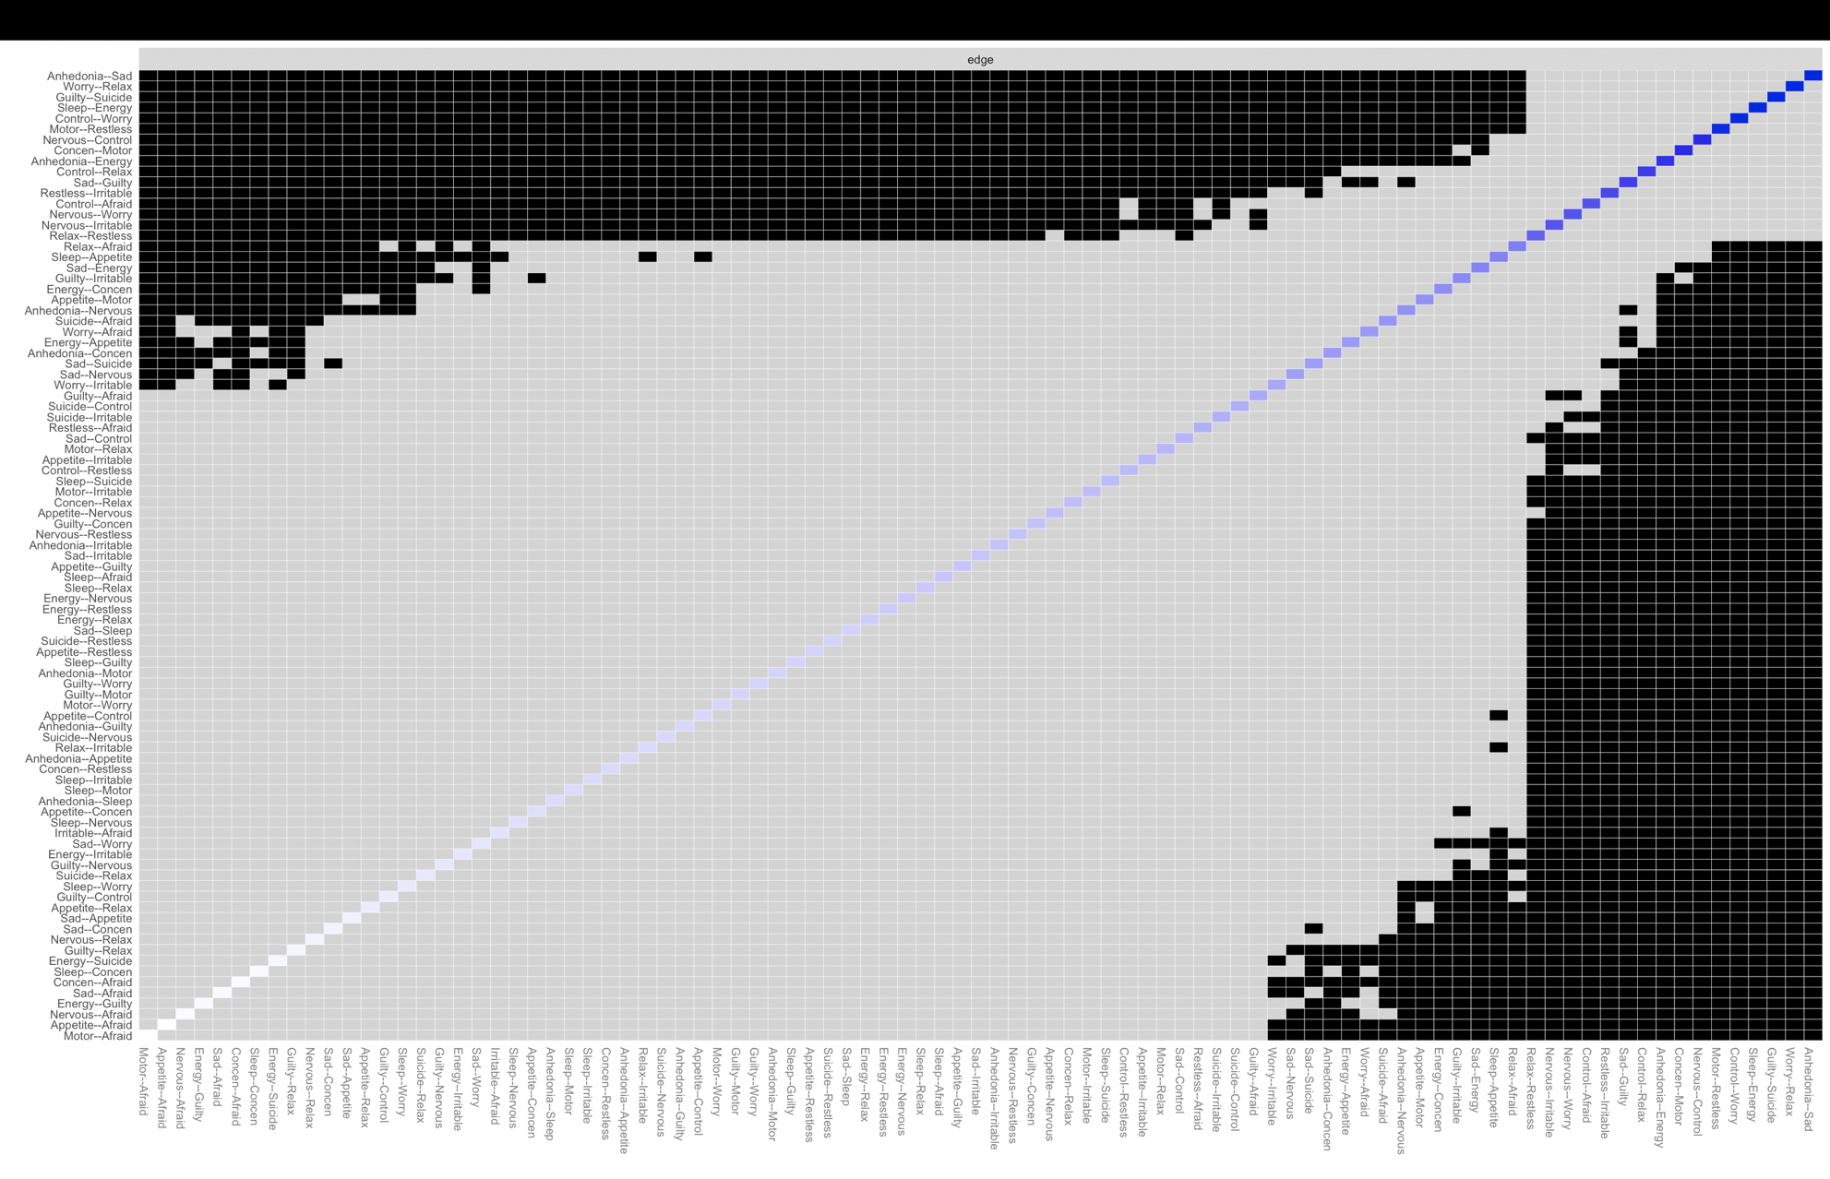
Fig S4. Result of difference tests for edge weight in school network (A) and vacation network (B).
Supplementary Figure 5
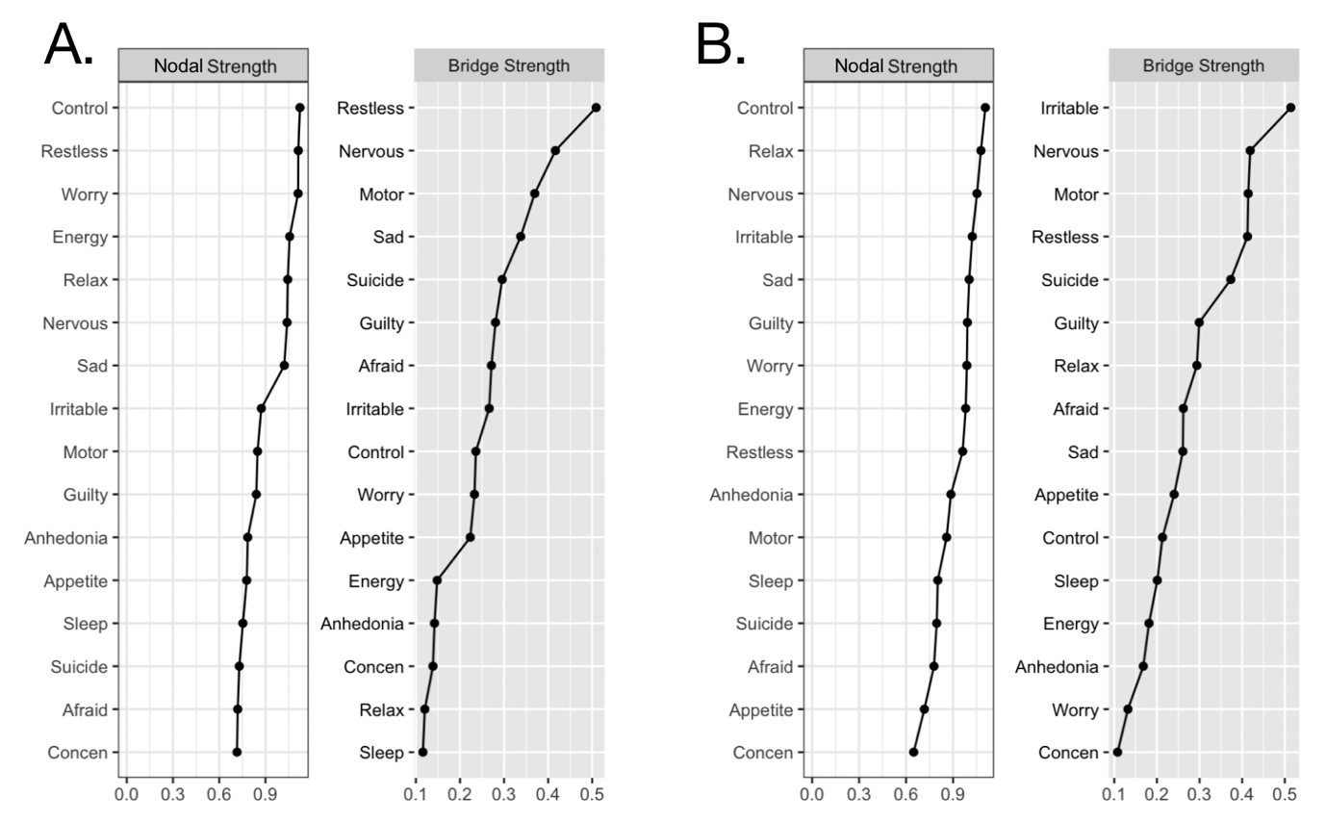
Fig S5. Nodal strength and bridge strength estimated for the depression and anxiety symptoms during school (A) and vacation (B).

Supplementary Figure 6
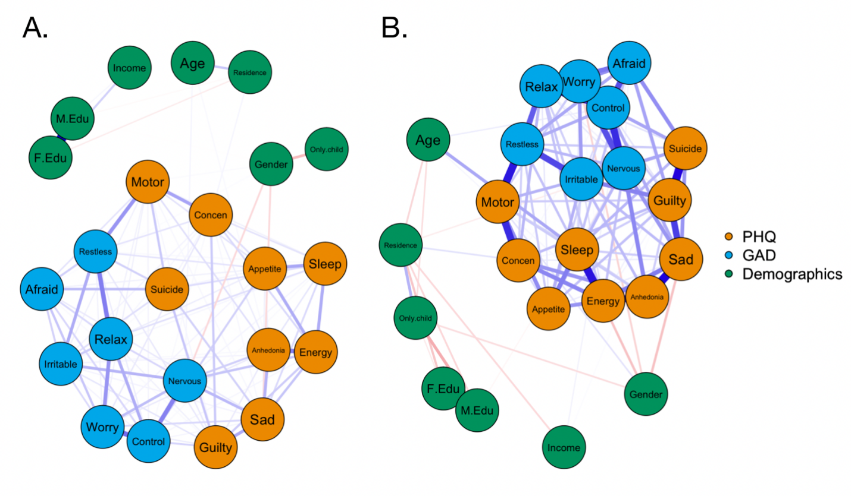
Fig S6. Estimated networks after controlling for covariates in school network (A) and vacation network (B).

Table S1. Questionnaires and items used psychological assessments
Scale | Node Reference Name | Item (Abbreviation) | Item content
PHQ-9 | Anhedonia | Anhedonia | 1. Little interest or pleasure in doing things
 | Sad | Sad Mood | 2. Feeling down, depressed, or hopeless
 | Sleep | Sleep | 3. Trouble falling or staying asleep, or sleeping too much
 | Energy | Energy | 4. Feeling tired or having little energy
 | Appetite | Appetite | 5. Poor appetite or overeating
 | Guilty | Guilty | 6. Feeling bad about yourself - or that you are a failure or have let yourself or your family down
 | Concen | Concentration | 7. Trouble concentrating on things, such as reading the newspaper or watching television
 | Motor | Motor | 8. Moving or speaking so slowly that other people could have noticed. Or so fidgety or restless that you have been moving a lot more than usual
 | Suicide | Suicide | 9. Thoughts that you would be better off dead, or thoughts of hurting yourself in some way
GAD-7 | Nervous | Nervous | 1. Feeling nervous, anxious, or on edge
 | Control | Control Worry | 2. Not being able to stop or control worrying
 | Worry | Worry A Lot | 3. Worrying too much about different things
 | Relax | Relax | 4. Trouble relaxing
 | Restless | Restless | 5. Being so restless that it is hard to sit still
 | Irritable | Irritable | 6. Becoming easily annoyed or irritable
 | Afraid | Afraid | 7. Feeling afraid, as if something awful might happen
Note. PHQ-9: Patient Health Questionnaire-9; GAD-7: Generalized Anxiety Disorder Scale.

Table S2. Descriptions of the 16 items during school and vacation
Participant characteristics | School  (n = 1380) | Vacation  (n = 1100) | Z/χ2 | P value
PHQ-9 (median, IQR)
Anhedonia | 1 (1-2) | 1 (0-1) | 7.25 | < 0.001 ª
Sad Mood | 1 (1-1) | 1 (0-1) | 12.14 | < 0.001 ª
Sleep | 1 (0-2) | 0 (0-1) | 5.61 | < 0.001 ª
Energy | 1 (1-2) | 1 (0-1) | 11.76 | < 0.001 ª
Appetite | 1 (0-2) | 0 (0-1) | 6.67 | < 0.001 ª
Guilty | 1 (0-2) | 0 (0-1) | 9.73 | < 0.001 ª
Concentration | 1 (0-1) | 0 (0-1) | 6.02 | < 0.001 ª
Motor | 0 (0-1) | 0 (0-1) | 4.91 | < 0.001 ª
Suicide | 0 (0-1) | 0 (0-0) | 5.95 | < 0.001 ª
GAD-7 (median, IQR)
Nervous | 1 (1-2) | 0 (0-1) | 15.56 | < 0.001 ª
Control Worry | 1 (0-2) | 0 (0-1) | 14.80 | < 0.001 ª
Worry A Lot | 1 (0-2) | 0 (0-1) | 12.77 | < 0.001 ª
Relax | 1 (0-1) | 0 (0-1) | 10.08 | < 0.001 ª
Restless | 0 (0-1) | 0 (0-1) | 8.00 | < 0.001 ª
Irritable | 1 (0-2) | 0 (0-1) | 7.10 | < 0.001 ª
Afraid | 1 (0-1) | 0 (0-1) | 10.72 | < 0.001 ª
Note. PHQ-9: Patient Health Questionnaire-9; GAD-7: Generalized Anxiety Disorder Scale; n, number of participants; a, P values obtained by Mann–Whitney U test.

Table S3. Associations of different factors with depressive and anxiety levels (Number of observations =2,480).
Coefficient | PHQ-9 |  |  |  | GAD-7
 | b | SE | P |  | b | SE | P
Age | 0.412 | 0.232 | 0.076 |  | 0.387 | 0.250 | 0.121
Gender
Male vs. Female | -1.236 | 0.194 | < 0.001 |  | -1.258 | 0.209 | < 0.001
Residence
Urban vs. Rural | 0.137 | 0.238 | 0.566 |  | -0.520 | 0.486 | 0.285
Only child
Yes vs. No | -0.199 | 0.210 | 0.343 |  | -0.174 | 0.226 | 0.441
Grade
7 vs. 8 | 0.035 | 0.357 | 0.921 |  | 0.155 | 0.372 | 0.678
8 vs. 9 | -0.146 | 0.509 | 0.774 |  | -0.152 | 0.541 | 0.778
7 vs. 9 | -0.181 | 0.350 | 0.604 |  | -0.307 | 0.369 | 0.406
Monthly household income per capita
< 1000 vs. 1000-5000 | 0.007 | 0.526 | 0.990 |  | -0.651 | 0.567 | 0.251
< 1000 vs. 5000-10000 | -0.207 | 0.530 | 0.696 |  | -0.667 | 0.572 | 0.243
< 1000 vs. 10000-50000 | 0.240 | 0.575 | 0.677 |  | -0.130 | 0.62 | 0.834
< 1000 vs. > 50000 | 0.927 | 0.839 | 0.269 |  | 0.644 | 0.905 | 0.477
1000-5000 vs. 5000-10000 | -0.214 | 0.225 | 0.342 |  | -0.016 | 0.243 | 0.947
1000-5000 vs. 10000-50000 | 0.233 | 0.288 | 0.418 |  | 0.521 | 0.311 | 0.093
1000-5000 vs. > 50000 | 0.920 | 0.674 | 0.172 |  | 1.296 | 0.727 | 0.075
5000-10000 vs. 10000-50000 | 0.447 | 0.271 | 0.098 |  | 0.537 | 0.292 | 0.066
5000-10000 vs. > 50000 | 1.134 | 0.666 | 0.089 |  | 1.312 | 0.719 | 0.068
10000-50000 vs. > 50000 | 0.687 | 0.677 | 0.310 |  | 0.774 | 0.73 | 0.289
Educational level of father
Primary school or below vs. Middle school | 0.121 | 0.450 | 0.788 |  | -0.52 | 0.486 | 0.285
Primary school or below vs. High school | 0.343 | 0.483 | 0.477 |  | -0.68 | 0.521 | 0.192
Primary school or below vs. Bachelor | -0.054 | 0.542 | 0.921 |  | -0.928 | 0.585 | 0.113
Primary school or below vs. Master or above | -0.346 | 0.840 | 0.680 |  | -0.95 | 0.905 | 0.294
Middle school vs. High school | 0.222 | 0.258 | 0.389 |  | -0.160 | 0.279 | 0.565
Middle school vs. Bachelor | -0.175 | 0.351 | 0.618 |  | -0.409 | 0.378 | 0.280
Middle school vs. Master or above | -0.467 | 0.731 | 0.523 |  | -0.430 | 0.788 | 0.585
High school vs. Bachelor | -0.397 | 0.329 | 0.227 |  | -0.307 | 0.369 | 0.406
High school vs. Master or above | -0.689 | 0.718 | 0.337 |  | -0.155 | 0.372 | 0.678
Bachelor vs. Master or above | -0.292 | 0.686 | 0.670 |  | -0.021 | 0.740 | 0.977
Educational level of mother
Primary school or below vs. Middle school | -0.797 | 0.401 | 0.047 |  | -0.517 | 0.433 | 0.232
Primary school or below vs. High school | -1.313 | 0.439 | 0.003 |  | -0.646 | 0.473 | 0.172
Primary school or below vs. Bachelor | -0.821 | 0.512 | 0.109 |  | -0.662 | 0.552 | 0.230
Primary school or below vs. Master or above | -0.547 | 0.870 | 0.530 |  | -0.819 | 0.939 | 0.383
Middle school vs. High school | -0.517 | 0.260 | 0.047 |  | -0.129 | 0.281 | 0.645
Middle school vs. Bachelor | -0.024 | 0.368 | 0.948 |  | -0.145 | 0.397 | 0.715
Middle school vs. Master or above | 0.250 | 0.796 | 0.754 |  | -0.302 | 0.859 | 0.726
High school vs. Bachelor | 0.493 | 0.343 | 0.152 |  | -0.016 | 0.371 | 0.966
High school vs. Master or above | 0.767 | 0.784 | 0.328 |  | -0.172 | 0.846 | 0.839
Bachelor vs. Master or above | 0.274 | 0.756 | 0.717 |  | -0.156 | 0.816 | 0.848
Group | -2.255 | 0.235 | < 0.001 |  | -2.996 | 0.241 | < 0.001
Notes: b, unstandardized coefficients; SE, standard error.

Table S4. Associations of different factors with depressive and anxiety levels – MLM further analysis (Number of observations =2,480).
Coefficient | PHQ-9 |  |  |  | GAD-7
 | b | SE | P |  | b | SE | P
Age | 0.347 | 0.233 | 0.137 |  | 0.367 | 0.250 | 0.142
Gender
Male vs. Female | -1.191 | 0.194 | < 0.001 |  | -1.243 | 0.209 | < 0.001
Residence
Urban vs. Rural | 0.122 | 0.237 | 0.608 |  | -0.045 | 0.256 | 0.859
Only child
Yes vs. No | -0.210 | 0.210 | 0.318 |  | -0.185 | 0.227 | 0.414
Grade
7 vs. 8 | -2.144 | 0.900 | 0.021 |  | 0.155 | 0.372 | 0.678
8 vs. 9 | -1.439 | 0.846 | 0.090 |  | -0.152 | 0.541 | 0.778
7 vs. 9 | 0.705 | 0.854 | 0.412 |  | -0.294 | 0.369 | 0.426
Monthly household income per capita
< 1000 vs. 1000-5000 | 0.066 | 0.525 | 0.900 |  | -0.584 | 0.568 | 0.303
< 1000 vs. 5000-10000 | -0.109 | 0.530 | 0.838 |  | -0.621 | 0.573 | 0.279
< 1000 vs. 10000-50000 | 0.381 | 0.575 | 0.507 |  | -0.084 | 0.621 | 0.892
< 1000 vs. > 50000 | 1.040 | 0.839 | 0.215 |  | 0.643 | 0.907 | 0.478
1000-5000 vs. 5000-10000 | -0.175 | 0.226 | 0.440 |  | -0.036 | 0.244 | 0.882
1000-5000 vs. 10000-50000 | 0.315 | 0.290 | 0.278 |  | 0.500 | 0.313 | 0.110
1000-5000 vs. > 50000 | 0.974 | 0.675 | 0.149 |  | 1.227 | 0.729 | 0.093
5000-10000 vs. 10000-50000 | 0.490 | 0.271 | 0.071 |  | 0.537 | 0.293 | 0.067
5000-10000 vs. > 50000 | 1.149 | 0.666 | 0.085 |  | 1.264 | 0.720 | 0.079
10000-50000 vs. > 50000 | 0.659 | 0.676 | 0.330 |  | 0.727 | 0.731 | 0.320
Educational level of father
Primary school or below vs. Middle school | 4.071 | 1.331 | 0.002 |  | 2.690 | 1.439 | 0.062
Primary school or below vs. High school | 3.968 | 1.381 | 0.004 |  | 1.952 | 1.494 | 0.191
Primary school or below vs. Bachelor | 4.215 | 1.463 | 0.004 |  | 1.215 | 1.582 | 0.443
Primary school or below vs. Master or above | 4.819 | 2.129 | 0.024 |  | 2.881 | 2.302 | 0.211
Middle school vs. High school | -0.103 | 0.732 | 0.888 |  | -0.738 | 0.791 | 0.351
Middle school vs. Bachelor | 0.144 | 0.881 | 0.871 |  | -1.475 | 0.952 | 0.122
Middle school vs. Master or above | 0.748 | 1.782 | 0.675 |  | 0.191 | 1.926 | 0.921
High school vs. Bachelor | 0.247 | 0.925 | 0.790 |  | -0.737 | 1.000 | 0.461
High school vs. Master or above | 0.851 | 1.797 | 0.636 |  | 0.929 | 1.942 | 0.632
Bachelor vs. Master or above | 0.604 | 1.834 | 0.742 |  | 1.666 | 1.983 | 0.401
Educational level of mother
Primary school or below vs. Middle school | -0.719 | 0.400 | 0.072 |  | -0.482 | 0.432 | 0.265
Primary school or below vs. High school | -1.225 | 0.438 | 0.005 |  | -0.611 | 0.473 | 0.197
Primary school or below vs. Bachelor | -0.734 | 0.512 | 0.151 |  | -0.574 | 0.553 | 0.300
Primary school or below vs. Master or above | -0.521 | 0.868 | 0.548 |  | -0.793 | 0.939 | 0.398
Middle school vs. High school | -0.505 | 0.260 | 0.052 |  | -0.129 | 0.281 | 0.646
Middle school vs. Bachelor | -0.015 | 0.370 | 0.967 |  | -0.092 | 0.400 | 0.818
Middle school vs. Master or above | 0.198 | 0.795 | 0.803 |  | -0.312 | 0.859 | 0.717
High school vs. Bachelor | 0.490 | 0.347 | 0.158 |  | 0.037 | 0.375 | 0.921
High school vs. Master or above | 0.703 | 0.782 | 0.369 |  | -0.182 | 0.846 | 0.829
Bachelor vs. Master or above | 0.213 | 0.756 | 0.778 |  | -0.220 | 0.817 | 0.788
Group | -0.271 | 0.878 | 0.758 |  | -1.139 | 0.887 | 0.199
Group * Grade
Group * 7 vs. 8 | 1.424 | 0.569 | 0.015 |  | n.s. | n.s. | n.s.
Group * 7 vs. 9 | 0.929 | 0.508 | 0.049 |  | n.s. | n.s. | n.s.
Group * 8 vs. 9 | -0.495 | 0.504 | 0.329 |  | n.s. | n.s. | n.s.
Group * Educational level of father
Group * Primary school or below vs. Middle school | -2.692 | 0.861 | 0.002 |  | -2.203 | 0.931 | 0.018
Group * Primary school or below vs. High school | -2.476 | 0.886 | 0.005 |  | -1.812 | 0.958 | 0.048
Group * Primary school or below vs. Bachelor | -2.879 | 0.928 | 0.002 |  | -1.500 | 1.003 | 0.135
Group * Primary school or below vs. Master or above | -3.492 | 1.340 | 0.009 |  | -2.632 | 1.450 | 0.070
Group * Middle school vs. High school | 0.217 | 0.462 | 0.639 |  | 0.391 | 0.499 | 0.433
Group * Middle school vs. Bachelor | -0.187 | 0.537 | 0.728 |  | 0.704 | 0.581 | 0.226
Group * Middle school vs. Master or above | -0.799 | 1.107 | 0.470 |  | -0.429 | 1.198 | 0.720
Group * High school vs. Bachelor | -0.403 | 0.567 | 0.477 |  | 0.312 | 0.613 | 0.610
Group * High school vs. Master or above | -1.016 | 1.117 | 0.363 |  | -0.820 | 1.208 | 0.497
Group * Bachelor vs. Master or above | -0.612 | 1.146 | 0.593 |  | -1.133 | 1.239 | 0.361
Notes: b, unstandardized coefficients; SE, standard error; n.s., not significant.

Table S5. Estimated edge weights in school network
 | Anhedonia | Sad | Sleep | Energy | Appetite | Guilty | Concen | Motor | Suicide | Nervous | Control | Worry | Relax | Restless | Irritable | Afraid
Anhedonia | NA | 0.16 | 0.05 | 0.27 | 0.03 | 0.04 | 0.04 | 0.06 | NA | 0.09 | NA | 0.04 | NA | NA | 0.01 | NA
Sad | 0.16 | NA | 0.08 | 0.12 | 0.03 | 0.18 | 0.01 | 0.02 | 0.09 | 0.15 | 0.01 | 0.08 | NA | -0.02 | 0.02 | 0.05
Sleep | 0.05 | 0.08 | NA | 0.17 | 0.19 | NA | 0.06 | 0.03 | 0.07 | 0.02 | 0.01 | NA | 0.06 | 0.01 | 0.02 | NA
Energy | 0.27 | 0.12 | 0.17 | NA | 0.17 | 0.10 | 0.08 | NA | NA | 0.12 | 0.01 | NA | NA | NA | 0.02 | NA
Appetite | 0.03 | 0.03 | 0.19 | 0.17 | NA | NA | 0.06 | 0.05 | 0.02 | NA | 0.09 | 0.02 | NA | 0.05 | 0.03 | 0.03
Guilty | 0.04 | 0.18 | NA | 0.10 | NA | NA | 0.11 | 0.02 | 0.12 | 0.04 | 0.08 | 0.03 | 0.02 | 0.05 | 0.05 | 0.01
Concen | 0.04 | 0.01 | 0.06 | 0.08 | 0.06 | 0.11 | NA | 0.19 | 0.02 | NA | 0.01 | 0.04 | 0.01 | 0.05 | 0.02 | NA
Motor | 0.06 | 0.02 | 0.03 | NA | 0.05 | 0.02 | 0.19 | NA | 0.11 | NA | 0.02 | 0.03 | 0.02 | 0.23 | 0.02 | 0.05
Suicide | NA | 0.09 | 0.07 | NA | 0.02 | 0.12 | 0.02 | 0.11 | NA | NA | NA | NA | NA | 0.09 | 0.06 | 0.14
Nervous | 0.09 | 0.15 | 0.02 | 0.12 | NA | 0.04 | NA | NA | NA | NA | 0.27 | 0.13 | 0.07 | NA | 0.15 | NA
Control | NA | 0.01 | 0.01 | 0.01 | 0.09 | 0.08 | 0.01 | 0.02 | NA | 0.27 | NA | 0.32 | 0.17 | 0.03 | 0.01 | 0.08
Worry | 0.04 | 0.08 | NA | NA | 0.02 | 0.03 | 0.04 | 0.03 | NA | 0.13 | 0.32 | NA | 0.23 | 0.02 | 0.07 | 0.11
Relax | NA | NA | 0.06 | NA | NA | 0.02 | 0.01 | 0.02 | NA | 0.07 | 0.17 | 0.23 | NA | 0.28 | 0.10 | 0.07
Restless | NA | -0.02 | 0.01 | NA | 0.05 | 0.05 | 0.05 | 0.23 | 0.09 | NA | 0.03 | 0.02 | 0.28 | NA | 0.17 | 0.10
Irritable | 0.01 | 0.02 | 0.02 | 0.02 | 0.03 | 0.05 | 0.02 | 0.02 | 0.06 | 0.15 | 0.01 | 0.07 | 0.10 | 0.17 | NA | 0.09
Afraid | NA | 0.05 | NA | NA | 0.03 | 0.01 | NA | 0.05 | 0.14 | NA | 0.08 | 0.11 | 0.07 | 0.10 | 0.09 | NA

Table S6. Estimated edge weights in vacation network
 | Anhedonia | Sad | Sleep | Energy | Appetite | Guilty | Concen | Motor | Suicide | Nervous | Control | Worry | Relax | Restless | Irritable | Afraid
Anhedonia | NA | 0.26 | 0.04 | 0.20 | 0.04 | 0.04 | 0.10 | 0.04 | NA | 0.11 | NA | NA | NA | NA | 0.06 | NA
Sad | 0.26 | NA | 0.05 | 0.12 | 0.01 | 0.19 | 0.01 | NA | 0.10 | 0.10 | 0.07 | 0.03 | NA | NA | 0.06 | 0.01
Sleep | 0.04 | 0.05 | NA | 0.24 | 0.12 | 0.04 | 0.01 | 0.04 | 0.07 | 0.03 | NA | 0.02 | 0.05 | NA | 0.04 | 0.06
Energy | 0.20 | 0.12 | 0.24 | NA | 0.10 | NA | 0.11 | NA | 0.01 | 0.05 | NA | NA | 0.05 | 0.05 | 0.02 | NA
Appetite | 0.04 | 0.01 | 0.12 | 0.10 | NA | 0.06 | 0.03 | 0.11 | NA | 0.06 | 0.04 | NA | 0.02 | 0.04 | 0.07 | NA
Guilty | 0.04 | 0.19 | 0.04 | NA | 0.06 | NA | 0.06 | 0.04 | 0.25 | 0.02 | 0.02 | 0.04 | 0.01 | NA | 0.12 | 0.09
Concen | 0.10 | 0.01 | 0.01 | 0.11 | 0.03 | 0.06 | NA | 0.21 | NA | NA | NA | NA | 0.07 | 0.04 | NA | 0.01
Motor | 0.04 | NA | 0.04 | NA | 0.11 | 0.04 | 0.21 | NA | NA | NA | NA | 0.04 | 0.07 | 0.23 | 0.07 | NA
Suicide | NA | 0.10 | 0.07 | 0.01 | NA | 0.25 | NA | NA | NA | 0.04 | 0.08 | NA | 0.02 | 0.04 | 0.08 | 0.11
Nervous | 0.11 | 0.10 | 0.03 | 0.05 | 0.06 | 0.02 | NA | NA | 0.04 | NA | 0.21 | 0.17 | 0.01 | 0.06 | 0.17 | NA
Control | NA | 0.07 | NA | NA | 0.04 | 0.02 | NA | NA | 0.08 | 0.21 | NA | 0.24 | 0.20 | 0.07 | NA | 0.17
Worry | NA | 0.03 | 0.02 | NA | NA | 0.04 | NA | 0.04 | NA | 0.17 | 0.24 | NA | 0.25 | NA | 0.09 | 0.10
Relax | NA | NA | 0.05 | 0.05 | 0.02 | 0.01 | 0.07 | 0.07 | 0.02 | 0.01 | 0.20 | 0.25 | NA | 0.16 | 0.04 | 0.13
Restless | NA | NA | NA | 0.05 | 0.04 | NA | 0.04 | 0.23 | 0.04 | 0.06 | 0.07 | NA | 0.16 | NA | 0.18 | 0.08
Irritable | 0.06 | 0.06 | 0.04 | 0.02 | 0.07 | 0.12 | NA | 0.07 | 0.08 | 0.17 | NA | 0.09 | 0.04 | 0.18 | NA | 0.03
Afraid | NA | 0.01 | 0.06 | NA | NA | 0.09 | 0.01 | NA | 0.11 | NA | 0.17 | 0.10 | 0.13 | 0.08 | 0.03 | NA

Table S7. Results of NCT comparing centrality indices between groups
Items | Nodal strength at school | Nodal strength at vacation | Bridge strength at school | Bridge strength at vacation | P₁ | P₂
1. Anhedonia (PHQ-1) | 0.78 | 0.89 | 0.14 | 0.17 | 0.10 | 0.60
2. Sad Mood (PHQ-2) | 1.02 | 1.00 | 0.34 | 0.26 | 0.76 | 0.20
3. Sleep (PHQ-3) | 0.75 | 0.80 | 0.12 | 0.20 | 0.35 | 0.12
4. Energy (PHQ-4) | 1.06 | 0.98 | 0.15 | 0.18 | 0.17 | 0.53
5. Appetite (PHQ-5) | 0.78 | 0.72 | 0.22 | 0.24 | 0.24 | 0.76
6. Guilty (PHQ-6) | 0.84 | 0.99 | 0.28 | 0.30 | 0.010** | 0.78
7. Concentration (PHQ-7) | 0.72 | 0.65 | 0.14 | 0.11 | 0.16 | 0.57
8. Motor (PHQ-8) | 0.85 | 0.86 | 0.37 | 0.41 | 0.87 | 0.47
9. Suicide (PHQ-9) | 0.73 | 0.80 | 0.30 | 0.37 | 0.23 | 0.23
10. Nervous (GAD-1) | 1.04 | 1.05 | 0.42 | 0.42 | 0.82 | 0.97
11. Control Worry (GAD-2) | 1.12 | 1.11 | 0.24 | 0.21 | 0.76 | 0.71
12. Worry A Lot (GAD-3) | 1.11 | 0.99 | 0.23 | 0.13 | 0.025* | 0.13
13. Relax (GAD-4) | 1.04 | 1.08 | 0.12 | 0.29 | 0.54 | 0.020*
14. Restless (GAD-5) | 1.11 | 0.96 | 0.51 | 0.41 | 0.016* | 0.21
15. Irritable (GAD-6) | 0.87 | 1.02 | 0.27 | 0.51 | 0.010* | 0.001***
16. Afraid (GAD-7) | 0.72 | 0.78 | 0.27 | 0.26 | 0.30 | 0.91
Note. P₁: Nodal strength at school vs. Nodal strength at vacation; P₂: Bridge strength at school vs. Bridge strength at vacation; n, number of participants; *, P < 0.05; **, P < 0.01; ***, P < 0.001.

Table S8. Delta edge weights in school network
 | Anhedonia | Sad | Sleep | Energy | Appetite | Guilty | Concen | Motor | Suicide | Nervous | Control | Worry | Relax | Restless | Irritable | Afraid
Anhedonia | 0.000 | 0.006 | 0.000 | 0.013 | 0.002 | 0.002 | 0.001 | 0.002 | 0.001 | 0.000 | 0.000 | 0.003 | 0.000 | 0.000 | 0.001 | 0.000
Sad | 0.006 | 0.000 | 0.003 | 0.001 | 0.001 | 0.010 | 0.000 | 0.003 | 0.005 | 0.012 | 0.005 | 0.003 | 0.000 | 0.023 | 0.003 | 0.002
Sleep | 0.000 | 0.003 | 0.000 | 0.006 | 0.009 | 0.000 | 0.003 | 0.000 | 0.004 | 0.004 | 0.003 | 0.000 | 0.001 | 0.000 | 0.000 | 0.000
Energy | 0.013 | 0.001 | 0.006 | 0.000 | 0.006 | 0.002 | 0.000 | 0.000 | 0.000 | 0.003 | 0.007 | 0.000 | 0.000 | 0.000 | 0.003 | 0.000
Appetite | 0.002 | 0.001 | 0.009 | 0.006 | 0.000 | 0.000 | 0.003 | 0.001 | 0.001 | 0.000 | 0.003 | 0.006 | 0.000 | 0.001 | 0.000 | 0.001
Guilty | 0.002 | 0.010 | 0.000 | 0.002 | 0.000 | 0.000 | 0.006 | 0.003 | 0.004 | 0.005 | 0.003 | 0.004 | 0.003 | 0.004 | 0.001 | 0.002
Concen | 0.001 | 0.000 | 0.003 | 0.000 | 0.003 | 0.006 | 0.000 | 0.010 | 0.000 | 0.000 | 0.003 | 0.000 | 0.003 | 0.000 | 0.000 | 0.000
Motor | 0.002 | 0.003 | 0.000 | 0.000 | 0.001 | 0.003 | 0.010 | 0.000 | 0.004 | 0.000 | 0.003 | 0.002 | 0.005 | 0.012 | 0.003 | 0.001
Suicide | 0.001 | 0.005 | 0.004 | 0.000 | 0.001 | 0.004 | 0.000 | 0.004 | 0.000 | 0.000 | 0.000 | 0.000 | 0.006 | 0.004 | 0.000 | 0.007
Nervous | 0.000 | 0.012 | 0.004 | 0.003 | 0.000 | 0.005 | 0.000 | 0.000 | 0.000 | 0.000 | 0.015 | 0.003 | 0.006 | 0.000 | 0.006 | 0.000
Control | 0.000 | 0.005 | 0.003 | 0.007 | 0.003 | 0.003 | 0.003 | 0.003 | 0.000 | 0.015 | 0.000 | 0.019 | 0.003 | 0.004 | 0.007 | 0.002
Worry | 0.003 | 0.003 | 0.000 | 0.000 | 0.006 | 0.004 | 0.000 | 0.002 | 0.000 | 0.003 | 0.019 | 0.000 | 0.009 | 0.006 | 0.001 | 0.001
Relax | 0.000 | 0.000 | 0.001 | 0.000 | 0.000 | 0.003 | 0.003 | 0.005 | 0.006 | 0.006 | 0.003 | 0.009 | 0.000 | 0.017 | 0.000 | 0.002
Restless | 0.000 | 0.023 | 0.000 | 0.000 | 0.001 | 0.004 | 0.000 | 0.012 | 0.004 | 0.000 | 0.004 | 0.006 | 0.017 | 0.000 | 0.008 | 0.002
Irritable | 0.001 | 0.003 | 0.000 | 0.003 | 0.000 | 0.001 | 0.000 | 0.003 | 0.000 | 0.006 | 0.007 | 0.001 | 0.000 | 0.008 | 0.000 | 0.002
Afraid | 0.000 | 0.002 | 0.000 | 0.000 | 0.001 | 0.002 | 0.000 | 0.001 | 0.007 | 0.000 | 0.002 | 0.001 | 0.002 | 0.002 | 0.002 | 0.000

Table S9. Delta edge weights in vacation network
 | Anhedonia | Sad | Sleep | Energy | Appetite | Guilty | Concen | Motor | Suicide | Nervous | Control | Worry | Relax | Restless | Irritable | Afraid
Anhedonia | 0.000 | 0.012 | 0.003 | 0.008 | 0.000 | 0.004 | 0.004 | 0.002 | 0.000 | 0.000 | 0.000 | 0.000 | 0.000 | 0.000 | 0.002 | 0.000
Sad | 0.012 | 0.000 | 0.002 | 0.003 | 0.003 | 0.010 | 0.004 | 0.000 | 0.001 | 0.003 | 0.001 | 0.002 | 0.001 | 0.000 | 0.002 | 0.003
Sleep | 0.003 | 0.002 | 0.000 | 0.014 | 0.006 | 0.000 | 0.001 | 0.002 | 0.003 | 0.001 | 0.000 | 0.000 | 0.001 | 0.000 | 0.001 | 0.002
Energy | 0.008 | 0.003 | 0.014 | 0.000 | 0.003 | 0.004 | 0.004 | 0.000 | 0.003 | 0.001 | 0.000 | 0.003 | 0.000 | 0.002 | 0.002 | 0.000
Appetite | 0.000 | 0.003 | 0.006 | 0.003 | 0.000 | 0.002 | 0.001 | 0.005 | 0.000 | 0.001 | 0.002 | 0.000 | 0.002 | 0.001 | 0.001 | 0.000
Guilty | 0.004 | 0.010 | 0.000 | 0.004 | 0.002 | 0.000 | 0.002 | 0.001 | 0.012 | 0.003 | 0.005 | 0.001 | 0.003 | 0.000 | 0.004 | 0.003
Concen | 0.004 | 0.004 | 0.001 | 0.004 | 0.001 | 0.002 | 0.000 | 0.011 | 0.000 | 0.000 | 0.000 | 0.000 | 0.001 | 0.003 | 0.000 | 0.000
Motor | 0.002 | 0.000 | 0.002 | 0.000 | 0.005 | 0.001 | 0.011 | 0.000 | 0.000 | 0.000 | 0.000 | 0.005 | 0.000 | 0.010 | 0.001 | 0.002
Suicide | 0.000 | 0.001 | 0.003 | 0.003 | 0.000 | 0.012 | 0.000 | 0.000 | 0.000 | 0.002 | 0.000 | 0.000 | 0.003 | 0.001 | 0.000 | 0.004
Nervous | 0.000 | 0.003 | 0.001 | 0.001 | 0.001 | 0.003 | 0.000 | 0.000 | 0.002 | 0.000 | 0.010 | 0.006 | 0.008 | 0.003 | 0.008 | 0.005
Control | 0.000 | 0.001 | 0.000 | 0.000 | 0.002 | 0.005 | 0.000 | 0.000 | 0.000 | 0.010 | 0.000 | 0.008 | 0.006 | 0.005 | 0.000 | 0.007
Worry | 0.000 | 0.002 | 0.000 | 0.003 | 0.000 | 0.001 | 0.000 | 0.005 | 0.000 | 0.006 | 0.008 | 0.000 | 0.012 | 0.000 | 0.001 | 0.000
Relax | 0.000 | 0.001 | 0.001 | 0.000 | 0.002 | 0.003 | 0.001 | 0.000 | 0.003 | 0.008 | 0.006 | 0.012 | 0.000 | 0.006 | 0.003 | 0.003
Restless | 0.000 | 0.000 | 0.000 | 0.002 | 0.001 | 0.000 | 0.003 | 0.010 | 0.001 | 0.003 | 0.005 | 0.000 | 0.006 | 0.000 | 0.007 | 0.001
Irritable | 0.002 | 0.002 | 0.001 | 0.002 | 0.001 | 0.004 | 0.000 | 0.001 | 0.000 | 0.008 | 0.000 | 0.001 | 0.003 | 0.007 | 0.000 | 0.002
Afraid | 0.000 | 0.003 | 0.002 | 0.000 | 0.000 | 0.003 | 0.000 | 0.002 | 0.004 | 0.005 | 0.007 | 0.000 | 0.003 | 0.001 | 0.002 | 0.000

