07 August 2023

Online Data Supplement

“Depression from childhood to early adulthood and respiratory health in early adulthood”

Authors:
Gang Wang; Jenny Hallberg; Natalia Hernandez-Pacheco Sandra; Sandra Ekström; Ellen Vercalsteren; Bronwyn K Brew; Catarina Almqvist; Christer Janson; Inger Kull; Anna Bergström; Erik Melén; Donghao Lu

Words: 234; References: 3; Tables: 8; Figure: 3

ONLINE SUPPLEMENT CONTENTS
METHODS 3
Definitions of potential confounders and covariates 3
References 3
ONLINE SUPPLEMENT TABLES 4
ONLINE SUPPLEMENT FIGURES 16

METHODS

Definitions of potential confounders and covariates
Preterm birth was defined as babies who were delivered before 37 completed weeks of gestation.
Maternal smoking during pregnancy was defined if the mother smoked at least one cigarette per day at any point in time during pregnancy.
Parental education levels were recorded as the highest education of parents at questionnaire 0. The university or higher levels were defined as high level, and the high school or lower levels were defined as low level.
Childhood asthma at ages 0–4 and 8-16 years was defined if at least two of the following three criteria were fulfilled: doctor’s diagnosis of asthma ever; wheezing in the past 12 months; and/or use of asthma medication during the past 12 months (1).
Early life bronchitis, pneumonia, and respiratory syncytial virus were based on parental questionnaire data at each follow-up time point.
Respiratory infections at 24 years of age were assessed based on the question “How many times have you had respiratory infections (a cold with rhinitis, coughing, fever) over the last 12 months?” according to the answers: 1) Never; 2) 1-3 times; 3) 4-6 times; 4) More than 6 times were classified into never, 1-3 times and ≥ 4 times.
BMI z-scores at 4, 8, 12, and 16 years were calculated based on the WHO Growth Reference z-scores (2). Details of the height and weight tests have been described previously (3).

References
1. Wang G, Hallberg J, Um Bergstrom P, Janson C, Pershagen G, Gruzieva O, et al. Assessment of chronic bronchitis and risk factors in young adults: results from BAMSE. Eur Respir J. 2021;57(3).
2. de Onis M. 4.1 The WHO Child Growth Standards. World Rev Nutr Diet. 2015;113:278-94.
3. Ekstrom S, Magnusson J, Kull I, Andersson N, Bottai M, Besharat Pour M, et al. Body Mass Index Development and Asthma Throughout Childhood. Am J Epidemiol. 2017;186(2):255-63.

ONLINE SUPPLEMENT TABLES
eTable 1. Full names of the 92 proteins included in the Proseek Multiplex Inflammation I panel.
Proteins | Full names
4EBP1 | Eukaryotic translation initiation factor 4E-binding protein 1
ADA | Adenosine Deaminase
ARTN | Artemin
AXIN1 | Axin-1
BetaNGF | Beta-nerve growth factor
CASP8 | Caspase-8
CCL3 | C-C motif chemokine 3
CCL4 | C-C motif chemokine 4
CCL11 | C-C motif chemokine 11
CCL19 | C-C motif chemokine 19
CCL20 | C-C motif chemokine 20
CCL23 | C-C motif chemokine 23
CCL25 | C-C motif chemokine 25
CCL28 | C-C motif chemokine 28
CD5 | Cluster of differentiation 5
CD6 | Cluster of differentiation 6
CD8A | Cluster of differentiation 8a
CD40 | Cluster of differentiation 40
CD244 | Natural Killer cell receptor 2B4
CDCP1 | CUB domain-containing protein 1
CSF1 | Macrophage colony-stimulating factor 1
CST5 | Cystatin D
CX3CL1 | Fractalkine
CXCL1 | C-X-C motif chemokine 1
CXCL5 | C-X-C motif chemokine 5
CXCL6 | C-X-C motif chemokine 6
CXCL9 | C-X-C motif chemokine 9
CXCL10 | C-X-C motif chemokine 10
CXCL11 | C-X-C motif chemokine 11
DNER | Delta and Notch-like epidermal or growth factor-related receptor
ENRAGE | Protein S100-A12
FGF5 | Fibroblast growth factor 5
FGF19 | Fibroblast growth factor 19
FGF21 | Fibroblast growth factor 21
FGF23 | Fibroblast growth factor 23
Flt3L | Fms-related tyrosine kinase 3 ligand
GDNF | Glial cell line-derived neurotrophic factor
HGF | Hepatocyte growth factor
IFNgamma | Interferon-gamma
IL1 alpha | Interleukin-1 alpha
IL2 | Interleukin-2
IL2RB | Interleukin-2 receptor subunit beta
IL4 | Interleukin-4
IL5 | nterleukin-5
IL6 | Interleukin-6
IL7 | Interleukin-7
IL8 | Interleukin-8
IL10 | Interleukin-10
IL10RA | Interleukin-10 receptor subunit alpha
IL10RB | Interleukin-10 receptor beta
IL12B | Interleukin-12 subunit beta
IL13 | Interleukin-13
IL15RA | Interleukin-15 receptor alpha
IL17A | Interleukin-17A
IL17C | Interleukin-17C
IL18 | Interleukin-18
IL18R1 | Interleukin-18 receptor 1
IL20 | nterleukin-20
IL20RA | Interleukin-20 receptor subunit alpha
IL22 RA1 | Interleukin-22 receptor subunit alpha-1
IL24 | Interleukin-24
IL33 | Interleukin-33
LAPTGFbeta1 | Latency-associated peptide transforming or growth factor beta-1
LIF | Leukemia inhibitory factor
LIFR | Leukemia inhibitory factor receptor
MCP1 | Monocyte chemotactic protein 1
MCP2 | Monocyte chemotactic protein 2
MCP3 | Monocyte chemotactic protein 3
MCP4 | Monocyte chemotactic protein 4
MMP1 | Matrix metalloproteinase-1
MMP10 | Matrix metalloproteinase-10
NRTN | Neurturin
NT3 | Neurotrophin-3
OPG | Osteoprotegerin
OSM | Oncostatin-M
PDL1 | Programmed cell death ligand 1
SCF | Stem Cell Factor
SIRT2 | SIR2-like protein 2
SLAMF1 | Signaling lymphocytic activation molecule
ST1A1 | Sulfotransferase 1A1
STAMBP | STAM-binding protein
TGFalpha | Transforming Growth Factor alpha
TNF | Tumor necrosis factor
TNFB | Tumor necrosis factor beta
TNFRSF9 | Tumor necrosis factor receptor superfamily member 9
TNFSF14 | Tumor necrosis factor ligand superfamily member 14
TRAIL | TNF-related apoptosis-inducing ligand
TRANCE | TNF-related activation-induced cytokine
TSLP | Thymic stromal lymphopoietin
TWEAK | TNF-related weak inducer of apoptosis
uPA | Urokinase-type plasminogen activator
VEGFA | Vascular endothelial growth factor A

eTable 2. Characteristics of participants been included in or excluded from the analysis.
 | Included (N=2994) | Excluded (N=1095) | P value
Sex
Female | 1586 (53.0%) | 438 (40.0%) | <0.001
Male | 1408 (47.0%) | 657 (60.0%)
Highest parental education
University | 1666 (55.7%) | 495 (45.3%) | <0.001
Primary school/High school | 1324 (44.3%) | 597 (54.7%)
BMI z-scores
4 years | 0.61 ± 0.89 | 0.64 ± 0.91 | 0.49
8 years | 0.58 ± 0.97 | 0.59 ± 1.02 | 0.89
12 years | -0.07 ± 1.08 | -0.04 ± 1.12 | 0.62
16 years | 0.12 ± 0.96 | 0.11 ± 1.03 | 0.95
Obesity
4 years | 285 (11.2%) | 93 (12.8%) | 0.21
8 years | 301 (14.2%) | 76 (15.2%) | 0.57
12 years | 143 (6.0%) | 44 (7.9%) | 0.096
16 years | 154 (6.0%) | 39 (7.2%) | 0.28
Asthma
Pre-school age (0-4y) | 654 (22.1%) | 256 (24.7%) | 0.085
School age (8-16y) | 500 (18.1%) | 133 (16.5%) | 0.31
Wheezing > 3 times
Pre-school age (0-4y) | 424 (14.3%) | 182 (17.6%) | 0.013
School age (8-16y) | 252 (9.1%) | 78 (9.4%) | 0.76
Early life events
Premature birth | 166 (5.5%) | 61 (5.6%) | 0.97
Maternal smoking during pregnancy | 355 (11.9%) | 172 (15.7%) | 0.0012
Birth weight, Kg | 3.53 ± 0.56 | 3.53 ± 0.56 | 0.94
Exclusive breast feeding for more than 4 months | 2336 (80.4%) | 780 (77.1%) | 0.026
Bronchitis during 0-1 years | 221 (7.6%) | 80 (7.9%) | 0.78
Pneumonia during 0-1 years | 99 (3.4%) | 43 (4.2%) | 0.22
RSV infections during 0-1 years | 133 (4.6%) | 32 (3.2%) | 0.053
Pneumonia during 0-4 years | 334 (11.3%) | 113 (10.9%) | 0.73

eTable 3. Association between depression and respiratory symptoms at age 24, stratified by sex, BMI, and asthma.
* | No depression | Depression
 | respiratory symptoms, N (%) | respiratory symptoms, N (%) | OR [95% CI]
By sex
Female | 251 (23.2%) | 88 (35.6%) | 1.73 [1.28, 2.35]
Male | 219 (20.5%) | 35 (22.4%) | 1.01 [0.67, 1.53]
P for interaction | 0.046
By BMI
Normal/underweight | 329 (20.1%) | 82 (28.6%) | 1.48 [1.11, 1.98]
Overweight/obesity | 141 (28.4%) | 39 (34.8%) | 1.24 [0.80, 1.93]
P for interaction | 0.61
By asthma
No | 192 (10.4%) | 54 (16.2%) | 1.49 [1.06, 2.08]
Yes | 276 (94.2%) | 69 (98.6%) | 3.25 [0.41, 25.51]
P for interaction | 0.39
* Results after adjustment for age, sex, parental education level, BMI, and current smoking status.

eTable 4. Levels of 84 plasma inflammatory markers across depression state.
Names* | Depression (n=280) | Non-depression (n=1471) | P value
ADA | 0.00 ± 1.00 | -0.03 ± 0.97 | 0.652
ARTN | 0.01 ± 1.01 | 0.02 ± 1.00 | 0.852
AXIN1 | -0.00 ± 1.00 | -0.01 ± 1.00 | 0.986
BetaNGF | -0.00 ± 1.01 | -0.02 ± 0.94 | 0.754
CASP8 | 0.00 ± 1.01 | -0.07 ± 0.97 | 0.265
CCL3 | -0.01 ± 0.99 | -0.00 ± 0.99 | 0.865
CCL4 | -0.01 ± 1.00 | -0.02 ± 1.03 | 0.826
CCL11 | -0.02 ± 1.01 | 0.09 ± 0.96 | 0.088
CCL19 | -0.03 ± 0.98 | 0.09 ± 1.04 | 0.083
CCL20 | -0.02 ± 1.00 | -0.01 ± 1.05 | 0.841
CCL23 | 0.01 ± 1.00 | -0.03 ± 0.94 | 0.457
CCL25 | -0.03 ± 1.01 | 0.05 ± 1.00 | 0.206
CCL28 | -0.02 ± 0.99 | 0.03 ± 1.01 | 0.479
CD5 | -0.01 ± 1.00 | -0.01 ± 0.95 | 0.970
CD6 | -0.01 ± 1.01 | -0.02 ± 0.92 | 0.940
CD8A | 0.01 ± 1.00 | 0.06 ± 0.96 | 0.467
CD40 | -0.01 ± 0.99 | -0.05 ± 1.01 | 0.518
CD244 | -0.01 ± 0.99 | -0.06 ± 0.98 | 0.406
CSF1 | 0.02 ± 1.01 | -0.07 ± 0.93 | 0.173
CST5 | -0.01 ± 0.99 | -0.06 ± 0.97 | 0.433
CXCL1 | 0.00 ± 1.00 | 0.00 ± 1.03 | 0.988
CXCL5 | -0.01 ± 1.00 | 0.03 ± 1.00 | 0.559
CXCL6 | 0.01 ± 0.99 | -0.04 ± 1.00 | 0.516
CXCL9 | 0.01 ± 1.01 | 0.02 ± 0.98 | 0.862
CXCL10 | 0.01 ± 1.00 | 0.00 ± 1.03 | 0.881
CXCL11 | -0.02 ± 1.01 | 0.06 ± 0.95 | 0.225
DNER | 0.00 ± 1.00 | 0.04 ± 1.01 | 0.519
EBP1 | -0.02 ± 1.00 | -0.00 ± 0.97 | 0.784
ENRAGE | -0.00 ± 1.00 | 0.01 ± 1.00 | 0.872
FGF5 | -0.01 ± 1.00 | 0.02 ± 0.99 | 0.657
FGF23 | -0.04 ± 0.98 | 0.09 ± 1.03 | 0.054
Flt3L | -0.00 ± 0.99 | 0.08 ± 1.02 | 0.175
GDNF | -0.04 ± 1.01 | 0.09 ± 0.96 | 0.059
HGF | -0.05 ± 1.02 | 0.01 ± 0.92 | 0.367
IFNgamma | 0.02 ± 1.01 | -0.05 ± 1.02 | 0.242
IL1alpha | -0.01 ± 1.00 | -0.01 ± 0.99 | 0.928
IL2 | -0.02 ± 1.00 | 0.04 ± 0.98 | 0.381
IL2RB | 0.03 ± 1.00 | 0.00 ± 0.97 | 0.655
IL4 | 0.00 ± 1.00 | -0.07 ± 1.04 | 0.241
IL5 | -0.00 ± 1.01 | 0.01 ± 1.04 | 0.878
IL7 | -0.00 ± 1.00 | 0.01 ± 1.01 | 0.867
IL8 | -0.02 ± 1.00 | -0.01 ± 0.98 | 0.959
IL10 | -0.02 ± 0.99 | 0.07 ± 1.01 | 0.158
IL10RA | 0.00 ± 0.99 | -0.09 ± 1.04 | 0.189
IL10RB | -0.02 ± 1.00 | 0.06 ± 1.00 | 0.211
IL12B | 0.01 ± 0.99 | -0.01 ± 1.04 | 0.846
IL13 | 0.02 ± 1.00 | -0.08 ± 0.94 | 0.130
IL15RA | 0.00 ± 1.01 | -0.05 ± 0.97 | 0.459
IL17A | 0.00 ± 1.00 | -0.04 ± 1.03 | 0.565
IL17C | -0.01 ± 1.02 | 0.04 ± 0.95 | 0.418
IL18 | -0.02 ± 1.00 | 0.06 ± 0.96 | 0.218
IL18R1 | -0.02 ± 1.00 | 0.06 ± 0.98 | 0.226
IL20 | -0.01 ± 1.00 | -0.01 ± 0.97 | 0.988
IL22RA1 | -0.00 ± 1.00 | 0.02 ± 0.95 | 0.700
IL24 | 0.02 ± 1.00 | -0.03 ± 1.01 | 0.412
IL33 | 0.00 ± 1.00 | -0.07 ± 0.99 | 0.239
LAPTGFbeta1 | -0.01 ± 1.01 | -0.05 ± 0.96 | 0.508
LIF | -0.01 ± 1.01 | 0.03 ± 0.93 | 0.551
LIFR | -0.01 ± 1.01 | 0.03 ± 0.97 | 0.549
MCP1 | -0.04 ± 0.99 | 0.07 ± 1.03 | 0.078
MCP2 | -0.01 ± 1.02 | -0.05 ± 0.92 | 0.528
MCP4 | -0.03 ± 1.00 | 0.03 ± 0.99 | 0.366
MMP1 | -0.01 ± 1.00 | -0.02 ± 0.97 | 0.927
NRTN | 0.02 ± 0.99 | -0.06 ± 0.99 | 0.178
NT3 | 0.02 ± 0.99 | -0.09 ± 1.06 | 0.094
OPG | 0.01 ± 1.01 | 0.02 ± 0.98 | 0.930
OSM | -0.01 ± 1.00 | -0.01 ± 0.92 | 0.989
PDL1 | 0.02 ± 1.00 | -0.08 ± 0.99 | 0.138
SCF | -0.01 ± 0.99 | 0.02 ± 0.93 | 0.590
SIRT2 | -0.01 ± 1.00 | -0.00 ± 1.00 | 0.922
SLAMF1 | -0.00 ± 1.02 | -0.01 ± 0.94 | 0.902
ST1A1 | 0.00 ± 1.00 | 0.01 ± 0.97 | 0.946
STAMBP | -0.01 ± 1.00 | -0.02 ± 1.00 | 0.819
TGFalpha | -0.04 ± 1.01 | 0.08 ± 0.93 | 0.069
TNF | -0.01 ± 1.00 | -0.00 ± 1.01 | 0.883
TNFB | 0.01 ± 1.00 | 0.00 ± 0.97 | 0.950
TNFRSF9 | -0.00 ± 0.98 | -0.00 ± 1.01 | 0.959
TNFSF14 | -0.01 ± 1.02 | -0.04 ± 0.93 | 0.676
TRAIL | -0.02 ± 1.02 | 0.09 ± 0.95 | 0.100
TRANCE | -0.02 ± 1.00 | -0.01 ± 0.90 | 0.864
TSLP | 0.01 ± 1.01 | -0.07 ± 0.98 | 0.216
TWEAK | -0.03 ± 1.02 | -0.01 ± 0.94 | 0.801
uPA | -0.03 ± 1.01 | 0.08 ± 0.97 | 0.091
VEGFA | -0.01 ± 0.99 | 0.00 ± 0.94 | 0.808
*: Data are presented as Normalized Protein eXpression (NPX) values, which are Olink Proteomics’ arbitrary units on a log2 scale.

eTable 5. Potential mediation effect of metabolic and inflammatory profiles on the association between depression and respiratory symptoms.
Mediatorª | Direct effect |  | Indirect effect |  | Total effect |  | Proportion of mediation
 | Estimate | 95% CI* | Estimate | 95% CI* | Estimate | 95% CI* | Mean and median (%) | 95% CI*
Fat mass index | 0.249 | [-0.023, 0.528] | 0.049 | [0.017, 0.089] | 0.387 | [0.147, 0.618] | 14.7, 12.3 | [4.1, 37.0]
LDL/HDL ratio | 0.277 | [-0.010, 0.556] | 0.014 | [-0.002, 0.039] | 0.387 | [0.147, 0.618] | - | -
FGF21 | 0.314 | [0.022, 0.598] | 0.007 | [-0.016, 0.034] | 0.387 | [0.147, 0.618] | - | -
FGF19 | 0.325 | [0.042, 0.616] | -0.005 | [-0.026, 0.011] | 0.387 | [0.147, 0.618] | - | -
IL-6 | 0.312 | [0.023, 0.607] | 0.014 | [-0.009, 0.044] | 0.387 | [0.147, 0.618] | - | -
IL-20RA | 0.317 | [0.030, 0.599] | 0.008 | [-0.012, 0.032] | 0.387 | [0.147, 0.618] | - | -
LDL: low-density lipoprotein; HDL: high-density lipoprotein; FGF21: fibroblast growth factor 21; FGF19: fibroblast growth factor 19; IL-6: Interleukin-6; IL-20RA: Interleukin-20 receptor subunit alpha.
*: 95% Bayesian credible interval.
ª: the models were adjusted for age, sex, parental education level, and smoking status.

eTable 6. Total, direct, and indirect effects of depression on respiratory symptoms (n = 1742)
 |  |  | Effect |  | The ratio of indirect to total effect*
By FEG21 and fat mass index |  |  | Mean and median | 95% CI | Mean and median | 95% CI
Total effect |  | c | 0.386, 0.389 | [0.142, 0.623] |  | -
Direct effect |  | c’ | 0.274, 0.273 | [ -0.020, 0.562] |  | -
Indirect effect
 | Via FGF 21 only | a1*b1 | -0.004, -0.003 | [-0.029, 0.021] |  | -
 | Via fat mass index only | a2*b2 | 0.046, 0.044 | [0.015, 0.087] | 15.2%, 11.6% | [3.4%, 36.0%]
 | Via FGF 21 and fat mass index | a1*d21*b2 | 0.010, 0.009 | [0.003, 0.020] | 3.1%, 2.4% | [0.6%, 8.4%]
By IL-6 and fat mass index
Total effect |  | c | 0.385, 0.385 | [0.140, 0.619] |  | -
Direct effect |  | c’ | 0.273, 0.273 | [-0.010, 0.569] |  | -
Indirect effect
 | Via IL-6 only | a1*b1 | -0.005, -0.005 | [-0.033, 0.022] |  | -
 | Via fat mass index only | a2*b2 | 0.039, 0.037 | [0.009 , 0.078] | 13.9%, 9.8% | [2.2%, 33.5%]
 | Via IL-6 and fat mass index | a1*d21*b2 | 0.018, 0.017 | [0.005 , 0.034] | 6.4%, 4.4% | [1.3%, 14.8%]
*: based on the absolute values.

eTable 7. Potential risk factors during childhood associated with depression in BAMSE.
 | No depression (n=2150) | Depression (n=403) | Model 1, OR [95% CI]ª | Model 2, OR [95% CI]^{b}
BMI z-scores
4 years | 0.60 ± 0.88 | 0.69 ± 0.93 | 1.15 [1.01, 1.31] | 1.09 [0.94, 1.26]
8 years | 0.56 ± 0.97 | 0.64 ± 0.94 | 1.10 [0.96, 1.26] | 1.02 [0.86, 1.20]
12 years | -0.08 ± 1.08 | 0.00 ± 1.08 | 1.10 [0.98, 1.24] | 1.02 [0.88, 1.18]
16 years | 0.11 ± 0.94 | 0.12 ± 1.05 | 1.03 [0.91, 1.16] | 0.92 [0.77, 1.09]
Obesity
4 years | 198 (10.7%) | 49 (15.0%) | 1.53 [1.09, 2.14] | 1.40 [0.97, 2.01]
8 years | 211 (13.4%) | 39 (15.4%) | 1.21 [0.84, 1.76] | 1.04 [0.68, 1.59]
12 years | 98 (5.7%) | 19 (6.1%) | 1.17 [0.70, 1.96] | 0.84 [0.46, 1.52]
16 years | 101 (5.4%) | 21 (6.4%) | 1.27 [0.78, 2.07] | 1.06 [0.61, 1.86]
Asthma
Pre-school age (0-4y) | 467 (22.0%) | 91 (22.7%) | 1.09 [0.84, 1.41] | 1.06 [0.82, 1.38]
School age (8-16y) | 366 (18.3%) | 65 (17.7%) | 0.98 [0.73, 1.31] | 0.95 [0.71, 1.28]
Wheezing > 3 times
Pre-school age (0-4y) | 314 (14.8%) | 50 (12.5%) | 0.86 [0.62, 1.18] | 0.83 [0.60, 1.15]
School age (8-16y) | 187 (9.3%) | 34 (9.2%) | 1.01 [0.68, 1.48] | 0.95 [0.64, 1.40]
Early life events
Premature birth | 124 (5.8%) | 14 (3.5%) | 0.59 [0.34, 1.04] | 0.62 [0.35, 1.10]
Maternal smoking during pregnancy | 247 (11.5%) | 51 (12.7%) | 1.11 [0.80, 1.55] | 0.97 [0.69, 1.36]
Birth weight, Kg | 3.53 ± 0.56 | 3.56 ± 0.56 | 1.18 [0.97, 1.43] | 1.14 [0.94, 1.40]
Exclusive breast feeding for more than 4 months | 1666 (79.7%) | 324 (81.8%) | 1.16 [0.88, 1.53] | 1.21 [0.91, 1.60]
Bronchitis during 0-1 years | 160 (7.7%) | 34 (8.6%) | 1.14 [0.78, 1.69] | 1.16 [0.78, 1.71]
Pneumonia during 0-1 years | 65 (3.1%) | 22 (5.6%) | 1.88 [1.14, 3.10] | 1.88 [1.13, 3.11]
Respiratory syncytial virus infections during 0-1 years | 99 (4.7%) | 17 (4.3%) | 0.82 [0.48, 1.41] | 0.81 [0.47, 1.39]
Pneumonia during 0-4 years | 220 (10.4%) | 54 (13.5%) | 1.38 [1.00, 1.90] | 1.39 [1.00, 1.92]
*: The estimates were adjusted for age, sex, and parental education level.
ª: The estimates were adjusted for age, sex, and parental education level.
^{b}: The estimates were adjusted for age, sex, parental education level, BMI, and current smoking status.

eTable 8. Sensitivity analysis.
Sensitivity analysis 1ª | No depression (n=2150) | Depression (n=126) | Model 1, OR [95% CI]^{e} | Model 2, OR [95% CI]^{f}
Respiratory symptoms
Any symptom | 470 (21.9%) | 41 (32.5%) | 1.65 [ 1.12, 2.43] | 1.53 [ 1.03, 2.27]
Wheezing > 3 times | 232 (10.8%) | 27 (21.4%) | 2.11 [ 1.35, 3.32] | 2.09 [ 1.33, 3.29]
Asthma | 293 (13.6%) | 20 (15.9%) | 1.14 [ 0.69, 1.87] | 1.11 [ 0.67, 1.84]
Respiratory infections
1-3 times | 1341 (65.9%) | 84 (68.3%) | 1.09 [0.62, 1.92] | 1.05 [0.59, 1.86]
More than 4 times | 427 (21.0%) | 24 (19.5%) | 0.91 [0.47, 1.79] | 0.90 [0.46, 1.78]
Chronic bronchitis symptoms
Any chronic bronchitis symptoms | 322 (15.9%) | 25 (20.5%) | 1.36 [ 0.86, 2.15] | 1.30 [ 0.82, 2.07]
Only Cough | 57 (2.8%) | 2 (1.6%) | 0.59 [0.14, 2.46] | 0.55 [0.13, 2.32]
Only Mucus | 174 (8.6%) | 17 (13.9%) | 1.75 [1.02, 3.02] | 1.74 [1.01, 3.00]
Chronic bronchitis | 91 (4.5%) | 6 (4.9%) | 1.11 [0.47, 2.61] | 1.01 [0.42, 2.41]
Sensitivity analysis 2^{b} | No depression (n=2150) | Depression (n= 844) | Model 1, OR [95% CI]ª | Model 2, OR [95% CI]^{b}
Respiratory symptoms
Any symptom | 470 (21.9%) | 249 (29.5%) | 1.45 [ 1.21, 1.74] | 1.38 [ 1.15, 1.66]
Wheezing > 3 times | 232 (10.8%) | 144 (17.1%) | 1.65 [1.32, 2.07] | 1.62 [1.29, 2.04]
Asthma | 293 (13.6%) | 124 (14.7%) | 1.06 [0.84, 1.33] | 1.03 [0.82, 1.30]
Respiratory infections
1-3 times | 1341 (65.9%) | 494 (61.1%) | 0.92 [0.72, 1.18] | 0.93 [0.72, 1.20]
More than 4 times | 427 (21.0%) | 208 (25.7%) | 1.18 [0.89, 1.57] | 1.18 [0.88, 1.57]
Chronic bronchitis symptoms
Any chronic bronchitis symptoms | 322 (15.9%) | 191 (23.8%) | 1.67 [ 1.36, 2.04] | 1.56 [ 1.27, 1.92]
Only Cough | 57 (2.8%) | 34 (4.2%) | 1.65 [1.06, 2.56] | 1.53 [0.98, 2.39]
Only Mucus | 174 (8.6%) | 95 (11.8%) | 1.55 [1.19, 2.03] | 1.49 [1.14, 1.96]
Chronic bronchitis | 91 (4.5%) | 62 (7.7%) | 1.91 [1.36, 2.68] | 1.71 [1.21, 2.42]
Sensitivity analysis 3^{c} | No depression (n=2150) | Depression (n=691) | Model 1, OR [95% CI]ª | Model 2, OR [95% CI]^{b}
Respiratory symptoms
Any symptom | 470 (21.9%) | 213 (30.8%) | 1.55 [ 1.28, 1.88] | 1.47 [ 1.21, 1.79]
Wheezing > 3 times | 232 (10.8%) | 124 (18.0%) | 1.76 [ 1.39, 2.23] | 1.72 [ 1.35, 2.19]
Asthma | 293 (13.6%) | 107 (15.5%) | 1.13 [ 0.89, 1.44] | 1.09 [ 0.85, 1.40]
Respiratory infections
1-3 times | 1341 (65.9%) | 400 (60.3%) | 0.91 [0.70, 1.19] | 0.92 [0.70, 1.20]
More than 4 times | 427 (21.0%) | 177 (26.7%) | 1.24 [0.92, 1.68] | 1.23 [0.91, 1.68]
Chronic bronchitis symptoms
Any chronic bronchitis symptoms | 322 (15.9%) | 165 (25.1%) | 1.78 [1.44, 2.21] | 1.67 [1.34, 2.07]
Only Cough | 57 (2.8%) | 26 (4.0%) | 1.57 [0.97, 2.53] | 1.45 [0.89, 2.35]
Only Mucus | 174 (8.6%) | 84 (12.8%) | 1.69 [1.28, 2.24] | 1.64 [1.23, 2.17]
Chronic bronchitis | 91 (4.5%) | 55 (8.4%) | 2.09 [1.47, 2.97] | 1.86 [1.30, 2.67]
Sensitivity analysis 4^{d} | No depression (n=2150) | Depression (n=556) | Model 1, OR [95% CI]ª | Model 2, OR [95% CI]^{b}
Respiratory symptoms
Any symptom | 470 (21.9%) | 159 (28.6%) | 1.39 [ 1.13, 1.72] | 1.30 [ 1.04, 1.61]
Wheezing > 3 times | 232 (10.8%) | 97 (17.4%) | 1.70 [ 1.31, 2.20] | 1.66 [ 1.28, 2.16]
Asthma | 293 (13.6%) | 87 (15.6%) | 1.15 [ 0.88, 1.49] | 1.09 [ 0.84, 1.43]
Respiratory infections
1-3 times | 1341 (65.9%) | 340 (63.8%) | 1.02 [0.76, 1.37] | 1.04 [0.77, 1.41]
More than 4 times | 427 (21.0%) | 127 (23.8%) | 1.16 [0.83, 1.63] | 1.17 [0.83, 1.65]
Chronic bronchitis symptoms
Any chronic bronchitis symptoms | 322 (15.9%) | 120 (22.6%) | 1.56 [1.23, 1.98] | 1.44 [1.13, 1.84]
Only Cough | 57 (2.8%) | 22 (4.1%) | 1.58 [0.95, 2.63] | 1.46 [0.87, 2.45]
Only Mucus | 174 (8.6%) | 63 (11.8%) | 1.53 [1.12, 2.09] | 1.46 [1.07, 2.00]
Chronic bronchitis | 91 (4.5%) | 35 (6.6%) | 1.62 [1.07, 2.43] | 1.40 [0.92, 2.13]
OR: odds ratio; CI: confidence interval.
a: Only participants with anti-depressant medication younger than 18 years were included.
b: The depression was defined as a record of antidepressant prescription or self-reported depression.
c: The depression was defined as a record of antidepressant prescription and self-reported depression or self-reported depression.
d: The depression was defined as a record of antidepressant prescription and self-reported depression or a record of antidepressant prescription.
^{e}: The estimates were adjusted for age, sex, and parental education level.
^{f}: The estimates were adjusted for age, sex, parental education level, BMI, and current smoking status.

ONLINE SUPPLEMENT FIGURES

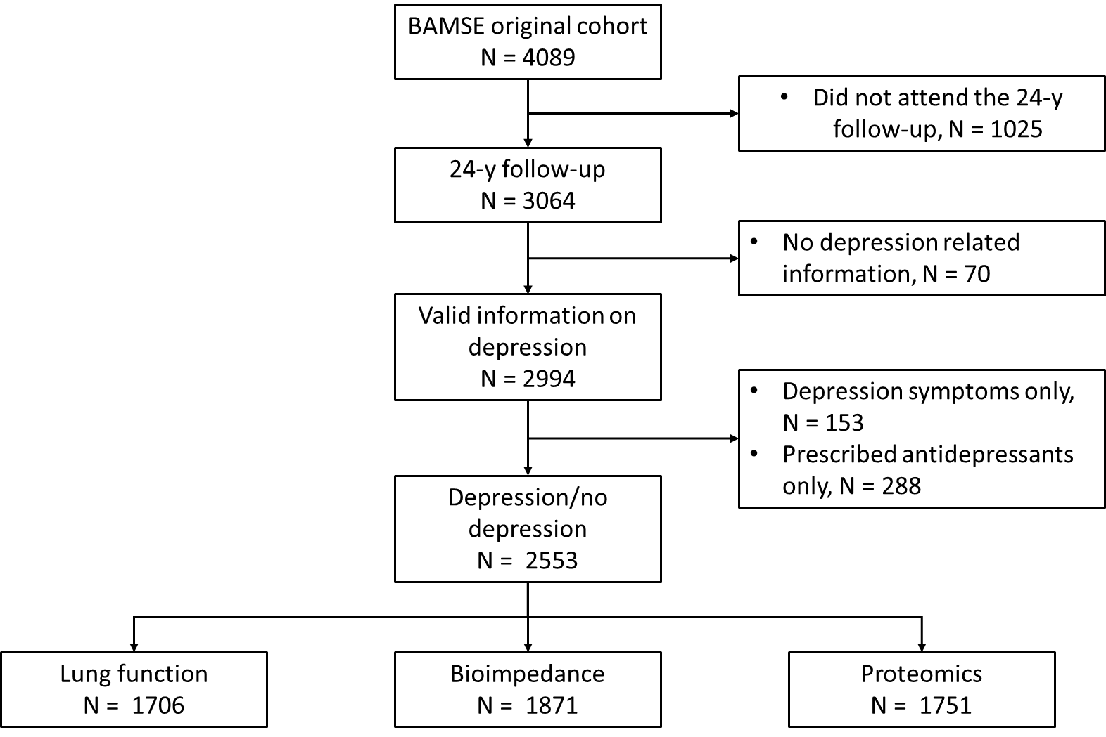
eFigure 1. Study design.

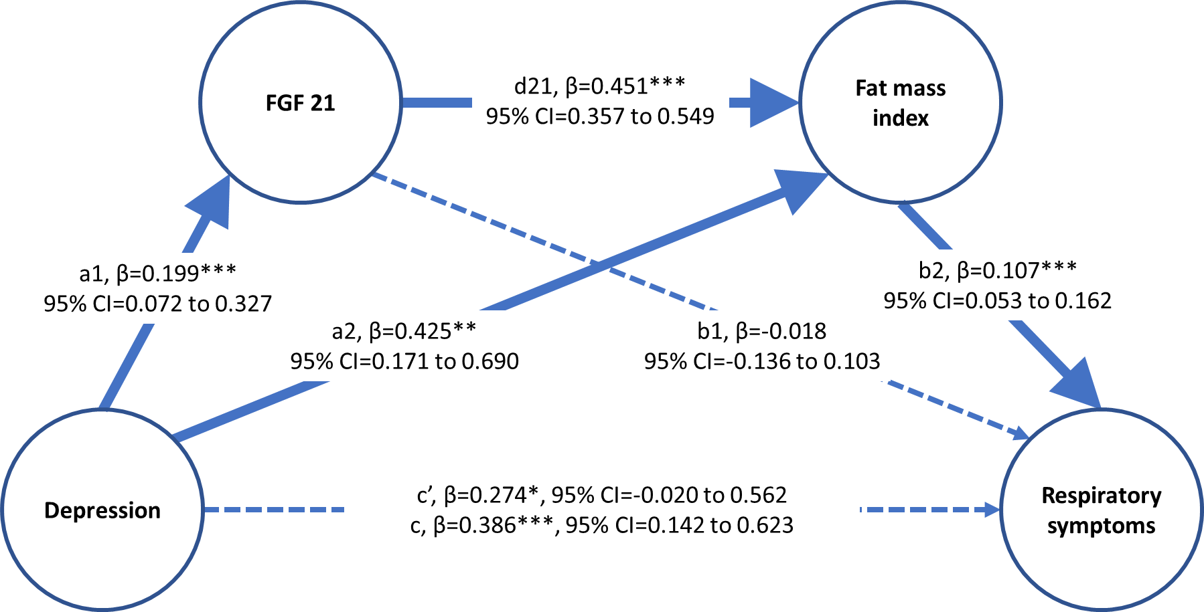
eFigure 2. Serial mediation model hypothesis linking depression and respiratory symptoms (n=1742). Effects were estimated using Bayesian based methods and presented as posterior mean with percentile-based 95% Bayesian credible interval of β (95% CI). The indirect effect (such as a1*b1, a2*b2, and a1*d21*b2) and the ratio of indirect to total effect is presented in eTable 6.
c: total effect; c’: total direct effect; *: the proportion of Bayesian credible interval less than 0 (Bayesian p value) <0.05; **: p<0.01; ***: p<0.001.

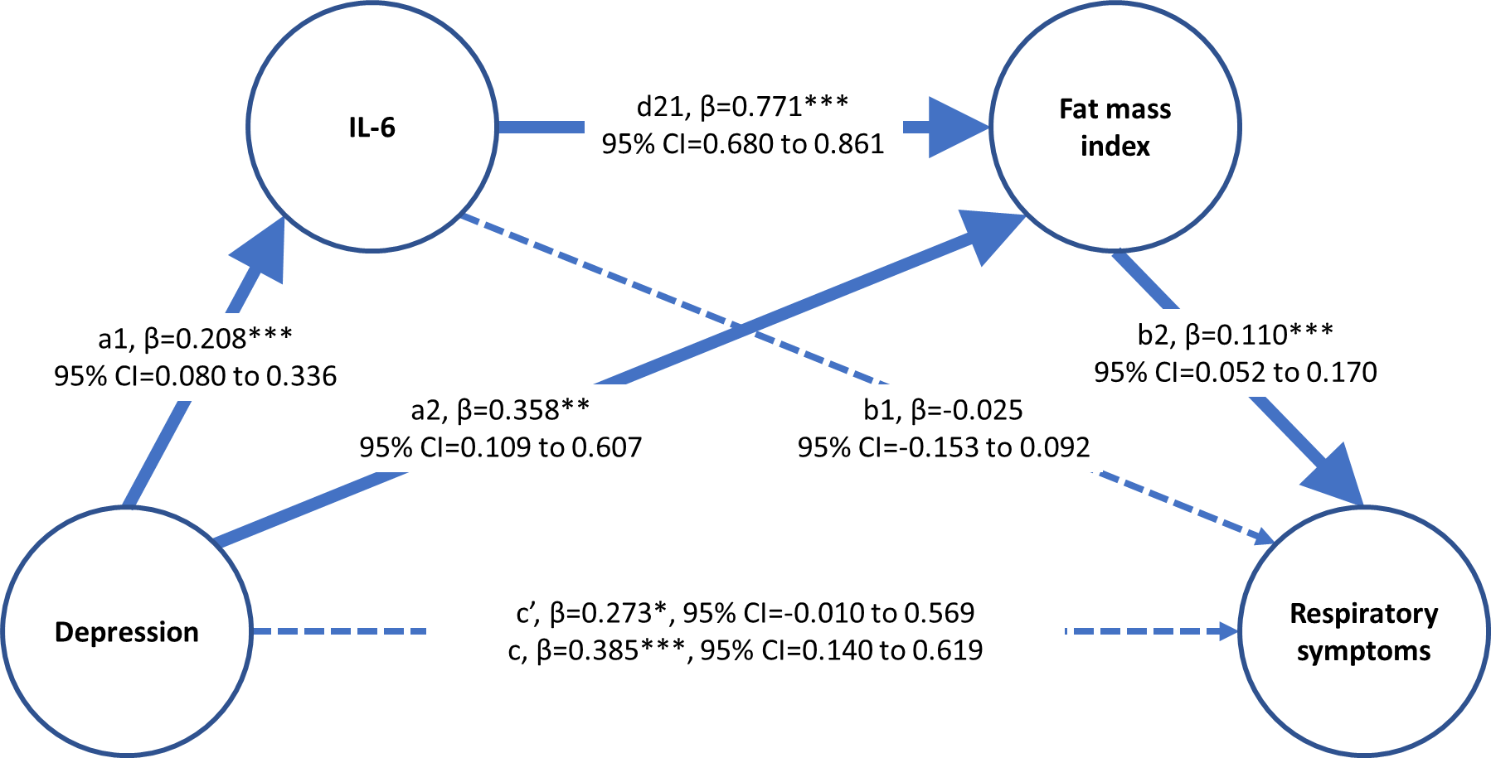
eFigure 3. Serial mediation model linking IL-6 and respiratory symptoms (n=1742). Effects were estimated using Bayesian based methods and presented as posterior mean with percentile-based 95% Bayesian credible interval of β. The indirect effect (such as a1*b1, a2*b2, and a1*d21*b2) and the ratio of indirect to total effect is presented in eTable 6.
*: the proportion of Bayesian credible interval less than 0 (Bayesian p value) <0.05; **: p<0.01; ***: p<0.001.

