Supplementary materials

Supplementary Data S1.
Formula for combined mean:
xc = (m.xa + n.xb)/(m = n)
xc = combined mean
xa = first group mean
xb = second group mean
m = number of items in first set
n = number of items in second set

Formula for combined standard deviation:
σ12=√(m-1)⋅σa+(n-1)⋅σb+(m⋅n)/(m+n)⋅(x2/1+x2/2-2xaxb)m+n-1
σ12 = combined standard deviation

Table S2. Antipsychotic medications for those without SMI, with OED
 | N (%) ª | Min TDD | Max TDD | Mean TDD (SD) | Mean OED TDD (SD)
Aripiprazole | 5 (25) | 2.5 | 45 | 11.5 (16.78) | 7.67 (11.19)
Asenapine | 1 (4) | 10 | 10 | 10 | 10
Chlorpromazine | 2 (8) | 50 | 400 | 225 (175) | 7.5 (5.83)
Lurasidone | 1 (4) | 10 | 10 | 10 | 1.25
Olanzapine | 3 (12) | 5 | 7.5 | 5.83 (1.18) | 5.83 (1.18)
Quetiapine | 7 (28) | 50 | 600 | 300 (208.74) | 9.99 (6.96)
Risperidone | 6 (24) | 0.25 | 1 | 0.71 (0.30) | 2.36 (1.01)
Ziprasidone | 1 (4) | 80 | 80 | 80 | 10
ª % of those on an antipsychotic medication without a SMI diagnosis (N=25); one patient was prescribed two antipsychotics off label

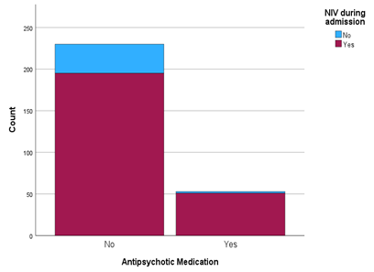
Figure S3: Number of patients with Type 2 Respiratory Failure requiring NIV, relative to antipsychotic medication use.

Table S4. Risk of NIV use for those with Type 2 Respiratory Failure on admission to HDU, adjusted for sex, age, BMI, COPD, OSA and smoking
Variable | B (SE) | Wald (df) | p-value | Odds ratio | (95% CI)
Sex (female) | 0.001 (0.38) | 0.000 (1) | 0.999 | 1.001 | (0.48-2.11)
Age | 0.02 (0.01) | 2.48 (1) | 0.12 | 1.02 | (0.995-1.05)
BMI | 0.034 (0.02) | 3.997 (1) | 0.046 * | 1.04 | (1.001-1.07)
COPD | 0.82 (0.397) | 4.28 (1) | 0.039 * | 2.27 | (1.04-4.96)
OSA | 1.18 (0.55) | 4.66 (1) | 0.03 * | 3.27 | (1.12-9.58)
Smoking (current or past) | -0.07 (0.46) | 0.02 (1) | 0.88 | 0.93 | (0.38-2.31)
Antipsychotic medication | 1.58 (0.77) | 4.21 (1) | 0.04* | 4.87 | (1.07-22.11)
*p<.05

