Supplementary materials
Supplementary Table S1 Weights of edges between nodes in the psychological resilience-social support-PTSD symptom network
Supplementary Table S2 Weights of edges between nodes in the psychological resilience-social support-depressive symptom network
Supplementary Table S3 Weights of edges between nodes in the psychological resilience-social support-anxiety symptom network
Supplementary Figure S1 Bootstrapped confidence intervals of edge weights of the psychological resilience-social support-PTSD symptom network
Supplementary Figure S2 Estimation of edge weight difference by bootstrapped difference test of the psychological resilience-social support-PTSD symptom network
Supplementary Figure S3 Bootstrapped confidence intervals of edge weights of the psychological resilience-social support-depressive symptom network
Supplementary Figure S4 Estimation of edge weight difference by bootstrapped difference test of the psychological resilience-social support- depressive symptom network
Supplementary Figure S5 Bootstrapped confidence intervals of edge weights of the psychological resilience-social support-anxiety symptom network
Supplementary Figure S6 Estimation of edge weight difference by bootstrapped difference test of the psychological resilience-social support- anxiety symptom network

 | P1 | P2 | P3 | P4 | P5 | P6 | P7 | P8 | P9 | P10 | P11 | P12 | P13 | P14 | P15 | P16 | P17 | P18 | P19 | P20 | PR | SS
P1 | 0.00 | 0.31 | 0.12 | 0.19 | 0.01 | 0.00 | 0.11 | 0.04 | 0.02 | 0.00 | 0.00 | 0.00 | 0.00 | 0.00 | 0.00 | 0.00 | 0.00 | 0.00 | 0.00 | 0.00 | 0.00 | -0.02
P2 | 0.31 | 0.00 | 0.30 | 0.00 | 0.06 | 0.02 | 0.14 | 0.00 | 0.00 | 0.00 | 0.00 | 0.25 | -0.01 | 0.00 | -0.02 | 0.00 | 0.00 | 0.00 | 0.00 | 0.01 | 0.00 | 0.00
P3 | 0.12 | 0.30 | 0.00 | 0.03 | 0.05 | 0.03 | 0.07 | 0.06 | 0.11 | 0.00 | 0.13 | 0.00 | 0.00 | 0.02 | 0.00 | 0.00 | 0.03 | 0.12 | 0.01 | 0.01 | 0.00 | 0.00
P4 | 0.19 | 0.00 | 0.03 | 0.00 | 0.15 | 0.03 | 0.04 | 0.13 | 0.00 | 0.00 | 0.00 | 0.00 | -0.01 | -0.03 | 0.00 | -0.01 | 0.02 | 0.00 | 0.00 | 0.01 | 0.02 | 0.00
P5 | 0.01 | 0.06 | 0.05 | 0.15 | 0.00 | 0.14 | 0.13 | 0.08 | 0.00 | 0.07 | 0.04 | 0.00 | 0.02 | 0.00 | 0.07 | 0.00 | 0.00 | 0.09 | 0.00 | 0.08 | -0.01 | 0.00
P6 | 0.00 | 0.02 | 0.03 | 0.03 | 0.14 | 0.00 | 0.30 | 0.00 | 0.04 | 0.04 | 0.00 | 0.01 | 0.00 | 0.03 | 0.00 | 0.00 | 0.00 | 0.00 | 0.00 | 0.00 | -0.12 | 0.00
P7 | 0.11 | 0.14 | 0.07 | 0.04 | 0.13 | 0.30 | 0.00 | 0.00 | 0.29 | 0.00 | 0.00 | 0.00 | 0.00 | 0.00 | 0.00 | 0.01 | 0.04 | 0.00 | 0.01 | 0.04 | 0.00 | 0.00
P8 | 0.04 | 0.00 | 0.06 | 0.13 | 0.08 | 0.00 | 0.00 | 0.00 | 0.07 | 0.01 | 0.00 | 0.08 | 0.02 | 0.00 | 0.06 | 0.00 | 0.00 | 0.06 | 0.00 | 0.00 | 0.00 | -0.03
P9 | 0.02 | 0.00 | 0.11 | 0.00 | 0.00 | 0.04 | 0.29 | 0.07 | 0.00 | 0.41 | 0.00 | 0.03 | 0.00 | 0.11 | 0.00 | 0.09 | 0.00 | 0.00 | 0.00 | 0.00 | -0.03 | 0.00
P10 | 0.00 | 0.00 | 0.00 | 0.00 | 0.07 | 0.04 | 0.00 | 0.01 | 0.41 | 0.00 | 0.14 | 0.11 | 0.07 | 0.00 | 0.00 | 0.04 | 0.00 | 0.03 | 0.00 | 0.00 | 0.00 | 0.00
P11 | 0.00 | 0.00 | 0.13 | 0.00 | 0.04 | 0.00 | 0.00 | 0.00 | 0.00 | 0.14 | 0.00 | 0.00 | 0.11 | 0.03 | 0.08 | 0.00 | 0.01 | 0.13 | 0.09 | 0.09 | 0.00 | 0.00
P12 | 0.00 | 0.25 | 0.00 | 0.00 | 0.00 | 0.01 | 0.00 | 0.08 | 0.03 | 0.11 | 0.00 | 0.00 | 0.01 | 0.10 | 0.05 | 0.21 | 0.02 | 0.22 | 0.00 | 0.00 | 0.00 | -0.02
P13 | 0.00 | -0.01 | 0.00 | -0.01 | 0.02 | 0.00 | 0.00 | 0.02 | 0.00 | 0.07 | 0.11 | 0.01 | 0.00 | 0.34 | 0.34 | 0.14 | 0.10 | 0.00 | 0.07 | 0.00 | 0.00 | 0.00
P14 | 0.00 | 0.00 | 0.02 | -0.03 | 0.00 | 0.03 | 0.00 | 0.00 | 0.11 | 0.00 | 0.03 | 0.10 | 0.34 | 0.00 | 0.06 | 0.29 | 0.01 | 0.00 | 0.00 | 0.00 | 0.00 | 0.00
P15 | 0.00 | -0.02 | 0.00 | 0.00 | 0.07 | 0.00 | 0.00 | 0.06 | 0.00 | 0.00 | 0.08 | 0.05 | 0.34 | 0.06 | 0.00 | 0.06 | 0.13 | 0.00 | 0.10 | 0.01 | 0.00 | 0.00
P16 | 0.00 | 0.00 | 0.00 | -0.01 | 0.00 | 0.00 | 0.01 | 0.00 | 0.09 | 0.04 | 0.00 | 0.21 | 0.14 | 0.29 | 0.06 | 0.00 | 0.00 | 0.00 | 0.00 | 0.00 | 0.00 | -0.08
P17 | 0.00 | 0.00 | 0.03 | 0.02 | 0.00 | 0.00 | 0.04 | 0.00 | 0.00 | 0.00 | 0.01 | 0.02 | 0.10 | 0.01 | 0.13 | 0.00 | 0.00 | 0.29 | 0.23 | 0.01 | -0.04 | 0.00
P18 | 0.00 | 0.00 | 0.12 | 0.00 | 0.09 | 0.00 | 0.00 | 0.06 | 0.00 | 0.03 | 0.13 | 0.22 | 0.00 | 0.00 | 0.00 | 0.00 | 0.29 | 0.00 | 0.08 | 0.01 | 0.00 | 0.00
P19 | 0.00 | 0.00 | 0.01 | 0.00 | 0.00 | 0.00 | 0.01 | 0.00 | 0.00 | 0.00 | 0.09 | 0.00 | 0.07 | 0.00 | 0.10 | 0.00 | 0.23 | 0.08 | 0.00 | 0.35 | 0.00 | -0.03
P20 | 0.00 | 0.01 | 0.01 | 0.01 | 0.08 | 0.00 | 0.04 | 0.00 | 0.00 | 0.00 | 0.09 | 0.00 | 0.00 | 0.00 | 0.01 | 0.00 | 0.01 | 0.01 | 0.35 | 0.00 | 0.00 | -0.09
PR | 0.00 | 0.00 | 0.00 | 0.02 | -0.01 | -0.12 | 0.00 | 0.00 | -0.03 | 0.00 | 0.00 | 0.00 | 0.00 | 0.00 | 0.00 | 0.00 | -0.04 | 0.00 | 0.00 | 0.00 | 0.00 | 0.21
SS | -0.02 | 0.00 | 0.00 | 0.00 | 0.00 | 0.00 | 0.00 | -0.03 | 0.00 | 0.00 | 0.00 | -0.02 | 0.00 | 0.00 | 0.00 | -0.08 | 0.00 | 0.00 | -0.03 | -0.09 | 0.21 | 0.00

Supplementary Table S1 Weights of edges between nodes in the psychological resilience-social support-PTSD symptom network

 | D1 | D2 | D3 | D4 | D5 | D6 | D7 | D8 | D9 | PR | SS
D1 | 0.00 | 0.40 | 0.19 | 0.23 | 0.18 | 0.20 | 0.00 | 0.00 | 0.00 | 0.00 | -0.03
D2 | 0.40 | 0.00 | 0.01 | 0.00 | 0.21 | 0.07 | 0.20 | 0.06 | 0.14 | 0.00 | 0.00
D3 | 0.19 | 0.01 | 0.00 | 0.40 | 0.16 | 0.00 | 0.00 | 0.00 | 0.00 | 0.00 | -0.02
D4 | 0.23 | 0.00 | 0.40 | 0.00 | 0.08 | 0.04 | 0.11 | 0.00 | 0.00 | 0.02 | -0.06
D5 | 0.18 | 0.21 | 0.16 | 0.08 | 0.00 | 0.25 | 0.00 | 0.00 | 0.00 | 0.00 | 0.00
D6 | 0.20 | 0.07 | 0.00 | 0.04 | 0.25 | 0.00 | 0.02 | 0.10 | 0.20 | -0.07 | 0.00
D7 | 0.00 | 0.20 | 0.00 | 0.11 | 0.00 | 0.02 | 0.00 | 0.30 | 0.22 | -0.04 | 0.00
D8 | 0.00 | 0.06 | 0.00 | 0.00 | 0.00 | 0.10 | 0.30 | 0.00 | 0.26 | -0.07 | -0.03
D9 | 0.00 | 0.14 | 0.00 | 0.00 | 0.00 | 0.20 | 0.22 | 0.26 | 0.00 | -0.06 | 0.00
PR | 0.00 | 0.00 | 0.00 | 0.02 | 0.00 | -0.07 | -0.04 | -0.07 | -0.06 | 0.00 | 0.23
SS | -0.03 | 0.00 | -0.02 | -0.06 | 0.00 | 0.00 | 0.00 | -0.03 | 0.00 | 0.23 | 0.00

Supplementary Table S2 Weights of edges between nodes in the psychological resilience-social support-depressive symptom network

 | A1 | A2 | A3 | A4 | A5 | A6 | A7 | PR | SS
A1 | 0.00 | 0.43 | 0.14 | 0.02 | 0.06 | 0.00 | -0.04 | -0.21 | 0.00
A2 | 0.43 | 0.00 | 0.22 | 0.16 | 0.00 | 0.01 | 0.00 | 0.06 | -0.04
A3 | 0.14 | 0.22 | 0.00 | 0.30 | 0.34 | 0.09 | 0.00 | 0.00 | 0.00
A4 | 0.02 | 0.16 | 0.30 | 0.00 | 0.28 | 0.29 | 0.00 | 0.00 | 0.00
A5 | 0.06 | 0.00 | 0.34 | 0.28 | 0.00 | 0.01 | 0.18 | -0.09 | 0.00
A6 | 0.00 | 0.01 | 0.09 | 0.29 | 0.01 | 0.00 | 0.46 | -0.02 | -0.08
A7 | -0.04 | 0.00 | 0.00 | 0.00 | 0.18 | 0.46 | 0.00 | -0.16 | -0.10
PR | -0.21 | 0.06 | 0.00 | 0.00 | -0.09 | -0.02 | -0.16 | 0.00 | 0.17
SS | 0.00 | -0.04 | 0.00 | 0.00 | 0.00 | -0.08 | -0.10 | 0.17 | 0.00

Supplementary Table S3 Weights of edges between nodes in the psychological resilience-social support-anxiety symptom network

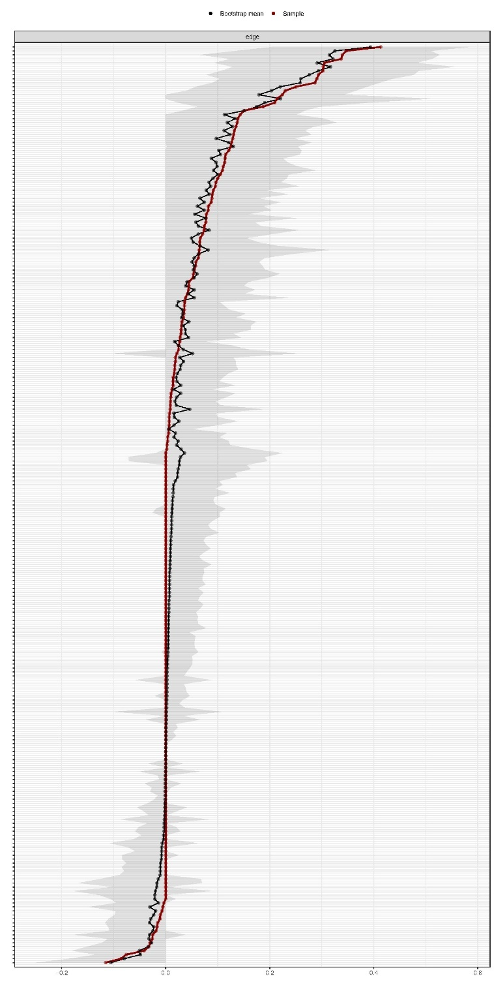
Supplementary Figure S1 Bootstrapped confidence intervals of edge weights of the psychological resilience-social support-PTSD symptom network
The black dots indicate the values of each edge weight, ordered from the highest to the lowest value. The gray area represents the 95% Confidence Intervals of edge weights, estimated with the non-parametric bootstrap procedure (by R bootnet package). Wide intervals suggest lower stability and narrow intervals mean higher stability.
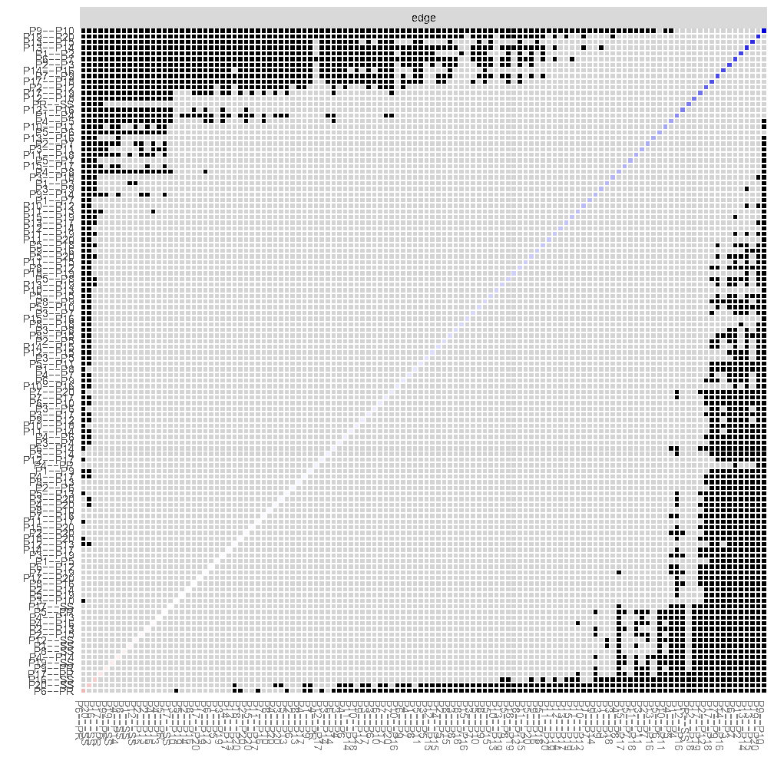
Supplementary Figure S2. Estimation of edge weight difference by bootstrapped difference test
Bootstrapped difference tests between edge weights in the network. Gray boxes suggest edges that do not differ significantly from one-another. Black boxes indicate edges with significant difference from one another (α = 0.05). Blue boxes in the edge-weight diagram indicate positive correlations.

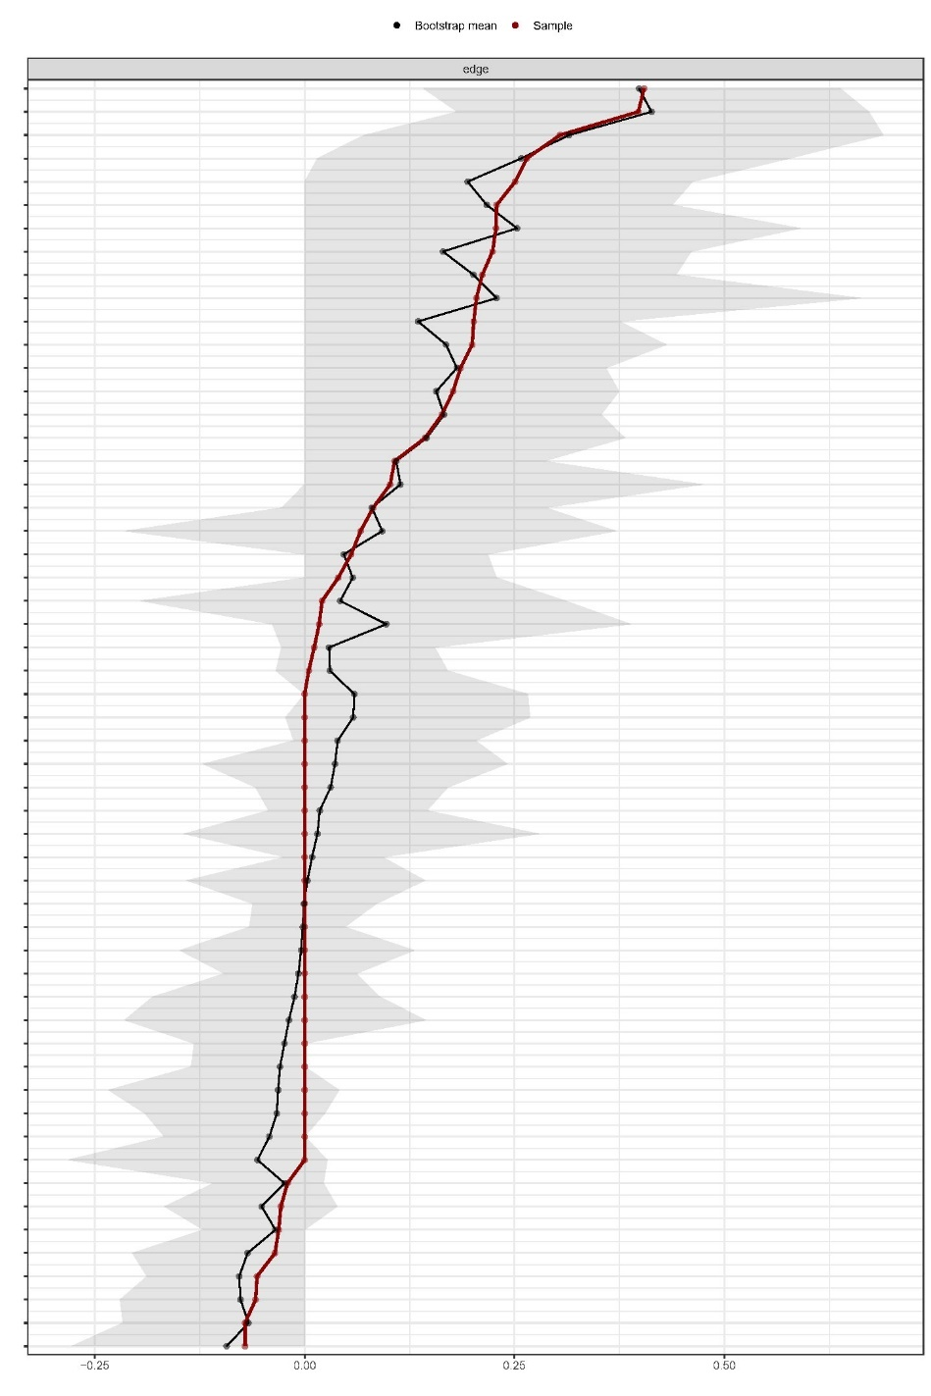
Supplementary Figure S3 Bootstrapped confidence intervals of edge weights of the psychological resilience-social support-depressive symptom network
The black dots indicate the values of each edge weight, ordered from the highest to the lowest value. The gray area represents the 95% Confidence Intervals of edge weights, estimated with the non-parametric bootstrap procedure (by R bootnet package). Wide intervals suggest lower stability and narrow intervals mean higher stability.

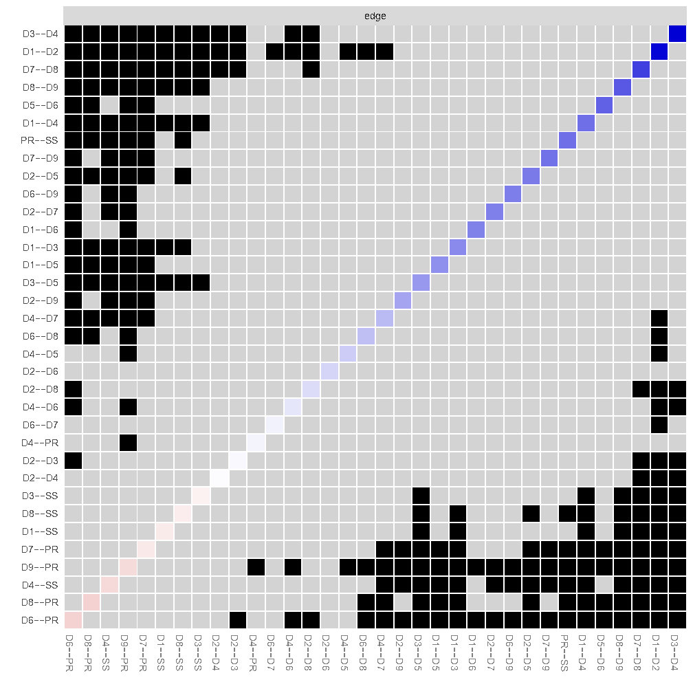
Supplementary Figure S4 Estimation of edge weight difference by bootstrapped difference test of the psychological resilience-social support- depressive symptom network
Bootstrapped difference tests between edge weights in the network. Gray boxes suggest edges that do not differ significantly from one-another. Black boxes indicate edges with significant difference from one another (α = 0.05). Blue boxes in the edge-weight diagram indicate positive correlations.

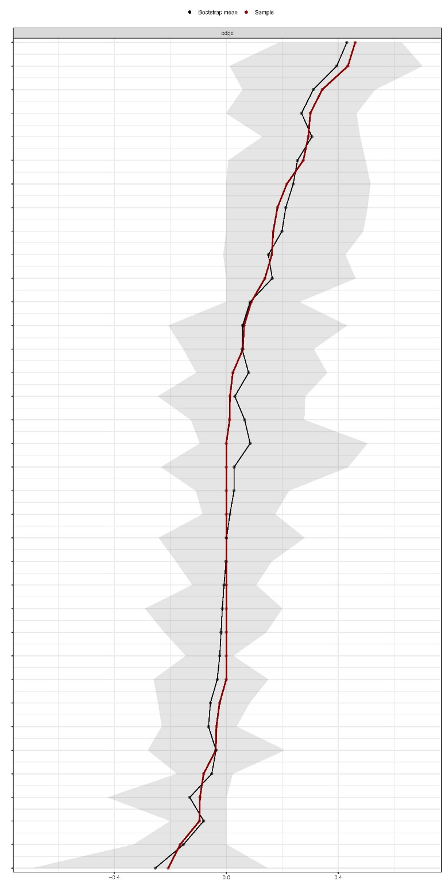
Supplementary Figure S5 Bootstrapped confidence intervals of edge weights of the psychological resilience-social support-anxiety symptom network
The black dots indicate the values of each edge weight, ordered from the highest to the lowest value. The gray area represents the 95% Confidence Intervals of edge weights, estimated with the non-parametric bootstrap procedure (by R bootnet package). Wide intervals suggest lower stability and narrow intervals mean higher stability

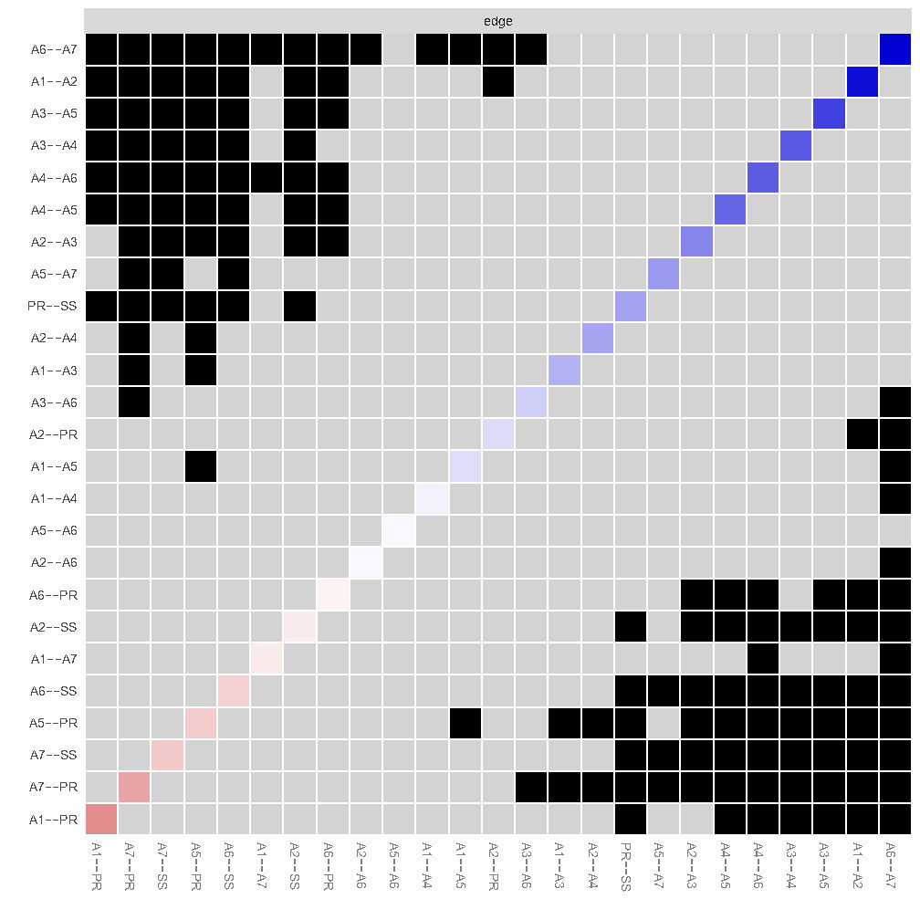
Supplementary Figure S6 Estimation of edge weight difference by bootstrapped difference test of the psychological resilience-social support- anxiety symptom network
Bootstrapped difference tests between edge weights in the network. Gray boxes suggest edges that do not differ significantly from one-another. Black boxes indicate edges with significant difference from one another (α = 0.05). Blue boxes in the edge-weight diagram indicate positive correlations.

