Supplementary Figures
Prevalence of hypomanic/manic and depressive predominant polarity in bipolar disorder 1
Supplementary Figure 1. Weighted prevalence of hypomanic/manic predominant polarity in bipolar disorder. 1
Supplementary Figure 2. Weighted prevalence of depressive predominant polarity in bipolar disorder. 2
Supplementary Figure 3. Weighted prevalence difference of hypomanic/manic vs. depressive predominant polarity in bipolar disorder. 3
Variables associated with hypomanic/manic predominant polarity 4
Supplementary Figure 4. Mean difference in age (years) between participants with a hypomanic/manic predominant polarity and those with a depressive predominant polarity. 4
Supplementary Figure 5. Male gender in participants with a hypomanic/manic predominant polarity vs. those with a depressive predominant polarity. 5
Supplementary Figure 6. Mean difference in age at onset (years) between participants with a hypomanic/manic predominant polarity and those with a depressive predominant polarity. 6
Supplementary Figure 7. Manic polarity of first episode in participants with a hypomanic/manic predominant polarity vs. those with a depressive predominant polarity. 7
Supplementary Figure 8. Diagnosis of bipolar-I disorder in participants with a hypomanic/manic predominant polarity vs. those with a depressive predominant polarity. 8
Supplementary Figure 9. Psychotic features in participants with a hypomanic/manic predominant polarity vs. those with a depressive predominant polarity. 9
Variables associated with depressive predominant polarity 10
Supplementary Figure 10. History of suicide attempts in participants with a depressive predominant polarity vs. those with a hypomanic/manic predominant polarity. 10
Supplementary Figure 11. Depressive polarity of first episode in participants with a depressive predominant polarity vs. those with a hypomanic/manic predominant polarity. 11
Supplementary Figure 12. Mean difference in number of mood episodes between participants with a depressive predominant polarity and those with a hypomanic/manic predominant polarity. 12
Supplementary Figure 13. Being in a relationship in participants with a depressive predominant polarity vs. those with a hypomanic/manic predominant polarity. 13
Variables not associated with any predominant polarity 14
Supplementary Figure 14. Mean difference in years of education between participants with a hypomanic/manic predominant polarity and those with a depressive predominant polarity. 14
Supplementary Figure 15. Unemployment in participants with a hypomanic/manic predominant polarity vs. those with a depressive predominant polarity. 15
Supplementary Figure 16. Mean difference in duration of illness (years) between participants with a hypomanic/manic predominant polarity and those with a depressive predominant polarity. 16
Supplementary Figure 17. Mixed polarity of episode in participants with a hypomanic/manic predominant polarity vs. those with a depressive predominant polarity. 17
Supplementary Figure 18. Rapid cycling course in participants with a hypomanic/manic predominant polarity vs. those with a depressive predominant polarity. 18
Supplementary Figure 19. Mean difference in number of hospital admission between participants with a hypomanic/manic predominant polarity and those with a depressive predominant polarity. 19
Supplementary Figure 20. Mean difference in number of suicide attempts between participants with a hypomanic/manic predominant polarity and those with a depressive predominant polarity. 20
Supplementary Figure 21. Alcohol use disorder in participants with a hypomanic/manic predominant polarity vs. those with a depressive predominant polarity. 21
Supplementary Figure 22. Substance use disorder in participants with a hypomanic/manic predominant polarity vs. those with a depressive predominant polarity. 22
Supplementary Figure 23. Family history of bipolar disorder in participants with a hypomanic/manic predominant polarity vs. those with a depressive predominant polarity. 23
Supplementary Figure 24. Family history of affective disorders in participants with a hypomanic/manic predominant polarity vs. those with a depressive predominant polarity. 24
Supplementary Figure 25. Family history of suicide in participants with a hypomanic/manic predominant polarity vs. those with a depressive predominant polarity. 25

Prevalence of hypomanic/manic and depressive predominant polarity in bipolar disorder

Supplementary Figure 1. Weighted prevalence of hypomanic/manic predominant polarity in bipolar disorder.

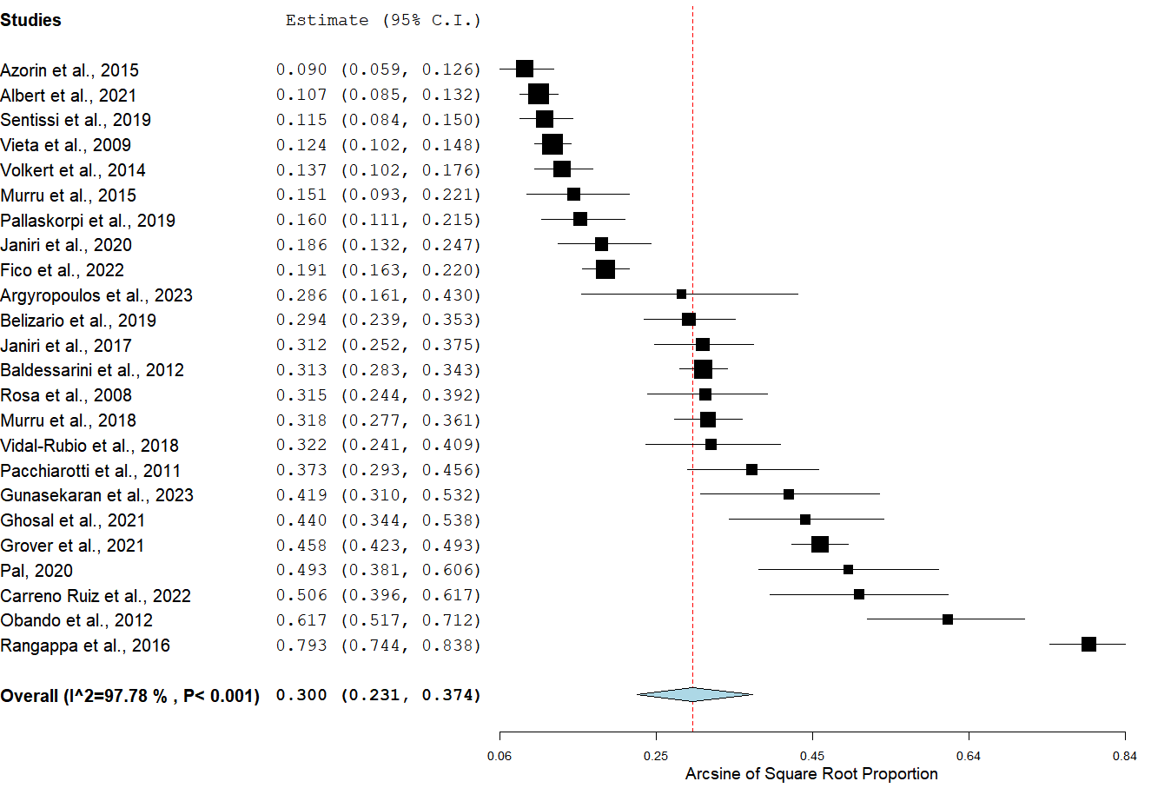

Supplementary Figure 2. Weighted prevalence of depressive predominant polarity in bipolar disorder.

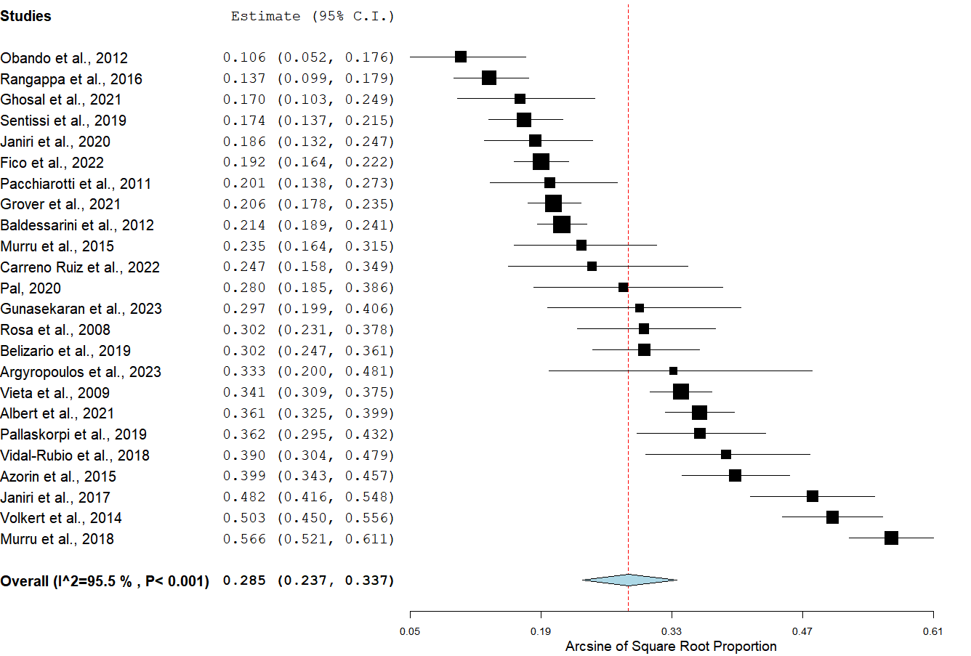

Supplementary Figure 3. Weighted prevalence difference of hypomanic/manic vs. depressive predominant polarity in bipolar disorder.

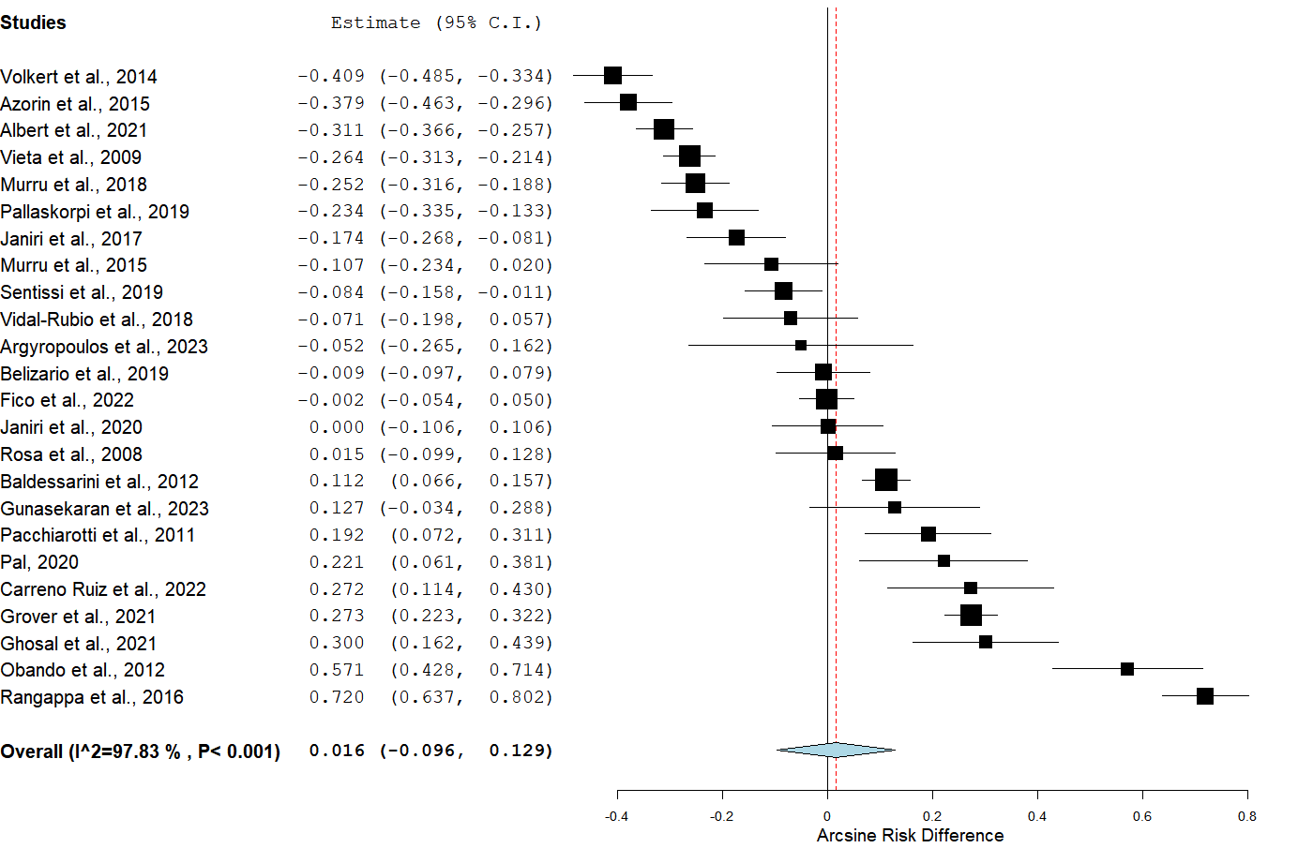

Variables associated with hypomanic/manic predominant polarity

Supplementary Figure 4. Mean difference in age (years) between participants with a hypomanic/manic predominant polarity and those with a depressive predominant polarity.

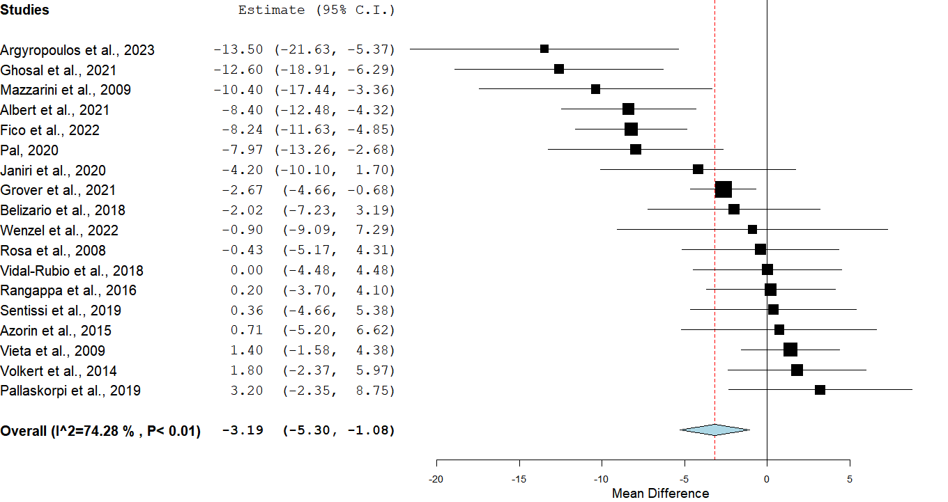

Supplementary Figure 5. Male gender in participants with a hypomanic/manic predominant polarity vs. those with a depressive predominant polarity.

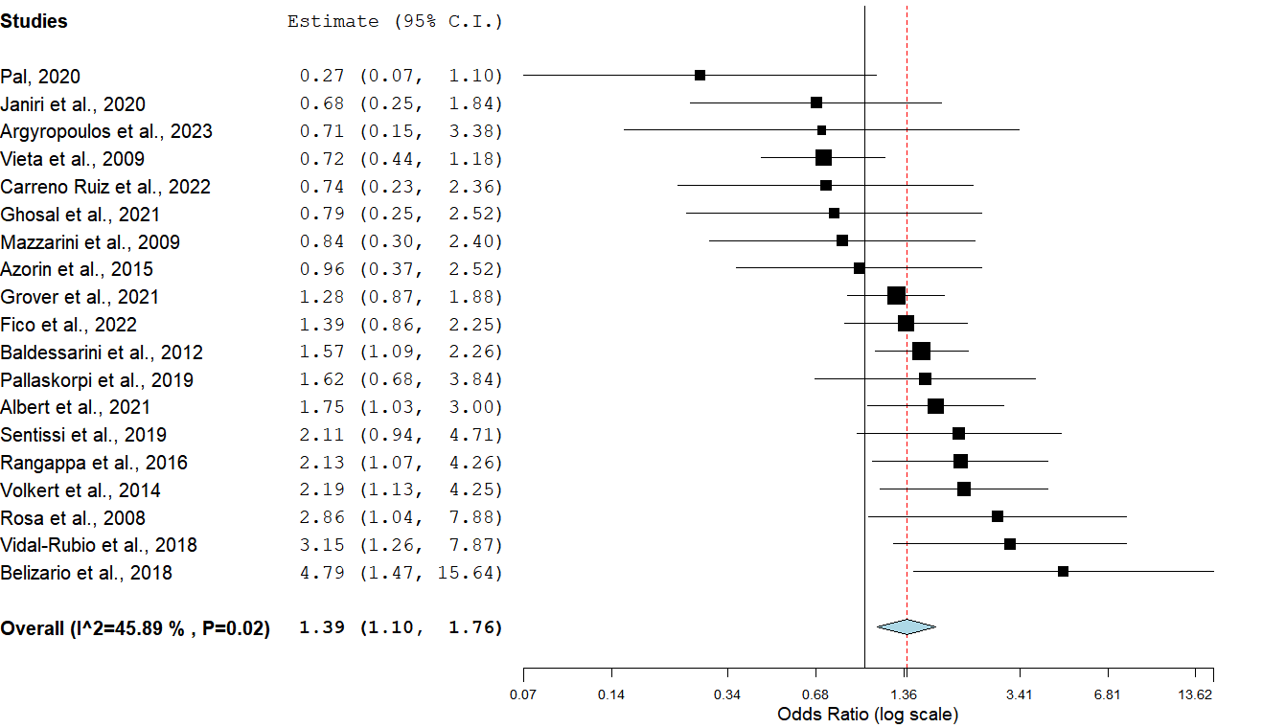

Supplementary Figure 6. Mean difference in age at onset (years) between participants with a hypomanic/manic predominant polarity and those with a depressive predominant polarity.

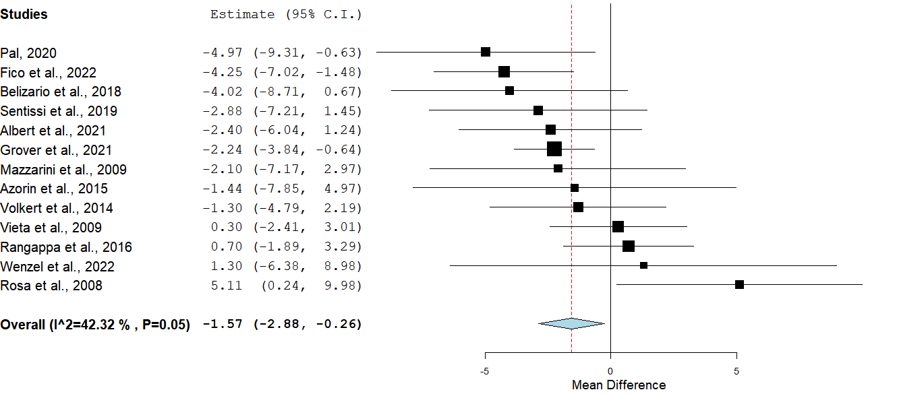

Supplementary Figure 7. Manic polarity of first episode in participants with a hypomanic/manic predominant polarity vs. those with a depressive predominant polarity.

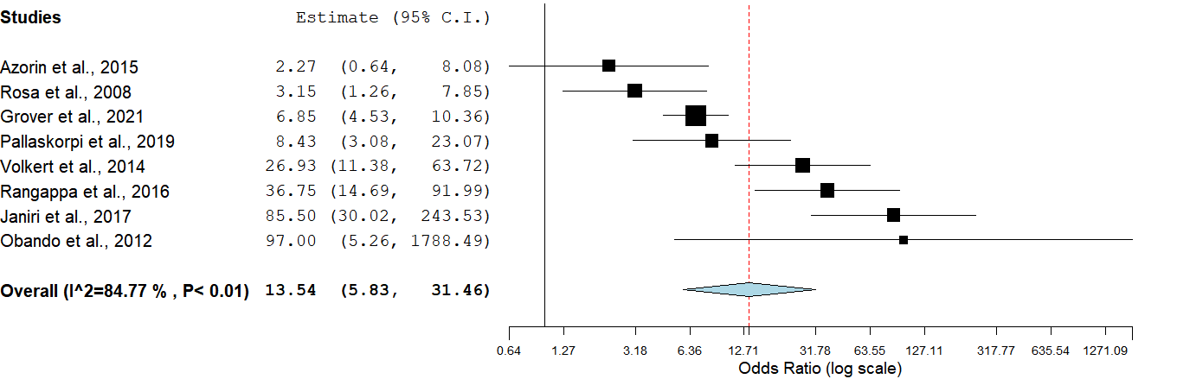

Supplementary Figure 8. Diagnosis of bipolar-I disorder in participants with a hypomanic/manic predominant polarity vs. those with a depressive predominant polarity.

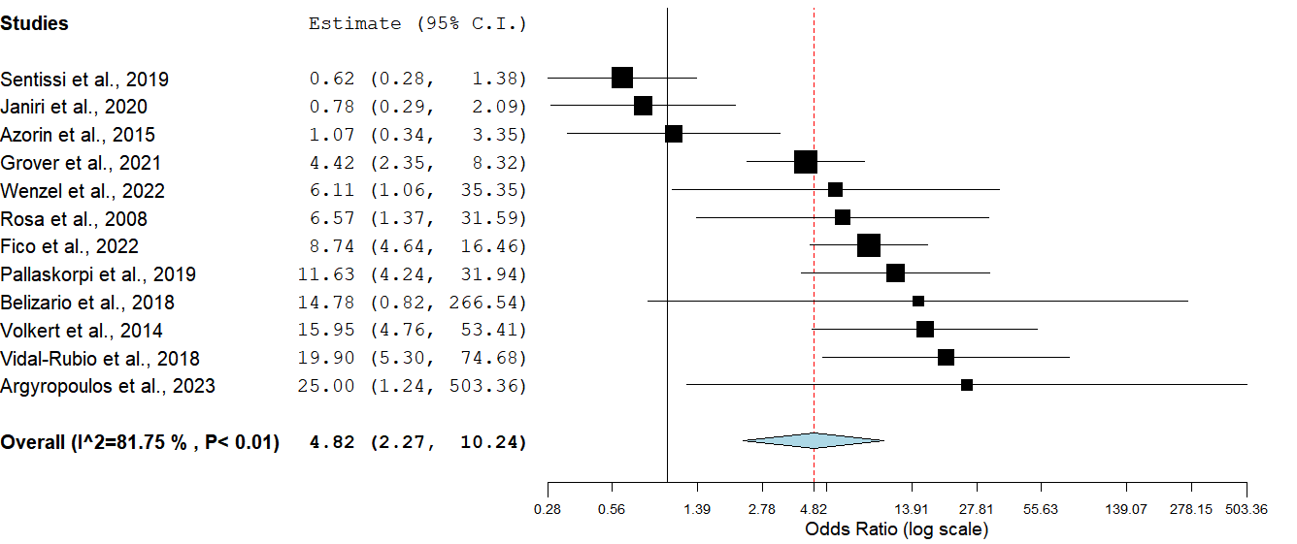

Supplementary Figure 9. Psychotic features in participants with a hypomanic/manic predominant polarity vs. those with a depressive predominant polarity.

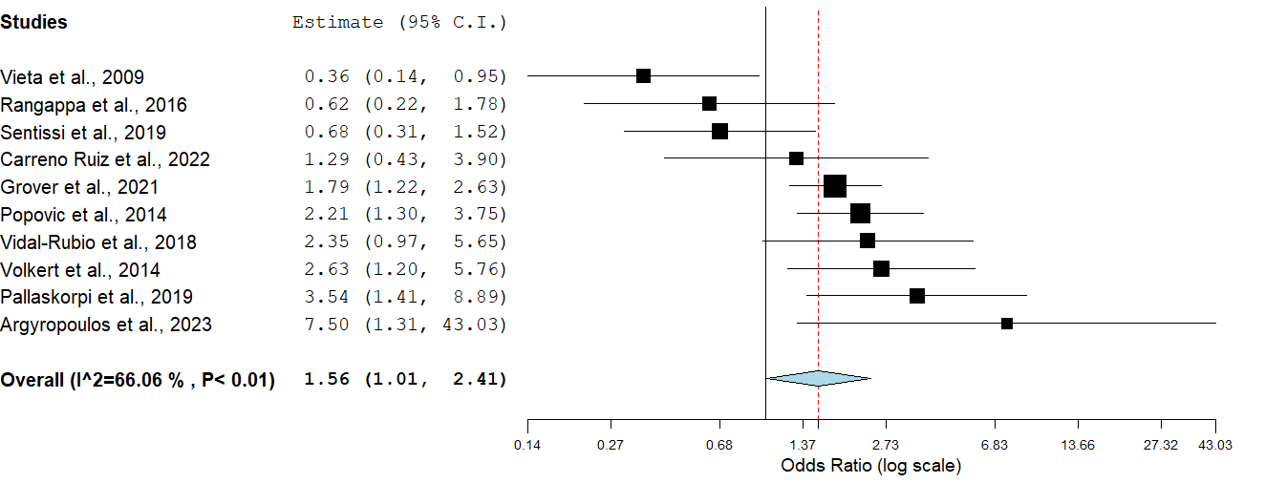

Variables associated with depressive predominant polarity

Supplementary Figure 10. History of suicide attempts in participants with a depressive predominant polarity vs. those with a hypomanic/manic predominant polarity.

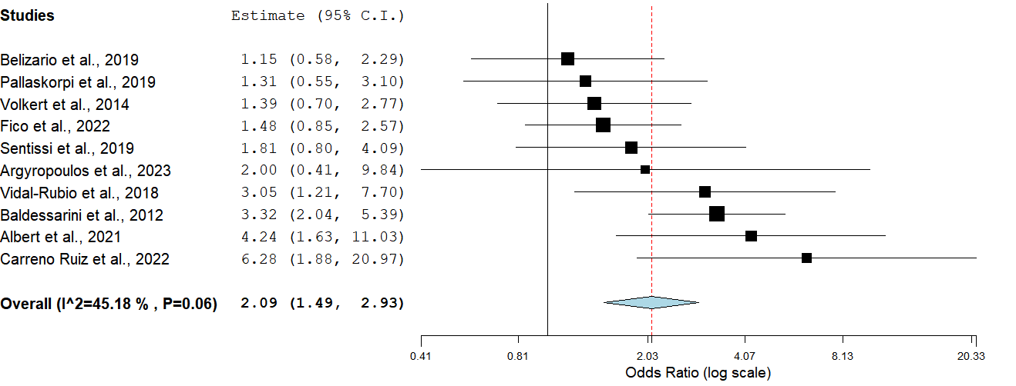

Supplementary Figure 11. Depressive polarity of first episode in participants with a depressive predominant polarity vs. those with a hypomanic/manic predominant polarity.

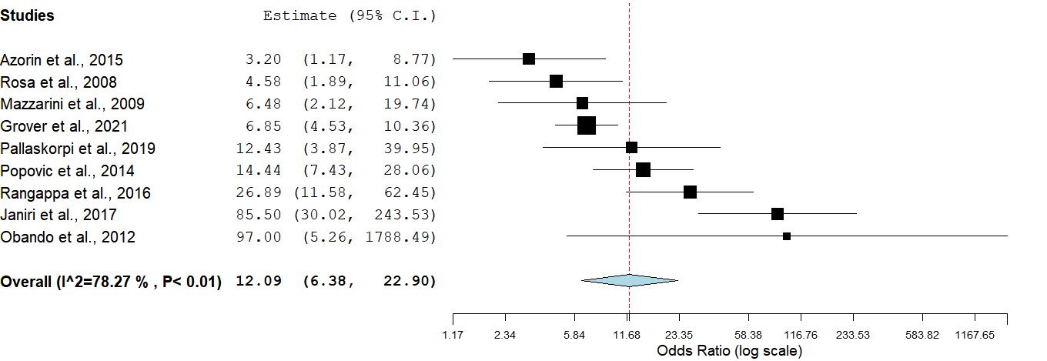

Supplementary Figure 12. Mean difference in number of mood episodes between participants with a depressive predominant polarity and those with a hypomanic/manic predominant polarity.

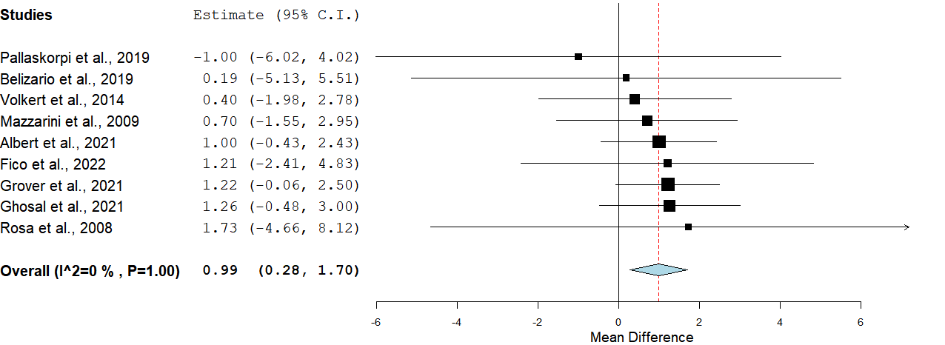

Supplementary Figure 13. Being in a relationship in participants with a depressive predominant polarity vs. those with a hypomanic/manic predominant polarity.

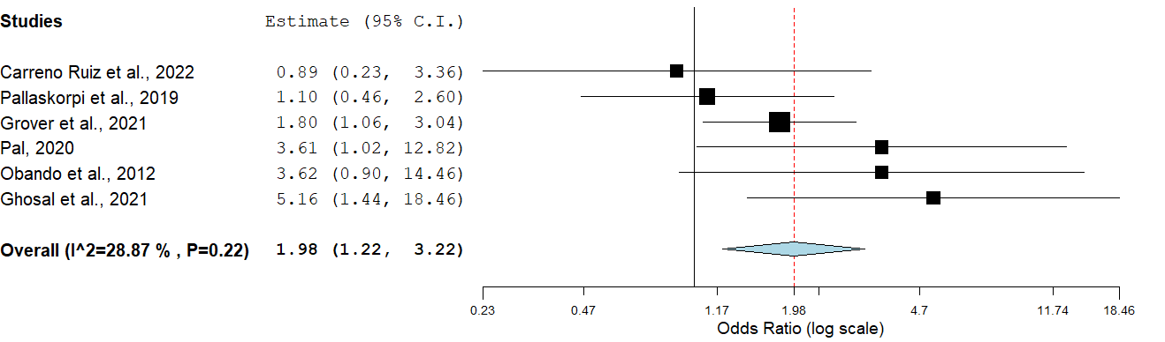

Variables not associated with any predominant polarity

Supplementary Figure 14. Mean difference in years of education between participants with a hypomanic/manic predominant polarity and those with a depressive predominant polarity.

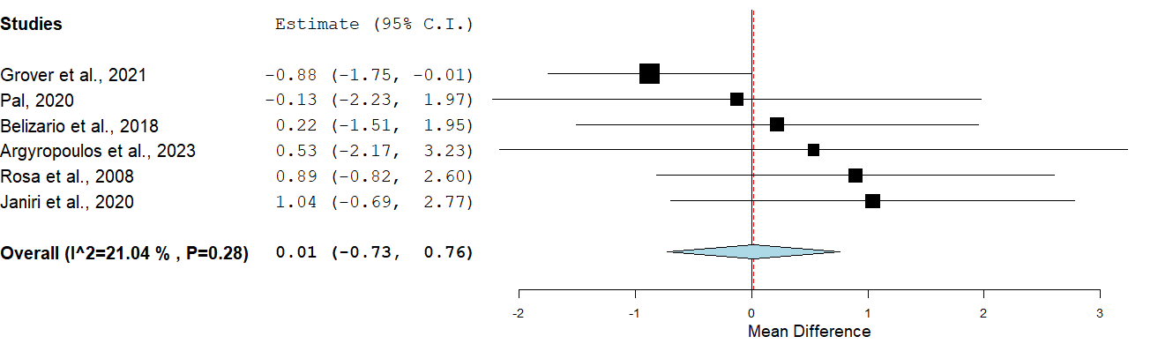

Supplementary Figure 15. Unemployment in participants with a hypomanic/manic predominant polarity vs. those with a depressive predominant polarity.

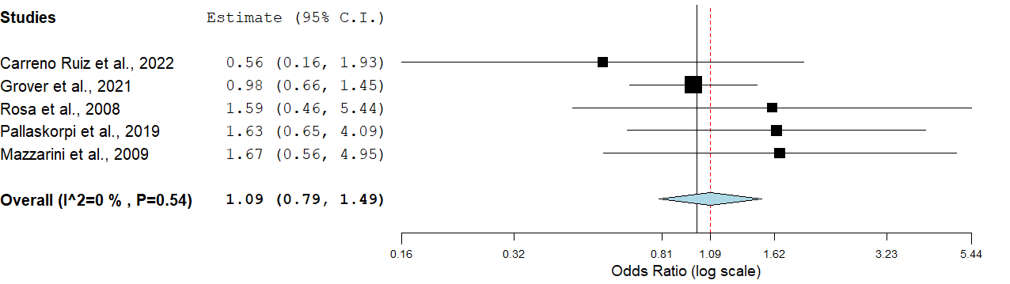

Supplementary Figure 16. Mean difference in duration of illness (years) between participants with a hypomanic/manic predominant polarity and those with a depressive predominant polarity.

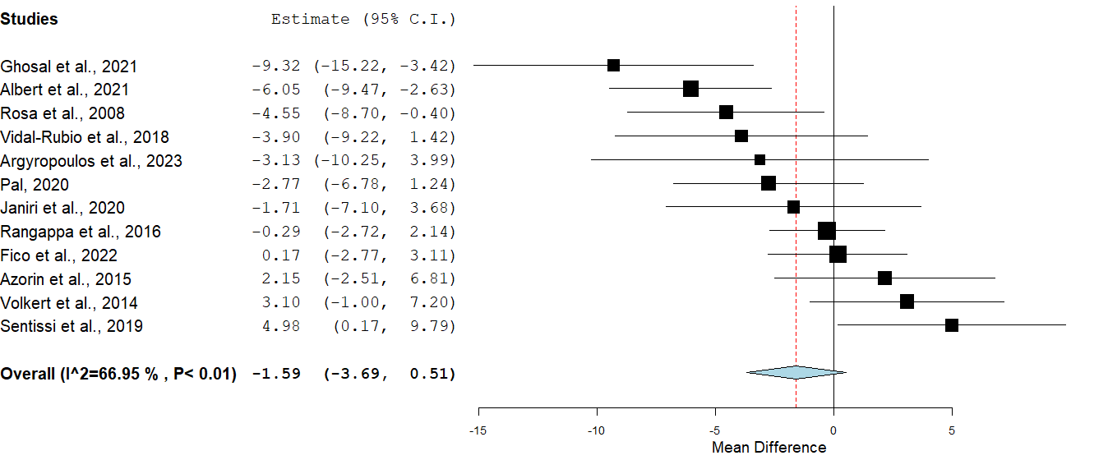

Supplementary Figure 17. Mixed polarity of episode in participants with a hypomanic/manic predominant polarity vs. those with a depressive predominant polarity.

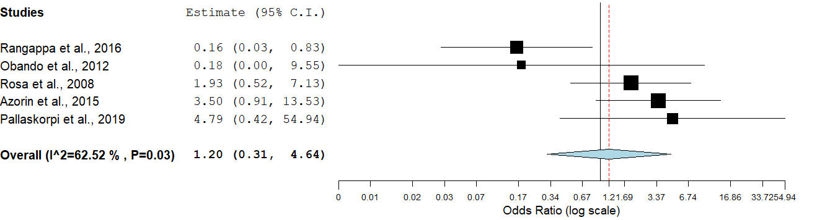

Supplementary Figure 18. Rapid cycling course in participants with a hypomanic/manic predominant polarity vs. those with a depressive predominant polarity.

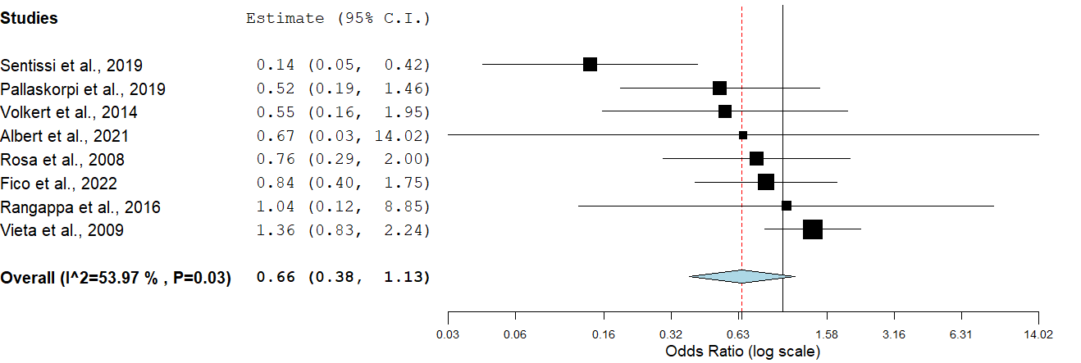

Supplementary Figure 19. Mean difference in number of hospital admission between participants with a hypomanic/manic predominant polarity and those with a depressive predominant polarity.

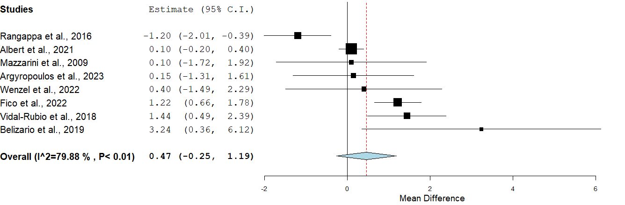

Supplementary Figure 20. Mean difference in number of suicide attempts between participants with a hypomanic/manic predominant polarity and those with a depressive predominant polarity.

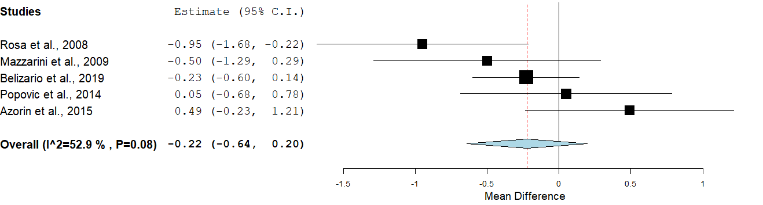

Supplementary Figure 21. Alcohol use disorder in participants with a hypomanic/manic predominant polarity vs. those with a depressive predominant polarity.

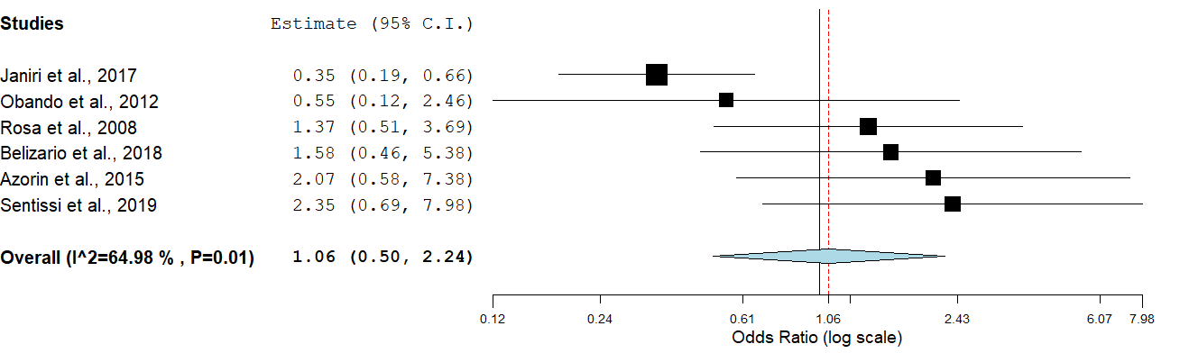

Supplementary Figure 22. Substance use disorder in participants with a hypomanic/manic predominant polarity vs. those with a depressive predominant polarity.

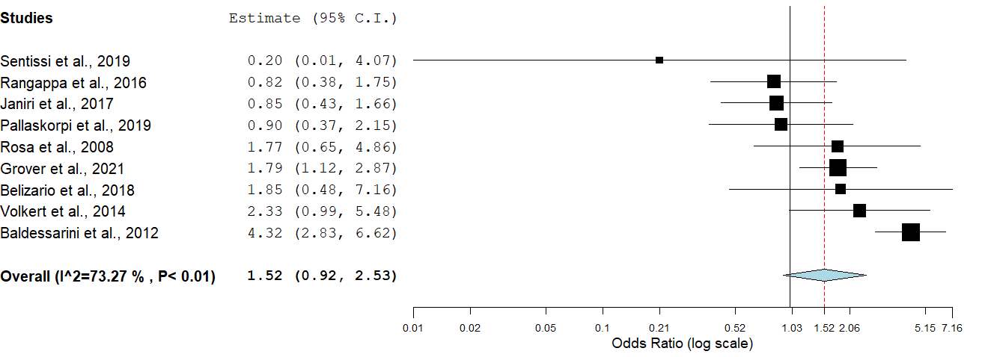

Supplementary Figure 23. Family history of bipolar disorder in participants with a hypomanic/manic predominant polarity vs. those with a depressive predominant polarity.

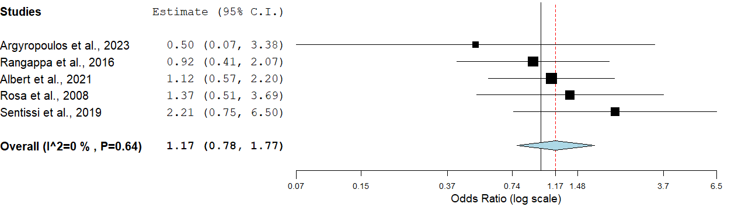

Supplementary Figure 24. Family history of affective disorders in participants with a hypomanic/manic predominant polarity vs. those with a depressive predominant polarity.

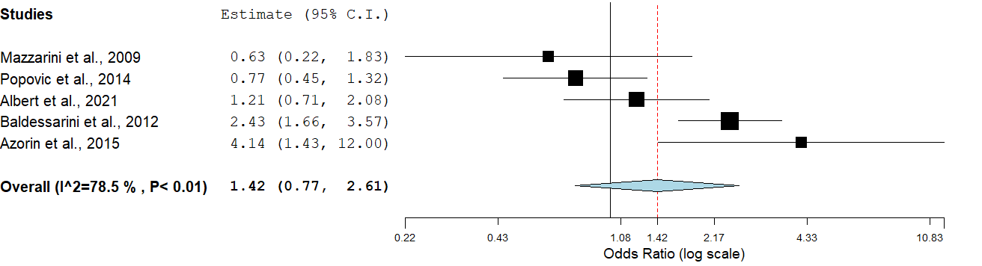

Supplementary Figure 25. Family history of suicide in participants with a hypomanic/manic predominant polarity vs. those with a depressive predominant polarity.

