Supplementary material for “Prevalence and clinical correlates of suicide attempts in first-episode, never treated major depressive disorder patients with comorbid autoimmune thyroiditis”
Figure S1 Results of LASSO regression
Table S1 Correlation matrix of thyroid indexes and clinical symptoms
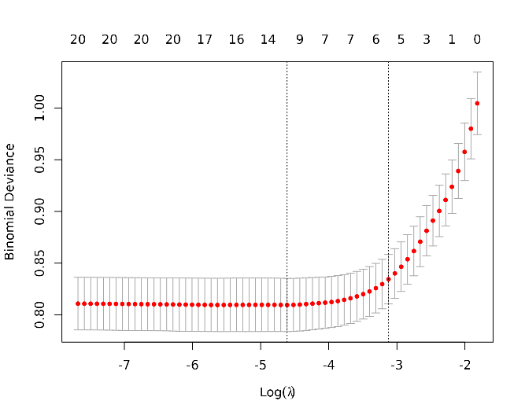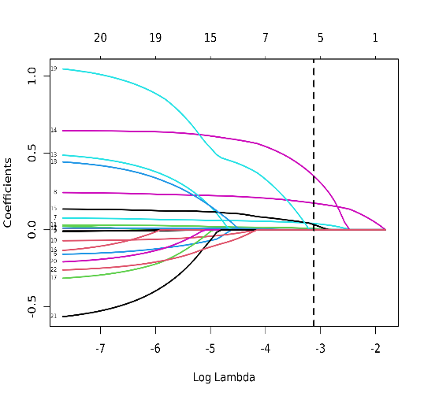
Figure S1 Results of LASSO regression. (a) Lasso Regression Cross-Validation Plot; (b) Lasso Regression Coefficient Path Plot
Table S1 Correlation matrix of thyroid indexes and clinical symptoms
 | HAMD | HAMA | PANSS-P
lnTSH | 0.429*** | 0.234*** | 0.276***
lnTgAb | 0.159*** | 0.200*** | 0.132***
lnTPOAb | 0.189*** | 0.211*** | 0.154***
lnFT3 | 0.033 | 0.022 | 0.002
lnFT4 | 0.007 | 0.026 | 0.020
*** p<0.001
Note: HAMD = Hamilton Depression Rating Scale, HAMA = Hamilton Anxiety Rating Scale, PANSS-P = the Positive and Negative Syndrome Scale positive subscale, TSH = thyroid-stimulating hormone, FT3 = free triiodothyronine, FT4 = free thyroxine, TgAb = antithyroglobulin, TPOAb = thyroid peroxidases antibody.

