Supplemental Materials

Fig S1: Methodological overview of the study design
Abbreviations: FSD=functional somatic disorders; IB=irritable bowel; CWP=chronic widespread pain; CF=chronic fatigue; stress=perceived stress; ALEs=accumulated number of adverse life events.
Fig S2: Flow of study participants

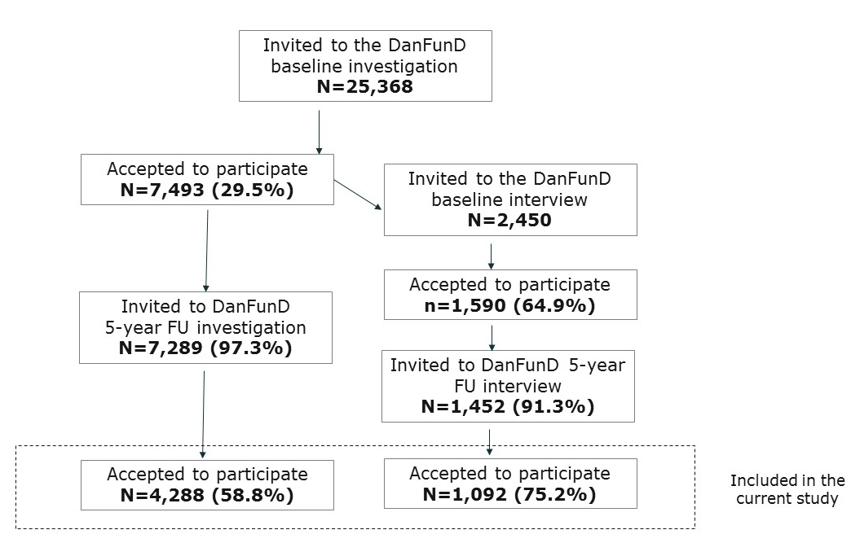

Abbreviations: FU = follow-up.

