Supplementary material

Table S1. List of countries by geographic region
Nordic countries (except Sweden) | Europe (except Nordic countries) | Africa | Asia | North America | South America | Oceania
Denmark | Albania | Algeria | Afghanistan | Anguilla | Argentina | Australia
Finland | Andorra | Angola | Armenia | Antigua and Barbuda | Bolivia | Fiji
Iceland | Austria | Benin | Azerbajdzjan | Bahamas | Brazil | Kiribati
Norway | Belarus | Botswana | Bahrain | Barbados | Chile | Marshall Islands
 | Belgium | Burkina Faso | Bangladesh | Belize | Colombia | Micronesia
 | Bosnia and Herzegovina | Burundi | Bhutan | Bermuda | Ecuador | Nauru
 |  | Cameroon | Brunei | British Virgin Islands | Guyana | New Zeeland
 | Bulgaria | Central African Republic | Cambodia | Canada | Paraguay | Palau
 | Croatia |  | China | Costa Rica | Peru | Papua New Guinea
 | Cyprus | Chad | East Timor | Cuba | Suriname | Samoa
 | Czech Republic | Comoros | Georgia | Dominica | Uruguay | Solomon Islands
 | Estonia | Democratic Republic of the Congo | India | Dominican Republic | Venezuela | Tonga
 | France |  | Indonesia | El Salvador |  | Tuvalu
 | Germany | Djibouti | Iran | Grenada |  | Vanuatu
 | Gibraltar | Egypt | Iraq | Guatemala
 | Greece | Equatorial Guinea | Israel | Haiti
 | Holy See | Eritrea | Japan | Honduras
 | Hungary | Eswatini | Jordan | Jamaica
 | Ireland | Ethiopia | Kazakhstan | Mexico
 | Italy | Gabon | Kirgizistan | Nicaragua
 | Kosovo | Gambia | Kuwait | Panama
 | Latvia | Ghana | Laos | Saint Kitts and Nevis
 | Liechtenstein | Guinea | Libanon | Saint Lucia
 | Lithuania | Guinea-Bissau | Malaysia | Saint Vincent and the Grenadines
 | Luxembourg | Ivory Coast | Maldives
 | Malta | Kap Verde | Mongolia | Trinidad and Tobago
 | Moldavia | Kenya | Myanmar | United States
 | Monaco | Lesotho | Nepal
 | Montenegro | Liberia | North Korea
 | Netherlands | Libya | Oman
 | North Macedonia | Madagascar | Pakistan
 | Poland | Malawi | Palestina
 | Portugal | Mali | Philippines
 | Romania | Mauretania | Qatar
 | Russia | Mauritius | Saudi Arabia
 | San Marino | Moçambique | Singapore
 | Serbia | Morocco | South Korea
 | Slovakia | Namibia | Sri Lanka
 | Slovenia | Niger | Syria
 | Spain | Nigeria | Taiwan
 | Switzerland | Republic of the Congo | Tajikistan
 | Turkey | Rwanda | Thailand
 | Ukraine | São Tomé and | Turkmenistan
 | United Kingdom | Príncipe | United Arab
 |  | Senegal | Emirates
 |  | Seychelles | Uzbekistan
 |  | Sierra Leone | Vietnam
 |  | Somalia | Yemen
 |  | South Africa
 |  | South Sudan
 |  | Sudan
 |  | Tanzania
 |  | Togo
 |  | Tunisia
 |  | Uganda
 |  | Zambia
 |  | Zimbabwe

Table S2. Description of the survey data by levels of exposure
 | Region of birth
 | Sweden |  |  | Europe (other than Sweden) |  |  | Non-European countries
 | n | % | Weighted % | n | % | Weighted % | n | % | Weighted %
Sex
Female | 23128 | 56.6 | 49.4 | 2858 | 61.3 | 57.7 | 1122 | 53.5 | 51.7
Male | 17727 | 43.4 | 50.6 | 1806 | 38.7 | 42.3 | 976 | 46.5 | 48.3
Age groups
22-29 years | 1355 | 3.3 | 19.2 | 39 | 0.8 | 3.8 | 60 | 2.9 | 7.6
30-44 years | 7544 | 18.5 | 32.5 | 534 | 11.4 | 18.3 | 537 | 25.6 | 29.9
45-66 years | 17587 | 43.0 | 30.7 | 2101 | 45.0 | 43.7 | 1227 | 58.5 | 52.0
67+ years | 14369 | 35.2 | 17.6 | 1990 | 42.7 | 34.1 | 274 | 13.1 | 10.5
 | Parent background
 | Both parents born in Sweden |  |  | One parent born abroad |  |  | Both parents born abroad
 | n | % | Weighted % | n | % | Weighted % | n | % | Weighted %
Sex
Female | 17612 | 56.5 | 48.4 | 2705 | 57.3 | 51.0 | 4186 | 59.3 | 53.6
Male | 13549 | 43.5 | 51.6 | 2014 | 42.7 | 49.0 | 2875 | 40.7 | 46.4
Age groups
22-29 years | 1041 | 3.3 | 18.7 | 214 | 4.5 | 24.6 | 201 | 2.8 | 10.0
30-44 years | 6175 | 19.8 | 34.4 | 952 | 20.2 | 32.3 | 1496 | 21.2 | 28.7
45-66 years | 14643 | 47.0 | 33.1 | 3201 | 48.8 | 32.3 | 3992 | 56.5 | 50.1
67+ years | 9302 | 29.9 | 13.7 | 1252 | 26.5 | 10.9 | 1372 | 19.4 | 11.2
 | Neighborhood population
 | <20% with migration background |  |  | 20-40% with migration background |  |  | >40% with migration background
 | n | % | Weighted % | n | % | Weighted % | n | % | Weighted %
Sex
Female | 10929 | 57.0 | 51.5 | 13907 | 57.0 | 50.5 | 2298 | 56.0 | 50.1
Male | 8325 | 43.0 | 48.5 | 10485 | 43.0 | 49.5 | 1808 | 44.0 | 49.9
Age groups
22-29 years | 481 | 2.5 | 13.9 | 850 | 3.5 | 17.3 | 125 | 3.0 | 13.0
30-44 years | 3198 | 16.7 | 31.0 | 4769 | 19.6 | 31.0 | 656 | 16.0 | 25.5
45-66 years | 8484 | 44.2 | 34.8 | 10625 | 43.6 | 34.2 | 1827 | 44.5 | 41.2
67+ years | 7001 | 36.5 | 20.2 | 8148 | 33.4 | 17.5 | 1498 | 36.5 | 20.3

Table S3. General linear model including region of birth, sex, and age
 | B (95% CI)
SCOFF3 score
Europe (other than Sweden)^{ⴕ} | 0.08 (0.06, 0.10)
Non-European countries^{ⴕ} | 0.23 (0.19, 0.27)
Sex (female) | 0.10 (0.09, 0.12)
Age | -0.004 (-0.003, -0.004)
Combined ED score
Europe (other than Sweden)^{ⴕ} | 0.09 (0.07, 0.11)
Non-European countries^{ⴕ} | 0.32 (0.27, 0.36)
Sex (female) | 0.11 (0.09, 0.13)
Age | -0.003 (-0.004, -0.003)
GHQ-12 score
Europe (other than Sweden)^{ⴕ} | 0.13 (0.00, 0.25)
Non-European countries^{ⴕ} | 0.33 (0.17, 0.39)
Sex (female) | 0.50 (0.40, 0.59)
Age | -0.029 (-0.033, -0.026)
Suicidality score
Europe (other than Sweden)^{ⴕ} | 0.02 (0.00, 0.03)
Non-European countries^{ⴕ} | 0.01 (-0.01, 0.03)
Sex (female) | 0.04 (0.03, 0.05)
Age | -0.003 (-0.004, -0.003)
BMI
Europe (other than Sweden)^{ⴕ} | 0.60 (0.44, 0.77)
Non-European countries^{ⴕ} | 0.69 (0.45, 0.93)
Sex (female) | -1.29 (-1.42, -1.16)
Age | 0.038 (0.033, 0.042)
(BMI: Body Mass Index; CI: Confidence interval; ED: Eating disorder; GHQ-12: 12-Item General Health Questionnaire)
^{ⴕ}Compared to the Swedish-born group as reference

Table S4. General linear model including parent background, sex, and age
 | B (95% CI)
SCOFF3 score
One parent born abroad^{ⴕ} | 0.03 (0.00, 0.06)
Both parents born abroad^{ⴕ} | 0.17 (0.14, 0.19)
Sex (female) | 0.11 (0.09, 0.13)
Age | -0.004 (-0.005, -0.003)
Combined ED score
One parent born abroad^{ⴕ} | 0.03 (0.00, 0.06)
Both parents born abroad^{ⴕ} | 0.22 (0.19, 0.24)
Sex (female) | 0.11 (0.09, 0.13)
Age | -0.004 (-0.004, -0.003)
GHQ-12 score
One parent born abroad^{ⴕ} | 0.19 (0.02, 0.37)
Both parents born abroad^{ⴕ} | 0.22 (0.11, 0.33)
Sex (female) | 0.49 (0.39, 0.59)
Age | -0.036 (-0.040, -0.032)
Suicidality score
One parent born abroad^{ⴕ} | 0.02 (0.00, 0.04)
Both parents born abroad^{ⴕ} | 0.02 (0.00, 0.03)
Sex (female) | 0.04 (0.03, 0.05)
Age | -0.003 (-0.004, -0.003)
BMI
One parent born abroad^{ⴕ} | 0.10 (-0.13, 0.32)
Both parents born abroad^{ⴕ} | 0.73 (0.54, 0.92)
Sex (female) | -1.33 (-1.46, -1.19)
Age | 0.053 (0.048, 0.058)
(BMI: Body Mass Index; CI: Confidence interval; ED: Eating disorder; GHQ-12: 12-Item General Health Questionnaire)
^{ⴕ}Compared to the group with two parents born in Sweden as reference

Table S5. General linear model including neighborhood population, sex, and age
 | B (95% CI)
SCOFF3 score
20-40% with migration background^{ⴕ} | 0.03 (0.02, 0.05)
>40% with migration background^{ⴕ} | 0.14 (0.11, 0.18)
Sex (female) | 0.11 (0.09, 0.13)
Age | -0.003 (-0.004, -0.003)
Combined ED score
20-40% with migration background^{ⴕ} | 0.04 (0.03, 0.06)
>40% with migration background^{ⴕ} | 0.18 (0.14, 0.22)
Sex (female) | 0.11 (0.10, 0.13)
Age | -0.003 (-0.003, -0.002)
GHQ-12 score
20-40% with migration background^{ⴕ} | 0.06 (-0.04, 0.15)
>40% with migration background^{ⴕ} | 0.20 (0.04, 0.36)
Sex (female) | 0.50 (0.41, 0.59)
Age | -0.029 (-0.032, -0.026)
Suicidality score
20-40% with migration background^{ⴕ} | 0.00 (-0.01, 0.01)
>40% with migration background^{ⴕ} | 0.01 (-0.01, 0.03)
Sex (female) | 0.04 (0.03, 0.05)
Age | -0.003 (-0.004, -0.003)
BMI
20-40% with migration background^{ⴕ} | 0.25 (0.12, 0.37)
>40% with migration background^{ⴕ} | 1.19 (0.95, 1.93)
Sex (female) | -1.26 (-1.39, -1.13)
Age | 0.040, 0.035, 0.044)
(BMI: Body Mass Index; CI: Confidence interval; ED: Eating disorder; GHQ-12: 12-Item General Health Questionnaire)
^{ⴕ}Compared to the group with <20% population with migration background as reference

Table S6. Disordered eating, mental distress, body mass index, SCOFF items, and restricitive eating in individuals whose both parents are born in a non-European country
 | Both parents born in Sweden | Both parents born in a non-European country
 | Mean | Mean | Mean difference^{ⴕ} (95% CI)
Total population
SCOFF3 score | 0.14 | 0.44 | 0.30 (0.17, 0.43)
Combined ED score | 0.16 | 0.53 | 0.38 (0.22, 0.53)
GHQ-12 score | 1.64 | 2.47 | 0.83 (0.38, 1.27)
Suicidality score | 0.15 | 0.22 | 0.08 (0.01, 0.14)
BMI | 25.0 | 25.4 | 0.48 (-0.76, 1.72)
Females
SCOFF3 score | 0.19 | 0.57 | 0.38 (0.18, 0.58)
Combined ED score | 0.22 | 0.67 | 0.46 (0.21, 0.70)
GHQ-12 score | 1.84 | 3.05 | 1.21 (0.56, 1.86)
Suicidality score | 0.16 | 0.29 | 0.13 (0.03, 0.22)
BMI | 24.3 | 24.2 | -0.18 (-0.82, 0.42)
Males
SCOFF3 score | 0.09 | 0.28 | 0.19 (0.06, 0.33)
Combined ED score | 0.10 | 0.37 | 0.27 (0.12, 0.42)
GHQ-12 score | 1.46 | 1.74 | 0.29 (-0.24, 0.82)
Suicidality score | 0.14 | 0.15 | 0.01 (-0.08, 0.10)
BMI | 25.6 | 26.9 | 1.38 (-1.09, 3.85)
 | % "Yes" | % "Yes" | OR^{ⴕ} (95% CI)
SCOFF item
Compensatory vomiting | 0.9 | 4.9 | 5.8 (2.6, 12.9)
Loss-of-control eating | 7.6 | 25.4 | 4.2 (2.9, 6.0)
Preoccupation with food | 5.4 | 13.3 | 2.7 (1.7, 4.4)
Restrictive eating | 2.0 | 9.0 | 4.8 (2.5, 9.0)
(BMI: Body Mass Index; CI: Confidence interval; ED: Eating disorder; GHQ-12: 12-Item General Health Questionnaire; OR: Odds ratio)
^{ⴕ}Compared to the group with two parents born in Sweden as reference

Table S7. Disordered eating, mental distress, body mass index, SCOFF items, and restricitive eating according to birth region
 | Sweden | Nordic countries (except Sweden) |  | Europe (except Nordic countries)
 | Mean | Mean | Mean difference^{ⴕ} (95% CI) | Mean | Mean difference^{ⴕ} (95% CI)
SCOFF3 score | 0.15 | 0.16 | 0.01 (-0.02, 0.04) | 0.24 | 0.09 (0.06, 0.12)
Combined ED score | 0.17 | 0.18 | 0.02 (-0.02, 0.05) | 0.28 | 0.11 (0.08, 0.15)
GHQ-12 score | 1.67 | 1.30 | -0.38 (-0.24, -0.21) | 1.75 | 0.08 (-0.11, 0.26)
Suicidality score | 0.15 | 0.12 | -0.03 (-0.05, -0.01) | 0.15 | 0.00 (-0.03, 0.02)
BMI | 25.0 | 26.0 | 1.04 (0.82, 1.27) | 25.7 | 0.77 (0.53, 1.01)
 | % "Yes" | % "Yes" | OR^{ⴕ} (95% CI) | % "Yes" | OR^{ⴕ} (95% CI)
SCOFF item
Compensatory vomiting | 1.1 | 2.0 | 1.9 (1.0, 3.5) | 3.2 | 3.1 (2.2, 4.4)
Loss-of-control eating | 7.9 | 7.6 | 1.0 (0.8, 1.2) | 11.7 | 1.6 (1.3, 1.9)
Preoccupation with food | 5.7 | 6.2 | 1.1 (0.9, 1.4) | 8.7 | 1.6 (1.3, 2.0)
Restrictive eating | 2.2 | 2.9 | 1.3 (1.0, 1.8) | 5.1 | 2.3 (1.8, 3.1)
 |  | Africa |  | Asia
 |  | Mean | Mean difference^{ⴕ} (95% CI) | Mean | Mean difference^{ⴕ} (95% CI)
SCOFF3 score |  | 0.27 | 0.13 (0.05, 0.21) | 0.44 | 0.30 (0.24, 0.35)
Combined ED score |  | 0.42 | 0.25 (0.16, 0.34) | 0.56 | 0.39 (0.33, 0.46)
GHQ-12 score |  | 1.89 | 0.22 (-0.17, 0.62) | 1.99 | 0.32 (0.11, 0.53)
Suicidality score |  | 0.11 | -0.04 (-0.08, 0.00) | 0.15 | 0.01 (-0.02, 0.03)
BMI |  | 25.9 | 0.96 (0.46, 1.46) | 25.6 | 0.66 (0.32, 1.00)
 |  | % "Yes" | OR^{ⴕ} (95% CI) | % "Yes" | OR^{ⴕ} (95% CI)
SCOFF item
Compensatory vomiting |  | 6.0 | 6.0 (3.4, 10.6) | 7.5 | 7.6 (5.5, 10.3)
Loss-of-control eating |  | 12.0 | 1.6 (1.1, 2.4) | 21.7 | 3.2 (2.7, 3.9)
Preoccupation with food |  | 10.1 | 1.9 (1.2, 2.9) | 15.0 | 2.9 (2.4, 3.6)
Restrictive eating |  | 14.7 | 7.5 (5.2, 10.9) | 11.3 | 5.6 (4.3, 7.2)
 |  | North America |  | South America
 |  | Mean | Mean difference^{ⴕ} (95% CI) | Mean | Mean difference^{ⴕ} (95% CI)
SCOFF3 score |  | 0.24 | 0.10 (-0.02, 0.21) | 0.25 | 0.10 (0.04, 0.17)
Combined ED score |  | 0.32 | 0.16 (0.03, 0.28) | 0.34 | 0.17 (0.10, 0.25)
GHQ-12 score |  | 1.60 | -0.08 (-0.57, 0-42) | 2.10 | 0.43 (0.03, 0.83)
Suicidality score |  | 0.16 | 0.01 (-0.06, 0.07) | 0.18 | 0.03 (-0.02, 0.08)
BMI |  | 25.6 | 0.66 (-0.07, 1.39) | 25.9 | 0.97 (0.48, 1.46)
 |  | % "Yes" | OR^{ⴕ} (95% CI) | % "Yes" | OR^{ⴕ} (95% CI)
SCOFF item
Compensatory vomiting |  | 0.8 | 0.7 (0.2, 3.1) | 3.9 | 3.8 (2.0, 7.0)
Loss-of-control eating |  | 14.2 | 1.9 (1.1, 3.3) | 14.4 | 2.0 (1.4, 2.8)
Preoccupation with food |  | 9.0 | 1.6 (0.8, 3.1) | 6.2 | 1.1 (0.6, 1.8)
Restrictive eating |  | 8.7 | 4.2 (2.2, 7.9) | 9.0 | 4.3 (2.9, 6.4)
 |  | Oceania
 |  | Mean | Mean difference^{ⴕ} (95% CI)
SCOFF3 score |  | 0.04 | -0.10 (-0.19, -0.01)
Combined ED score |  | 0.04 | -0.12 (-0.21, -0.04)
GHQ-12 score |  | 0.53 | -1.15 (-1.60, -0.69)
Suicidality score |  | 0.00 | -0.15 (-0.16, -0.14)
BMI |  | 26.3 | 1.32 (-2.01, 4.65)
 |  | % "Yes" | OR^{ⴕ} (95% CI)
SCOFF item
Compensatory vomiting |  | 0.0 | n/a
Loss-of-control eating |  | 4.5 | 0.5 (0.1, 4.2)
Preoccupation with food |  | 0.0 | n/a
Restrictive eating |  | 0.0 | n/a
(BMI: Body Mass Index; CI: Confidence interval; ED: Eating disorder; GHQ-12: 12-Item General Health Questionnaire; OR: Odds ratio)
^{ⴕ}Compared to Swedish-born group as reference

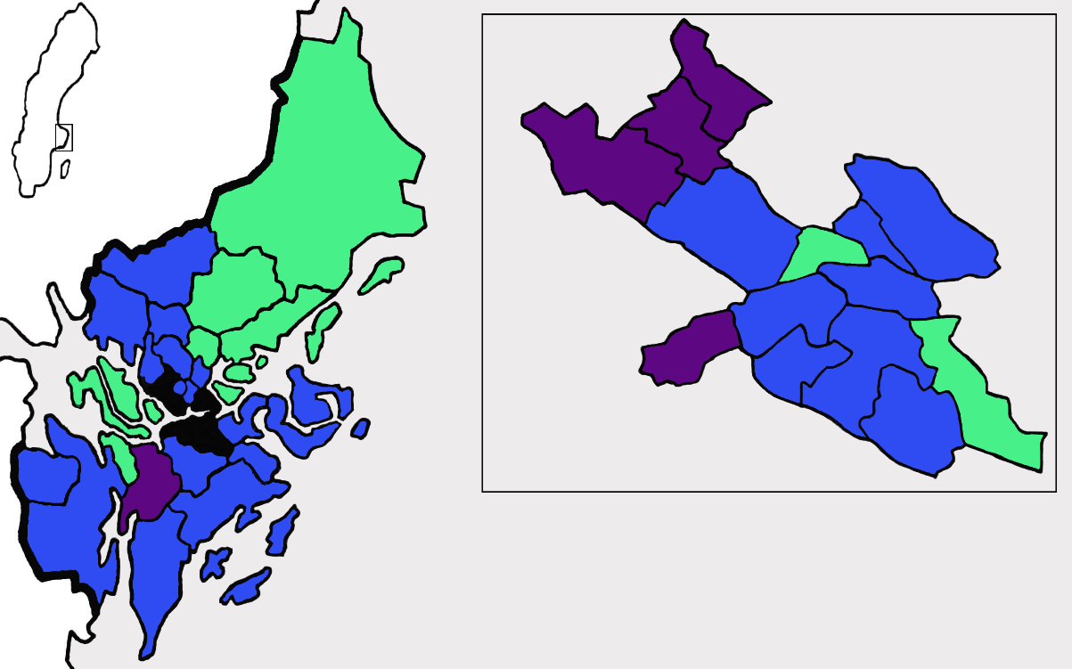
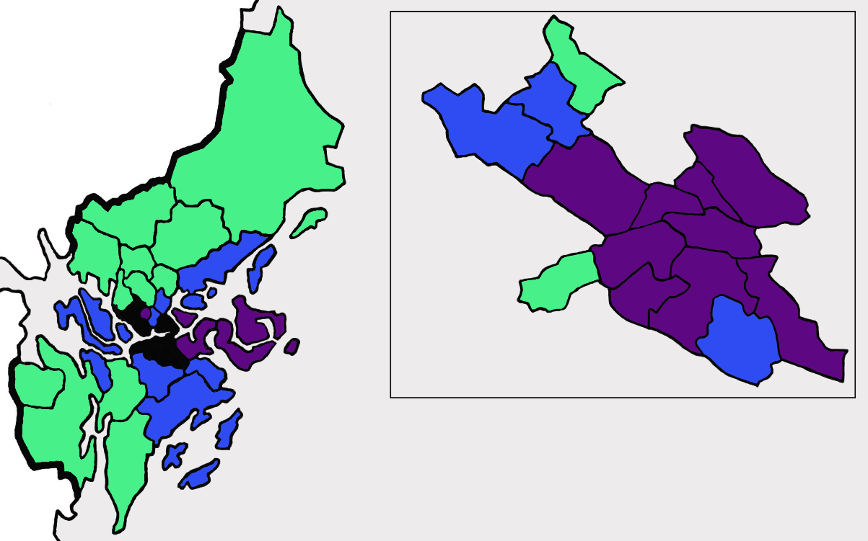
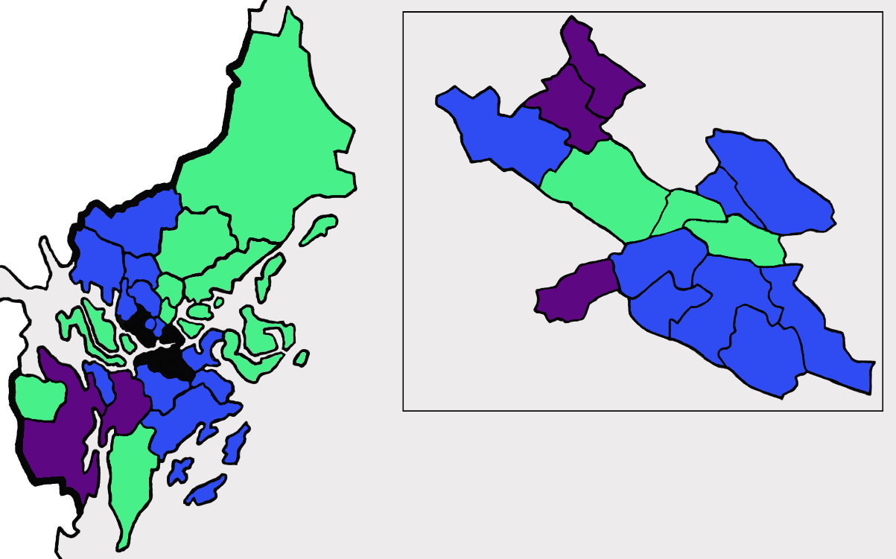
A. Eating disorder symptoms
B. Treatment seeking
C. Population with migration background
Around county average
Clearly below county average
Clearly above county average
Supplemental figure 1. Eating disorder symptoms (A), treatment seeking patterns (B), and proportion of population with a migration background in Stockholm county (with the City of Stockholm shown as inset). The Stockholm County is divided into 26 municipalities. One of these municipalities, the City of Stockholm—the most populous municipality in Sweden—is further divided into 14 districts. Thus, a total of 39 geographic strata were used in this study.

