Supplementary Materials
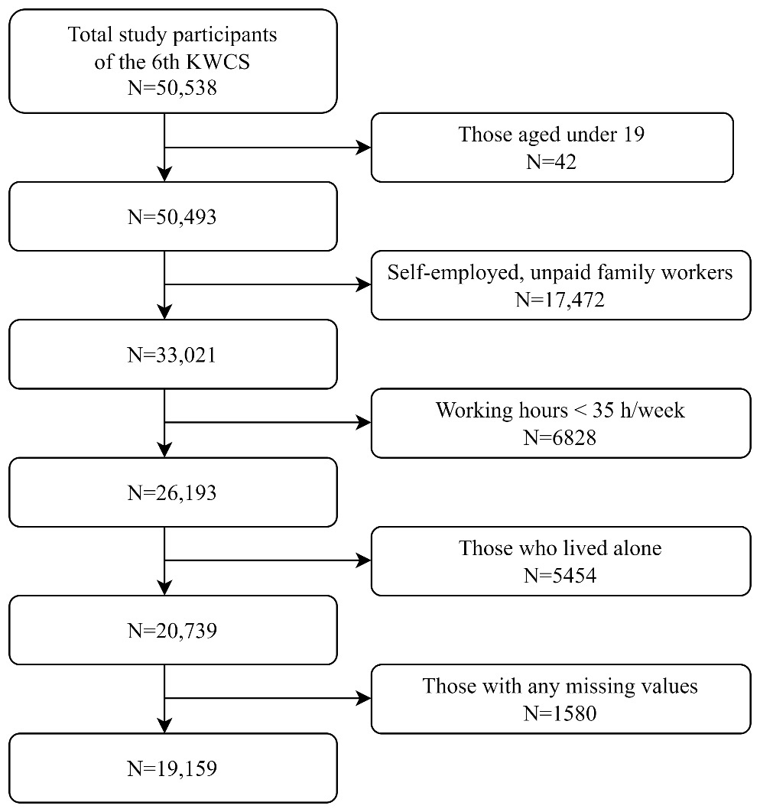
Figure S1. Flowchart of study sample selection

Supplementary details. Results of the factor analysis of work-family conflict (WFC).
- We tested four items assessing WFC using a factor analysis with varimax rotation to determine the domain structure.
- Factors with eigenvalues > 1 and items with factor loading > 0.4 were retained.
- Consequently, a single factor was identified, and no items were dropped.
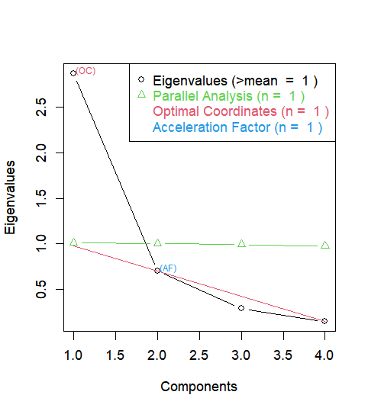
Figure S2. Scree plot of the 4-item WFC scale

Table S1. Questionnaires and factor loadings
 | Responses | Factor 1
Questions: “How often in the last 12 months (or since you started your job) have you…?” | 5-point Likert scale for each item
(Item 1) felt too tired after work to do some of the household jobs which need to be done |  | 0.61
(Item 2) found that your job prevented you from giving the time you wanted to your family |  | 0.63
(Item 3) found it difficult to concentrate on your job because of your family responsibilities |  | 0.91
(Item 4) found that your family responsibilities prevented you from giving the time to do your job |  | 0.90

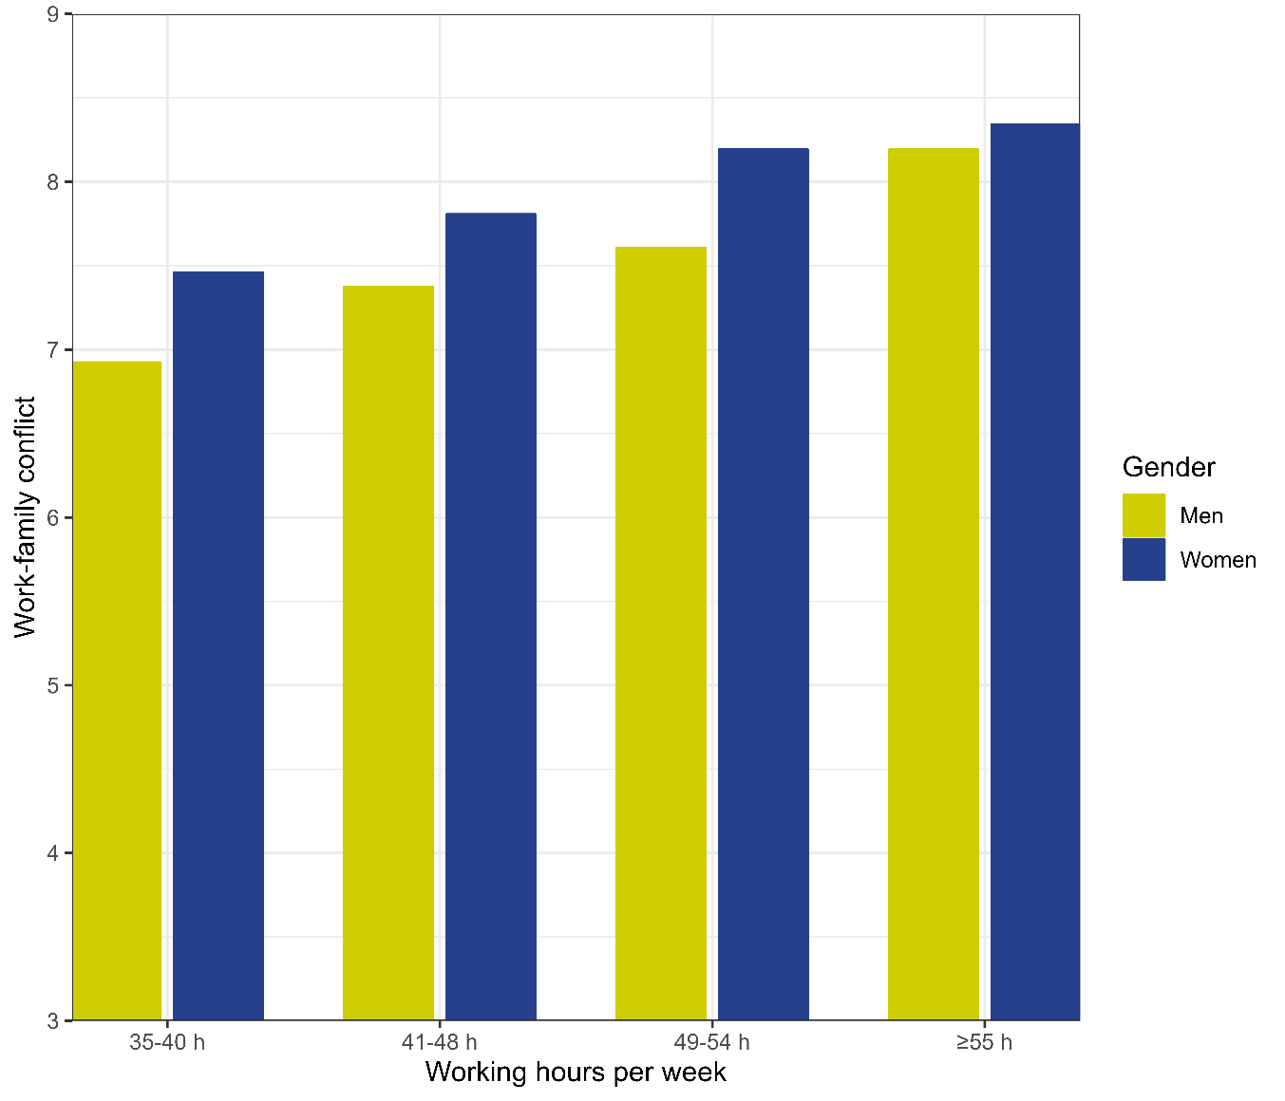
Figure S3 Mean score of WFC according to gender

Table S2. Total, direct, and indirect effect of long working hours on sleep disturbance and burnout. Gender stratified analysis (OR: odds ratio; CI: confidence interval)
 | Men |  |  |  |  |  |  | Women
 | Total effect |  | Direct effect |  | Indirect effect |  | Proportion mediated | Total effect |  | Direct effect |  | Indirect effect |  | Proportion mediated
 | OR | 95% CI | OR | 95% CI | OR | 95% CI | % | OR | 95% CI | OR | 95% CI | OR | 95% CI | %
Sleep disturbance
Working hours per week
< 40 h | 1.00 | reference | 1.00 | reference | 1.00 | reference |  | 1.00 | reference | 1.00 | reference | 1.00 | reference
41-48 h | 1.14 | 0.90-1.44 | 1.02 | 0.82-1.29 | 1.11 | 1.06-1.16 | 81.0% | 1.27 | 1.07-1.51 | 1.18 | 1.00-1.39 | 1.08 | 1.04-1.12 | 32.5%
49-54 h | 2.10 | 1.67-2.64 | 1.75 | 1.41-2.17 | 1.20 | 1.13-1.28 | 24.6% | 1.77 | 1.35-2.32 | 1.51 | 1.16-1.96 | 1.17 | 1.10-1.24 | 27.7%
≥ 55 h | 2.90 | 2.27-3.70 | 1.37 | 1.27-1.47 | 2.12 | 1.67-2.69 | 29.4% | 1.24 | 0.85-1.81 | 1.03 | 0.71-1.49 | 1.21 | 1.12-1.30 | 87.4%
Burnout
Working hours per week
< 40 h | 1.00 | reference | 1.00 | reference | 1.00 | reference |  | 1.00 | reference | 1.00 | reference | 1.00 | reference
41-48 h | 1.25 | 1.13-1.40 | 1.13 | 1.03-1.27 | 1.10 | 1.07-1.13 | 41.5% | 1.20 | 1.08-1.32 | 1.12 | 1.01-1.23 | 1.07 | 1.04-1.10 | 37.4%
49-54 h | 1.33 | 1.17-1.52 | 1.16 | 1.02-1.31 | 1.15 | 1.11-1.20 | 49.2% | 1.45 | 1.22-1.72 | 1.26 | 1.06-1.49 | 1.15 | 1.10-1.20 | 38.5%
≥ 55 h | 1.60 | 1.36-1.88 | 1.23 | 1.05-1.44 | 1.30 | 1.24-1.36 | 55.7% | 1.39 | 1.11-1.76 | 1.17 | 0.94-1.46 | 1.19 | 1.12-1.26 | 52.5%
Age, education, income, marital status, number of household members, and occupation were adjusted.
Table S3. Results of sensitivity analysis in which working hours and outcomes were treated as continuous variables
 | Total effect |  |  | Direct effect |  |  | Indirect effect |  |  | Proportion mediated
 | β | 95% CI |  | β | 95% CI |  | β | 95% CI |  | %
Sleep disturbance
Working hours per week  (unit: 1 hour) | 0.022 | 0.018-0.015 |  | 0.010 | 0.006-0.015 |  | 0.012 | 0.010-0.014 |  | 53.3%
Burnout
Working hours per week  (unit: 1 hour) | 0.017 | 0.013-0.021 |  | 0.007 | 0.003-0.010 |  | 0.010 | 0.009-0.012 |  | 60.7%
Gender, age, education, income, marital status, number of household members, and occupation were adjusted.

