Supplementary figure S1. Scree Plot
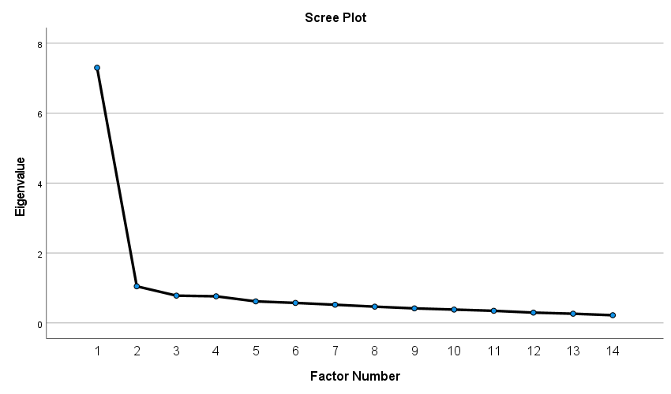

Supplementary Table 1 Modification of the existing DISCUS Mental health scale items for use with people living with dementia based on stakeholder feedback
Original DISC item | DISCUS-Dementia item (adaptations to original item in bold font)
Have you been treated unfairly in dating or intimate relationships? | Have you been treated unfairly in dating or intimate relationships?
Have you been treated unfairly in making or keeping friends? | Have you been treated unfairly in making or keeping friends?
Have you been treated unfairly in housing? | Have you been treated unfairly in housing (including having to move your house, move to a nursing home before you felt that you were ready or becoming homeless)?
Have you been treated unfairly in your social life? | Have you been treated unfairly in your social life (for example, being excluded from socialising, hobbies, attending events, leisure activities)?
Have you been treated unfairly in your levels of privacy? | Have you been treated unfairly in your levels of privacy (for example, privacy in hospital and / or in community settings, e.g. private letters or phone calls, medical records, criminal records bureau check)?
Have you been treated unfairly in your personal safety and security? | Have you been treated unfairly in your personal safety and security? (for example, verbal abuse, physical abuse, assault)
Have you been treated unfairly in starting a family or having children? | Have you been treated unfairly by your children or other family members ?
Have you been avoided or shunned by people who know that you have a mental health problem | Have you been avoided or shunned by people who know that you have dementia (for example, people do not want to come to your house or do not invite you out)?
Have you been treated unfairly in finding a job? | REMOVED
Have you been treated unfairly in keeping a job? | REMOVED
 | Have you been treated unfairly by health or medical staff (for example, did a health care professional suggest that you disengage from daily activities or social situation)¹
 | Have you had rights or responsibilities unfairly taken away from you (for example, in family taking over financial decisions without a legal basis)?
 | Do people do things for you that you could do yourself because they know you have dementia?
 | Have you been told that you couldn’t do something that you still thought you could do?
 | Do people often joke about your dementia symptoms?
 | Because of your dementia have some people not taken your opinions seriously?

¹Adapted from the original DISC-12: Brohan E, Clement S, Rose D, Sartorius N, Slade M, Thornicroft G. Development and psychometric evaluation of the discrimination and stigma scale (DISC). Psychiatry Res. 2013;208(1):33-40.

Supplementary Table 2. Participant socio-demographic characteristics for total sample (n=704)
Variable | N(%) or Mean(SD) |  |  | Variable | N(%)
Sex | Male |  | 281(37.7%) | Country | Argentina | 6(.8%)
 | /Female |  | 464(62.3%) |  | Australia | 27(3.6%)
Age | N=745, Range: 24-94 |  | 65.6(11.52) |  | Belgium | 10(1.3%)
Employment status | Full time paid employment |  | 96(12.9%) |  | Brazil | 45(6.0%)
 | Part time paid employment |  | 28(3.8%) |  | Canada | 29(3.9%)
 | Self-employed |  | 48(6.4%) |  | China | 12(1.6%)
 | Unpaid/voluntary work |  | 54(7.2%) |  | Colombia | 2(0.3%)
 | Unpaid carer |  | 18(2.4%) |  | Costa Rica | 4(0.5%)
 | Retired |  | 422(59.9%) |  | Croatia | 3(0.4%)
 | Student |  | 4(0.5) |  | Dominican Republic | 1(0.1%)
 | Illness/sick-leave |  | 44(5.9%)
 | Looking for paid work, unemployed |  | 14(1.9%) |  | France | 2(0.3%)
 |  |  |  |  | Germany | 3(0.4%)
Education | Less than primary/elementary school |  | 6(0.8%) |  | Greece | 6(0.8%)
 |  |  |  |  | Iceland | 1(0.1%)
 | Primary/elementary school |  | 27(3.6%) |  | India | 14(1.9%)
 | Secondary school |  | 67(9.0%) |  | Indonesia | 10(1.3%)
 | High school (or equivalent) |  | 107(14.4%) |  | Iran | 1(0.1%)
 | Vocational training or apprenticeship |  | 100(13.4%) |  | Ireland | 1(0.1%)
 |  |  |  |  | Italy | 50(6.7%)
 | College/pre-university/university |  | 262(35.2%) |  | Japan | 8(1.1%)
 |  |  |  |  | Kenya | 1(0.1%)
 | Post graduate degree completed |  | 176(23.6%) |  | Lebanon | 1(0.1%)
Area of residence | Urban |  | 336(45.1%) |  | Malaysia | 10(1.3%)
 | Suburban |  | 173(23.2%) |  | Mauritius | 1(0.1%)
 | Semi-rural |  | 164(22.0%) |  | Mexico | 7(0.9%)
 | Rural |  | 61(8.2%) |  | Netherlands | 208(27.9%)
Mean DISCUS-Dementia² | n=720 | Range: 0, 2.79 | 0.44(0.46) |  | New Zealand | 17(2.3%)
 |  |  |  |  | Norway | 1(.1%)
Stigma impact scale | n=731 | Range: 0, 78 | 42.25(16.22) |  | Philippines | 2(.3%)
 |  |  |  |  | Portugal | 2(0.3%)
WEMWBS total | n=713 | Range: 15, 70 | 44.69(10.67) |  | Puerto Rico | 1(0.1%)
DEMQoL total | n=682 | Range: 1.10, 2.80 | 1.98(0.31) |  | Qatar | 3(0.4%)
WEMWBS categorical | Higher mental wellbeing ≥42 |  | 435(58.4%) |  | Russia | 2(0.3%)
 | Lower mental wellbeing (0-41) |  | 278(37.3%) |  | Singapore | 1(0.1%)
DQoL categorical | Higher QoL (> median 2.25) |  | 110(14.8%) |  | Slovenia | 4(0.5%)
 | Lower QoL (< median 2.25) |  | 348(76.8%) |  | South Africa | 5(0.7%)
WHO Region | African Region |  | 7(0.9%) |  | Spain | 2(0.3%)
 | Eastern Mediterranean Region |  | 5(0.7%) |  | Taiwan | 18(2.4%)
 | European Region |  | 333(44.7%) |  | Thailand | 5(0.7%)
 | Region of the Americas |  | 260(34.9%) |  | United Kingdom | 38(5.1%)
 | South-East Asia Region |  | 29(3.9%) |  | United States | 165(22.1%)
 | Western Pacific Region |  | 111(14.9%) |  | Vietnam | 16(2.1%)
World bank income categories | High-income economies |  | 606(81.3)
 | Upper-middle economies |  | 96(12.9)
 | Lower-middle economies |  | 43(5.8)

