Annexes (Supplementary material)

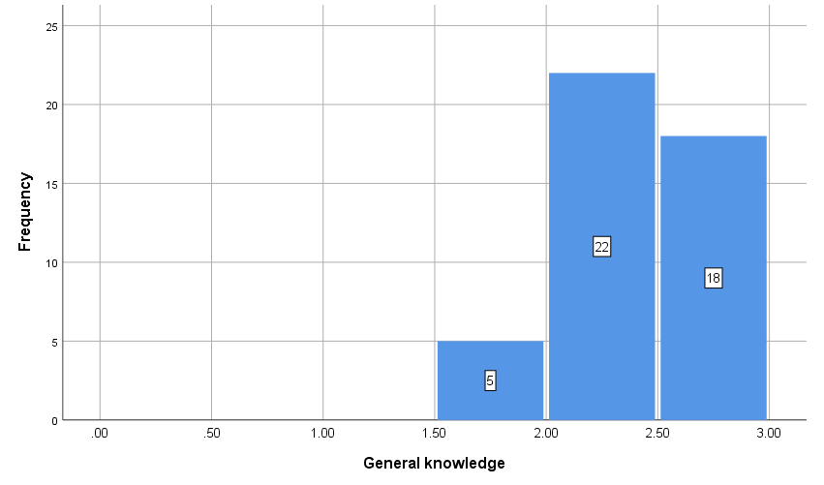
Figure 1: General knowledge (x-axis) vs. frequency of participants (y-axis). The mean “Knowledge” score on the Mental Health Literacy Scale (MHLS) ranges from 0 to 3, where 0 corresponds to very poor knowledge and 3 corresponds to very good knowledge.

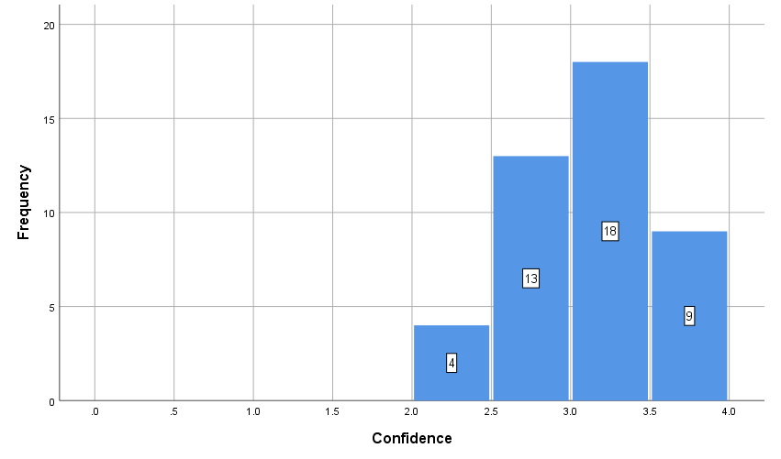
Figure 2: Confidence of seeking information (x-axis) vs. frequency of participants (y-axis). The mean “Confidence” score on the Mental Health Literacy Scale (MHLS) ranges 0 to 4, where 0 corresponds to very low confidence and 4 corresponds to very high confidence.

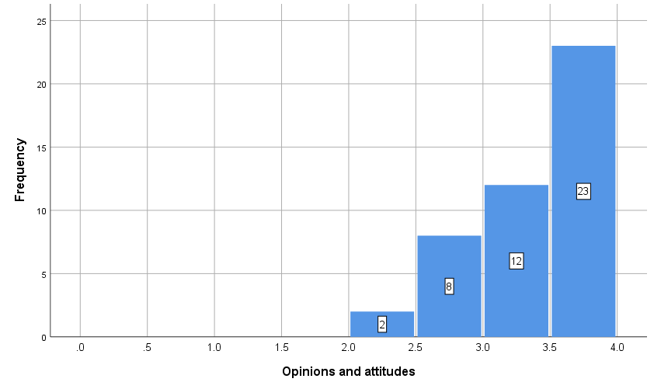
Figure 3: Opinions and Attitude (x-axis) vs. frequency of participants (y-axis). The mean “Opinion & Attitude” score on the Mental Health Literacy Scale (MHLS) ranges from 0 to 4, where 0 corresponds to a very negative attitude towards mental illness and 4 corresponds to a very positive attitude.

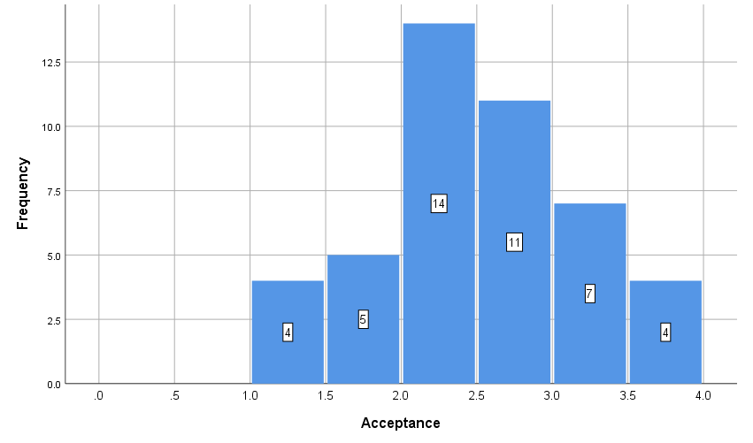
Figure 4: Acceptance (x-axis) vs. frequency of participants (y-axis). The mean “Acceptance” score on the Mental Health Literacy Scale (MHLS) ranges from 0 to 4, where 0 corresponds to very poor acceptance (i.e. high stigma) and 4 corresponds to very high acceptance (i.e. low stigma).

 |  | Sample Size | Mean | Std. Deviation | P-value
General knowledge | Male | 12 | 2.40 | 0.316 | 0.654
 | Female | 33 | 2.37 | 0.265
Confidence | Male | 12 | 2.92 | 0.404 | 0.778
 | Female | 32 | 2.96 | 0.480
Opinions and attitudes | Male | 12 | 3.11 | 0.446 | 0.022
 | Female | 33 | 3.47 | 0.417
Acceptance | Male | 12 | 2.35 | 0.747 | 0.440
 | Female | 33 | 2.53 | 0.723
Table 1: One-way ANOVA: Gender differences in the Mental Health Literacy Scale (MHLS) sub-themes.

 |  | Sample size | Mean | Std. Deviation | P-value
General knowledge | 23-25 | 14 | 2.35 | 0.266 | 0.521
 | 26-28 | 22 | 2.34 | 0.317
 | 29-31 | 9 | 2.46 | 0.170
Confidence | 23-25 | 14 | 2.91 | 0.411 | 0.836
 | 26-28 | 21 | 2.94 | 0.558
 | 29-31 | 9 | 3.03 | 0.232
Opinions and attitudes | 23-25 | 14 | 3.47 | 0.380 | 0.537
 | 26-28 | 22 | 3.30 | 0.457
 | 29-31 | 9 | 3.33 | 0.530
Acceptance | 23-25 | 14 | 2.22 | 0.613 | 0.122
 | 26-28 | 22 | 2.71 | 0.706
 | 29-31 | 9 | 2.35 | 0.839
Table 2: One-way ANOVA: Age-group differences in the Mental Health Literacy Scale (MHLS) sub-themes.

 |  | Sample size | Mean | Std. Deviation | P-value
General knowledge | 1 year | 20 | 2.46 | 0.194 | 0.000
 | 2 years | 13 | 2.10 | 0.322
 | 3 years | 12 | 2.49 | 0.108
Confidence | 1 year | 20 | 2.88 | 0.401 | 0.218
 | 2 years | 12 | 2.88 | 0.406
 | 3 years | 12 | 3.15 | 0.558
Opinions and attitudes | 1 year | 20 | 3.56 | 0.295 | 0.014
 | 2 years | 13 | 3.12 | 0.339
 | 3 years | 12 | 3.28 | 0.611
Acceptance | 1 year | 20 | 2.44 | 0.602 | 0.875
 | 2 years | 13 | 2.57 | 0.625
 | 3 years | 12 | 2.48 | 1.022
Table 3: One-way ANOVA: Years in General Practitioner (GP) practice differences in the Mental Health Literacy Scale (MHLS) sub-themes

Appendix:

Mental Health Literacy Scale
The purpose of these questions is to gain an understanding of your knowledge of various aspects to do with mental health. When responding, we are interested in your degree of knowledge.
Kindly circle the most likely correct answer.

1. If someone became extremely nervous or anxious in one or more situations with other people (e.g., a party) or performance situations (e.g., presenting at a meeting) in which they were afraid of being evaluated by others and that they would act in a way that was humiliating or feel embarrassed, then to what extent do you think it is likely they have Social Phobia.
Very unlikely Unlikely Likely Very Likely

2. If someone experienced excessive worry about a number of events or activities where this level of concern was not warranted, had difficulty controlling this worry and had physical symptoms such as having tense muscles and feeling fatigued then to what extent do you think it is likely they have Generalised Anxiety Disorder.
Very unlikely Unlikely Likely Very Likely

3. If someone experienced a low mood for two or more weeks, had a loss of pleasure or interest in their normal activities and experienced changes in their appetite and sleep then to what extent do you think it is likely they have Major Depressive Disorder.
Very unlikely Unlikely Likely Very Likely

4. To what extent do you think it is likely that Personality Disorders are a category of mental illness:
Very unlikely Unlikely Likely Very Likely

5. To what extent do you think it is likely that Dysthymia is a disorder:
Very unlikely Unlikely Likely Very Likely

6. To what extent do you think it is likely that the diagnosis of Agoraphobia includes anxiety about situations where escape may be difficult or embarrassing?
Very unlikely Unlikely Likely Very Likely

7. To what extent do you think it is likely that the diagnosis of Bipolar Disorder includes experiencing periods of elevated (i.e., high) and periods of depressed (i.e., low) mood?
Very unlikely Unlikely Likely Very Likely

8. To what extent do you think it is likely that the diagnosis of Drug Dependence includes physical and psychological tolerance of the drug (i.e., require more of the drug to get the same effect)?
Very unlikely Unlikely Likely Very Likely

9. To what extent do you think it is likely that in general, in Malta, women are more likely to experience a mental illness of any kind compared to men?
Very unlikely Unlikely Likely Very Likely

10. To what extent do you think it is likely that in general, in Malta, men are more likely to experience an anxiety disorder compared to women?
Very unlikely Unlikely Likely Very Likely

11. To what extent do you think it would be helpful for someone to improve their quality of sleep if they were having difficulties managing their emotions (e.g., becoming very anxious or depressed)?
Very unhelpful Unhelpful Helpful Very helpful

12. To what extent do you think it would be helpful for someone to avoid all activities or situations that made them feel anxious if they were having difficulties managing their emotions?
Very unhelpful Unhelpful Helpful Very helpful

13. To what extent do you think it is likely that Cognitive Behaviour Therapy (CBT) is a therapy based on challenging negative thoughts and increasing helpful behaviours?
Very unlikely Unlikely Likely Very Likely

14. Mental health professionals are bound by confidentiality; however there are certain conditions under which this does not apply. To what extent do you think it is likely that the following is a condition that would allow a mental health professional to break confidentiality?
i. If you are at immediate risk of harm to yourself or others
Very unlikely Unlikely Likely Very Likely

ii. if your problem is not life-threatening and they want to assist others to better support you
Very unlikely Unlikely Likely Very Likely

16. I am confident that I know where to seek information about mental illness:
Strongly Disagree Disagree Neither agree or disagree Agree Strongly agree

17. I am confident using the computer or telephone to seek information about mental illness:
Strongly Disagree Disagree Neither agree or disagree Agree Strongly agree

18. I am confident attending face to face appointments to seek information about mental illness
(e.g., seeing the GP):
Strongly Disagree Disagree Neither agree or disagree Agree Strongly agree

19. I am confident I have access to resources (e.g., GP, internet, friends) that I can use to seek information about mental illness:
Strongly Disagree Disagree Neither agree or disagree Agree Strongly agree

20. People with a mental illness could snap out if it if they wanted:
Strongly Disagree Disagree Neither agree or disagree Agree Strongly agree

21. A mental illness is a sign of personal weakness:
Strongly Disagree Disagree Neither agree or disagree Agree Strongly agree

22. A mental illness is not a real medical illness:
Strongly Disagree Disagree Neither agree or disagree Agree Strongly agree

23. People with a mental illness are dangerous:
Strongly Disagree Disagree Neither agree or disagree Agree Strongly agree

24. It is best to avoid people with a mental illness so that you don't develop this problem:
Strongly Disagree Disagree Neither agree or disagree Agree Strongly agree

25. If I had a mental illness, I would not tell anyone:
Strongly Disagree Disagree Neither agree or disagree Agree Strongly agree

26. Seeing a mental health professional means you are not strong enough to manage your own difficulties:
Strongly Disagree Disagree Neither agree or disagree Agree Strongly agree

27. If I had a mental illness, I would not seek help from a mental health professional:
Strongly Disagree Disagree Neither agree or disagree Agree Strongly agree

28. I believe treatment for a mental illness, provided by a mental health professional, would not be effective:
Strongly Disagree Disagree Neither agree or disagree Agree Strongly agree

29. How willing would you be to move next door to someone with a mental illness?
Definitely unwilling ; Probably unwilling ; Neither unwilling or willing ; Probably willing ; Definitely willing

30. How willing would you be to spend an evening socialising with someone with a mental illness?
Definitely unwilling ; Probably unwilling ; Neither unwilling or willing ; Probably willing ; Definitely willing

31. How willing would you be to make friends with someone with a mental illness?
Definitely unwilling ; Probably unwilling ; Neither unwilling or willing ; Probably willing ; Definitely willing

32. How willing would you be to have someone with a mental illness start working closely with you on a job?
Definitely unwilling ; Probably unwilling ; Neither unwilling or willing ; Probably willing ; Definitely willing

33. How willing would you be to have someone with a mental illness marry into your family?
Definitely unwilling ; Probably unwilling ; Neither unwilling or willing ; Probably willing ; Definitely willing

34. How willing would you be to vote for a politician if you knew they had suffered a mental illness?
Definitely unwilling ; Probably unwilling ; Neither unwilling or willing ; Probably willing ; Definitely willing

35. How willing would you be to employ someone if you knew they had a mental illness?
Definitely unwilling ; Probably unwilling ; Neither unwilling or willing Probably willing ; Definitely willing

Reference: O’Connor, M., & Casey, L. (2015). The mental health literacy scale (MHLS): A new scale-based measure of mental health literacy, Psychiatry Research.

The MHLS was used with the kind permission of Dr. Matt O’Connor

