Supplementary Results
Between countries comparison of Demographics
Participants in the Netherlands were significantly older than participants in India (p=0.05) and the United States (p=0.05) and had higher FSIQ than participants from Brazil (p=0.02) and India (p<0.001). South African participants had fewer years of education than those from Brazil (p<0.001) and those from the United States (p=0.008). Participants in the United States had significantly higher WAMI index scores than participants at every other site except the Netherlands (Brazil: p<0.001; India: p<0.001; Netherlands: p=0.93; South Africa: p=0.007); whereas, Indian participants had significantly lower WAMI index scores than participants in all sites except Brazil (Netherlands: p<0.001; South Africa: p<0.001).

Table S1. Ethnoracial Backgrounds of Included Participants
 | Site
 |  | Brazil | India | Neth. | S. Africa | U.S.
Ethnicity |  | % within site | % within site | % within site | % within site | % within site
Non-Hispanic |  | 98.1 | 100 | 96.0 | 100 | 82.4
Caribbean |  | - | - | - | - | 3.9
Central American |  | - | - | - | - | 2.0
South American |  | - | - | - | - | 9.8
Spanish |  | - | - | - | - | 2.0
Hispanic |  | 1.9 | - | 4.0 | - | 17.6
Race
White |  | 52.8 | - | 96.0 | 50.0 | 47.1
East Asian |  | 3.8 | - | - | - | 17.6
South Asian |  | - | 100 | - | - | 7.8
Black |  | 17.0 | - | - | 11.5 | 19.6
Mixed/Other |  | 26.4 | - | 4.0 | 38.5 | 7.8
Note: Neth.=Netherlands, S. Africa=South Africa, U.S.=United States, %=percent

Table S2. Mean Raw Intelligence Scores Across Sites
 | Site |  |  |  |  |  | F | p | Post Hocª
 |  | Brazil | India | Neth. | S. Africa | U.S.
Mean FSIQ (SD) |  | 104.42 (11.58) | 101.16 (10.69) | 112.56 (12.70) | 107.88 (12.90) | 108.98 (10.52) | 7.00 | <0.001 | Neth.>Brazil=India; US>India
Mean VIQ (SD)* |  | 106.45 (11.04) | - | 113.44 (12.58) | 112.25 (13.13) | 109.92 (11.26) | 3.40 | 0.02 | Neth.>Brazil,
Mean PIQ (SD)* |  | 101.21 (14.24) | - | 109.16 (14.89) | 101.38 (14.01) | 105.59 (11.50) | 3.92 | 0.01 | Neth.>Brazil=SA
Note. FSIQ = full scale intelligence quotient, Neth. = Netherlands, S. Africa = South Africa, PIQ = perceptual intelligence quotient, U.S. = United States, VIQ = verbal intelligence quotient, F= ANOVA F Statistic
*The Binet Kamat test does not provide index scores for verbal or perceptual reasoning.
- Sites shown with = indicate they were not significantly different at p<0.05. Sites shown with > indicate significant difference at p<0.05

Table S3. ANOVAs Predicting VIQ and PIQ Scores
Model Predicting VIQ Scores*
Source | SS | df | F | partial η² | p-value
Covariate
Site | 264.28 | 3 | .72 | .012 | .54
Age | 372.40 | 1 | 3.04 | .016 | .08
Sex | 512.29 | 1 | 4.18 | .022 | .04
Years of Ed. | 241.41 | 1 | 1.97 | .011 | .16
SES | 827.37 | 1 | 6.75 | .035 | .01
Age*Site | 563.70 | 3 | 1.53 | .024 | .21
Sex*Site | 176.20 | 3 | .48 | .008 | .70
Ed.*Site | 1496.81 | 3 | 4.07 | .062 | .008
SES*Site | 509.96 | 3 | 1.39 | .022 | .25
Error | 22666 | 185
Total | 2531973 | 205
Model Predicting PIQ Scores**
Source | SS | df | F | partial η² | p-value
Covariate
Site | 831.34 | 3 | 1.58 | .025 | .20
Age | 19.67 | 1 | .11 | .001 | .74
Sex | 264.90 | 1 | 1.51 | .008 | .22
Years of Ed. | 85.70 | 1 | .49 | .003 | .49
SES | 595.17 | 1 | 3.39 | .018 | .07
Age*Site | 575.96 | 3 | 1.10 | .017 | .35
Sex*Site | 512.31 | 3 | .97 | .015 | .41
Ed.*Site | 1025.92 | 3 | 1.95 | .030 | .12
SES*Site | 559.24 | 3 | 1.06 | .017 | .37
Error | 32612 | 186
Total | 2279809 | 206
Note: PIQ=Perceptual Intelligence Quotient, VIQ=Verbal Intelligence Quotient, Ed.=education, SES=socioeconomic status from the WAMI, SS=Type III sum of squares, df= degrees of freedom, Neth.=Netherlands, S. Africa = South Africa, U.S = United States
*Adjusted R²=.18
**Adjusted R²=.11

Table S4. Sensitivity Analyses: ANOVAs Predicting IQ Scores Including Language Proficiency
Model Predicting FSIQ Scores*
Source | SS | df | F | partial η² | p-value
Covariate
Site | 448.05 | 4 | .97 | .017 | .43
Lang. Proficiency | 73.13 | 1 | .63 | .003 | .43
Age | 25.80 | 1 | .22 | .001 | .64
Sex | 337.97 | 1 | 2.92 | .013 | .09
Years of Ed. | 273.08 | 1 | 2.36 | .010 | .13
SES | 1466.75 | 1 | 12.66 | .053 | <.001
Age*Site | 504.88 | 4 | 1.09 | .019 | .36
Sex*Site | 399.58 | 4 | .86 | .015 | .49
Ed.*Site | 1532.71 | 4 | 3.31 | .055 | .01
SES*Site | 239.69 | 4 | .52 | .009 | .72
Error | 26425 | 228
Total | 2946992 | 254
Model Predicting VIQ Scores**
Source | SS | df | F | partial η² | p-value
Covariate
Site | 290.39 | 3 | 1.64 | .03 | .18
Lang. Proficiency | 259.72 | 1 | .79 | .013 | .50
Age | 406.86 | 1 | 2.12 | .011 | .15
Sex | 462.72 | 1 | 3.33 | .018 | .07
Years of Ed. | 249.70 | 1 | 3.78 | .020 | .05
SES | 862.48 | 1 | 2.04 | .011 | .16
Age*Site | 572.90 | 3 | 7.05 | .037 | .009
Sex*Site | 220.92 | 3 | 1.56 | .025 | .20
Ed.*Site | 1408.68 | 3 | .60 | .010 | .61
SES*Site | 442.66 | 3 | 3.84 | .059 | .01
Error | 22381 | 183
Total | 2521364 | 204
Model Predicting PIQ Scores***
Source | SS | df | F | partial η² | p-value
Covariate
Site | 831.48 | 3 | 1.57 | .025 | .20
Lang. Proficiency | .35 | 1 | .002 | .000 | .97
Age | 25.42 | 1 | .14 | .001 | .71
Sex | 291.56 | 1 | 1.65 | .009 | .20
Years of Ed. | 87.68 | 1 | .50 | .003 | .48
SES | 599.15 | 1 | 3.40 | .018 | .07
Age*Site | 586.26 | 3 | 1.11 | .018 | .35
Sex*Site | 482.15 | 3 | .91 | .015 | .44
Ed.*Site | 1023.71 | 3 | 1.94 | .031 | .13
SES*Site | 551.84 | 3 | 1.04 | .017 | .38
Error | 32451 | 184
Total | 2271528 | 205
Note: FSIQ = Full-Scale Intelligence Quotient, Lang. = Language, PIQ=Perceptual Intelligence Quotient, VIQ=Verbal Intelligence Quotient, Ed.=education, SES=socioeconomic status from the WAMI, SS=Type III sum of squares, df= degrees of freedom, Neth.=Netherlands, S. Africa = South Africa, U.S = United States
*Adjusted R²=.23
**Adjusted R²=.19
**Adjusted R²=.10
Table S5. Sensitivity Analyses: ANOVAs Predicting IQ Scores Excluding Data From India and South Africa Sites
Model Predicting FSIQ Scores*
Source | SS | df | F | partial η² | p-value
Covariate
Site | 18.85 | 1 | .08 | .001 | .92
Age | .78 | 2 | .01 | .000 | .94
Sex | 110.20 | 1 | .92 | .007 | .34
Years of Ed. | 80.84 | 1 | .68 | .005 | .41
SES | 385.41 | 1 | 3.23 | .023 | .08
Age*Site | 75.18 | 1 | .32 | .005 | .73
Sex*Site | 1.31 | 2 | .01 | .000 | .99
Ed.*Site | 1550.82 | 2 | 6.50 | .085 | .002
SES*Site | 44.42 | 2 | .19 | .003 | .83
Error | 16592.67 | 2
Total | 1837432.00 | 139
Model Predicting VIQ Scores**
Source | SS | df | F | partial η² | p-value
Covariate
Site | 92.20 | 2 | .39 | .006 | .68
Age | 54.59 | 1 | .46 | .003 | .50
Sex | 168.57 | 1 | 1.41 | .010 | .24
Years of Ed. | 88.49 | 1 | .74 | .005 | .39
SES | 470.25 | 1 | 3.93 | .027 | .050
Age*Site | 140.89 | 2 | .59 | .008 | .56
Sex*Site | .61 | 2 | .003 | .000 | .99
Ed.*Site | 1496.29 | 2 | 6.25 | .083 | .003
SES*Site | 446.76 | 2 | 1.87 | .026 | .16
Error | 16632.23 | 139
Total | 1880694.00 | 154
Model Predicting PIQ Scores***
Source | SS | df | F | partial η² | p-value
Covariate
Site | 297.57 | 2 | .83 | .012 | .44
Age | 104.65 | 1 | .58 | .004 | .45
Sex | 7.88 | 1 | .04 | .000 | .83
Years of Ed. | 76.51 | 1 | .43 | .003 | .52
SES | 112.49 | 1 | .63 | .004 | .43
Age*Site | 423.92 | 2 | 1.18 | .017 | .31
Sex*Site | .68 | 2 | .002 | .000 | .99
Ed.*Site | 933.22 | 2 | 2.60 | .036 | .08
SES*Site | 100.69 | 2 | .28 | .004 | .76
Error | 24964.09 | 139
Total | 1735305.00 | 154
Note: FSIQ = Full-Scale Intelligence Quotient, PIQ=Perceptual Intelligence Quotient, VIQ=Verbal Intelligence Quotient, Ed.=education, SES=socioeconomic status from the WAMI, SS=Type III sum of squares, df= degrees of freedom, Neth.=Netherlands, S. Africa = South Africa, U.S = United States
*Adjusted R²=.17
**Adjusted R²=.16
**Adjusted R²=.07
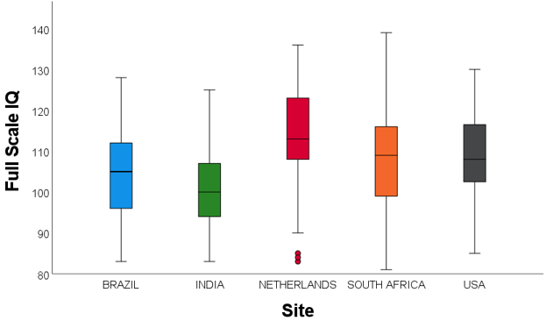
Figure S1. Unadjusted FSIQ across Sites. Participants in the Netherlands had higher FSIQ scores than participants in Brazil, India, and South Africa; participants in the United States also had higher FSIQ scores than participants in India.
Note: FSIQ=Full Scale Intelligence Quotient, USA=United States

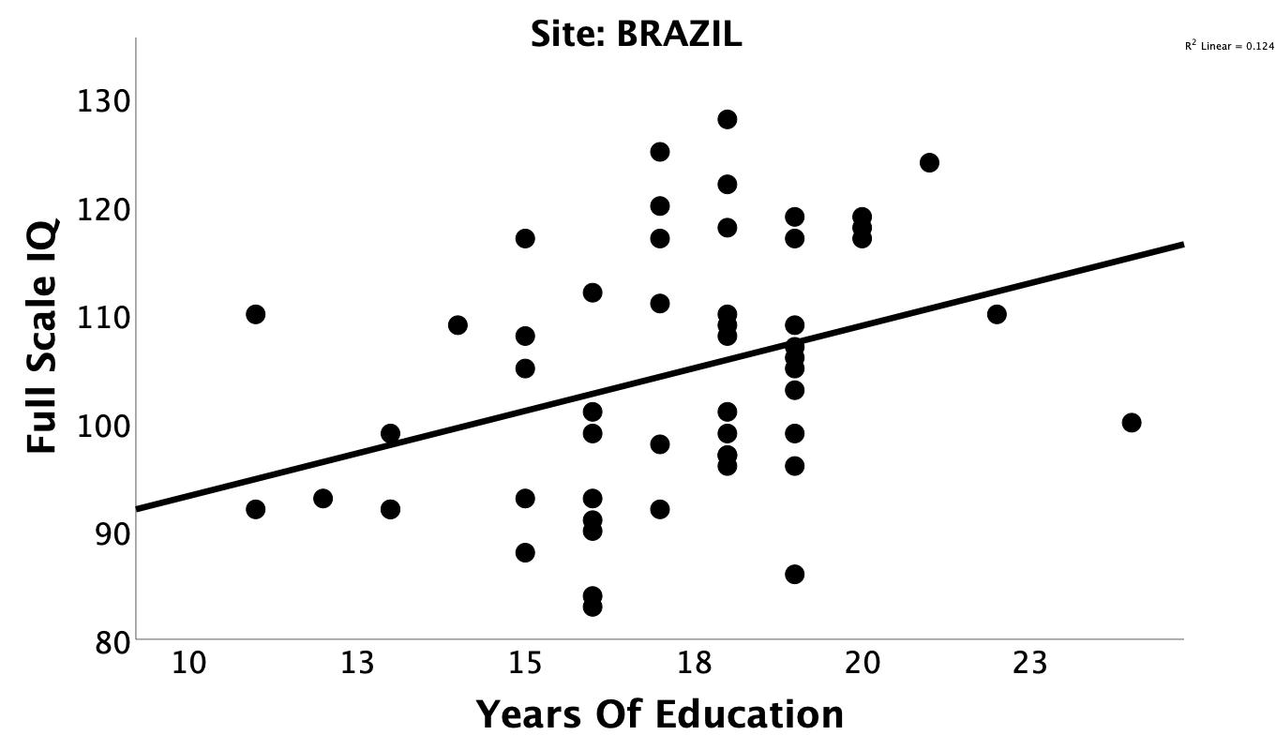
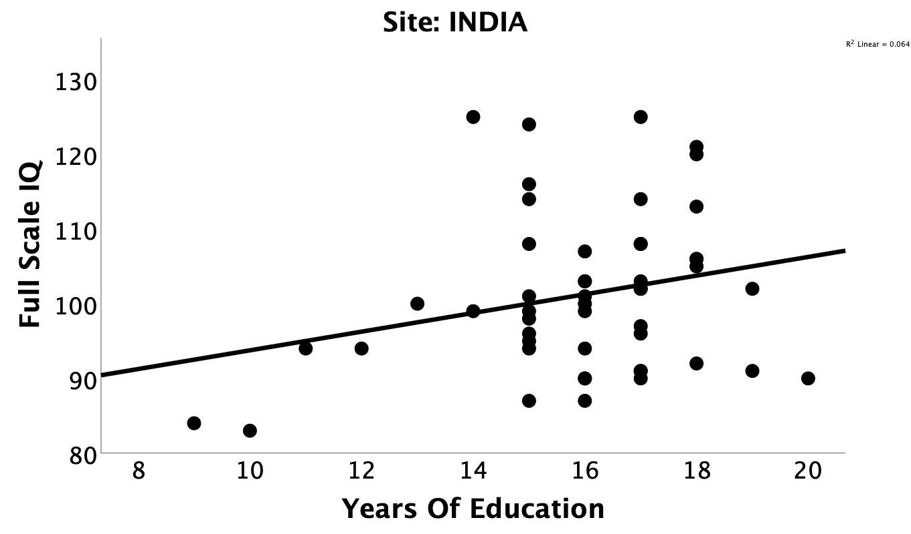
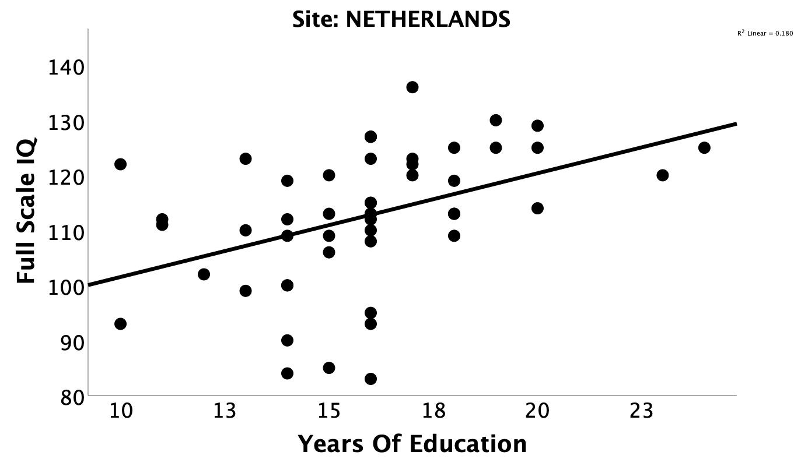
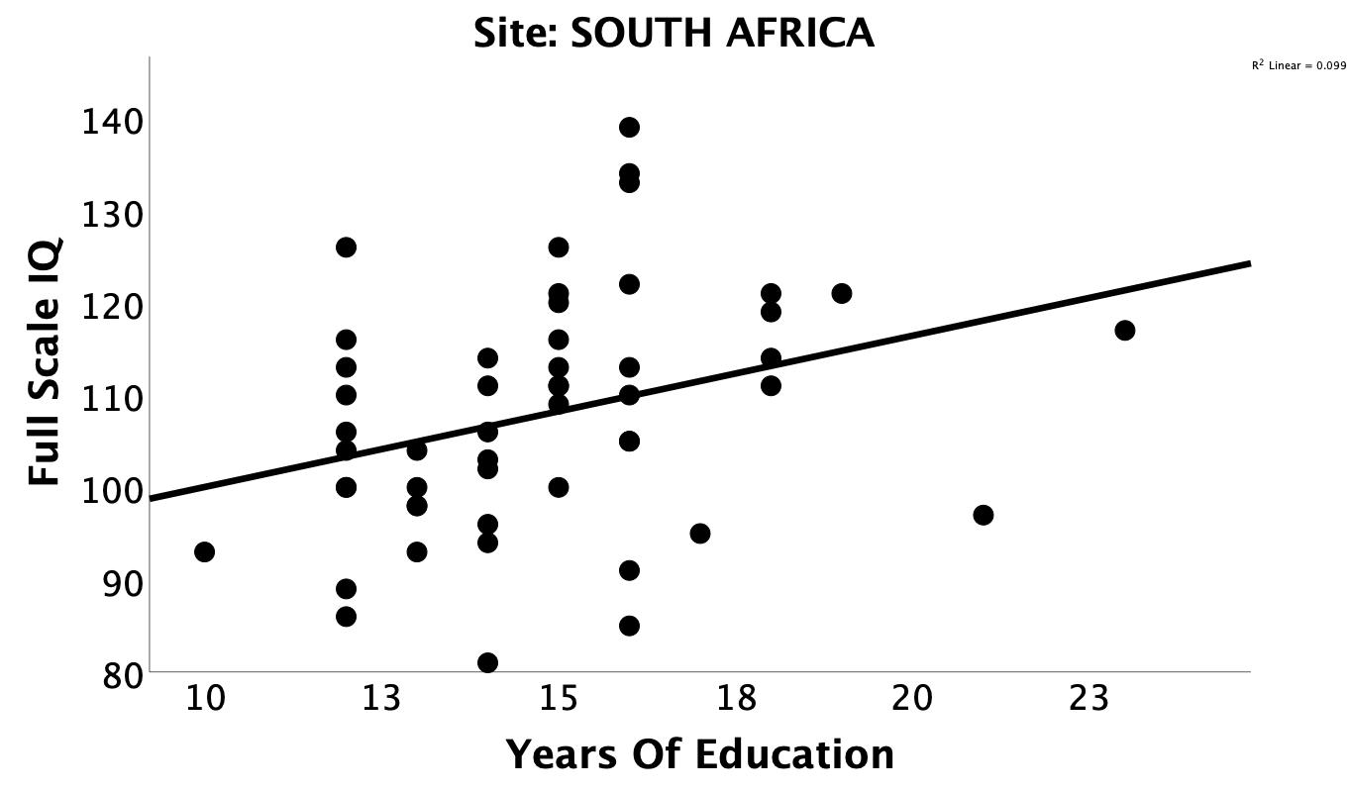
(A)
(B)
(C)
(D)
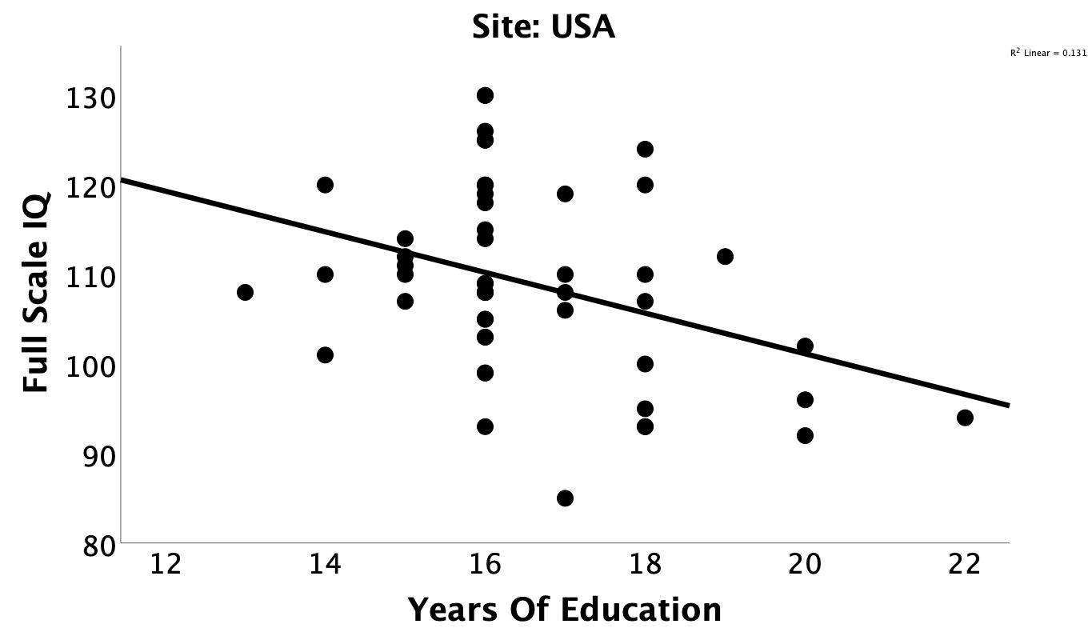
Figure S2. Associations between FSIQ scores and Sociodemographics. Full scale IQ score is positively associated with educational attainment in A) Brazil, B) India, C) Netherlands, and D) South Africa, and negatively associated with educational attainment in the E) United States.
Note: FSIQ=Full Scale IQ.
(E)

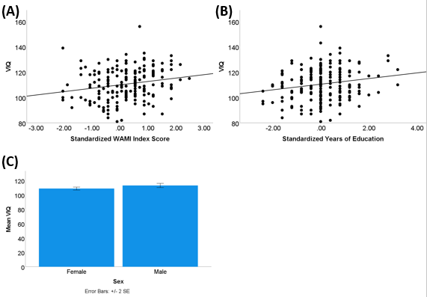
Figure S3. Associations between VIQ scores and Sociodemographics. A) Main effect of the WAMI index score (SES) was significant. Main effects of B) years of education, and C) sex were not significant.
Note: SES=socioeconomic status from the WAMI, VIQ=Verbal Comprehension Index

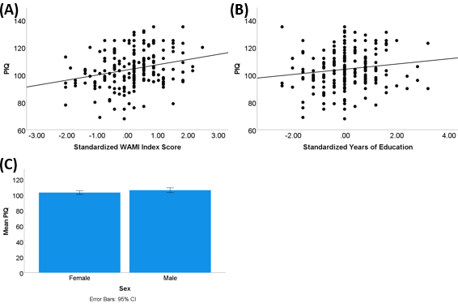
Figure S4. Associations between PIQ scores and Sociodemographics. A) Main effect of the WAMI index score (SES) was significant. Main effects of B) years of education, and C) sex were not significant.
Note: SES=socioeconomic status from the WAMI, PIQ=Perceptual Reasoning Index

