Risk of Bias tables

a) Risk of bias of individual RCTs

Short Title | Risk of bias arising from the randomisation process | Risk of bias due to deviations from the intended interventions | Missing outcome data | Risk of bias in measurement of the outcome | Risk of bias in selection of the reported results | Overall risk of bias
Ahmadi (2023) | + | + | - | + | + | -
Annan (2017) | ? | + | + | + | + | ?
Barron (2016) | + | + | + | + | + | +
Betancourt (2014) | + | + | + | + | + | +
Bolton (2007) | + | + | + | + | + | +
Brown (2023) | + | ? | + | + | + | ?
Bryant (2022) | + | + | + | + | + | +
Catani (2009) | ? | + | + | + | + | ?
Chen (2014) | ? | - | - | - | + | -
Cluver (2015) | ? | - | - | - | + | -
Dawson (2018) | + | + | + | + | + | +
Dybdahl (2001) | ? | - | + | + | + | -
El-Khani (2021) | ? | + | + | + | + | ?
Ertl (2011) | ? | + | + | + | + | ?
Getanda and Vostanis (2020) | ? | ? | + | - | + | -
Gordon (2008) | - | + | + | - | + | -
Kalantari (2012) | ? | ? | - | - | + | -
Khamis (2004) | ? | - | - | + | + | -
Lange-Nielsen (2012) | ? | ? | + | - | + | -
Layne (2008) | - | - | - | - | + | -
McMullen (2013) | + | ? | + | + | + | ?
O’Callaghan (2013) | + | + | + | + | + | +
O’Callaghan (2014) | + | ? | + | + | + | ?
O’Callaghan (2015) | + | + | + | + | + | +
Panter‐Brick (2018) | + | + | + | + | + | +
Pityaratstian (2015) | ? | ? | + | + | + | ?
Richards (2014) | ? | + | ? | + | + | ?
Robjant (2019) | + | ? | + | + | + | ?
SHoaakazemi (2012) | ? | ? | - | - | - | -
Sirin (2018) | ? | - | - | - | ? | -
Yankey (2019) | ? | - | - | ? | + | -

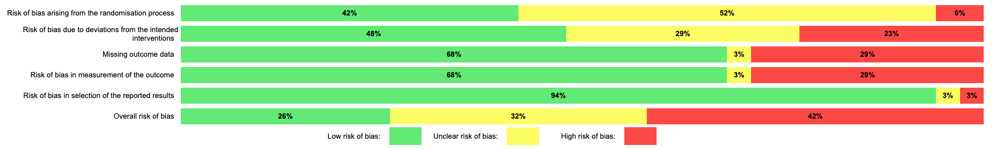

B) Risk of bias of Cluster RCTs

Short Title | Risk of bias judgement | Risk of bias arising from the timing of identification or recruitment of participants in a cluster-randomized trial | Risk of bias due to deviations from the intended interventions | Missing outcome data | Risk of bias in measurement of the outcome | Risk of bias in selection of the reported results | Overall risk of bias
Berger (2009) | ? | + | ? | + | + | + | ?
Berger (2018) | + | + | + | - | + | ? | -
Dhital (2019) | + | ? | ? | - | - | + | -
Fine (2021) | + | ? | ? | + | + | ? | ?
Jordans (2010) | + | ? | + | + | ? | + | ?
Nopembri (2019) | - | + | + | - | - | + | -
Qouta (2012) | ? | + | + | + | ? | + | ?
Schauer (2008) | ? | + | + | + | + | + | ?
Tol (2008) | ? | ? | + | + | + | + | ?
Tol (2012) | ? | + | + | + | + | + | ?
Tol (2014) | - | - | ? | + | - | + | -
Torrente (2019) | + | + | + | - | + | + | -

