Forest plots

- The impact of MHPSS on PTSD
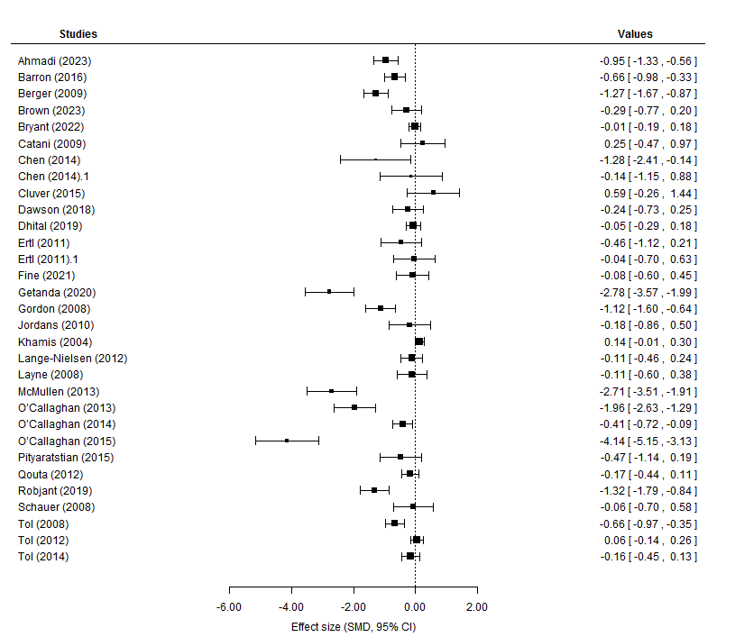

- The impact of MHPSS on depression
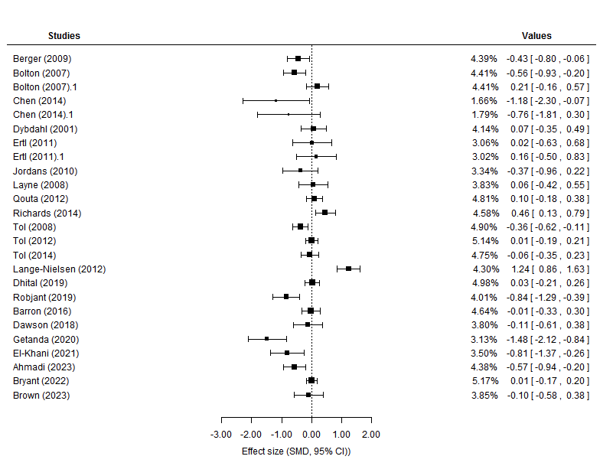

- The impact of MHPSS on conduct problems
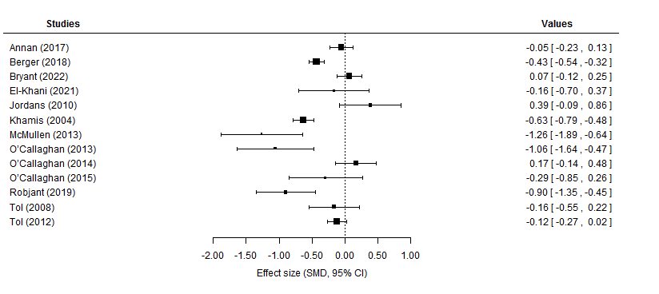

- The impact of MHPSS on functional impairment
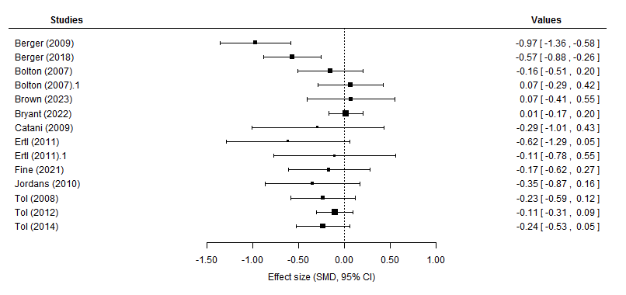
- The impact of MHPSS on prosocial behaviour
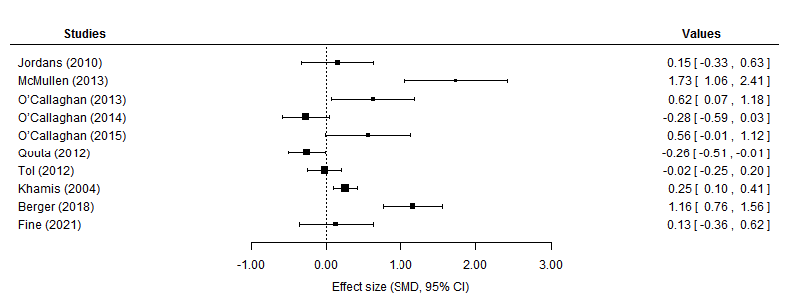
- The impact of MHPSS on anxiety
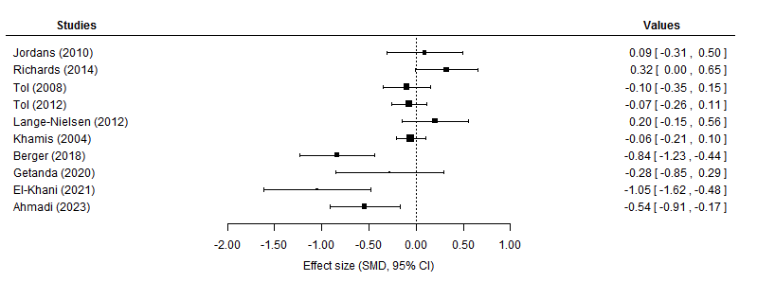

- The impact of MHPSS on psychosocial distress
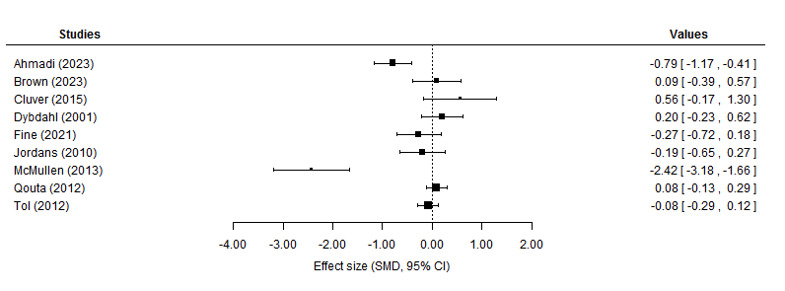
- The impact of MHPSS on emotional problems
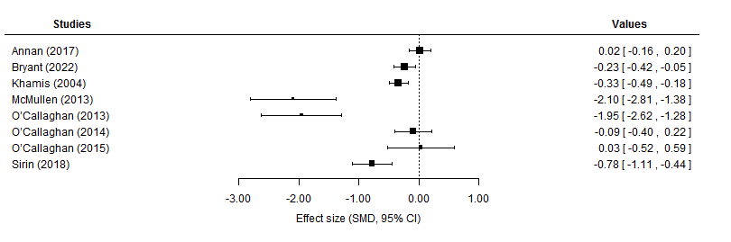

- The impact of MHPSS on hope
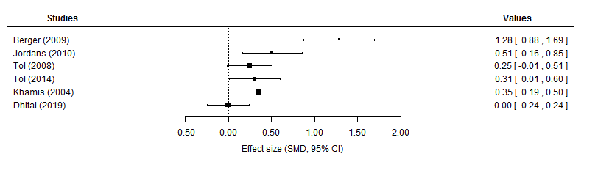

- The impact of MHPSS on somatic complaints
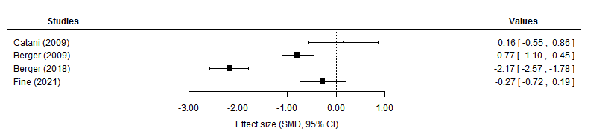

- The impact of MHPSS on coping
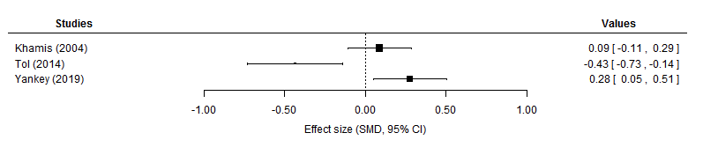
- The impact of MHPSS on grief
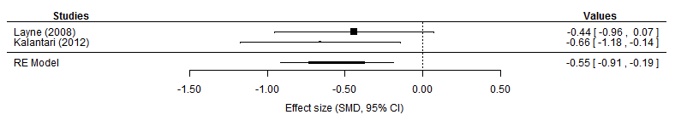

Main Summary
Random-Effects Model (k = 2; tau^2 estimator: DL)
tau^2 (estimated amount of total heterogeneity): 0 (SE = 0.10)
tau (square root of estimated tau^2 value): 0
I^2 (total heterogeneity / total variability): 0.00%
H^2 (total variability / sampling variability): 1.00
Test for Heterogeneity:
Q(df = 1) = 0.34, p-val = 0.56
Model Results:
estimate se zval pval ci.lb ci.ub
-0.55 0.19 -2.97 <.01 -0.91 -0.19 **

- The impact of MHPSS on guilt
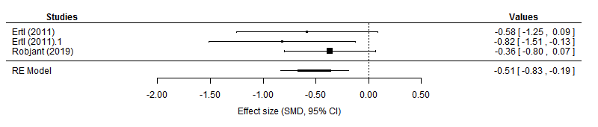

Main Summary
Random-Effects Model (k = 3; tau^2 estimator: DL)
tau^2 (estimated amount of total heterogeneity): 0 (SE = 0.09)
tau (square root of estimated tau^2 value): 0
I^2 (total heterogeneity / total variability): 0.00%
H^2 (total variability / sampling variability): 1.00
Test for Heterogeneity:
Q(df = 2) = 1.24, p-val = 0.54
Model Results:
estimate se zval pval ci.lb ci.ub
-0.51 0.16 -3.12 <.01 -0.83 -0.19 **

- The impact of psychosocial programmes on PTSD

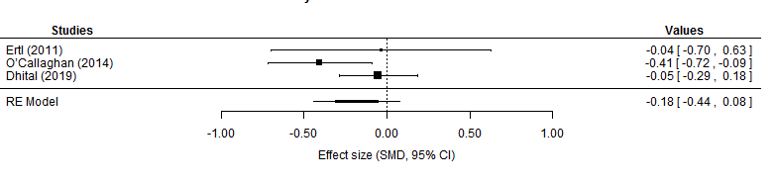

Main Summary
Random-Effects Model (k = 3; tau^2 estimator: DL)
tau^2 (estimated amount of total heterogeneity): 0.02 (SE = 0.05)
tau (square root of estimated tau^2 value): 0.14
I^2 (total heterogeneity / total variability): 39.30%
H^2 (total variability / sampling variability): 1.65
Test for Heterogeneity:
Q(df = 2) = 3.30, p-val = 0.19
Model Results:
estimate se zval pval ci.lb ci.ub
-0.18 0.13 -1.38 0.17 -0.44 0.08

- The impact of psychosocial programmes on conduct problems
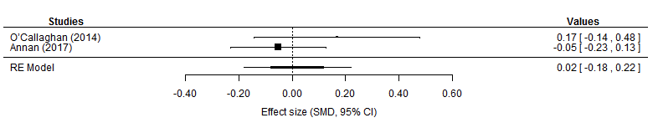

Main Summary
Random-Effects Model (k = 2; tau^2 estimator: DL)
tau^2 (estimated amount of total heterogeneity): 0.01 (SE = 0.03)
tau (square root of estimated tau^2 value): 0.08
I^2 (total heterogeneity / total variability): 30.03%
H^2 (total variability / sampling variability): 1.43
Test for Heterogeneity:
Q(df = 1) = 1.43, p-val = 0.23
Model Results:
estimate se zval pval ci.lb ci.ub
0.02 0.10 0.19 0.85 -0.18 0.22

- The impact of psychosocial programmes on emotional problems

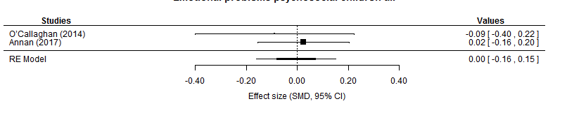

Main Summary
Random-Effects Model (k = 2; tau^2 estimator: DL)
tau^2 (estimated amount of total heterogeneity): 0 (SE = 0.02)
tau (square root of estimated tau^2 value): 0
I^2 (total heterogeneity / total variability): 0.00%
H^2 (total variability / sampling variability): 1.00
Test for Heterogeneity:
Q(df = 1) = 0.38, p-val = 0.54
Model Results:
estimate se zval pval ci.lb ci.ub
-0.00 0.08 -0.05 0.96 -0.16 0.15

- The impact of psychosocial programmes on functioning

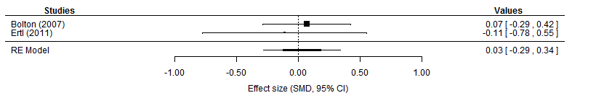

Main Summary
Random-Effects Model (k = 2; tau^2 estimator: DL)
tau^2 (estimated amount of total heterogeneity): 0 (SE = 0.10)
tau (square root of estimated tau^2 value): 0
I^2 (total heterogeneity / total variability): 0.00%
H^2 (total variability / sampling variability): 1.00
Test for Heterogeneity:
Q(df = 1) = 0.22, p-val = 0.64
Model Results:
estimate se zval pval ci.lb ci.ub
0.03 0.16 0.18 0.86 -0.29 0.34

- The impact of psychosocial programmes on depression
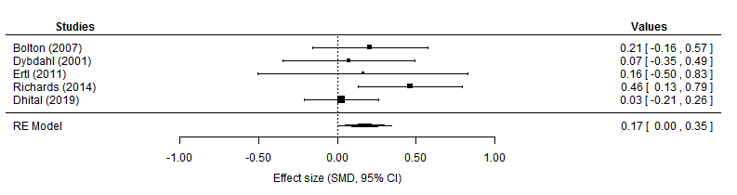

Main Summary
Random-Effects Model (k = 5; tau^2 estimator: DL)
tau^2 (estimated amount of total heterogeneity): 0.01 (SE = 0.03)
tau (square root of estimated tau^2 value): 0.08
I^2 (total heterogeneity / total variability): 14.49%
H^2 (total variability / sampling variability): 1.17
Test for Heterogeneity:
Q(df = 4) = 4.68, p-val = 0.32
Model Results:
estimate se zval pval ci.lb ci.ub
0.17 0.09 1.99 0.05 0.00 0.35 *

- The impact of NET on guilt
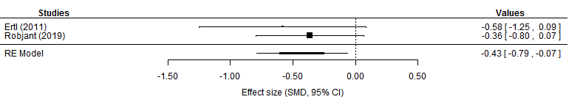

Main Summary
Random-Effects Model (k = 2; tau^2 estimator: DL)
tau^2 (estimated amount of total heterogeneity): 0 (SE = 0.12)
tau (square root of estimated tau^2 value): 0
I^2 (total heterogeneity / total variability): 0.00%
H^2 (total variability / sampling variability): 1.00
Test for Heterogeneity:
Q(df = 1) = 0.29, p-val = 0.59
Model Results:
estimate se zval pval ci.lb ci.ub
-0.43 0.18 -2.32 0.02 -0.79 -0.07 *

