Appendix C— Screening and Selection Tool

Document created and used to identify studies from the literature search for inclusion in the review. The screening tool was filled out by the reviewer for each reference that underwent a full text screening.

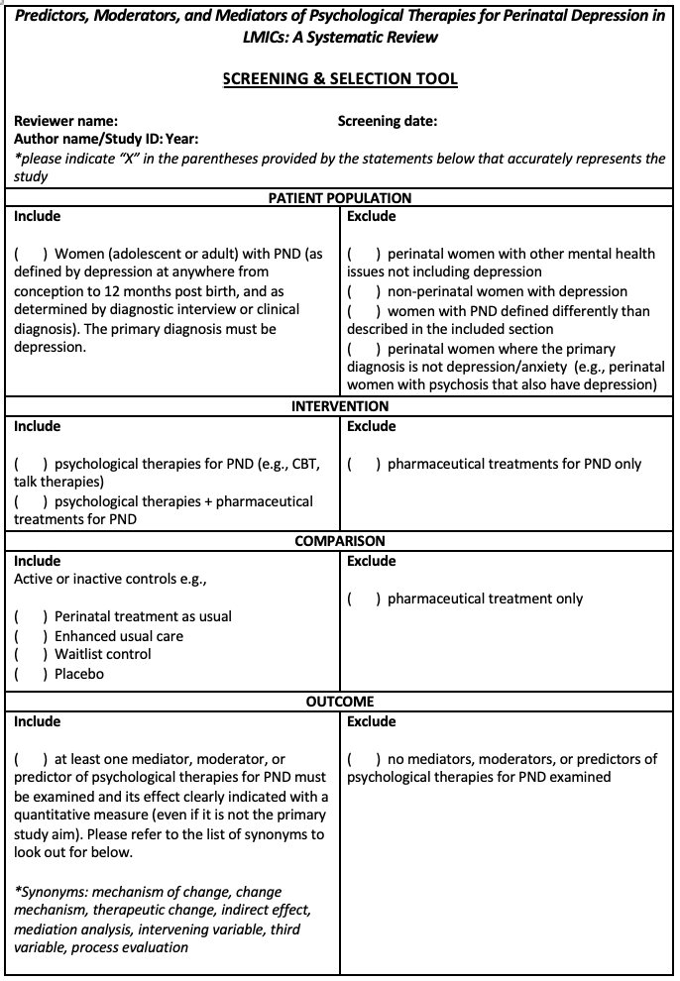

Appendix C continued
