Supplementary Material

Table S1: 3-Factor solution
 |  | Factor 1 | Factor 2 | Factor 3
seasa2 | If you have serious thoughts of killing yourself in the future,  how confident are you that you will be able to keep  yourself from attempting suicide? | 0.94
seasa4 | How certain are you that you could control future thoughts of suicide if you were experiencing physical or emotional pain? | 0.91
seasa1 | How confident are you that you will not attempt suicide in the future? | 0.82
seasa5 | How certain are you that you could control future suicidal thoughts if you lost an important relationship? | 0.84
seasa6 | How certain are you that you could control future suicidal thoughts if you lost a job, could not find employment, or suffered a financial crisis? | 0.70
seasa3 | If you have thoughts of killing yourself in the future, how confident are you that you will tell someone? | 0.44
cssrs5 | Have you started to work out or worked out the details of how to kill yourself? Do you intend to carry out this plan? |  | 0.96
cssrs6 | Have you ever done anything, started to do anything, or prepared to do anything to end your life? |  | 0.87
cssrs4 | Have you had these thoughts and had some intention of acting on them? |  | 0.74
cssrs3 | Have you been thinking about how you might do this? |  | 0.79
brfl7 | I want to watch my children as they grow |  |  | 0.92
brfl5 | I love and enjoy my family too much and could not leave them |  |  | 0.66
brfl4 | The effect on my children could be harmful |  |  | 0.79
brfl2 | My family depends upon me and needs me |  |  | 0.82
brfl12 | I believe I can find purpose in life, a reason to live |  |  | 0.56
brfl6 | My religious beliefs forbid it |  |  | 0.51
brfl11 | I would not want people to think I did not have control over my life |  |  | 0.52
brfl9 | I consider it morally wrong |  |  | 0.56

Table S2: 5-Factor solution
 |  | Factor 1 | Factor 2 | Factor 3 | Factor 4 | Factor 5
seasa2 | If you have serious thoughts of killing yourself in the future,  how confident are you that you will be able to keep  yourself from attempting suicide? | 0.93
seasa4 | How certain are you that you could control future thoughts of suicide if you were experiencing physical or emotional pain? | 0.89
seasa1 | How confident are you that you will not attempt suicide in the future? | 0.87
seasa5 | How certain are you that you could control future suicidal thoughts if you lost an important relationship? | 0.85
seasa6 | How certain are you that you could control future suicidal thoughts if you lost a job, could not find employment, or suffered a financial crisis? | 0.68
seasa3 | If you have thoughts of killing yourself in the future, how confident are you that you will tell someone? | 0.42
cssrs5 | Have you started to work out or worked out the details of how to kill yourself? Do you intend to carry out this plan? |  | 0.94
cssrs6 | Have you ever done anything, started to do anything, or prepared to do anything to end your life? |  | 0.84
cssrs4 | Have you had these thoughts and had some intention of acting on them? |  | 0.83
cssrs3 | Have you been thinking about how you might do this? |  | 0.81
brfl7 | I want to watch my children as they grow |  |  | 0.68 |  | -0.48
brfl5 | I love and enjoy my family too much and could not leave them |  |  | 0.68
brfl4 | The effect on my children could be harmful |  |  | 0.85
brfl2 | My family depends upon me and needs me |  |  | 0.80
brfl12 | I believe I can find purpose in life, a reason to live |  |  | 0.35
brfl6 | My religious beliefs forbid it
brfl8 | I am concerned about what others would think of me |  |  |  | 0.59
brfl10 | I am afraid of the actual “act” of killing myself (the pain, blood, violence) |  |  |  | 0.68
brfl11 | I would not want people to think I did not have control over my life |  |  |  | 0.64
brfl9 | I consider it morally wrong |  |  |  | 0.76
brfl1 | I am afraid of death |  |  |  |  | 0.56
brfl3 | I do not want to die |  |  |  |  | 0.71

Figure S1: Items Endorsement
- C-SSRS
Item | n(%)
Have you wished you were dead or wished you could go to sleep and not wake up?
Yes | 80 (100)
No | 0 (0)
Have you had any actual thoughts of killing yourself?
Yes | 67 (83.8)
No | 13 (16.2)
Have you been thinking about how you might do this?
Yes | 48 (60.0)
No | 32 (40.0)
Have you had these thoughts and had some intention of acting on them?
Yes | 36 (45.0)
No | 44 (55.0)
Have you started to work out or worked out the details of how to kill yourself? Do you intend to carry out this plan?
Yes | 22 (27.5)
No | 58 (72.5)
Have you ever done anything, started to do anything, or prepared to do anything to end your life?
Yes | 22 (27.5)
No | 58 (72.5)

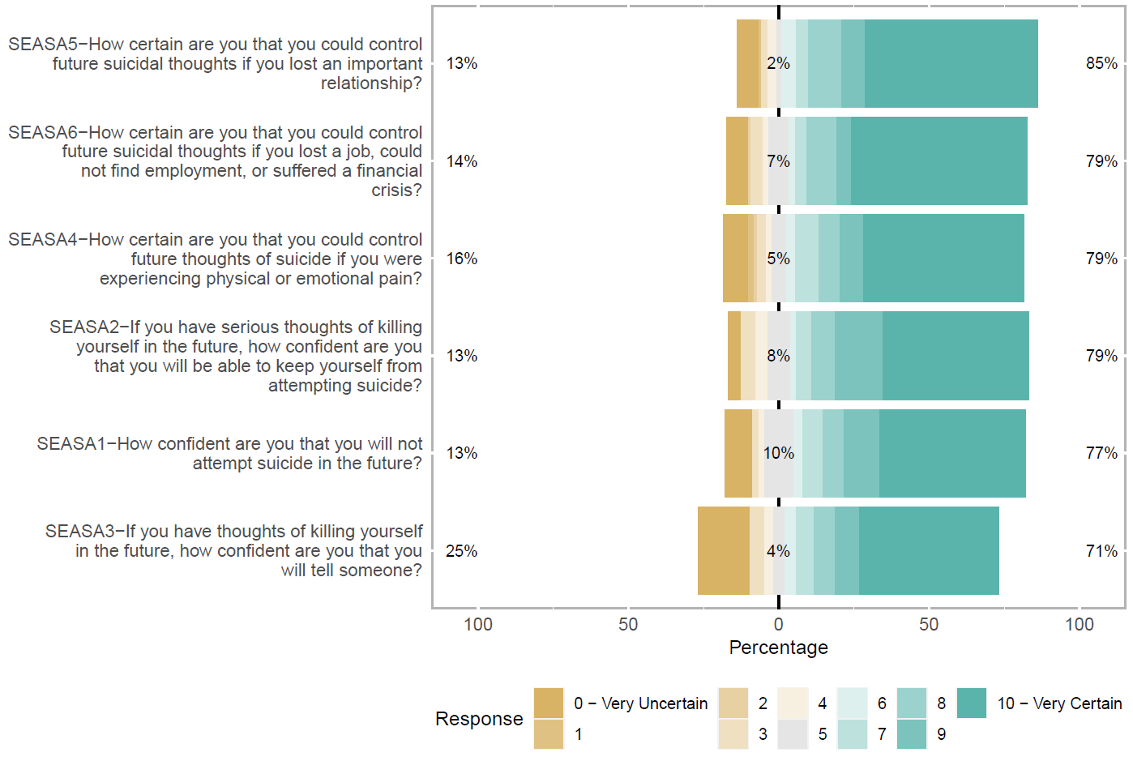
- Self-Efficacy to Avoid Suicidal Action
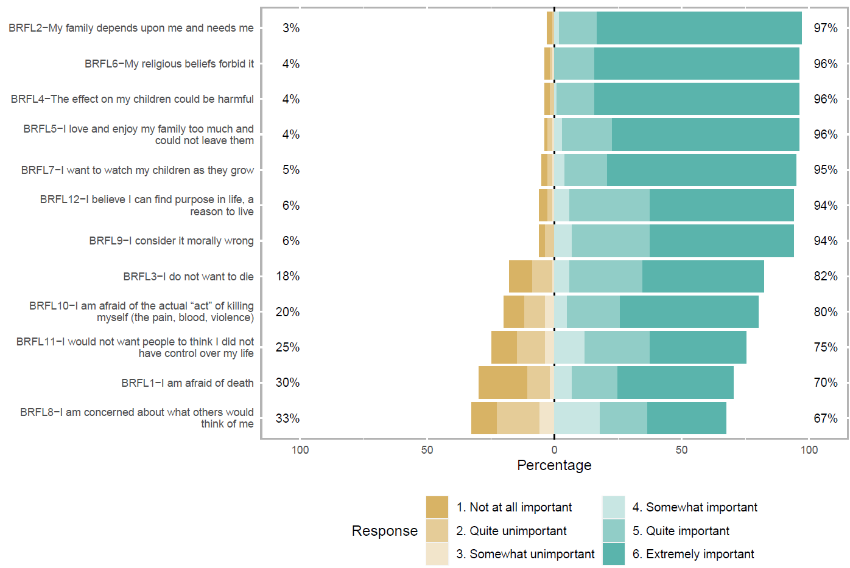
- Brief Reasons for Living (BRFL)

Figure S2: Polychoric Matrix

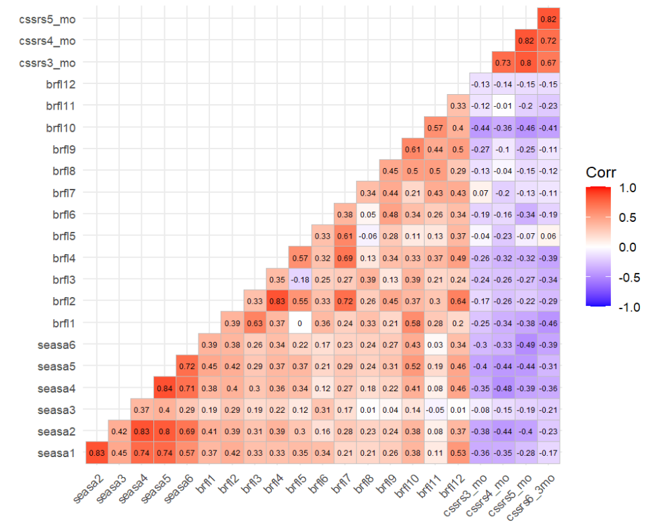

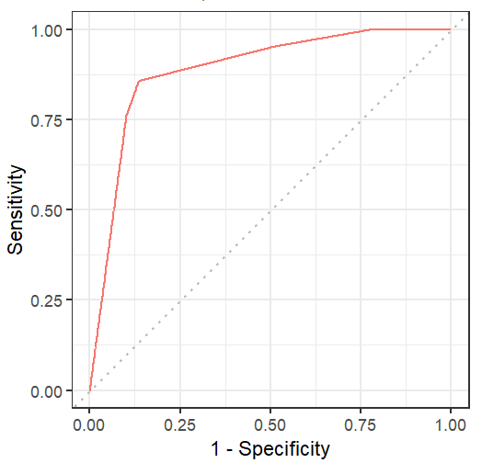
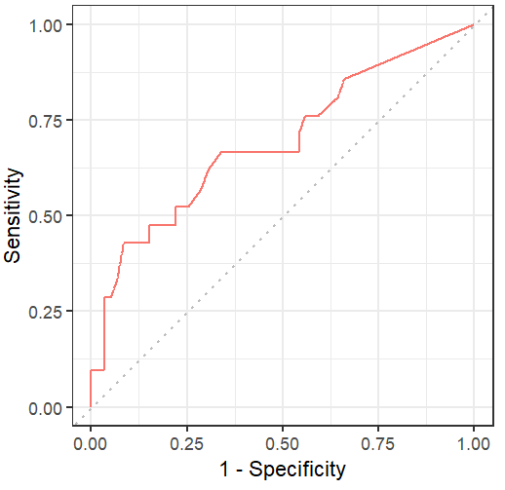
Figure S3: ROC curves
Self-Efficacy
Intensity of suicidality

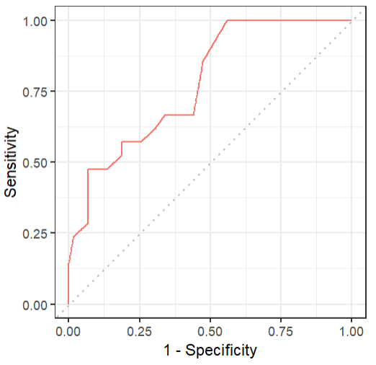
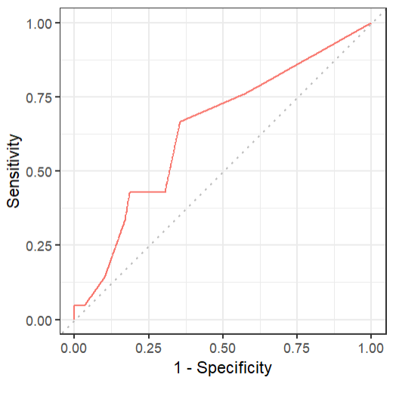
Fear and social concern
Family and spirituality

