The Impact of Female Education on Fertility: Evidence from Malawi Universal Primary Education Program
Supplementary Materials

Appendix
Table A.1 Summary Statistics of the PHC
 | All | Treated group (Ages 10-15 in 1994) | Control group (Ages 17-22 in 1994) | Difference  (2)-(3)
 | (1) | (2) | (3) | (4)
Panel A: Predetermined Variable
Age | 28.94 | 26.11 | 33.21 | -7.10***
 | (3.89) | (1.72) | (1.77)
Christian (=1 if religion is Christian, =0 otherwise) | 0.84 | 0.83 | 0.84 | -0.01***
 | (0.37) | (0.37) | (0.36)
Chewa (=1 if ethnicity is Chewa, =0 otherwise) | 0.33 | 0.32 | 0.34 | -0.02***
 | (0.47) | (0.47) | (0.47)
Lomwe (=1 if ethnicity is Lomwe, =0 otherwise) | 0.18 | 0.19 | 0.18 | 0.01*
 | (0.39) | (0.39) | (0.38)
Yao (=1 if ethnicity is Yao, =0 otherwise) | 0.13 | 0.14 | 0.12 | 0.02***
 | (0.34) | (0.35) | (0.33)
Tumbuka (=1 if ethnicity is Tumbuka, =0 otherwise) | 0.09 | 0.09 | 0.09 | 0.00*
 | (0.28) | (0.28) | (0.29)
Ngoni (=1 if ethnicity is Ngoni, =0 otherwise) | 0.12 | 0.12 | 0.12 | 0.00
 | (0.32) | (0.32) | (0.32)
Rural (=1 if living in rural areas, =0 otherwise) | 0.84 | 0.83 | 0.85 | -0.02***
 | (0.37) | (0.37) | (0.35)
Panel B: Outcome Variable
Years of Education | 4.88 | 5.32 | 4.23 | 1.09***
 | (4.03) | (3.98) | (4.02)
Number of children ever born | 3.51 | 3.80 | 4.59 | -1.78***
 | (1.98) | (1.46) | (2.07)
Number of total living children | 3.12 | 2.56 | 3.96 | -1.39***
 | (1.76) | (1.22) | (1.68)
Husband-wife age difference | 5.85 | 5.60 | 6.26 | -0.66***
 | (5.83) | (5.28) | (6.58)
Husband education | 6.32 | 6.62 | 5.89 | 0.73***
 | (3.95) | (3.97) | (3.88)
Labor market participation | 0.78 | 0.77 | 0.80 | -0.03***
 | (0.41) | (0.40) | (0.42)
Paid in cash | 0.14 | 0.13 | 0.15 | -0.02***
 | (0.34) | (0.33) | (0.36)
Occupation: professional/technical/managerial | 0.04 | 0.03 | 0.05 | -0.02***
 | (0.19) | (0.16) | (0.22)
Number of Observations | 106,297 | 63,913 | 42,384
Notes: Standard deviations are reported in parentheses. ***, **, and * indicate significance at the 1, 5, and 10 percent levels.

Table A.2 Balance Test
 | Christian |  |  | CCAP |  | Muslim | Chewa | Lomwe | Yao | Tumbuka | Ngoni
 | (1) |  |  | (2) |  | (3) | (4) | (5) | (6) | (7) | (8)
Panel A: DHS
UPE Policy | 0.016 |  |  | 0.001 |  | 0.001 | 0.017* | -0.001 | -0.004 | 0.003 | -0.021**
 | (0.017) |  |  | (0.012) |  | (0.008) | (0.010) | (0.010) | (0.009) | (0.006) | (0.008)
District FE | Yes |  |  | Yes |  | Yes | Yes | Yes | Yes | Yes | Yes
Observations | 16,367 |  |  | 16,367 |  | 16,367 | 16,367 | 16,367 | 16,367 | 16,367 | 16,367
Mean of Dep. Var | 0.61 |  |  | 0.14 |  | 0.13 | 0.31 | 0.19 | 0.13 | 0.10 | 0.12
Panel B: PHC
UPE Policy | -0.008 |  |  | n/a |  | 0.008 | -0.004 | -0.002 | 0.010* | 0.000 | -0.003
 | (0.005) |  |  | n/a |  | (0.005) | (0.004) | (0.003) | (0.004) | (0.002) | (0.004)
District FE | Yes |  |  | n/a |  | Yes | Yes | Yes | Yes | Yes | Yes
Observations | 88,699 |  |  | n/a |  | 88,699 | 88,699 | 88,699 | 88,699 | 88,699 | 88,699
Mean of Dep. Var | 0.84 |  |  | n/a |  | 0.13 | 0.34 | 0.18 | 0.12 | 0.09 | 0.12
Notes: Chewa, Yao, Lomwe, Tumbuka, and Ngoni are the five most populous ethnic groups in Malawi. UPE Policy = 1 if the person was born between 1979 and 1984, it is zero if the year of birth is between 1972 and 1977. The 1978 cohort is excluded because the extent to which those born in 1978 were affected by the UPE policy is uncertain. Standard errors reported in parentheses. Each specification controls for district fixed effects. Specifications in Panel A additionally control for year of survey fixed effects. ***, **, and * indicate significance at the 1, 5, and 10 percent levels.

Table A.3 First Stage Results: The Impact of the UPE Policy on Female Schooling Attainment Using Data of PHC
 | All | Rural | Urban | All | Rural | Urban
 | (1) | (2) | (3) | (4) | (5) | (6)
UPE Policy | 0.292*** | 0.328*** | 0.117 | 0.310*** | 0.331*** | 0.158
 | (0.075) | (0.073) | (0.150) | (0.065) | (0.068) | (0.132)
Controls | No | No | No | Yes | Yes | Yes
District FE | Yes | Yes | Yes | Yes | Yes | Yes
First Stage F-stat | 15.18 | 20.39 | 0.61 | 23.05 | 24.04 | 1.43
Observations | 106,297 | 88,699 | 16,910 | 106,297 | 88,699 | 16,910
Mean of Dep. Var | 4.88 | 4.26 | 7.96 | 4.88 | 4.26 | 7.96
Notes: UPE Policy = 1 if the person was born between 1979 and 1984, it is zero if the year of birth is between 1972 and 1977. The 1978 cohort is excluded because the extent to which those born in 1978 were affected by the UPE policy is uncertain. Standard errors are clustered at the district-by-birth cohort level and reported in parentheses. Individual controls include religion, ethnicity. Each specification controls for district fixed effects and year of survey fixed effects. ***, **, and * indicate significance at the 1, 5, and 10 percent levels.

Table A.4 The Impact of the UPE Policy on Rural Women’s Propensity of Completing Primary School and Some Secondary School
 | DHS |  |  | PHC
 | Primary school completion | Some secondary school completion |  | Primary school completion | Some secondary school completion
 | (1) | (2) |  | (3) | (4)
UPE Policy | 0.040*** | 0.038*** |  | 0.041*** | 0.030***
 | (0.011) | (0.012) |  | (0.007) | (0.005)
District FE | Yes | Yes |  | Yes | Yes
First Stage F-stat | 9.70 | 9.02 |  | 31.07 | 32.29
Observations | 16,367 | 16,367 |  | 88,518 | 88,518
R-squared | 0.092 | 0.075 |  | 0.064 | 0.032
Mean of Dep. Var | 0.15 | 0.08 |  | 0.22 | 0.12
Notes: UPE Policy = 1 if the person was born between 1979 and 1984, it is zero if the year of birth is between 1972 and 1977. The 1978 cohort is excluded because the extent to which those born in 1978 were affected by the UPE policy is uncertain. Standard errors are clustered at the district-by-birth cohort level and reported in parentheses. Individual controls include religion, ethnicity. Each specification controls for district fixed effects and year of survey fixed effects. ***, **, and * indicate significance at the 1, 5, and 10 percent levels.

Table A.5 First Stage Results: The Impact of the UPE Policy on Male Schooling Attainment
 | DHS | PHC
UPE Policy | 0.124 | -0.007
 | (0.139) | (0.066)
District FE | Yes | Yes
First Stage F-stat | 0.80 | 0.01
Observations | 5,003 | 90,897
R-squared | 0.159 | 0.161
Notes: UPE Policy = 1 if the person was born between 1979 and 1984, it is zero if the year of birth is between 1972 and 1977. The 1978 cohort is excluded because the extent to which those born in 1978 were affected by the UPE policy is uncertain. Standard errors are clustered at the district-by-birth cohort level and reported in parentheses. Individual controls include religion, ethnicity. Each specification controls for district fixed effects and year of survey fixed effects. ***, **, and * indicate significance at the 1, 5, and 10 percent levels.

Table A.6 The Impact of Female Education on Fertility Using Data of PHC
 | Number of Children Ever Born |  |  | Number of Living Children
 | OLS | Reduced Form | 2SLS | OLS | Reduced Form | 2SLS
 | (1) | (2) | (3) | (4) | (5) | (6)
Education | -0.101*** |  | -0.497*** | -0.063*** |  | -0.342***
 | (0.002) |  | (0.120) | (0.001) |  | (0.097)
UPE Policy |  | -0.163*** |  |  | -0.114***
 |  | (0.029) |  |  | (0.026)
District FE | Yes | Yes | Yes | Yes | Yes | Yes
Observations | 88,699 | 88,699 | 88,699 | 88,699 | 88,699 | 88,699
First Stage F-stat |  |  | 24.04 |  |  | 24.04
Effective First Stage F-stat |  |  | 24.04 |  |  | 24.04
Anderson-Rubin confidence interval |  |  | [-0.86,-0.31] |  |  | [-0.78,-0.27]
Mean of Dep. Var | 4.76 | 4.76 | 4.76 | 4.06 | 4.06 | 4.06
Notes: Education refers to the respondent’s years of schooling. UPE Policy = 1 if the person was born between 1979 and 1984, it is zero if the year of birth is between 1972 and 1977. The 1978 cohort is excluded because the extent to which those born in 1978 were affected by the UPE policy is uncertain. Standard errors are clustered at the district-by-birth cohort level and reported in parentheses. Individual controls include religion, ethnicity. Each specification controls for district fixed effects and year of survey fixed effects. ***, **, and * indicate significance at the 1, 5, and 10 percent levels.

Table A.7 The Impact of Female Education on Fertility in Various Specifications Using Data of PHC
 | Baseline | Include cohorts aged 16 as treatment group |  | Exclude cohorts aged 15 and 16 | Quadratic function | Bandwidth=8 | Bandwidth=7 | Bandwidth=5 | Bandwidth=4 | SE clustered at birth cohort level
 | (1) | (2) | (3) |  | (4) | (5) | (6) | (7) | (8) | (9)
Panel A: Number of children ever born
Education | -0.497*** | -0.407*** | -0.591*** |  | -0.341** | -0.389*** | -0.365*** | -0.569*** | -0.378*** | -0.497***
 | (0.120) | (0.073) | (0.190) |  | (0.163) | (0.071) | (0.083) | (0.170) | (0.113) | (0.141)
District FE | Yes | Yes | Yes |  | Yes | Yes | Yes | Yes | Yes | Yes
Observations | 88,699 | 88,779 | 78,038 |  | 88,699 | 116,738 | 101,420 | 73,568 | 56,950 | 88,699
First Stage F-stat | 24.04 | 53.07 | 11.67 |  | 8.141 | 58.91 | 37.40 | 14.14 | 17.47 | 22.08
Panel B: Number of living children
Education | -0.342*** | -0.264*** | -0.446*** |  | -0.125 | -0.325*** | -0.281*** | -0.317*** | -0.245*** | -0.342***
 | (0.097) | (0.053) | (0.168) |  | (0.102) | (0.065) | (0.073) | (0.115) | (0.089) | (0.112)
District FE | Yes | Yes | Yes |  | Yes | Yes | Yes | Yes | Yes | Yes
Observations | 88,699 | 88,779 | 78,038 |  | 88,699 | 111,425 | 101,420 | 73,568 | 56,950 | 88,699
First Stage F-stat | 24.04 | 53.07 | 11.67 |  | 8.141 | 56.15 | 37.40 | 14.14 | 17.47 | 22.08
Notes: Education refers to the respondent’s years of schooling. Standard errors are clustered at the district-by-birth cohort level and reported in parentheses. Individual controls include religion, ethnicity. Each specification controls for district fixed effects and year of survey fixed effects. ***, **, and * indicate significance at the 1, 5, and 10 percent levels.

Table A.8 Placebo Tests Using Data of PHC
 | 2 years back | 3 years back | 4 years back | 2 years forward | 3 years forward | 4 years forward
 | (1) | (2) | (3) | (4) | (5) | (6)
Panel A: Number of children ever born
Placebo reform | 0.024 | 0.053 | 0.059 | -0.002 | 0.017 | 0.041**
 | (0.032) | (0.035) | (0.036) | (0.022) | (0.019) | (0.018)
District FE | Yes | Yes | Yes | Yes | Yes | Yes
Observations | 77,960 | 74,063 | 69,971 | 94,561 | 95,687 | 96,889
Panel B: Number of children living children
Placebo reform | 0.013 | 0.013 | -0.016 | -0.029 | -0.016 | 0.002
 | (0.027) | (0.030) | (0.029) | (0.020) | (0.018) | (0.017)
District FE | Yes | Yes | Yes | Yes | Yes | Yes
Observations | 77,960 | 74,063 | 69,971 | 94,561 | 95,687 | 96,889
Notes: The estimates presented in Table A.8 are derived from a reduced-form specification. This approach was used to assess the impact of the policy by shifting the year of the reform both backwards and forwards, while keeping the number of cohorts before and after the pivotal cohorts consistent with the baseline analysis. In the placebo tests conducted in columns (1) to (3), the treated cohorts identified in the baseline analysis are not excluded. Each column represents a different hypothetical scenario, with the year of the reform moved backward and forward by 2, 3, and 4 years respectively. These different scenarios may have led to variations in the available data, causing the number of observations to differ for each placebo test. Standard errors are clustered at the district-by-birth cohort level and reported in parentheses. Individual controls include religion, ethnicity. Each specification controls for district fixed effects and year of survey fixed effects. ***, **, and * indicate significance at the 1, 5, and 10 percent levels.
Table A.9 The Impact of Female Education on Assortative Mating and Labor Market Participation (PHC)
 | Husband education |  |  |  | Age difference between husband and wife |  |  |  | Labor market participation |  |  |  | Paid in cash |  |  |  | Occupation: professional/  technical/managerial
 | OLS |  | 2SLS |  | OLS |  | 2SLS |  | OLS |  | 2SLS |  | OLS |  | 2SLS |  | OLS |  | 2SLS
 | (1) |  | (2) |  | (3) |  | (4) |  | (5) |  | (6) |  | (7) |  | (8) |  | (9) |  | (10)
Education | 0.234*** |  | 0.596*** |  | -0.525*** |  | -1.400*** |  | -0.001 |  | -0.003 |  | -0.000 |  | -0.001 |  | -0.003 |  | -0.006
 | (0.071) |  | (0.156) |  | (0.111) |  | (0.364) |  | (0.006) |  | (0.017) |  | (0.006) |  | (0.014) |  | (0.003) |  | (0.008)
District FE | Yes |  | Yes |  | Yes |  | Yes |  | Yes |  | Yes |  | Yes |  | Yes |  | Yes |  | Yes
Observations | 59,692 |  | 59,692 |  | 69,075 |  | 69,075 |  | 88,699 |  | 88,699 |  | 52,200 |  | 52,200 |  | 51,894 |  | 51,894
First Stage F-stat |  |  | 31.42 |  |  |  | 28.21 |  |  |  | 24.04 |  |  |  | 28.24 |  |  |  | 29.49
Mean of Dep. Var. | 5.24 |  | 5.24 |  | 6.33 |  | 6.33 |  | 0.81 |  | 0.81 |  | 0.11 |  | 0.11 |  | 0.03 |  | 0.03
Notes: Education refers to the respondent’s years of schooling. Standard errors are clustered at the district-by-birth cohort level and reported in parentheses. Individual controls include religion, ethnicity. Each specification controls for district fixed effects, and year of survey fixed effects. ***, **, and * indicate significance at the 1, 5, and 10 percent levels.

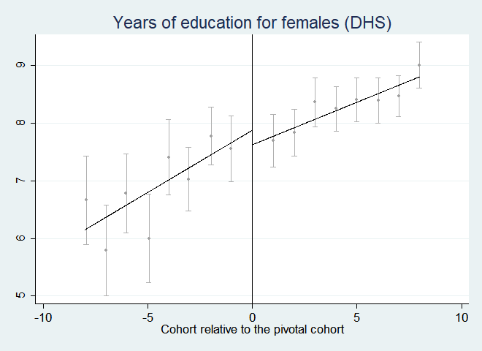
Figure A.1 Years of education for urban women

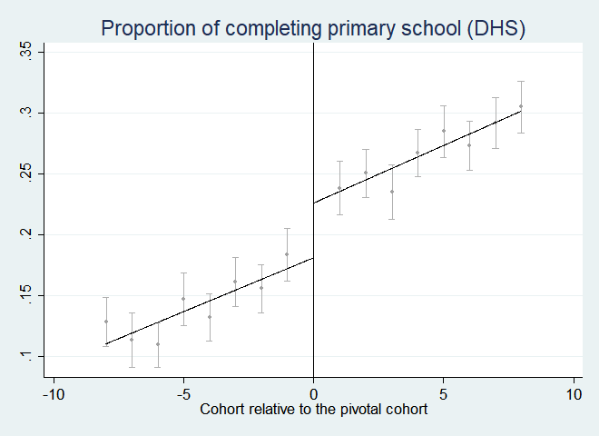
Figure A.2 Proportion of completing primary school

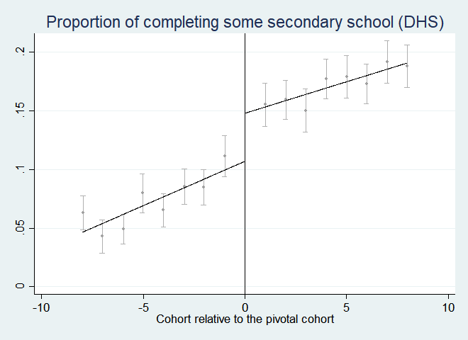
Figure A.3 Proportion of completing some secondary school

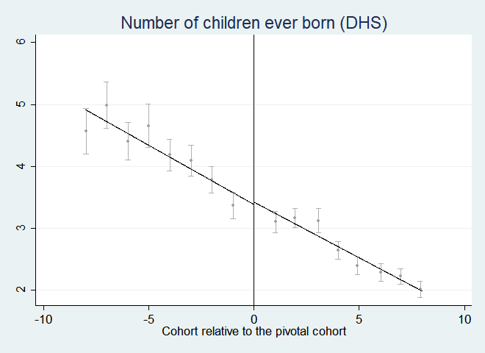
Figure A.4 Number of children ever born for urban women

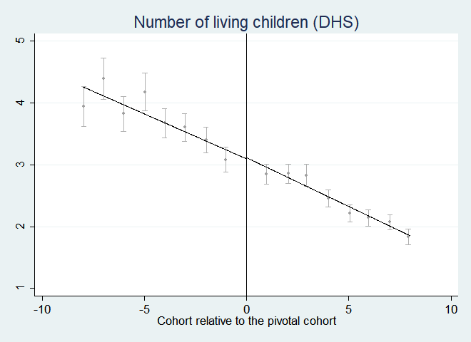
Figure A.5 Number of living children for urban women

