ONLINE APPENDIX

Household structure decisions and positive wealth shocks:
A natural experiment from the Spanish Christmas lottery

Figure A1 (Appendix). Marriage, divorce and birth rates in Spain (2000–2018)
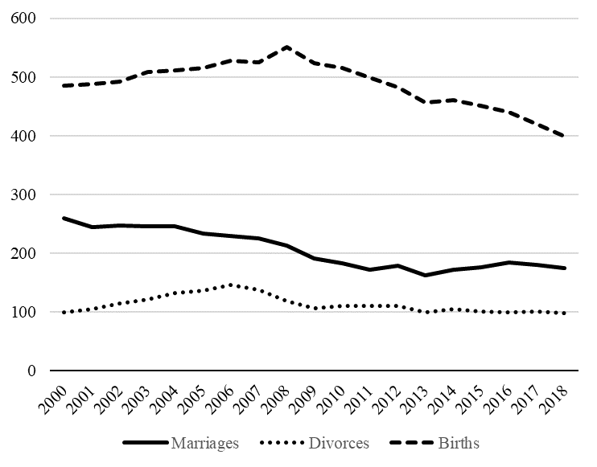

Figure A2 (Appendix). Number of winning provinces and jackpot prizes (2000–2018)

Table A1 (Appendix). Source of the data
Variable information | Source
Christmas lottery—only-winning provinces | Sociedad Estatal Loterías y Apuestas del Estado (Spanish for “State Society for State Lotteries and Bets,” SELAE)
Households’ decisions
Household structure—number of marriages, number of divorces, number of births | Spanish Statistical Office (INE)
Macroeconomic controls (province level)
Population and foreign population | Spanish Statistical Office (INE)  Spanish Statistical Office (INE)  Spanish Statistical Office (INE)  Valencian Institute of Economic Research (IVIE)  Spanish Statistical Office (INE)  Bank of Spain
GDP
Consumer Price Index
Population with higher education—human capital
Labor market—unemployment
Household savings

Table A2 (Appendix). Panel data estimates (probit model)
Dependent variable is the probability of a jackpot-winning province
 | Jackpot-winning province
Macroeconomic variables
GDP | 1.32e-11 (1.19e-11)
Population | -9.38e-08 (3.24e-07)
Higher education (rate) | -2.832 (3.982)
Unemployment (rate) | -0.016 (0.027)
Provinces | 52
Number of observations | 832
Notes: Robust standard errors are reported in parentheses. None of estimated coefficients is statistically significant from zero.

