**Online Appendix: Validating Whites’ Reactions to the “Racial Shift”**

**Appendix A: Experimental Design and Questionnaire** 1

**A1: Pre-treatment Items** 1

**A2: Treatments** 2

**A3: Subjective Manipulation Checks** 8

**A4: Post-Treatment: Mechanisms** 9

**A5: Post-Treatment: Dependent Variables** 11

**Appendix B: Pre-Treatment Covariate Balance and Treatment Means** 13

**Appendix C: Regression Results** 13

**Appendix D: Status Threat Mechanism Dimensionality** 28

**Appendix E: Results for Factual Manipulation Check Passage** 30

**Appendix F: Results Removing Straightliners** 34

**Appendix G: Restricted-Use Replication Results** 38

**G1: Regression Results** 39

**G2: Status Threat Mechanism Dimensionality** 51

**G3: Results for Factual Manipulation Check Passage** 52

**G4: Results Removing Straightliners** 63

**Appendix H: Ethical and Reporting Standards** 74

## **Appendix A: Experimental Design and Questionnaire**

The sections below provide the item question wording and response scales, as well as the programming information on item and scale order.

### **A1: Pre-treatment Items**

First, we’d like to get your feelings on some people in the news. Use the response scale provided to indicate whether you have a favorable or unfavorable opinion of that person.

{Programming note: randomize item order}

|  |  |  |  |  |  |
| --- | --- | --- | --- | --- | --- |
|  | 0-Very unfavorable |  | 5-Neither favorable nor unfavorable |  | 10-Very favorable |
| Donald Trump |  |  |  |  |  |
| Joe Biden |  |  |  |  |  |
| Taylor Swift |  |  |  |  |  |
| Jimmy Kimmel |  |  |  |  |  |

{Programming note: new page}

*Ideology* (following Brown, Rucker, and Richeson 2022)

Changing topics, please indicate whether you agree or disagree with the following statements.

{Programming note: randomize item order}

I endorse many aspects of liberal political ideology.

|  |  |  |  |  |  |  |
| --- | --- | --- | --- | --- | --- | --- |
| 1 - Strongly disagree | 2-Disagree | 3-Somewhat disagree | 4-Neither agree nor disagree | 5-Somewhat Agree | 6-Agree | 7-Strongly Agree |

{Programming note: new page}

I endorse many aspects of conservative political ideology.

|  |  |  |  |  |  |  |
| --- | --- | --- | --- | --- | --- | --- |
| 1 - Strongly disagree | 2-Disagree | 3-Somewhat disagree | 4-Neither agree nor disagree | 5-Somewhat Agree | 6-Agree | 7-Strongly Agree |

{Note: Bovitz has panelist profile information on 7-point partisanship.}

#### 

### **A2: Treatments**

{Programming note: respondents will be randomly assigned with equal probability to each of the four conditions.}

*Geographic Mobility*

U.S. Census Bureau Estimates Residents Recently Moving More

AP NEWS WIRE

WASHINGTON, DC (AP) – New U.S. Census Bureau data suggest that the rate of geographical mobility, or the number of individuals who have moved within the past year, is increasing, reversing a downward trend. The national mover rate increased from 8.4 percent in 2021 (the lowest rate since the U.S. Census Bureau began tracking the data in 1948) to 8.7 percent in 2022. 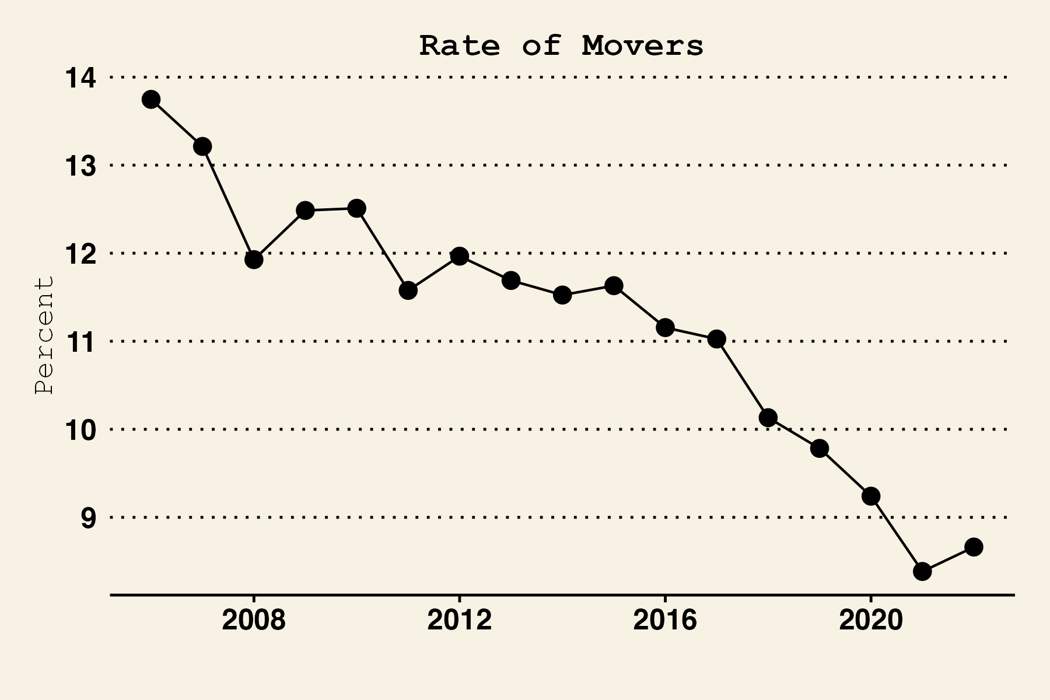

According to the new data, 28.2 million people changed residences in the U.S. within the past year. Eighty-three percent of all movers stayed within the same state. The estimates also reveal that most movers are headed to suburbs. The Census reports that while principal cities in metropolitan areas experienced a net loss of 1.66 million, suburban areas gained 1.54 million.

For those who moved to a different county or state, the reasons for moving varied considerably by the length of their move. Census demographers note these figures depend on current and historical trends, which can be thrown awry by several variables, including prospective overhauls of public policy.

Manipulation Check  
{programming note: new page}

The following question tests your recollection and opinions about the previous article. If you are uncertain of your answer, please make an educated guess. (Adapted from Brown, Rucker, and Richeson, 2022)

{programming note: rotate answer options}

Which of the following best summarizes the point being made by the experts mentioned in the article?

1. Recent data reveal more people moved over the last year.
2. The U.S. population will likely pass 400 million by 2060.
3. Leisure travel spending will likely pass $1 trillion by 2030.
4. Attendance at the 2024 Summer Olympics will likely pass London 2012’s record attendance of 8.2 million.

*Racial Shift*

Census Bureau: Racial Minorities will soon be U.S. Majority

AP NEWS WIRE

WASHINGTON, DC (AP) – New U.S. Census Bureau data suggest that America remains on track to become a “majority-minority” nation by midcentury. The nation's racial minority population is steadily rising, advancing an unmistakable trend that will make minorities the new American majority. These trends include declining numbers of white adults and growing under-18 populations of Hispanics, Asians, and other minorities.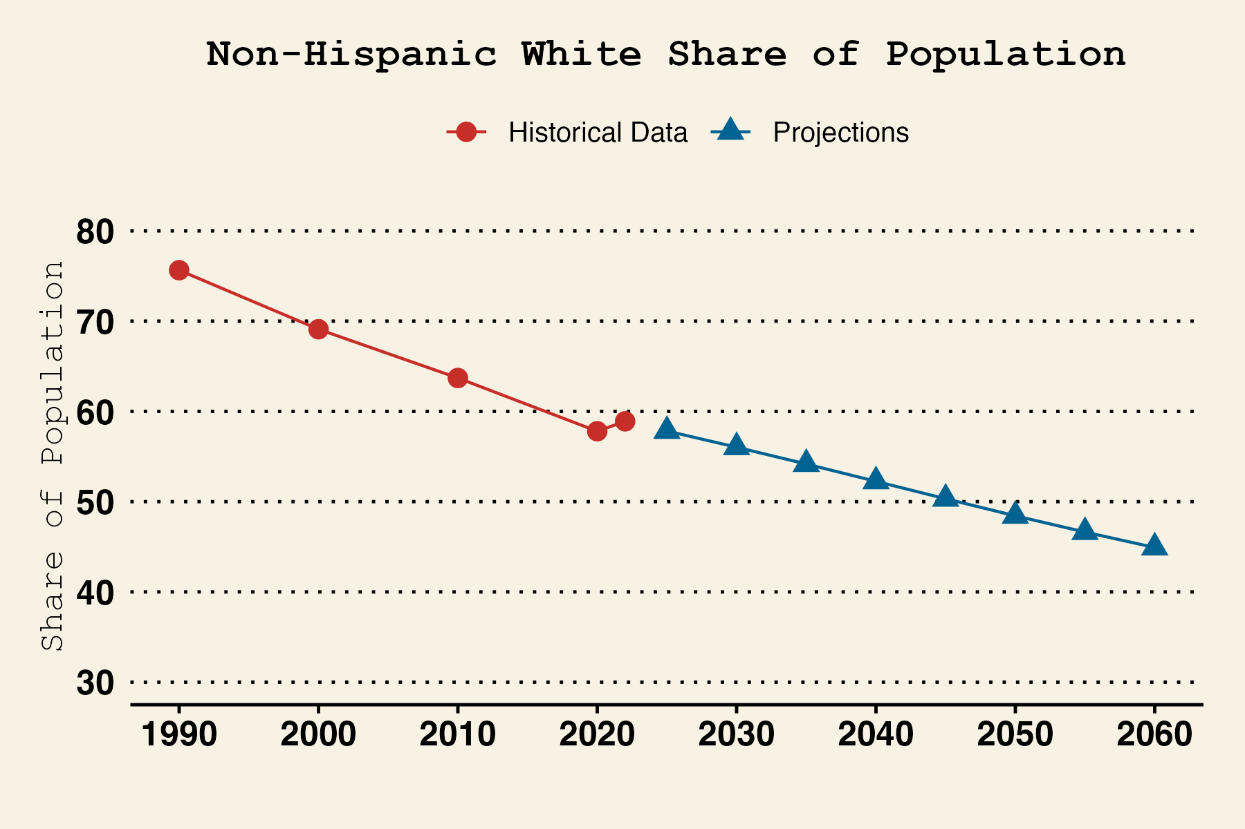

Demographers calculate that by 2046, Americans who identify as Hispanic, Black, Asian, American Indian, Native Hawaiian, or Pacific Islander will together outnumber non-Hispanic whites.

Immigration growth and differences in birthrates explain these trends. Non-white Americans are driving U.S. population growth because the white population is both older and has lower birthrates. For example, the Census estimates roughly 11 births for every 1 death among Hispanics, compared to roughly 2 deaths per birth for whites. Census demographers note these figures are predicated on current and historical trends, which can be thrown awry by several variables, including prospective overhauls of public policy.  
  
“Where the country is heading in terms of increasing racial diversity is unprecedented,” said Robert Lewis, a Census analyst. “The growth in the non-white population is unmistakable.”

Manipulation check  
{programming note: new page}

The following question tests your recollection and opinions about the previous article. If you are uncertain of your answer, please make an educated guess. (Adapted from Brown, Rucker, and Richeson, 2022)

{programming note: rotate answer options}

Which of the following best summarizes the point being made by the experts mentioned in the article?

1. Racial minorities will outnumber Whites in the USA by the year 2046.
2. The U.S. population will likely pass 400 million by 2060.
3. Leisure travel spending will likely pass $1 trillion by 2030.
4. Attendance at the 2024 Summer Olympics will likely pass London 2012’s record attendance of 8.2 million.

*Political Racial Shift*

Researchers: Racial Minorities’ Political Influence Growing

AP NEWS WIRE

WASHINGTON, DC (AP) – New data suggest that the American electorate is on track to become “majority-minority” before the 2064 presidential election, highlighting non-white Americans’ growing political influence. Eligible voters are becoming increasingly diverse, advancing an unmistakable trend of election results and enacted policies increasingly reflecting the preferences of minorities. These trends include declining numbers of white adults and growing turnout rates among Hispanics, Asians, and other minorities.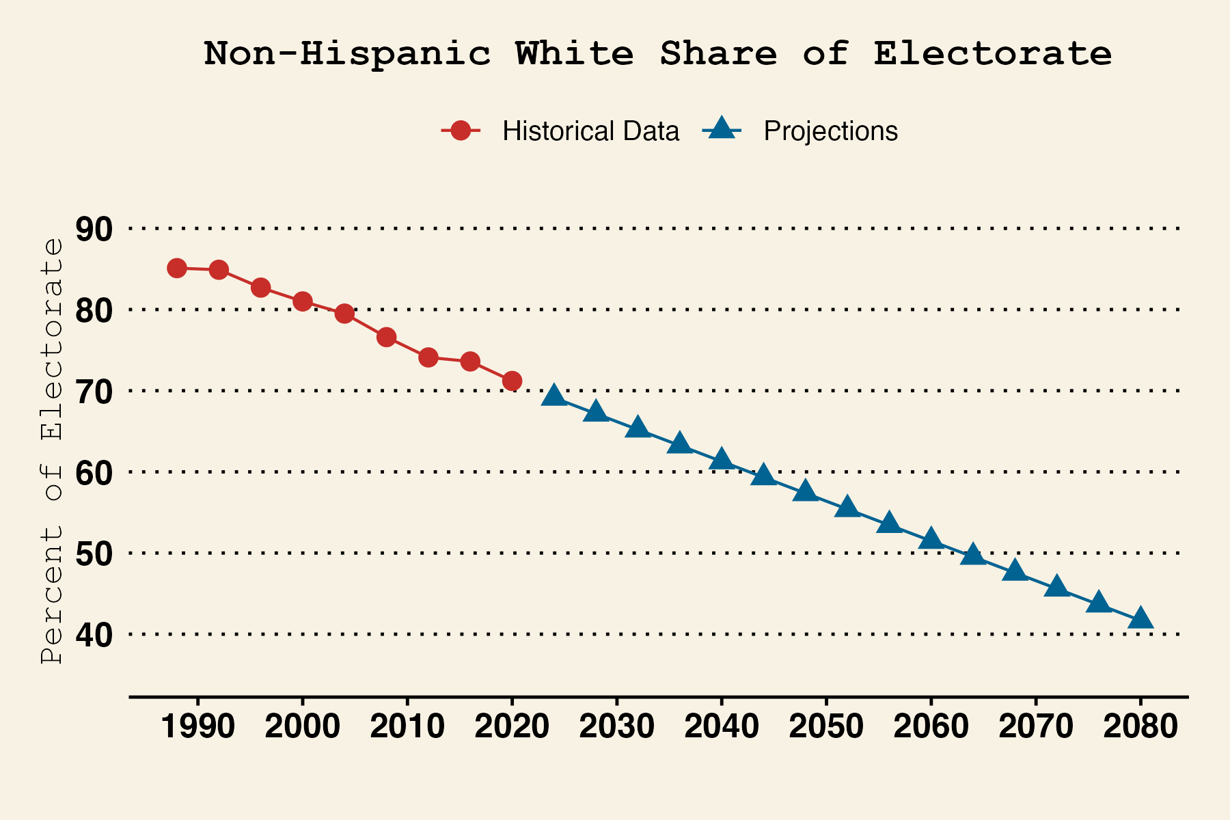

Researchers calculate that after 2060, voters who identify as Hispanic, Black, Asian, American Indian, Native Hawaiian, or Pacific Islander will together outnumber non-Hispanic whites.

Population growth and differences in turnout explain these trends. The number of non-white voters is increasing and the advantage whites have in turnout is decreasing. For example, while whites were over 18 points more likely to vote in 2016 compared to typical non-whites, this gap decreased to under 13 points in 2020 and is expected to decrease further. These changes, analysts note, suggest politicians will increasingly pay attention to the concerns of non-white voters over white voters. Researchers also note these figures depend on current and historical trends, which can be thrown awry by several variables, including prospective overhauls of public policy.

“Where the electorate is heading in terms of increasing racial diversity is unprecedented,” said Robert Lewis, a political analyst. “The growth in non-whites’ political influence is unmistakable.”

Manipulation Check

{programming note: new page}

The following question tests your recollection and opinions about the previous article. If you are uncertain of your answer, please make an educated guess. (Adapted from Brown, Rucker, and Richeson, 2022)

{programming note: rotate answer options}

Which of the following best summarizes the point being made by the experts mentioned in the article?

1. Racial minorities will be the majority of voters by the year 2064.
2. The U.S. population will likely pass 400 million by 2060.
3. Leisure travel spending will likely pass $1 trillion by 2030.
4. Attendance at the 2024 Summer Olympics will likely pass London 2012’s record attendance of 8.2 million.

*Cultural Racial Shift*

Researchers: Racial Minorities’ Cultural Influence Growing

AP NEWS WIRE

WASHINGTON, DC (AP) – New data suggest that the American media and entertainment landscape will soon become “majority-minority,” highlighting non-whites’ growing cultural influence. Movie and TV show casts, and Billboard Top 100 artists, are increasingly diverse, advancing an unmistakable trend of media increasingly reflecting the values and beliefs of minorities. These trends include declining shares of white lead actors and actresses on scripted television programming and an increasing share of non-whites in movie casts as content shifts to emphasize non-white cultural preferences.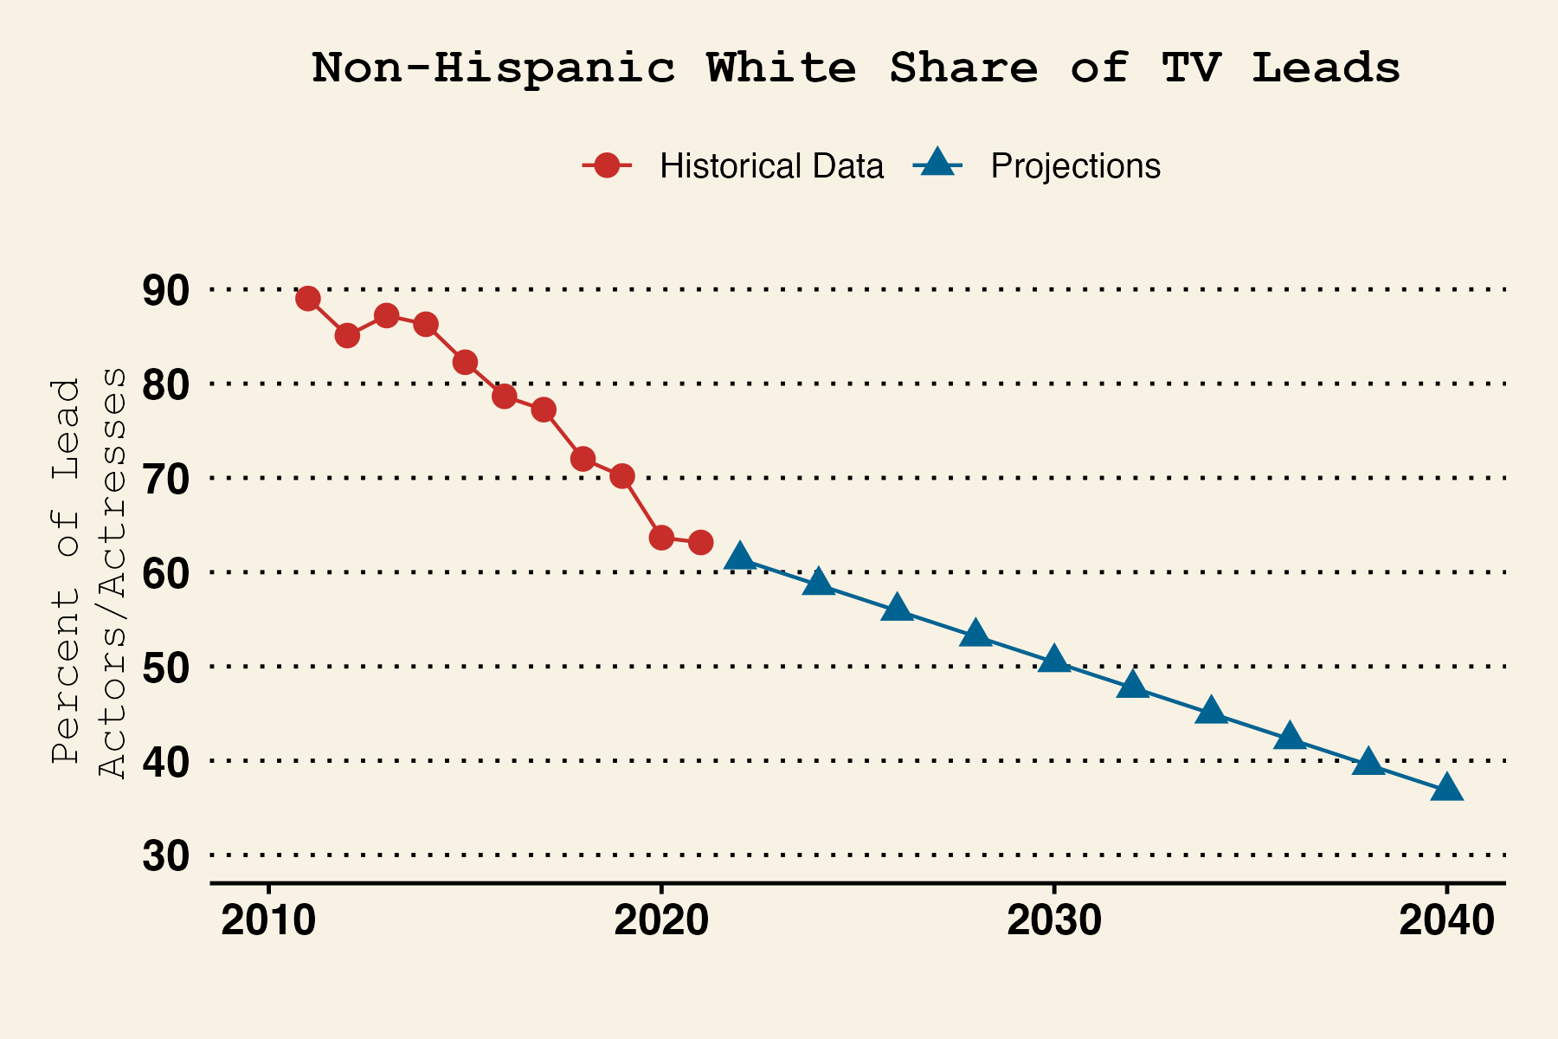

Researchers calculate that by 2032, Americans who identify as Hispanic, Black, Asian, American Indian, Native Hawaiian, or Pacific Islander will together outnumber non-Hispanic whites in leading roles on television, with similar trends true for theatrical movies.

Studio decisions and audience demands explain these trends. Non-whites are a growing share of TV show creators and whites are watching less television and fewer movies on average than non-whites. For example, analysts estimate that non-whites accounted for at least half of the revenue generated by seven of 2022’s ten highest-grossing movies, the most recent data available. These changes, analysts note, suggest entertainment media will increasingly focus on non-whites’ perspectives over whites’ values and beliefs. These analysts also note these figures depend on current and historical trends, which can be thrown awry by several variables.

“Where the entertainment landscape is heading in terms of increasing racial diversity is unprecedented,” said Robert Lewis, an industry analyst. “The growth in non-whites’ cultural influence is unmistakable.”

Manipulation Check

{programming note: new page}

The following question tests your recollection and opinions about the previous article. If you are uncertain of your answer, please make an educated guess. (Adapted from Brown, Rucker, and Richeson, 2022)

{programming note: rotate answer options}

Which of the following best summarizes the point being made by the experts mentioned in the article?

1. Racial minorities will be the majority of leads in TV shows and movies by the year 2032.
2. The U.S. population will likely pass 400 million by 2060.
3. Leisure travel spending will likely pass $1 trillion by 2030.
4. Attendance at the 2024 Summer Olympics will likely pass London 2012’s record attendance of 8.2 million.

### **A3: Subjective Manipulation Checks**

{Programming note: randomize order of trends_closed*, with each on individual page}

[trends_closed_demog] How likely is it that white people will soon be a minority of the U.S. population?

1. Extremely unlikely

2. Unlikely

3. Somewhat unlikely

4. Somewhat likely

5. Likely

6. Extremely likely

[trends_closed_pol] How likely is it that white people will soon be a minority of U.S. voters?

1. Extremely unlikely
2. Unlikely
3. Somewhat unlikely
4. Somewhat likely
5. Likely
6. Extremely likely

[trends_closed_media] How likely is it that white people will soon be a minority of actors on TV shows and in movies?

1. Extremely unlikely
2. Unlikely
3. Somewhat unlikely
4. Somewhat likely
5. Likely
6. Extremely likely

### **A4: Post-Treatment: Mechanisms**

{Programming note: randomize mechanism item set ordering, one battery per survey page}

Changing topics, please indicate whether you agree or disagree with the following statements.

*Status Change* (from Craig and Richeson 2014a; Bai and Federico 2021)

{Programming note: randomize item order}

1. If they increase in status, racial minorities are likely to reduce the influence of White Americans in society.
2. If other racial groups attain higher status, it will be good for White Americans.
3. White Americans are losing influence in society due to gains from racial minorities.

|  |  |  |  |  |  |  |
| --- | --- | --- | --- | --- | --- | --- |
| 1 - Strongly disagree | 2-Disagree | 3-Somewhat disagree | 4-Neither agree nor disagree | 5-Somewhat Agree | 6-Agree | 7-Strongly Agree |

*Symbolic Threat* (from Bai and Federico 2021)

{Programming note: randomize item order}

1. The values and beliefs of other ethnic groups regarding moral issues are not compatible with the values and beliefs of my ethnic group.
2. The growth of other ethnic groups is strengthening American culture.
3. The values and beliefs of other ethnic groups regarding work are not compatible with the values and beliefs of my ethnic group

|  |  |  |  |  |  |  |
| --- | --- | --- | --- | --- | --- | --- |
| 1 - Strongly disagree | 2-Disagree | 3-Somewhat disagree | 4-Neither agree nor disagree | 5-Somewhat Agree | 6-Agree | 7-Strongly Agree |

*Prototypicality Threat* (from Danbold and Huo 2015; Bai and Federico 2021)

{Programming note: randomize item order}

1. Compared to today, 50 years from now what it means to be a true American will be less clear.
2. Compared to today, 50 years from now the values and beliefs of the typical American will be more different from the values and beliefs of people like me.
3. I believe that in the future, my ethnic group will represent the American identity.

|  |  |  |  |  |  |  |
| --- | --- | --- | --- | --- | --- | --- |
| 1 - Strongly disagree | 2-Disagree | 3-Somewhat disagree | 4-Neither agree nor disagree | 5-Somewhat Agree | 6-Agree | 7-Strongly Agree |

*Realistic Threat*

{Programming note: randomize item order}

1. Members of other racial groups are displacing members of my racial group from jobs.
2. Even if racial minorities increase in number, my political beliefs will still be well-represented in America.
3. Public officials pay more attention to the concerns of other racial groups than White people.

|  |  |  |  |  |  |  |
| --- | --- | --- | --- | --- | --- | --- |
| 1 - Strongly disagree | 2-Disagree | 3-Somewhat disagree | 4-Neither agree nor disagree | 5-Somewhat Agree | 6-Agree | 7-Strongly Agree |

#### 

### **A5: Post-Treatment: Dependent Variables**

{Programming note: randomize presentation of policies and group attitudes, one battery per survey page.}

{Note: Racial and non-racial policies are placed in a single grid with item order randomized.

*Racial Policies*

Please indicate whether you favor, oppose, or neither favor nor oppose the following.

{Programming note: randomize item order}

1. Requiring universities to have ‘‘legacy admissions,’’ which admit some students based on whether their parents or grandparents attended a school.
2. Expanding the number of visas available to legal immigrants wishing to enter the United States.
3. Increasing the number of border patrol agents along the U.S.–Mexico border.

*Non-Racial Policies*

1. Increasing taxes on people making over one million dollars per year.
2. Requiring transgender people to use the bathrooms of the gender they were born as.
3. Making access to abortion a constitutionally protected right.

|  |  |  |  |  |  |  |
| --- | --- | --- | --- | --- | --- | --- |
| 1 - Strongly oppose | 2-Oppose | 3-Somewhat Oppose | 4-Neither favor nor oppose | 5-Somewhat Favor | 6-Favor | 7-Strongly Favor |

*Group Attitudes*

Next, we’d like to get your feelings on some groups in the news again using the feeling thermometer. Ratings between 50 degrees and 100 degrees mean that you feel favorable and warm toward the group. Ratings between 0 degrees and 50 degrees mean that you don’t feel favorable toward the group and that you don’t care too much for it. You would rate the group at the 50 degree mark if you don’t feel particularly warm or cold toward it.

{Programming note: randomize item order, with each group on its own page.}

1. Asians
2. Blacks
3. Latinos
4. Whites
5. The Alt Right
6. Black Lives Matter

*Participation*

{Programming note: randomize item order}

{Note: Participatory acts are placed in a single grid with item order randomized.}

Please indicate how likely you are to engage in the following activities over the next year if given the opportunity to do so.

*Political–Backlash*

1. Put a yard sign up for a candidate who made an insensitive statement about immigrants
2. Attend a local school board meeting to ensure students are learning about key events in U.S. history like the American Revolution and key figures like Susan B. Anthony, Thomas Edison, and Charlie Chaplin.

*Political–Supportive*

1. Vote for a political candidate who vows to fight against racism
2. Attend a rally to support increasing the number of immigrants able to come to the U.S.

*Interpersonal–Backlash*

1. Buy a friend or family member a book about the difficulties poor White Americans face
2. Boycott a company that employs undocumented immigrants

*Interpersonal–Supportive*

1. Buy a friend or family member a book about the unique experiences of people of color
2. Purchase goods or services from a company donating a portion of their profits to resources for undocumented immigrants

|  |  |  |  |  |  |  |
| --- | --- | --- | --- | --- | --- | --- |
| 1 - Not at all likely | 2- | 3- | 4- | 5- | 6- | 7-Extremely Likely |

#### 

## **Appendix B: Pre-Treatment Covariate Balance and Treatment Means**

|  | **Control (N=541)** | | **Cultural Shift (N=533)** | | **Political Shift (N=525)** | | **Population Shift (N=531)** | |
| --- | --- | --- | --- | --- | --- | --- | --- | --- |
|  | **Mean** | **Std. Dev.** | **Mean** | **Std. Dev.** | **Mean** | **Std. Dev.** | **Mean** | **Std. Dev.** |
| Age  (years) | 47.79 | 16.83 | 48.16 | 16.78 | 46.60 | 16.40 | 47.67 | 17.28 |
| Education  (4 categories) | 2.22 | 0.96 | 2.23 | 0.95 | 2.21 | 1.01 | 2.26 | 0.94 |
| Gender (3 categories) | 1.54 | 0.56 | 1.56 | 0.54 | 1.52 | 0.53 | 1.53 | 0.53 |
| Partisanship  (1-7 scale) | 3.84 | 1.98 | 3.99 | 1.91 | 3.98 | 1.97 | 3.91 | 1.97 |
| Ideology (0-1 scale) | 0.48 | 0.29 | 0.48 | 0.28 | 0.50 | 0.28 | 0.48 | 0.29 |

|  | **Control (N=541)** | | **Cultural Shift (N=533)** | | **Political Shift (N=525)** | | **Population Shift (N=531)** | |
| --- | --- | --- | --- | --- | --- | --- | --- | --- |
|  | **Mean** | **Std. Dev.** | **Mean** | **Std. Dev.** | **Mean** | **Std. Dev.** | **Mean** | **Std. Dev.** |
| Status Change | 0.48 | 0.20 | 0.54 | 0.19 | 0.54 | 0.20 | 0.55 | 0.18 |
| Symbolic Threat | 0.41 | 0.24 | 0.40 | 0.23 | 0.41 | 0.23 | 0.41 | 0.23 |
| Realistic Threat | 0.42 | 0.22 | 0.44 | 0.22 | 0.45 | 0.22 | 0.44 | 0.22 |
| Prototypicality Threat | 0.58 | 0.18 | 0.58 | 0.18 | 0.57 | 0.19 | 0.57 | 0.19 |
| Black Thermometer | 0.65 | 0.28 | 0.67 | 0.25 | 0.65 | 0.27 | 0.65 | 0.27 |
| Latinos Thermometer | 0.66 | 0.27 | 0.65 | 0.26 | 0.65 | 0.26 | 0.65 | 0.25 |
| Asian Thermometer | 0.67 | 0.27 | 0.68 | 0.25 | 0.66 | 0.25 | 0.68 | 0.24 |
| White Thermometer | 0.73 | 0.23 | 0.72 | 0.24 | 0.74 | 0.23 | 0.73 | 0.22 |
| BLM Thermometer | 0.44 | 0.36 | 0.44 | 0.35 | 0.44 | 0.35 | 0.46 | 0.35 |
| Alt Right Thermometer | 0.31 | 0.29 | 0.30 | 0.29 | 0.31 | 0.31 | 0.31 | 0.29 |
| Racial Policies | 0.47 | 0.20 | 0.47 | 0.21 | 0.49 | 0.19 | 0.48 | 0.19 |
| Non-racial Policies | 0.39 | 0.27 | 0.39 | 0.28 | 0.38 | 0.25 | 0.39 | 0.27 |
| Backlash participation (politics) | 0.31 | 0.26 | 0.33 | 0.26 | 0.36 | 0.26 | 0.30 | 0.26 |
| Backlash participation (personal) | 0.34 | 0.26 | 0.34 | 0.26 | 0.36 | 0.27 | 0.33 | 0.28 |
| Supportive participation (politics) | 0.48 | 0.24 | 0.48 | 0.25 | 0.50 | 0.23 | 0.46 | 0.24 |
| Supportive participation (personal) | 0.38 | 0.27 | 0.39 | 0.28 | 0.40 | 0.26 | 0.36 | 0.27 |

## **Appendix C: Regression Results**

Tables C1-7 report effects relative to the control on our main outcomes. Tables C8-13 and C14-C19 report differences in associations by ideological self-identification and partisanship, respectively.

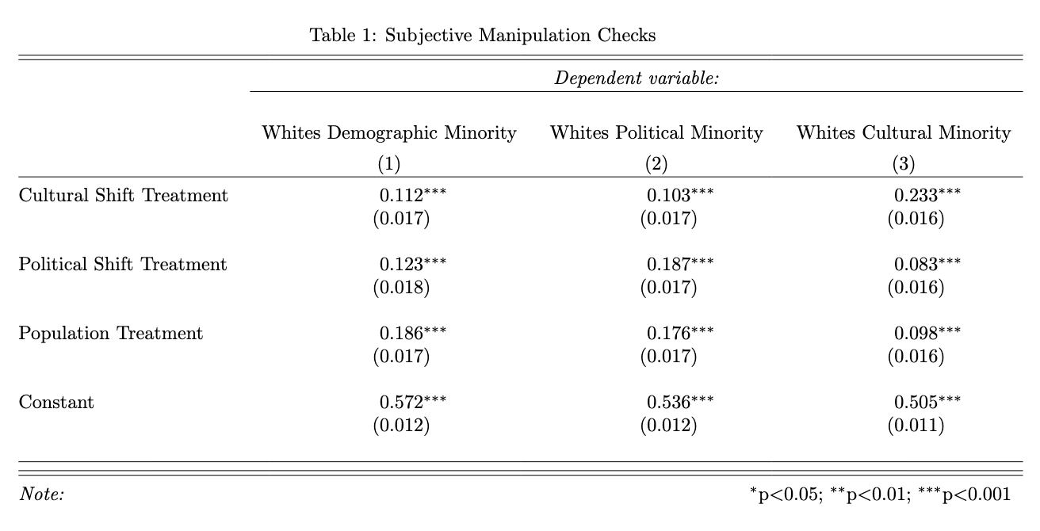

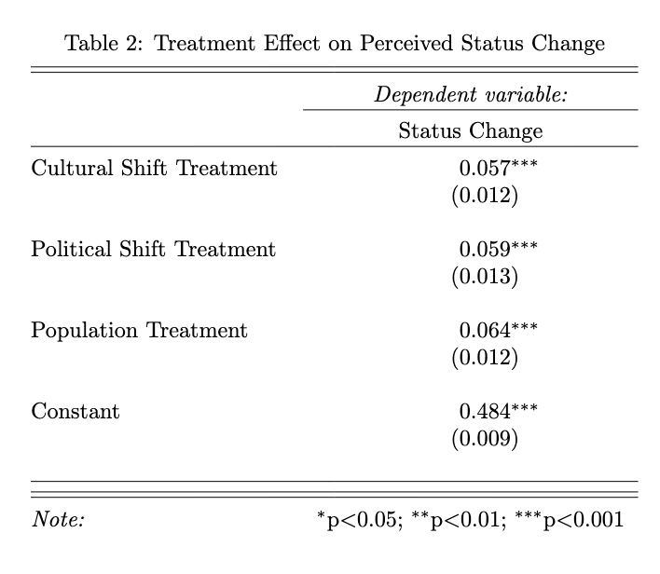

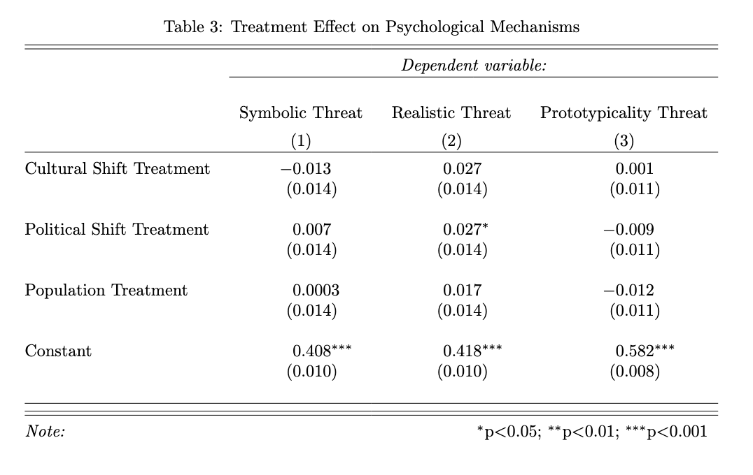

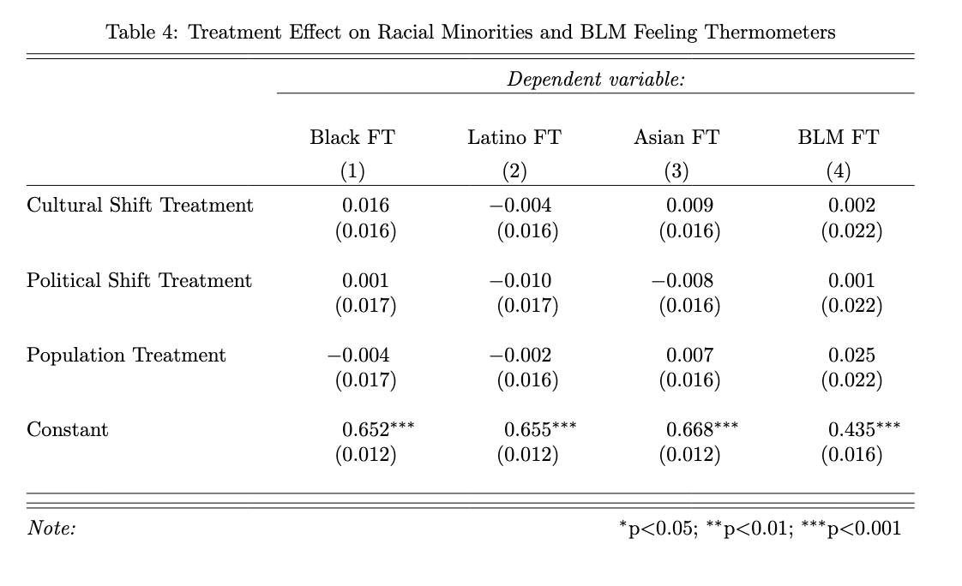

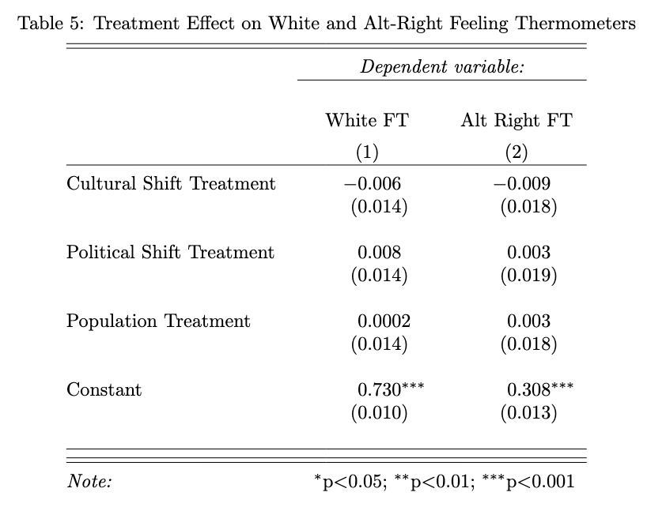

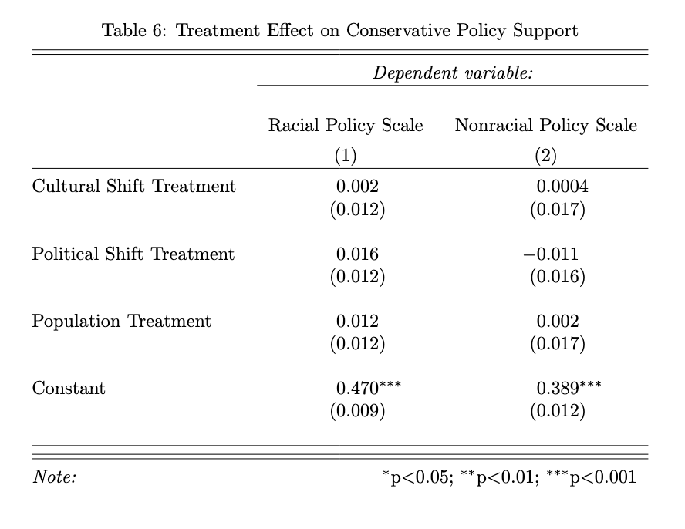

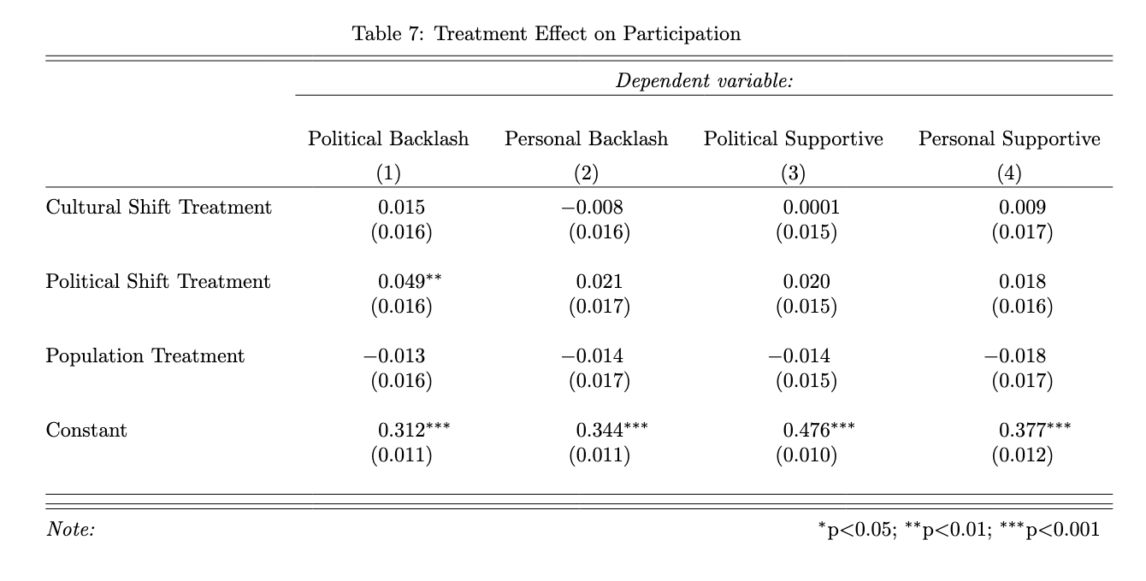

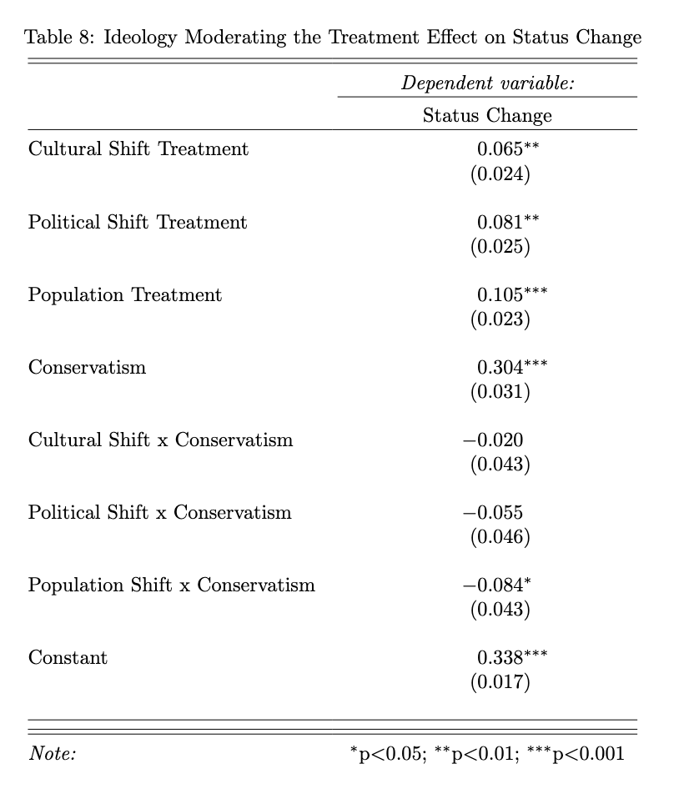

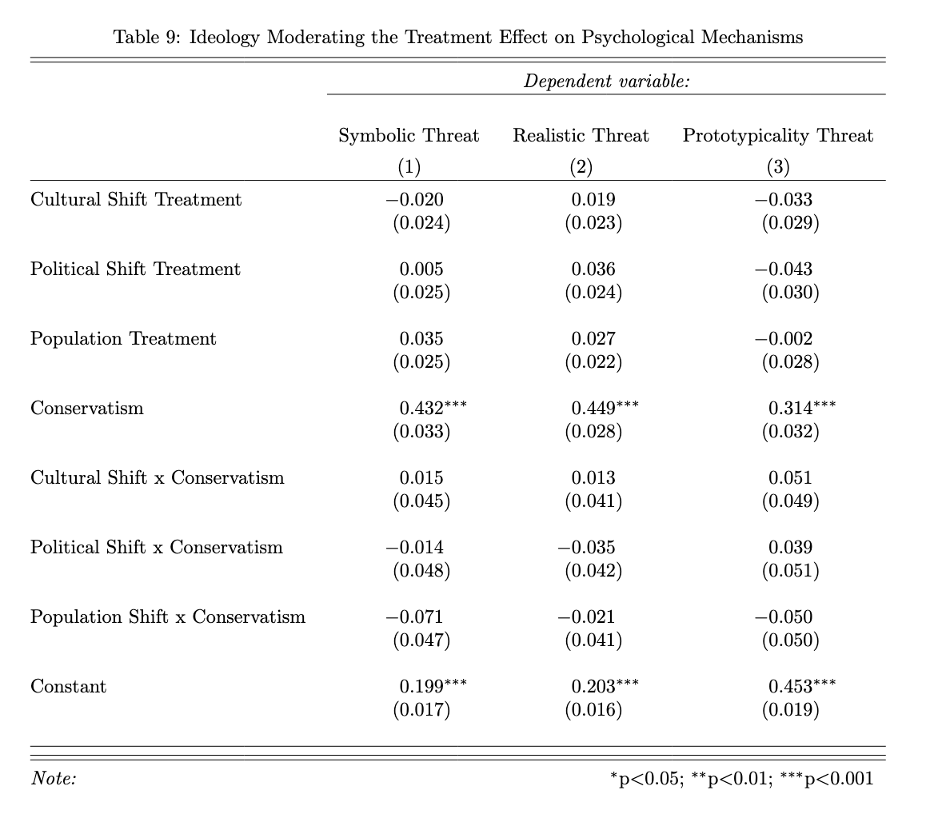

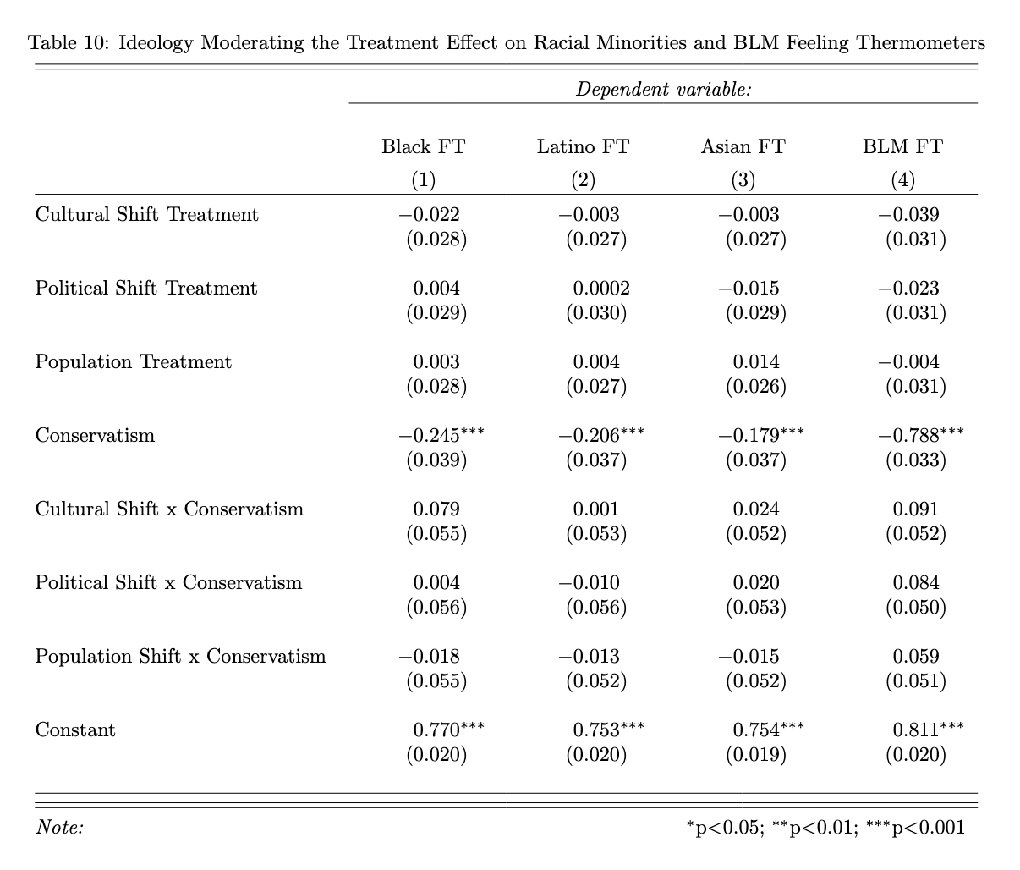

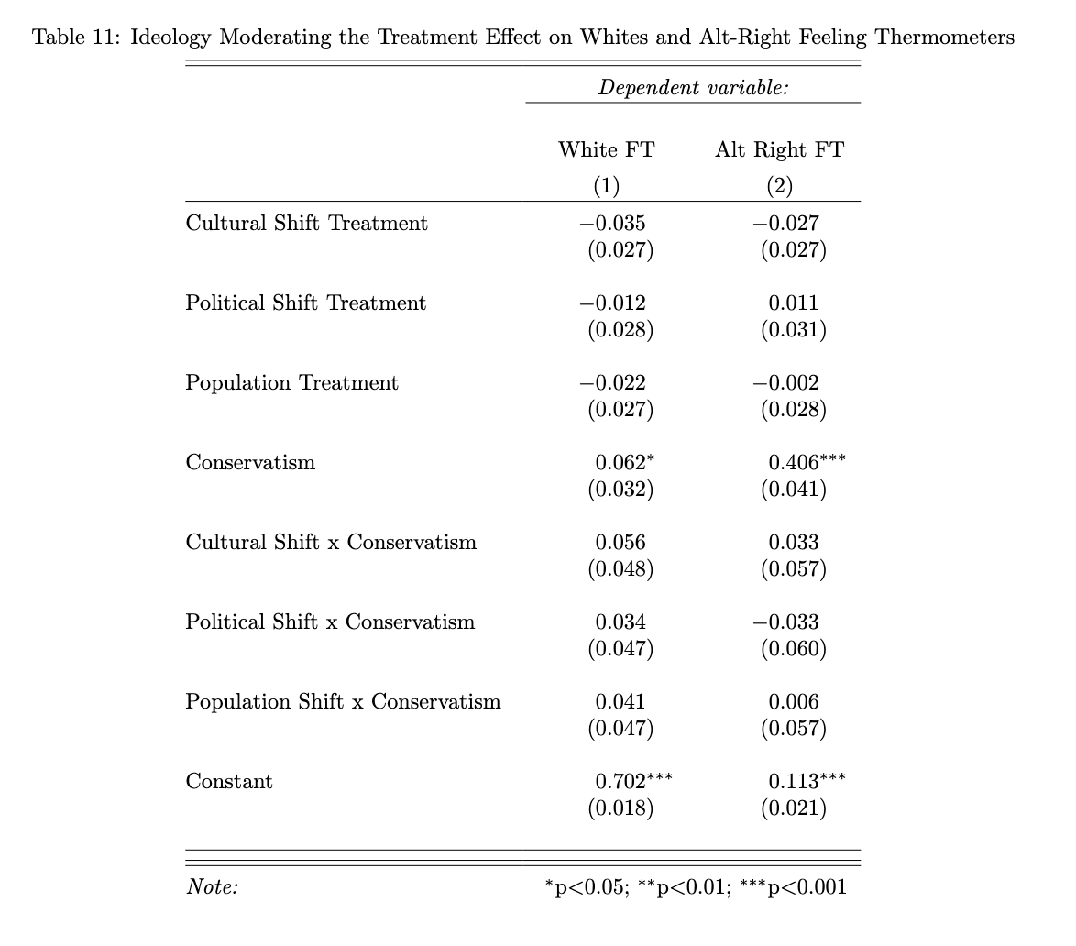

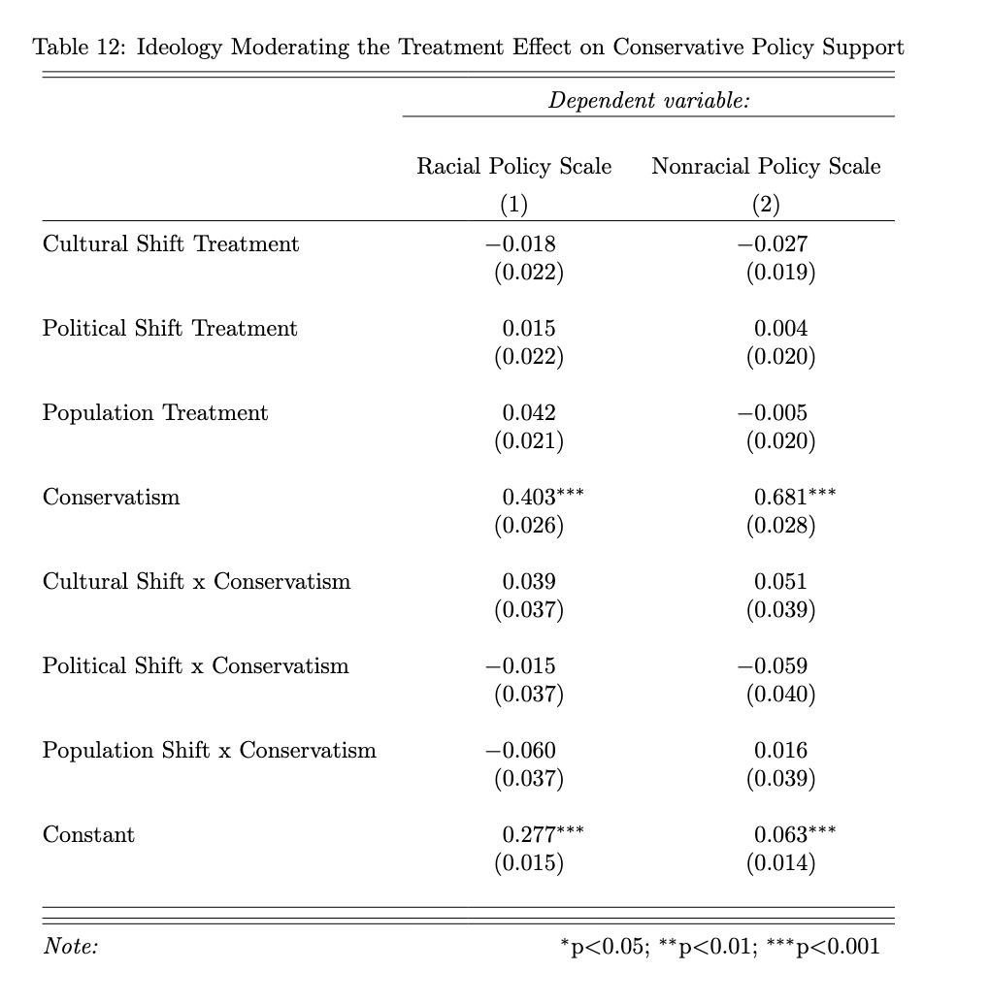

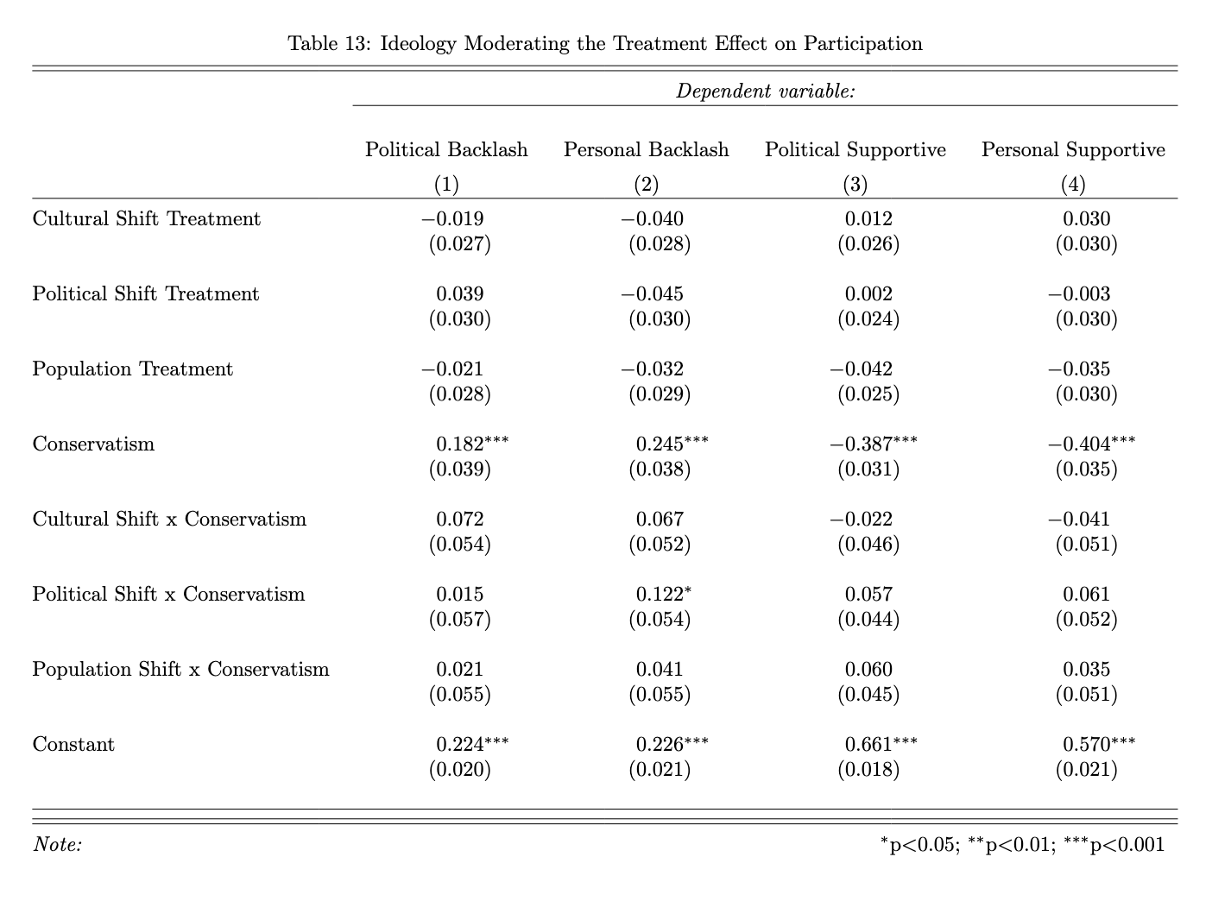

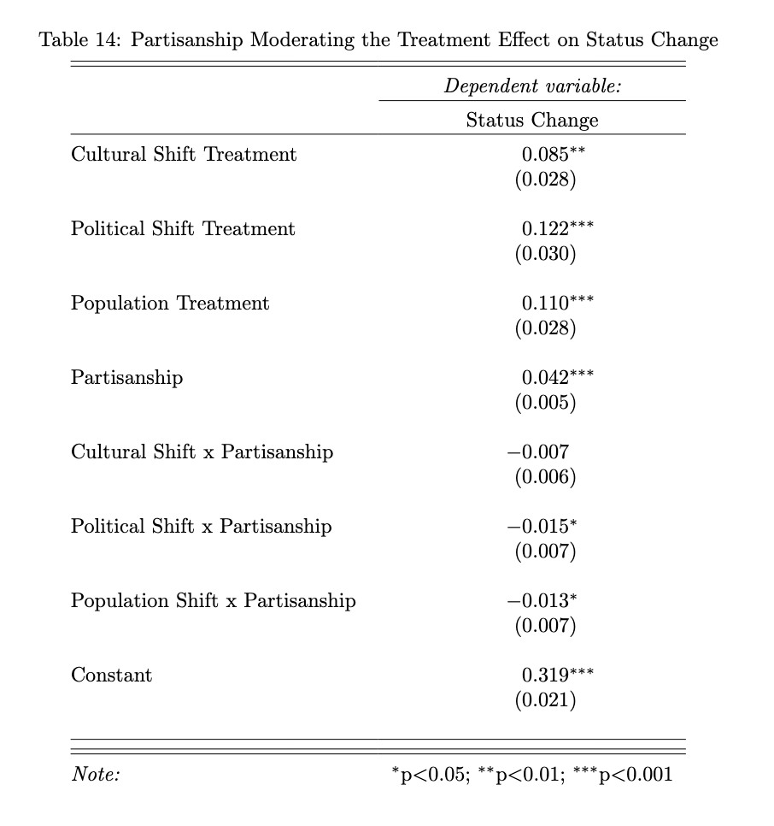

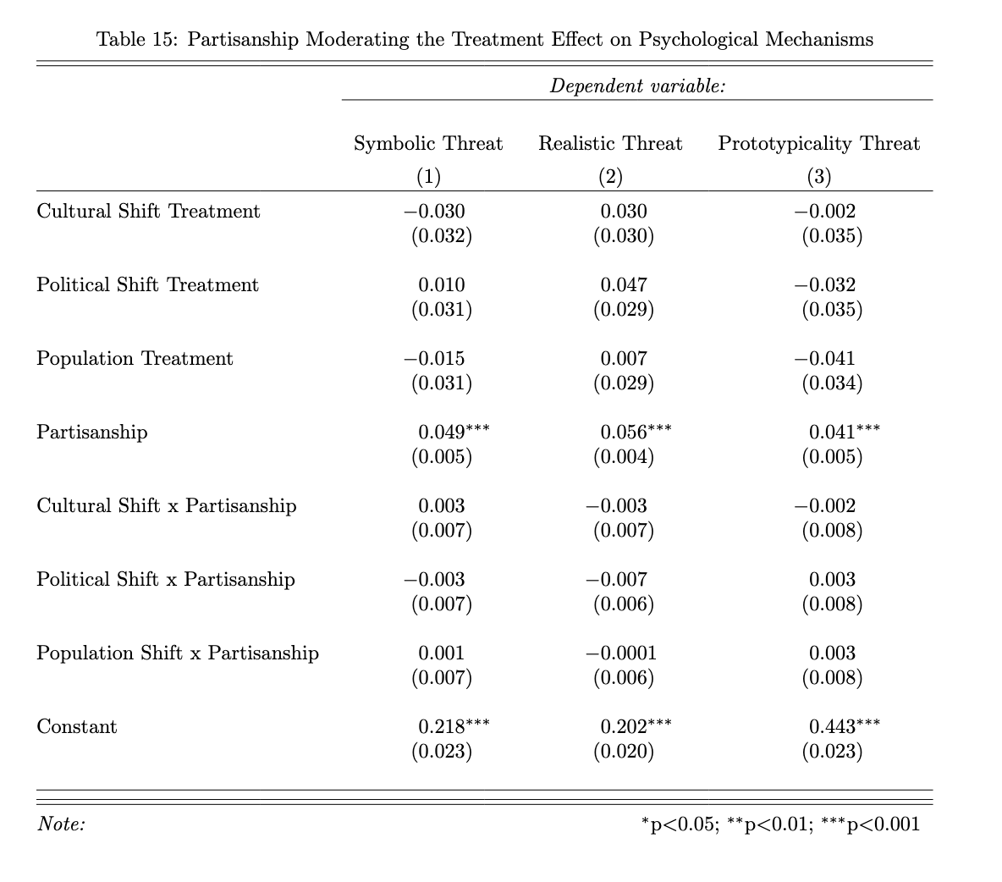

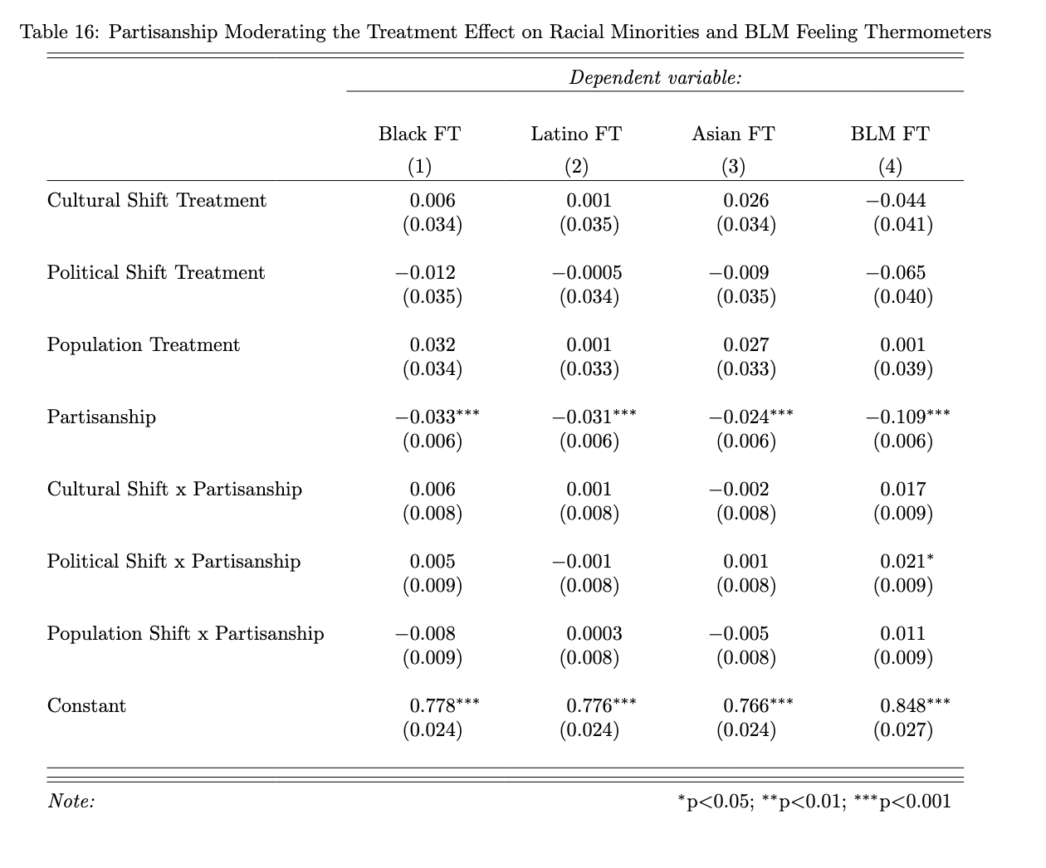

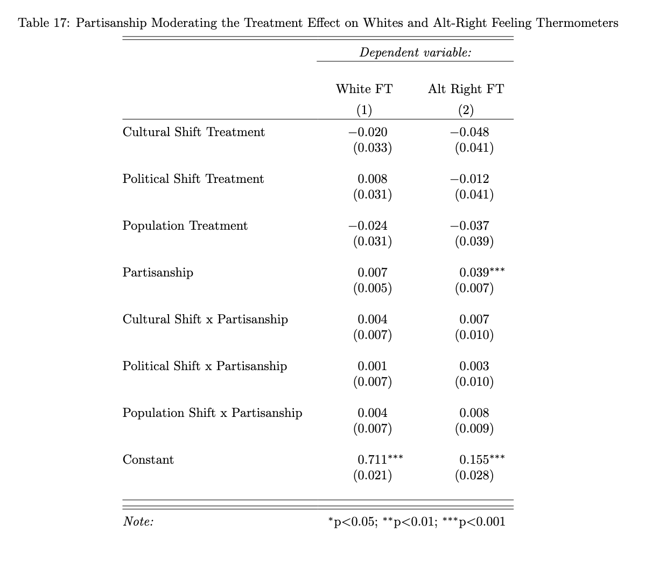

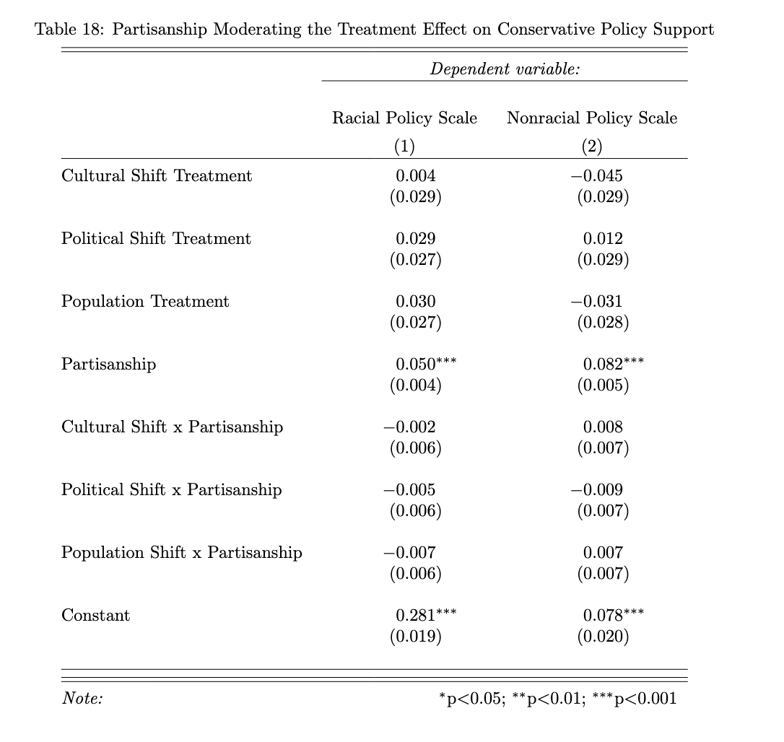

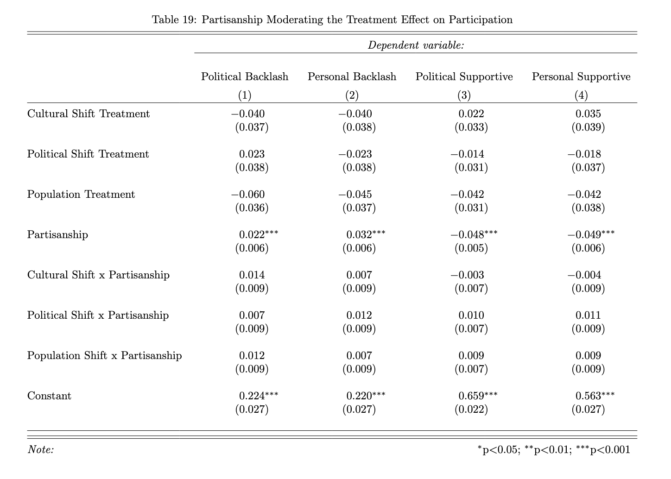

## **Appendix D: Status Threat Mechanism Dimensionality**

Our analyses assumed that our status threat mechanisms–status change, realistic threat, symbolic threat, prototypicality threat, and realistic threat–capture different concepts and thus we modeled changes in levels. Conceivably, however, treatment information changed how people answered these questions in ways altering not levels but correlations. In other words, the treatments help construct attitudes.

We test this using confirmatory factor analysis. First, we probe variation within each treatment condition. We estimate two models. One places all 12 items on a single dimension under an assumption the treatments construct a more general status threat orientation. Another separately estimates all 4 factors. Given the unidimensional model nests the four-factor model, we can compare model fit across models to see if a uni- or multi-dimensional model holds.

Table D1 reports the results from these tests. Across all conditions, the four-factor model fits the data better than the one-factor model, supporting treating the mechanisms as separate not just conceptually but also empirically. Model fit for all standard metrics but SRMR improves appreciably moving to the four-dimensional model.

|  |  |  |  |  |  |
| --- | --- | --- | --- | --- | --- |
| **Table D1:**  Dimensionality Assessment of Status Threat Mechanisms | | | | | |
| **Condition** | **Dimensions** | **X2(df)** | **CFI** | **RMSEA** | **SRMR** |
| Geographic Mobility | 1 | 735.099(54) | 0.752 | 0.155 | 0.085 |
|  | 4 | 421.488(48) | 0.864 | 0.122 | 0.091 |
| Racial Shift | 1 | 770.016(54) | 0.703 | 0.136 | 0.098 |
|  | 4 | 509.381(48) | 0.809 | 0.120 | 0.136 |
| Political Racial Shift | 1 | 746.193(54) | 0.721 | 0.159 | 0.098 |
|  | 4 | 502.519(48) | 0.817 | 0.136 | 0.103 |
| Cultural Racial Shift | 1 | 603.204(54) | 0.783 | 0.140 | 0.081 |
|  | 4 | 429.950(48) | 0.849 | 0.124 | 0.082 |

We next assess whether this solution holds to like degree across treatment groups. Comparing means as we have requires the survey items capture the same construct to the same degree and with the same ease across treatment conditions, a requirement known as measurement equivalence. If not, treatment comparisons become contaminated (e.g., Stoetzer, Zhou, and Steenbergen 2024).

To test this we estimate 2 different multi-group confirmatory factor analysis models, using treatment condition as the grouping variable and specifying the 4-factor solution found to best fit the data in each condition. The first allows item factor loadings and intercepts to vary. The second constrains loadings and intercepts to equality. If this second model fits the data worse than the first, then we have evidence for measurement inequivalence–the relationship between observed item responses and latent attitude differs across treatment conditions.

Table D2 indicates that constraining the four dimensional solution does lead to some decline in model fit, evidence consistent with the relationships between the items capturing the four dimensions and their latent variables varying across conditions. But at the same time these differences are small, especially in light of the factor solution. The CFI changes by only .004, RMSEA by .013, and SRMR by .006. Consequently, we conclude, in light of parsimony, that treatment exposure did not uniquely alter how our respondents answered these questions.

|  |  |  |  |  |
| --- | --- | --- | --- | --- |
| **Table D2**: Measurement Equivalence test of four-dimensional solution across treatment conditions | | | | |
|  | X2(df) | CFI | RMSEA | SRMR |
| Unconstrained | 1863.338(192) | 0.836 | 0.130 | 0.092 |
| Constrained | 1944.443(240) | 0.832 | 0.117 | 0.098 |

## **Appendix E: Results for Factual Manipulation Check Passage**

Our primary analyses combine together all respondents regardless of whether they passed a factual manipulation check. Doing so ensures we do not introduce post-treatment bias by conditioning on a post-treatment variable. Work in the racial shift paradigm often drops such respondents, presumably under the assumption they have not been treated. We replicate our main analyses dropping the 13% of our sample who answered incorrectly the associated factual manipulation check as indicated in our pre-registration.

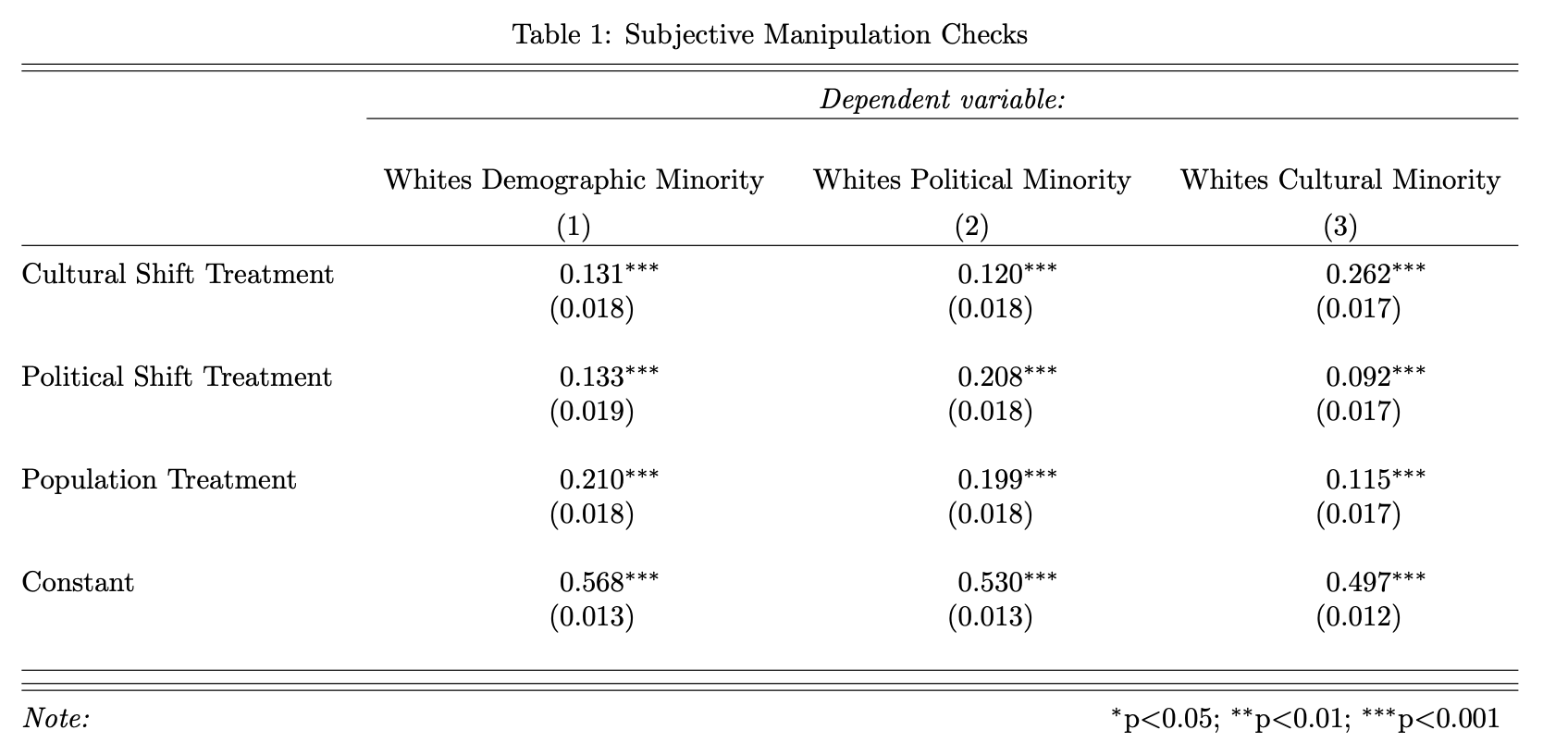

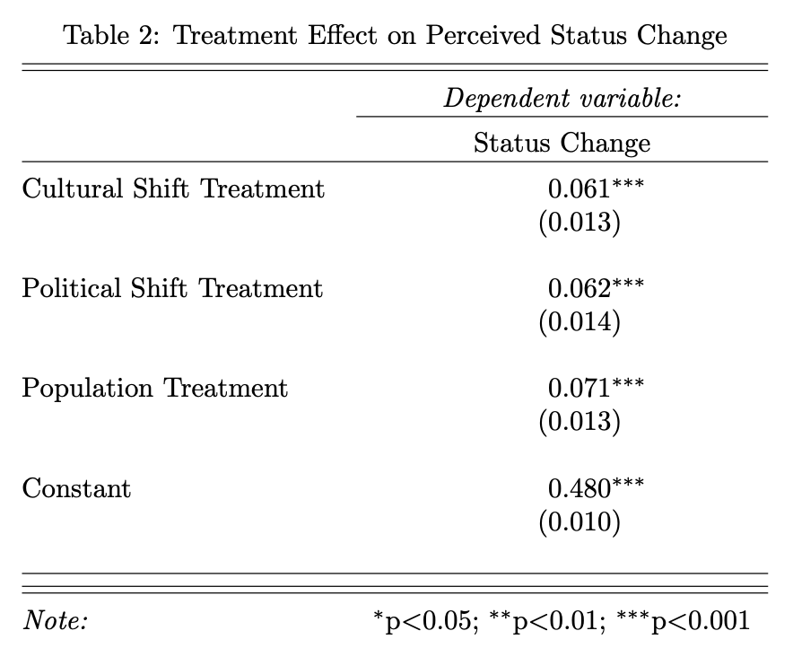

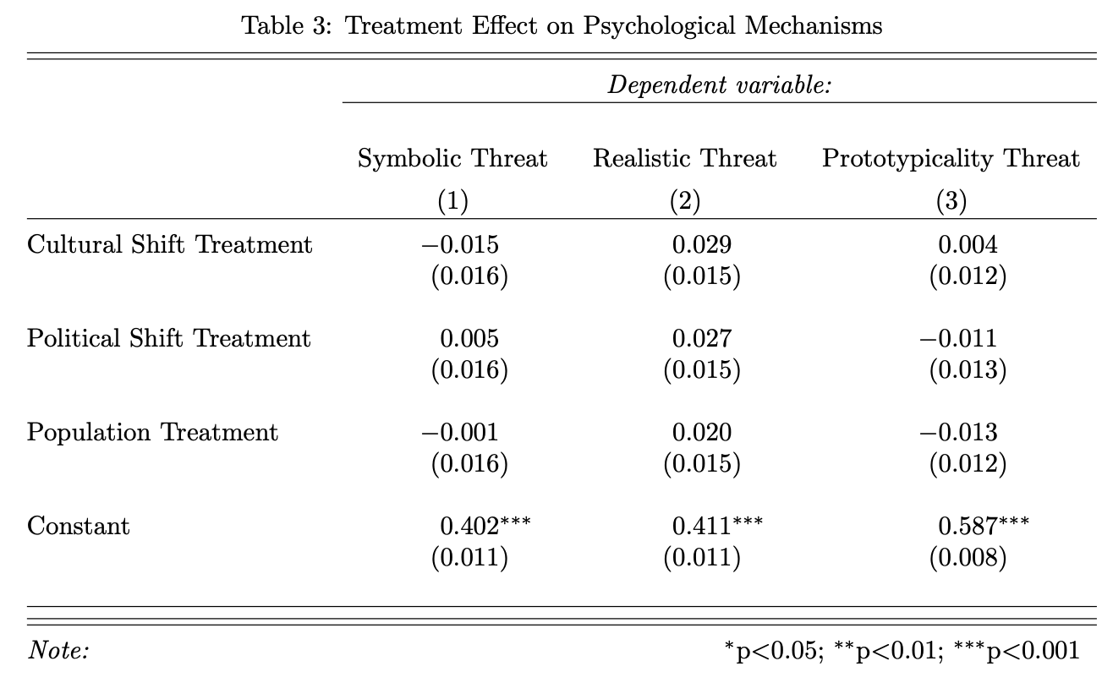

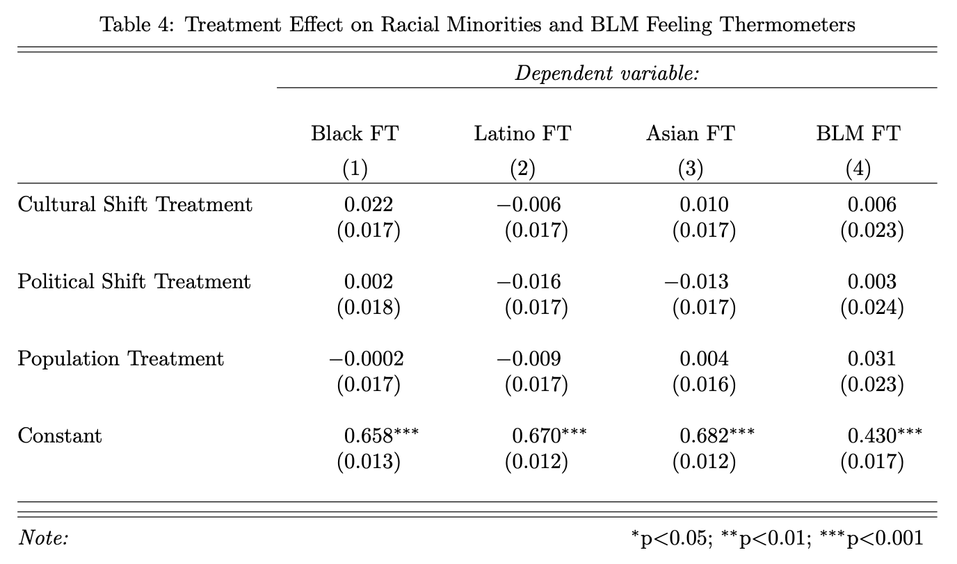

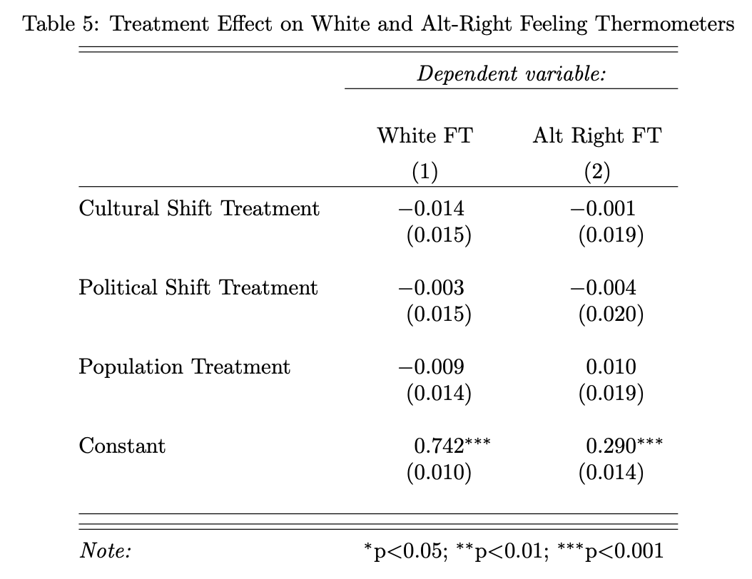

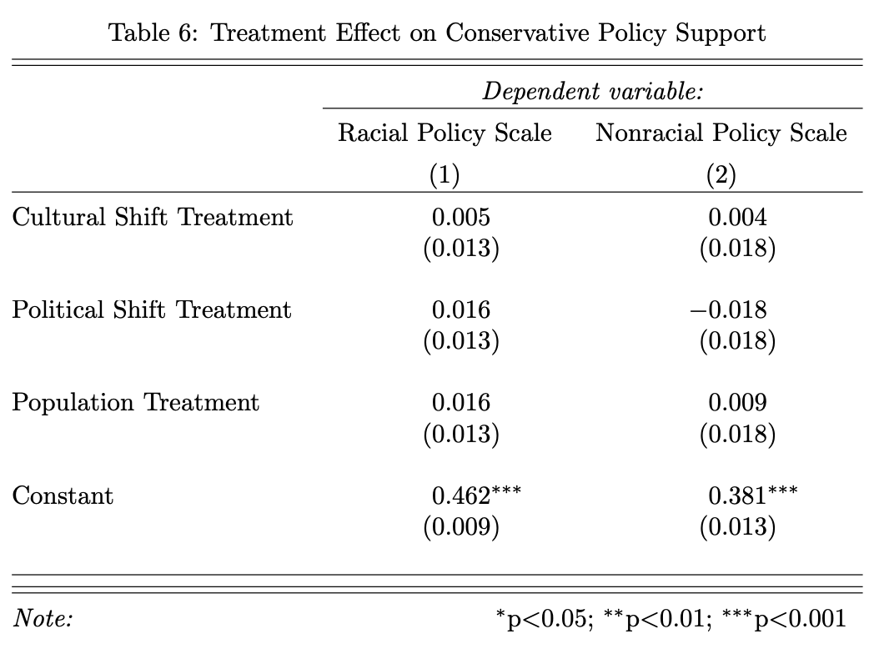

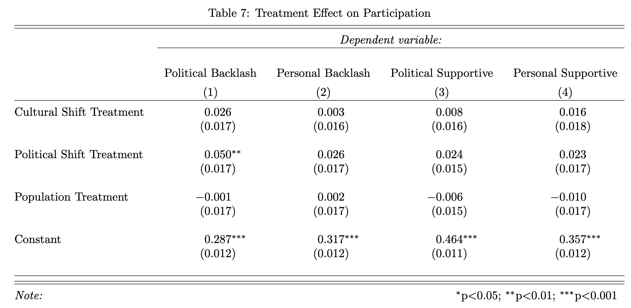

## **Appendix F: Results Removing Straightliners**

Our primary analyses ignore potential variation in respondent quality. While rates of factual manipulation check passage and the treatment effects on the subjective manipulation checks suggest engaged respondents, our results could be related to a small set of inattentive respondents. As we pre-registered, we address this by removing individuals based on straightlining favorability ratings of 4 public figures: Donald Trump, Joe Biden, Taylor Swift, and Jimmy Kimmel. We selected these individuals because it is unlikely someone truly views all of them similarly, though one could perhaps dislike all of them. The results below show that dropping the 2.6% of respondents who rated all four figures the same are quite similar to those reported in the main text.

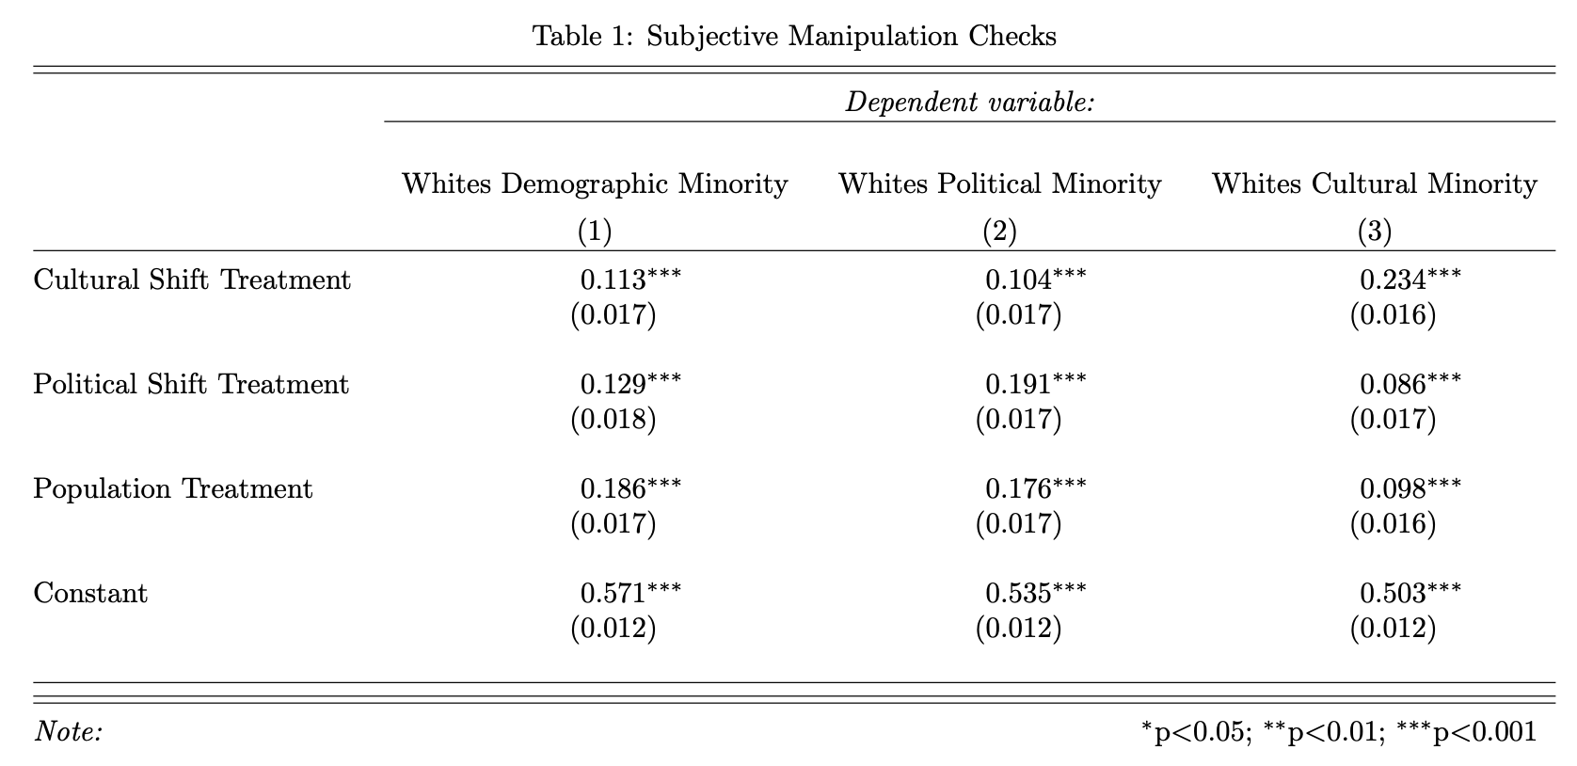

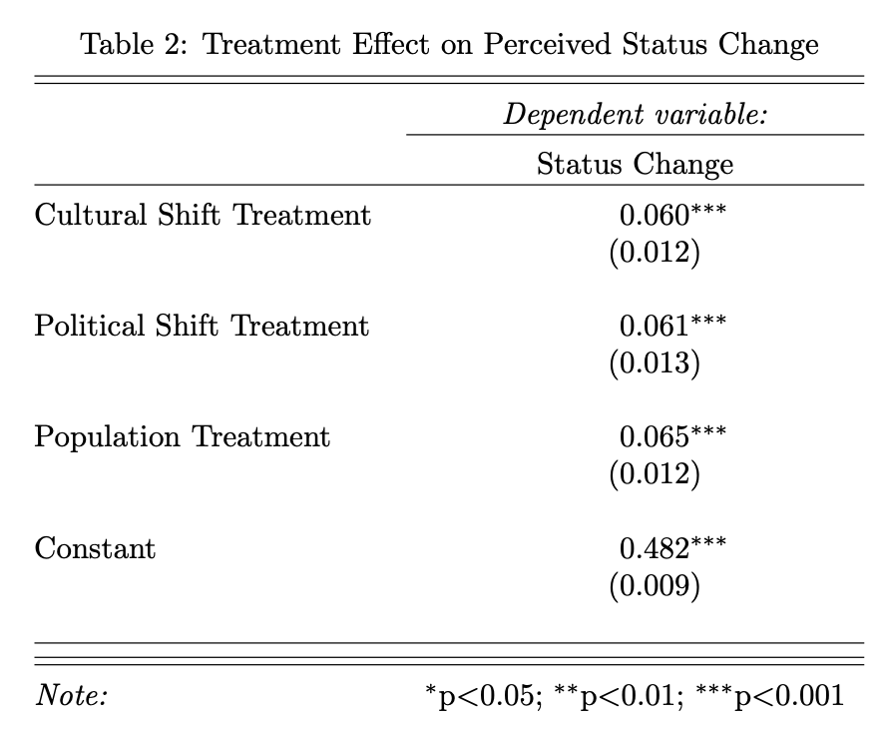

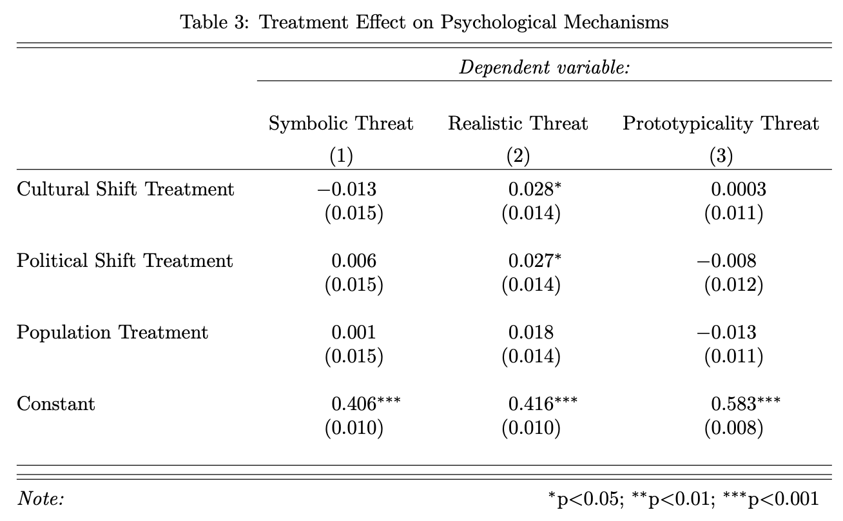

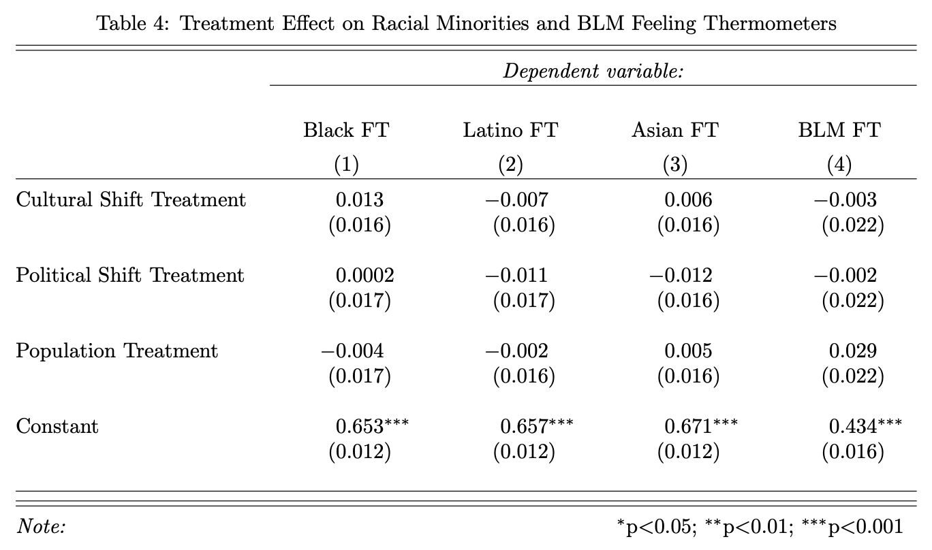

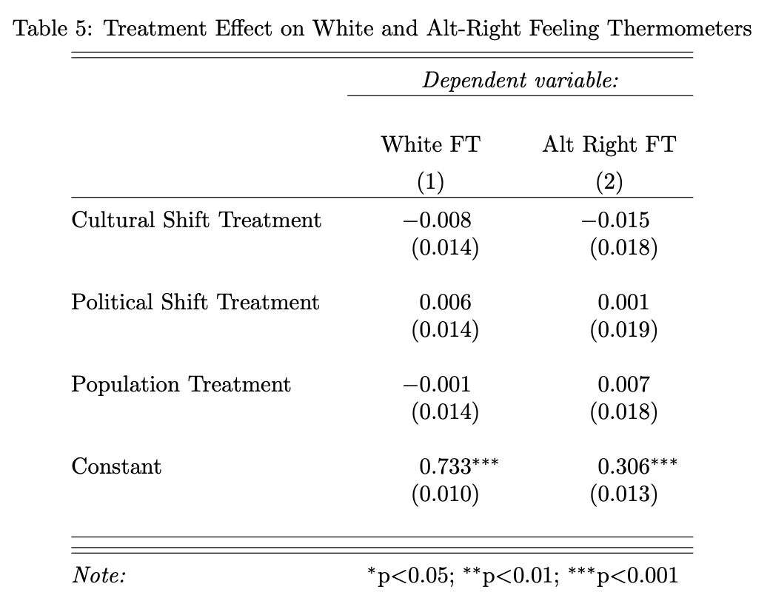

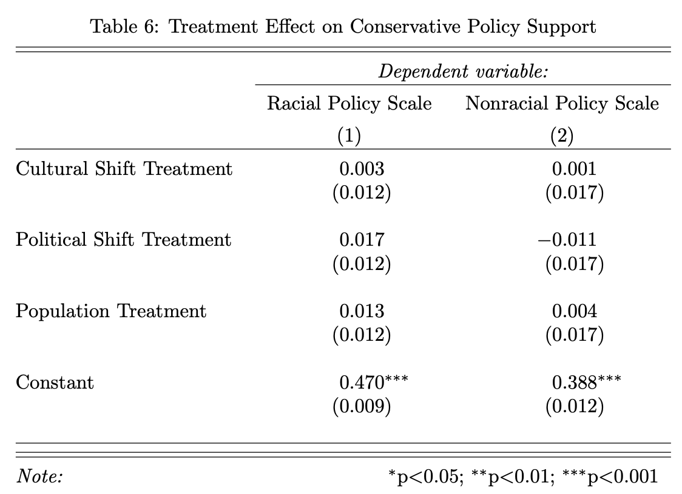

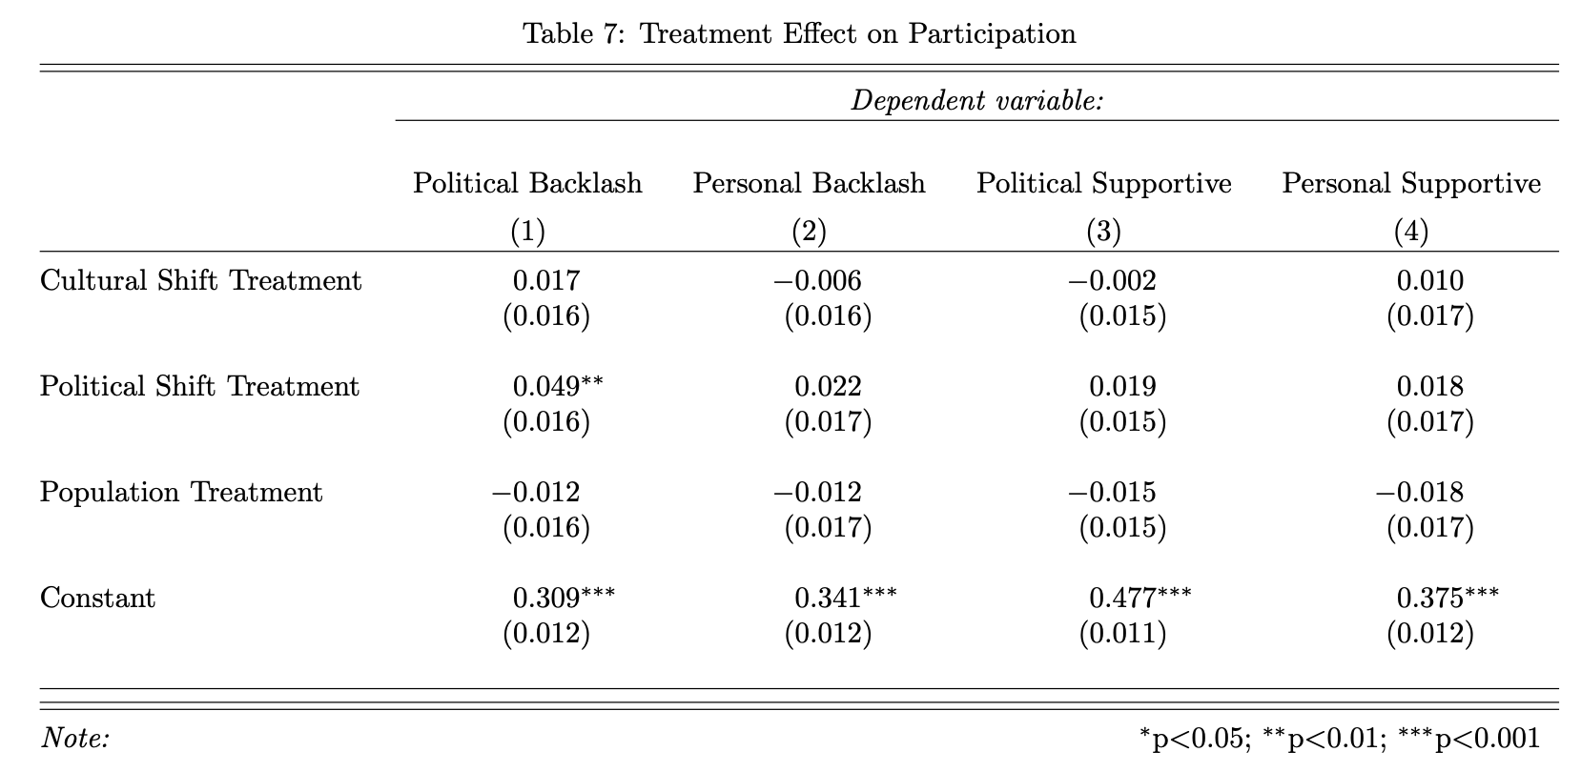

## **Appendix G: Restricted-Use Replication Results**

The preceding results use the complete sample of 2130 respondents. These data include 500 respondents who reported that they wished to remove their data based on exposure to a hypothetical news article. We report the full sample to be consistent with our preregistration. However, to respect the wishes of these respondents, our replication archive contains only the 1630 respondents who did not wish to remove their data to preserve their autonomy. While this does constitute a meaningful change in the number of cases in the data, we show here that no differences exist between the results based on these exclusions.

This lack of difference, we think, relates to potential misreadings or misunderstandings of the data removal option, reading it more like a data sharing cookies or other information security component. These removals, in other words, are effectively random. Table F1 reports comparisons of pre-treatment and demographic indicators across the removal and retain individuals. We find pairwise differences on age, education, partisanship, passage rates for the factual manipulation check, and pre-treatment straightlining on the favorability grid of Joe Biden, Donald Trump, Taylor Swift, and Jimmy Kimmel. Together, these differences suggest to us more inattentiveness than desire to withdraw data.

|  |  |  |
| --- | --- | --- |
| **Table G1.** Differences between Withdraw and Retain Respondents | | |
|  | **Withdraw** | **Retain** |
| **Demographics** |  |  |
| Age  (t = 14.56 (943.96), p < .001) | Mean = 39 years | 50 years |
| Education  (X2 = 17.07 (3), p < .001) | 31% HS or less  36% Some College  19% College  13% Post-grad | 23% HS or Less  41% Some College  24% College  12% Post-grad |
| Gender (X2 = 4.13 (2), p = .129) | 45% male 53% female 2% nonbinary | 50% male 48% female  2% nonbinary |
| Partisanship  (X2 = 10.23 (2), p = .006) | 36% Democrat  23% pure Independent  41% Republican | 43% Democrat  17% pure Independent  40% Republican |
| Ideology (t = -1.35 (937.2), p = .179) | Mean = 0.50 (0-1 scale) | 0.48 |
| **Treatment**  (X2 = 2.30 (3), p = .512) | 25% Placebo  24% Population Shift  27% Political Shift  24% Cultural Shift | 26% Placebo  25% Population Shift  24% Political Shift  25% Cultural Shift |
| **Factual Manipulation Check**  (t = 8.38 (622.42), p < .001) | 75% Correct | 92% Correct |
| **Pre-Treatment Straightlining**  (t = -2.37 (643.98), p = .018) | 4% straightlined | 2% straightlined |

### **G1: Regression Results**

Next, we report all the pre-registered results comparing results across the full sample and excluded subset in the replication archive. In few instances do parameter estimates differ by greater than .01. Most amount to differences of thousandths on outcomes scaled 0-1.

***Subjective Manipulation Checks. Whites soon a...***

|  |  |  |  |  |  |  |
| --- | --- | --- | --- | --- | --- | --- |
|  | Demographic Minority | | Political Minority | | Cultural Minority | |
|  | Full Sample | Retained | Full Sample | Retained | Full Sample | Retained |
| Cultural Shift Treatment | 0.112* | 0.116* | 0.103* | 0.102* | 0.233* | 0.254* |
|  | (0.017) | (0.019) | (0.017) | (0.019) | (0.016) | (0.018) |
| Political Shift Treatment | 0.123* | 0.129* | 0.187* | 0.199* | 0.083* | 0.084* |
|  | (0.018) | (0.021) | (0.017) | (0.020) | (0.016) | (0.019) |
| Population Shift Treatment | 0.186* | 0.200* | 0.176* | 0.185* | 0.098* | 0.100* |
|  | (0.017) | (0.019) | (0.017) | (0.020) | (0.016) | (0.019) |
| Constant | 0.572* | 0.579* | 0.536* | 0.539* | 0.505* | 0.503* |
|  | (0.012) | (0.014) | (0.012) | (0.014) | (0.011) | (0.013) |
| N | 2112 | 1612 | 2112 | 1612 | 2112 | 1612 |
| R2 | 0.055 | 0.064 | 0.067 | 0.074 | 0.091 | 0.108 |
| * p < 0.05 | | | | | | |
| OLS coefficients with standard errors in parentheses. Variables scaled 0-1. | | | | | | |

***Psychological Mechanisms***

|  |  |  |  |  |  |  |  |  |
| --- | --- | --- | --- | --- | --- | --- | --- | --- |
|  | Status Change | | Symbolic Threat | | Realistic Threat | | Prototypicality Threat | |
|  | Full Sample | Retained | Full Sample | Retained | Full Sample | Retained | Full Sample | Retained |
| Cultural Shift Treatment | 0.057* | 0.054* | -0.013 | -0.017 | 0.027 | 0.021 | 0.001 | 0.001 |
|  | (0.012) | (0.014) | (0.014) | (0.017) | (0.014) | (0.016) | (0.011) | (0.013) |
| Political Shift Treatment | 0.059* | 0.056* | 0.007 | -0.001 | 0.027* | 0.012 | -0.009 | -0.010 |
|  | (0.013) | (0.015) | (0.014) | (0.017) | (0.014) | (0.016) | (0.011) | (0.014) |
| Population Shift Treatment | 0.064* | 0.060* | 0.000 | -0.007 | 0.017 | 0.012 | -0.012 | -0.010 |
|  | (0.012) | (0.014) | (0.014) | (0.017) | (0.014) | (0.016) | (0.011) | (0.013) |
| Constant | 0.484* | 0.489* | 0.408* | 0.403* | 0.418* | 0.416* | 0.582* | 0.586* |
|  | (0.009) | (0.010) | (0.010) | (0.012) | (0.010) | (0.011) | (0.008) | (0.009) |
| N | 2100 | 1601 | 2101 | 1603 | 2100 | 1600 | 2102 | 1605 |
| R2 | 0.017 | 0.015 | 0.001 | 0.001 | 0.003 | 0.001 | 0.001 | 0.001 |
| * p < 0.05 | | | | | | | | |
| OLS coefficients with standard errors in parentheses. Variables scaled 0-1. | | | | | | | | |

***Policy Attitudes***

|  |  |  |  |  |
| --- | --- | --- | --- | --- |
|  | Racial Policy | | Nonracial Policy | |
|  | Full Sample | Retained | Full Sample | Retained |
| Cultural Shift Treatment | 0.002 | -0.004 | 0.000 | -0.007 |
|  | (0.012) | (0.014) | (0.017) | (0.020) |
| Political Shift Treatment | 0.016 | 0.012 | -0.011 | -0.015 |
|  | (0.012) | (0.014) | (0.016) | (0.019) |
| Population Shift Treatment | 0.012 | 0.002 | 0.002 | 0.004 |
|  | (0.012) | (0.014) | (0.017) | (0.020) |
| Constant | 0.470* | 0.470* | 0.389* | 0.388* |
|  | (0.009) | (0.010) | (0.012) | (0.014) |
| N | 2103 | 1604 | 2098 | 1600 |
| R2 | 0.001 | 0.001 | 0.000 | 0.001 |
| * p < 0.05 | | | | |
| OLS coefficients with standard errors in parentheses. Variables scaled 0-1. | | | | |

***Evaluations of Non-White Groups***

|  |  |  |  |  |  |  |  |  |
| --- | --- | --- | --- | --- | --- | --- | --- | --- |
|  | Black FT | | Latino FT | | Asian FT | | BLM FT | |
|  | Full Sample | Retained | Full Sample | Retained | Full Sample | Retained | Full Sample | Retained |
| Cultural Shift Treatment | 0.016 | 0.012 | -0.004 | -0.008 | 0.009 | 0.012 | 0.002 | 0.015 |
|  | (0.016) | (0.018) | (0.016) | (0.018) | (0.016) | (0.018) | (0.022) | (0.025) |
| Political Shift Treatment | 0.001 | 0.005 | -0.010 | -0.014 | -0.008 | -0.006 | 0.001 | 0.002 |
|  | (0.017) | (0.019) | (0.017) | (0.019) | (0.016) | (0.018) | (0.022) | (0.026) |
| Population Shift Treatment | -0.004 | -0.010 | -0.002 | -0.010 | 0.007 | 0.002 | 0.025 | 0.038 |
|  | (0.017) | (0.019) | (0.016) | (0.018) | (0.016) | (0.017) | (0.022) | (0.025) |
| Constant | 0.652* | 0.667* | 0.655* | 0.673* | 0.668* | 0.689* | 0.435* | 0.425* |
|  | (0.012) | (0.013) | (0.012) | (0.013) | (0.012) | (0.013) | (0.016) | (0.018) |
| N | 2100 | 1602 | 2096 | 1600 | 2097 | 1601 | 2083 | 1589 |
| R2 | 0.001 | 0.001 | 0.000 | 0.000 | 0.001 | 0.001 | 0.001 | 0.002 |
| * p < 0.05 | | | | | | | | |
| OLS coefficients with standard errors in parentheses. Variables scaled 0-1. | | | | | | | | |

***Evaluations of White Groups***

|  |  |  |  |  |
| --- | --- | --- | --- | --- |
|  | White FT | | Alt-Right | |
|  | Full Sample | Retained | Full Sample | Retained |
| Cultural Shift Treatment | -0.006 | -0.019 | -0.009 | -0.007 |
|  | (0.014) | (0.015) | (0.018) | (0.020) |
| Political Shift Treatment | 0.008 | -0.005 | 0.003 | -0.013 |
|  | (0.014) | (0.016) | (0.019) | (0.021) |
| Population Shift Treatment | 0.000 | -0.018 | 0.003 | 0.004 |
|  | (0.014) | (0.015) | (0.018) | (0.020) |
| Constant | 0.730* | 0.753* | 0.308* | 0.298* |
|  | (0.010) | (0.010) | (0.013) | (0.014) |
| N | 2100 | 1603 | 2057 | 1565 |
| R2 | 0.000 | 0.001 | 0.000 | 0.001 |
| * p < 0.05 | | | | |
| OLS coefficients with standard errors in parentheses. Variables scaled 0-1. | | | | |

***Participatory Intentions***

|  |  |  |  |  |  |  |  |  |
| --- | --- | --- | --- | --- | --- | --- | --- | --- |
|  | Political Backlash | | Personal Backlash | | Political Supportive | | Personal Supportive | |
|  | Full Sample | Retained | Full Sample | Retained | Full Sample | Retained | Full Sample | Retained |
| Cultural Shift Treatment | 0.015 | 0.011 | -0.008 | 0.000 | 0.000 | 0.009 | 0.009 | 0.018 |
|  | (0.016) | (0.018) | (0.016) | (0.018) | (0.015) | (0.017) | (0.017) | (0.019) |
| Political Shift Treatment | 0.049* | 0.033 | 0.021 | 0.012 | 0.020 | 0.013 | 0.018 | 0.008 |
|  | (0.016) | (0.018) | (0.017) | (0.019) | (0.015) | (0.017) | (0.016) | (0.019) |
| Population Shift Treatment | -0.013 | -0.032 | -0.014 | -0.029 | -0.014 | -0.017 | -0.018 | -0.018 |
|  | (0.016) | (0.018) | (0.017) | (0.018) | (0.015) | (0.016) | (0.017) | (0.018) |
| Constant | 0.312* | 0.293* | 0.344* | 0.327* | 0.476* | 0.463* | 0.377* | 0.354* |
|  | (0.011) | (0.013) | (0.011) | (0.012) | (0.010) | (0.012) | (0.012) | (0.013) |
| N | 2095 | 1598 | 2094 | 1595 | 2096 | 1599 | 2098 | 1601 |
| R2 | 0.008 | 0.008 | 0.002 | 0.003 | 0.003 | 0.002 | 0.003 | 0.002 |
| * p < 0.05 | | | | | | | | |
| OLS coefficients with standard errors in parentheses. Variables scaled 0-1. | | | | | | | | |

**Pre-registered moderation by ideology**

***Psychological Mechanisms***

|  |  |  |  |  |  |  |  |  |
| --- | --- | --- | --- | --- | --- | --- | --- | --- |
|  | Status Change | | Symbolic Threat | | Realistic Threat | | Prototypicality Threat | |
|  | Full Sample | Retained | Full Sample | Retained | Full Sample | Retained | Full Sample | Retained |
| Cultural Shift Treatment | 0.065* | 0.057* | -0.020 | -0.024 | 0.019 | 0.022 | -0.033 | -0.032 |
|  | (0.024) | (0.027) | (0.024) | (0.026) | (0.023) | (0.025) | (0.029) | (0.032) |
| Culture*Ideology | -0.020 | 0.000 | 0.015 | 0.029 | 0.013 | 0.010 | 0.051 | 0.046 |
|  | (0.043) | (0.048) | (0.045) | (0.049) | (0.041) | (0.046) | (0.049) | (0.057) |
| Political Shift Treatment | 0.081* | 0.078* | 0.005 | -0.006 | 0.036 | 0.020 | -0.043 | -0.042 |
|  | (0.025) | (0.028) | (0.025) | (0.028) | (0.024) | (0.026) | (0.030) | (0.035) |
| Political*Ideology | -0.055 | -0.048 | -0.014 | 0.003 | -0.035 | -0.025 | 0.039 | 0.028 |
|  | (0.046) | (0.051) | (0.048) | (0.053) | (0.042) | (0.046) | (0.051) | (0.059) |
| Population Shift Treatment | 0.105* | 0.092* | 0.035 | 0.029 | 0.027 | 0.024 | -0.002 | -0.009 |
|  | (0.023) | (0.026) | (0.025) | (0.027) | (0.022) | (0.024) | (0.028) | (0.032) |
| Pop*Ideology | -0.084* | -0.061 | -0.071 | -0.065 | -0.021 | -0.014 | -0.050 | -0.054 |
|  | (0.043) | (0.048) | (0.047) | (0.053) | (0.041) | (0.045) | (0.050) | (0.057) |
| Ideology | 0.304* | 0.284* | 0.432* | 0.432* | 0.449* | 0.451* | 0.314* | 0.317* |
|  | (0.031) | (0.034) | (0.033) | (0.036) | (0.028) | (0.031) | (0.032) | (0.037) |
| Constant | 2095 | 1596 | 2096 | 1598 | 2095 | 1595 | 2098 | 1601 |
|  | 0.166 | 0.156 | 0.261 | 0.270 | 0.323 | 0.333 | 0.142 | 0.146 |
| N | 0.065* | 0.057* | -0.020 | -0.024 | 0.019 | 0.022 | -0.033 | -0.032 |
| R2 | (0.024) | (0.027) | (0.024) | (0.026) | (0.023) | (0.025) | (0.029) | (0.032) |
| * p < 0.05 | | | | | | | | |
| OLS coefficients with standard errors in parentheses. Variables scaled 0-1. | | | | | | | | |

***Policy Attitudes***

|  |  |  |  |  |
| --- | --- | --- | --- | --- |
|  | Racial Policy | | Nonracial Policy | |
|  | Full Sample | Retained | Full Sample | Retained |
| Cultural Shift Treatment | -0.018 | -0.027 | -0.027 | -0.029 |
|  | (0.022) | (0.024) | (0.019) | (0.021) |
| Culture*Ideology | 0.039 | 0.058 | 0.051 | 0.059 |
|  | (0.037) | (0.041) | (0.039) | (0.043) |
| Political Shift Treatment | 0.015 | 0.011 | 0.004 | 0.009 |
|  | (0.022) | (0.024) | (0.020) | (0.023) |
| Political*Ideology | -0.015 | -0.005 | -0.059 | -0.063 |
|  | (0.037) | (0.042) | (0.040) | (0.045) |
| Population Shift Treatment | 0.042 | 0.031 | -0.005 | -0.003 |
|  | (0.021) | (0.024) | (0.020) | (0.022) |
| Pop*Ideology | -0.060 | -0.050 | 0.016 | 0.029 |
|  | (0.037) | (0.041) | (0.039) | (0.042) |
| Ideology | 0.403* | 0.393* | 0.681* | 0.696* |
|  | (0.026) | (0.029) | (0.028) | (0.032) |
| Constant | 0.277* | 0.279* | 0.063* | 0.052* |
|  | (0.015) | (0.016) | (0.014) | (0.016) |
| N | 2098 | 1599 | 2093 | 1595 |
| R2 | 0.324 | 0.330 | 0.535 | 0.555 |
| * p < 0.05 | | | | |
| OLS coefficients with standard errors in parentheses. Variables scaled 0-1. | | | | |

***Evaluations of Non-White Groups***

|  |  |  |  |  |  |  |  |  |
| --- | --- | --- | --- | --- | --- | --- | --- | --- |
|  | Black FT | | Latino FT | | Asian FT | | BLM FT | |
|  | Full Sample | Retained | Full Sample | Retained | Full Sample | Retained | Full Sample | Retained |
| Cultural Shift Treatment | -0.022 | -0.015 | -0.003 | 0.005 | -0.003 | 0.010 | -0.039 | -0.045 |
|  | (0.028) | (0.031) | (0.027) | (0.030) | (0.027) | (0.029) | (0.031) | (0.035) |
| Culture*Ideology | 0.079 | 0.048 | 0.001 | -0.029 | 0.024 | -0.002 | 0.091 | 0.110 |
|  | (0.055) | (0.060) | (0.053) | (0.057) | (0.052) | (0.056) | (0.052) | (0.059) |
| Political Shift Treatment | 0.004 | 0.002 | 0.000 | -0.002 | -0.015 | -0.015 | -0.023 | -0.052 |
|  | (0.029) | (0.032) | (0.030) | (0.033) | (0.029) | (0.031) | (0.031) | (0.035) |
| Political*Ideology | 0.004 | 0.010 | -0.010 | -0.017 | 0.020 | 0.018 | 0.084 | 0.129* |
|  | (0.056) | (0.062) | (0.056) | (0.062) | (0.053) | (0.057) | (0.050) | (0.056) |
| Population Shift Treatment | 0.003 | 0.008 | 0.004 | 0.002 | 0.014 | 0.018 | -0.004 | -0.008 |
|  | (0.028) | (0.031) | (0.027) | (0.030) | (0.026) | (0.029) | (0.031) | (0.034) |
| Pop*Ideology | -0.018 | -0.046 | -0.013 | -0.032 | -0.015 | -0.040 | 0.059 | 0.079 |
|  | (0.055) | (0.061) | (0.052) | (0.056) | (0.052) | (0.056) | (0.051) | (0.056) |
| Ideology | -0.245* | -0.217* | -0.206* | -0.181* | -0.179* | -0.144* | -0.788* | -0.814* |
|  | (0.039) | (0.043) | (0.037) | (0.040) | (0.037) | (0.040) | (0.033) | (0.036) |
| Constant | 0.770* | 0.773* | 0.753* | 0.760* | 0.754* | 0.760* | 0.811* | 0.816* |
|  | (0.020) | (0.022) | (0.020) | (0.022) | (0.019) | (0.021) | (0.020) | (0.022) |
| N | 2095 | 1597 | 2092 | 1596 | 2092 | 1596 | 2078 | 1584 |
| R2 | 0.063 | 0.060 | 0.054 | 0.054 | 0.038 | 0.034 | 0.354 | 0.372 |
| * p < 0.05 | | | | | | | | |
| OLS coefficients with standard errors in parentheses. Variables scaled 0-1. | | | | | | | | |

***Evaluations of White Groups***

|  |  |  |  |  |
| --- | --- | --- | --- | --- |
|  | White FT | | Alt-Right | |
|  | Full Sample | Retained | Full Sample | Retained |
| Cultural Shift Treatment | -0.035 | -0.049 | -0.027 | -0.046 |
|  | (0.027) | (0.030) | (0.027) | (0.030) |
| Culture*Ideology | 0.056 | 0.058 | 0.033 | 0.089 |
|  | (0.048) | (0.050) | (0.057) | (0.062) |
| Political Shift Treatment | -0.012 | -0.027 | 0.011 | -0.023 |
|  | (0.028) | (0.031) | (0.031) | (0.033) |
| Political*Ideology | 0.034 | 0.038 | -0.033 | 0.010 |
|  | (0.047) | (0.051) | (0.060) | (0.065) |
| Population Shift Treatment | -0.022 | -0.032 | -0.002 | -0.014 |
|  | (0.027) | (0.029) | (0.028) | (0.030) |
| Pop*Ideology | 0.041 | 0.024 | 0.006 | 0.038 |
|  | (0.047) | (0.049) | (0.057) | (0.061) |
| Ideology | 0.062* | 0.082* | 0.406* | 0.386* |
|  | (0.032) | (0.033) | (0.041) | (0.044) |
| Constant | 0.702* | 0.716* | 0.113* | 0.112* |
|  | (0.018) | (0.020) | (0.021) | (0.023) |
| N | 2095 | 1598 | 2053 | 1561 |
| R2 | 0.015 | 0.024 | 0.153 | 0.179 |
| * p < 0.05 | | | | |
| OLS coefficients with standard errors in parentheses. Variables scaled 0-1. | | | | |

***Participatory Intentions***

|  |  |  |  |  |  |  |  |  |
| --- | --- | --- | --- | --- | --- | --- | --- | --- |
|  | Political Backlash | | Personal Backlash | | Political Supportive | | Personal Supportive | |
|  | Full Sample | Retained | Full Sample | Retained | Full Sample | Retained | Full Sample | Retained |
| Cultural Shift Treatment | -0.040 | -0.032 | -0.019 | -0.017 | 0.012 | 0.027 | 0.030 | 0.034 |
|  | (0.028) | (0.030) | (0.027) | (0.030) | (0.026) | (0.028) | (0.030) | (0.034) |
| Culture*Ideology | 0.067 | 0.075 | 0.072 | 0.066 | -0.022 | -0.045 | -0.041 | -0.041 |
|  | (0.052) | (0.056) | (0.054) | (0.060) | (0.046) | (0.049) | (0.051) | (0.054) |
| Cultural Shift Treatment | -0.045 | -0.051 | 0.039 | 0.031 | 0.002 | -0.004 | -0.003 | -0.011 |
|  | (0.030) | (0.032) | (0.030) | (0.032) | (0.024) | (0.027) | (0.030) | (0.033) |
| Culture*Ideology | 0.122* | 0.126* | 0.015 | 0.005 | 0.057 | 0.047 | 0.061 | 0.049 |
|  | (0.054) | (0.059) | (0.057) | (0.063) | (0.044) | (0.047) | (0.052) | (0.054) |
| Political Shift Treatment | -0.032 | -0.045 | -0.021 | -0.038 | -0.042 | -0.037 | -0.035 | -0.049 |
|  | (0.029) | (0.030) | (0.028) | (0.029) | (0.025) | (0.027) | (0.030) | (0.034) |
| Political*Ideology | 0.041 | 0.041 | 0.021 | 0.020 | 0.060 | 0.035 | 0.035 | 0.057 |
|  | (0.055) | (0.058) | (0.055) | (0.059) | (0.045) | (0.047) | (0.051) | (0.052) |
| Population Shift Treatment | 0.245* | 0.233* | 0.182* | 0.162* | -0.387* | -0.404* | -0.404* | -0.452* |
|  | (0.038) | (0.040) | (0.039) | (0.042) | (0.031) | (0.033) | (0.035) | (0.037) |
| Pop*Ideology | 0.226* | 0.213* | 0.224* | 0.213* | 0.661* | 0.658* | 0.570* | 0.572* |
|  | (0.021) | (0.021) | (0.020) | (0.021) | (0.018) | (0.019) | (0.021) | (0.024) |
| N | 2089 | 1590 | 2090 | 1593 | 2091 | 1594 | 2093 | 1596 |
| R2 | 0.108 | 0.117 | 0.060 | 0.055 | 0.193 | 0.244 | 0.175 | 0.237 |
| * p < 0.05 | | | | | | | | |
| OLS coefficients with standard errors in parentheses. Variables scaled 0-1. | | | | | | | | |

**Pre-registered moderation by Partisanship**

***Psychological Mechanisms***

|  |  |  |  |  |  |  |  |  |
| --- | --- | --- | --- | --- | --- | --- | --- | --- |
|  | Status Change | | Symbolic Threat | | Realistic Threat | | Prototypicality Threat | |
|  | Full Sample | Retained | Full Sample | Retained | Full Sample | Retained | Full Sample | Retained |
| Cultural Shift Treatment | 0.085* | 0.073* | -0.030 | -0.038 | 0.030 | 0.029 | -0.002 | -0.011 |
|  | (0.028) | (0.032) | (0.032) | (0.036) | (0.030) | (0.033) | (0.035) | (0.041) |
| Culture*PID | -0.007 | -0.005 | 0.003 | 0.005 | -0.003 | -0.004 | -0.002 | -0.001 |
|  | (0.006) | (0.007) | (0.007) | (0.008) | (0.007) | (0.007) | (0.008) | (0.009) |
| Political Shift Treatment | 0.122* | 0.121* | 0.010 | -0.007 | 0.047 | 0.032 | -0.032 | -0.058 |
|  | (0.030) | (0.034) | (0.031) | (0.035) | (0.029) | (0.033) | (0.035) | (0.040) |
| Political*PID | -0.015* | -0.015 | -0.003 | 0.001 | -0.007 | -0.006 | 0.003 | 0.009 |
|  | (0.007) | (0.008) | (0.007) | (0.008) | (0.006) | (0.007) | (0.008) | (0.009) |
| Population Shift Treatment | 0.110* | 0.100* | -0.015 | -0.014 | 0.007 | 0.002 | -0.041 | -0.046 |
|  | (0.028) | (0.032) | (0.031) | (0.034) | (0.029) | (0.031) | (0.034) | (0.039) |
| Pop*PID | -0.013* | -0.010 | 0.001 | 0.002 | 0.000 | 0.002 | 0.003 | 0.004 |
|  | (0.007) | (0.007) | (0.007) | (0.008) | (0.006) | (0.007) | (0.008) | (0.009) |
| Partisanship | 0.042* | 0.042* | 0.049* | 0.052* | 0.056* | 0.059* | 0.041* | 0.039* |
|  | (0.005) | (0.005) | (0.005) | (0.006) | (0.004) | (0.005) | (0.005) | (0.006) |
| Constant | 0.319* | 0.326* | 0.218* | 0.203* | 0.202* | 0.190* | 0.443* | 0.448* |
|  | (0.021) | (0.023) | (0.023) | (0.025) | (0.020) | (0.022) | (0.023) | (0.027) |
| N | 1923 | 1468 | 1923 | 1468 | 1922 | 1466 | 1924 | 1471 |
| R2 | 0.130 | 0.128 | 0.172 | 0.190 | 0.225 | 0.242 | 0.110 | 0.111 |
| * p < 0.05 | | | | | | | | |
| OLS coefficients with standard errors in parentheses. Variables scaled 0-1. | | | | | | | | |

***Policy Attitudes***

|  |  |  |  |  |
| --- | --- | --- | --- | --- |
|  | Racial Policy | | Nonracial Policy | |
|  | 0.004 | -0.017 | -0.045 | -0.055 |
| Cultural Shift Treatment | (0.029) | (0.033) | (0.029) | (0.033) |
|  | -0.002 | 0.002 | 0.008 | 0.010 |
| Culture*PID | (0.006) | (0.007) | (0.007) | (0.008) |
|  | 0.029 | 0.017 | 0.012 | -0.002 |
| Political Shift Treatment | (0.027) | (0.030) | (0.029) | (0.032) |
|  | -0.005 | -0.002 | -0.009 | -0.005 |
| Political*PID | (0.006) | (0.006) | (0.007) | (0.008) |
|  | 0.030 | 0.017 | -0.031 | -0.032 |
| Population Shift Treatment | (0.027) | (0.030) | (0.028) | (0.031) |
|  | -0.007 | -0.005 | 0.007 | 0.010 |
| Pop*PID | (0.006) | (0.006) | (0.007) | (0.008) |
|  | 0.050* | 0.049* | 0.082* | 0.086* |
| Partisanship | (0.004) | (0.005) | (0.005) | (0.005) |
|  | 0.281* | 0.284* | 0.078* | 0.058* |
| Constant | (0.019) | (0.021) | (0.020) | (0.022) |
|  | 1926 | 1471 | 1920 | 1466 |
| N | 0.210 | 0.219 | 0.362 | 0.399 |
| R2 | 0.004 | -0.017 | -0.045 | -0.055 |
| * p < 0.05 | | | | |
| OLS coefficients with standard errors in parentheses. Variables scaled 0-1. | | | | |

***Evaluations of Non-White Groups***

|  |  |  |  |  |  |  |  |  |
| --- | --- | --- | --- | --- | --- | --- | --- | --- |
|  | Black FT | | Latino FT | | Asian FT | | BLM FT | |
|  | Full Sample | Retained | Full Sample | Retained | Full Sample | Retained | Full Sample | Retained |
| Cultural Shift Treatment | 0.006 | -0.008 | 0.001 | -0.002 | 0.026 | 0.025 | -0.044 | -0.031 |
|  | (0.034) | (0.038) | (0.035) | (0.038) | (0.034) | (0.036) | (0.041) | (0.046) |
| Culture*PID | 0.006 | 0.007 | 0.001 | 0.000 | -0.002 | -0.003 | 0.017 | 0.015 |
|  | (0.008) | (0.009) | (0.008) | (0.009) | (0.008) | (0.009) | (0.009) | (0.010) |
| Political Shift Treatment | -0.012 | -0.021 | 0.000 | -0.007 | -0.009 | -0.015 | -0.065 | -0.062 |
|  | (0.035) | (0.039) | (0.034) | (0.038) | (0.035) | (0.037) | (0.040) | (0.045) |
| Political*PID | 0.005 | 0.008 | -0.001 | 0.000 | 0.001 | 0.003 | 0.021* | 0.019* |
|  | (0.009) | (0.010) | (0.008) | (0.009) | (0.008) | (0.009) | (0.009) | (0.010) |
| Population Shift Treatment | 0.032 | 0.029 | 0.001 | -0.018 | 0.027 | 0.018 | 0.001 | 0.013 |
|  | (0.034) | (0.037) | (0.033) | (0.036) | (0.033) | (0.035) | (0.039) | (0.043) |
| Pop*PID | -0.008 | -0.011 | 0.000 | 0.002 | -0.005 | -0.005 | 0.011 | 0.007 |
|  | (0.009) | (0.010) | (0.008) | (0.009) | (0.008) | (0.009) | (0.009) | (0.010) |
| Partisanship | -0.033* | -0.031* | -0.031* | -0.030* | -0.024* | -0.021* | -0.109* | -0.114* |
|  | (0.006) | (0.007) | (0.006) | (0.006) | (0.006) | (0.006) | (0.006) | (0.006) |
| Constant | 0.778* | 0.789* | 0.776* | 0.791* | 0.766* | 0.778* | 0.848* | 0.858* |
|  | (0.024) | (0.027) | (0.024) | (0.025) | (0.024) | (0.025) | (0.027) | (0.030) |
| N | 1923 | 1469 | 1919 | 1467 | 1920 | 1468 | 1908 | 1457 |
| R2 | 0.061 | 0.057 | 0.056 | 0.052 | 0.042 | 0.035 | 0.298 | 0.333 |
| * p < 0.05 | | | | | | | | |
| OLS coefficients with standard errors in parentheses. Variables scaled 0-1. | | | | | | | | |

***Evaluations of White Groups***

|  |  |  |  |  |
| --- | --- | --- | --- | --- |
|  | White FT | | Alt-Right | |
|  | Full Sample | Retained | Full Sample | Retained |
| Cultural Shift Treatment | -0.020 | -0.039 | -0.048 | -0.079 |
|  | (0.033) | (0.035) | (0.041) | (0.046) |
| Culture*PID | 0.004 | 0.004 | 0.007 | 0.016 |
|  | (0.007) | (0.008) | (0.010) | (0.011) |
| Political Shift Treatment | 0.008 | -0.021 | -0.012 | -0.063 |
|  | (0.031) | (0.034) | (0.041) | (0.046) |
| Political*PID | 0.001 | 0.005 | 0.003 | 0.013 |
|  | (0.007) | (0.008) | (0.010) | (0.011) |
| Population Shift Treatment | -0.024 | -0.047 | -0.037 | -0.061 |
|  | (0.031) | (0.032) | (0.039) | (0.042) |
| Pop*PID | 0.004 | 0.006 | 0.008 | 0.015 |
|  | (0.007) | (0.007) | (0.009) | (0.010) |
| Partisanship | 0.007 | 0.007 | 0.039* | 0.035* |
|  | (0.005) | (0.005) | (0.007) | (0.008) |
| Constant | 0.711* | 0.732* | 0.155* | 0.161* |
|  | (0.021) | (0.021) | (0.028) | (0.032) |
| N | 1923 | 1470 | 1883 | 1435 |
| R2 | 0.008 | 0.014 | 0.083 | 0.098 |
| * p < 0.05 | | | | |
| OLS coefficients with standard errors in parentheses. Variables scaled 0-1. | | | | |

***Participatory Intentions***

|  |  |  |  |  |  |  |  |  |
| --- | --- | --- | --- | --- | --- | --- | --- | --- |
|  | Political Backlash | | Personal Backlash | | Political Supportive | | Personal Supportive | |
|  | Full Sample | Retained | Full Sample | Retained | Full Sample | Retained | Full Sample | Retained |
| Cultural Shift Treatment | -0.040 | -0.031 | -0.040 | -0.043 | 0.022 | 0.044 | 0.035 | 0.050 |
|  | (0.038) | (0.041) | (0.037) | (0.042) | (0.033) | (0.036) | (0.039) | (0.044) |
| Culture*PID | 0.007 | 0.008 | 0.014 | 0.015 | -0.003 | -0.006 | -0.004 | -0.005 |
|  | (0.009) | (0.009) | (0.009) | (0.010) | (0.007) | (0.008) | (0.009) | (0.009) |
| Political Shift Treatment | -0.023 | -0.031 | 0.023 | 0.017 | -0.014 | -0.007 | -0.018 | -0.012 |
|  | (0.038) | (0.041) | (0.038) | (0.041) | (0.031) | (0.034) | (0.037) | (0.042) |
| Political*PID | 0.012 | 0.011 | 0.007 | 0.005 | 0.010 | 0.006 | 0.011 | 0.006 |
|  | (0.009) | (0.009) | (0.009) | (0.010) | (0.007) | (0.008) | (0.009) | (0.009) |
| Population Shift Treatment | -0.045 | -0.046 | -0.060 | -0.068 | -0.042 | -0.033 | -0.042 | -0.049 |
|  | (0.037) | (0.039) | (0.036) | (0.039) | (0.031) | (0.034) | (0.038) | (0.041) |
| Pop*PID | 0.007 | 0.004 | 0.012 | 0.010 | 0.009 | 0.004 | 0.009 | 0.008 |
|  | (0.009) | (0.009) | (0.009) | (0.009) | (0.007) | (0.008) | (0.009) | (0.009) |
| Partisanship | 0.032* | 0.032* | 0.022* | 0.019* | -0.048* | -0.053* | -0.049* | -0.058* |
|  | (0.006) | (0.006) | (0.006) | (0.007) | (0.005) | (0.005) | (0.006) | (0.007) |
| Constant | 0.220* | 0.203* | 0.224* | 0.217* | 0.659* | 0.666* | 0.563* | 0.571* |
|  | (0.027) | (0.029) | (0.027) | (0.030) | (0.022) | (0.025) | (0.027) | (0.031) |
| N | 1917 | 1462 | 1918 | 1465 | 1918 | 1465 | 1920 | 1467 |
| R2 | 0.081 | 0.088 | 0.060 | 0.054 | 0.129 | 0.187 | 0.110 | 0.169 |
| * p < 0.05 | | | | | | | | |
| OLS coefficients with standard errors in parentheses. Variables scaled 0-1. | | | | | | | | |

### **G2: Status Threat Mechanism Dimensionality**

Here we replicate the models from Appendix D regarding the dimensionality of the status threat mechanisms. Table G2.1 reports information comparing, within treatment conditions, a four-factor model to a one-factor model. Like the Appendix C results, we find our four constructs empirically distinguishable from each other. Table G2.2 then reports information on tests, across treatment conditions, of the measurement equivalence of the four-factor model. We find results comparable to the full sample. Table G2.1 shows that four-dimension models consistently fit the data between than single dimension variants in each treatment condition. Table G2.2 shows, likewise, similar changes in model fit when establishing measurement equivalence across all four conditions using the four-factor model.

|  |  |  |  |  |  |
| --- | --- | --- | --- | --- | --- |
| **Table G2.1:** Status Threat Measure Dimensionality Assessment | | | | | |
| **Full** |  |  |  |  |  |
| Condition | Dimensions | X2(df) | CFI | RMSEA | SRMR |
| Geographic Mobility | 1 | 735.099(54) | 0.752 | 0.155 | 0.085 |
|  | 4 | 421.488(48) | 0.864 | 0.122 | 0.091 |
| Racial Shift | 1 | 770.016(54) | 0.703 | 0.136 | 0.098 |
|  | 4 | 509.381(48) | 0.809 | 0.120 | 0.136 |
| Political Racial Shift | 1 | 746.193(54) | 0.721 | 0.159 | 0.098 |
|  | 4 | 502.519(48) | 0.817 | 0.136 | 0.103 |
| Cultural Racial Shift | 1 | 603.204(54) | 0.783 | 0.140 | 0.081 |
|  | 4 | 429.950(48) | 0.849 | 0.124 | 0.082 |
| **Retained** |  |  |  |  |  |
| Geographic Mobility | 1 | 484.80(54) | 0.792 | 0.141 | 0.073 |
|  | 4 | 294.06(48) | 0.881 | 0.113 | 0.082 |
| Racial Shift | 1 | 562.61(54) | 0.747 | 0.154 | 0.086 |
|  | 4 | 388.54(48) | 0.831 | 0.134 | 0.086 |
| Political Racial Shift | 1 | 475.44(54) | 0.776 | 0.144 | 0.082 |
|  | 4 | 318.93(48) | 0.856 | 0.123 | 0.088 |
| Cultural Racial Shift | 1 | 389.97(54) | 0.836 | 0.124 | 0.071 |
|  | 4 | 287.16(48) | 0.883 | 0.111 | 0.065 |

|  |  |  |  |  |
| --- | --- | --- | --- | --- |
| **Table G2.2**: Measurement Equivalence Tests of Status Threat Mechanisms | | | | |
| **Full** |  |  |  |  |
|  | X2(df) | CFI | RMSEA | SRMR |
| Unconstrained | 1863.338(192) | 0.836 | 0.130 | 0.092 |
| Constrained | 1944.443(240) | 0.832 | 0.117 | 0.098 |
| **Retained** |  |  |  |  |
| Unconstrained | 1288.7(192) | 0.863 | 0.120 | 0.075 |
| Constrained | 1371.9(240) | 0.859 | 0.109 | 0.083 |

### **G3: Results for Factual Manipulation Check Passage**

The tables below contrast the full sample and retained respondents who passed the factual manipulation check, related to Appendix E.

***Subjective Manipulation Checks. Whites soon a...***

|  |  |  |  |  |  |  |
| --- | --- | --- | --- | --- | --- | --- |
|  | Demographic Minority | | Political Minority | | Cultural Minority | |
|  | Full Sample | Retained | Full Sample | Retained | Full Sample | Retained |
| Cultural Shift Treatment | 0.131* | 0.131* | 0.120* | 0.118* | 0.262* | 0.277* |
|  | (0.018) | (0.020) | (0.018) | (0.020) | (0.017) | (0.019) |
| Political Shift Treatment | 0.133* | 0.135* | 0.208* | 0.215* | 0.092* | 0.096* |
|  | (0.019) | (0.022) | (0.018) | (0.021) | (0.017) | (0.019) |
| Population Shift Treatment | 0.210* | 0.219* | 0.199* | 0.205* | 0.115* | 0.113* |
|  | (0.018) | (0.020) | (0.018) | (0.020) | (0.017) | (0.019) |
| Constant | 0.568* | 0.575* | 0.530* | 0.534* | 0.497* | 0.496* |
|  | (0.013) | (0.015) | (0.013) | (0.014) | (0.012) | (0.013) |
| N | 1874 | 1500 | 1874 | 1500 | 1874 | 1500 |
| R2 | 0.069 | 0.075 | 0.084 | 0.088 | 0.116 | 0.128 |
| * p < 0.05 | | | | | | |
| OLS coefficients with standard errors in parentheses. Variables scaled 0-1. Respondents passing factual manipulation check. | | | | | | |

***Psychological Mechanisms***

|  |  |  |  |  |  |  |  |  |
| --- | --- | --- | --- | --- | --- | --- | --- | --- |
|  | Status Change | | Symbolic Threat | | Realistic Threat | | Prototypicality Threat | |
|  | Full Sample | Retained | Full Sample | Retained | Full Sample | Retained | Full Sample | Retained |
| Cultural Shift Treatment | 0.061* | 0.059* | -0.015 | -0.020 | 0.029 | 0.023 | 0.004 | 0.001 |
|  | (0.013) | (0.015) | (0.016) | (0.018) | (0.015) | (0.017) | (0.012) | (0.014) |
| Political Shift Treatment | 0.062* | 0.059* | 0.005 | -0.003 | 0.027 | 0.010 | -0.011 | -0.014 |
|  | (0.014) | (0.015) | (0.016) | (0.018) | (0.015) | (0.017) | (0.013) | (0.014) |
| Population Shift Treatment | 0.071* | 0.067* | -0.001 | -0.010 | 0.020 | 0.012 | -0.013 | -0.012 |
|  | (0.013) | (0.014) | (0.016) | (0.018) | (0.015) | (0.017) | (0.012) | (0.014) |
| Constant | 0.480* | 0.484* | 0.402* | 0.400* | 0.411* | 0.412* | 0.587* | 0.590* |
|  | (0.010) | (0.011) | (0.011) | (0.013) | (0.011) | (0.012) | (0.008) | (0.010) |
| N | 1863 | 1490 | 1865 | 1492 | 1862 | 1488 | 1867 | 1494 |
| R2 | 0.020 | 0.018 | 0.001 | 0.001 | 0.003 | 0.001 | 0.002 | 0.001 |
| * p < 0.05 | | | | | | | | |
| OLS coefficients with standard errors in parentheses. Variables scaled 0-1. Respondents passing factual manipulation check. | | | | | | | | |

***Policy Attitudes***

|  |  |  |  |  |
| --- | --- | --- | --- | --- |
|  | Racial Policy | | Nonracial Policy | |
|  | Full Sample | Retained | Full Sample | Retained |
| Cultural Shift Treatment | 0.005 | -0.003 | 0.004 | -0.002 |
|  | (0.014) | (0.015) | (0.018) | (0.021) |
| Political Shift Treatment | 0.016 | 0.012 | -0.018 | -0.019 |
|  | (0.013) | (0.015) | (0.018) | (0.020) |
| Population Shift Treatment | 0.016 | 0.007 | 0.009 | 0.011 |
|  | (0.013) | (0.015) | (0.018) | (0.021) |
| Constant | 0.462* | 0.464* | 0.381* | 0.381* |
|  | (0.010) | (0.010) | (0.013) | (0.015) |
| N | 1868 | 1494 | 1863 | 1491 |
| R2 | 0.001 | 0.001 | 0.001 | 0.001 |
| * p < 0.05 | | | | |
| OLS coefficients with standard errors in parentheses. Variables scaled 0-1. Respondents passing factual manipulation check. | | | | |

***Evaluations of Non-White Groups***

|  |  |  |  |  |  |  |  |  |
| --- | --- | --- | --- | --- | --- | --- | --- | --- |
|  | Black FT | | Latino FT | | Asian FT | | BLM FT | |
|  | Full Sample | Retained | Full Sample | Retained | Full Sample | Retained | Full Sample | Retained |
| Cultural Shift Treatment | 0.022 | 0.012 | -0.006 | -0.015 | 0.010 | 0.010 | 0.006 | 0.014 |
|  | (0.017) | (0.019) | (0.017) | (0.018) | (0.017) | (0.018) | (0.023) | (0.026) |
| Political Shift Treatment | 0.002 | 0.001 | -0.016 | -0.023 | -0.013 | -0.014 | 0.003 | 0.011 |
|  | (0.018) | (0.019) | (0.017) | (0.019) | (0.017) | (0.018) | (0.024) | (0.026) |
| Population Shift Treatment | 0.000 | -0.006 | -0.009 | -0.016 | 0.004 | 0.001 | 0.031 | 0.041 |
|  | (0.017) | (0.019) | (0.017) | (0.018) | (0.016) | (0.018) | (0.023) | (0.026) |
| Constant | 0.658* | 0.672* | 0.670* | 0.686* | 0.682* | 0.697* | 0.430* | 0.423* |
|  | (0.013) | (0.014) | (0.012) | (0.013) | (0.012) | (0.013) | (0.017) | (0.019) |
| N | 1864 | 1491 | 1861 | 1489 | 1861 | 1491 | 1850 | 1480 |
| R2 | 0.001 | 0.001 | 0.000 | 0.001 | 0.001 | 0.001 | 0.001 | 0.002 |
| * p < 0.05 | | | | | | | | |
| OLS coefficients with standard errors in parentheses. Variables scaled 0-1. Respondents passing factual manipulation check. | | | | | | | | |

***Evaluations of White Groups***

|  |  |  |  |  |
| --- | --- | --- | --- | --- |
|  | White FT | | Alt-Right | |
|  | Full Sample | Retained | Full Sample | Retained |
| Cultural Shift Treatment | -0.014 | -0.022 | -0.001 | -0.014 |
|  | (0.015) | (0.016) | (0.019) | (0.021) |
| Political Shift Treatment | -0.003 | -0.011 | -0.004 | -0.018 |
|  | (0.015) | (0.016) | (0.020) | (0.022) |
| Population Shift Treatment | -0.009 | -0.019 | 0.010 | 0.001 |
|  | (0.014) | (0.015) | (0.019) | (0.021) |
| Constant | 0.742* | 0.755* | 0.290* | 0.295* |
|  | (0.010) | (0.011) | (0.014) | (0.015) |
| N | 1865 | 1493 | 1824 | 1456 |
| R2 | 0.001 | 0.002 | 0.000 | 0.001 |
| * p < 0.05 | | | | |
| OLS coefficients with standard errors in parentheses. Variables scaled 0-1. Respondents passing factual manipulation check. | | | | |

***Participatory Intentions***

|  |  |  |  |  |  |  |  |  |
| --- | --- | --- | --- | --- | --- | --- | --- | --- |
|  | Political Backlash | | Personal Backlash | | Political Supportive | | Personal Supportive | |
|  | Full Sample | Retained | Full Sample | Retained | Full Sample | Retained | Full Sample | Retained |
| Cultural Shift Treatment | 0.026 | 0.016 | 0.003 | 0.004 | 0.008 | 0.011 | 0.016 | 0.020 |
|  | (0.017) | (0.018) | (0.016) | (0.018) | (0.016) | (0.018) | (0.018) | (0.020) |
| Political Shift Treatment | 0.050* | 0.036 | 0.026 | 0.016 | 0.024 | 0.016 | 0.023 | 0.017 |
|  | (0.017) | (0.018) | (0.017) | (0.019) | (0.015) | (0.017) | (0.017) | (0.019) |
| Population Shift Treatment | -0.001 | -0.023 | 0.002 | -0.019 | -0.006 | -0.011 | -0.010 | -0.013 |
|  | (0.017) | (0.018) | (0.017) | (0.018) | (0.015) | (0.017) | (0.017) | (0.019) |
| Constant | 0.287* | 0.278* | 0.317* | 0.313* | 0.464* | 0.459* | 0.357* | 0.345* |
|  | (0.012) | (0.013) | (0.012) | (0.013) | (0.011) | (0.012) | (0.012) | (0.014) |
| N | 1862 | 1489 | 1860 | 1487 | 1864 | 1491 | 1863 | 1491 |
| R2 | 0.007 | 0.007 | 0.002 | 0.002 | 0.002 | 0.002 | 0.002 | 0.003 |
| * p < 0.05 | | | | | | | | |
| OLS coefficients with standard errors in parentheses. Variables scaled 0-1. Respondents passing factual manipulation check. | | | | | | | | |

**Pre-registered moderation by ideology**

***Psychological Mechanisms***

|  |  |  |  |  |  |  |  |  |
| --- | --- | --- | --- | --- | --- | --- | --- | --- |
|  | Status Change | | Symbolic Threat | | Realistic Threat | | Prototypicality Threat | |
|  | Full Sample | Retained | Full Sample | Retained | Full Sample | Retained | Full Sample | Retained |
| Cultural Shift Treatment | 0.070* | 0.060* | -0.025 | -0.029 | 0.026 | 0.021 | 0.000 | 0.003 |
|  | (0.025) | (0.028) | (0.024) | (0.026) | (0.023) | (0.025) | (0.022) | (0.024) |
| Culture*Ideology | -0.022 | 0.003 | 0.019 | 0.030 | 0.001 | 0.011 | 0.007 | 0.001 |
|  | (0.045) | (0.049) | (0.046) | (0.050) | (0.042) | (0.047) | (0.040) | (0.045) |
| Political Shift Treatment | 0.079* | 0.073* | 0.003 | -0.008 | 0.039 | 0.019 | -0.018 | -0.022 |
|  | (0.026) | (0.028) | (0.026) | (0.028) | (0.025) | (0.027) | (0.024) | (0.027) |
| Political*Ideology | -0.045 | -0.030 | -0.012 | 0.003 | -0.041 | -0.025 | 0.007 | 0.016 |
|  | (0.048) | (0.053) | (0.050) | (0.055) | (0.044) | (0.048) | (0.042) | (0.048) |
| Population Shift Treatment | 0.109* | 0.094* | 0.036 | 0.027 | 0.034 | 0.025 | 0.009 | 0.007 |
|  | (0.024) | (0.026) | (0.025) | (0.028) | (0.023) | (0.025) | (0.021) | (0.024) |
| Pop*Ideology | -0.082 | -0.051 | -0.078 | -0.069 | -0.035 | -0.020 | -0.044 | -0.031 |
|  | (0.044) | (0.048) | (0.049) | (0.054) | (0.042) | (0.046) | (0.040) | (0.044) |
| Ideology | 0.309* | 0.280* | 0.445* | 0.441* | 0.469* | 0.461* | 0.212* | 0.205* |
|  | (0.032) | (0.035) | (0.034) | (0.037) | (0.029) | (0.032) | (0.026) | (0.030) |
| Constant | 0.334* | 0.350* | 0.190* | 0.187* | 0.189* | 0.191* | 0.486* | 0.490* |
|  | (0.018) | (0.019) | (0.018) | (0.020) | (0.016) | (0.018) | (0.015) | (0.017) |
| N | 1861 | 1488 | 1863 | 1490 | 1860 | 1486 | 1865 | 1492 |
| R2 | 0.177 | 0.164 | 0.278 | 0.282 | 0.340 | 0.345 | 0.102 | 0.097 |
| * p < 0.05 | | | | | | | | |
| OLS coefficients with standard errors in parentheses. Variables scaled 0-1. Respondents passing factual manipulation check. | | | | | | | | |

***Policy Attitudes***

|  |  |  |  |  |
| --- | --- | --- | --- | --- |
|  | Racial Policy | | Nonracial Policy | |
|  | Full Sample | Retained | Full Sample | Retained |
| Cultural Shift Treatment | -0.017 | -0.031 | -0.026 | -0.025 |
|  | (0.022) | (0.024) | (0.019) | (0.020) |
| Culture*Ideology | 0.041 | 0.068 | 0.052 | 0.057 |
|  | (0.038) | (0.041) | (0.038) | (0.042) |
| Political Shift Treatment | 0.013 | 0.008 | 0.005 | 0.013 |
|  | (0.022) | (0.025) | (0.020) | (0.022) |
| Political*Ideology | -0.007 | 0.003 | -0.073 | -0.077 |
|  | (0.039) | (0.043) | (0.040) | (0.045) |
| Population Shift Treatment | 0.038 | 0.026 | 0.006 | 0.009 |
|  | (0.022) | (0.024) | (0.020) | (0.022) |
| Pop*Ideology | -0.048 | -0.033 | 0.003 | 0.016 |
|  | (0.037) | (0.041) | (0.039) | (0.041) |
| Ideology | 0.404* | 0.385* | 0.710* | 0.718* |
|  | (0.027) | (0.029) | (0.028) | (0.031) |
| Constant | 0.271* | 0.279* | 0.046* | 0.038* |
|  | (0.015) | (0.017) | (0.014) | (0.015) |
| N | 1866 | 1492 | 1861 | 1489 |
| R2 | 0.338 | 0.337 | 0.566 | 0.578 |
| * p < 0.05 | | | | |
| OLS coefficients with standard errors in parentheses. Variables scaled 0-1. Respondents passing factual manipulation check. | | | | |

***Evaluations of Non-White Groups***

|  |  |  |  |  |  |  |  |  |
| --- | --- | --- | --- | --- | --- | --- | --- | --- |
|  | Black FT | | Latino FT | | Asian FT | | BLM FT | |
|  | Full Sample | Retained | Full Sample | Retained | Full Sample | Retained | Full Sample | Retained |
| Cultural Shift Treatment | -0.013 | -0.004 | 0.009 | 0.017 | 0.004 | 0.017 | -0.028 | -0.032 |
|  | (0.028) | (0.031) | (0.027) | (0.030) | (0.027) | (0.029) | (0.032) | (0.035) |
| Culture*Ideology | 0.072 | 0.026 | -0.028 | -0.070 | 0.012 | -0.021 | 0.077 | 0.081 |
|  | (0.056) | (0.062) | (0.053) | (0.057) | (0.053) | (0.057) | (0.053) | (0.059) |
| Political Shift Treatment | 0.007 | 0.008 | 0.007 | 0.007 | -0.017 | -0.012 | -0.023 | -0.044 |
|  | (0.029) | (0.033) | (0.030) | (0.033) | (0.029) | (0.032) | (0.032) | (0.036) |
| Political*Ideology | -0.004 | -0.014 | -0.040 | -0.060 | 0.010 | -0.007 | 0.083 | 0.127* |
|  | (0.058) | (0.063) | (0.057) | (0.062) | (0.054) | (0.058) | (0.051) | (0.057) |
| Population Shift Treatment | 0.007 | 0.014 | 0.011 | 0.015 | 0.017 | 0.023 | 0.010 | 0.003 |
|  | (0.028) | (0.031) | (0.028) | (0.030) | (0.027) | (0.029) | (0.031) | (0.034) |
| Pop*Ideology | -0.017 | -0.052 | -0.042 | -0.068 | -0.029 | -0.053 | 0.051 | 0.068 |
|  | (0.057) | (0.062) | (0.053) | (0.056) | (0.053) | (0.057) | (0.051) | (0.057) |
| Ideology | -0.235* | -0.198* | -0.179* | -0.148* | -0.165* | -0.130* | -0.798* | -0.810* |
|  | (0.041) | (0.044) | (0.038) | (0.040) | (0.038) | (0.041) | (0.034) | (0.038) |
| Constant | 0.770* | 0.769* | 0.754* | 0.757* | 0.761* | 0.761* | 0.805* | 0.809* |
|  | (0.020) | (0.022) | (0.020) | (0.022) | (0.019) | (0.021) | (0.021) | (0.023) |
| N | 1862 | 1489 | 1860 | 1488 | 1859 | 1489 | 1848 | 1478 |
| R2 | 0.065 | 0.059 | 0.057 | 0.057 | 0.040 | 0.036 | 0.385 | 0.390 |
| * p < 0.05 | | | | | | | | |
| OLS coefficients with standard errors in parentheses. Variables scaled 0-1. Respondents passing factual manipulation check. | | | | | | | | |

***Evaluations of White Groups***

|  |  |  |  |  |
| --- | --- | --- | --- | --- |
|  | White FT | | Alt-Right | |
|  | Full Sample | Retained | Full Sample | Retained |
| Cultural Shift Treatment | -0.037 | -0.040 | -0.011 | -0.032 |
|  | (0.027) | (0.030) | (0.026) | (0.029) |
| Culture*Ideology | 0.044 | 0.037 | 0.013 | 0.043 |
|  | (0.047) | (0.050) | (0.057) | (0.062) |
| Political Shift Treatment | -0.018 | -0.018 | 0.018 | -0.008 |
|  | (0.028) | (0.031) | (0.029) | (0.032) |
| Political*Ideology | 0.024 | 0.009 | -0.061 | -0.030 |
|  | (0.047) | (0.051) | (0.061) | (0.066) |
| Population Shift Treatment | -0.019 | -0.019 | 0.016 | -0.002 |
|  | (0.027) | (0.029) | (0.027) | (0.029) |
| Pop*Ideology | 0.017 | -0.002 | -0.021 | 0.005 |
|  | (0.047) | (0.049) | (0.057) | (0.061) |
| Ideology | 0.083* | 0.107* | 0.436* | 0.429* |
|  | (0.032) | (0.032) | (0.040) | (0.044) |
| Constant | 0.705* | 0.706* | 0.085* | 0.091* |
|  | (0.018) | (0.020) | (0.019) | (0.021) |
| N | 1863 | 1491 | 1822 | 1454 |
| R2 | 0.020 | 0.028 | 0.175 | 0.198 |
| * p < 0.05 | | | | |
| OLS coefficients with standard errors in parentheses. Variables scaled 0-1. Respondents passing factual manipulation check. | | | | |

***Participatory Intentions***

|  |  |  |  |  |  |  |  |  |
| --- | --- | --- | --- | --- | --- | --- | --- | --- |
|  | Political Backlash | | Personal Backlash | | Political Supportive | | Personal Supportive | |
|  | Full Sample | Retained | Full Sample | Retained | Full Sample | Retained | Full Sample | Retained |
| Cultural Shift Treatment | -0.018 | -0.016 | -0.013 | -0.019 | 0.020 | 0.036 | 0.040 | 0.039 |
|  | (0.028) | (0.030) | (0.028) | (0.029) | (0.026) | (0.028) | (0.031) | (0.034) |
| Culture*Ideology | 0.091 | 0.071 | 0.032 | 0.055 | -0.020 | -0.061 | -0.047 | -0.049 |
|  | (0.056) | (0.061) | (0.052) | (0.056) | (0.046) | (0.050) | (0.051) | (0.055) |
| Political Shift Treatment | 0.040 | 0.035 | -0.025 | -0.037 | 0.006 | 0.005 | 0.000 | -0.005 |
|  | (0.030) | (0.032) | (0.029) | (0.032) | (0.025) | (0.027) | (0.030) | (0.034) |
| Political*Ideology | 0.016 | 0.000 | 0.094 | 0.107 | 0.053 | 0.031 | 0.061 | 0.049 |
|  | (0.059) | (0.064) | (0.055) | (0.060) | (0.045) | (0.049) | (0.052) | (0.056) |
| Population Shift Treatment | -0.014 | -0.032 | -0.002 | -0.027 | -0.029 | -0.023 | -0.019 | -0.035 |
|  | (0.029) | (0.030) | (0.029) | (0.030) | (0.025) | (0.027) | (0.031) | (0.034) |
| Pop*Ideology | 0.025 | 0.023 | 0.008 | 0.021 | 0.049 | 0.018 | 0.022 | 0.038 |
|  | (0.056) | (0.060) | (0.055) | (0.058) | (0.045) | (0.047) | (0.051) | (0.053) |
| Ideology | 0.175* | 0.164* | 0.268* | 0.255* | -0.393* | -0.385* | -0.414* | -0.445* |
|  | (0.040) | (0.043) | (0.038) | (0.040) | (0.032) | (0.034) | (0.035) | (0.037) |
| Constant | 0.204* | 0.200* | 0.190* | 0.191* | 0.650* | 0.644* | 0.553* | 0.558* |
|  | (0.020) | (0.021) | (0.020) | (0.021) | (0.018) | (0.020) | (0.022) | (0.025) |
| N | 1860 | 1487 | 1858 | 1485 | 1862 | 1489 | 1861 | 1489 |
| R2 | 0.064 | 0.058 | 0.118 | 0.127 | 0.219 | 0.245 | 0.203 | 0.243 |
| * p < 0.05 | | | | | | | | |
| OLS coefficients with standard errors in parentheses. Variables scaled 0-1. Respondents passing factual manipulation check. | | | | | | | | |

**Pre-registered moderation by Partisanship**

***Psychological Mechanisms***

|  |  |  |  |  |  |  |  |  |
| --- | --- | --- | --- | --- | --- | --- | --- | --- |
|  | Status Change | | Symbolic Threat | | Realistic Threat | | Prototypicality Threat | |
|  | Full Sample | Retained | Full Sample | Retained | Full Sample | Retained | Full Sample | Retained |
| Cultural Shift Treatment | 0.084* | 0.072* | -0.041 | -0.050 | 0.038 | 0.031 | 0.013 | 0.009 |
|  | (0.030) | (0.033) | (0.033) | (0.037) | (0.031) | (0.035) | (0.027) | (0.031) |
| Culture*PID | -0.006 | -0.003 | 0.005 | 0.007 | -0.005 | -0.004 | -0.003 | -0.002 |
|  | (0.007) | (0.008) | (0.007) | (0.008) | (0.007) | (0.008) | (0.006) | (0.007) |
| Political Shift Treatment | 0.124* | 0.114* | 0.012 | -0.009 | 0.053 | 0.034 | -0.006 | -0.022 |
|  | (0.032) | (0.035) | (0.033) | (0.036) | (0.031) | (0.034) | (0.028) | (0.032) |
| Political*PID | -0.014 | -0.012 | -0.003 | 0.001 | -0.007 | -0.006 | -0.001 | 0.003 |
|  | (0.008) | (0.008) | (0.008) | (0.009) | (0.007) | (0.008) | (0.007) | (0.007) |
| Population Shift Treatment | 0.111* | 0.101* | -0.011 | -0.014 | 0.017 | 0.007 | -0.006 | -0.016 |
|  | (0.030) | (0.033) | (0.032) | (0.036) | (0.030) | (0.033) | (0.026) | (0.030) |
| Pop*PID | -0.011 | -0.008 | 0.000 | 0.001 | -0.002 | 0.002 | -0.002 | 0.002 |
|  | (0.007) | (0.008) | (0.008) | (0.009) | (0.007) | (0.008) | (0.006) | (0.007) |
| Partisanship | 0.044* | 0.042* | 0.053* | 0.054* | 0.062* | 0.061* | 0.031* | 0.029* |
|  | (0.005) | (0.006) | (0.006) | (0.006) | (0.005) | (0.005) | (0.004) | (0.005) |
| Constant | 0.307* | 0.319* | 0.198* | 0.194* | 0.175* | 0.176* | 0.465* | 0.474* |
|  | (0.022) | (0.024) | (0.024) | (0.026) | (0.021) | (0.024) | (0.018) | (0.021) |
| N | 1713 | 1370 | 1713 | 1370 | 1711 | 1367 | 1715 | 1372 |
| R2 | 0.147 | 0.142 | 0.193 | 0.202 | 0.248 | 0.254 | 0.093 | 0.090 |
| * p < 0.05 | | | | | | | | |
| OLS coefficients with standard errors in parentheses. Variables scaled 0-1. Respondents passing factual manipulation check. | | | | | | | | |

***Policy Attitudes***

|  |  |  |  |  |
| --- | --- | --- | --- | --- |
|  | Racial Policy | | Nonracial Policy | |
|  | Full Sample | Retained | Full Sample | Retained |
| Cultural Shift Treatment | 0.002 | -0.019 | -0.038 | -0.039 |
|  | (0.031) | (0.034) | (0.030) | (0.032) |
| Culture*PID | -0.001 | 0.003 | 0.007 | 0.007 |
|  | (0.007) | (0.007) | (0.007) | (0.008) |
| Political Shift Treatment | 0.037 | 0.025 | 0.026 | 0.022 |
|  | (0.028) | (0.031) | (0.029) | (0.031) |
| Political*PID | -0.005 | -0.003 | -0.012 | -0.011 |
|  | (0.006) | (0.007) | (0.007) | (0.008) |
| Population Shift Treatment | 0.034 | 0.018 | -0.010 | -0.004 |
|  | (0.028) | (0.031) | (0.029) | (0.031) |
| Pop*PID | -0.008 | -0.003 | 0.003 | 0.005 |
|  | (0.006) | (0.007) | (0.007) | (0.007) |
| Partisanship | 0.053* | 0.050* | 0.092* | 0.095* |
|  | (0.004) | (0.005) | (0.005) | (0.005) |
| Constant | 0.261* | 0.273* | 0.033 | 0.018 |
|  | (0.020) | (0.022) | (0.020) | (0.021) |
| N | 1718 | 1374 | 1712 | 1370 |
| R2 | 0.232 | 0.230 | 0.410 | 0.434 |
| * p < 0.05 | | | | |
| OLS coefficients with standard errors in parentheses. Variables scaled 0-1. Respondents passing factual manipulation check. | | | | |

***Evaluations of Non-White Groups***

|  |  |  |  |  |  |  |  |  |
| --- | --- | --- | --- | --- | --- | --- | --- | --- |
|  | Black FT | | Latino FT | | Asian FT | | BLM FT | |
|  | Full Sample | Retained | Full Sample | Retained | Full Sample | Retained | Full Sample | Retained |
| Cultural Shift Treatment | -0.008 | -0.008 | 0.008 | 0.007 | 0.014 | 0.027 | -0.042 | -0.023 |
|  | (0.036) | (0.040) | (0.035) | (0.039) | (0.035) | (0.037) | (0.042) | (0.047) |
| Culture*PID | 0.010 | 0.006 | -0.002 | -0.005 | 0.000 | -0.004 | 0.016 | 0.012 |
|  | (0.009) | (0.010) | (0.009) | (0.009) | (0.009) | (0.009) | (0.009) | (0.011) |
| Political Shift Treatment | -0.011 | -0.015 | 0.003 | 0.000 | -0.020 | -0.016 | -0.054 | -0.053 |
|  | (0.036) | (0.040) | (0.035) | (0.038) | (0.035) | (0.038) | (0.041) | (0.046) |
| Political*PID | 0.004 | 0.004 | -0.004 | -0.005 | 0.002 | 0.000 | 0.016 | 0.017 |
|  | (0.009) | (0.010) | (0.009) | (0.010) | (0.009) | (0.009) | (0.009) | (0.010) |
| Population Shift Treatment | 0.026 | 0.026 | 0.000 | -0.016 | 0.024 | 0.016 | 0.000 | 0.026 |
|  | (0.035) | (0.038) | (0.034) | (0.037) | (0.034) | (0.036) | (0.040) | (0.043) |
| Pop*PID | -0.007 | -0.010 | -0.002 | -0.001 | -0.006 | -0.005 | 0.012 | 0.004 |
|  | (0.009) | (0.010) | (0.009) | (0.009) | (0.008) | (0.009) | (0.009) | (0.010) |
| Partisanship | -0.032* | -0.029* | -0.028* | -0.024* | -0.023* | -0.019* | -0.114* | -0.114* |
|  | (0.007) | (0.007) | (0.006) | (0.006) | (0.006) | (0.007) | (0.006) | (0.007) |
| Constant | 0.784* | 0.787* | 0.779* | 0.785* | 0.774* | 0.777* | 0.859* | 0.857* |
|  | (0.025) | (0.027) | (0.024) | (0.026) | (0.025) | (0.026) | (0.027) | (0.031) |
| N | 1714 | 1371 | 1711 | 1369 | 1711 | 1371 | 1702 | 1361 |
| R2 | 0.058 | 0.051 | 0.054 | 0.047 | 0.038 | 0.031 | 0.327 | 0.345 |
| * p < 0.05 | | | | | | | | |
| OLS coefficients with standard errors in parentheses. Variables scaled 0-1. Respondents passing factual manipulation check. | | | | | | | | |

***Evaluations of White Groups***

|  |  |  |  |  |
| --- | --- | --- | --- | --- |
|  | White FT | | Alt-Right | |
|  | Full Sample | Retained | Full Sample | Retained |
| Cultural Shift Treatment | -0.010 | -0.034 | -0.037 | -0.063 |
|  | (0.034) | (0.036) | (0.041) | (0.046) |
| Culture*PID | -0.001 | 0.003 | 0.005 | 0.010 |
|  | (0.008) | (0.008) | (0.010) | (0.011) |
| Political Shift Treatment | 0.006 | -0.010 | 0.018 | -0.024 |
|  | (0.032) | (0.035) | (0.042) | (0.046) |
| Political*PID | 0.000 | 0.002 | -0.006 | 0.002 |
|  | (0.007) | (0.008) | (0.010) | (0.011) |
| Population Shift Treatment | -0.014 | -0.035 | -0.019 | -0.037 |
|  | (0.032) | (0.033) | (0.039) | (0.043) |
| Pop*PID | -0.001 | 0.003 | 0.004 | 0.009 |
|  | (0.007) | (0.008) | (0.010) | (0.010) |
| Partisanship | 0.012* | 0.012* | 0.046* | 0.045* |
|  | (0.005) | (0.005) | (0.007) | (0.008) |
| Constant | 0.700* | 0.716* | 0.115* | 0.122* |
|  | (0.021) | (0.022) | (0.028) | (0.032) |
| N | 1715 | 1373 | 1676 | 1338 |
| R2 | 0.013 | 0.018 | 0.098 | 0.115 |
| * p < 0.05 | | | | |
| OLS coefficients with standard errors in parentheses. Variables scaled 0-1. Respondents passing factual manipulation check. | | | | |

***Participatory Intentions***

|  |  |  |  |  |  |  |  |  |
| --- | --- | --- | --- | --- | --- | --- | --- | --- |
|  | Political Backlash | | Personal Backlash | | Political Supportive | | Personal Supportive | |
|  | Full Sample | Retained | Full Sample | Retained | Full Sample | Retained | Full Sample | Retained |
| Cultural Shift Treatment | -0.042 | -0.039 | -0.026 | -0.019 | 0.030 | 0.056 | 0.030 | 0.038 |
|  | (0.037) | (0.041) | (0.037) | (0.040) | (0.033) | (0.036) | (0.040) | (0.045) |
| Culture*PID | 0.018* | 0.015 | 0.006 | 0.005 | -0.002 | -0.009 | -0.001 | -0.003 |
|  | (0.009) | (0.010) | (0.009) | (0.009) | (0.007) | (0.008) | (0.009) | (0.010) |
| Political Shift Treatment | 0.045 | 0.042 | 0.005 | -0.006 | 0.003 | -0.001 | -0.013 | -0.019 |
|  | (0.038) | (0.041) | (0.038) | (0.041) | (0.031) | (0.034) | (0.038) | (0.042) |
| Political*PID | 0.002 | 0.000 | 0.006 | 0.007 | 0.006 | 0.004 | 0.010 | 0.009 |
|  | (0.009) | (0.010) | (0.009) | (0.010) | (0.007) | (0.008) | (0.009) | (0.009) |
| Population Shift Treatment | -0.058 | -0.059 | -0.023 | -0.025 | -0.036 | -0.028 | -0.045 | -0.054 |
|  | (0.036) | (0.039) | (0.037) | (0.039) | (0.032) | (0.035) | (0.039) | (0.043) |
| Pop*PID | 0.014 | 0.010 | 0.005 | 0.001 | 0.010 | 0.004 | 0.012 | 0.010 |
|  | (0.009) | (0.010) | (0.009) | (0.010) | (0.008) | (0.008) | (0.009) | (0.009) |
| Partisanship | 0.022* | 0.020* | 0.035* | 0.036* | -0.052* | -0.054* | -0.056* | -0.062* |
|  | (0.006) | (0.007) | (0.006) | (0.007) | (0.005) | (0.005) | (0.006) | (0.007) |
| Constant | 0.201* | 0.196* | 0.183* | 0.176* | 0.662* | 0.668* | 0.569* | 0.582* |
|  | (0.027) | (0.030) | (0.026) | (0.028) | (0.023) | (0.025) | (0.028) | (0.032) |
| N | 1712 | 1369 | 1710 | 1367 | 1713 | 1370 | 1712 | 1370 |
| R2 | 0.063 | 0.055 | 0.088 | 0.094 | 0.163 | 0.205 | 0.141 | 0.186 |
| * p < 0.05 | | | | | | | | |
| OLS coefficients with standard errors in parentheses. Variables scaled 0-1. Respondents passing factual manipulation check. | | | | | | | | |

### **G4: Results Removing Straightliners**

The tables below report the results from the full and retained samples after moving straightliners, as described in Appendix F.

***Subjective Manipulation Checks. Whites soon a...***

|  |  |  |  |  |  |  |
| --- | --- | --- | --- | --- | --- | --- |
|  | Demographic Minority | | Political Minority | | Cultural Minority | |
|  | Full Sample | Retained | Full Sample | Retained | Full Sample | Retained |
| Cultural Shift Treatment | 0.113* | 0.116* | 0.104* | 0.103* | 0.234* | 0.253* |
|  | (0.017) | (0.019) | (0.017) | (0.020) | (0.016) | (0.018) |
| Political Shift Treatment | 0.129* | 0.135* | 0.191* | 0.205* | 0.086* | 0.088* |
|  | (0.018) | (0.021) | (0.017) | (0.020) | (0.017) | (0.019) |
| Population Shift Treatment | 0.186* | 0.200* | 0.176* | 0.185* | 0.098* | 0.100* |
|  | (0.017) | (0.019) | (0.017) | (0.020) | (0.016) | (0.019) |
| Constant | 0.571* | 0.578* | 0.535* | 0.539* | 0.503* | 0.502* |
|  | (0.012) | (0.014) | (0.012) | (0.014) | (0.012) | (0.013) |
| N | 2066 | 1586 | 2066 | 1586 | 2066 | 1586 |
| R2 | 0.056 | 0.065 | 0.069 | 0.077 | 0.091 | 0.107 |
| * p < 0.05 | | | | | | |
| OLS coefficients with standard errors in parentheses. Variables scaled 0-1. Respondents not straightlining a favorability grid. | | | | | | |

***Psychological Mechanisms***

|  |  |  |  |  |  |  |  |  |
| --- | --- | --- | --- | --- | --- | --- | --- | --- |
|  | Status Change | | Symbolic Threat | | Realistic Threat | | Prototypicality Threat | |
|  | Full Sample | Retained | Full Sample | Retained | Full Sample | Retained | Full Sample | Retained |
| Cultural Shift Treatment | 0.060* | 0.056* | -0.013 | -0.017 | 0.028* | 0.022 | 0.000 | -0.001 |
|  | (0.012) | (0.014) | (0.015) | (0.017) | (0.014) | (0.016) | (0.011) | (0.013) |
| Political Shift Treatment | 0.061* | 0.058* | 0.006 | -0.001 | 0.027* | 0.013 | -0.008 | -0.010 |
|  | (0.013) | (0.015) | (0.015) | (0.017) | (0.014) | (0.016) | (0.012) | (0.014) |
| Population Shift Treatment | 0.065* | 0.060* | 0.001 | -0.007 | 0.018 | 0.012 | -0.013 | -0.011 |
|  | (0.012) | (0.014) | (0.015) | (0.017) | (0.014) | (0.016) | (0.011) | (0.013) |
| Constant | 0.482* | 0.487* | 0.406* | 0.402* | 0.416* | 0.414* | 0.583* | 0.587* |
|  | (0.009) | (0.010) | (0.010) | (0.012) | (0.010) | (0.011) | (0.008) | (0.009) |
| N | 2055 | 1576 | 2055 | 1577 | 2055 | 1575 | 2056 | 1579 |
| R2 | 0.019 | 0.016 | 0.001 | 0.001 | 0.003 | 0.001 | 0.001 | 0.001 |
| * p < 0.05 | | | | | | | | |
| OLS coefficients with standard errors in parentheses. Variables scaled 0-1. Respondents not straightlining a favorability grid. | | | | | | | | |

***Policy Attitudes***

|  |  |  |  |  |
| --- | --- | --- | --- | --- |
|  | Racial Policy | | Nonracial Policy | |
|  | Full Sample | Retained | Full Sample | Retained |
| Cultural Shift Treatment | 0.003 | -0.004 | 0.001 | -0.008 |
|  | (0.013) | (0.015) | (0.017) | (0.020) |
| Political Shift Treatment | 0.017 | 0.012 | -0.011 | -0.016 |
|  | (0.012) | (0.014) | (0.016) | (0.019) |
| Population Shift Treatment | 0.013 | 0.003 | 0.004 | 0.005 |
|  | (0.012) | (0.014) | (0.017) | (0.020) |
| Constant | 0.470* | 0.470* | 0.388* | 0.387* |
|  | (0.009) | (0.010) | (0.012) | (0.014) |
| N | 2057 | 1578 | 2052 | 1574 |
| R2 | 0.001 | 0.001 | 0.000 | 0.001 |
| * p < 0.05 | | | | |
| OLS coefficients with standard errors in parentheses. Variables scaled 0-1. Respondents not straightlining a favorability grid. | | | | |

***Evaluations of Non-White Groups***

|  |  |  |  |  |  |  |  |  |
| --- | --- | --- | --- | --- | --- | --- | --- | --- |
|  | Black FT | | Latino FT | | Asian FT | | BLM FT | |
|  | Full Sample | Retained | Full Sample | Retained | Full Sample | Retained | Full Sample | Retained |
| Cultural Shift Treatment | 0.013 | 0.007 | -0.007 | -0.013 | 0.006 | 0.007 | -0.003 | 0.013 |
|  | (0.016) | (0.018) | (0.016) | (0.018) | (0.016) | (0.018) | (0.022) | (0.025) |
| Political Shift Treatment | 0.000 | 0.004 | -0.011 | -0.015 | -0.012 | -0.010 | -0.002 | 0.000 |
|  | (0.017) | (0.019) | (0.017) | (0.019) | (0.016) | (0.018) | (0.022) | (0.026) |
| Population Shift Treatment | -0.004 | -0.011 | -0.002 | -0.012 | 0.005 | -0.001 | 0.029 | 0.041 |
|  | (0.017) | (0.019) | (0.016) | (0.018) | (0.016) | (0.017) | (0.022) | (0.025) |
| Constant | 0.653* | 0.670* | 0.657* | 0.677* | 0.671* | 0.693* | 0.434* | 0.425* |
|  | (0.012) | (0.013) | (0.012) | (0.013) | (0.012) | (0.013) | (0.016) | (0.018) |
| N | 2054 | 1576 | 2050 | 1574 | 2051 | 1575 | 2037 | 1563 |
| R2 | 0.001 | 0.001 | 0.000 | 0.001 | 0.001 | 0.001 | 0.001 | 0.002 |
| * p < 0.05 | | | | | | | | |
| OLS coefficients with standard errors in parentheses. Variables scaled 0-1. Respondents not straightlining a favorability grid. | | | | | | | | |

***Evaluations of White Groups***

|  |  |  |  |  |
| --- | --- | --- | --- | --- |
|  | White FT | | Alt-Right | |
|  | Full Sample | Retained | Full Sample | Retained |
| Cultural Shift Treatment | -0.008 | -0.024 | -0.015 | -0.014 |
|  | (0.014) | (0.015) | (0.018) | (0.020) |
| Political Shift Treatment | 0.006 | -0.008 | 0.001 | -0.016 |
|  | (0.014) | (0.016) | (0.019) | (0.021) |
| Population Shift Treatment | -0.001 | -0.019 | 0.007 | 0.005 |
|  | (0.014) | (0.015) | (0.018) | (0.021) |
| Constant | 0.733* | 0.757* | 0.306* | 0.299* |
|  | (0.010) | (0.010) | (0.013) | (0.014) |
| N | 2054 | 1577 | 2013 | 1540 |
| R2 | 0.000 | 0.002 | 0.001 | 0.001 |
| * p < 0.05 | | | | |
| OLS coefficients with standard errors in parentheses. Variables scaled 0-1. Respondents not straightlining a favorability grid. | | | | |

***Participatory Intentions***

|  |  |  |  |  |  |  |  |  |
| --- | --- | --- | --- | --- | --- | --- | --- | --- |
|  | Political Backlash | | Personal Backlash | | Political Supportive | | Personal Supportive | |
|  | Full Sample | Retained | Full Sample | Retained | Full Sample | Retained | Full Sample | Retained |
| Cultural Shift Treatment | 0.017 | 0.012 | -0.006 | 0.000 | -0.002 | 0.009 | 0.010 | 0.018 |
|  | (0.016) | (0.018) | (0.016) | (0.018) | (0.015) | (0.017) | (0.017) | (0.019) |
| Political Shift Treatment | 0.049* | 0.034 | 0.022 | 0.014 | 0.019 | 0.013 | 0.018 | 0.009 |
|  | (0.016) | (0.018) | (0.017) | (0.019) | (0.015) | (0.017) | (0.017) | (0.019) |
| Population Shift Treatment | -0.012 | -0.033 | -0.012 | -0.029 | -0.015 | -0.019 | -0.018 | -0.020 |
|  | (0.016) | (0.018) | (0.017) | (0.018) | (0.015) | (0.017) | (0.017) | (0.019) |
| Constant | 0.309* | 0.291* | 0.341* | 0.324* | 0.477* | 0.464* | 0.375* | 0.352* |
|  | (0.012) | (0.013) | (0.012) | (0.012) | (0.011) | (0.012) | (0.012) | (0.013) |
| N | 2049 | 1572 | 2048 | 1569 | 2051 | 1573 | 2052 | 1575 |
| R2 | 0.007 | 0.009 | 0.002 | 0.004 | 0.003 | 0.003 | 0.003 | 0.003 |
| * p < 0.05 | | | | | | | | |
| OLS coefficients with standard errors in parentheses. Variables scaled 0-1. Respondents not straightlining a favorability grid. | | | | | | | | |

**Pre-registered moderation by ideology**

***Psychological Mechanisms***

|  |  |  |  |  |  |  |  |  |
| --- | --- | --- | --- | --- | --- | --- | --- | --- |
|  | Status Change | | Symbolic Threat | | Realistic Threat | | Prototypicality Threat | |
|  | Full Sample | Retained | Full Sample | Retained | Full Sample | Retained | Full Sample | Retained |
| Cultural Shift Treatment | 0.070* | 0.061* | -0.019 | -0.024 | 0.023 | 0.025 | -0.004 | -0.001 |
|  | (0.024) | (0.027) | (0.024) | (0.026) | (0.023) | (0.025) | (0.021) | (0.024) |
| Culture*Ideology | -0.023 | -0.003 | 0.014 | 0.029 | 0.009 | 0.007 | 0.009 | 0.008 |
|  | (0.043) | (0.048) | (0.045) | (0.049) | (0.041) | (0.046) | (0.039) | (0.044) |
| Political Shift Treatment | 0.086* | 0.086* | 0.004 | -0.004 | 0.038 | 0.026 | -0.021 | -0.021 |
|  | (0.025) | (0.028) | (0.026) | (0.028) | (0.024) | (0.026) | (0.023) | (0.027) |
| Political*Ideology | -0.062 | -0.058 | -0.015 | -0.001 | -0.040 | -0.034 | 0.018 | 0.022 |
|  | (0.046) | (0.052) | (0.048) | (0.054) | (0.042) | (0.047) | (0.040) | (0.046) |
| Population Shift Treatment | 0.108* | 0.096* | 0.035 | 0.029 | 0.029 | 0.026 | 0.008 | 0.004 |
|  | (0.023) | (0.026) | (0.025) | (0.027) | (0.022) | (0.024) | (0.021) | (0.024) |
| Pop*Ideology | -0.088* | -0.066 | -0.069 | -0.064 | -0.022 | -0.017 | -0.042 | -0.026 |
|  | (0.043) | (0.048) | (0.047) | (0.053) | (0.041) | (0.045) | (0.038) | (0.043) |
| Ideology | 0.307* | 0.288* | 0.431* | 0.431* | 0.451* | 0.454* | 0.196* | 0.190* |
|  | (0.031) | (0.034) | (0.033) | (0.036) | (0.029) | (0.031) | (0.025) | (0.029) |
| Constant | 0.335* | 0.347* | 0.198* | 0.191* | 0.200* | 0.194* | 0.488* | 0.493* |
|  | (0.017) | (0.019) | (0.018) | (0.019) | (0.016) | (0.017) | (0.014) | (0.017) |
| N | 2050 | 1571 | 2050 | 1572 | 2050 | 1570 | 2051 | 1574 |
| R2 | 0.168 | 0.157 | 0.263 | 0.271 | 0.326 | 0.336 | 0.091 | 0.087 |
| * p < 0.05 | | | | | | | | |
| OLS coefficients with standard errors in parentheses. Variables scaled 0-1. Respondents not straightlining a favorability grid. | | | | | | | | |

***Policy Attitudes***

|  |  |  |  |  |
| --- | --- | --- | --- | --- |
|  | Racial Policy | | Nonracial Policy | |
|  | Full Sample | Retained | Full Sample | Retained |
| Cultural Shift Treatment | -0.016 | -0.028 | -0.023 | -0.025 |
|  | (0.022) | (0.024) | (0.019) | (0.021) |
| Culture*Ideology | 0.039 | 0.062 | 0.044 | 0.051 |
|  | (0.037) | (0.041) | (0.038) | (0.042) |
| Political Shift Treatment | 0.015 | 0.012 | 0.006 | 0.012 |
|  | (0.022) | (0.024) | (0.020) | (0.023) |
| Political*Ideology | -0.013 | -0.004 | -0.063 | -0.069 |
|  | (0.037) | (0.042) | (0.039) | (0.045) |
| Population Shift Treatment | 0.042 | 0.030 | 0.000 | 0.003 |
|  | (0.021) | (0.024) | (0.020) | (0.022) |
| Pop*Ideology | -0.057 | -0.046 | 0.011 | 0.023 |
|  | (0.037) | (0.041) | (0.038) | (0.041) |
| Ideology | 0.400* | 0.389* | 0.687* | 0.704* |
|  | (0.026) | (0.029) | (0.028) | (0.031) |
| Constant | 0.278* | 0.281* | 0.058* | 0.047* |
|  | (0.015) | (0.016) | (0.014) | (0.016) |
| N | 2052 | 1573 | 2047 | 1569 |
| R2 | 0.326 | 0.332 | 0.541 | 0.562 |
| * p < 0.05 | | | | |
| OLS coefficients with standard errors in parentheses. Variables scaled 0-1. Respondents not straightlining a favorability grid. | | | | |

***Evaluations of Non-White Groups***

|  |  |  |  |  |  |  |  |  |
| --- | --- | --- | --- | --- | --- | --- | --- | --- |
|  | Black FT | | Latino FT | | Asian FT | | BLM FT | |
|  | Full Sample | Retained | Full Sample | Retained | Full Sample | Retained | Full Sample | Retained |
| Cultural Shift Treatment | -0.027 | -0.022 | -0.008 | -0.003 | -0.009 | 0.001 | -0.048 | -0.052 |
|  | (0.028) | (0.031) | (0.027) | (0.030) | (0.027) | (0.028) | (0.031) | (0.035) |
| Culture*Ideology | 0.082 | 0.053 | 0.004 | -0.024 | 0.029 | 0.006 | 0.096 | 0.114 |
|  | (0.055) | (0.060) | (0.053) | (0.057) | (0.052) | (0.055) | (0.052) | (0.059) |
| Political Shift Treatment | -0.003 | -0.007 | -0.008 | -0.011 | -0.024 | -0.024 | -0.032 | -0.061 |
|  | (0.029) | (0.032) | (0.030) | (0.033) | (0.029) | (0.031) | (0.031) | (0.035) |
| Political*Ideology | 0.017 | 0.024 | 0.003 | -0.002 | 0.029 | 0.027 | 0.094 | 0.140* |
|  | (0.056) | (0.062) | (0.056) | (0.062) | (0.053) | (0.057) | (0.050) | (0.056) |
| Population Shift Treatment | 0.000 | 0.002 | 0.001 | -0.003 | 0.008 | 0.011 | -0.004 | -0.010 |
|  | (0.028) | (0.031) | (0.027) | (0.030) | (0.026) | (0.028) | (0.031) | (0.034) |
| Pop*Ideology | -0.011 | -0.038 | -0.008 | -0.026 | -0.009 | -0.032 | 0.065 | 0.086 |
|  | (0.056) | (0.061) | (0.052) | (0.056) | (0.052) | (0.056) | (0.051) | (0.057) |
| Ideology | -0.249* | -0.222* | -0.211* | -0.188* | -0.185* | -0.153* | -0.793* | -0.819* |
|  | (0.039) | (0.043) | (0.037) | (0.040) | (0.037) | (0.039) | (0.034) | (0.036) |
| Constant | 0.774* | 0.779* | 0.757* | 0.767* | 0.760* | 0.768* | 0.813* | 0.820* |
|  | (0.020) | (0.022) | (0.020) | (0.022) | (0.019) | (0.021) | (0.020) | (0.023) |
| N | 2049 | 1571 | 2046 | 1570 | 2046 | 1570 | 2032 | 1558 |
| R2 | 0.063 | 0.060 | 0.055 | 0.055 | 0.040 | 0.035 | 0.360 | 0.377 |
| * p < 0.05 | | | | | | | | |
| OLS coefficients with standard errors in parentheses. Variables scaled 0-1. Respondents not straightlining a favorability grid. | | | | | | | | |

***Evaluations of White Groups***

|  |  |  |  |  |
| --- | --- | --- | --- | --- |
|  | White FT | | Alt-Right | |
|  | Full Sample | Retained | Full Sample | Retained |
| Cultural Shift Treatment | -0.039 | -0.058* | -0.032 | -0.052 |
|  | (0.027) | (0.029) | (0.027) | (0.030) |
| Culture*Ideology | 0.059 | 0.067 | 0.033 | 0.090 |
|  | (0.047) | (0.050) | (0.057) | (0.063) |
| Political Shift Treatment | -0.017 | -0.032 | 0.003 | -0.031 |
|  | (0.028) | (0.031) | (0.031) | (0.033) |
| Political*Ideology | 0.039 | 0.043 | -0.021 | 0.022 |
|  | (0.047) | (0.050) | (0.060) | (0.066) |
| Population Shift Treatment | -0.027 | -0.039 | 0.000 | -0.014 |
|  | (0.026) | (0.029) | (0.028) | (0.030) |
| Pop*Ideology | 0.049 | 0.035 | 0.011 | 0.043 |
|  | (0.047) | (0.049) | (0.057) | (0.061) |
| Ideology | 0.055 | 0.072* | 0.403* | 0.383* |
|  | (0.031) | (0.032) | (0.041) | (0.045) |
| Constant | 0.709* | 0.725* | 0.112* | 0.113* |
|  | (0.018) | (0.019) | (0.021) | (0.023) |
| N | 2049 | 1572 | 2009 | 1536 |
| R2 | 0.015 | 0.025 | 0.158 | 0.185 |
| * p < 0.05 | | | | |
| OLS coefficients with standard errors in parentheses. Variables scaled 0-1. Respondents not straightlining a favorability grid. | | | | |

***Participatory Intentions***

|  |  |  |  |  |  |  |  |  |
| --- | --- | --- | --- | --- | --- | --- | --- | --- |
|  | Political Backlash | | Personal Backlash | | Political Supportive | | Personal Supportive | |
|  | Full Sample | Retained | Full Sample | Retained | Full Sample | Retained | Full Sample | Retained |
| Cultural Shift Treatment | -0.019 | -0.017 | -0.036 | -0.028 | 0.007 | 0.024 | 0.029 | 0.032 |
|  | (0.027) | (0.030) | (0.028) | (0.030) | (0.026) | (0.028) | (0.031) | (0.034) |
| Culture*Ideology | 0.076 | 0.068 | 0.065 | 0.069 | -0.016 | -0.041 | -0.038 | -0.040 |
|  | (0.054) | (0.060) | (0.052) | (0.056) | (0.046) | (0.050) | (0.051) | (0.054) |
| Political Shift Treatment | 0.037 | 0.032 | -0.042 | -0.045 | -0.003 | -0.008 | -0.006 | -0.014 |
|  | (0.030) | (0.032) | (0.030) | (0.032) | (0.024) | (0.027) | (0.030) | (0.033) |
| Political*Ideology | 0.019 | 0.006 | 0.118* | 0.118* | 0.063 | 0.053 | 0.068 | 0.056 |
|  | (0.058) | (0.063) | (0.054) | (0.060) | (0.044) | (0.048) | (0.052) | (0.054) |
| Population Shift Treatment | -0.020 | -0.039 | -0.029 | -0.042 | -0.045 | -0.041 | -0.037 | -0.053 |
|  | (0.028) | (0.030) | (0.029) | (0.030) | (0.025) | (0.027) | (0.031) | (0.034) |
| Pop*Ideology | 0.023 | 0.020 | 0.039 | 0.037 | 0.062 | 0.037 | 0.037 | 0.058 |
|  | (0.055) | (0.059) | (0.055) | (0.058) | (0.045) | (0.047) | (0.051) | (0.053) |
| Ideology | 0.179* | 0.160* | 0.248* | 0.238* | -0.389* | -0.408* | -0.406* | -0.454* |
|  | (0.039) | (0.043) | (0.038) | (0.040) | (0.031) | (0.033) | (0.035) | (0.037) |
| Constant | 0.222* | 0.212* | 0.220* | 0.207* | 0.663* | 0.661* | 0.569* | 0.572* |
|  | (0.020) | (0.021) | (0.021) | (0.021) | (0.018) | (0.019) | (0.022) | (0.024) |
| N | 2044 | 1567 | 2043 | 1564 | 2046 | 1568 | 2047 | 1570 |
| R2 | 0.060 | 0.056 | 0.111 | 0.119 | 0.196 | 0.249 | 0.177 | 0.241 |
| * p < 0.05 | | | | | | | | |
| OLS coefficients with standard errors in parentheses. Variables scaled 0-1. Respondents not straightlining a favorability grid. | | | | | | | | |

**Pre-registered moderation by Partisanship**

***Psychological Mechanisms***

|  |  |  |  |  |  |  |  |  |
| --- | --- | --- | --- | --- | --- | --- | --- | --- |
|  | Status Change | | Symbolic Threat | | Realistic Threat | | Prototypicality Threat | |
|  | Full Sample | Retained | Full Sample | Retained | Full Sample | Retained | Full Sample | Retained |
| Cultural Shift Treatment | 0.085* | 0.074* | -0.031 | -0.039 | 0.028 | 0.027 | 0.012 | 0.008 |
|  | (0.028) | (0.032) | (0.032) | (0.035) | (0.030) | (0.033) | (0.026) | (0.030) |
| Culture*PID | -0.007 | -0.005 | 0.003 | 0.005 | -0.003 | -0.003 | -0.004 | -0.003 |
|  | (0.006) | (0.007) | (0.007) | (0.008) | (0.007) | (0.007) | (0.006) | (0.007) |
| Political Shift Treatment | 0.127* | 0.127* | 0.012 | -0.002 | 0.049 | 0.037 | -0.004 | -0.019 |
|  | (0.030) | (0.034) | (0.032) | (0.036) | (0.029) | (0.033) | (0.026) | (0.031) |
| Political*PID | -0.016* | -0.016* | -0.003 | -0.001 | -0.007 | -0.008 | -0.001 | 0.003 |
|  | (0.007) | (0.008) | (0.007) | (0.008) | (0.006) | (0.007) | (0.006) | (0.007) |
| Population Shift Treatment | 0.113* | 0.103* | -0.013 | -0.012 | 0.008 | 0.002 | -0.010 | -0.016 |
|  | (0.028) | (0.032) | (0.031) | (0.034) | (0.029) | (0.031) | (0.025) | (0.029) |
| Pop*PID | -0.013* | -0.011 | 0.001 | 0.001 | 0.000 | 0.002 | -0.001 | 0.002 |
|  | (0.007) | (0.007) | (0.007) | (0.008) | (0.006) | (0.007) | (0.006) | (0.007) |
| Partisanship | 0.042* | 0.042* | 0.050* | 0.053* | 0.057* | 0.059* | 0.028* | 0.027* |
|  | (0.005) | (0.005) | (0.005) | (0.006) | (0.005) | (0.005) | (0.004) | (0.005) |
| Constant | 0.317* | 0.324* | 0.214* | 0.198* | 0.199* | 0.187* | 0.471* | 0.479* |
|  | (0.021) | (0.023) | (0.023) | (0.025) | (0.020) | (0.022) | (0.017) | (0.020) |
| N | 1889 | 1450 | 1888 | 1449 | 1888 | 1448 | 1888 | 1451 |
| R2 | 0.130 | 0.129 | 0.177 | 0.196 | 0.229 | 0.246 | 0.079 | 0.079 |
| * p < 0.05 | | | | | | | | |
| OLS coefficients with standard errors in parentheses. Variables scaled 0-1. Respondents not straightlining a favorability grid. | | | | | | | | |

***Policy Attitudes***

|  |  |  |  |  |
| --- | --- | --- | --- | --- |
|  | Racial Policy | | Nonracial Policy | |
|  | Full Sample | Retained | Full Sample | Retained |
| Cultural Shift Treatment | 0.005 | -0.017 | -0.046 | -0.056 |
|  | (0.030) | (0.033) | (0.030) | (0.033) |
| Culture*PID | -0.003 | 0.002 | 0.008 | 0.010 |
|  | (0.006) | (0.007) | (0.007) | (0.008) |
| Political Shift Treatment | 0.029 | 0.020 | 0.010 | -0.005 |
|  | (0.027) | (0.030) | (0.029) | (0.032) |
| Political*PID | -0.005 | -0.003 | -0.008 | -0.004 |
|  | (0.006) | (0.007) | (0.007) | (0.008) |
| Population Shift Treatment | 0.033 | 0.020 | -0.028 | -0.031 |
|  | (0.027) | (0.030) | (0.028) | (0.031) |
| Pop*PID | -0.008 | -0.005 | 0.007 | 0.011 |
|  | (0.006) | (0.006) | (0.007) | (0.007) |
| Partisanship | 0.051* | 0.050* | 0.082* | 0.087* |
|  | (0.004) | (0.005) | (0.005) | (0.005) |
| Constant | 0.278* | 0.281* | 0.073* | 0.054* |
|  | (0.019) | (0.021) | (0.020) | (0.023) |
| N | 1891 | 1452 | 1885 | 1447 |
| R2 | 0.217 | 0.226 | 0.369 | 0.408 |
| * p < 0.05 | | | | |
| OLS coefficients with standard errors in parentheses. Variables scaled 0-1. Respondents not straightlining a favorability grid. | | | | |

***Evaluations of Non-White Groups***

|  |  |  |  |  |  |  |  |  |
| --- | --- | --- | --- | --- | --- | --- | --- | --- |
|  | Black FT | | Latino FT | | Asian FT | | BLM FT | |
|  | Full Sample | Retained | Full Sample | Retained | Full Sample | Retained | Full Sample | Retained |
| Cultural Shift Treatment | 0.003 | -0.013 | 0.001 | -0.007 | 0.027 | 0.020 | -0.056 | -0.036 |
|  | (0.035) | (0.039) | (0.035) | (0.038) | (0.034) | (0.036) | (0.041) | (0.046) |
| Culture*PID | 0.007 | 0.007 | 0.001 | 0.000 | -0.003 | -0.002 | 0.019* | 0.017 |
|  | (0.008) | (0.009) | (0.008) | (0.009) | (0.008) | (0.009) | (0.009) | (0.010) |
| Political Shift Treatment | -0.017 | -0.024 | -0.005 | -0.010 | -0.011 | -0.014 | -0.074 | -0.066 |
|  | (0.035) | (0.039) | (0.034) | (0.038) | (0.035) | (0.037) | (0.040) | (0.045) |
| Political*PID | 0.006 | 0.009 | 0.000 | 0.001 | 0.001 | 0.002 | 0.022* | 0.020* |
|  | (0.009) | (0.010) | (0.008) | (0.009) | (0.008) | (0.009) | (0.009) | (0.010) |
| Population Shift Treatment | 0.030 | 0.028 | 0.003 | -0.016 | 0.027 | 0.019 | -0.001 | 0.014 |
|  | (0.034) | (0.037) | (0.033) | (0.036) | (0.033) | (0.035) | (0.039) | (0.043) |
| Pop*PID | -0.007 | -0.010 | 0.000 | 0.001 | -0.005 | -0.006 | 0.012 | 0.007 |
|  | (0.009) | (0.010) | (0.008) | (0.009) | (0.008) | (0.009) | (0.009) | (0.010) |
| Partisanship | -0.033* | -0.032* | -0.032* | -0.030* | -0.024* | -0.021* | -0.111* | -0.114* |
|  | (0.006) | (0.007) | (0.006) | (0.006) | (0.006) | (0.006) | (0.006) | (0.006) |
| Constant | 0.779* | 0.789* | 0.776* | 0.792* | 0.766* | 0.778* | 0.850* | 0.857* |
|  | (0.025) | (0.027) | (0.024) | (0.025) | (0.024) | (0.025) | (0.027) | (0.030) |
| N | 1888 | 1450 | 1884 | 1448 | 1885 | 1449 | 1873 | 1438 |
| R2 | 0.060 | 0.056 | 0.056 | 0.052 | 0.043 | 0.035 | 0.300 | 0.333 |
| * p < 0.05 | | | | | | | | |
| OLS coefficients with standard errors in parentheses. Variables scaled 0-1. Respondents not straightlining a favorability grid. | | | | | | | | |

***Evaluations of White Groups***

|  |  |  |  |  |
| --- | --- | --- | --- | --- |
|  | White FT | | Alt-Right | |
|  | Full Sample | Retained | Full Sample | Retained |
| Cultural Shift Treatment | -0.018 | -0.043 | -0.061 | -0.089* |
|  | (0.033) | (0.035) | (0.040) | (0.045) |
| Culture*PID | 0.003 | 0.005 | 0.009 | 0.017 |
|  | (0.007) | (0.008) | (0.009) | (0.011) |
| Political Shift Treatment | 0.008 | -0.017 | -0.021 | -0.068 |
|  | (0.032) | (0.034) | (0.041) | (0.046) |
| Political*PID | 0.000 | 0.004 | 0.004 | 0.014 |
|  | (0.007) | (0.008) | (0.010) | (0.011) |
| Population Shift Treatment | -0.024 | -0.046 | -0.033 | -0.056 |
|  | (0.031) | (0.032) | (0.039) | (0.042) |
| Pop*PID | 0.004 | 0.005 | 0.007 | 0.015 |
|  | (0.007) | (0.007) | (0.009) | (0.010) |
| Partisanship | 0.007 | 0.008 | 0.040* | 0.037* |
|  | (0.005) | (0.005) | (0.007) | (0.007) |
| Constant | 0.710* | 0.732* | 0.150* | 0.155* |
|  | (0.021) | (0.021) | (0.028) | (0.032) |
| N | 1888 | 1451 | 1850 | 1417 |
| R2 | 0.008 | 0.015 | 0.091 | 0.108 |
| * p < 0.05 | | | | |
| OLS coefficients with standard errors in parentheses. Variables scaled 0-1. Respondents not straightlining a favorability grid. | | | | |

***Participatory Intentions***

|  |  |  |  |  |  |  |  |  |
| --- | --- | --- | --- | --- | --- | --- | --- | --- |
|  | Political Backlash | | Personal Backlash | | Political Supportive | | Personal Supportive | |
|  | Full Sample | Retained | Full Sample | Retained | Full Sample | Retained | Full Sample | Retained |
| Cultural Shift Treatment | -0.043 | -0.044 | -0.045 | -0.034 | 0.016 | 0.044 | 0.032 | 0.049 |
|  | (0.037) | (0.041) | (0.038) | (0.040) | (0.033) | (0.036) | (0.039) | (0.044) |
| Culture*PID | 0.015 | 0.015 | 0.009 | 0.009 | -0.001 | -0.005 | -0.003 | -0.005 |
|  | (0.009) | (0.010) | (0.009) | (0.009) | (0.007) | (0.008) | (0.009) | (0.009) |
| Political Shift Treatment | 0.025 | 0.027 | -0.026 | -0.024 | -0.018 | -0.005 | -0.022 | -0.010 |
|  | (0.038) | (0.041) | (0.038) | (0.041) | (0.031) | (0.035) | (0.037) | (0.042) |
| Political*PID | 0.007 | 0.003 | 0.012 | 0.010 | 0.011 | 0.006 | 0.012 | 0.006 |
|  | (0.009) | (0.010) | (0.009) | (0.009) | (0.007) | (0.008) | (0.009) | (0.009) |
| Population Shift Treatment | -0.055 | -0.060 | -0.044 | -0.043 | -0.041 | -0.029 | -0.042 | -0.044 |
|  | (0.036) | (0.038) | (0.037) | (0.039) | (0.032) | (0.034) | (0.038) | (0.042) |
| Pop*PID | 0.011 | 0.007 | 0.008 | 0.003 | 0.009 | 0.002 | 0.009 | 0.007 |
|  | (0.009) | (0.009) | (0.009) | (0.009) | (0.007) | (0.008) | (0.009) | (0.009) |
| Partisanship | 0.023* | 0.020* | 0.032* | 0.033* | -0.048* | -0.052* | -0.050* | -0.057* |
|  | (0.006) | (0.007) | (0.006) | (0.006) | (0.005) | (0.005) | (0.006) | (0.007) |
| Constant | 0.218* | 0.209* | 0.216* | 0.196* | 0.660* | 0.664* | 0.563* | 0.568* |
|  | (0.027) | (0.029) | (0.027) | (0.028) | (0.023) | (0.025) | (0.027) | (0.031) |
| N | 1883 | 1446 | 1882 | 1443 | 1884 | 1446 | 1885 | 1448 |
| R2 | 0.063 | 0.057 | 0.086 | 0.093 | 0.130 | 0.189 | 0.110 | 0.169 |
| * p < 0.05 | | | | | | | | |
| OLS coefficients with standard errors in parentheses. Variables scaled 0-1. Respondents not straightlining a favorability grid. | | | | | | | | |

## **Appendix H: Ethical and Reporting Standards**

The survey firm Bovitz handled survey recruitment. They contacted as least 2128 non-Hispanic White Americans with 2100 qualified completes based on meeting quotas to achieve a sample that matched the US Census on age, sex, and region. We did not use any sample weighting procedures in our analyses.

After clicking the link to the survey, participants were directed to an online consent form. The consent form was approved by the Stony Brook Institutional Review Board (IRB2024-00265). There were not any expected potential harms in the study. Participants were informed they would be compensated at the rate Bovitz sets for their Forthright Access Panel for this study, which was expected to last 12 minutes (median completion time 10.7 minutes).

After completing the pre-treatment measures, participants were randomly assigned to one of the four treatments. Participants were unaware of that others were being assigned to other conditions and by extension, what their condition was in relation to others. 541 participants were assigned to the control group, 533 were assigned to the cultural shift treatment, 531 were assigned to the population shift treatment, and 525 were assigned to the political shift treatment.

After completing the study, participants were informed about the different treatments other participants received and given links to receive more information on the trends shown in these treatments if they wished. They were asked whether they would like to remove their data. In honoring the respect for our participants, our public data has removed the responses of people who wanted their responses removed. After removing these responses, 418 participants remained in the control group, 413 remained in the cultural shift treatment, 410 remained in the population shift treatment, and 389 remained in the political shift treatment. Appendix F demonstrates that despite a higher than expected amount of respondents selecting this option (see Appendix F for more details), the results reproduce regardless of the inclusion or exclusion of these responses.