**Appendix 1. Newspaper “The Truth about Moscow”**

Page 1 contains a short biography of Sergey Sobyanin, emphasizing that he changed his political views several times. During the Soviet era, he was a member of the Communist Party of the Soviet Union. After the collapse of the Soviet Union, he left the Communist Party and became a pro-democratic activist. He was appointed mayor of Kogalym, a city in the oil province of Khanty-Mansiysk. Rumors were that this appointment was related to his friendship with local oil oligarchs. After Putin was elected president in 2000, Sobyanin again changed his political views and became a member of United Russia, a pro-Putin political party. He was a strong Putin advocate and actively promoted the law to increase the presidential term from 4 to 7 years. Eventually, the presidential term was increased to 6 years. His political career has flourished in the next 10 years. In 2005, he was appointed head of the presidential administration, and in 2010, he was appointed mayor of Moscow.

Page 2 contains two articles about alleged corruption in refurbishing city sidewalks and urban forestry. The city spent 130 million dollars on paving slabs. However, in 102 places, the slabs were not laid (according to the documents, the paving slabs in these places were laid). In many locations, the paving slabs were destroyed after a few months (if laid properly, they should serve for 25-30 years). Several media sources stated that the wife of Sergey Sobyanin, Irina Sobyanina, was the owner of the company that produced paving slabs. This company was the main contractor hired to repair sidewalks in Khanty-Mansiysk, where Sobyanin was mayor at the beginning of the 2000s. The forestry of Tverskaya also raised many questions. According to expert estimates, one set including a small tree, a bench, and a trash installed in the city center should cost approximately 10,000 dollars. However, the city government paid 100,000 dollars for each set. The company that served as the contractor for this project is related to Vladimir Resin, the former vice-mayor of Moscow.

Page 3 contains an article about illegal migrants. Illegal migration causes considerable tension in Moscow. In fact, the city government and affiliated entities are the main sources of demand for illegal labor. Officially, the budget pays approximately $800-$1,000 per month for low-qualified labor. This money is enough to attract students, retired people, and residents of adjacent areas. However, corrupt officials pay approximately $250-$300 per month to illegal immigrants and pocket the difference. Thus, local low-qualified labor cannot obtain jobs, and corrupt officials earn $550-$700 from each illegal migrant. The total corruption in this market is estimated at 17 billion dollars per year.

Page 4 contains several jokes about Vladimir Putin, Sergey Sobyanin, and Elena Baturina (the wife of the former mayor of Moscow Yuri Luzhkov).



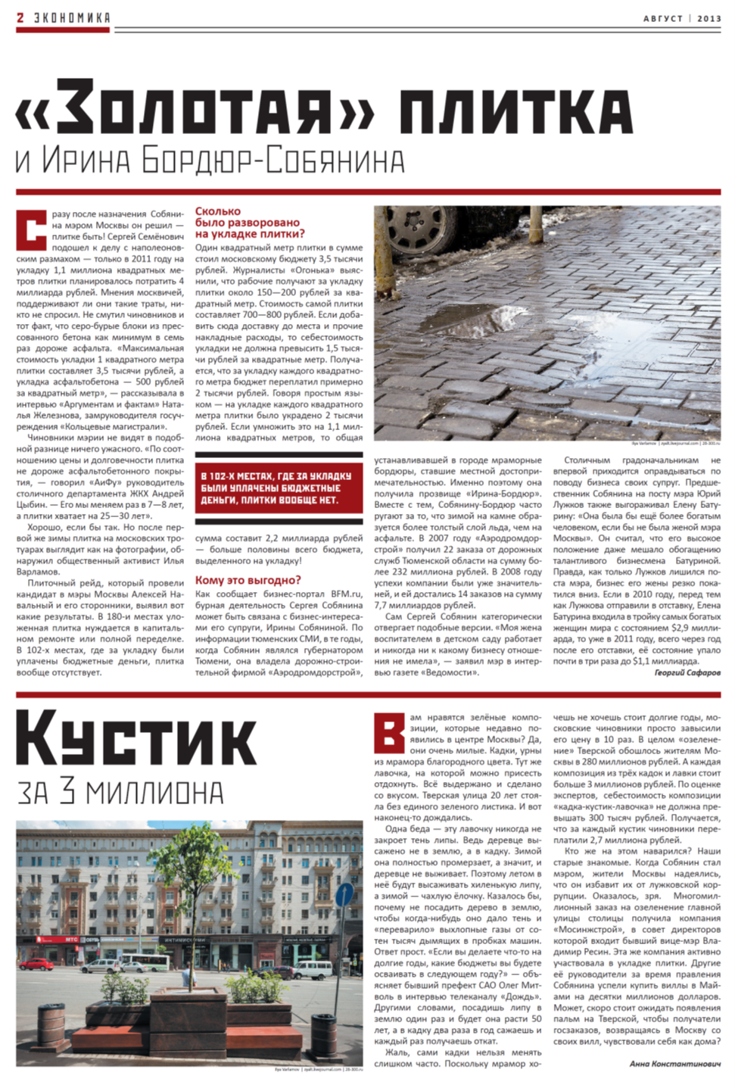

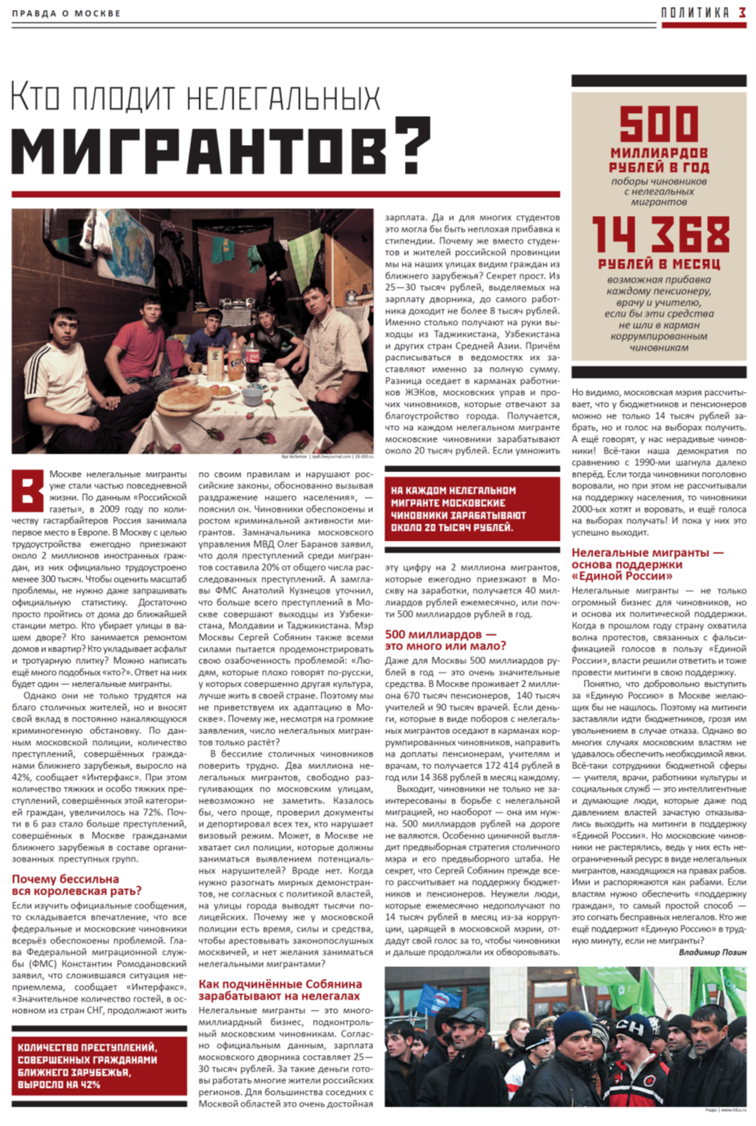



**Appendix 2. Moscow metro map**

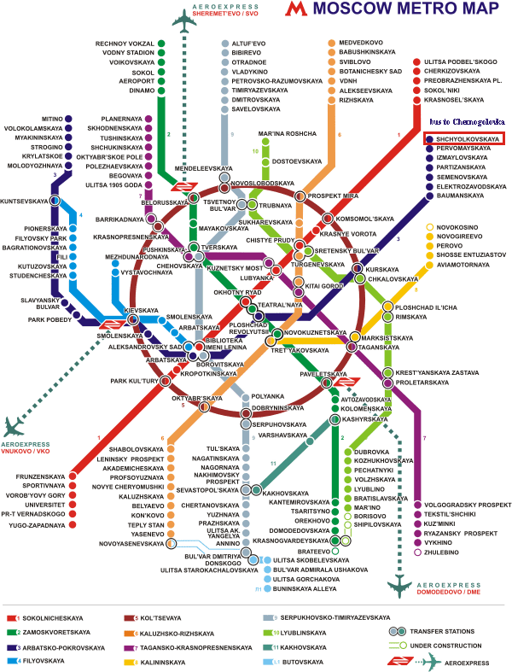

* metro stations where local transport hubs are located (train stations, bus stations, etc.)
* metro stations located outsides of the city of Moscow
* metro stations where the newspaper was distributed
* metro stations in the control group

**Appendix 3. Randomization**

Table 1A. Pairs of metro lines to be selected into the treatment group

|  |  |
| --- | --- |
|  | Metro Lines |
| 1 | Dark blue, West |
| Blue, West |
| 2 | Purple, West |
| Green, West |
| 3 | Grey, North |
| Orange, North |
| 4 | Red, North |
| Dark blue, East |
| 5 | Purple, East |
| Light green, South |
| 6 | Green, South |
| Grey, South |
| 7 | Orange, South |
| Red, South |

Table 2A. Metro stations of the newspaper distribution

|  |  |  |
| --- | --- | --- |
| Metro line | Station | Manager |
| Red, North | Krasnoselskaya | Manager 2 |
| Red, North | Sokolniki | Manager 2 |
| Red, North | Preobrazhenskaya Ploschad | Manager 2 |
| Red, North | Cherkizovskaya | Manager 2 |
| Red, North | Ulitsa Podbelskogo | Manager 2 |
| Dark blue, East | Baumanskaya | Manager 2 |
| Dark blue, East | Semenovskaya | Manager 2 |
| Dark blue, East | Partizanskaya | Manager 2 |
| Dark blue, East | Izmailovskaya | Manager 2 |
| Dark blue, East | Pervomaiskaya | Manager 2 |
| Dark blue, West | Park Pobedy | Manager 1 |
| Dark blue, West | Slavyansky Bulvar | Manager 1 |
| Dark blue, West | Molodezhnaya | Manager 1 |
| Dark blue, West | Krylatskoe | Manager 1 |
| Dark blue, West | Strogino | Manager 1 |
| Blue, West | Studencheskaya | Manager 1 |
| Blue, West | Kutuzovskaya | Manager 1 |
| Blue, West | Bagrationovskaya | Manager 1 |
| Blue, West | Filevsky Park | Manager 1 |
| Blue, West | Pionerskaya | Manager 1 |

**Appendix 4. Ethical issues of the study**

This study presents a field experiment that aims to estimate the effect of media in a nondemocratic regime. For this study, we create a newspaper that discusses alleged corruption in the government of Moscow. In this section, we discuss three types of potential risks of the study: (a) human subjects (b) confederates, and (c) election results alteration.

*Human subjects*

The newspaper is distributed to human subjects near the entrances to the randomly selected Moscow metro stations. We do not follow up and do not track participants’ behavior. No personal data are involved in the analysis. We do not gather any personal or demographic information about human subjects to whom the newspaper is handed out. The estimation of the media effect is conducted on the level of voting stations located close to the metro stations where the newspaper is distributed. The data come from official records. Because the analysis does not involve any personal data, the IRB has determined that this study does not meet the definition of "human subjects" research (IRB# 20-001751). Human subjects are not explicitly informed that they participate in an experiment. It is a minimal risk study in which people are voluntarily asked to read a newspaper with publicly available information about the Moscow mayor. Some of them may have previously known the facts presented in the newspaper articles. The time of contact with a newspaper distributor involves no more than a few seconds. Then, if a person decides to read the newspaper, it takes 10-15 minutes. Our research does not target any population groups that may be considered vulnerable. Distributors handed out the copy of the newspaper to all people who entered stations in the morning and who exited them in the evening and who agreed to take the newspaper. The only enrollment criterion is age (participants must be older than 18; at this age, people start voting in Russia). At the bottom of the last page of the newspaper, we report our real names, although we do not reveal our affiliations with academic institutions. For the purpose of the experiment, it was important that participants do not know that they take part in research. In this case, they would realize that they read an artificial newspaper and are expected to process the presented information in a certain way. We wanted them to believe that they deal with one of the many pieces of real political communication they get during the pre-election campaign. Additionally, given the research design, it was important to reach as many individuals as possible. Because we measure the aggregate result, to capture the media effect, we needed a large sample of individuals. Obtaining informed consent from every individual to whom we handed out the newspaper would significantly decrease the scale of the distribution.

*Confederates*

We hired managers among advanced students of Moscow universities. They hired and monitored distributors at each treated station. In 2013, participation in this kind of experiment posed no risk for them. None of our contributors has ever been detained by the police for distributing the anti-incumbent newspaper. It has not happened during the campaign or later. We protect their anonymity. The authors of this paper live and work outside Russia. The publication does not endanger them or their families.

*Election results alteration*

The experiment was fielded in a real election which means that the results might have been changed. According to the “Principals and Guidelines for Human Subjects Research” adopted by the American Political Science Association in 2020, interventions present “minimal social risk if they are not done at a scale liable to alter electoral outcomes.” The problem is that one cannot know to what extent treatment will affect election results *ex ante*. Slough (2021) formulates criteria to mitigate the risk of altering election results at the stage of research design: treating fewer voters, not intervening in close contests and PR systems, and intervening in larger districts. Our design meets the last three criteria. First, at the beginning of the race, the difference between Sobyanin’s rating and the rating of the closest rival was 50% (56% vs. 6%). Second, it was a mayoral election with only one winner. Finally, Moscow is a huge electoral district with more than 7 million registered voters. We did not anticipate huge treatment effects because our budget was very small compared to the budgets of election candidates. *Ex post*, Sobyanin was close to a second-round runoff. The official count gave him 51.37%, while the threshold for winning in the first round was 50%. Navalny, who came second with 27.24%, refused to recognize the results. It is still unlikely that the experiment could have changed the election outcome. The average number of people participating in the mayoral election was 689 people per voting station. In absolute terms, the newspaper led to a decrease in Sobyanin votes by 10.17 votes at every voting station participating in the experiment. The total effect of the newspaper campaign can be estimated as –2,369 votes for Sobyanin. This number represents 0.1% of voters who showed up at the voting booths and 0.03% of Moscow voters. In general, this study follows the ethics guidance discussed in Grose (2015, 2021). Specifically, the risks of the experiment participants and confederates were infinitesimal. The intervention posed minimal social risk, while the experiment addressed a theoretically important question. The impact on the election results was insignificant.

**Appendix 5. Randomization inference**

As an additional robustness test, we perform randomization inference for the model reported in Table 4.[1]

Figure 1A. Simulated effects of the treatment on the sample of the 5 closest voting stations

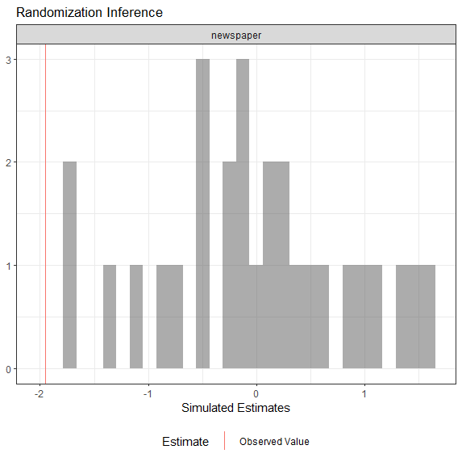

Notes: The coefficient estimation for *Newspaper* is -1.95, *p*-value is 0. Errors are clustered by metro line pairs.

Figure 2A. Simulated effects of the treatment on the sample of the 6-10 closest voting stations

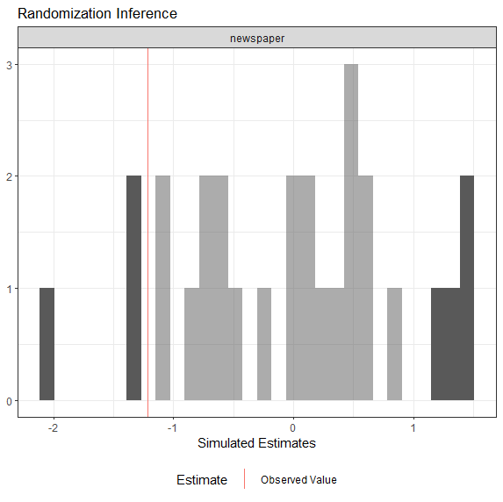

Notes: The coefficient estimation for *Newspaper* is -1.21, *p*-value is 0.25. Errors are clustered by metro line pairs.

Figure 3A. Simulated effects of the treatment on the sample of the 11-15 closest voting stations

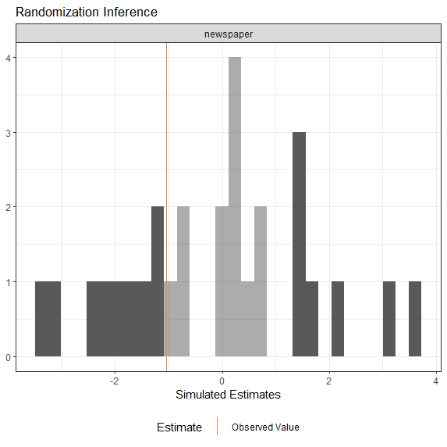

Notes: The coefficient estimation for *Newspaper* is - 1.04, *p*-value is 0.57. Errors are clustered by metro line pairs.

Notes: The coefficient estimation for *Newspaper* is -1.57, *p*-value is 0.18. Errors are clustered by metro line pairs.

**Appendix 6. Compliance with experimental reporting standards**

|  |
| --- |
| **Subjects and Context** |
| Did the author(s) report who was eligible to participate in the study?  **Adults older than 18** **who entered stations in the treatment group in the morning and who exited them in the evening and who agreed to take the newspaper** |
| Did the author(s) report dates defining the periods of recruitment and when the experiments were conducted?  **Four weeks prior to the 2013 Moscow mayoral election**  Did the authors report the dates of any repeated measurements as part of a follow-up?  **N/A** |
| If a survey: Did the author(s) identify the survey firm used and describe how it recruits respondents if the survey firm is not well known?  **N/A** |
| If a survey: Did the author(s) provide the response rate and how it was calculated?  **N/A** |
| **Allocation Method** |
| Did the author(s) report whether random assignment was used?  **Two pairs of metro lines were randomly selected. Eligible stations on these lines were included into the treatment group** |
| If random assignment was used, did the author(s) report the unit of randomization (individuals, groups, households, etc.)?  **Pairs of metro lines were used as units of randomization** |
| Did the author(s) provide a table (in the text or an appendix) showing baseline means and standard deviations for demographic characteristics and other pretreatment measures (if collected) by experimental group?  **Table 2 provides means of the dependent variables (election outcomes) by treatment condition. Demographic characteristics are not applicable** |
| **Treatments** |
| Did the author(s) report what treatment was given to each of the treatment groups and what was given to the control group?  **The newspaper was distributed near the metro stations in the treatment group. Nothing was given to the control group** |
| Did the author(s) make the complete treatment materials available? If treatments are scripts, did the author(s) make the exact scripts available?  **The copy of the newspaper and the summary of the articles are provided in the supplementary materials**  If the treatments are question wordings, did the author(s) make exact variations in question wordings available? If the treatments are mailings, did the author(s) make sample mailings available?  **N/A** |
| **Measurement** |
| Did the author(s) report how the outcome variables are measured and coded?  **The outcome variables are the election results in the voting stations located not further than 2 km from the metro stations. Each voting station within this distance was assigned to the metro station either in the treatment or control group and election results compared** |
| If there is an index used, did the author(s) report exactly how it was constructed?  **N/A** |
| Did the author(s) report how all other variables included in the statistical models are measured and coded?  **All control variables are described** |
| **CONSORT Diagram Information** |
| Did the author(s) report the number of subjects initially assessed for eligibility for the study?  **N/A** |
| Did the author(s) report exclusions prior to random assignment and the reasons for the exclusions?  **Short lines were excluded from random assignment for logistical reasons. In addition, three other types of stations were excluded both from the treatment and control groups for reasons described in the “Experimental design” section** |
| Did the author(s) report the number of subjects assigned to each experimental group?  **N/A** |
| Did the author(s) report the proportion of each group that received its allocated intervention and the reasons why subjects did not receive the intended intervention?  **N/A** |
| Did the author(s) report the number of subjects in each group that dropped out or for other reasons do not have outcome data?  **N/A** |
| Did the authors report the number of subjects in each group that are included in the statistical analysis, and the reasons for any exclusions?  **N/A** |
| **Statistical Analyses** |
| Did the author(s) report sample means and standard deviations, and Ns for the outcome variables using intent- to-treat (ITT) analysis (i.e., means and standard deviations for the entire collection of subjects assigned to a  group, whether a treatment is successfully delivered or not)?  **N/A** |

**References**

Grose, Christian R. 2015. “Field Experiments on Elected and Public Officials: Ethical Obligations and Requirements.” In *Ethics and Experiments*, 241–52.

Grose, Christian R. 2021. “Experiments, Political Elites, and Political Institutions.” In Advances in Experimental Political Science, 149–64.

Slough, Tara. 2021. “The Ethics of Electoral Experimentation: Design-based Recommendations. Working Paper.

1. We would like to thank an anonymous referee for this suggestion.