**APPENDIX III: Additional Tests and Robustness Checks**

Normality of Dependent Variables

Figure A3.1: Test of normality for post-treatment general interest in U.S. foreign trade policy,

variable is not normally distributed.

|  |  |
| --- | --- |
|  |  |

*Note:* Shapiro-Wilk W = 0.984; p < 0.001

Shapiro-Francia W' = 0.985; p < 0.001

Joint Skewness-Kurtosis χ2 = 36.260; p < 0.001

Figure A3.2: Test of normality for the difference in pre- and post-treatment general interests in U.S. foreign trade policy, variable is not normally distributed

|  |  |
| --- | --- |
|  |  |

*Note:* Shapiro-Wilk W = 0.944; p < 0.001

Shapiro-Francia W' = 0.947; p < 0.001

Joint Skewness-Kurtosis χ2 = 67.960; p < 0.001

Figure A3.3: Test of normality for the interest in U.S. policy specifically discussed in the prompt,

variable is not normally distributed

|  |  |
| --- | --- |
|  |  |

*Note:* Shapiro-Wilk W = 0.987; p < 0.001

Shapiro-Francia W' = 0.987; p < 0.001

Joint Skewness-Kurtosis χ2 = 49.410; p < 0.001

Homogeneity of Variance

Primary operationalization of dependent variable #1 (post-treatment general interest in the U.S. foreign trade policy) meets the homogeneity of variance assumption as tested by the variance-comparison test utilizing the dependent variable and treatment, but the follow-up analysis using Levene’s test does not consistently demonstrate that homogeneity of variance is met. Complementary operationalization of dependent variable #1 (difference between pre- and post-treatment general interest) does not meet the homogeneity of variance assumption as evaluated by either variance-comparison test or Levene’s test. Dependent variable #2 (interest in U.S. policy specifically discussed in the prompt) also does not consistently meet the homogeneity of variance assumption under both variance-comparison and Levene’s tests.

Results calculated using ordered logit analysis

Table A3.1: Ordered Logit Analysis of the Effect of Receiving the Treatment Vignette on Respondent’s General Interest in the U.S. Foreign Trade Policy moderated by gamer identity and controlling for the pre-test value of the dependent variable



Table A3.2: Ordered Logit Analysis of the Effect of Receiving the Treatment Vignette on Specific U.S. Foreign Trade Policy Discussed in the Vignette (gaming vs. general) moderated by gamer identity



Additional analysis with different operationalization of dependent variable #1

In addition to the OLS analysis with controls presented in the main manuscript, I calculated a difference between the post-test and pre-test measures to capture the treatment effect on generalized interest among gamers and non-gamers. A positive value indicates that the respondent’s interest in U.S. foreign trade increased after receiving the treatment, while a negative value signifies that the respondent became less interested. The results of this analysis are presented in Table A3.3 and visualized in Figure A3.4. The study uses OLS regression since the difference is a continuous number.

Table A3.3: OLS Analysis of the Effect of Receiving the Treatment Vignette on the Difference between the respondent’s Pre- and Post-test General Interest in the U.S. Foreign Trade Policy moderated by gamer identity moderated by gamer identity



These results suggest that gamer identity—however specified—slightly decreases respondents’ interest in the specific policy listed in the article. More importantly, I observe a statistically significant and consistent effect of the treatment and the treatment’s interaction with gamer identity on the interest in the vignette topic. As Figure A3.4 shows, treated gamers consistently expressed higher interest in U.S. foreign trade policy than control group gamers, and this difference is estimated to be 0.562 index points (about 8 percentage points). Similarly, treated gamers are estimated to show 0.454 index points (about 6.5 percentage points) higher general interest when compared to treated non-gamers.

Figure A3.4: Visualization of the predicted values as calculated in Table A3.3



Note: Shaded regions represent 95% confidence intervals.

To summarize, if primed with a prompt that interlaces gaming with a broader political context, gamers can frame nebulous topics like foreign trade in terms of their hobby. The boost in salience, therefore, has an apparent effect on interest. I present this relationship even more clearly in the following section, where I discuss the impact of the interaction between treatment and gamer identity on one’s interest in the foreign trade policy discussed in the article.

Results calculated using Kruskal Wallis models on subsets of data

*General Interest*

The average difference in pre- and post-test general interest was 0.084 (s.d. = 1.380, N = 429) among those who received the control manipulation. The same pre- and post-test difference among those who received the treatment was 0.044 (s.d. = 1.694, N = 431), suggesting that while the interest in this group also rose on average, the increase was smaller than among the control group. This difference is not statistically significant (Kruskal Wallis χ2 = 0.026, p = 0.873).

Gamers who received the control manipulation barely changed in their self-declared general interest, with the average change of only 0.007 (s.d. = 1.500, N = 145), while gamers who received the treatment manipulation reported average increase of interest in the magnitude of 0.279 (s.d. = 1.838, N = 154). This difference between the groups is statistically significant (Kruskal Wallis χ2 = 4.116, p = 0.043), which lends credence to my hypothesis that gamers who received the treatment manipulation would increase their interest in U.S. foreign trade policy more than gamers who did not.

The average difference in general interest among non-gamers in the control group increased by 0.123 (s.d. = 1.317, N = 284) and *decreased* by 0.087 (s.d. = 1.597 N = 277) among non-gamers in the treatment group. The resulting difference which can be attributed to the treatment translates to -0.210—ergo a decrease in interest due to the treatment—and this result approaches statistical significance at 0.05 level (Kruskal Wallis χ2 = 3.505, p = 0.061). These results are consistent with those reported elsewhere in this appendix and in the main body of the manuscript.

*Specific Interest*

The average interest in the policy specifically discussed among those research participants in the control group was 6.372 (s.d. = 2.420, N = 433). The value among those who received the treatment was 5.840 (s.d. = 2.709), suggesting that among all respondents, receiving the treatment decreased the interest in the U.S. foreign trade policy with China. This difference is statistically significant (Kruskal Wallis χ2 = 7.094, p = 0.008).

Control group gamers recorded the average specific interest of 6.852 (s.d. = 2.328, N = 142), while gamers who received the treatment manipulation return the average of 7.529 (s.d. = 1.900, N = 157). This difference of 0.677 between the groups is statistically significant (Kruskal Wallis χ2 = 6.013, p = 0.014), which further supports my hypothesis that gamers who received the treatment manipulation would increase their interest in U.S. foreign trade policy more than gamers who did not.

The average specific interest among non-gamers in the control group equals 6.137 (s.d. = 2.434, N = 291) and 4.901(s.d. = 2.638, N = 282) among non-gamers in the treatment group. As the apparent result of the experimental treatment, the interest among non-gamers *decreased* by 1.236. This difference is statistically significant (Kruskal Wallis χ2 = 31.278, p < 0.001). These results are consistent with those reported elsewhere in this appendix and in the main body of the manuscript.

Results of Testing for the Linearity of Interaction

Using the methodology developed by Hainmueller and colleagues (2019) I tested whether the interaction was linear. Figures A3.5 and A3.6 demonstrate that we can assume a linear nature of the interactive relationship.

Figure A3.5: Conditional marginal effects from binning estimators using post-test general interest as dependent variable in both plots demonstrate linearity of the interactive relationship. Panel A uses Gamer Identity Index as the moderator and Panel B uses gaming time as the moderator.

|  |  |
| --- | --- |
| Panel A: Gamer Identity Index Moderator | Panel B: Gaming Time Moderator |
|  |  |

Note: Error bars and shaded regions represent 95% confidence intervals.

Figure A3.6: Conditional marginal effects from binning estimators using post-test specific interest as dependent variable in both plots demonstrate linearity of the interactive relationship. Panel A uses Gamer Identity Index as the moderator and Panel B uses gaming time as the moderator.

|  |  |
| --- | --- |
| Panel A: Gamer Identity Index Moderator | Panel B: Gaming Time Moderator |
|  |  |

Note: Error bars and shaded regions represent 95% confidence intervals.

Conditional Treatment Effect Plots

In addition to the predicted values plots presented in Figures 4 and 5 in the main manuscript, I also constructed conditional treatment effects plots presented below as figures A3.7 and A3.8. The relationships visualized in those figures support the hypothesis that gamers who receive the treatment manipulation become more interested in the U.S. foreign trade policy than non-gamers.

Figure A3.7: Conditional treatment effects plots constructed based on regressions presented in Table 2. The visuals suggest positive effect of the treatment on general interest in U.S foreign policy among gamers and negative effect of the treatment among non-gamers.

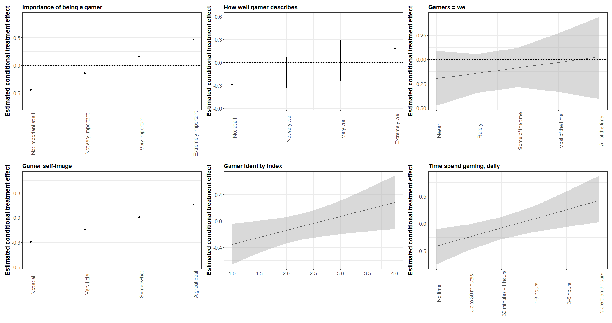

Note: Error bars and shaded regions represent 95% confidence intervals.

Figure A3.8: Conditional treatment effects plots constructed based on regressions presented in Table 3. The visuals suggest that the treatment on the specific U.S. foreign trade policy topic in the vignette is positive among gamers and negative among non-gamers.

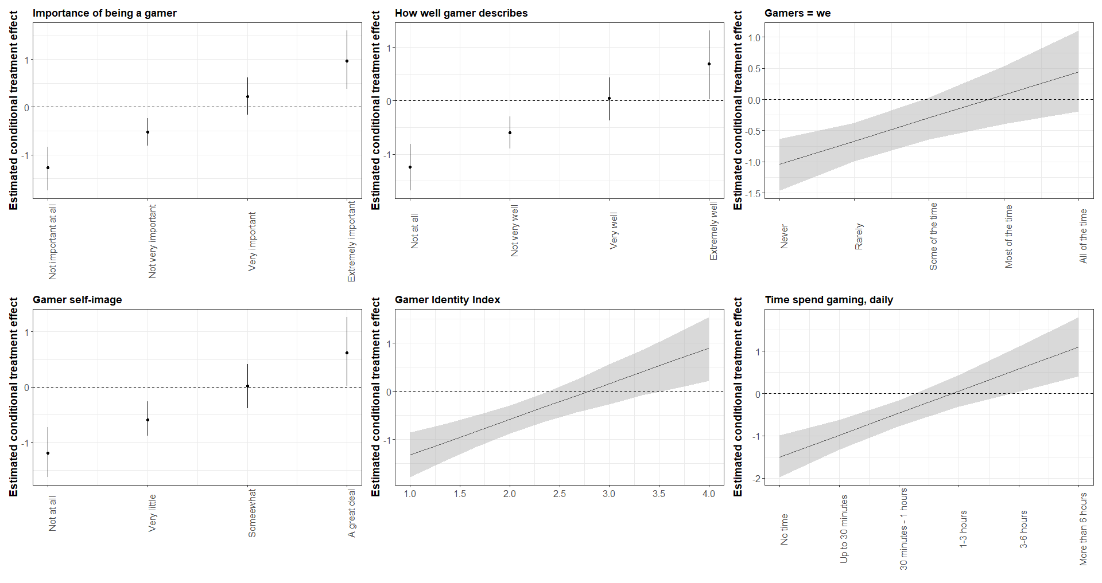

Note: Error bars and shaded regions represent 95% confidence intervals.