**APPENDIX II: Detailed Sample Demographics[1]**

Figure A2.1: Sample breakdown by age categories and comparison with U.S. population.

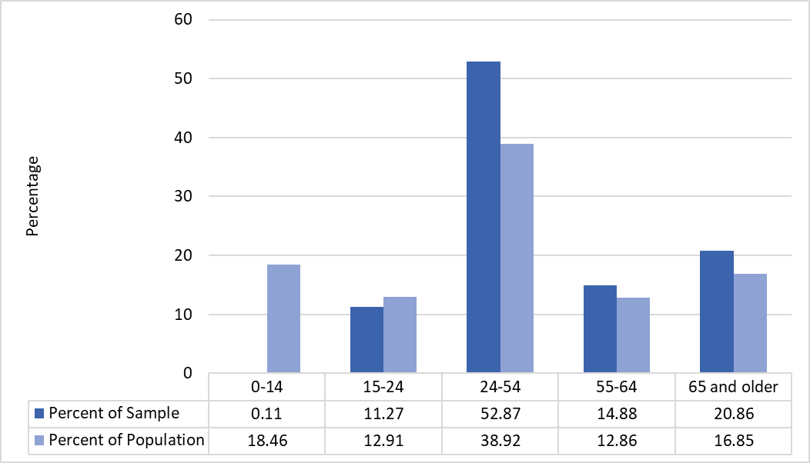

Figure A2.2: Sample breakdown by gender and comparison with the U.S. population.

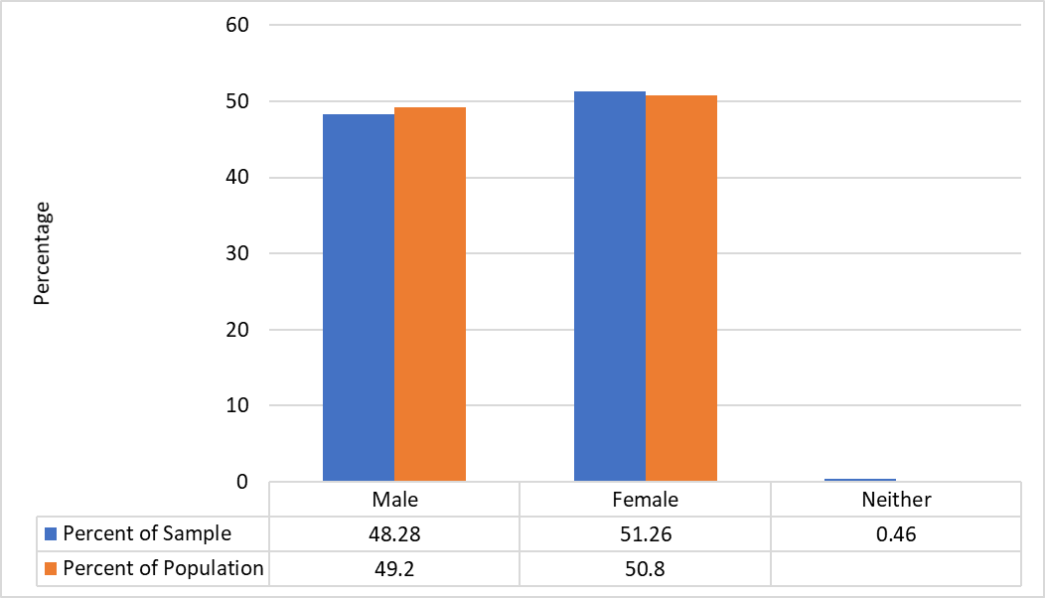

Figure A2.3: Sample breakdown by race and comparison with the U.S. population.

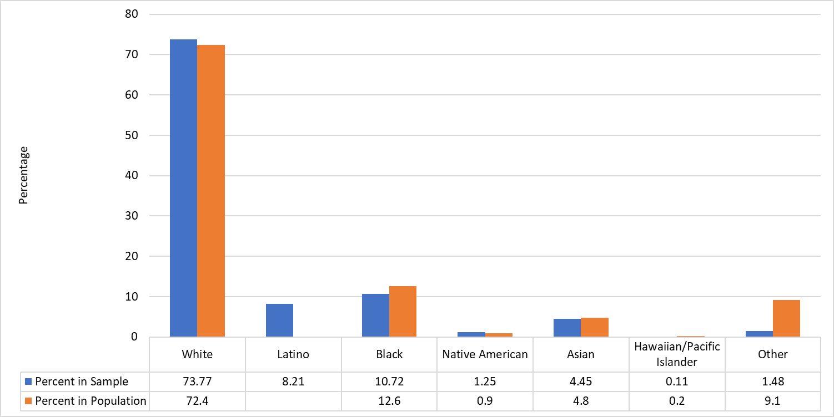

Figure A2.4: Sample breakdown by education attainment

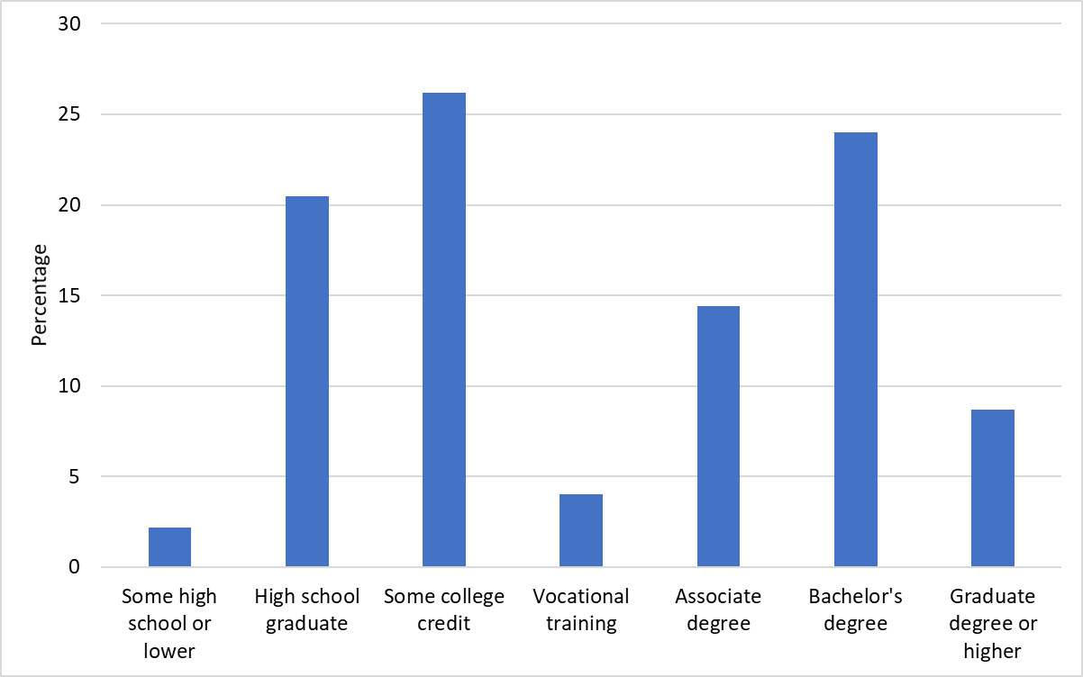

Figure A2.5: Sample breakdown by employment status

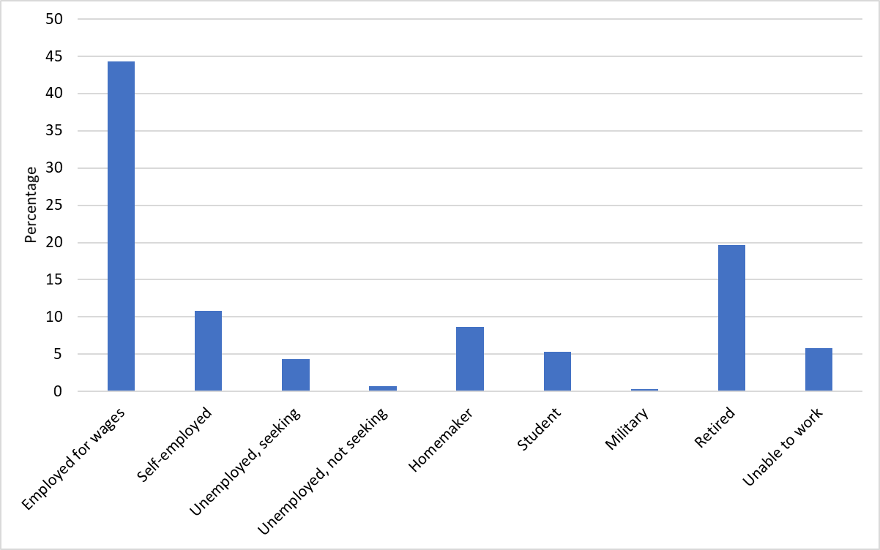

Table A2.1: Sample breakdown by state of residence



Figure A2.6: Sample breakdown by city size

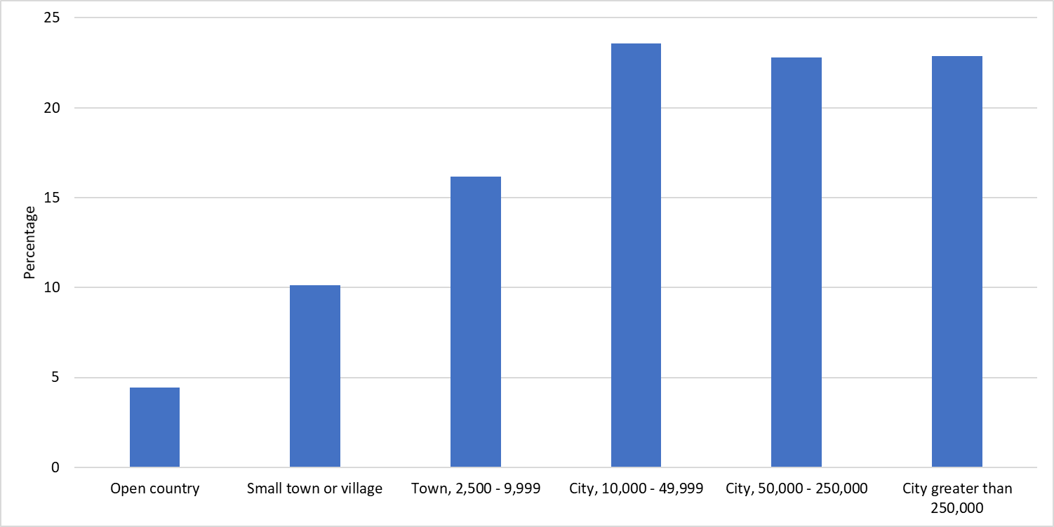

Figure A2.7: Sample breakdown by party identification

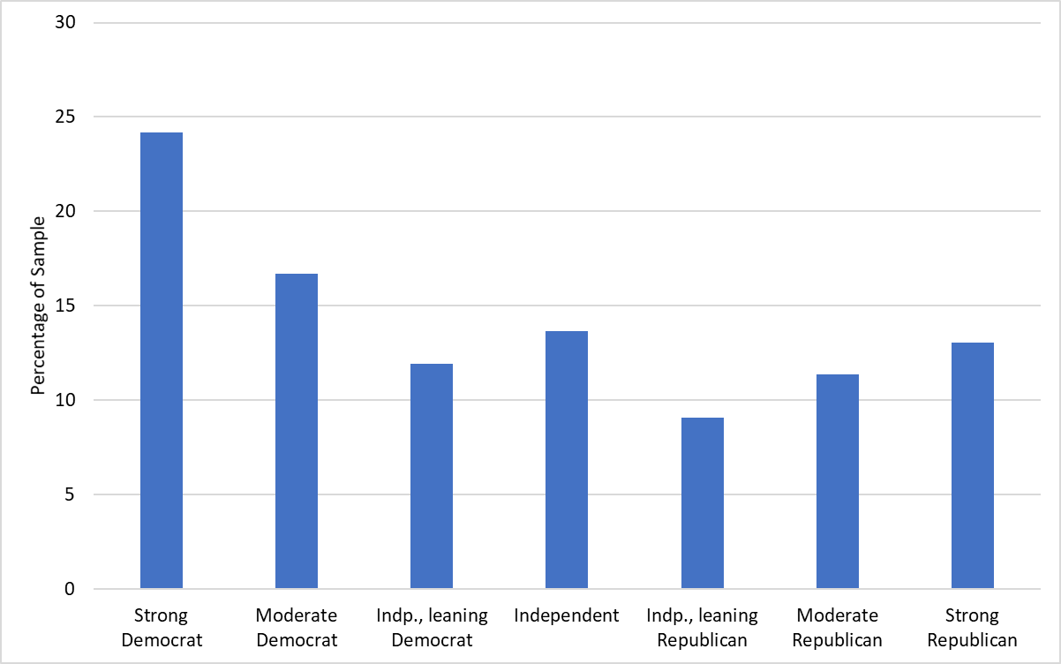

Figure A2.8: Sample breakdown by ideology

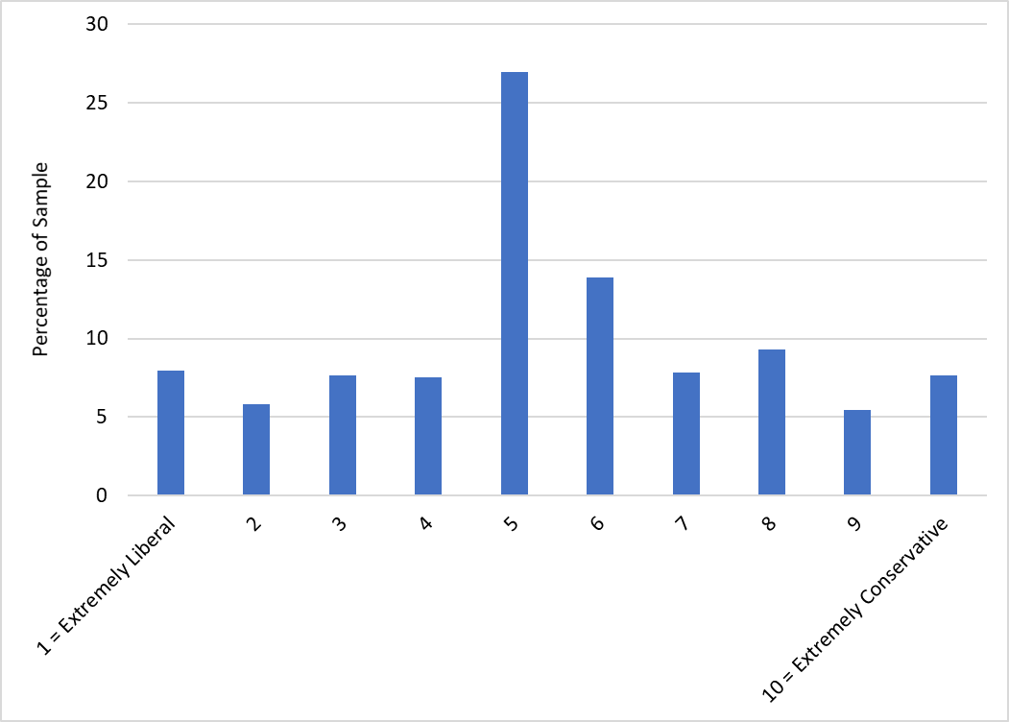

Figure A2.9: Majority of the sample passed the manipulation checks

|  |  |
| --- | --- |
| Panel A: Manipulation Check #1, Goods |  |
| Panel B: Manipulation Check #2, Country |  |
| Panel C: Manipulation Check #3, Price |  |

Table A2.2: Gamer identity index demonstrates high internal consistency



Table A2.3: Balance Test Correlation Matrix #1, showing no relationship between the treatment and dependent and independent variables.



(N = 860)

Table A2.4: Balance Test Correlation Matrix #2, showing no relationship between the treatment and demographic indicators.



(N = 834)

1. For more discussion, see: <redacted>. Dataset and code are available upon request at <redacted>.