Online Appendix

Appendix A: Ethics

Our priming experiment was approved by the appropriate Ethics Committee of Centro de Estudios Públicos on August 12, 2022 (protocol 8.12.2022). It was designed to activate affective polarization not by providing negative information about outgroup voters but by relying on individuals' own views about them. We believe our treatment question subtly boosts affective polarization, especially in the context of a polarized election in which highly aggressive (often false) information about outgroup voters spread broadly via social networks and word of mouth. Furthermore, we implemented the study more than a week before the election so that any effects would have time to dissipate. Finally, during the pretesting process, we assessed the questionnaire and treatment to ensure they were not complicated for participants for any reason.

Appendix B: Additional Tables and Figures

Table B.1: Population and sample distributions
Variable | Group | Census | Survey
Education | <Secondary complete | 36.3% | 8.9%
 | Secondary complete | 34.0% | 32.9%
 | >Secondary complete | 29.8% | 58.3%
Age | 18–35 | 37.0% | 22.4%
 | 36–54 | 35.4% | 41.7%
 | >54 | 27.6% | 35.9%
Sex | Male | 48.3% | 49.0%
 | Female | 51.7% | 51.0%
 | N | 13,314,848 | 1,499

Table B.2: Question wording

QUESTION | CREATED  VARIABLE | SCALE
Now, some groups of people are shown. On a scale from 0 to 10, where 0 indicates that you have a very negative opinion of these people, 5 that you have neither a negative nor a positive opinion, and 10 that you have a very positive opinion about these people, what is your opinion about each group of people?
People who vote for Approve  People who vote for Reject | Plebiscite voters | 0–10 scale  0= Very negative  5= Neither positive nor negative  10= Very positive
People who voted for Gabriel Boric  People who voted for José Antonio Kast | Presidential voters
Right-wing people  Left-wing people | Left–Right
Using the same scale, where 0 is strongly disagree and 10 is strongly agree, how much do you agree with the following statements?
- People who vote [outgroup from plebiscite vote] are a serious threat to Chile and its people. | Threat | 0–10 scale  0= Strongly disagree  10= Strongly agree
- People who vote [outgroup from plebiscite vote] are not only worse for politics, they are downright evil. | Evil
With which of the following statements do you most agree?  - Democracy is preferable to any other form of government  - Under some circumstances, an authoritarian government may be preferable to a democratic one  - For people like me, whether it is a democratic or an authoritarian regime makes no difference. | Democracy pre-treatment question | Dummies
On a 0-10 scale, where 0 is strongly disagree and 10 is strongly agree, how much do you agree with the following statement?  Democracy is preferable to any other form of government. | Democracy (main outcome) | 0–10 scale  0= Strongly disagree  10= Strongly agree

Table B.3: Effect of treatment on support for democracy, by group

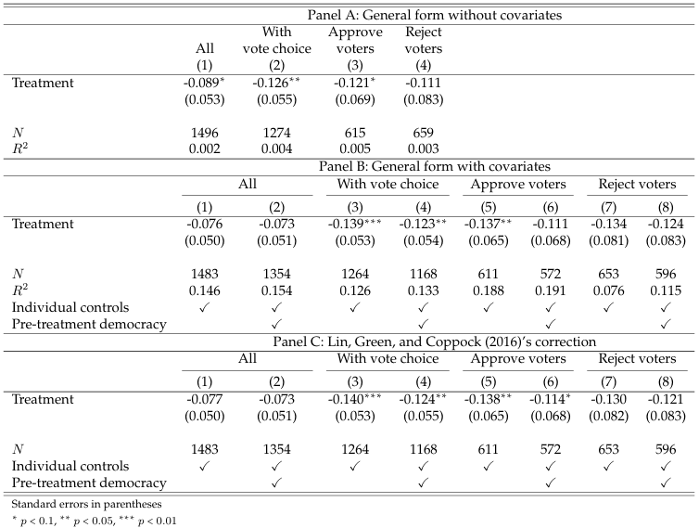

Note: OLS regressions for standardized support for democracy, for the full sample (“All”), respondents who had decided how they would vote in the plebiscite at the time of the survey (“With vote choice”), and Approve and Reject voters. Panel A shows results without controls. Panel B, in odd columns, includes a set of controls: sociodemographic variables (age, sex, metropolitan region, and education), left–right ideology (in five groups), interest in politics, and baseline preferences for the past runoff and plebiscite. Even columns in Panel B include an additional pre-treatment measure of democratic commitment. Panel C follows the structure of Panel B, but using Lin (2013) and Lin, Green, and Coppock (2016)’s approach for covariate adjustment.

Table B.4: Heterogeneous effects (respondents with vote choice)

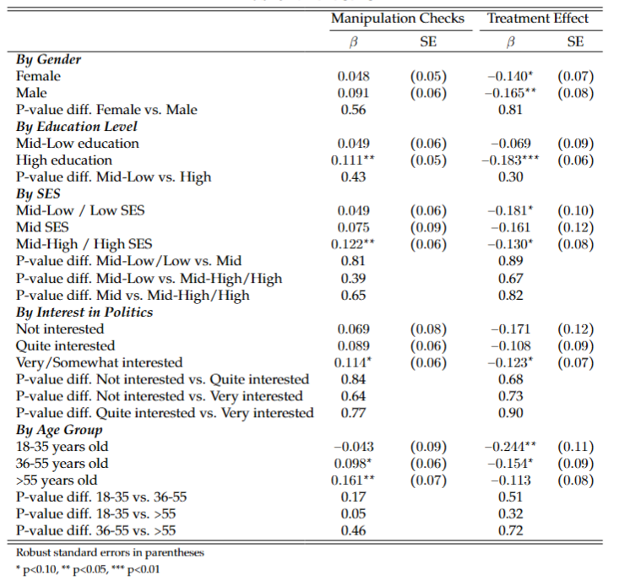

Note: This table shows the estimated results for the manipulation checks and the main results for respondents with a vote choice, by groups of gender, education, SES, interest in politics, and age. Columns 1 and 2 show the $β$ and its standard error for the manipulation checks by group, estimated for the Affective Polarization Index, as in Table C.1, Panel B, column 3; columns 3 and 4 show the $β$ and its standard error for the effect of treatment on support for democracy by group, estimated as in Table B.3, Panel B, column 3. The p-value rows show the p-value of the difference in the $β$ of the specified groups within the category.

Appendix C: Manipulation checks

The validity of our prime experiment rests on whether it successfully activated affective polarization. Table C.1, Panel A, displays the treatment effects on our three measures of affective polarization based on feeling ratings, all of which are standardized, for the full sample (“All”) and those with and without a vote choice. For the full sample, there are statistically significant effects at the 90% level for presidential vote and left vs. right; when distinguishing by vote choice, the results are only statistically significant for presidential voters among those with a vote choice. We complement these results with those in Panel B, with the two additional affective polarization outcomes from Kalmoe and Mason (2022), also based on the plebiscite divide: whether the outgroup voters are “a threat to Chile and its people” or “downright evil.” Approve voters answered these questions about Reject voters, and vice versa; we only present these results for respondents with a vote choice, for whom it makes sense to define an outgroup. These questions point more directly to the idea of despising the outgroup, and consequently show stronger results than the previous ones. Receiving the treatment significantly increased the chances of considering the outgroup a threat or evil by 0.19 and 0.1 standard deviations, significant at the 99 and 90% levels, respectively.

Table C.1: Effect of treatment on affective polarization (manipulation checks)

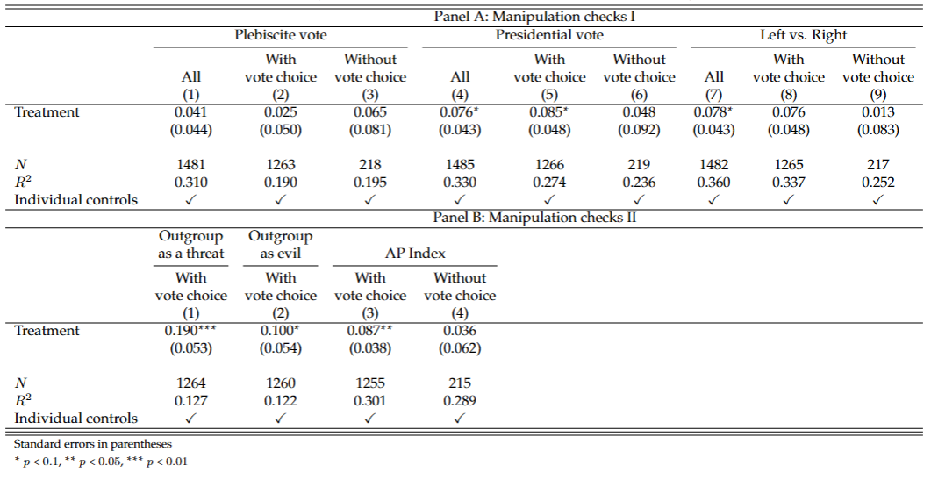

Note: OLS regressions. The measures of affective polarization in Panel A as described in the Research design section, for the full sample (“All”), respondents who had decided how they would vote in the plebiscite at the time of the survey (“With vote choice”), and those who did not (“Without vote choice”). The affective polarization outcomes in Panel B come from Kalmoe and Mason (2022): whether the outgroup voters are “a threat to Chile and its people” or “downright evil.” We do not show these results for those without vote choice because they lack an outgroup. The Affective Polarization (AP) Index in Panel B is constructed based on the previous measures of affective polarization, following Kling, Liebman, and Katz (2007); including the five measures for those with vote choice and the three measures in Panel A for those without vote choice. All regressions control for sociodemographic variables (age, sex, region, education, and socioeconomic status), left–right ideology (in five groups), interest in politics, party ID, and baseline preferences for the past presidential runoff and plebiscite. All outcomes are standardized.

Overall, these results suggest that our priming experiment increased respondents’ affective polarization. For confirmation, the last columns of Panel B include the Affective Polarization Index, constructed following Kling, Liebman, and Katz (2007) based on the previous measures of affective polarization (the three in Panel A, plus the outgroup as threat/evil ones in Panel B in the case of respondents with an outgroup). The treatment effect on this summary index is 0.09 standard deviations for respondents with a vote choice, significant at the 95% level, showing an important increase in affective polarization. The analysis of a question on feelings toward the outgroup reinforces this conclusion, as we show in the next subsection. The coefficient is smaller and not statistically significant for respondents without vote choice.

Answers to treatment
As a complement to the manipulation checks, we assess the treatment effects on respondents’ views toward the outgroup, using answers to the question that we included for all respondents at the end of the survey: “What is the main feeling that the people who vote for the different options generate in you? Remember that we are asking you about the people who support these options and not about the constitutional proposal. We are very interested in your views on this. Please take at least thirty seconds to answer this question without rushing.” We then asked the respondents how they felt about Apruebo and Rechazo voters, in random order. Following Ferrario and Stantcheva (2022), we employ keyness analyses to compare the frequency of words used in their responses to the question on feelings toward outgroup voters between the treated and control groups. To determine whether the differences in the prevalence of keywords are statistically significant, we use chi-square statistics at the 95% level (|$χ2$| > 3.84). Figure C.1 depicts the results for respondents with a vote choice (85% of the sample), for whom we can identify an outgroup.

Figure C.1: Keyness analysis: feelings toward the outgroup by treatment condition (only respondents with vote choice)
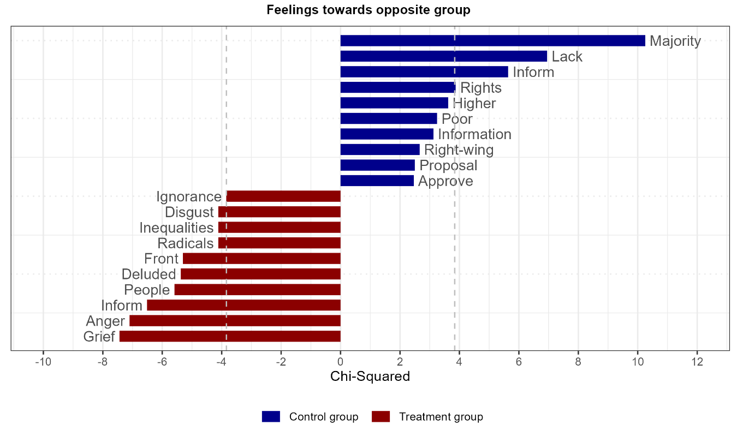
Note: Dashed lines represent 95% significance levels (|$χ2$| > 3.84).

While the words that significantly distinguish the control group’s responses do not have a clearly negative connotation (majority, lack, inform, rights), at least seven of the terms that distinguish treated respondents have a strongly negative tone: grief, anger, deluded, radicals, inequality, disgust, and ignorance.

Appendix additional references
Ferrario, Beatrice, and Stefanie Stantcheva. 2022. "Eliciting People’s First-Order Concerns: Text Analysis of Open-Ended Survey Questions." AEA Papers and Proceedings 112: 163–169.

Le Foulon worked at Centro de Estudios Públicos at the time.
A March 2022 Datavoz survey found that 58% of Chileans had been exposed to fake news (available here).

