**The benefit task**

Imagine that you have been hired as a journalist to cover local village self-governance in a region.

The villages in the region you are going to investigate have a long-standing tradition of collective economy and communal decision-making. Local residents of these villages actively engage in self-governance as these villages are all led by their own elected councils consisting of five to eight representatives. These representatives are chosen by villagers directly through a voting process. The head of the council, who is also called a “village head”, is responsible for managing village affairs, including the setting of village budgets and the use of village revenues.

In general, according to a village collective-decision rule, if a village head decides to adjust village spending ratios, he/she must first hold a village public meeting for villagers to express their ideas and concerns on this decision. However, your colleague thinks that some village heads do not actually comply with this rule just as there are many reported cases where some village heads had misused the village revenues saved from the welfare spending cuts for their own personal benefits.

Thus, you choose to investigate whether village heads in the region comply with the following rule:

**If a village head decides to implement a spending cut on social welfare, then he/she must first hold a village public meeting.**

The cards below have information about four different village heads. Each card represents one leader. One side of the card tells whether a village head implemented a spending cut on social welfare, and the other side tells whether or not s/he held a village public meeting in the first place. Indicate which card(s) you would need to turn over in order to see whether the leaders violated this rule. Do not turn over any more cards than absolutely necessary.

Did not hold a village public meeting

Held a village public meeting

Implemented a spending cut

Did not implement a spending cut

*P Not-P Q Not-Q*

**Figure A: The benefit task**

**The no-benefit task**

Imagine that you have been hired as an assistant to a village head to help with planning and hosting public meetings and hearings related to local village self-governance. However, because nobody in the village head’s office knows when and whether village heads should hold public hearings, you are asked to investigate the practices in other villages, that is, what village heads customarily do.

The villages in the region you are going to investigate all have a long-standing tradition of collective economy and communal decision-making. Local residents of these villages actively engage in self-governance as these villages are all led by their own elected councils consisting of five to eight representatives. These representatives are chosen by villagers directly through a voting process. The head of the council, who is also called a “village head”, is responsible for managing village economic affairs, including the setting of village budgets and the use of village revenues.

You have heard that according to a village collective-decision rule, if a village head decides to adjust village spending ratios, he/she must first hold a village meeting for villagers to express their ideas and concerns on this decision. But your colleague thinks that some village heads in the region do not actually comply with this rule, just as you become aware that spending cuts would not benefit the village heads because all the saved amounts from the village public coffers in the region will be automatically transferred back to the central government by the end of each calendar month.

Thus, you choose to investigate whether village heads in the region comply with the following rule:

**If a village head decides to implement a spending cut on social welfare, then he/she must first hold a village public meeting.**

The cards below have information about four different village heads. Each card represents one leader. One side of the card tells whether a village head implemented a spending cut on social welfare, and the other side tells whether or not s/he held a village public meeting in the first place. Indicate which card(s) you would need to turn over in order to see if the leaders violated this rule. Do not turn over any more cards than absolutely necessary.

Did not hold a village public meeting

Held a village public meeting

Implemented a spending cut

Did not implement a spending cut

*P Not-P Q Not-Q*

**Figure B: The no-benefit task**

Table 1. Sample characteristics for **Study 1**

|  |  |  |  |  |
| --- | --- | --- | --- | --- |
|  | All tasks | The voice task | The student document task | The ideology task |
| Total respondents | 306 | 103 | 102 | 101 |
| Gender |  |  |  |  |
| Male | 132 | 50 | 43 | 85 |
| Female | 174 | 53 | 59 | 115 |
| Average Age | 29.53 | 28.93 | 30.24 | 29.42 |
| Occupation |  |  |  |  |
| Professionals | 29 | 11 | 9 | 9 |
| Service sector workers | 18 | 8 | 3 | 7 |
| Freelancers | 32 | 16 | 10 | 12 |
| Industrial workers | 10 | 5 | 5 | 0 |
| Private sector employees | 154 | 44 | 57 | 53 |
| Public organization employees | 16 | 4 | 6 | 6 |
| Students | 46 | 21 | 12 | 13 |
| Other | 1 | 0 | 0 | 1 |
| Education |  |  |  |  |
| High school or lower | 9 | 4 | 3 | 2 |
| Associate degree | 30 | 10 | 11 | 9 |
| Undergraduate | 244 | 82 | 80 | 82 |
| Postgraduate | 23 | 7 | 8 | 8 |
| Party affiliation |  |  |  |  |
| Party1 members | 52 | 17 | 18 | 17 |
| Alternate party members | 31 | 8 | 10 | 13 |
| Communist Youth League members | 105 | 38 | 37 | 30 |
| Members of other political parties | 6 | 1 | 4 | 1 |
| No party affiliation | 112 | 39 | 33 | 40 |
| Political sophistication |  |  |  |  |
| Mean | 0.556 | 0.575 | 0.567 | 0.526 |
| SD | 0.188 | 0.186 | 0.183 | 0.193 |

1 The Chinese Communist Party

Table 2. Effects of political sophistication on correct WST response for **Study 1**

|  |  |  |
| --- | --- | --- |
|  | **Model 1** | **Model 2** |
|  | Correct Response:  The voice task | Correct Response:  The ideology task |
| **Political sophistication** | 1.098 | -0.564 |
|  | (-1.155) | (-1.594) |
| **Gender (Female=1）** | -0.095* | -0.008 |
|  | (-0.042) | (-0.05) |
| **Age** | 0.12 | 0.377 |
|  | (-0.454) | (-0.661) |
| **Education**  **(Undergraduate=1)** | -0.332 | -0.786 |
|  | (-0.459) | (-0.694) |
| **Occupation (Private sector employee=1)** | -0.473 | -0.233 |
|  | (-0.560) | (-0.753) |
| **Party affiliation**  **(No party affiliation=1)** | -0.242 | -0.603 |
|  | (-0.452) | (-0.758) |
| **Constant** | 2.378* | -0.935 |
|  | (-1.417) | (-1.722) |
| **N** | 103 | 101 |
| **Pseudo R2** | 0.0787 | 0.0537 |

*Note: Logit coefficients with standard errors in parentheses. *p<0.1; **p<0.05; ***p<0.01. All tests are two-sides.*

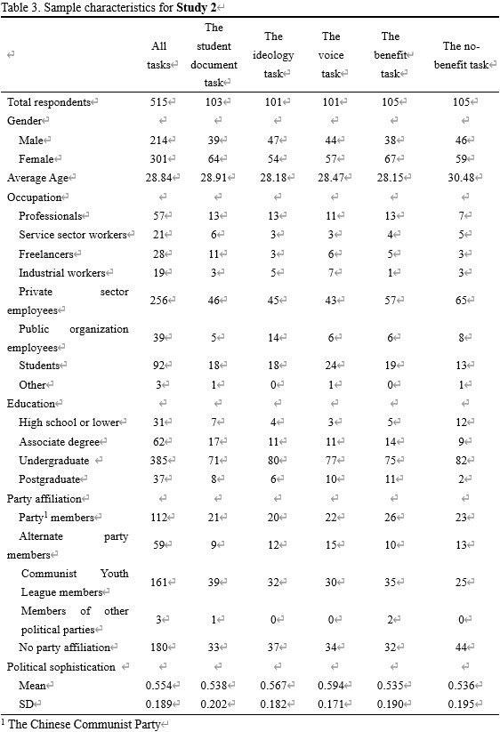

**A note on the significance of group comparisons**

For Study 1, since *p*-values of the two group comparisons are both less than 0.01 in hypothesis tests, the probability of making Type I errors is very low. In the revision, we have included a correction for the family-wise error rate (FWER) using the Holm–Bonferroni method for Study 2. The results remain robust to Holm–Bonferroni correction (*p*<0.05), as of below:

When testing several hypotheses, the problem of multiplicity arises: The more hypotheses are tested, the higher the probability of obtaining Type I errors (false positives). The Holm-Bonferroni method is a key approach for controlling the FWER (Holm, 1979). The procedure is as follows:

First, to sort the 5 *p*-values into order lowest to highest: P1(voice/document), P2(voice/ideology), P3(benefit/no-benefit), P4(voice/no-benefit), P5(voice/benefit). Each *p*-value corresponds to a null hypotheses H1, H2, H3, H4, H5 (these hypotheses are for pairwise group comparisons in the correction procedure, unrelated to H1 to H4 in the main manuscript). We want to ensure the FWER to be no higher than the pre-specified significance level *α* = 0.05.

Second, for each *p*-value, to test whether Pk ≤ , where *m* denotes the number of tests (which in our case is 5) and *k* denotes the rank order of *p*-values. If so, reject Hk and continue to examine the larger P values, otherwise stop testing and exit.

Accordingly, we test that P1(voice/document) ≈ 0.000 < 0.01 = *α* / 5 and reject H1; then P2(voice/ideology) ≈ 0.000 < 0.0125 = *α /* 4 and reject H2; then P3(benefit/no-benefit) ≈ 0.000 < 0.0167 = *α /* 3 and reject H3; then P4(voice/no-benefit) = 0.005 < 0.025 = *α /* 2 and reject H4; then P5(voice/benefit) = 0.026 < 0.05 = *α /* 1 and reject H5. To conclude, all 5 null hypotheses are rejected while controlling the FWER at *α* = 0.05.

* Holm, Sture. (1979). A simple sequentially rejective multiple test procedure. *Scandinavian Journal of Statistics*, 65-70.