Yellow Peril or Model Minority?

Measuring Janus-Faced Prejudice toward Asians in the United States

Online Appendix

Contents

Figure A.1.1: Confirmatory factor analysis and correlation matrix
Figure A.1.2: Principal component analysis and exploratory factor analysis
Figure A.2: Distributions of and correlations between AAR and MMS
Figure A.3: Demographic and dispositional correlates of AAR
Figure A.4: Demographic and dispositional correlates of MMS
Figure A.5: Correlations between MMS and symbolic racism
Figure A.6: Cognitive responses to AAR and MMS scale items

Table A.1: Summary statistics
Table A.2: Open-ended coding protocol
Table A.3: Predictors of key themes in open-ended responses to AAR
Table A.4: Predictors of key themes in open-ended responses to MMS
Table A.5.1: AAR and support for racialized public policies
Table A.5.2: AAR and support for racialized public policies (with controls)
Table A.6.1: MMS and support for racialized public policies
Table A.6.2: MMS and support for racialized public policies (with controls)
Table A.7.1: AAR, MMS, and support for racialized public policies
Table A.7.2: AAR, MMS, and support for racialized public policies (with
controls)
Table A.8.1: Combinations of AAR and MMS and support for racialized
public policies
Table A.8.2: Combinations of AAR and MMS and support for racialized
public policies (with controls)
Table A.9.1: Effects of feeling thermometer and stereotype measures
Table A.9.2: Effects of AAR, MMS, and feeling thermometer I
Table A.9.3: Effects of AAR, MMS, and feeling thermometer II
Table A.10: AAR, MMS, and support for African American racial policies
Table A.11: Self-monitoring scale and social desirability bias
Table A.12: Survey questions
Table A.13.1: Resentment scales
Table A.13.2: Notes on the AAR & MMS Scales
Table A.14.1: White vs. non-white subgroup analysis I
Table A.14.2: White vs. non-white subgroup analysis II
Table A.14.3: White vs. non-white subgroup analysis III
Table A.14.4: Notes on white vs. non-white differences

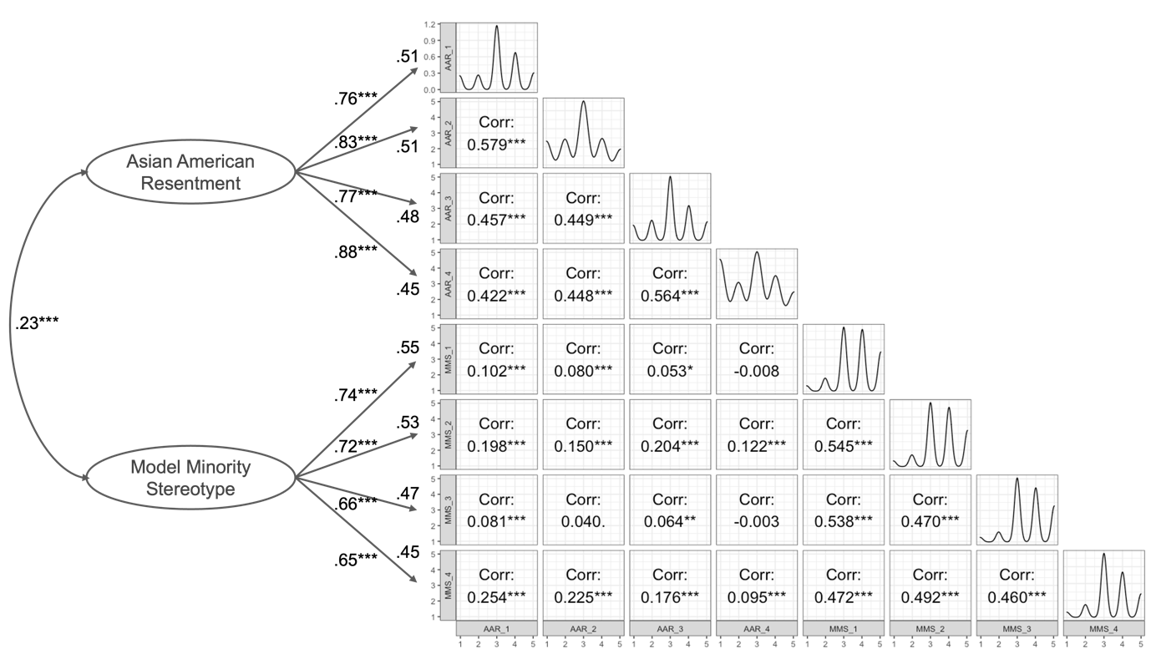
Note: The figure displays the key parameter estimates from a confirmatory factor analysis (the left panel) and Pearson correlation coefficients among the eight scale items (the right panel). * p<.05. ** p<.01. *** p<.001. The same pattern holds for the Dynata sample in the main paper. Consistent with the discussion in the paper, the analysis shows that each scale item significantly loads onto its respective higher-order factor. Based on the conventional measures of model fit – the comparative fit index (CFI) = .91 (.93), the standardized root mean squared residual (SRMR) = .07 (.06), the root mean square error of approximation (RMSEA) = .10 (.09), and the Tucker-Lewis index (TLI) = .87 (.90) – we also confirm that the two-factor model adequately fits the data. The four items in each scale cohere well together, demonstrating the internal consistency of the two measures: Cronbach’s alpha averaged across the two surveys equals .77 for the AAR and .78 for the MMS.

Figure A.1.1: Confirmatory factor analysis and correlation matrix (Lucid)

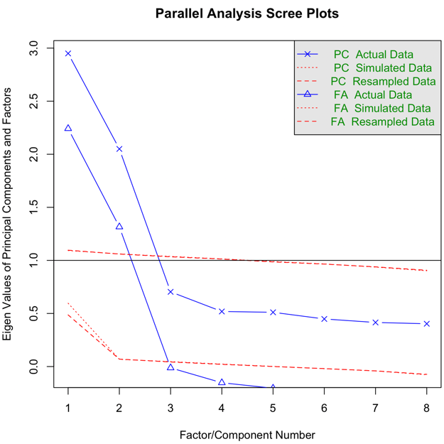 | 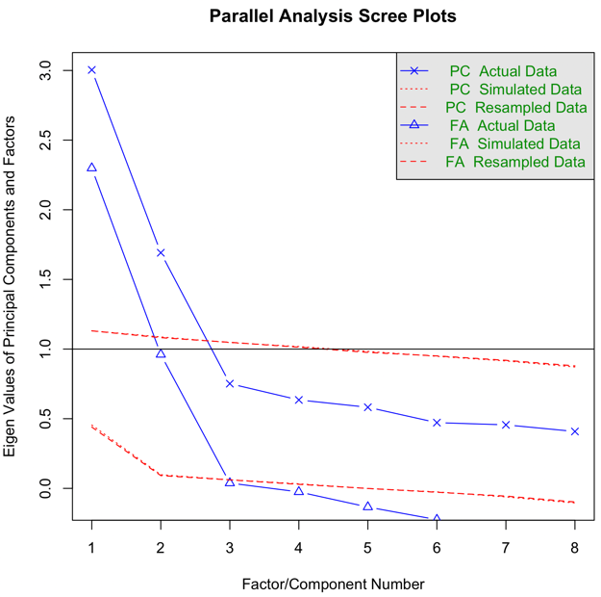

Figure A.1.2: Principal component analysis and exploratory factor analysis (Left: Lucid sample; Right: Dynata sample)

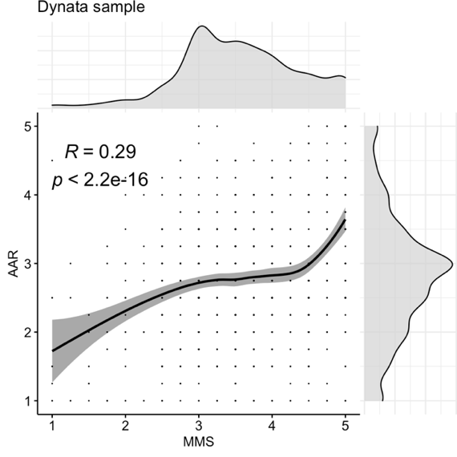 | 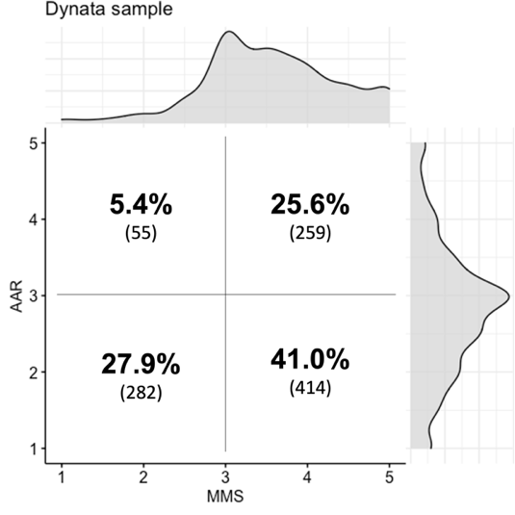
Note: The left panel displays scatter plots and density plots of AAR and MMS, including smoothed loess lines with shaded bands indicating 95 percent confidence intervals and a Pearson correlation coefficient between the two scales. The right panel shows the distributions of responses to the two scales split by the midpoint (3=“neither agree nor disagree”) with raw counts in parentheses. Both panels are based on the Dynata sample, and the same results with the Lucid sample can be found in the appendix.

Figure A.2.1: Distributions of and correlations between AAR and MMS (Dynata sample)

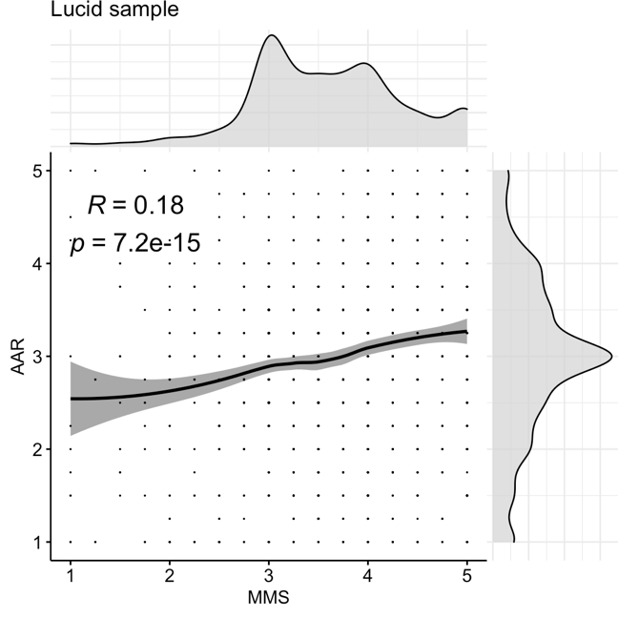 | 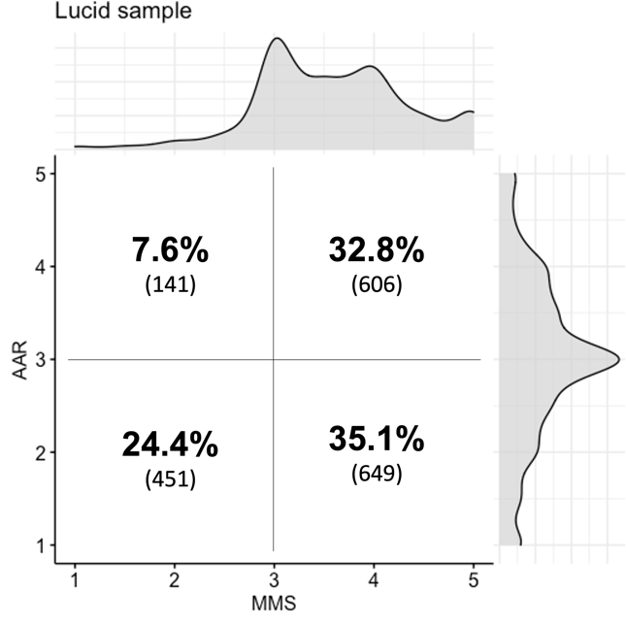
Note: The left panel displays scatter plots and density plots of AAR and MMS across the two surveys, including smoothed loess lines with shaded bands indicating 95 percent confidence intervals and a Pearson correlation coefficient between the two scales. The right panel shows the distributions of responses to the two scales split by the midpoint (3=“neither agree nor disagree”) with raw counts in parentheses.

Figure A.2.2: Distributions of and correlations between AAR and MMS (Lucid sample)

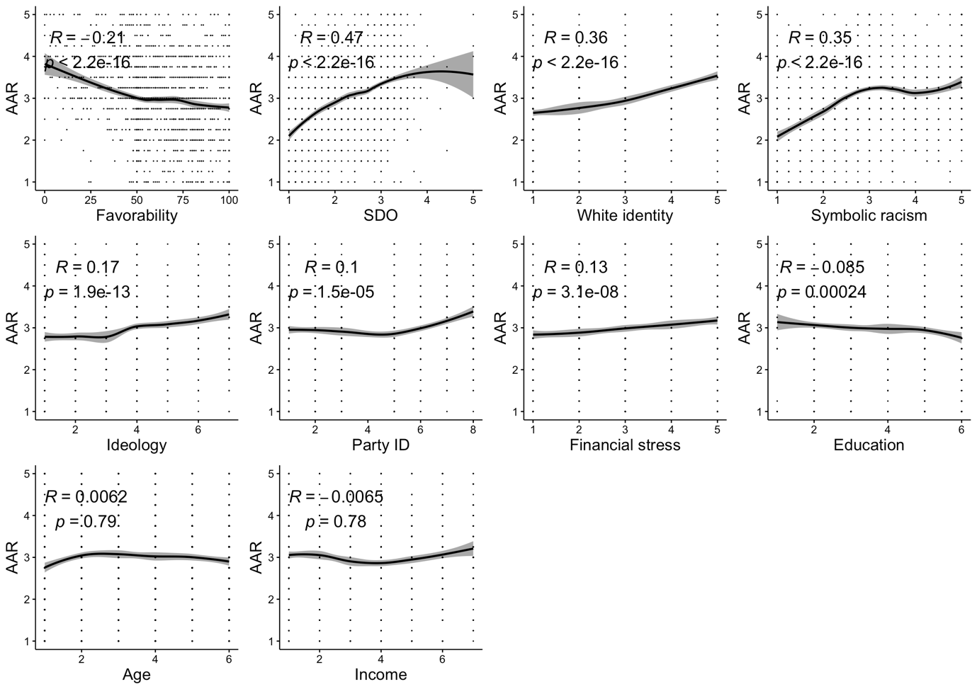
Note: The figure displays scatter plots and correlations between AAR and demographic and dispositional traits (Lucid sample). The plots include smoothed loess lines with shaded bands indicating 95 percent confidence intervals and Pearson correlation coefficients with p values.
Figure A.3: Demographic and dispositional correlates of AAR (Lucid sample)

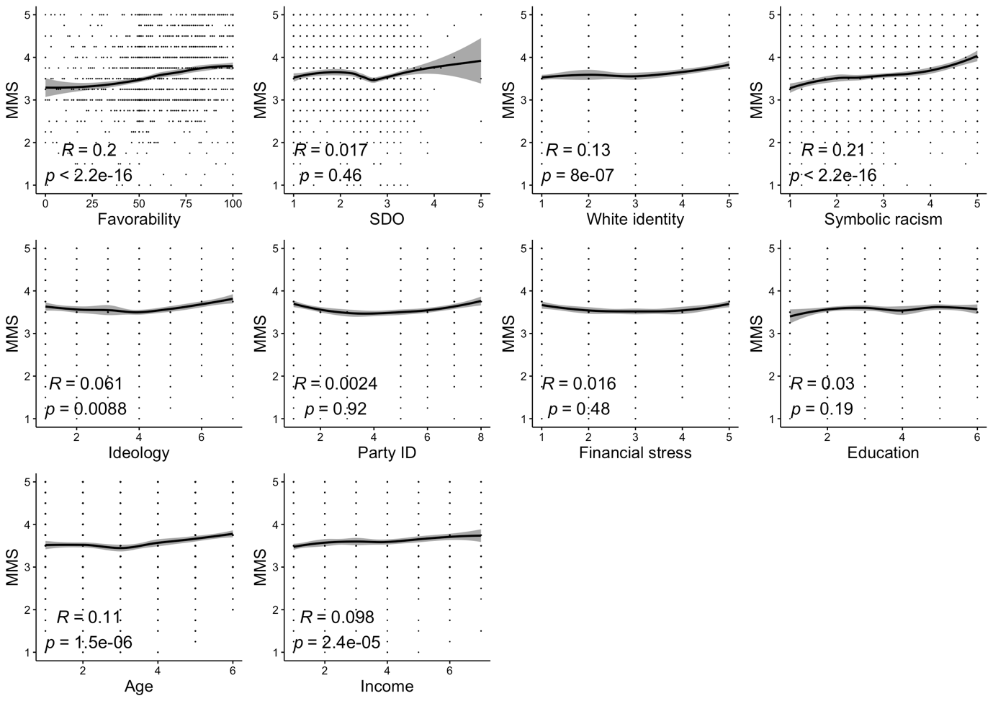Note: The figure displays scatter plots and correlations between AAR and demographic and dispositional traits (Lucid sample). The plots include smoothed loess lines with shaded bands indicating 95 percent confidence intervals.

Figure A.4: Demographic and dispositional correlates of MMS (Lucid sample)

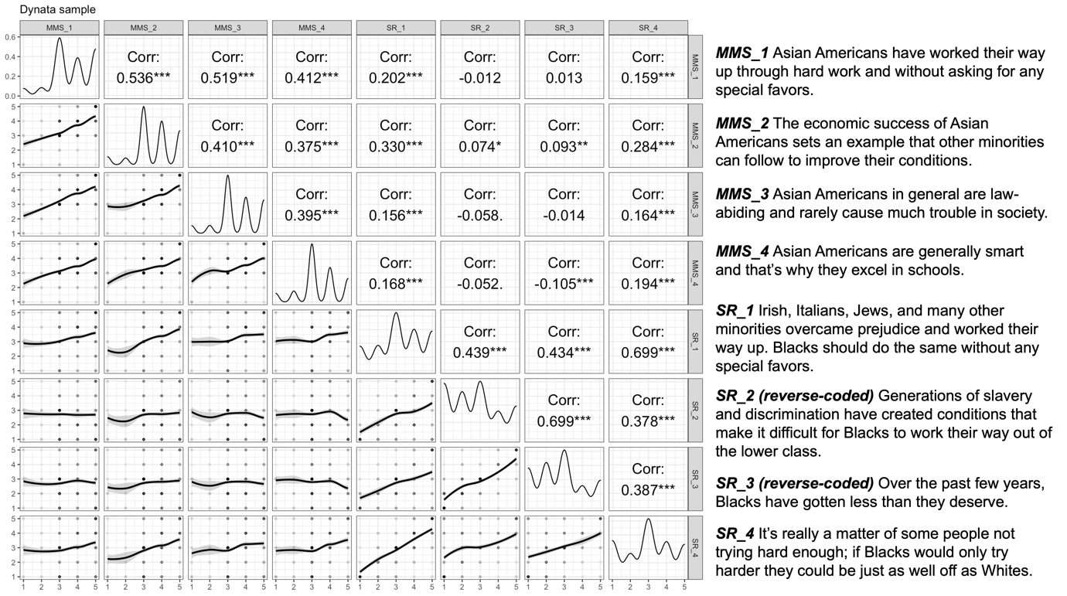

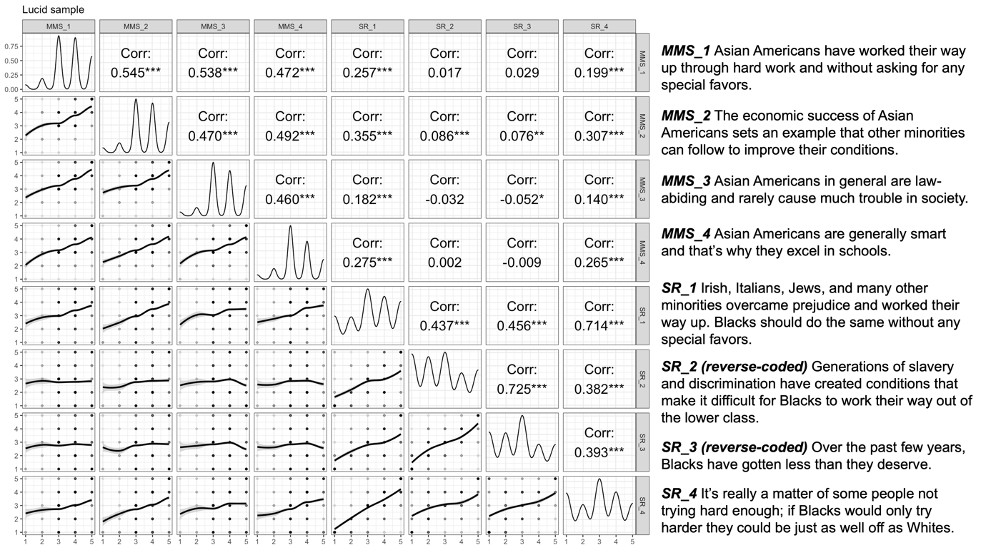
Note: The top panel displays Pearson correlation coefficients among the eight scale items of MMS and symbolic racism from the Dynata survey and the bottom panel displays the results from the Lucid survey. Corresponding scale item wordings are shown. * p<.05. ** p<.01. *** p<.001.

Figure A.5: Correlations between MMS and symbolic racism scale items

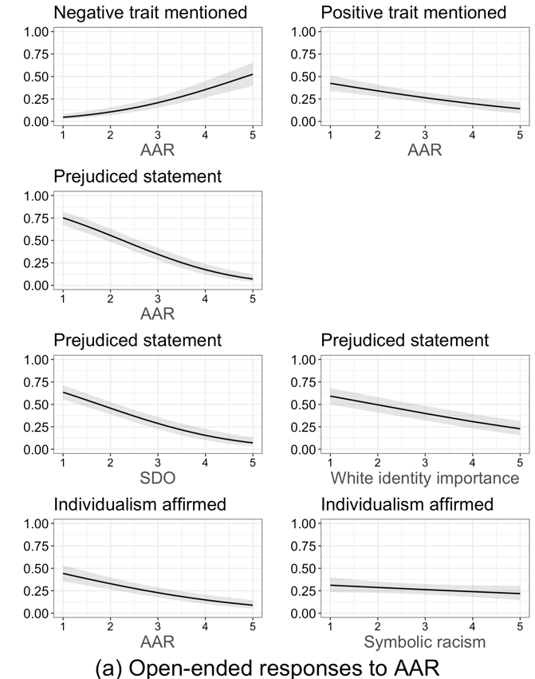 | 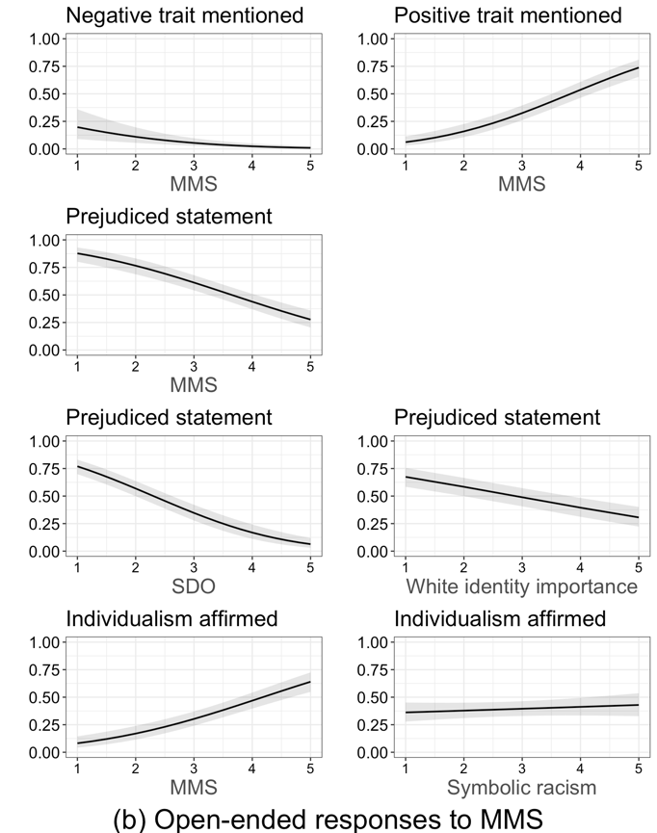
Note: The figure displays the predicted probabilities of key themes appearing in open-ended responses to the AAR (left panel) and MMS (right panel) scales in the Dynata sample, derived from estimates in Tables A.3 and A.4 in the appendix.

Figure A.6: Cognitive responses to AAR and MMS scale items

Open-ended Responses
To analyze in more detail how the survey respondents reacted to the AAR and MMS scales, now we turn to data from open-ended questions we embedded in the Dynata survey. By examining these cognitive responses to each scale item, we can further probe how ordinary Americans actually think and feel about the two prominent racial tropes of Asian Americans. Following Kam and Burge (2018), we asked the following question after the participants answered each scale item for AAR and MMS: “Thinking about the question you just answered, exactly what things went through your mind? Please type your response below.” Two coders independently hand-coded the open-ended responses to identify the key themes informing how individuals understood and reacted to the AAR and MMS scales. The coders were blind to the respondents’ scores on each scale and other background characteristics as well as the purpose of the study. For our analysis, we focus on four key themes identified in the open-ended responses: positive traits of Asian Americans, negative traits of Asian Americans, affirmation of individualism, and rejection of the item statement itself as prejudiced.
Figure A.6 summarizes the predicted probabilities of the four key themes appearing in open-ended responses for each scale, based on AAR and MMS scores and some of the other key dispositional traits. First, we find that a significant portion of the responses included positive characterizations of Asian Americans (e.g., “Hardworking,” “Diligent,” “This is a very good thing.”), mentioned at least once by about 39% of respondents for the AAR battery and 39% for the MMS battery. As shown in Figure A.6, those who scored higher on AAR were less likely to offer a comment in this category, while those who embrace the model minority trope were more likely to characterize Asians in a positive light. This result thus aligns with the above finding that favorable feelings toward Asian Americans tend to go hand in hand with the perception of the group as a “model minority.” Similarly, about 15% and 5% of respondents described the racial group in an explicitly negative light in their responses to the AAR and MMS scales respectively (e.g., “It makes them less human-like,” “Money minds.”), and such negative comments were indeed associated with higher levels of AAR and lower levels of MMS.
Next, about 33% and 35% of respondents referred at least once to principles of individualism in a positive light in their responses to the AAR and MMS battery respectively (e.g., “Work ethic,” “There is nothing wrong with striving to succeed,” “Asians are hardworking.”). As shown in the bottom of Figure A.6, we find that a lower (higher) AAR (MMS) score is associated with a higher likelihood of providing comments in this category. This result suggests that how one views the principle of individualism partially affects the person’s attitudes toward Asian Americans: Those who value hard work, for instance, are more likely to accept the racialized view of Asian Americans as a “model minority” and are less likely to feel resentful toward the group.
Finally, we found that about 37% and 49% of respondents commented directly on the AAR and MMS scale item statements respectively, pointing out that the statements reflect prejudiced perspectives on the Asian population and that the described characteristics have nothing to do with race or ethnicity. For example, responses in this category included “Most people have worked hard to get to where they are,” “Anybody can get ahead if they work hard enough,” “Everyone, no specific race, is competitive for success,” and “Race has nothing to do with achieving anything.” As shown in the same figure, those who scored low on either scale were much more likely to offer comments in this category. Simply put, a significant portion of the American public also rejects both racial tropes as prejudiced and inaccurate characterizations of Asian Americans. The analysis further reveals that respondents higher on SDO and white racial identity were significantly less likely to offer comments in this category; moving from the lowest to the highest values of SDO and white identity, respondents became approximately 30 to 60 percentage points less likely to dismiss the AAR and MMS scale items as prejudiced. In other words, more racially conservative individuals find it less problematic to characterize Asian Americans with the two outstanding racial tropes.

Table A.1: Summary statistics

Variable | Mean | SD | Min | Max
Racial attitudes:
AAR (composite) | 2.99 (2.81) | .91 (.92) | 1 (1) | 5 (5)
AAR_1 | 3.19 (3.18) | 1.07 (1.12) | 1 (1) | 5 (5)
AAR_2 | 2.90 (2.82) | 1.16 (1.17) | 1 (1) | 5 (5)
AAR_3 | 3.14 (2.83) | 1.11 (1.19) | 1 (1) | 5 (5)
AAR_4 | 2.73 (2.42) | 1.32 (1.37) | 1 (1) | 5 (5)
MMS (composite) | 3.59 (3.56) | .77 (.81) | 1 (1) | 5 (5)
MMS_1 | 3.64 (3.68) | .99 (1.09) | 1 (1) | 5 (5)
MMS_2 | 3.62 (3.59) | .99 (1.05) | 1 (1) | 5 (5)
MMS_3 | 3.64 (3.56) | .97 (1.07) | 1 (1) | 5 (5)
MMS_4 | 3.46 (3.39) | .97 (1.06) | 1 (1) | 5 (5)
Symbolic racism | 2.95 (2.93) | 1.06 (1.05) | 1 (1) | 5 (5)
Favorability – Asian | 63.94 (66.35) | 24.11 (23.10) | 0 (0) | 100 (100)
Favorability – White | 67.11 (65.27) | 25.54 (24.65) | 0 (0) | 100 (100)
Favorability – Black | 65.85 (66.26) | 25.05 (24.02) | 0 (0) | 100 (100)
Favorability – Hispanic | 64.79 (65.57) | 24.48 (23.87) | 0 (0) | 100 (100)
Stereotype – Asian | -- (2.98) | -- (1.04) | -- (1) | -- (7)
Stereotype – White | -- (3.53) | -- (1.13) | -- (1) | -- (7)
Stereotype – Black | -- (3.58) | -- (1.15) | -- (1) | -- (7)
Stereotype – Hispanic | -- (3.37) | -- (1.07) | -- (1) | -- (7)
Dispositions:
Ethnocentrism | -- (.02) | -- (.16) | -- (-.72) | -- (1)
Social dominance orientation | 2.34 (2.28) | .81 (.81) | 1 (1) | 5 (5)
White identity importance | 2.69 (2.65) | .41 (.47) | 1 (1) | 5 (5)
Financial stress | 3.02 (2.86) | 1.34 (1.33) | 1 (1) | 5 (5)
Fiscal conservatism | 2.70 (2.67) | 1.14 (1.20) | 1 (1) | 5 (5)
Demographics:
Republican | .29 (.29) | .46 (.45) | 0 (0) | 1 (1)
Democrat | .45 (.49) | .50 (.50) | 0 (0) | 1 (1)
Independent | .25 (.22) | .44 (.41) | 0 (0) | 1 (1)
Ideology | 3.85 (3.96) | 1.75 (1.73) | 1 (1) | 7 (7)
White | .78 (.67) | .41 (.47) | 0 (0) | 1 (1)
College degree | .29 (.34) | .46 (.47) | 0 (0) | 1 (1)
Female | .52 (.53) | .50 (.50) | 0 (0) | 1 (1)
Age | 3.54 (44.89) | 1.63 (16.49) | 1 (18) | 6 (88)
Income | 3.19 (3.50) | 1.78 (1.90) | 1 (1) | 7 (7)
Unemployed | .17 (.14) | .48 (.48) | 0 (0) | 1 (1)
Note: The table summarizes key descriptive statistics of racial attitudes, dispositional variables, and demographics across Lucid (n=1,847) and Dynata (n=1,010) samples. Entries from Dynata are in parentheses. Both samples include white, Black, and Hispanic respondents only. Entries for white identity importance are based on a subset of white respondents.

Table A.2: Open-ended coding protocol

Codeable content? (code)

0 = no (use if: blank/R writes don’t know or not sure/R repeats the question)
1 = yes (use if: R provides any idea that is understandable and suggests some potentially code-able reaction to the question-including remarks about the question wording/bias in the questions/vagueness in the questions)

Average inter-coder Cohen’s kappa / percent agreement for AAR: .50 / 78.38
Average inter-coder Cohen’s kappa / percent agreement for MMS: .43 / 73.13

Reactions to the statement itself as racist/biased/prejudiced (rxn)

0 = no reaction
1 = R thinks the question/statement itself is racist/biased/prejudiced/stereotyped or made R uncomfortable (e.g., “racist statement”)
2 = R thinks Asians are no different from/just like other groups or the traits have nothing to do with race/ethnicity (e.g., “we are all competitive,” “Same as others,” “It depends on the person,” “Every Asian is different,” “it has nothing to do with race)

Average inter-coder Cohen’s kappa / percent agreement for AAR: .71 / 93.38
Average inter-coder Cohen’s kappa / percent agreement for MMS: .72 / 91.53

Traits of Asians (tasian)

0 = no mention
1 = positive (mentioning explicitly positive traits, e.g., hardworking/smart, or endorsement of the statement in a positive light, e.g., “this is a very good thing,” “there is nothing wrong with striving to succeed”)
2 = neutral (mentioning positive & negative traits together, or endorsement of the statement in neither negative or positive light, e.g., “this is true,” “they are born this way,” “they want to make their parents proud”)
3 = negative (mentioning explicitly negative traits, e.g., cold/overachieving/“money minds”, or endorsement of the statement in a negative/sarcastic light, e.g., “How annoying it is,” “…makes them less human like”)

Average inter-coder Cohen’s kappa / percent agreement for AAR: .29 / 67.15
Average inter-coder Cohen’s kappa / percent agreement for MMS: .41 / 77.20

Individualism (individ)

0 = no individualism or work ethic-related comments mentioned
1 = affirmation of individualism (e.g., positively mentioning working hard/work ethic, “there is nothing wrong with striving to succeed,” “Asians are hardworking”)

Average inter-coder Cohen’s kappa / percent agreement for AAR: .34 / 94.03
Average inter-coder Cohen’s kappa / percent agreement for MMS: .49 / 92.08

Table A.3: Predictors of key themes in open-ended responses to AAR scale items from Dynata sample

 | Prejudiced statement | Negative trait mentioned | Positive trait mentioned | Individualism affirmed |  | Prejudiced statement
 | (1) | (2) | (3) | (4) | (5) | (6) | (7)
AAR | -.54*** | .44*** | -.22*** | -.30***
 | (.05) | (.06) | (.05) | (.05)
Symbolic racism |  |  |  |  | -.07
 |  |  |  |  | (.05)
SDO |  |  |  |  |  | -.45***
 |  |  |  |  |  | (.05)
White identity |  |  |  |  |  |  | -.25***
 |  |  |  |  |  |  | (.04)
Independent | .01 | -.11 | .06 | .10 | .12 | .07 | -.11
 | (.12) | (.15) | (.11) | (.12) | (.12) | (.11) | (.14)
Republican | .06 | .09 | .46*** | .35*** | .36** | .06 | -.001
 | (.13) | (.14) | (.12) | (.12) | (.12) | (.12) | (.15)
Ideology | -.03 | .09* | .01 | .02 | .02 | -.003 | -.03
 | (.03) | (.04) | (.03) | (.03) | (.03) | (.03) | (.04)
Education | .01 | -.09* | .06 | .04 | .03 | .02 | -.001
 | (.03) | (.04) | (.03) | (.03) | (.03) | (.03) | (.04)
Male | -.03 | -.34** | .19* | .08 | .04 | -.07 | -.17
 | (.09) | (.11) | (.08) | (.09) | (.09) | (.09) | (.11)
Black | -.32** | -.28 | -.02 | .06 | -.02 | -.39***
 | (.12) | (.15) | (.11) | (.11) | (.11) | (.11)
Hispanic | -.15 | -.11 | .09 | -.01 | -.04 | -.16
 | (.14) | (.18) | (.13) | (.14) | (.14) | (.14)
Age | .002 | .01 | .01* | .01* | .01* | -.004 | .002
 | (.003) | (.003) | (.003) | (.003) | (.003) | (.003) | (.003)
Income | -.03 | .05 | .03 | .01 | .01 | -.04 | -.03
 | (.03) | (.03) | (.03) | (.03) | (.03) | (.03) | (.03)
Constant | 1.28*** | -2.56*** | -.53* | -.36 | -.90*** | 1.04*** | .60*
 | (.24) | (.30) | (.22) | (.23) | (.22) | (.23) | (.24)
N | 1,009 | 1,008 | 1,009 | 1,007 | 1,007 | 1,009 | 673
Note: Probit coefficients with standard errors in parentheses. * p<.05. ** p<.01. *** p<.001.

Table A.4: Predictors of key themes in open-ended responses to MMS scale items from Dynata sample

 | Prejudiced statement | Negative trait mentioned | Positive trait mentioned | Individualism affirmed |  | Prejudiced statement
 | (1) | (2) | (3) | (4) | (5) | (6) | (7)
MMS | -.44*** | -.38*** | .55*** | .44***
 | (.05) | (.09) | (.06) | (.06)
Symbolic racism |  |  |  |  | .04
 |  |  |  |  | (.05)
SDO |  |  |  |  |  | -.57***
 |  |  |  |  |  | (.05)
White identity |  |  |  |  |  |  | -.24***
 |  |  |  |  |  |  | (.03)
Independent | -.01 | -.55* | -.18 | -.02 | -.14 | .16 | .06
 | (.11) | (.23) | (.12) | (.12) | (.12) | (.11) | (.14)
Republican | .05 | -.13 | .07 | .04 | .06 | .06 | .05
 | (.12) | (.21) | (.12) | (.12) | (.12) | (.12) | (.14)
Ideology | -.04 | -.08 | .02 | .01 | .004 | -.01 | -.03
 | (.03) | (.05) | (.03) | (.03) | (.03) | (.03) | (.04)
Education | .01 | -.04 | -.01 | -.02 | -.01 | .02 | .002
 | (.03) | (.06) | (.03) | (.03) | (.03) | (.03) | (.04)
Male | -.01 | .25 | -.16 | -.14 | -.07 | -.03 | -.11
 | (.08) | (.15) | (.09) | (.09) | (.08) | (.08) | (.10)
Black | -.26* | .22 | -.29* | -.24* | -.29** | -.16
 | (.11) | (.17) | (.11) | (.11) | (.11) | (.11)
Hispanic | -.30* | .06 | -.005 | -.05 | -.03 | -.32*
 | (.13) | (.25) | (.14) | (.14) | (.13) | (.13)
Age | .0001 | .01 | .003 | .01** | .01** | -.01* | -.0003
 | (.003) | (.005) | (.003) | (.003) | (.003) | (.003) | (.003)
Income | .001 | -.06 | -.01 | -.05 | -.04 | -.01 | .02
 | (.03) | (.05) | (.03) | (.03) | (.03) | (.03) | (.03)
Constant | 1.75*** | -.23 | -2.25*** | -2.00*** | -.57** | 1.56*** | .71**
 | (.27) | (.45) | (.28) | (.28) | (.22) | (.24) | (.24)
N | 1,009 | 1,009 | 1,009 | 1,009 | 1,009 | 1,009 | 673
Note: Probit coefficients with standard errors in parentheses. * p<.05. ** p<.01. *** p<.001.

Table A.5.1: AAR and support for racialized public policies

 | More Asian immigrants |  | More Asian American  elected officials |  | More Asian American college students |  | More spend on hate crime | More foreign Chinese students
 | Lucid  (1) | Dynata  (2) | Lucid  (3) | Dynata  (4) | Lucid  (5) | Dynata  (6) | Lucid  (7) | Dynata  (8)
AAR | -.02*** | -.01 | -.04*** | -.02** | .004 | .01 | -.03*** | .01
 | (.01) | (.01) | (.01) | (.01) | (.01) | (.01) | (.01) | (.01)
Independent | -.05*** | -.06** | -.07*** | -.10*** | -.03* | -.08*** | -.08*** | -.08***
 | (.01) | (.02) | (.01) | (.02) | (.01) | (.02) | (.02) | (.02)
Republican | -.09*** | -.03 | -.06*** | -.04* | -.03 | -.04* | -.08*** | -.08***
 | (.02) | (.02) | (.01) | (.02) | (.02) | (.02) | (.02) | (.02)
Ideology | -.02*** | -.02** | -.03*** | -.03*** | -.01 | -.02** | -.05*** | -.08***
 | (.01) | (.01) | (.01) | (.01) | (.01) | (.01) | (.01) | (.02)
Demographic controls | Yes | Yes | Yes | Yes | Yes | Yes | Yes | Yes
N | 1,847 | 1,010 | 1,847 | 1,010 | 1,847 | 1,010 | 1,847 | 1,010
Adjusted $R^{2}$ | .13 | .08 | .14 | .08 | .02 | .06 | .11 | .16

Note: * p<.05. ** p<.01. *** p<.001.

Table A.5.2: AAR and support for racialized public policies
(controlling for symbolic racism and fiscal conservatism)

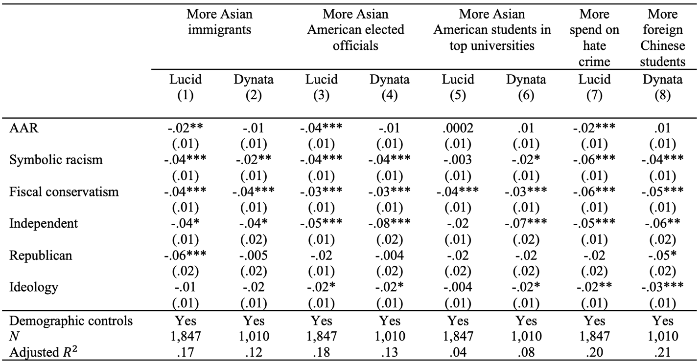
Note: OLS regression coefficients with standard errors in parentheses. Outcome measures are recoded 0-1. Key covariates shown in the table are standardized for easier comparison of effect sizes. * p<.05. ** p<.01. *** p<.001.

Table A.6.1: MMS and support for racialized public policies

 | More Asian immigrants |  | More Asian American  elected officials |  | More Asian American college students |  | More spend on hate crime | More foreign Chinese students
 | Lucid  (1) | Dynata  (2) | Lucid  (3) | Dynata  (4) | Lucid  (5) | Dynata  (6) | Lucid  (7) | Dynata  (8)
MMS | .04*** | .05*** | .05*** | .06*** | .07*** | .07*** | .04*** | .04***
 | (.01) | (.01) | (.01) | (.01) | (.01) | (.01) | (.01) | (.01)
Independent | -.04** | -.05* | -.06*** | -.08*** | -.02 | -.05** | -.06*** | -.07***
 | (.01) | (.02) | (.01) | (.02) | (.01) | (.02) | (.01) | (.02)
Republican | -.09*** | -.04* | -.06*** | -.05** | -.03 | -.02** | -.08*** | -.09***
 | (.02) | (.02) | (.01) | (.02) | (.02) | (.01) | (.02) | (.02)
Ideology | -.03*** | -.02** | -.04*** | -.03*** | -.02* | -.01 | -.05*** | -.04***
 | (.01) | (.01) | (.01) | (.01) | (.01) | (.01) | (.01) | (.01)
Demographic controls | Yes | Yes | Yes | Yes | Yes | Yes | Yes | Yes
N | 1,847 | 1,010 | 1,847 | 1,010 | 1,847 | 1,010 | 1,847 | 1,010
Adjusted $R^{2}$ | .14 | .12 | .14 | .14 | .11 | .15 | .12 | .19

Note: * p<.05. ** p<.01. *** p<.001.

Table A.6.2: MMS and support for racialized public policies
(controlling for symbolic racism and fiscal conservatism)

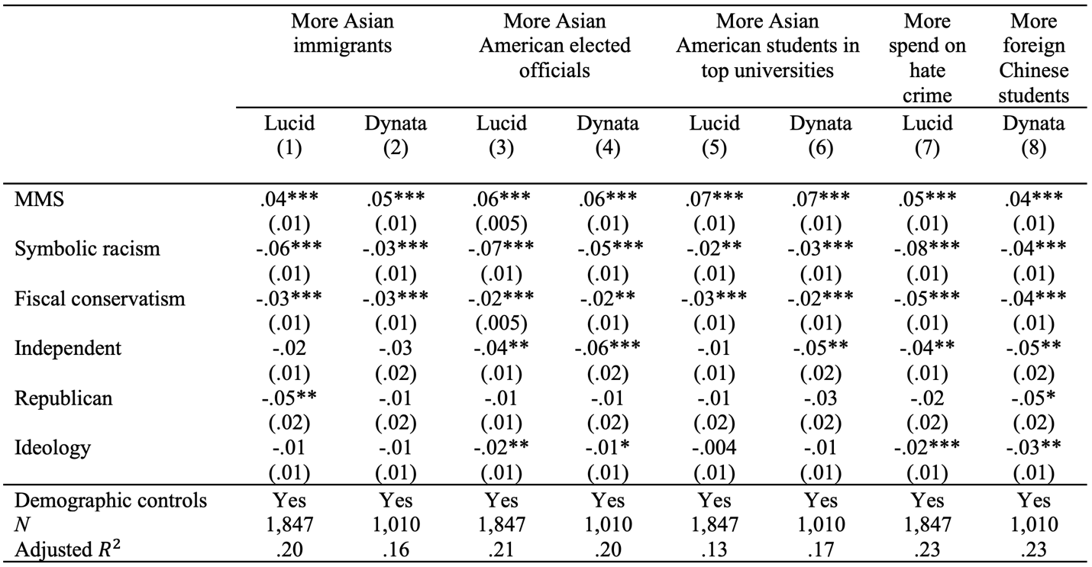
Note: OLS regression coefficients with standard errors in parentheses. Outcome measures are recoded 0-1. Key covariates shown in the table are standardized for easier comparison of effect sizes. * p<.05. ** p<.01. *** p<.001.

Table A.7.1: AAR, MMS, and support for racialized public policies

 | More Asian immigrants |  | More Asian American  elected officials |  | More Asian American college students |  | More spend on hate crime | More foreign Chinese students
 | Lucid  (1) | Dynata  (2) | Lucid  (3) | Dynata  (4) | Lucid  (5) | Dynata  (6) | Lucid  (7) | Dynata  (8)
AAR | -.03*** | -.02** | -.05*** | -.04*** | -.01 | -.01* | -.04*** | -.004
 | (.01) | (.01) | (.005) | (.01) | (.01) | (.01) | (.01) | (.01)
MMS | .04*** | .05*** | .05*** | .07*** | .07*** | .07*** | .05*** | .04***
 | (.01) | (.01) | (.005) | (.01) | (.01) | (.01) | (.01) | (.01)
Independent | -.04** | -.04* | -.06*** | -.08*** | -.02 | -.05** | -.08*** | -.07***
 | (.01) | (.02) | (.01) | (.02) | (.01) | (.02) | (.02) | (.02)
Republican | -.09*** | -.04* | -.06*** | -.05** | -.02 | -.02** | -.08*** | -.09***
 | (.02) | (.02) | (.01) | (.02) | (.02) | (.01) | (.02) | (.02)
Ideology | -.03*** | -.02** | -.03*** | -.03*** | -.01* | -.01 | -.05*** | -.04***
 | (.01) | (.01) | (.01) | (.01) | (.01) | (.01) | (.01) | (.01)
Demographic controls | Yes | Yes | Yes | Yes | Yes | Yes | Yes | Yes
N | 1,847 | 1,010 | 1,847 | 1,010 | 1,847 | 1,010 | 1,847 | 1,010
Adjusted $R^{2}$ | .15 | .13 | .19 | .17 | .11 | .15 | .15 | .19

Note: * p<.05. ** p<.01. *** p<.001.

Table A.7.2: AAR, MMS, and support for racialized public policies
(controlling for symbolic racism and fiscal conservatism)

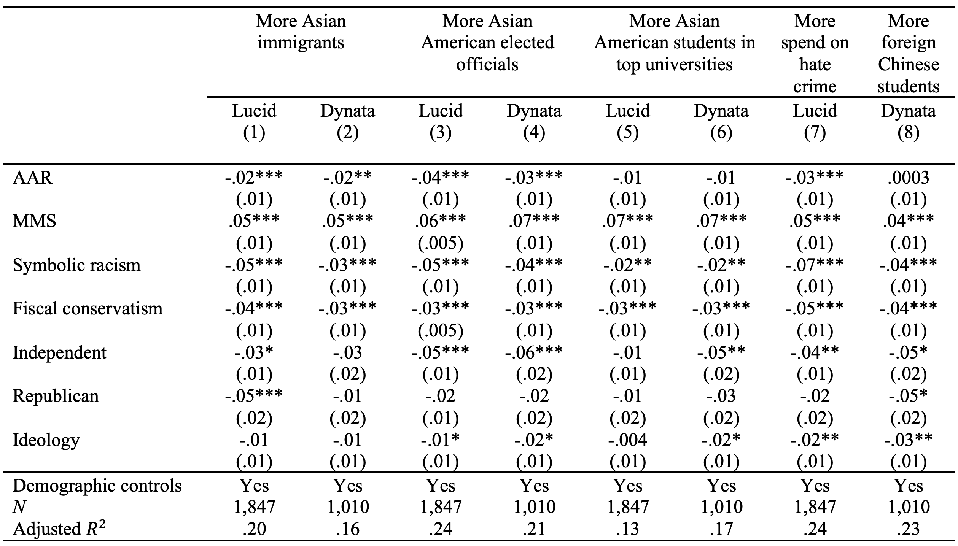
Note: OLS regression coefficients with standard errors in parentheses. Outcome measures are recoded 0-1. Key covariates shown in the table are standardized for easier comparison of effect sizes. * p<.05. ** p<.01. *** p<.001.

Table A.8.1: Combinations of AAR and MMS and support for racialized public policies

 | More Asian immigrants |  | More Asian American  elected officials |  | More Asian American college students |  | More spend on hate crime | More foreign Chinese students
 | Lucid  (1) | Dynata  (2) | Lucid  (3) | Dynata  (4) | Lucid  (5) | Dynata  (6) | Lucid  (7) | Dynata  (8)
High MMS, low AAR | .03 | .02 | .07*** | .07*** | .11*** | .07*** | .06*** | .02
 | (.01) | (.02) | (.01) | (.02) | (.01) | (.02) | (.02) | (.02)
Low MMS, high AAR | -.12*** | -.14*** | -.12*** | -.14*** | -.02 | -.12*** | -.10*** | -.09**
 | (.02) | (.03) | (.02) | (.03) | (.02) | (.03) | (.02) | (.03)
High MMS, high AAR | -.01 | .05** | .004 | .07*** | .12*** | .10*** | .02 | .06**
 | (.01) | (.02) | (.01) | (.02) | (.01) | (.02) | (.02) | (.02)
Independent | -.05*** | -.05** | -.07*** | -.09*** | -.02 | -.06*** | -.07*** | -.07***
 | (.01) | (.01) | (.01) | (.02) | (.01) | (.02) | (.02) | (.02)
Republican | -.09*** | -.03 | -.06*** | -.05* | -.03 | -.04* | -.08*** | -.08***
 | (.02) | (.02) | (.01) | (.02) | (.02) | (.02) | (.02) | (.02)
Ideology | -.03*** | -.03** | -.03*** | -.03*** | -.01 | -.03** | -.05*** | -.04***
 | (.01) | (.01) | (.01) | (.01) | (.01) | (.01) | (.01) | (.01)
Demographic controls | Yes | Yes | Yes | Yes | Yes | Yes | Yes | Yes
N | 1,847 | 1,010 | 1,847 | 1,010 | 1,847 | 1,010 | 1,847 | 1,010
Adjusted $R^{2}$ | .14 | .11 | .15 | .14 | .07 | .12 | .12 | .18

Note: * p<.05. ** p<.01. *** p<.001.

Table A.8.2: Combinations of AAR and MMS and support for racialized public policies (controlling for symbolic racism and fiscal conservatism)

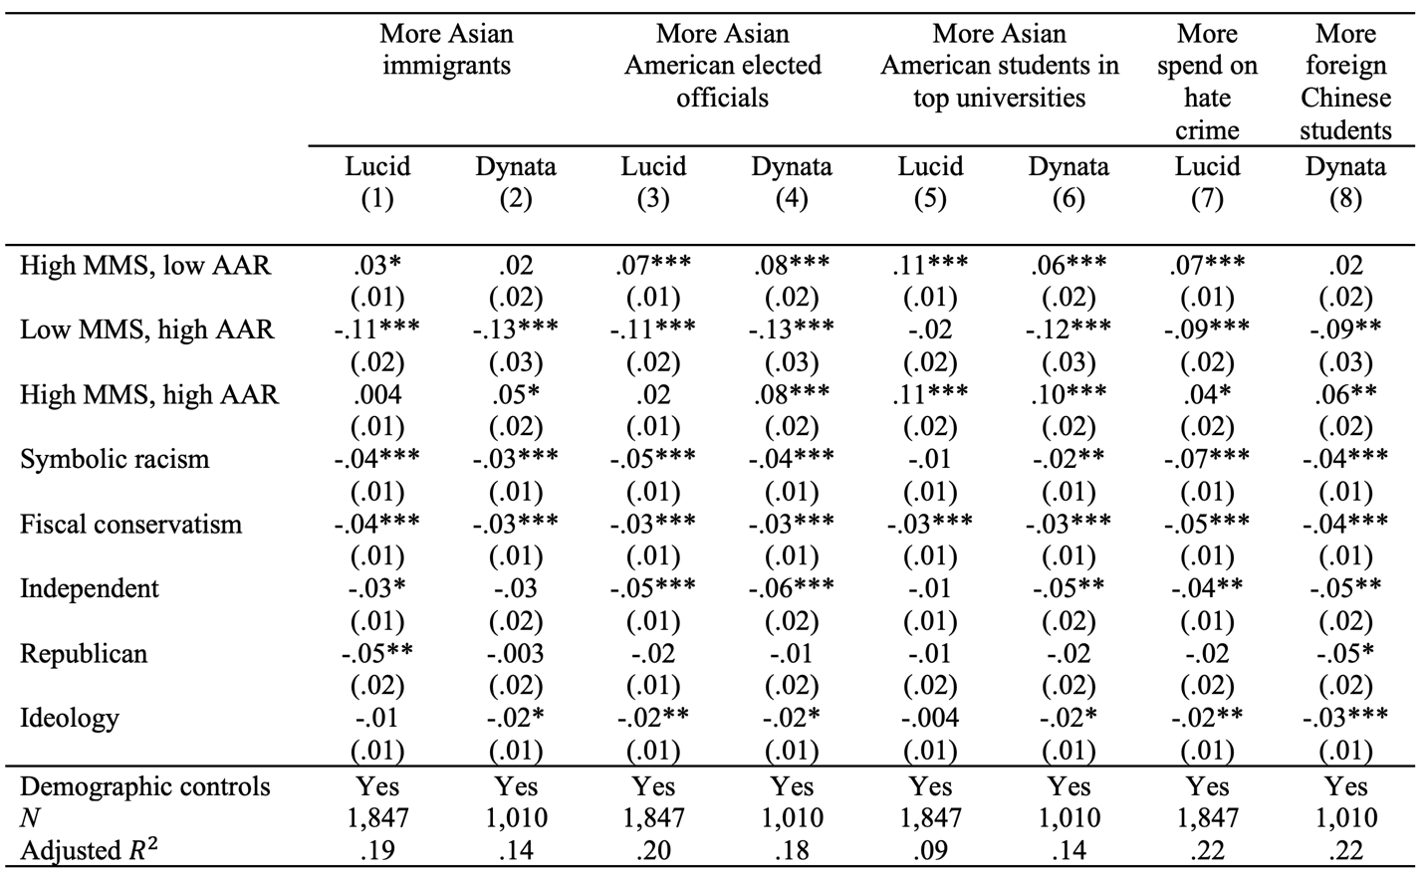
Note: OLS regression coefficients with standard errors in parentheses. Outcome measures are recoded 0-1. Key covariates shown in the table are standardized for easier comparison of effect sizes. * p<.05. ** p<.01. *** p<.001.

Table A.9.1: Effects of feeling thermometer and stereotype measures

 | More Asian immigrants |  | More Asian American  elected officials |  |  | More Asian American college students |  | More spend on hate crime |  |  | More foreign Chinese students
 | Lucid  (1) | Dynata  (2) |  | Lucid  (3) | Dynata  (4) |  | Lucid  (5) |  | Dynata  (6) | Lucid  (7) |  | Dynata  (8)
Feeling thermometer | .03*** | .04*** |  | .05*** | .05*** |  | .01* |  | .03*** | .04*** |  | .02*
 | (.01) | (.01) |  | (.01) | (.01) |  | (.01) |  | (.01) | (.01) |  | (.01)
Stereotype: violent |  | -.01 |  |  | -.004 |  |  |  | -.02* |  |  | -.003
 |  | (.01) |  |  | (.01) |  |  |  | (.01) |  |  | (.01)
Stereotype: untrustworthy |  | .002 |  |  | -.0004 |  |  |  | .01 |  |  | -.001
 |  | (.01) |  |  | (.01) |  |  |  | (.01) |  |  | (.01)
Stereotype: intelligent |  | -.01 |  |  | -.01 |  |  |  | .01 |  |  | -.01
 |  | (.01) |  |  | (.01) |  |  |  | (.01) |  |  | (.01)
Stereotype: hardworking |  | .004 |  |  | .01 |  |  |  | .01 |  |  | .01
 |  | (.01) |  |  | (.01) |  |  |  | (.01) |  |  | (.01)
Demographic controls | Yes | Yes |  | Yes | Yes |  | Yes |  | Yes | Yes |  | Yes
N | 1,847 | 1,010 |  | 1,847 | 1,010 |  | 1,847 |  | 1,010 | 1,847 |  | 1,010
Adjusted $R^{2}$ | .14 | .12 |  | .15 | .13 |  | .02 |  | .09 | .13 |  | .17

Note: Both feeling thermometer and stereotype scales use relative scores, that is, differences between feelings or stereotypes toward Asian Americans and respondents’ racial ingroup, such that higher values for ‘Feeling thermometer’ indicate relatively warmer feelings toward Asian Americans compared to one’s own race, higher values for ‘Stereotype: violent’ and ‘Stereotype: untrustworthy’ indicate the perception of Asian Americans as more violent and untrustworthy than one’s own race, and higher values for ‘Stereotype: intelligent’ and ‘Stereotype: hardworking’ indicate the perception of Asian Americans as more intelligent and hardworking than one’s own. All models control for party ID dummies, ideology, and demographic covariates. * p<.05. ** p<.01. *** p<.001.

Table A.9.2: Effects of AAR, MMS, and feeling thermometer I

 | More Asian immigrants |  | More Asian American  elected officials |  | More Asian American college students |  | More spend on hate crime | More foreign Chinese students
 | Lucid  (1) | Dynata  (2) | Lucid  (3) | Dynata  (4) | Lucid  (5) | Dynata  (6) | Lucid  (7) | Dynata  (8)
AAR | -.02*** | -.01 | -.04*** | -.03*** | -.01 | -.004 | -.03*** | .004
 | (.01) | (.01) | (.01) | (.01) | (.01) | (.01) | (.01) | (.01)
MMS | .04*** | .05*** | .05*** | .06*** | .07*** | .06*** | .04*** | .04***
 | (.01) | (.01) | (.005) | (.01) | (.01) | (.01) | (.01) | (.01)
Feeling thermometer | .02*** | .04*** | .03*** | .04*** | .003 | .03*** | .03*** | .02*
 | (.01) | (.01) | (.01) | (.01) | (.01) | (.01) | (.01) | (.01)
Demographic controls | Yes | Yes | Yes | Yes | Yes | Yes | Yes | Yes
N | 1,847 | 1,010 | 1,847 | 1,010 | 1,847 | 1,010 | 1,847 | 1,010
Adjusted $R^{2}$ | .16 | .16 | .21 | .19 | .11 | .17 | .16 | .19

Note: Models with the Dynata sample include the four stereotype measures but all of them are statistically insignificant and hence dropped from the summary. * p<.05. ** p<.01. *** p<.001.

Table A.9.3: Effects of AAR, MMS, and feeling thermometer II

 | More Asian immigrants |  | More Asian American  elected officials |  | More Asian American college students |  | More spend on hate crime | More foreign Chinese students
 | Lucid  (1) | Dynata  (2) | Lucid  (3) | Dynata  (4) | Lucid  (5) | Dynata  (6) | Lucid  (7) | Dynata  (8)
High MMS, low AAR | .02 | .02 | .06*** | .07*** | .11*** | .06*** | .06*** | .02
 | (.01) | (.02) | (.01) | (.02) | (.01) | (.02) | (.02) | (.02)
Low MMS, high AAR | -.10*** | -.09** | -.09*** | -.10*** | -.01 | -.09** | -.07** | -.07**
 | (.02) | (.03) | (.02) | (.03) | (.02) | (.03) | (.02) | (.03)
High MMS, high AAR | .003 | .06** | .02 | .08*** | .12*** | .11*** | .03 | .07***
 | (.01) | (.02) | (.01) | (.02) | (.02) | (.02) | (.02) | (.02)
Feeling thermometer | .03*** | .04*** | .04*** | .04*** | .01 | .03*** | .04*** | .02*
 | (.01) | (.01) | (.01) | (.01) | (.01) | (.01) | (.01) | (.01)
Demographic controls | Yes | Yes | Yes | Yes | Yes | Yes | Yes | Yes
N | 1,847 | 1,010 | 1,847 | 1,010 | 1,847 | 1,010 | 1,847 | 1,010
Adjusted $R^{2}$ | .15 | .15 | .18 | .17 | .07 | .14 | .14 | .18

Note: Models with the Dynata sample include the four stereotype measures but all of them are statistically insignificant and hence dropped from the summary. * p<.05. ** p<.01. *** p<.001.

Table A.10: AAR, MMS, and support for African American racial policies

 | More federal assistance to African Americans |  | Preferential hiring of African Americans |  | Affirmative action for African American students
 | Lucid | Dynata | Lucid | Dynata | Lucid | Dynata
 | (1) | (2) | (3) | (4) | (5) | (6)
Symbolic racism | -.11*** | -.10*** | -.10*** | -.08*** | -.10*** | -.08***
 | (.01) | (.01) | (.01) | (.01) | (.01) | (.01)
AAR | .002 | .001 | .02** | .01 | .02** | .002
 | (.01) | (.01) | (.01) | (.01) | (.01) | (.01)
MMS | .04*** | .03*** | .03*** | .02** | .03*** | .01
 | (.01) | (.01) | (.01) | (.01) | (.01) | (.01)
Fiscal conservatism | -.09*** | -.11*** | -.09*** | -.12*** | -.10*** | -.13***
 | (.01) | (.01) | (.01) | (.01) | (.01) | (.01)
Independent | -.05*** | -.005 | -.03 | .01 | -.03* | -.02
 | (.01) | (.02) | (.01) | (.02) | (.01) | (.02)
Republican | -.02 | -.02 | -.01 | -.04 | -.03 | -.02
 | (.02) | (.02) | (.02) | (.02) | (.02) | (.02)
Ideology | -.003 | -.01 | -.002 | -.003 | -.0005 | -.004
 | (.01) | (.01) | (.01) | (.01) | (.01) | (.01)
Education | .001 | -.001 | -.003 | -.002 | -.002 | -.002
 | (.004) | (.01) | (.004) | (.01) | (.004) | (.01)
Male | -.01 | .005 | -.01 | .003 | -.01 | -.02
 | (.01) | (.01) | (.01) | (.01) | (.01) | (.01)
Black | .02 | .04* | .04** | .02 | .03 | .03
 | (.02) | (.02) | (.02) | (.02) | (.02) | (.02)
Hispanic | .02 | -.02 | .04 | -.02 | .02 | -.01
 | (.02) | (.02) | (.02) | (.02) | (.02) | (.02)
Age | -.01** | -.001* | -.02*** | -.002*** | -.02*** | -.002***
 | (.003) | (.0004) | (.003) | (.0005) | (.003) | (.0005)
Income | .002 | -.01 | -.002 | -.01 | -.0003 | -.01
 | (.003) | (.004) | (.003) | (.005) | (.003) | (.005)
N | 1,847 | 1,010 | 1,847 | 1,010 | 1,847 | 1,010
Adjusted $R^{2}$ | .38 | .40 | .34 | .38 | .37 | .38
Note: OLS regression coefficients with standard errors in parentheses. Outcome measures are recoded 0-1. Key covariates shown in the table are standardized for easier comparison of effect sizes.* p<.05. ** p<.01. *** p<.001.

Table A.11: Self-monitoring scale and social desirability bias

 | MMS | AAR | Self-Monitor
 | (1) | (2) | (3)
Self-Monitor | .01* | .05***
 | (.01) | (.01)
High MMS, low AAR |  |  | -.02
 |  |  | (.01)
Low MMS, high AAR |  |  | .01
 |  |  | (.02)
High MMS, high AAR |  |  | .05***
 |  |  | (.01)
N | 1,847 | 1,847 | 1,847
Adjusted $R^{2}$ | .03 | .09 | .19

Note: OLS regression coefficients with standard errors in parentheses. Outcome measures are recoded 0-1. All models control for party ID, ideology, and standard demographics.* p<.05. ** p<.01. *** p<.001.

In the Lucid survey, we included the self-monitoring scale that has been developed and extensively tested in the public opinion literature (see e.g., Berinsky and Lavine 2011) to capture individual differences in susceptibility to social desirability bias. Table A.11 shows the results of three OLS regression analyses. The first and second models show that those who score higher on the self-monitoring scale are significantly more likely to score higher on both MMS and AAR. The third model provides a consistent story: those who score high on both MMS and AAR are significantly more likely to be self-monitors. This result alleviates the concern that high self-monitors would deliberately answer higher on MMS but lower on AAR, or lower on both scales, making our main results difficult to interpret.

Table A.12: Survey questions

Demographics
(Age) How old are you?*
- 18 to 24 years
- 25 to 34 years
- 35 to 44 years
- 45 to 54 years
- 55 to 64 years
- Age 65 or older
*For the Dynata survey, the question was answered with an open-ended response.
(Race) What is your race?
- White
- Black or African American
- Spanish/Hispanic/Latino
- Asian
- Native Hawaiian or Pacific Islander
- American Indian and Alaska Native
- Other: please specify
(Gender) What is your gender?
- Male
- Female
- Other
(Income) What was your total household income before taxes during the past 12 months?
- Less than $24,999
- $25,000 to $34,999
- $35,000 to $49,999
- $50,000 to $74,999
- $75000 to $99,999
- $100,000 to $149,999
- $150,000 or more
(Employment status) What is your employment status?
- Working (paid employee)
- Working (self-employed)
- Not working (temporarily laid off)
- Not working (Looking for a job)
- Retired
- Student
- Homemaker
- Other

Table A.12: Survey questions, continued

(Education level) What is the highest degree or level of education you have completed?
- Less than high school
- High school graduate
- Some college, no degree
- 2-year college degree
- 4-year college degree
- Postgraduate degree (MA, MBA, MD, JD, PhD, etc)

Dispositional covariates
(Social dominance orientation) Please indicate whether you agree or disagree with below statements (1=“Strongly agree” – 5=“Strongly disagree”)
- To get ahead in life, it is sometimes necessary to step on other groups.
- It’s probably a good thing that certain groups are at the top and other groups are at the bottom.
- If certain groups stayed in their place, we would have fewer problems.
- Some groups of people are simply inferior to other groups.
- We should do what we can to equalize conditions for different groups.
- No one group should dominate in society.
- Group equality should be our ideal.
(White racial identity) How important is being White to your identity?
- Extremely important
- Very important
- Moderately important
- Slightly important
- Not at all important
(Party identification) Generally speaking, do you think of yourself as a …
- Strong Democrat
- Democrat
- Independent, but lean Democrat
- Independent
- Independent, but lean Republican
- Republican
- Strong Republican

Table A.12: Survey questions, continued

(Political ideology) Thinking about politics these days, how would you describe your political viewpoint?
- Very liberal
- Liberal
- Slightly liberal
- Moderate
- Slightly conservative
- Conservative
- Very conservative
(Financial stress) How worried are you about your/your family’s current financial situation?
- Extremely worried
- Very worried
- Moderately worried
- A little worried
- Not at all worried
(Fiscal conservatism) Please indicate whether you would like to see the following “increased,” “stay the same,” or “decreased” (1=“Increased a lot” – 5=“Decreased a lot”)
- The federal government’s role in the American economy.
(Self-Monitoring Scale*)
- When you’re with other people, how often do you put on a show to impress or entertain them? (Never – Once in a while – About half the time – Most of the time – Always)
- How good or bad of an actor would you be? (Very poor – Poor – Fair – Good – Excellent)
- When you’re in a group of people, how often are you the center of attention? (Never – Once in a while – About half the time – Most of the time – Always)
*This question was included in the Lucid survey only

Racial attitudes
(Racial stereotypes*) Choose a number between 1 and 7 on which the characteristics about different groups of people in American society can be rated.
Where would you rate (Whites/Blacks/Hispanics/Asians) in general on this scale?
1=(Peaceful/Lazy/Not intelligent/Not trustworthy) – 7=(Violent/Hardworking/Intelligent/Trustworthy)
*This question was included in the Dynata survey only.

Table A.12: Survey questions, continued

(Symbolic racism/racial resentment scale) Please indicate whether you agree or disagree with below statements (1=”strongly agree” – 7=”strongly disagree”)
- Irish, Italians, Jews, and many other minorities overcame prejudice and worked their way up. Blacks should do the same without any special favors.
- Generations of slavery and discrimination have created conditions that make it difficult for Blacks to work their way out of the lower class.
- Over the past few years, Blacks have gotten less than they deserve.
- It’s really a matter of some people not trying hard enough; if Blacks would only try harder they could be just as well off as Whites.
(Racial feeling thermometer) Please choose between 0 and 100 to express how you feel about particular groups of people in our society.
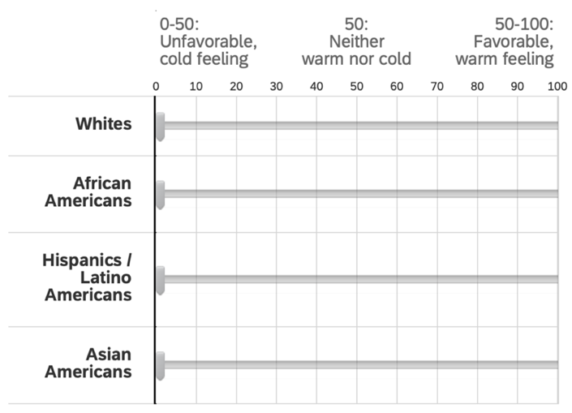
Public policies
(Asian American policies) Please indicate whether you would like to see the following “increased,” “stay the same,” or “decreased” (1=“Increased a lot” – 5=“Decreased a lot”)
- Immigrants from Asia.
- Asian Americans elected in public offices.
- Federal spending on addressing anti-Asian hate crimes.*
- Chinese students studying in the U.S.**
- Asian American students admitted to top (e.g., Ivy League) universities.

*This question was included in the Lucid survey only.
**This question was included in the Dynata survey only.
(African American policies) Please indicate whether you would like to see the following “increased,” “stay the same,” or “decreased” (1=“Increased a lot” – 5=“Decreased a lot”)
- Federal spending on programs that assist African Americans.
- Preferential hiring and promotion of African Americans in jobs.
- Affirmative action for African Americans in college admissions.
- The federal government’s role in the American economy.

Table A.13.1: Resentment scales

Asian American Resentment  (Kim 2023; Ralston 2023) | Muslim American Resentment  (Lajevardi and Abrajano 2018) | Native American Resentment (Beauvais 2021; Beauvais 2022)
- Asian Americans are often overly competitive for their success*  - When it comes to education, Asian Americans strive to achieve too much*  - Asian Americans need to embrace American values more*  - It is annoying when Asian Americans speak in their own languages in public places*  - Asian Americans make the job market too competitive  - Asian Americans think they are smarter than others  Note: The first four items marked with * comprise the shortened version of the AAR scale in the present study. | - Most Muslim Americans integrate successfully into American culture (reversed)  - Muslim Americans sometimes do not have the best interests of Americans at heart  - Muslims living in the United States should be subject to more surveillance than others  - Muslim Americans, in general, tend to be more violent than other people  - Most Muslim Americans reject jihad and violence  - Most Muslim Americans lack basic English language skills  - Most Muslim Americans are not terrorists (reversed)  - Wearing headscarves should be banned in all public spaces  - Muslim Americans do a good job of speaking out against Islamic terrorism (reversed) | - Aboriginals are getting too demanding in their push for land rights  - More must be done to protect Aboriginal languages (reversed)  - Aboriginals get unfair tax breaks  - Irish, Jewish, Chinese, and many other minorities overcame prejudice and worked their way up. Aboriginals should do the same without any special favors  - The government does not show enough respect toward Aboriginals (reversed)  - Aboriginal activists are making reasonable demands (reversed)  - Aboriginals get more favors from the education system than they should have

Table A.13.2: Notes on the AAR & MMS Scales

Notes on the AAR scale:
Different versions of the AAR scale have appeared in previous studies. D.G. Kim (2024) and Ralston (2024) employ a 6-item AAR scale that adds the following question items to the four items listed in Table 1: “Asian Americans think they are smarter than others,” and “Asian Americans make the job market too competitive.” It is also important to note that we do not propose to replace the existing measures of anti-Asian stereotypes in the social psychology literature (Ho and Jackson 2001; Lin et al. 2005) with the AAR scale. As noted in the paper, the previous psychological scales capture a wider range of social stereotypes against Asians in American society, including lack of sociality and other putative dispositional traits of the minority group. The AAR scale, on the other hand, focuses on capturing the perception of Asians as a competitive foreign threat (the “yellow peril” racial trope), which has been highlighted in the literature in American race and ethnic politics as the key components of racialized resentment against the minority population. The MMS scale also contributes to a more direct measurement of the specific perception of Asians as a “model minority.” Future studies can examine how the particular racial tropes we focus on in this paper might systematically relate to a broad range of entrenched anti-Asian stereotypes in the United States and beyond.

Notes on reverse-coded items:
Before we turn to our data, it should be stressed that neither of our scales includes reverse-coded items, which have been extensively used in previous measures of racial attitudes as a tool to reduce acquiescence bias (Lajevardi 2020). While some of the recent measures of racial attitudes including the Native American resentment scale (Foxworth and Boulding 2022) have been developed and validated without any reverse-coded items, we suggest future empirical studies to stress-test the robustness of our new measures with additional items that capture the opposite end of each measured construct (Huddy and Bankert 2017). For the present study, we provide a first-cut empirical examination of the overall structure of mass racialized views toward Asian Americans by utilizing our proposed measures that employ four single-valenced items in each scale.

Notes on acquiescence bias:
To allay concerns about acquiescence bias, we show in Table A.11 in the Appendix that our survey respondents did not exhibit a significant bias towards stronger agreement with the items comprising the model minority stereotype scale.

Table A.14.1: White vs. non-white subgroup analysis I

 |  | AAR | MMS
Dynata sample | White | 2.79 (.92) | 3.61 (.79)
 | Black | 2.95 (.96) | 3.42 (.90)
 | Hispanic | 2.68 (.79) | 3.50 (.78)
 |  | AAR | MMS
Lucid sample | White | 2.97 (.91) | 3.61 (.77)
 | Black | 3.07 (.91) | 3.45 (.77)
 | Hispanic | 3.06 (.92) | 3.56 (.79)

Note: Mean levels of AAR and MMS among different racial subgroups across two surveys. Standard deviations are in parentheses.

Table A.14.2: White vs. non-white subgroup analysis II (Table 2 with Blacks only)

 | More Asian immigrants |  | More Asian American  elected officials |  | More Asian American college students |  | More spend on hate crime | More foreign Chinese students
 | Lucid  (1) | Dynata  (2) | Lucid  (3) | Dynata  (4) | Lucid  (5) | Dynata  (6) | Lucid  (7) | Dynata  (8)
Each scale alone
AAR | .004 | -.02 | -.004 | .01 | .03 | .01 | .01 | .004
 | (.01) | (.02) | (.02) | (.01) | (.02) | (.02) | (.02) | (.02)
MMS | .04** | .05** | .06*** | .04** | .06*** | .06*** | .05*** | .06***
 | (.01) | (.02) | (.01) | (.01) | (.01) | (.01) | (.01) | (.02)
Both scales together
AAR | -.01 | -.04* | -.03 | -.01 | .01 | -.01 | -.01 | -.02
 | (.01) | (.02) | (.02) | (.02) | (.02) | (.02) | (.02) | (.02)
MMS | .04** | .06*** | .07*** | .04** | .06*** | .06*** | .06*** | .06***
 | (.01) | (.02) | (.01) | (.01) | (.01) | (.02) | (.01) | (.02)
AAR x MMS
High MMS, low AAR | .08* | .02 | .13** | .03 | .11** | .03 | .13** | .03
 | (.04) | (.04) | (.04) | (.04) | (.04) | (.04) | (.04) | (.04)
Low MMS, high AAR | .06 | -.18* | .01 | -.17* | .11 | -.20** | .08 | -.14
 | (.06) | (.07) | (.07) | (.07) | (.07) | (.07) | (.07) | (.07)
High MMS, high AAR | .05 | .05 | .12** | .08* | .12** | .12** | .11** | .06
 | (.04) | (.04) | (.04) | (.04) | (.04) | (.04) | (.04) | (.04)
Adjusted $R^{2}$
AAR only | .06 | .07 | .04 | .02 | .02 | .06 | .08 | .06
MMS only | .09 | .11 | .13 | .06 | .08 | .13 | .13 | .12
Both scales | .09 | .13 | .13 | .06 | .08 | .13 | .13 | .12
AAR x MMS | .07 | .09 | .09 | .08 | .04 | .14 | .12 | .08
N | 262 | 213 | 262 | 213 | 262 | 213 | 262 | 213
Note: OLS regression coefficients with standard errors in parentheses. Outcome measures are recoded 0-1. Each model controls for demographic covariates, ideology, and party identification. Both AAR and MMS are standardized for comparison of effect sizes. * p<.05. ** p<.01. *** p<.001.

Table A.14.3: White vs. non-white subgroup analysis III (Table 2 with Hispanics only)

 | More Asian immigrants |  | More Asian American  elected officials |  | More Asian American college students |  | More spend on hate crime | More foreign Chinese students
 | Lucid  (1) | Dynata  (2) | Lucid  (3) | Dynata  (4) | Lucid  (5) | Dynata  (6) | Lucid  (7) | Dynata  (8)
Each scale alone
AAR | -.01 | -.03 | -.02 | -.07** | -.002 | -.01 | -.03 | -.02
 | (.02) | (.02) | (.02) | (.02) | (.02) | (.02) | (.02) | (.02)
MMS | .07*** | .06** | .06** | .06** | .06*** | .10*** | .07*** | .05*
 | (.02) | (.02) | (.02) | (.02) | (.02) | (.02) | (.02) | (.02)
Both scales together
AAR | -.04 | -.04 | -.05* | -.08*** | -.03 | -.03 | -.07** | -.03
 | (.02) | (.02) | (.02) | (.02) | (.02) | (.02) | (.02) | (.02)
MMS | .09*** | .07*** | .07*** | .07*** | .07*** | .10*** | .10*** | .05*
 | (.02) | (.02) | (.02) | (.02) | (.02) | (.02) | (.02) | (.02)
AAR x MMS
High MMS, low AAR | .06 | .02 | .06 | .17*** | .07 | .14** | .10 | .08
 | (.05) | (.04) | (.05) | (.04) | (.05) | (.05) | (.06) | (.05)
Low MMS, high AAR | -.26** | -.14 | -.24** | -.15 | -.09 | -.01 | -.29** | -.10
 | (.09) | (.08) | (.09) | (.08) | (.08) | (.08) | (.09) | (.08)
High MMS, high AAR | .07 | .06 | .04 | .05 | .10* | .18** | .10 | .06
 | (.05) | (.06) | (.05) | (.06) | (.05) | (.06) | (.06) | (.06)
Adjusted $R^{2}$
AAR only | .03 | .04 | .04 | .05 | .04 | .02 | .01 | .06
MMS only | .12 | .11 | .09 | .05 | .14 | .19 | .09 | .09
Both scales | .14 | .12 | .12 | .14 | .15 | .19 | .14 | .09
AAR x MMS | .12 | .07 | .11 | .15 | .09 | .12 | .14 | .09
N | 262 | 213 | 262 | 213 | 262 | 213 | 262 | 213
Note: OLS regression coefficients with standard errors in parentheses. Outcome measures are recoded 0-1. Each model controls for demographic covariates, ideology, and party identification. Both AAR and MMS are standardized for comparison of effect sizes. Full results can be found in the appendix. * p<.05. ** p<.01. *** p<.001.

Table A.14.4: Notes on white vs. non-white differences

We found interesting patterns of differences in responses between white and non-White respondents across both surveys, which can be probed further in follow-up surveys with larger numbers of respondents with diverse ethno-racial backgrounds. While both African and Hispanic American respondents subscribe to the two racial tropes as strongly as their White counterparts, their levels of racial identification are either unrelated to or much less strongly correlated with both AAR and MMS than levels of white racial identity. In addition, as shown in Tables A.14.2 and A.14.3, AAR, but not MMS, has either null or much less salient effects on racial policy opinion among Black and Hispanic respondents, despite their similar levels of AAR scores in both surveys. These results suggest distinct patterns of racial attitude and policy opinion formation among non-White Americans who may be less inclined to translate their resentful feelings toward other minorities (such as Asian Americans) into actual public policy preferences.

References

Berinsky, Adam J., and Howard Lavine. 2011. “Self-Monitoring and Political Attitudes.” In
Improving Public Opinion Surveys: Interdisciplinary Innovation and the American
National Election Studies, edited by Kathleen M. McGraw and John H. Aldrich.
Princeton: Princeton University Press.
Blum, Lawrence. 2002. “I’m Not Racist But...”: The Moral Quandary of Race. Ithaca:
Cornell University Press.
Kim, D.G. 2023. “The Politicization of COVID-19 and Anti-Asian Racism in the United States:
An Experimental Approach.” Journal of Experimental Political Science 11(1): 1-11.
Lajevardi, Nazita, and Marisa Abrajano. 2018. “How Negative Sentiment toward Muslim
Americans Predicts Support for Trump in the 2016 Presidential Election.” The Journal
of Politics 81 (1): 296-302.
Ralston, Robert. 2023. “American Decline and Anti-Asian Sentiment.” Politics, Groups, and
Identities.
Beauvais, Edana. 2021. “Measuring Anti-Indigenous Attitudes: The Indigenous Resentment
Scale.” Race and Social Problems 13: 306-319.
Beauvais, Edana. 2022. “The Political Consequences of Indigenous Resentment.” Journal of
Race, Ethnicity, and Politics 7 (1): 37-64.

The entries in parentheses are from the Lucid survey.
See Table A.2 in the appendix for the detailed coding protocol and inter-coder reliability scores.

