**Appendix for “Are Solidarity and Identification as People of Color Distinct?”**

A.1) Sensitivity of results to weighting

A.2) Mediation analyses with full set of policy outcomes in the 2023 AMPS

A.3) Sensitivity analyses for mediation analyses in section A.2

A.4) A Comparison of indirect effects (IE) in models with and without acquiescence bias addressed

**A1. Sensitivity of Results to Weighting**

The analyses reported in the paper use unweighted data, as this requires fewer assumptions. The loadings below, which estimate our configural model with weights turned on, show largely identical loadings and standard errors to the ones we report in table 3 in the text.

Table A1. Weighted versus Unweighted Loadings from Configural MG-CFA Models

Note: The top panel of entries are for PoC ID. The bottom panel of entries are for PoC Solidarity. For each latent variable, one item is fixed to 1.0 to identify the measurement model. Italicized entries are weighted. Unweighted entries are unitalicized.

B = Black adults; A = Asian adults; L = Latino adults; M = Multiracial adults. All loadings are significant at the 1% or better.

|  |  |  |  |  |  |  |  |  |  |  |  |  |  |  |
| --- | --- | --- | --- | --- | --- | --- | --- | --- | --- | --- | --- | --- | --- | --- |
|  | B | A | L | M |  | B | A | L | M |  | B | A | L | M |
| Imp. ID | 1.00 | 1.00 | 1.00 | 1.00 | See myself | .91  (.03) | 1.02  (.01) | 1.04  (.01) | 1.00  (.01) | Think  About | .70  (.05) | .83  (.02) | .91  (.03) | .87  (.01) |
| Weighted | 1.00 | 1.00 | 1.00 | 1.00 |  | *.92*  *(.03)* | *1.02*  *(.01)* | *1.03*  *(.02)* | *1.02*  *(.01)* |  | *.71*  *(.06)* | *.86*  *(.02)* | *.91*  *(.04)* | *.88*  *(.02)* |
| Feel bond | 1.00 | 1.00 | 1.00 | 1.00 | See allies | 1.00  (.04) | .86  (.02) | 1.04  (.01) | .94  (.03) | Common  Fate | .92  (.06) | .79  (.02) | .97  (.03) | 1.09  (.04) |
| Weighted | 1.00 | 1.00 | 1.00 | 1.00 |  | *1.00*  *(.04)* | *.81*  *(.03)* | *1.07*  *(.04)* | *.95*  *(.03)* |  | *.91*  *(.07)* | *.74*  *(.03)* | *1.01*  *(.03)* | *1.10*  *(.05)* |

**A.2) Mediation analyses with full set of policy outcomes in the 2023 AMPS**

In the paper, we report mediation analyses for all respondents where the outcome is support for slavery reparations. The 2023 AMPS fielded two additional policy proposals that implicated Latinos and Asians, respectively. These were support for renewal of deferred action on childhood arrivals (DACA), which strongly implicates Latinos; and support for increases in H1-B visas for high-skilled immigrants, which strongly implicates Latinos (see Pérez 2022; Pérez et al. 2022). These policy items were answered on the same scale running from 1-strongly disagree to 5-strongly agree. The path diagrams below depict the findings for all relevant policy outcomes available in the 2023 AMPS. The findings are generally consistent across groups and policy outcomes. All variables are continuous and normed to a 0-1 range, making the coefficients percentage-point shifts. All analyses include ideology as a covariate. The direct path between PoC identity and each outcome, without inclusion of our proposed mediator, is denoted by c. The same direct path, with inclusion of our proposed mediator is dented by ‘c.

Panel A. Support for slavery reparations

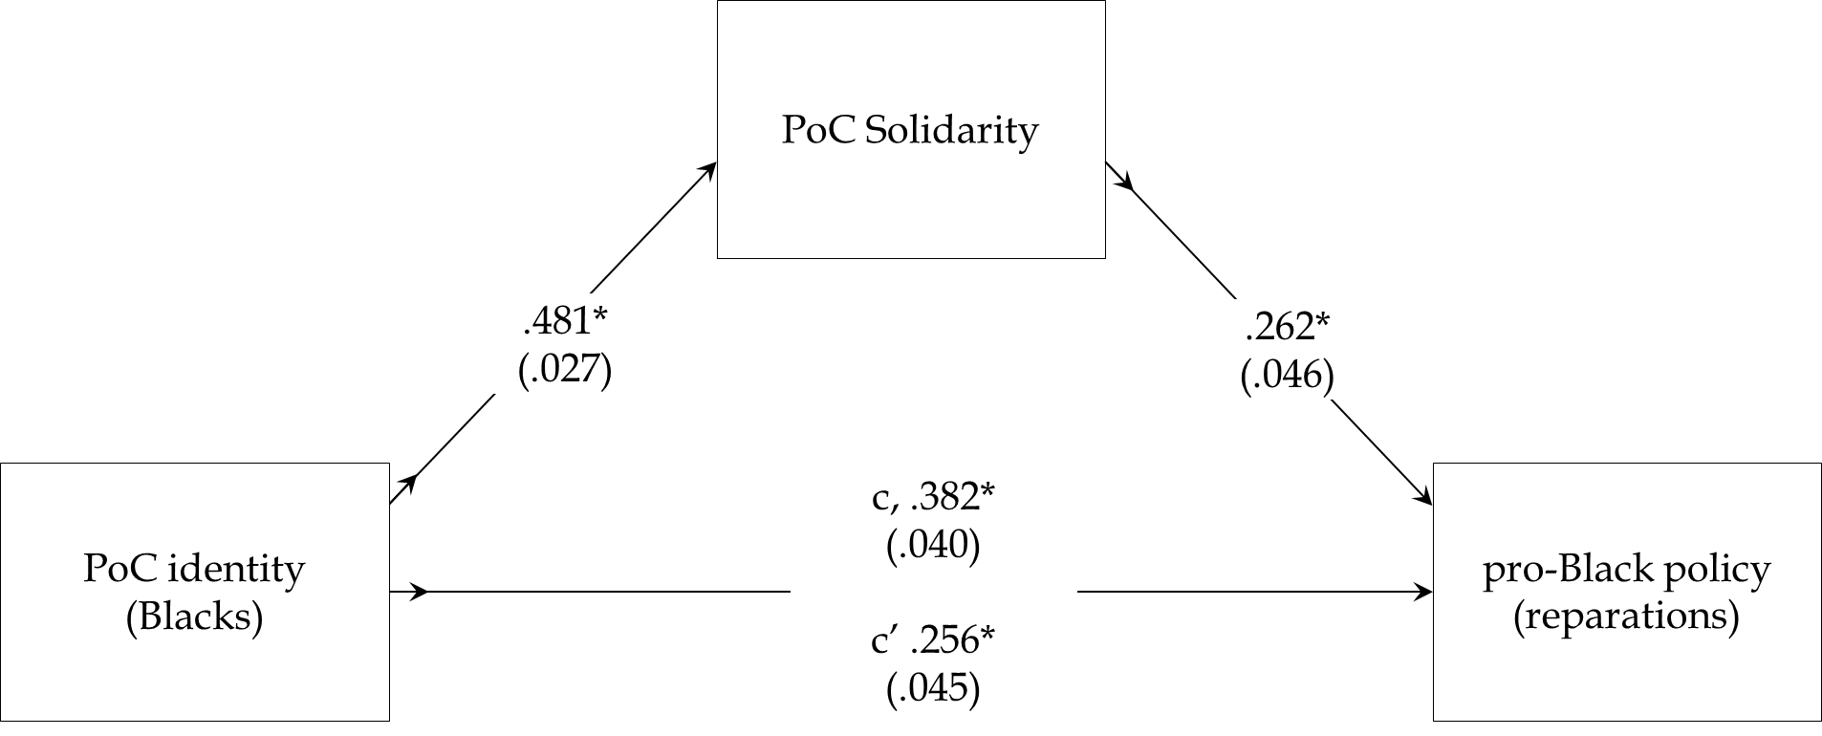

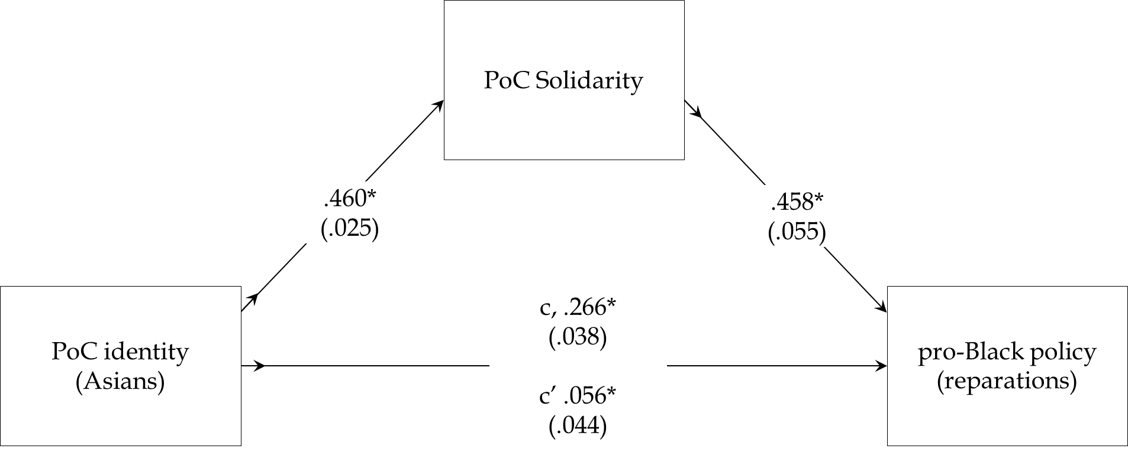

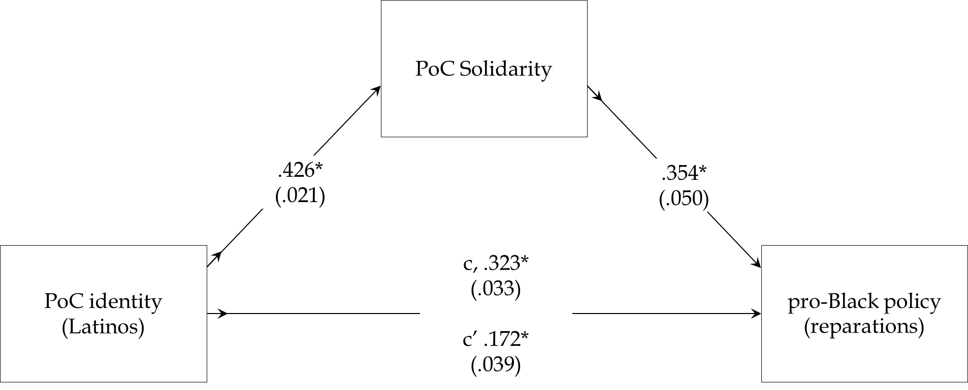

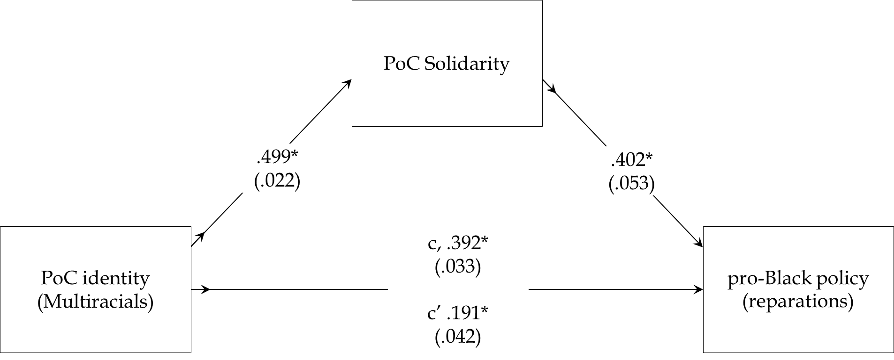

Panel B. Support for DACA

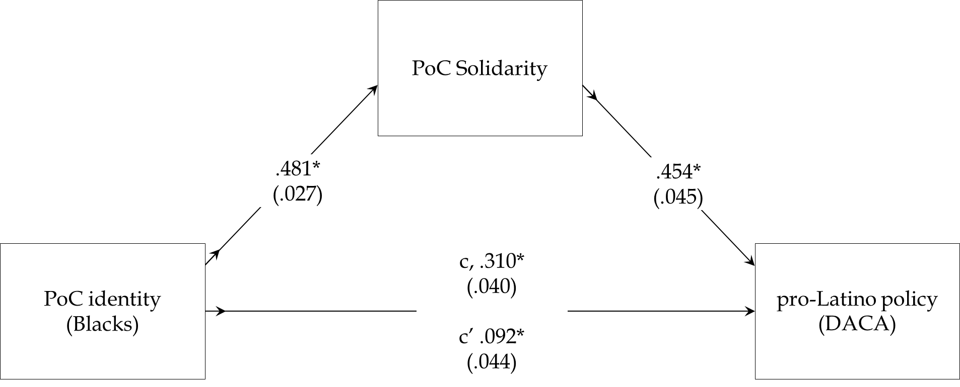

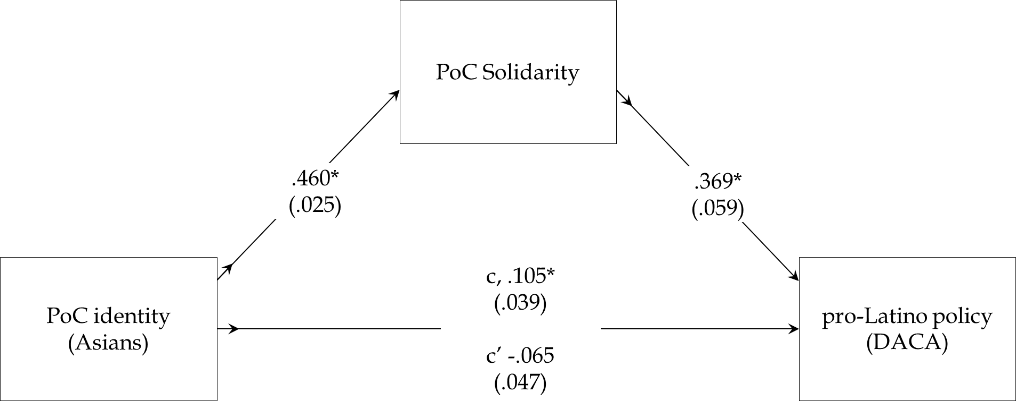

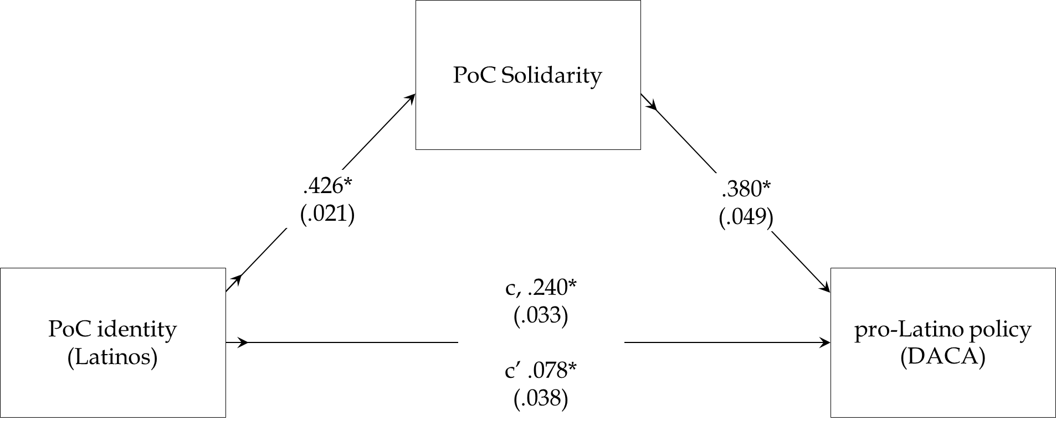

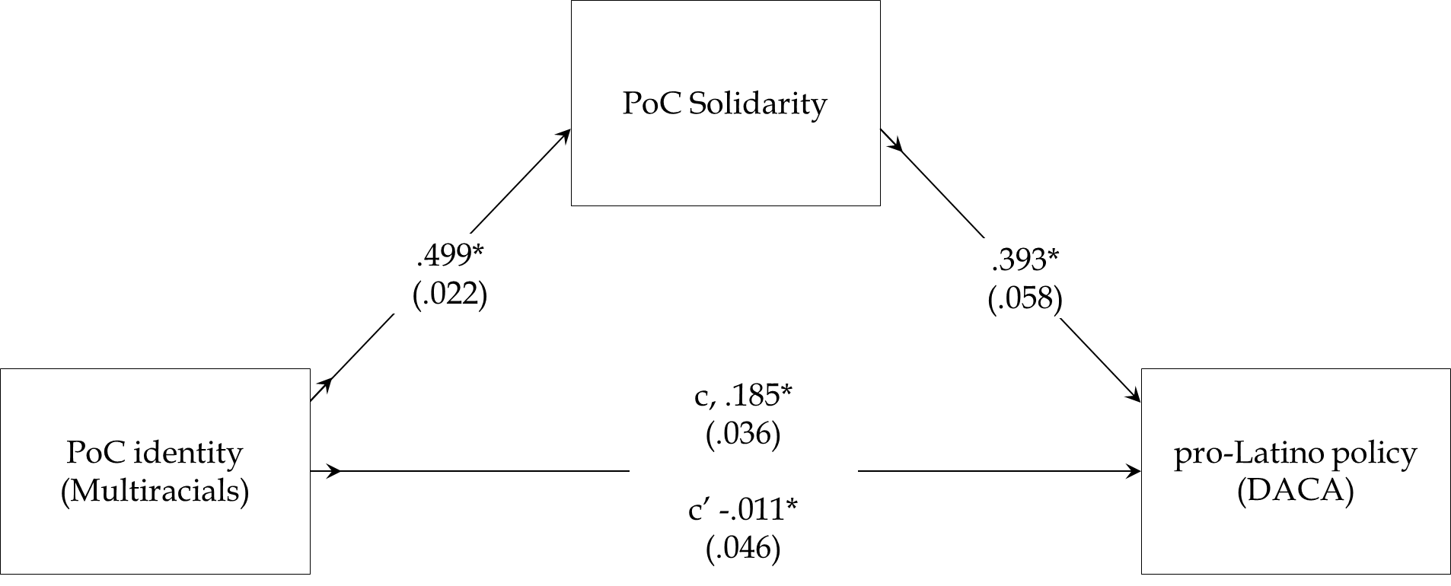

Panel C. Support for H1-B visas

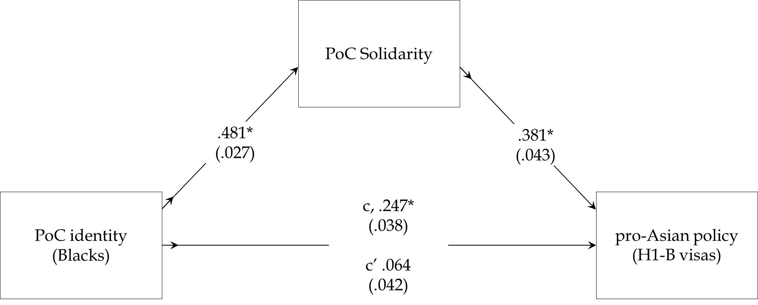

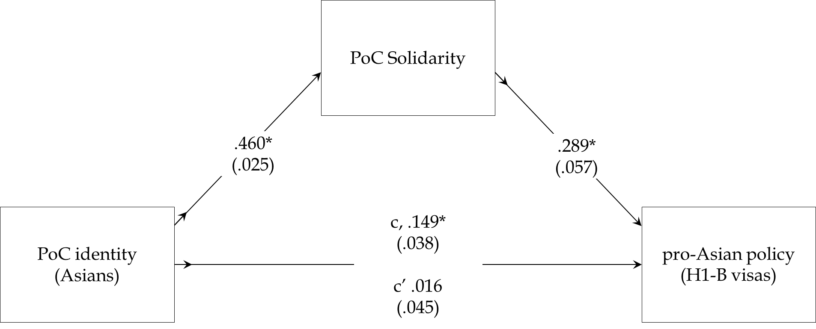

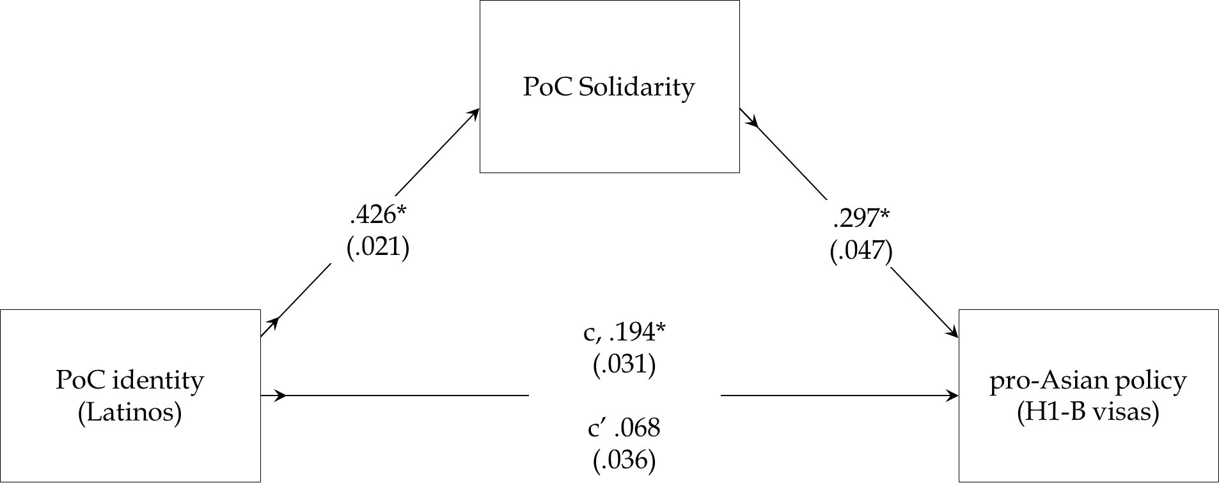

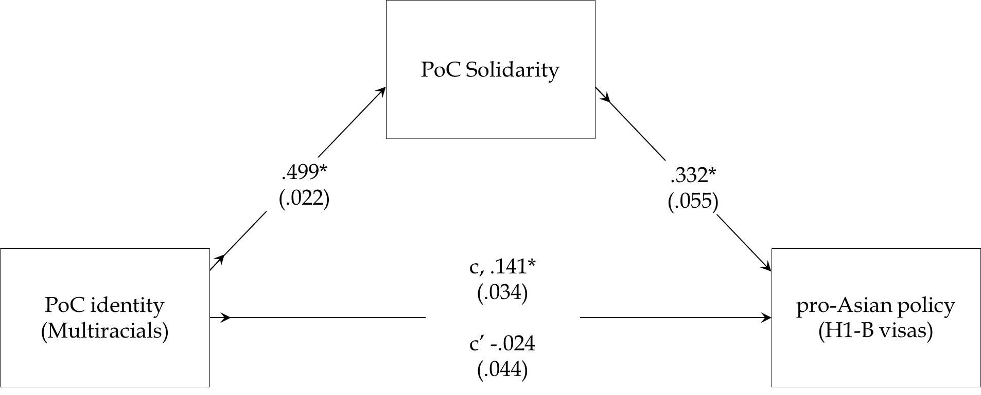

**A.3) Sensitivity analyses for mediation analyses in section A.1**

The analyses below provide a formal sense of how robust the mediation analyses reported in section A.1 are. In the table below, consider Black individuals’ support for DACA. The PR2 value for this downstream estimate suggests that if confounders explained all the residual variance in this outcome, they would need to explain at least 9.40% of solidarity’s residual variance to fully account for its downstream influence. In turn, the robustness value (RVα=.05) means that unobserved confounders would need to explain at least 27.44% of the residual variance of solidarity and support for DACA to bring solidarity’s downstream influence among Black respondents to zero (0). Moving down across the rows, we learn that these mediation results, based on correlational data, are fairly robust (Cinelli and Hazlett 2020).

Table A.3.1. Sensitivity Analyses for Downstream Paths by Outcome and Racial Group

*Note:* RV is the partial R2 of the treatment with the outcome. RVα=.05 is the robustness value for the point estimate. The interpretation of each statistic is explained in the text.

|  |  |  |  |
| --- | --- | --- | --- |
|  | Support DACA | Support H1-B | Support Reparations |
| Blacks |  |  |  |
| PR2 | 9.40% | 7.41% | 3.20% |
| RVα=.05 | 27.44% | 24.57% | 16.61% |
|  |  |  |  |
| Asians |  |  |  |
| RV | 5.49% | 3.67% | 9.33% |
| RVα=.05 | 21.36% | 17.72% | 27.34% |
| Latinos |  |  |  |
| RV | 5.84% | 3.96% | 4.92% |
| RVα=.05 | 22.00% | 18.34% | 20.30% |
| Multiracials |  |  |  |
| RV | 4.52% | 3.62% | 5.60% |
| RVα=.05 | 19.53% | 17.60% | 21.58% |

**A.4) A Comparison of Indirect Effects (IE) in Models With and Without Acquiescence Bias Addressed**

For ease of interpretation, our paper reports mediation analyses without considering acquiescence bias (i.e., all items are positively worded). We address this issue here by comparing our original indirect effects to those obtained from a structural equation model (SEM) where acquiescence bias is modeled as a separate factor, in addition to our substantive latent variables (*PoC identity*, *PoC solidarity*).

Specifically, we draw on Savalei and Falk (2014) to estimate a multi-group model where all our available indicators (which run from 1 to 5) are modeled as part of a common method factor (i.e., acquiescence bias). This includes our three policy outcome variables (i.e., *support reparations*, *support DACA*, *support H1B1 visas*). We then recover new indirect effects (IEs) with their respective 95% confidence interval (CIs). This allows us to gauge possible discrepancies between these new estimates and our original IEs.

Table A.3.1 reports the correlations between *PoC identity* and *PoC solidarity* with method artifact removed. For comparison, we report the original correlation between both factors from the model reported in the text. Modeling this method factor reduces the correlation between both factors (Savalei and Falk 2014). This means failure to model method artifact can artificially increase the correlation between our substantive latent variables. How does this affect the IEs reported in the text?

Table A.3.2 reports indirect effects (IEs) from our revised model, along with their respective 95% confidence intervals (CIs). Critically, both the original and revised estimates display the same sign, with more than half of the original estimates falling within the 95% CI of the revised estimates. In the remaining cases, the original estimates are significantly larger, but still in the same hypothesized direction.

This analysis should encourage analysts of these data to appreciate that the strength of indirect effects can be affected by method artifact. When the hypotheses being tested are directional (as in our paper), the difference in IEs is largely negligible to the inference being drawn. But, in the case where one is testing more granular hypotheses about the size of coefficients, then the point estimates with method artifact modeled will be of more value to the analyst.

Savalei, Victoria, and Carl F. Falk. 2014. Recovering Substantive Factor Loadings in the Presence of Acquiescence Bias: A Comparison of Three Approaches. *Multivariate Behavioral Research* 49(5): 407-424.

Table A.4.1. Inter-Factor Correlations Between PoC Identity and PoC Solidarity From Models With and Without Acquiescence Bias Addressed

*Note:* All inter-factor correlations are significant at the 5% level or better.

|  |  |  |
| --- | --- | --- |
|  | Correlation  (w/out method artifact) | Correlation  (w/ method artifact) |
| PoC ID w/ PoC Solidarity (Blacks) | .41 | .38 |
| PoC ID w/ PoC Solidarity (Asians) | .64 | .42 |
| PoC ID w/ PoC Solidarity (Latinos) | .51 | .36 |
| PoC ID w/ PoC Solidarity (Multiracials) | .61 | .42 |

Table A.3.2. Comparison of Indirect Effects (IE) in Models With and Without Acquiescence Bias Addressed

|  |  |  |
| --- | --- | --- |
| Outcome (Sample) | IE w/ Method Factor  [95% CI] | IE w/out Method Factor |
| Reparations for Black people (Black adults) | .060  [.034, .087] | .126 |
| Reparations for Black people (Asian adults) | .175  [.133, .216] | .211 |
| Reparations for Black people (Latino adults) | .137  [.102, .172] | .151 |
| Reparations for Black people (Multiracial adults) | .245  [.164, .325] | .201 |
|  |  |  |
| Support DACA  (Black adults) | .130  [.093, .166] | .218 |
| Support DACA  (Asian adults) | .147  [.111, .183] | .170 |
| Support DACA  (Latino adults) | .132  [.100, .164] | .162 |
| Support DACA  (Multiracial adults) | .194  [.139, .249] | .196 |
|  |  |  |
| Support H1B1  (Black adults) | .124  [.090, .159] | .183 |
| Support H1B1  (Asian adults) | .094  [.063, .125] | .133 |
| Support H1B1  (Latino adults) | .098  [.071, .125] | .127 |
| Support H1B1  (Multiracial adults) | .143  [.102, .185] | .166 |