**Online Appendix**

**Appendix A**: Diagnostics of STM models with different number of topics (K).

**Appendix B**: The fifty terms with the highest FREX score for the k=5 topic model.

|  |  |  |  |  |
| --- | --- | --- | --- | --- |
| Topic 1 | Topic 2 | Topic 3 | Topic 4 | Topic 5 |
| illicit | vote | nuclear | space | machineri |
| mine | paragraph | npt | outer | debat |
| trade | draft | zone | chemic | chairman |
| small | entitl | east | missil | commiss |
| personnel | sponsor | middl | opcw | session |
| landmin | rev | free | technolog | presid |
| light | resolut | test | biolog | know |
| munit | text | ctbt | cwc | agenda |
| traffick | abstain | energi | race | ambassador |
| transfer | explain | elimin | european | work |
| anti | introduc | iaea | union | colleagu |
| combat | preambular | prolifer | ballist | bodi |
| erad | contain | fissil | bwc | week |
| att | refer | treati | code | come |
| africa | amend | non | terrorist | say |
| conflict | favour | atom | council | revit |
| arm | list | safeguard | prevent | committe |
| ccw | oper | ban | cyberspac | let |
| ammunit | document | comprehens | build | substant |
| violenc | explan | assur | norm | discuss |
| ottawa | request | arsenal | investig | membership |
| humanitarian | floor | materi | joint | special |
| indiscrimin | languag | total | regim | affair |
| civilian | reflect | entri | verif | function |
| subregion | deleg | agenc | activ | thank |
| trace | revis | step | scientif | chair |
| centr | reason | toward | complianc | much |
| victim | consult | reduct | placement | secretari |
| assist | reserv | review | attack | think |
| caricom | submit | sign | scienc | begin |
| african | armament | weapon | toxin | abl |
| popul | consensus | world | violat | want |
| border | posit | achiev | behaviour | devot |
| econom | loor | ratifi | system | tri |
| export | ask | goal | confid | method |
| excess | opinion | cut | capabl | back |
| convent | decid | possess | actor | mandat |
| suffer | whole | asia | launch | next |
| caus | accept | ratif | environ | reform |
| human | previous | strateg | use | repli |
| social | content | mass | satellit | structur |
| illeg | advisori | commit | conduct | room |
| manufactur | subject | complet | mechan | institut |
| biennial | read | verifi | destruct | move |
| clearanc | separ | acced | telecommun | sir |
| regul | court | establish | sustain | sure |
| demin | howev | doctrin | explor | task |
| protocol | adopt | progress | develop | item |
| firearm | word | earli | mass | get |
| million | deplet | guarante | condemn | speaker |

**Appendix C**: The fifty terms with the highest FREX score for the k=8 topic model.

|  |  |  |  |  |  |  |  |
| --- | --- | --- | --- | --- | --- | --- | --- |
| Topic 1 | Topic 2 | Topic 3 | Topic 4 | Topic 5 | Topic 6 | Topic 7 | Topic 8 |
| centr | paragraph | landmin | chemic | machineri | nuclear | space | trade |
| region | vote | personnel | opcw | debat | npt | outer | illicit |
| latin | draft | mine | biolog | session | test | european | light |
| subregion | entitl | regist | cwc | commiss | free | union | small |
| central | sponsor | anti | bwc | agenda | ctbt | missil | combat |
| asean | rev | ottawa | terrorist | week | zone | race | att |
| caribbean | resolut | protocol | council | substant | energi | code | erad |
| peac | text | indiscrimin | mass | chairman | iaea | ballist | ammunit |
| america | explain | ccw | violat | think | east | technolog | arm |
| africa | preambular | convent | investig | work | treati | cyberspac | traffick |
| asia | introduc | transfer | arab | presid | middl | build | action |
| mediterranean | abstain | armament | toxin | ambassador | fissil | placement | trace |
| south | contain | clearanc | condemn | colleagu | prolifer | strateg | violenc |
| pacif | refer | restrict | complianc | bodi | elimin | prevent | programm |
| elect | list | excess | regim | procedur | non | confid | biennial |
| congratul | explan | victim | destruct | committe | safeguard | activ | aspect |
| econom | document | ban | attack | discuss | comprehens | expert | munit |
| tension | languag | demin | isra | item | materi | system | societi |
| affair | favour | certain | alleg | revit | atom | satellit | regul |
| neighbour | floor | product | terror | membership | assur | norm | instrument |
| resourc | request | land | democrat | chair | step | explor | african |
| social | amend | civilian | republ | say | toward | government | women |
| mainten | oper | self | wmds | next | entri | deploy | implement |
| disput | reflect | export | peopl | let | total | environ | firearm |
| stabil | deleg | injuri | bacteriolog | come | arsenal | inform | impact |
| wast | revis | war | compli | mandat | review | telecommun | crime |
| cold | consult | legitim | prohibit | move | ban | measur | assist |
| bureau | reserv | humanitarian | accus | special | cut | transpar | outcom |
| consolid | ask | remnant | inspect | abl | agenc | conduct | humanitarian |
| contin | reason | defenc | deliveri | begin | weapon | behaviour | mark |
| millennium | opinion | explos | agent | function | goal | launch | broker |
| mercosur | consensus | stockpil | verif | back | achiev | sustain | illeg |
| expenditur | loor | deem | oblig | panel | reduct | benefit | cluster |
| cultur | whole | caus | mechan | devot | disarma | communic | gender |
| prosper | content | munit | mission | much | verifi | applic | manufactur |
| rio | posit | categori | destroy | thank | negoti | feder | human |
| ocean | court | militari | claim | method | ratifi | rang | civil |
| radioact | previous | transpar | toxic | first | progress | abm | welcom |
| climat | submit | moratorium | facil | want | confer | potenti | circul |
| promot | decid | million | acquir | paper | sign | stabil | prevent |
| head | word | suffer | reject | confer | conven | preserv | divers |
| connect | accept | devic | actor | secretari | earli | legal | held |
| settlement | separ | prohibit | aggress | secretariat | commit | increas | transfer |
| cooper | read | uranium | act | recommend | ratif | cybersecur | autonom |
| island | abstent | territori | organ | room | world | common | law |
| creation | advisori | deplet | repli | know | doctrin | ict | fight |
| asian | chang | ratif | refus | forward | concret | scienc | juli |
| confront | adopt | may | joint | get | irrevers | capabl | group |
| poverti | element | innoc | perpetr | disarma | call | bind | meet |
| experi | propos | scope | intersession | point | possess | humankind | pose |

**Appendix D**: Term discrimination parameters (betas) and exclusivity scores for k=8 topics

Topic 1: Regional

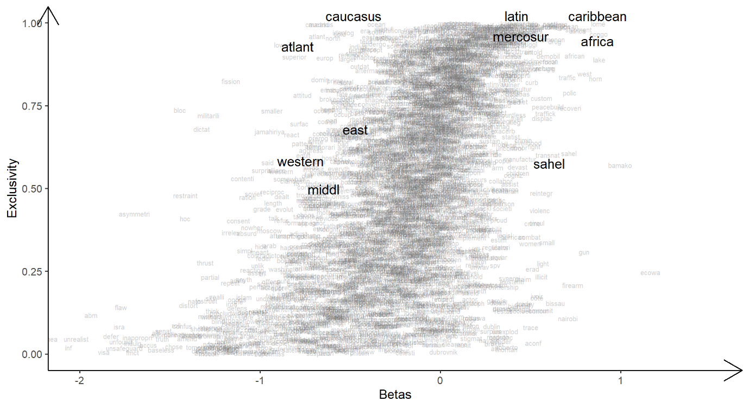

Topic 3: Landmines

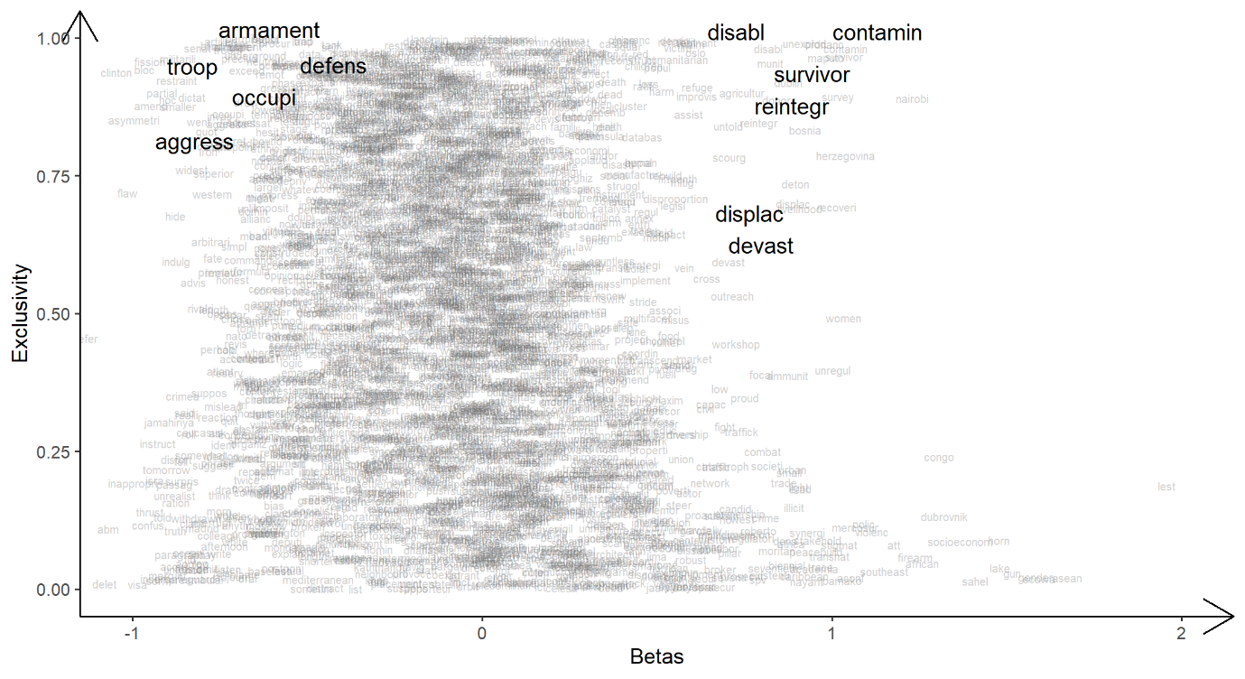

Topic 4: CBW

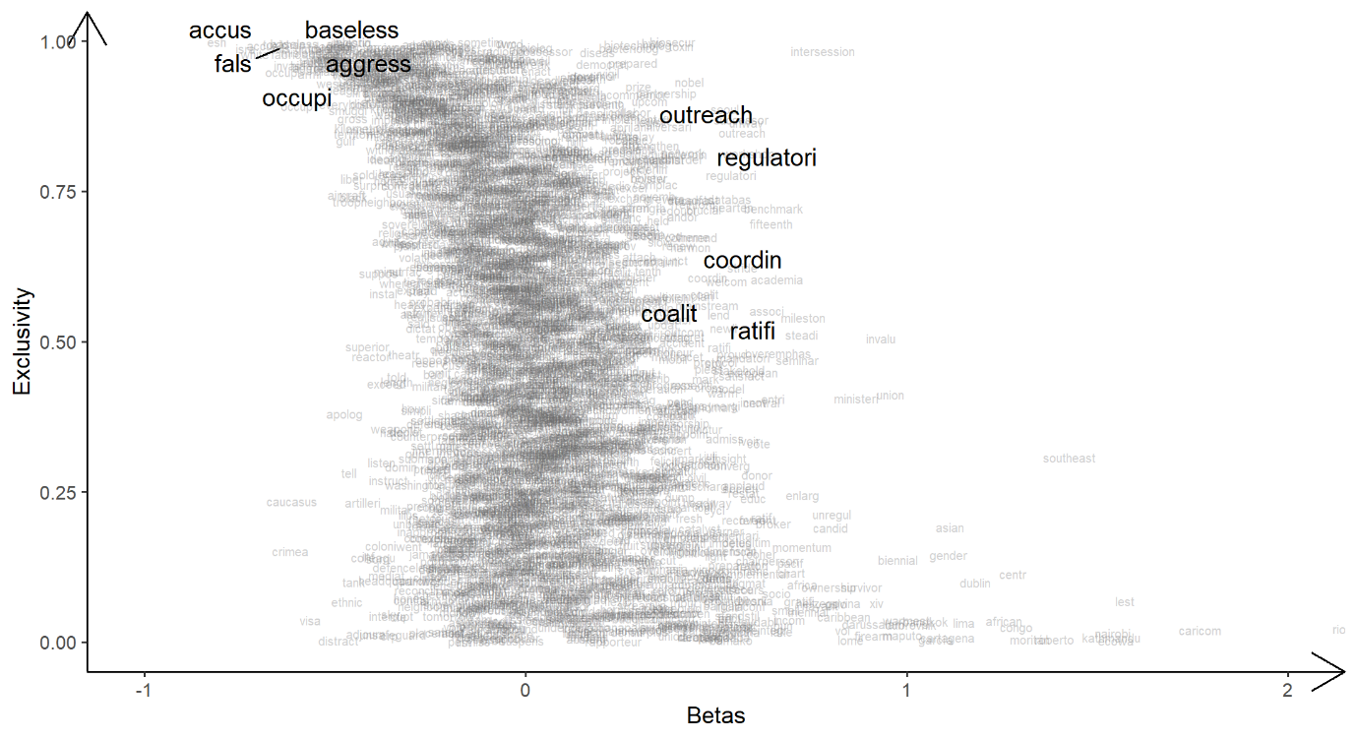

Topic 6: Nuclear

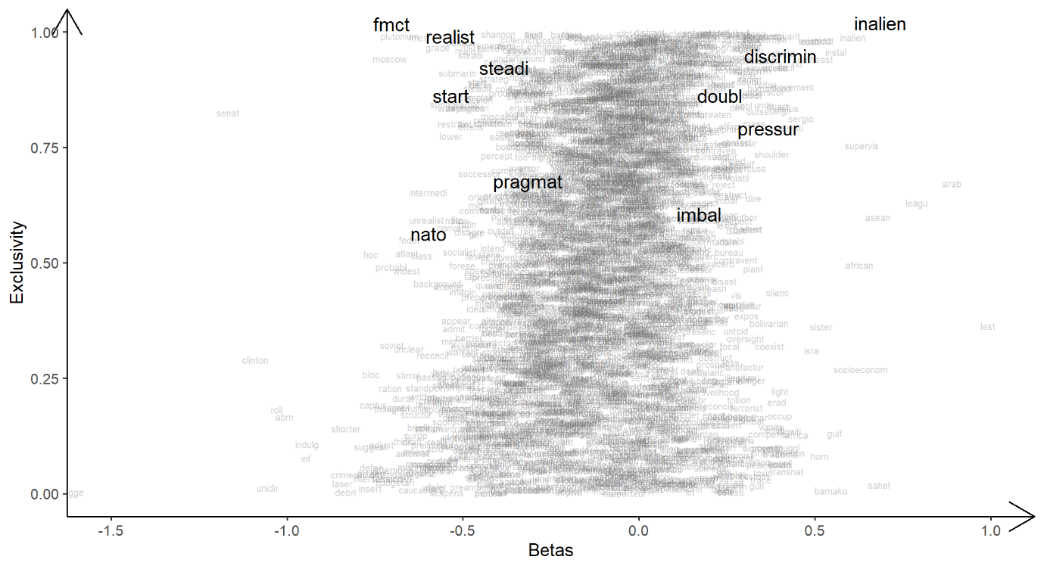

Topic 7: Space

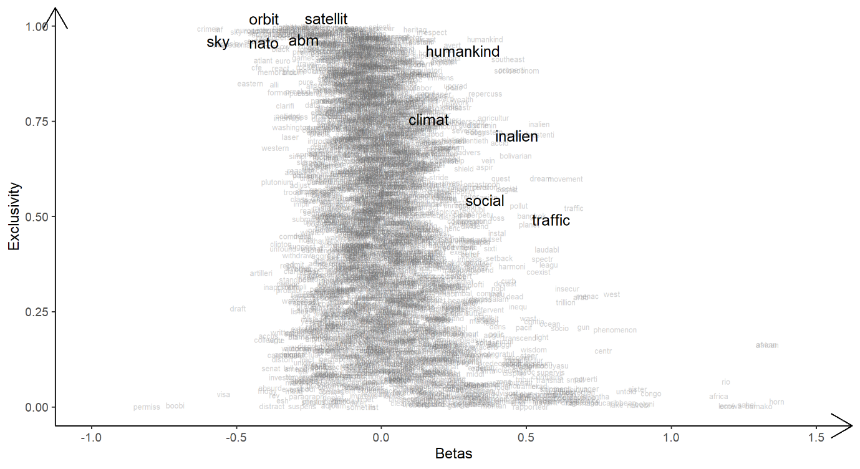

Topic 8: Arms trade

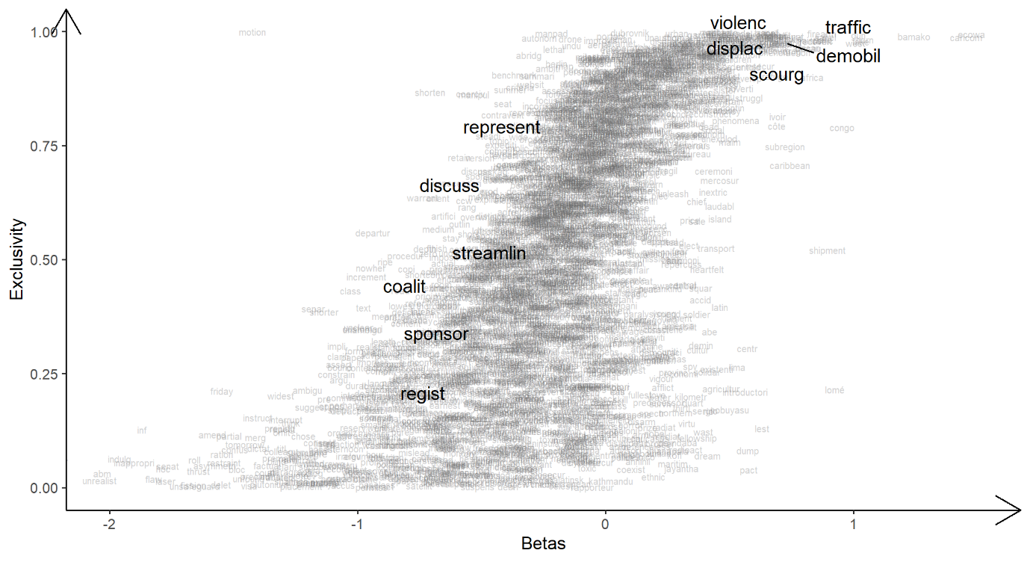

**Appendix E**: Correlations With Existing Measures

In addition to our analyses of the correlations between our dimensions and Risse’s (2023) measure of state support for arms control, we compare our estimates to several other variables measuring states’ arms control preferences.

First, Barnum and Lo (2020) deploy Wordfish to government statements given at the 13 NPT review conferences between 2000 and 2018. They interpret their estimates as reflecting a latent “non-proliferation vs. disarmament” conflict dimension, which is arguably closely related to our interpretation of the WMD dimension. Consistent with this, we find that the latent conflict over WMD, but not the one over conventional weapons, is highly correlated with Barnum and Lo’s estimates.

Second, Bailey, Strezhnev, and Voeten (2017) argue that their ideal point estimates based on recorded UNGA votes reflect a conflict over the “US-led liberal order.” We expect that support for this order to be similar to support for the status quo, as measured by our WMD dimension. Indeed, position estimates on the rhetorical conflict over WMD are highly correlated with the ideal point estimates. This holds true for their ideal points incorporating all votes as well as those on nuclear issues. Again, this supports our interpretation that our WMD dimension reflects an underlying conflict between supporters of the status quo on the one hand and challengers of the status quo on the other. Similar to Barnum and Lo’s estimates, the UNGA ideal points are only weakly correlated to our latent conflict over conventional arms.

Third, Efrat (2010) presents a measure of states’ support for controlling the trade of Small Arms and Light Weapons (SALW) that is based on a survey among government officials. As with Risse’s (2023) measure, the position estimates of the conventional weapons dimension should be positively correlated with this variable. However, Efrat (2010) measures only a narrowly defined issue instead of all topics covered by the first dimension. Moreover, his survey reflects positions at one specific point in time rather than over the entire observation period. In line with this, his measure is positively correlated with the latent conflict over conventional weapons, but to a lesser extent than the measure by Risse (2023). Nevertheless, his estimates are more closely related to our conventional weapons than to our WMD conflict dimension.

Correlations on the country level

|  |  |  |  |
| --- | --- | --- | --- |
|  | Conv. | WMD | N |
| Support for arms control, conv. (Risse 2023) | 0.54*** | 0.17* | 181 |
| Support for arms control, WMD (Risse 2023) | 0.21** | -0.17* | 181 |
| Ideal points, all votes (Bailey et al. 2017) | -0.30*** | -0.64*** | 181 |
| Ideal points, nuclear (Bailey et al. 2017) | -0.41*** | -0.66*** | 181 |
| Non-proliferation vs. disarmament (Barnum & Lo 2020) | -0.32** | -0.69*** | 114 |
| Support for SALW trade control (Efrat 2010) | 0.28** | -0.12 | 117 |

Note: Significance levels: \*\*\**p* < 0.001; \*\**p* < 0.01; \**p* < 0.05; †*p* < 0.1.

Correlations on the country-year level

|  |  |  |  |
| --- | --- | --- | --- |
|  | Conv. | WMD | N |
| Support for arms control, conv. (Risse 2023) | 0.40*** | 0.10*** | 2,570 |
| Support for arms control, WMD (Risse 2023) | 0.26*** | -0.05** | 2,572 |
| Ideal points, all votes (Bailey et al. 2017) | -0.28*** | -0.58*** | 3,081 |
| Ideal points, nuclear (Bailey et al. 2017) | -0.35*** | -0.61*** | 3,059 |
| Non-proliferation vs. disarmament (Barnum and Lo 2019) | -0.22*** | -0.56*** | 490 |
| Support for SALW trade control (Efrat 2010) | 0.20† | -0.23* | 86 |

Note: Significance levels: \*\*\**p* < 0.001; \*\**p* < 0.01; \**p* < 0.05; †*p* < 0.1.

**Appendix F**: Regression analyses

No controls

|  | **Conventional** | **WMD** | **Conventional** | **WMD** |
| --- | --- | --- | --- | --- |
| Intercept | 0.367 (0.236) | 0.054 (0.093) | 0.266 (0.230) | 0.061 (0.092) |
| Arms Exports (log.) | -0.102 (0.024)*** | -0.031 (0.013)* |  |  |
| Arms Imports (log.) | -0.052 (0.016)** | 0.010 (0.009) |  |  |
| Nuc. Possession |  |  | -2.753 (0.512)*** | -1.192 (0.377)** |
| CW Possession |  |  | -0.072 (0.236) | 0.554 (0.129)*** |
| Observations | 3106 | 3106 | 3106 | 3106 |
| Country-Clusters | 181 | 181 | 181 | 181 |
| Year-Clusters | 27 | 27 | 27 | 27 |
| NOTE: Standard errors in parentheses. Significance levels: \*\*\**p* < 0.001; \*\**p* < 0.01; \**p* < 0.05; †*p* < 0.1. | | | | |

Cross-dimensional models and all independent variables

|  | **Conventional** | **WMD** | **Conventional** | **WMD** |
| --- | --- | --- | --- | --- |
| Intercept | 2.023 (0.668)** | 0.734 (0.371)* | 2.139 (0.667)** | 0.668 (0.381)† |
| Nuc. Possession | -1.469 (0.398)*** |  | -1.353 (0.404)*** | -0.441 (0.252)† |
| CW Possession | -0.506 (0.249)* |  | -0.517 (0.248)* | 0.358 (0.140)* |
| Arms Exports (log.) |  | -0.022 (0.014) | -0.038 (0.026) | -0.018 (0.014) |
| Arms Imports (log.) |  | 0.018 (0.010)† | -0.038 (0.019)* | 0.017 (0.010)† |
| Democracy | 1.199 (0.274)*** | -0.345 (0.151)* | 1.186 (0.273)*** | -0.347 (0.151)* |
| GDPPC (logged) | -0.295 (0.068)*** | -0.106 (0.041)** | -0.255 (0.070)*** | -0.097 (0.041)* |
| CINC (logged) | -0.101 (0.048)* | -0.093 (0.029)** | -0.055 (0.051) | -0.091 (0.031)** |
| Armed Conflict | -0.186 (0.099)† | 0.010 (0.052) | -0.165 (0.100)† | 0.011 (0.052) |
| Region#Americas | -0.427 (0.268) | -0.140 (0.166) | -0.469 (0.267)† | -0.138 (0.166) |
| Region#Asia | -0.827 (0.239)*** | -0.591 (0.147)*** | -0.819 (0.238)*** | -0.579 (0.148)*** |
| Region#Europe | -1.715 (0.269)*** | -1.171 (0.166)*** | -1.706 (0.269)*** | -1.167 (0.166)*** |
| Region#Middle East | -0.568 (0.339)† | 1.382 (0.205)*** | -0.567 (0.337)† | 1.283 (0.209)*** |
| Observations | 2656 | 2656 | 2656 | 2656 |
| Country-Clusters | 166 | 166 | 166 | 166 |
| Year-Clusters | 24 | 24 | 24 | 24 |
| NOTE: Standard errors in parentheses. Significance levels: \*\*\**p* < 0.001; \*\**p* < 0.01; \**p* < 0.05; †*p* < 0.1. | | | | |