Atypical Violence and Conflict Dynamics: Evidence from Jerusalem
Supplementary Information
This Appendix provides additional information about our analyses.

Table 1A lists the candidate events discussed in the main text: 5 commemoration/anniversary dates per year as well as the AK murder. We evaluate the impact of each event on riots in two ways. The first is a “local” measurement which ranks events by the increase in riots from the week prior to the week after. We also use a “global” anomaly method, calculating the Z-score over the expanding riot time-series data. The Z-score for each candidate uses a mean and standard deviation based only on past values.
Based on the two anomaly assessment methods, the four top ranked candidates (in bold) are the AK murder, 2015 beginning of Ramadan, 2014 beginning of Ramadan, and 2013 anniversary of the 2nd Intifada. The short-term impacts of the beginning of Ramadan in 2014 and the AK murder overlap because Ramadan began 4 days before the murder. This raises the question of whether both events actually had large impacts or whether only one of these events did. We note that in the days between June 28 and July 2, 2014, there was not a significant increase in the number of riots. And the riots that occurred starting July 3 were clearly motivated by the AK murder. We therefore conclude that the beginning on Ramadan in 2014 did not have a large impact on riots, and that the increase in riots in the week after this event is actually driven by the impact of the AK murder 4 days later. We therefore focus our remaining analysis on the AK murder, 2015 beginning of Ramadan, and 2013 anniversary of the 2nd Intifada.

Selecting Cases for comparison
Index | Date | Description | Number of Events Increase from Past Week | Expanding Z-score
1 | 2014-07-02 | AK murder | 92 | 3.268
2 | 2015-06-17 | Ramadan Begins | 62 | 2.167
3 | 2014-06-28 | Ramadan Begins | 36 | 1.215
4 | 2013-09-27 | 2nd Intifada Anniversary | 20 | 2.053
5 | 2014-09-27 | 2nd Intifada Anniversary | 17 | 0.3
6 | 2015-06-05 | Six-Day War Anniversary | 16 | 0.435
7 | 2014-05-27 | Jerusalem Day | 12 | 0.059
8 | 2013-05-07 | Jerusalem Day | 4 | -0.032
9 | 2013-07-08 | Ramadan Begins | 2 | -0.323
10 | 2015-05-16 | Jerusalem Day | 2 | 0.25
11 | 2015-09-27 | 2nd Intifada Anniversary | -4 | 0.132
12 | 2015-07-17 | Ramadan Ends | -5 | -0.186
13 | 2013-08-07 | Ramadan Ends | -6 | 0.183
14 | 2013-06-05 | Six-Day War Anniversary | -7 | 0.049
15 | 2014-06-05 | Six-Day War Anniversary | -7 | 0.015
16 | 2014-07-28 | Ramadan Ends | -18 | 0.977

Table 1A: Case Selection using anomaly ranking.

The remainder of this Appendix provides additional information about the Bayesian Poisson Change Point Analysis discussed in the main text. We begin by estimating three models that assume there is only one change point in the data. The first model includes the full span of data across the years 2013 through 2015. Because the date of the murder of Abu Khdeir (July 2, 2014) occurred near the halfway point across the data, one might suspect that this might bias toward finding a change point around that time. We therefore estimate two additional models: one that ends on July 31, 2014, such that the murder is near the end of the time series; and one that begins on June 1, 2014, such that the murder is near the beginning of the time series.
For each model, we estimate the probability that a change point occurred on each day. In each model, the probability is largest on July 2, 2014, indicating that the data-generating process (DGP) most likely changed on that date. Figure 1A shows the probability that that day’s riots were produced by the first DGP (in black) or the second DGP (red). The probability that a day’s riots were produced by the first DGP is 1 (or trivially close to 1) for every day prior to July 2, 2014, and 0 thereafter. The reverse is true for the second DGP as of July 2, 2014. This result shows that our finding of a change point on July 2, 2014, is robust to choice of time span.
In addition, we tested whether the finding of a change point on the date of the murder is robust to varying the assumed number of change points. We therefore estimated a set of models, using the full time span, that assumed a range of change points from 1 to 10. July 2, 2014 was the only date identified as a change point in each model, indicating that this is the date of the most important change in the DGP. The model that best fit the data (based on the natural log of the Bayes Factors) contained 8 change points. Table 2A provides a matrix of these Bayes Factors. The lower panel of Figure 2A shows how the probabilities of the riot data being produced by different DGPs changes over the course of 2013-2015 using a different color after each change point. The upper panel of Figure 2A shows the underlying riot data over the same time span, indicating the three spikes around the three events discussed in the main paper.
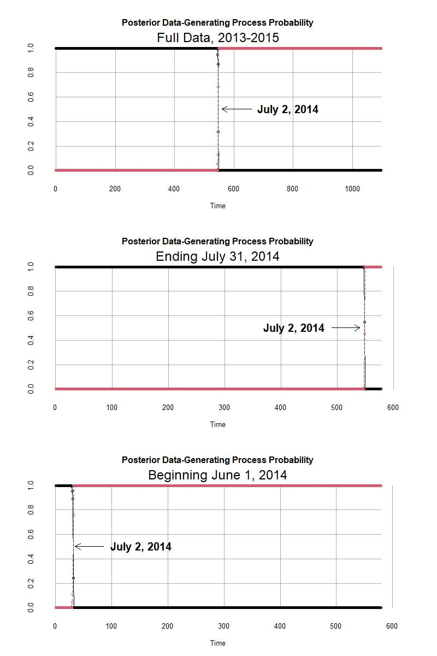
Figure 1A: Bayesian Poisson Change Point Analysis

Number of Change Points
 | 1 | 2 | 3 | 4 | 5 | 6 | 7 | 8 | 9 | 10
1 | 0 | -10.8557 | -54.2706 | -58.0197 | -83.0075 | -84.0246 | -115.197 | -132.24 | -131.367 | -95.2018
2 | 10.85567 | 0 | -43.4149 | -47.164 | -72.1519 | -73.169 | -104.341 | -121.384 | -120.512 | -84.3461
3 | 54.27061 | 43.41494 | 0 | -3.74907 | -28.7369 | -29.754 | -60.9265 | -77.9692 | -77.0967 | -40.9312
4 | 58.01968 | 47.164 | 3.749069 | 0 | -24.9879 | -26.005 | -57.1774 | -74.2201 | -73.3476 | -37.1821
5 | 83.00755 | 72.15188 | 28.73694 | 24.98787 | 0 | -1.01709 | -32.1896 | -49.2322 | -48.3598 | -12.1942
6 | 84.02464 | 73.16897 | 29.75403 | 26.00496 | 1.017089 | 0 | -31.1725 | -48.2151 | -47.3427 | -11.1772
7 | 115.1971 | 104.3414 | 60.92649 | 57.17743 | 32.18955 | 31.17246 | 0 | -17.0427 | -16.1702 | 19.99531
8 | 132.2398 | 121.3841 | 77.96915 | 74.22008 | 49.23221 | 48.21512 | 17.04266 | 0 | 0.872458 | 37.03797
9 | 131.3673 | 120.5116 | 77.0967 | 73.34763 | 48.35975 | 47.34267 | 16.1702 | -0.87246 | 0 | 36.16551
10 | 95.20179 | 84.34612 | 40.93119 | 37.18212 | 12.19424 | 11.17715 | -19.9953 | -37.038 | -36.1655 | 0
Table 2A: Matrix of the Natural Logs of the Bayes Factors across Multiple Models

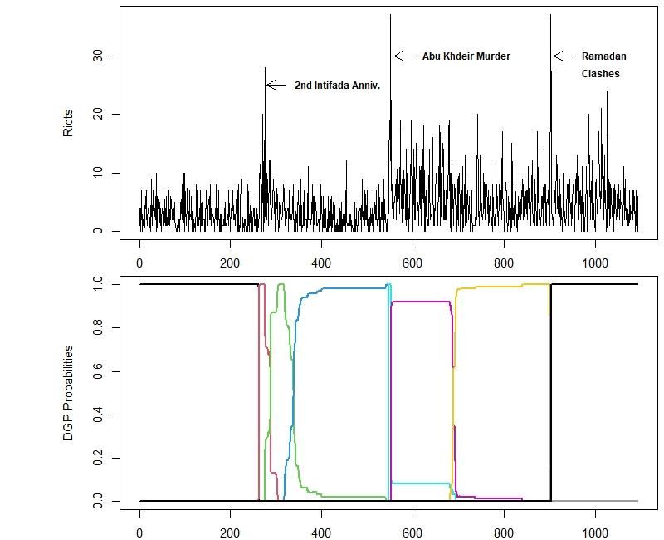
Figure 2A: Bayesian Poisson Change Point Analysis with 8 Change Points

