Supplemental Material

Supplemental Table 1. HEI-2020 sub-scores and scoring standards.
Component | Score Range | Maximum Score Standard | Minimum Score Standard

Adequacy Sub-Scores
Vegetables | 0-5 | ≥ 1.1 cup equivalent per 1000 kcal | No vegetable intake
Greens and Beans | 0-5 | ≥ 0.2 cup equivalent per 1000 kcal | No dark green vegetables of legume intake
Fruit | 0-5 | ≥ 0.8 cup equivalent per 1000 kcal | No fruit intake
Whole Fruit | 0-5 | ≥ 0.4 cup equivalent per 1000 kcal | No whole fruit intake
Whole Grains | 0-10 | ≥ 1.5 oz. equivalent per 1000 kcal | No whole grain intake
Dairy | 0-10 | ≥ 1.3 cup equivalent per 1000 kcal | No dairy intake
Total Protein | 0-5 | ≥ 2.5 oz equivalent per 1000 kcal | No protein foods intake
Seafood and Plant Protein | 0-5 | ≥ 0.8 oz equivalent per 1000 kcal | No seafood or plant protein foods intake
FA Ratio | 0-10 | (PUFA + MUFA) / SFA ≥ 2.5 | (PUFA + MUFA) / SFA ≤ 1.2

Discretionary Sub-Scores
Sodium | 0-10 | ≤ 1.8 oz equivalent per 1000 kcal | ≥ 4.3 oz equivalent per 1000 kcal
Refined Grains | 0-10 | ≤ 1.1 g per 1000 kcal | ≥ 2.0 g per 1000 kcal
Saturated FA | 0-10 | < 6.5% of total kcal intake | ≥ 26% of total kcal intake
Added Sugar | 0-10 | ≤ 8.0% of total kcal intake | ≥ 16% of total kcal intake

HEI-2020, Healthy Eating Index-2020; FA, fatty acids; PUFA, polyunsaturated fatty acids; MUFA, monounsaturated fatty acids.

Fruit includes 100% fruit juice; Whole Fruit includes all forms excluding juice; Greens and Beans includes beans, peas, and lentils; Dairy includes all milk products (e.g., milk, yogurt, cheese, fortified soy beverages); Seafood and Plant Protein includes seafood, nuts, seeds, soy, beans, peas, and lentils. Adapted from USDA: Food and Nutrition Service, (2023): How the HEI is Scored.

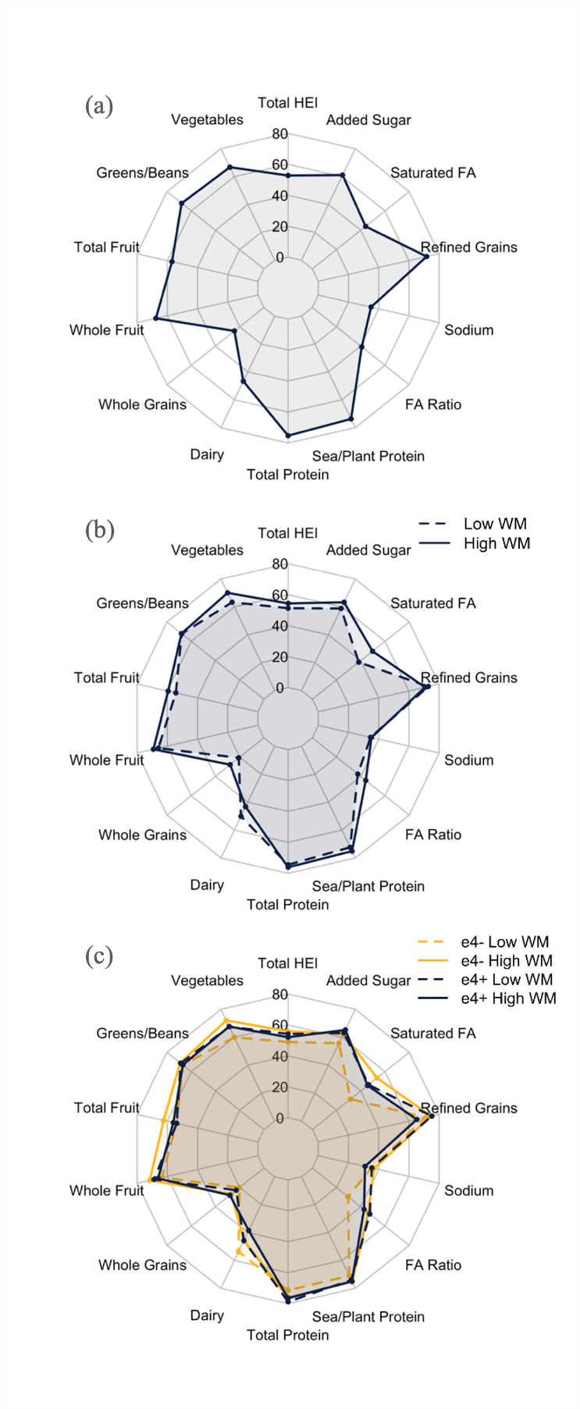
(a)
(b)
(c)
(d)
Supplemental Figure 1. HEI-2020 radar plots across (a) low vs high working memory performers, (b) low vs high working memory performers stratified by APOE-ε4 carrier status, (c) low vs high cognitive flexibility performers, and (d) low vs high cognitive flexibility performers stratified by APOE-ε4 carrier status.
e4-, APOE-ε4 noncarriers; e4+, APOE-ε4 carriers; WM, composite working memory scores; Flex, composite cognitive flexibility scores; FA, fatty acids; HEI, Healthy Eating Index-2020.

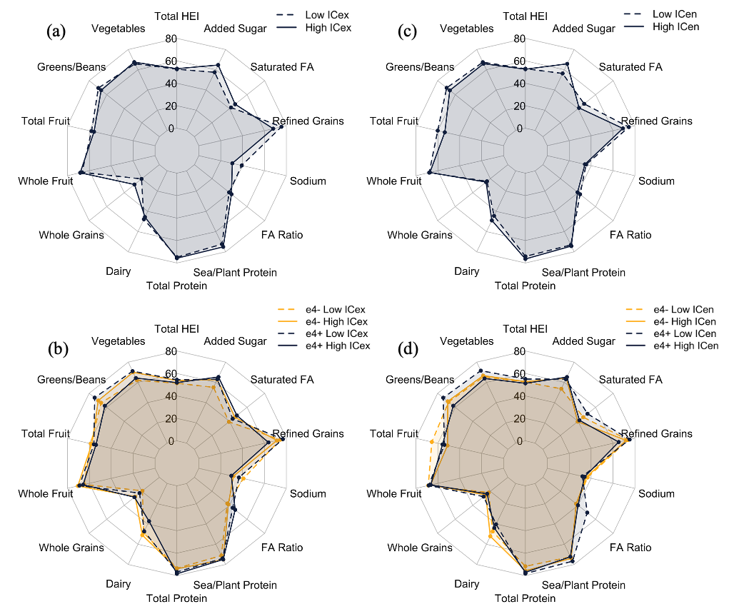

Supplemental Figure 2. HEI-2020 radar plots across (a) low vs high exogenous inhibitory control performers, (b) low vs high exogenous inhibitory control performers stratified by APOE-ε4 carrier status, (c) low vs high endogenous inhibitory control performers, and (d) low vs high endogenous inhibitory control performers stratified by APOE-ε4 carrier status.
e4-, APOE-ε4 noncarriers; e4+, APOE-ε4 carriers; ICen, composite endogenous inhibitory control scores; ICex, composite exogenous inhibitory control scores; FA, fatty acids; HEI, Healthy Eating Index-2020.

Supplemental Table 2. HEI-2020 sub-scores stratified by APOE-ε4 carrier status.
HEI-2020 Sub-Score | APOE-ε4 Carriers (n = 41) |  | APOE-ε4 Noncarriers (n = 61) |  | Significance
 | Mean | SD | Mean | SD
Adequacy HEI-2020 Components
Vegetables | 4.2 | 0.9 | 4.1 | 1.0 | .623
Greens and Beans | 4.2 | 1.3 | 4.3 | 1.3 | .953
Fruit | 3.4 | 1.5 | 3.6 | 1.6 | .501
Whole Fruit | 4.2 | 1.4 | 4.2 | 1.3 | .947
Whole Grain | 3.2 | 2.1 | 2.9 | 2.2 | .559
Dairy | 5.3 | 2.3 | 6.2 | 2.4 | .046*
Total Protein | 4.9 | 0.5 | 4.6 | 0.8 | .062†
Seafood and Plant Protein | 4.7 | 0.9 | 4.6 | 0.9 | .664
FA Ratio | 5.6 | 2.8 | 4.8 | 3.3 | .151
Moderation HEI-2020 Components
Sodium | 4.1 | 2.5 | 4.5 | 3.0 | .494
Refined Grains | 8.8 | 1.8 | 9.1 | 1.7 | .340
Saturated FA | 5.8 | 3.5 | 5.3 | 3.3 | .550
Added Sugars | 8.0 | 2.6 | 7.4 | 2.9 | .240
HEI-2020, Healthy Eating Index-2020; APOE-ε4, apolipoprotein E epsilon 4 allele; FA, fatty acids.
* Indicates statistically significant results (p < .05).
† Indicates trend towards significance (p < .10).

Supplemental Figure 3. Scatter plot with fitted regression lines stratified by APOE-ε4 carrier status illustrating the association between HEI-2020 and overall executive function. while simple slopes derived from the moderation analyses are presented in Figure 3a-b, this figure displays raw, individual participant data with unadjusted regression lines.

Supplemental Figure 4. Scatter plot with fitted regression lines stratified by APOE-ε4 carrier status illustrating the association between HEI-2020 and working memory. while simple slopes derived from the moderation analyses are presented in Figure 3a-b, this figure displays raw, individual participant data with unadjusted regression lines.
Supplemental Table 3. Conditional effects of overall HEI-2020 scores and sub-scores on composite cognitive performance scores stratified by APOE-ε4 carrier status.
APOE-ε4 Carriage | b | SE | t | p | CI (LL, UL)
Overall Executive Function
Overall HEI-2020
Noncarriers | 0.0242 | 0.0081 | 3.0016 | 0.0034* | 0.0082, 0.0403
Carriers | -0.0066 | 0.0122 | -0.5378 | 0.5920 | -0.0309, 0.0177
Vegetables
Noncarriers | 0.4091 | 0.1584 | 2.5821 | 0.0113* | 0.0946, 0.7236
Carriers | -0.1292 | 0.1912 | -0.6758 | 0.5008 | -0.5086, 0.2503
Saturated FA
Noncarriers | 0.3640 | 0.1592 | 2.2869 | 0.0244* | 0.0481, 0.6799
Carriers | -0.1346 | 0.1959 | -0.6871 | 0.4937 | -0.5234, 0.2542
Working Memory
Overall HEI-2020
Noncarriers | 0.0223 | 0.0077 | 2.8876 | .0048* | 0.0070, 0.0377
Carriers | -0.0066 | 0.0123 | -0.5377 | .5920 | -0.0310, 0.0178
Saturated FA
Noncarriers | 0.5492 | 0.1819 | 3.0195 | .0032* | 0.1882, 0.9102
Carriers | -0.1146 | 0.2239 | -0.5119 | .6099 | -0.5590, 0.3298
Exogenous Inhibitory Control
Vegetables
Noncarriers | 0.6932 | 0.1923 | 3.6056 | .0005* | 0.3116, 1.0748
Carriers | -0.1399 | 0.2319 | -0.6033 | .5477 | -0.6003, 0.3205
Endogenous Inhibitory Control
Added Sugar
Noncarriers | 0.4184 | 0.2079 | 2.0131 | .0469* | 0.0058, 0.8310
Carriers | -0.1743 | 0.2541 | -0.6859 | .4944 | -0.6787, 0.3301
APOE-ε4, apolipoprotein E epsilon 4 allele; CI, confidence interval; HEI-2020, Healthy Eating Index-2020; FA, fatty acids.
* Indicates statistically significant results (p < .05).

Supplemental Table 4. Correlation matrix.
 | BMI | HEI-2020 | Education
BMI
HEI-2020 | -0.059
Education | 0.008 | 0.122

Supplemental Table 5. p-value matrix.
 | BMI | HEI-2020 | Education
BMI
HEI-2020 | .556
Education | .933 | .224

Supplemental Table 6. Effects of HEI-2020 overall score and the other predictors on overall EF composite score.
Predictor | b | t | p | CI (LL, UL)
Overall Executive Function
R² = .135, F (6, 95) = 2.475, p = .029*
HEI-2020 | 0.0149 | 2.0914 | 0.0392* | 0.0008, 0.0290
APOE-ε4 carriage | 0.1003 | 0.8084 | 0.4209 | -0.1460, 0.3465
HEI-2020*APOE-ε4 carriage | -0.0243 | -1.8920 | 0.0615† | -0.0498, 0.0012
Age | -0.0278 | -2.5500 | 0.0124* | -0.0495, -0.0062
Education | 0.0078 | 0.2376 | 0.8127 | -0.0571, 0.0727
BMI | -0.0089 | -0.7742 | 0.4407 | -0.0319, 0.0140
CI=confidence interval; HEI-2020, Healthy Eating Index-2020; APOE-ε4, apolipoprotein E epsilon 4 allele.
* Indicates statistically significant results (p < .05).
† Indicates trend towards significance (p < .10).

