Table S1. MaAsLin2 output between placebo and cocoa-flavanol supplementation.
Feature | coef | stderr | N | N.not.0 | pval | qval
Ruminococcus | 0.451715 | 0.156843 | 16 | 10 | 0.028056 | 0.666013944
Tyzzerella | 0.969929 | 0.444276 | 16 | 5 | 0.053956 | 0.666013944
Phascolarctobacterium | 0.263093 | 0.127575 | 16 | 9 | 0.084791 | 0.666013944
Odoribacter | 0.566303 | 0.284411 | 16 | 14 | 0.093567 | 0.666013944
Gordonibacter | -1.10061 | 0.619823 | 16 | 5 | 0.10617 | 0.666013944
Intestinibacter | 1.481288 | 0.782455 | 16 | 5 | 0.107186 | 0.666013944
Eggerthella | 0.894829 | 0.511724 | 16 | 6 | 0.110922 | 0.666013944
Prevotella | -0.68028 | 0.365478 | 16 | 6 | 0.112015 | 0.666013944
Holdemanella | 0.194942 | 0.112901 | 16 | 4 | 0.134977 | 0.666013944
Fusicatenibacter | -0.45457 | 0.263309 | 16 | 16 | 0.135031 | 0.666013944
Lachnospiraceae | 0.378908 | 0.224262 | 16 | 16 | 0.142069 | 0.666013944
Butyricimonas | 0.64831 | 0.387257 | 16 | 5 | 0.145133 | 0.666013944
Eubacterium | 0.445119 | 0.270481 | 16 | 16 | 0.150935 | 0.666013944
Allisonella | 0.097892 | 0.063666 | 16 | 4 | 0.175067 | 0.666013944
Prevotellaceae | -0.65103 | 0.432493 | 16 | 8 | 0.182956 | 0.666013944
Dialister | 0.627505 | 0.471517 | 16 | 9 | 0.212794 | 0.666013944
Lachnoclostridium.Roseburia | -0.60849 | 0.443019 | 16 | 13 | 0.218707 | 0.666013944
Slackia | 0.140357 | 0.102813 | 16 | 4 | 0.22117 | 0.666013944
Faecalibacterium | -0.24464 | 0.179216 | 16 | 16 | 0.221195 | 0.666013944
Family.XIII | 0.454945 | 0.338725 | 16 | 11 | 0.227809 | 0.666013944
Bifidobacterium | -0.43731 | 0.338497 | 16 | 16 | 0.243911 | 0.666013944
Dorea | -0.14026 | 0.109413 | 16 | 16 | 0.247185 | 0.666013944
Ruminococcaceae | 0.961522 | 0.753823 | 16 | 16 | 0.249279 | 0.666013944
Marvinbryantia | 0.677462 | 0.576526 | 16 | 13 | 0.28448 | 0.666013944
Desulfovibrio | -0.05614 | 0.050069 | 16 | 6 | 0.305009 | 0.666013944
Bacteroides | -0.07534 | 0.067767 | 16 | 16 | 0.308793 | 0.666013944
Adlercreutzia.Asaccharobacter | -0.3992 | 0.364193 | 16 | 8 | 0.315062 | 0.666013944
Ruminiclostridium | 0.648093 | 0.592802 | 16 | 16 | 0.316214 | 0.666013944
Anaerotruncus | 0.386983 | 0.359403 | 16 | 11 | 0.322974 | 0.666013944
Erysipelatoclostridium | 0.461018 | 0.443017 | 16 | 7 | 0.338151 | 0.666013944
Coriobacteriaceae | -0.23019 | 0.22125 | 16 | 8 | 0.338242 | 0.666013944
Faecalitalea | 0.324775 | 0.324783 | 16 | 4 | 0.355928 | 0.666013944
Paraprevotella | 0.476019 | 0.492133 | 16 | 6 | 0.370771 | 0.666013944
Alistipes | 0.243078 | 0.253396 | 16 | 14 | 0.37446 | 0.666013944
Akkermansia | -0.38717 | 0.404976 | 16 | 6 | 0.375976 | 0.666013944
Bilophila | -0.21261 | 0.237979 | 16 | 11 | 0.406039 | 0.692140329
Parabacteroides | 0.331689 | 0.377208 | 16 | 15 | 0.413051 | 0.692140329
Senegalimassilia | 0.132627 | 0.157189 | 16 | 6 | 0.43116 | 0.693112777
Enterorhabdus | -0.14851 | 0.179547 | 16 | 4 | 0.439796 | 0.693112777
Coprococcus | 0.20152 | 0.247815 | 16 | 16 | 0.44717 | 0.693112777
Streptococcus | -0.35101 | 0.447798 | 16 | 15 | 0.46294 | 0.700056305
Sutterella | -0.416 | 0.552515 | 16 | 11 | 0.479988 | 0.708553379
Lachnoclostridium | 0.081802 | 0.115844 | 16 | 16 | 0.506583 | 0.717201934
Veillonella | 0.319964 | 0.484641 | 16 | 6 | 0.524035 | 0.717201934
Romboutsia | -0.27513 | 0.419525 | 16 | 16 | 0.536262 | 0.717201934
Erysipelotrichaceae | 0.236973 | 0.377825 | 16 | 14 | 0.553628 | 0.717201934
Barnesiella | 0.090967 | 0.147746 | 16 | 8 | 0.560708 | 0.717201934
Blautia | 0.086888 | 0.141624 | 16 | 16 | 0.562058 | 0.717201934
Flavonifractor | 0.182597 | 0.302552 | 16 | 6 | 0.56826 | 0.717201934
Blautia.Lachnoclostridium | 0.106595 | 0.187204 | 16 | 5 | 0.589747 | 0.717201934
Escherichia.Shigella | 0.445328 | 0.800024 | 16 | 5 | 0.597904 | 0.717201934
Parasutterella | -0.03932 | 0.071367 | 16 | 4 | 0.601524 | 0.717201934
Subdoligranulum | 0.145418 | 0.321003 | 16 | 16 | 0.666461 | 0.779634046
Christensenellaceae | 0.162152 | 0.435185 | 16 | 13 | 0.72225 | 0.808336304
Howardella | -0.06629 | 0.182577 | 16 | 4 | 0.728978 | 0.808336304
Clostridium | 0.159754 | 0.441913 | 16 | 7 | 0.73011 | 0.808336304
Lachnospira | 0.199812 | 0.599611 | 16 | 14 | 0.750293 | 0.816108399
Turicibacter | -0.06554 | 0.218583 | 16 | 10 | 0.774431 | 0.827839791
Anaerostipes | -0.04539 | 0.251156 | 16 | 16 | 0.862533 | 0.893651388
Collinsella | 0.049243 | 0.277152 | 16 | 14 | 0.864824 | 0.893651388
Thalassospira | 0.029729 | 0.253812 | 16 | 4 | 0.910579 | 0.925506882
Roseburia | -0.00997 | 0.326609 | 16 | 16 | 0.976635 | 0.976635049
Placebo is used as reference. Total sum scaling normalization, minimum abundance set to 0.0001 and prevalence set to 0.2. Supplement, treatment sequence, study phase age, and BMI included as fixed factors. Subject included as random effect.

Table S2. DESeq2 output between placebo and cocoa-flavanol supplementation
 | baseMean | log2FoldChange | lfcSE | stat | pvalue | padj
Phascolarctobacterium | 155.87698 | 24.41959 | 1.37275 | 3.59242 | 0.05804 | 1.00000
Gordonibacter | 12.23250 | -6.13908 | 2.92469 | 3.28503 | 0.06991 | 1.00000
Intestinibacter | 65.23610 | 22.44300 | 2.86694 | 3.24590 | 0.07160 | 1.00000
Bifidobacterium | 1322.68590 | -0.84379 | 0.51541 | 2.63385 | 0.10461 | 1.00000
Eubacterium | 2158.42091 | 0.47162 | 0.31992 | 2.15089 | 0.14249 | 1.00000
Faecalibacterium | 3791.17158 | -0.25869 | 0.18518 | 1.93164 | 0.16458 | 1.00000
Blautia.Lachnoclostridium | 40.20264 | 30.00000 | 2.85981 | 1.75904 | 0.18474 | 1.00000
Ruminiclostridium | 225.34208 | 0.86373 | 0.67057 | 1.52296 | 0.21717 | 1.00000
Butyricimonas | 10.85746 | 29.83533 | 2.95201 | 1.23490 | 0.26646 | 1.00000
Romboutsia | 245.62137 | -0.87410 | 0.78094 | 1.22647 | 0.26809 | 1.00000
Fusicatenibacter | 1059.23253 | -0.49938 | 0.45398 | 1.20388 | 0.27255 | 1.00000
Lachnospiraceae | 1831.70850 | 0.31309 | 0.29200 | 1.14629 | 0.28433 | 1.00000
Ruminococcaceae | 2215.79355 | 0.62382 | 0.59120 | 1.04280 | 0.30717 | 1.00000
Marvinbryantia | 67.50321 | 1.27471 | 1.27304 | 0.75676 | 0.38434 | 1.00000
Faecalitalea | 5.72072 | 11.14593 | 2.98264 | 0.66917 | 0.41334 | 1.00000
Lachnoclostridium.Roseburia | 177.78745 | -0.93866 | 1.13812 | 0.63998 | 0.42372 | 1.00000
Escherichia-Shigella | 77.78109 | 2.28170 | 2.93662 | 0.61352 | 0.43347 | 1.00000
Adlercreutzia.Asaccharobacter | 28.69338 | -1.78972 | 2.16371 | 0.58840 | 0.44304 | 1.00000
Tyzzerella | 18.31460 | 2.15507 | 2.86840 | 0.54968 | 0.45845 | 1.00000
Family XIII | 23.22465 | 1.37799 | 1.63061 | 0.54195 | 0.46163 | 1.00000
Paraprevotella | 93.67199 | 1.85278 | 2.66191 | 0.45678 | 0.49913 | 1.00000
Coprococcus | 553.12332 | 0.38969 | 0.55497 | 0.45436 | 0.50027 | 1.00000
Bilophila | 24.38800 | -0.98238 | 1.48823 | 0.38610 | 0.53435 | 1.00000
Lachnospira | 215.79854 | 0.65980 | 1.07404 | 0.35314 | 0.55234 | 1.00000
Subdoligranulum | 951.04180 | 0.29317 | 0.49711 | 0.34213 | 0.55860 | 1.00000
Streptococcus | 177.27243 | -0.45825 | 0.85982 | 0.26228 | 0.60856 | 1.00000
Odoribacter | 50.48839 | 0.53741 | 1.04420 | 0.25644 | 0.61258 | 1.00000
Prevotella | 1196.68943 | -1.37792 | 2.88574 | 0.21846 | 0.64022 | 1.00000
Christensenellaceae | 123.32777 | 0.61147 | 1.22204 | 0.21412 | 0.64356 | 1.00000
Erysipelatoclostridium | 29.49891 | 1.12583 | 2.45135 | 0.19436 | 0.65931 | 1.00000
Clostridium | 178.38434 | 0.96006 | 2.32516 | 0.16896 | 0.68104 | 1.00000
Sutterella | 183.81940 | -0.70865 | 1.63852 | 0.16536 | 0.68427 | 1.00000
Akkermansia | 205.48841 | -1.30130 | 2.88613 | 0.16393 | 0.68557 | 1.00000
Ruminococcus | 688.31603 | 0.84006 | 2.10111 | 0.16175 | 0.68755 | 1.00000
Bacteroides | 2968.61821 | -0.15234 | 0.42940 | 0.12423 | 0.72450 | 1.00000
Alistipes | 407.36727 | 0.33326 | 0.98102 | 0.10686 | 0.74375 | 1.00000
Senegalimassilia | 42.45078 | 0.89632 | 2.76517 | 0.10648 | 0.74419 | 1.00000
Dorea | 830.03096 | -0.12496 | 0.38609 | 0.10359 | 0.74757 | 1.00000
Parabacteroides | 332.59391 | 0.20751 | 0.75007 | 0.07533 | 0.78372 | 1.00000
Prevotellaceae | 752.57908 | -0.70232 | 2.88597 | 0.05741 | 0.81064 | 1.00000
Collinsella | 990.90057 | 0.22672 | 0.99842 | 0.05149 | 0.82049 | 1.00000
Blautia | 4313.71283 | 0.02716 | 0.17925 | 0.02271 | 0.88020 | 1.00000
Anaerostipes | 440.24392 | -0.06349 | 0.48005 | 0.01720 | 0.89566 | 1.00000
Dialister | 341.67667 | -0.10339 | 1.41787 | 0.00960 | 0.92194 | 1.00000
Erysipelotrichaceae | 407.42781 | -0.11209 | 1.18082 | 0.00832 | 0.92733 | 1.00000
Howardella | 7.67701 | 0.25401 | 2.99443 | 0.00752 | 0.93092 | 1.00000
Lachnoclostridium | 924.79904 | 0.03923 | 0.48445 | 0.00648 | 0.93585 | 1.00000
Roseburia | 688.51793 | 0.03147 | 0.51391 | 0.00373 | 0.95128 | 1.00000
Turicibacter | 95.67444 | 0.08480 | 1.80151 | 0.00223 | 0.96229 | 1.00000
Allisonella | 7.58817 | 0.15092 | 2.98707 | 0.00160 | 0.96804 | 1.00000
Barnesiella | 80.55008 | -0.05763 | 2.42241 | 0.00056 | 0.98107 | 1.00000
Anaerotruncus | 65.81868 | 0.03692 | 1.71548 | 0.00046 | 0.98296 | 1.00000
Thalassospira | 45.02274 | -0.26557 | 2.97515 | 0.00000 | 0.99978 | 1.00000
Holdemanella | 173.46777 | 0.28340 | 2.63031 | 0.00000 | 0.99997 | 1.00000
Coriobacteriaceae | 39.32390 | -0.00248 | 2.06839 | -0.00007 | 1.00000 | 1.00000
Parasutterella | 40.13601 | -0.03472 | 2.91660 | -0.00001 | 1.00000 | 1.00000
Veillonella | 30.10648 | -1.59461 | 2.61627 | -0.08471 | 1.00000 | 1.00000
Flavonifractor | 14.07246 | -13.86326 | 2.54041 | -0.20593 | 1.00000 | 1.00000
Eggerthella | 15.47814 | 1.57007 | 2.36409 | -1.12452 | 1.00000 | 1.00000
Desulfovibrio | 16.90285 | -0.04661 | 2.66261 | -0.00194 | 1.00000 | 1.00000
Enterorhabdus | 24.50976 | -0.08029 | 2.97524 | -0.00012 | 1.00000 | 1.00000
Slackia | 31.56076 | 0.11102 | 2.98302 | 0.00000 | 1.00000 | 1.00000
Supplement, treatment sequence, study phase age, and BMI included as fixed factors.

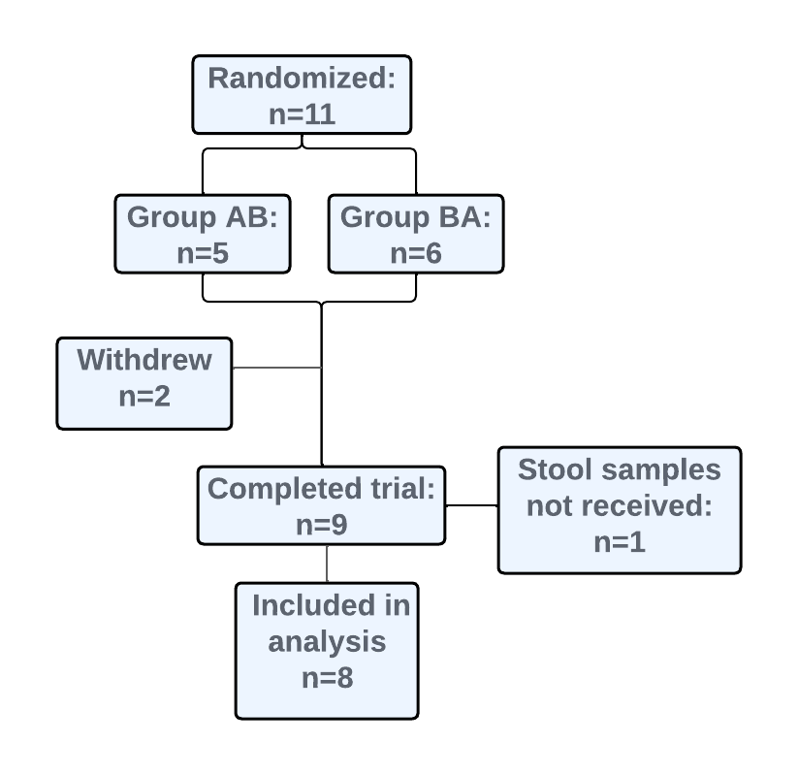
Supplemental Figure 1. Flow diagram of the progress through the randomized, double-blind, placebo-controlled, crossover study.

