Additional file 2. Examples illustrating how the scoring in both our modified EPAO and the CELEBRATE scales can differ. A) Are examples of how the same score could arise for both scales given different scenarios and b) are examples of how the same situations would result in different scores on both scales.

a)
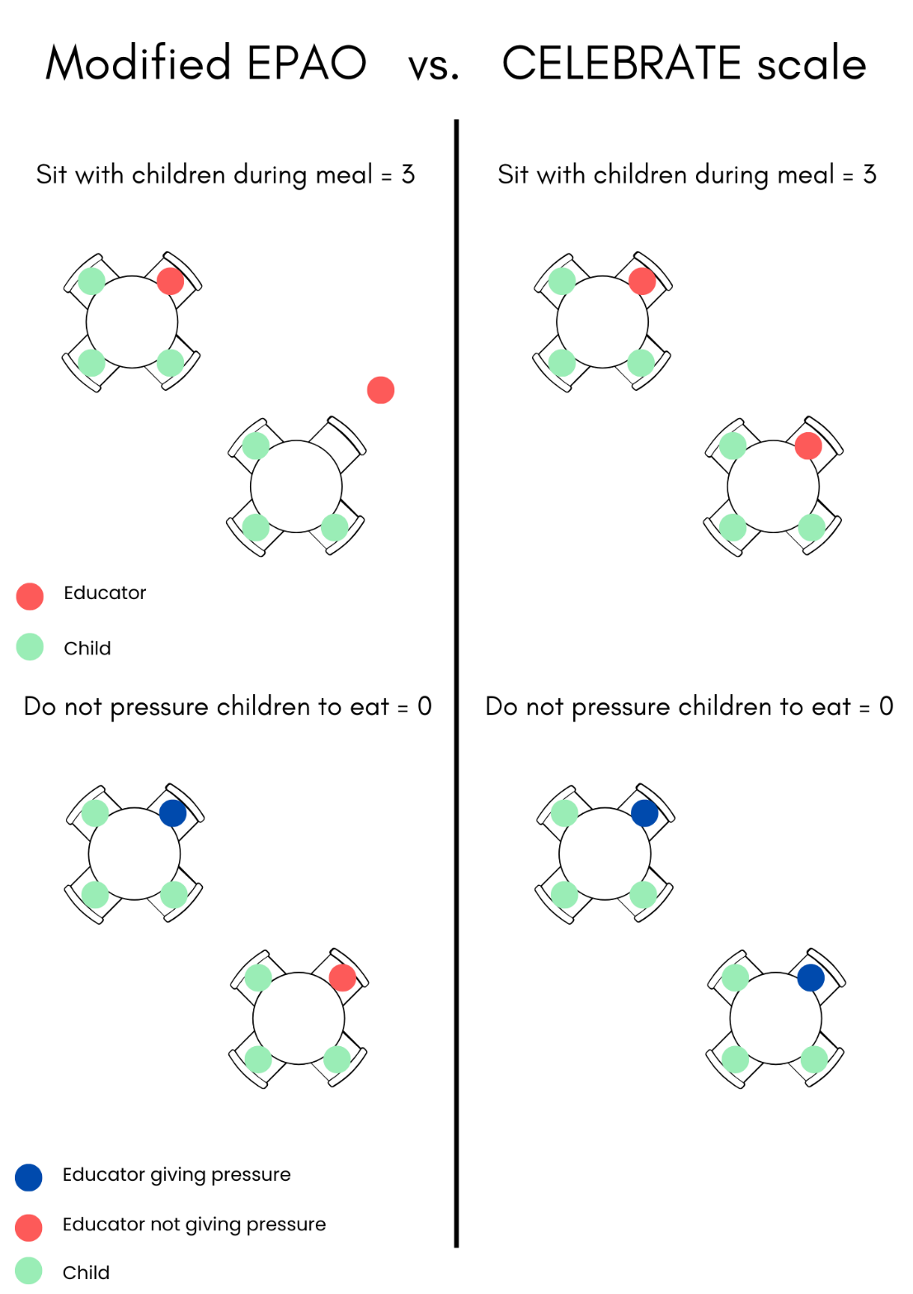

b)
